**Colors set**

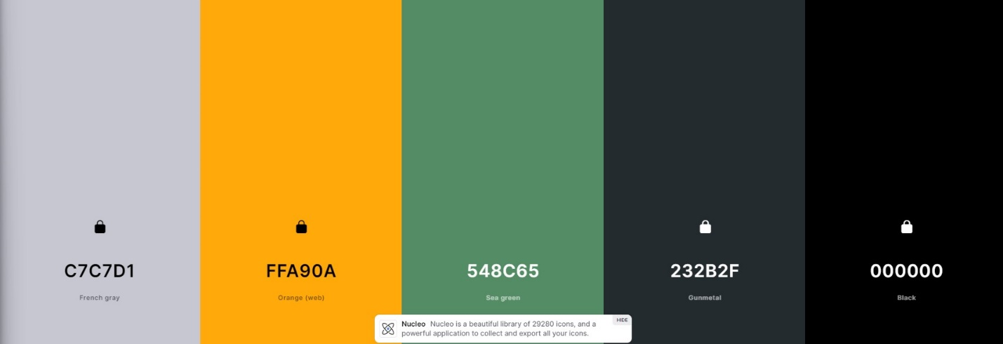**Images examples:**

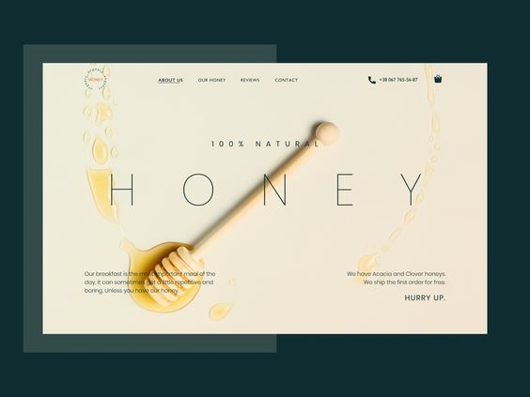

**Fonts:**

