Firstly, thank you for taking the time to complete the developer assessment. We would like to collect some feedback from the candidates on this testing method so would appreciate if you would provide your feedback based on the questions below and return this form to us.

1. How much time did you spend on the assessment?

**32 Hours due to 0 knowledge in Angular JS.**

1. Were the requirements of the assessment clear?

**Yes.**

1. Was the information in the assessment document clear and useful?

**Yes, Very useful.**

1. Was the assessment easy or difficult for you?

**No quite, just because very new to Angular, it become a bit difficult for me. And after trying many hours still not able to bring up the date-picker to the UI. Anyway, will continue learning.**

1. Any other comments.
   1. Using **Blazor** will be much more easy for me.
   2. The schema on the original **data.db** file for the **Id** field is declared as **Blob** data type which in **.Net**, it would be a Byte array – **byte[]**.

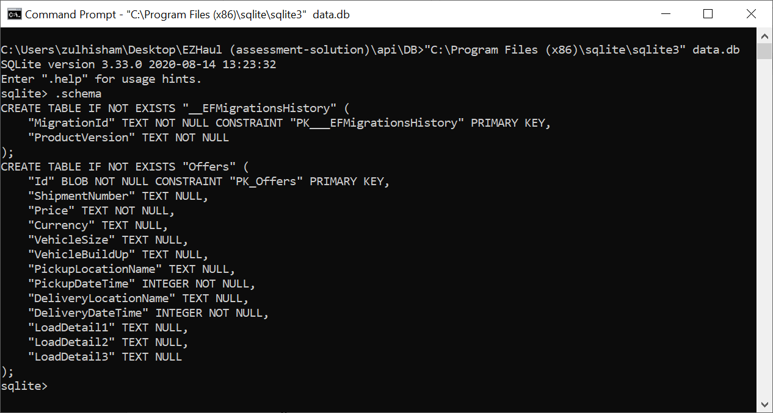

I hitting a lot of error when trying to work with byte[] with **Entity Framework and Linq**. Which also had spent some time to figure out the work around. However, still failed. Since the requirement is using **EF**, so…when trying to do **code-first approach**, it become **Text** data type (see screen-shot below). With Text data type, everything is works as expected.

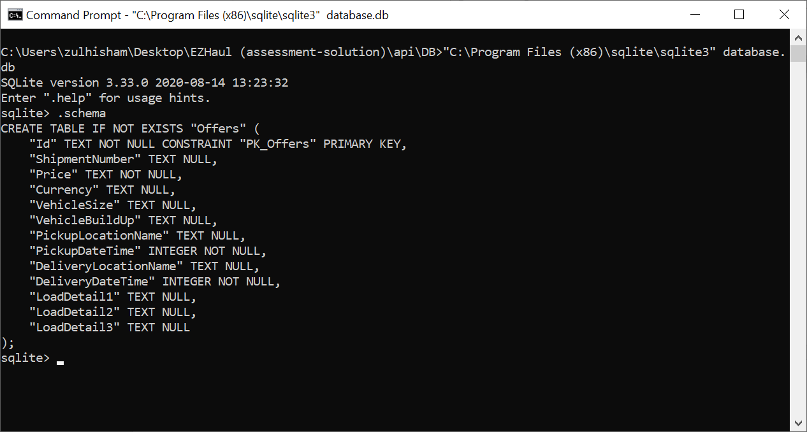

* 1. I also try to use **Auto-Mapper** and **Dependencies Injection** in order to make the code cleaner and easy to maintain.

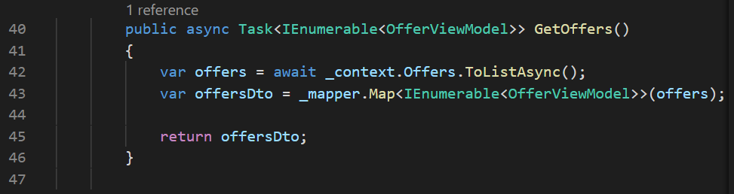

**To Test the application…**

1. Run the .Net Core Web API. You should notice it is listening to port [**https://localhost:5001**](https://localhost:5001) **and** [**http://localhost:5000**](http://localhost:5000)

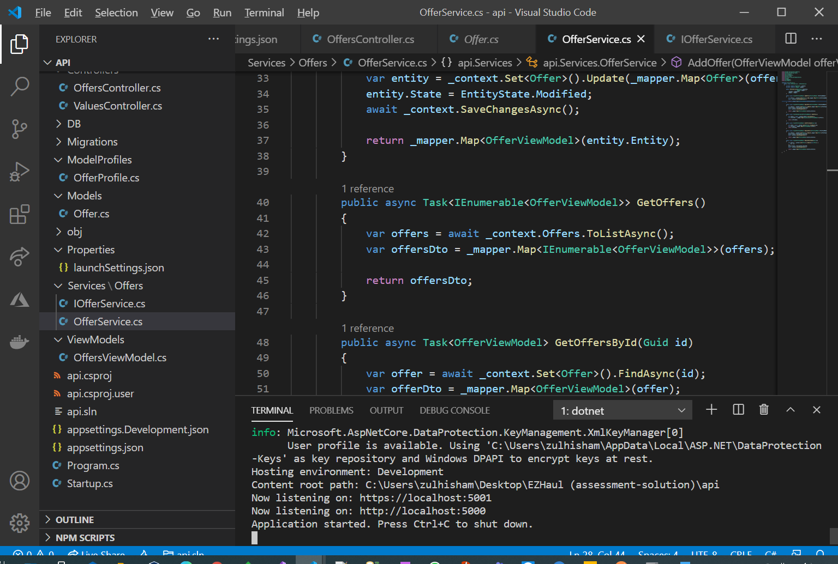

1. If the Web API is up and run, you should be able to see the **swagger page** <https://localhost:5001/swagger> .

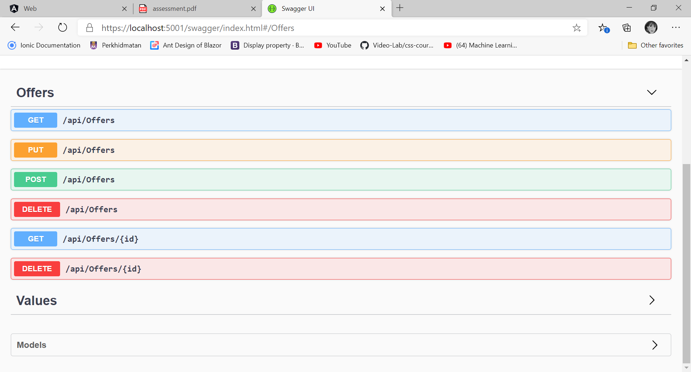

1. Run the client UI – Angular project – By typing the command ‘**ng server --open**’. If the project is built successfully then it will open the browser.

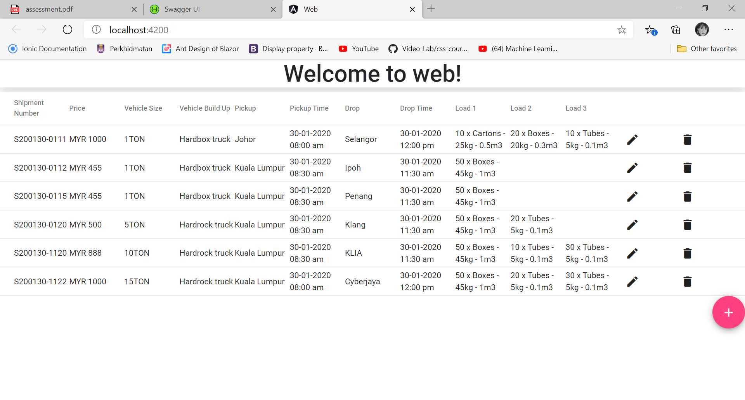

1. To delete a record, press the ‘**recycle bin**’ icon. A message will pop-up for reconfirmation.

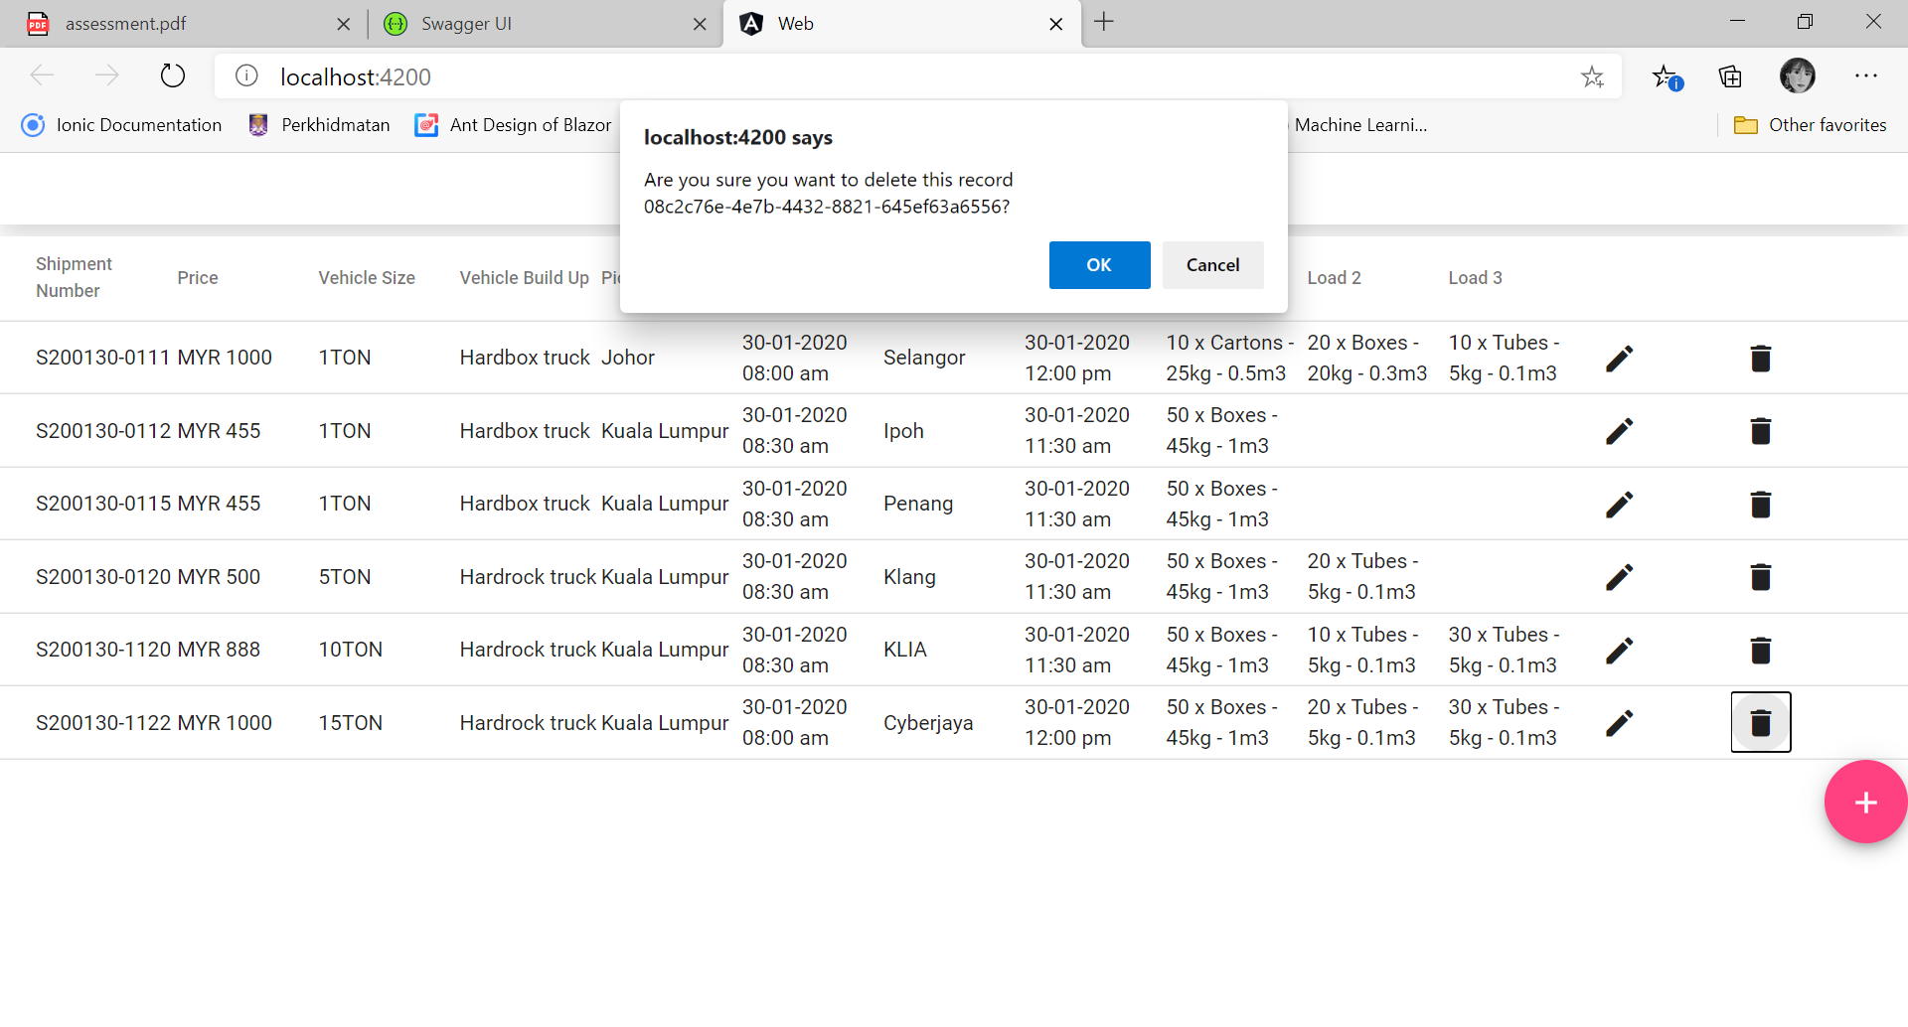

1. To edit a record, simply click on the ‘**edit-pen**’ icon. The system will redirect the user to edit page.

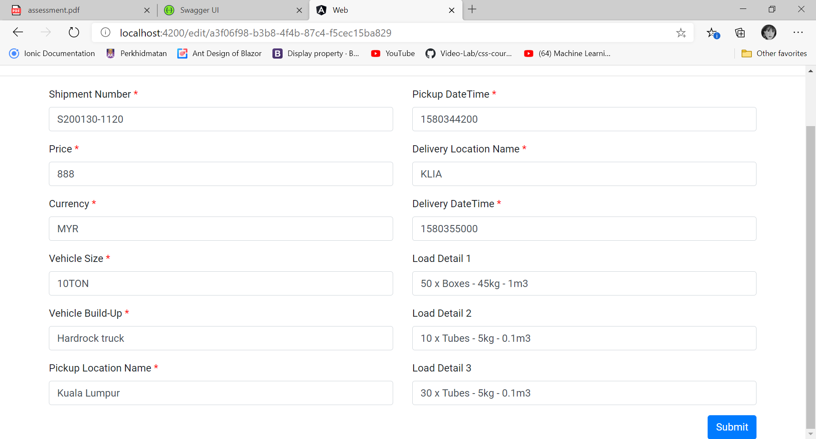

Click on the ‘**Submit**’ button to save changes. Note that, required field are need to be filled, otherwise an error will pop-up.

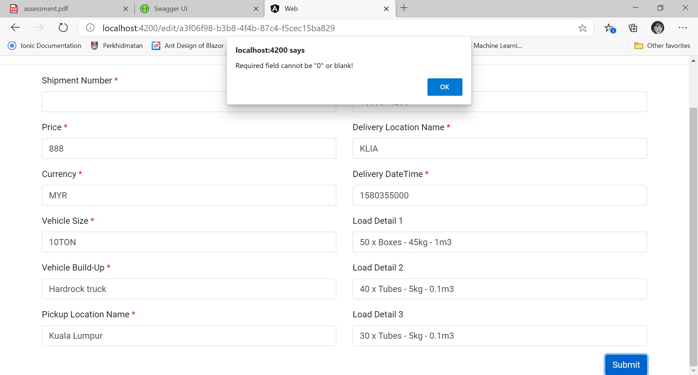

1. To create a new record, simple click on the pink color plus sign button.

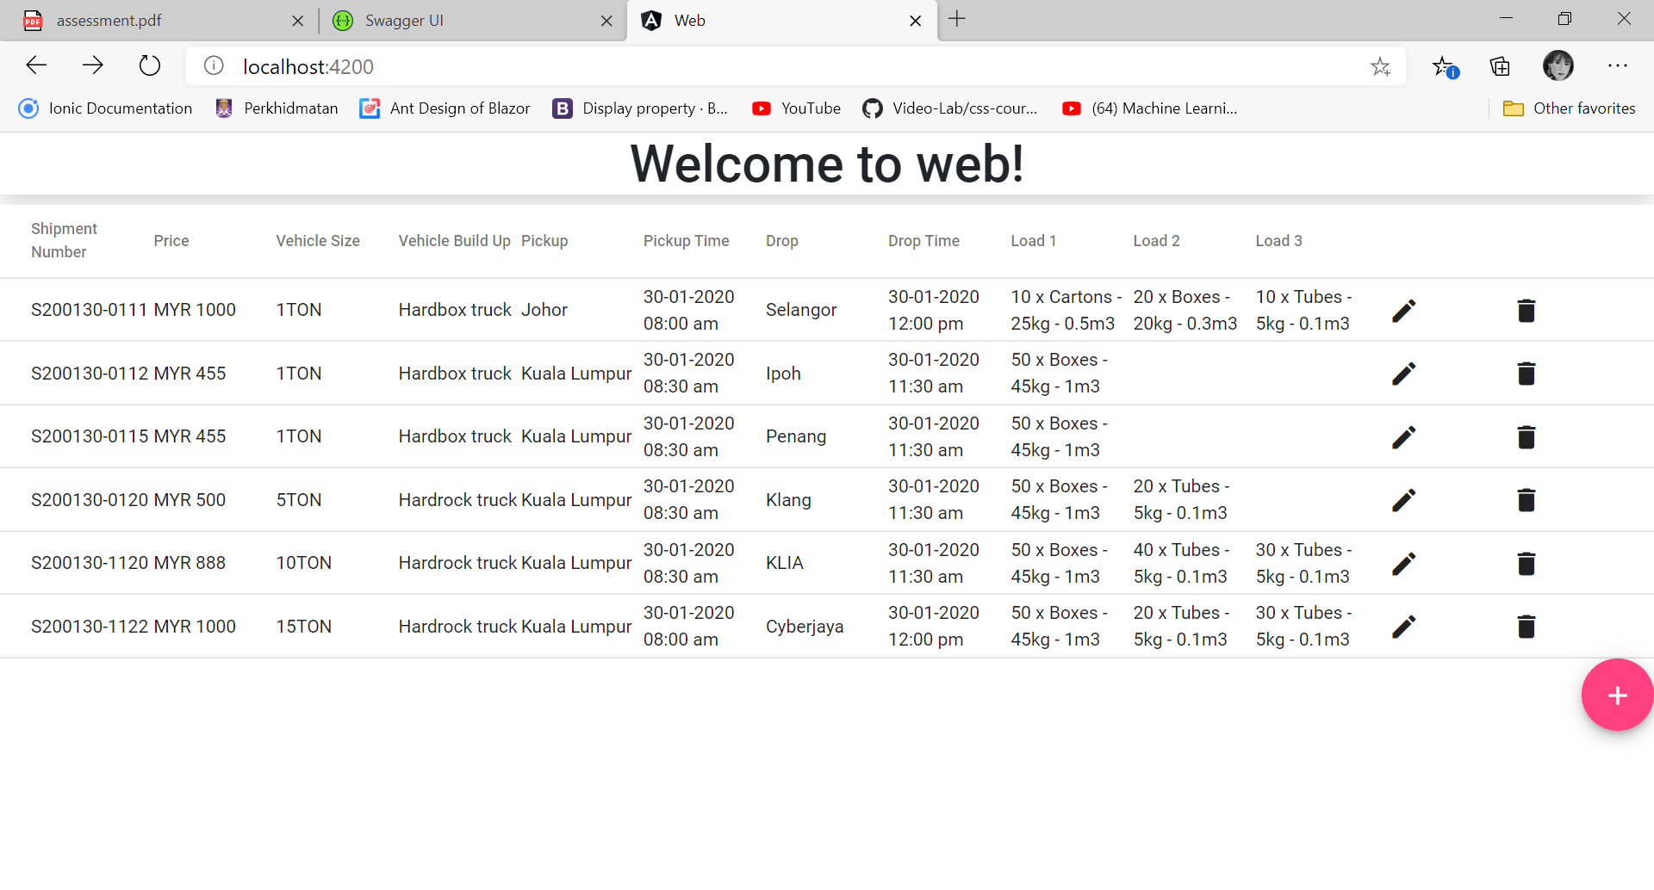

The system will redirect the user to the ‘**Create New Offer**’ page.

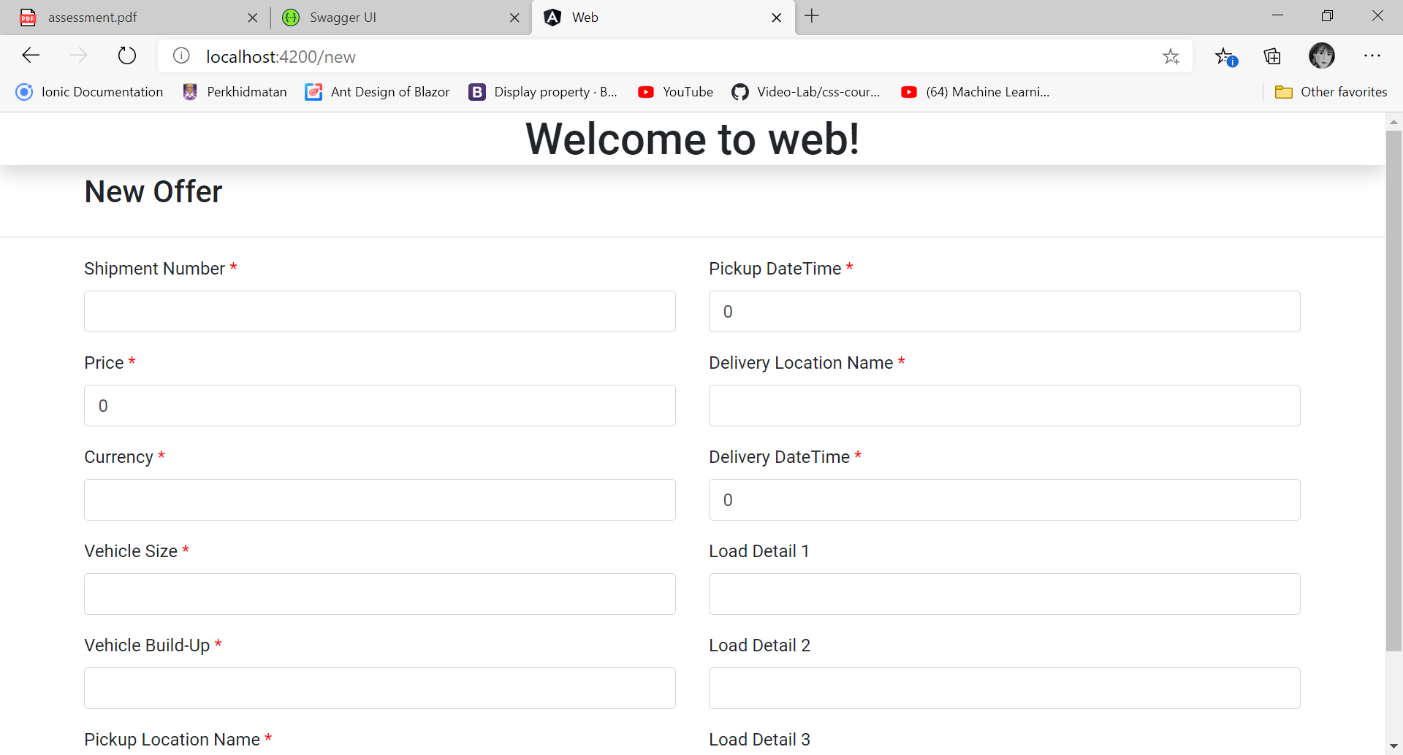

Similar to edit function, all the required field are need to be filled, otherwise an error will pop-up.