**eVolve – The Petrel Workflow**

|  |  |
| --- | --- |
| Application Name | Petrel – eVolve Plugin |
| Application Framework | .Net Framework |
| UI Framework | Petrel |
| IDE | Visual Studio 2019 |
| Repository | <https://geoimaging.petronas.com/tfs/DefaultCollection/_git/EVOLVE> |
| Application Url | N/A – Standalone Desktop Application |
| Host | TechAppLauncher / TechApp Store |

**Overview**

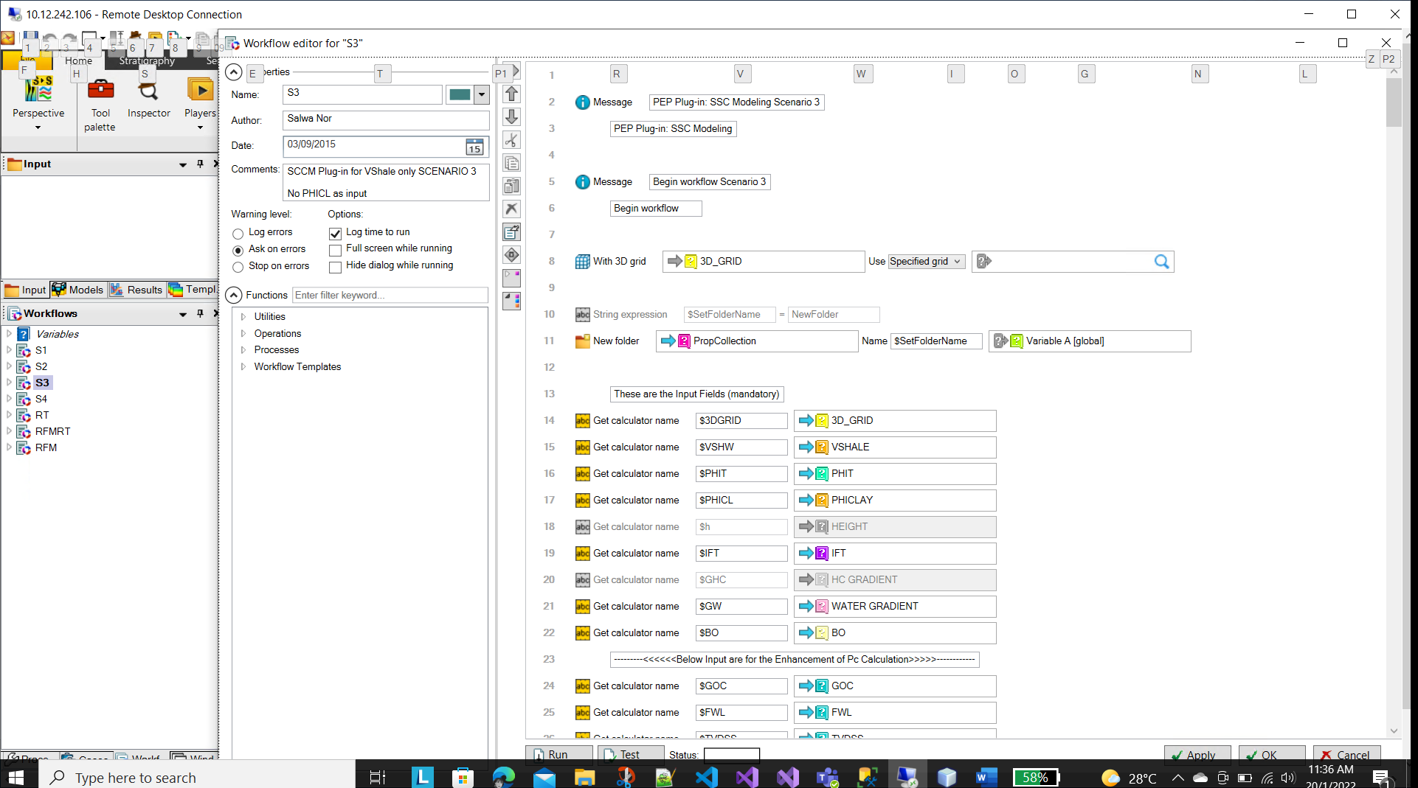

The workflow is a Petrel project, the file is located at the folder ‘**/Petronas_CannedWorkflow/Output/projects**’ within the repository. You need to decrypt the file and then unzip it in order to open it with Petrel.

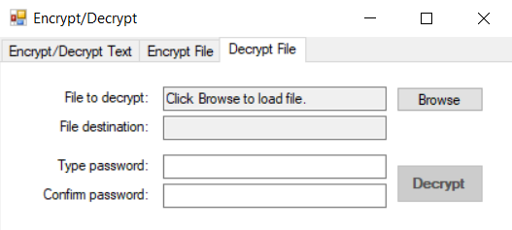

The encrypt/decrypt application repository can be found at ‘**https://geoimaging.petronas.com/tfs/DefaultCollection/_git/Evolve-%20Workflow%20Encryption**’.

The password can be found from the **resource file** of the **eVolve plugin project** with the name of the key ‘**Wf1SecetCode**’.

Once you have successfully decrypted the file, you need to unzip it before opens it with **Petrel** application.

Any changes that you have done and if you wish to deploy it as a plugin then you need to zip the entire Petrel project and name it as ‘**wf1.zip**’. Then use the encrypt/decrypt project to encrypt the zip file as ‘**wf1z_zzip.encrypt**’. And finally, copy the encrypted file to the folder ‘**/Petronas_CannedWorkflow/Output/projects**’.

**\*\*\* Important Notes**

**The Expression in the workflow being greyed out (disabled)**

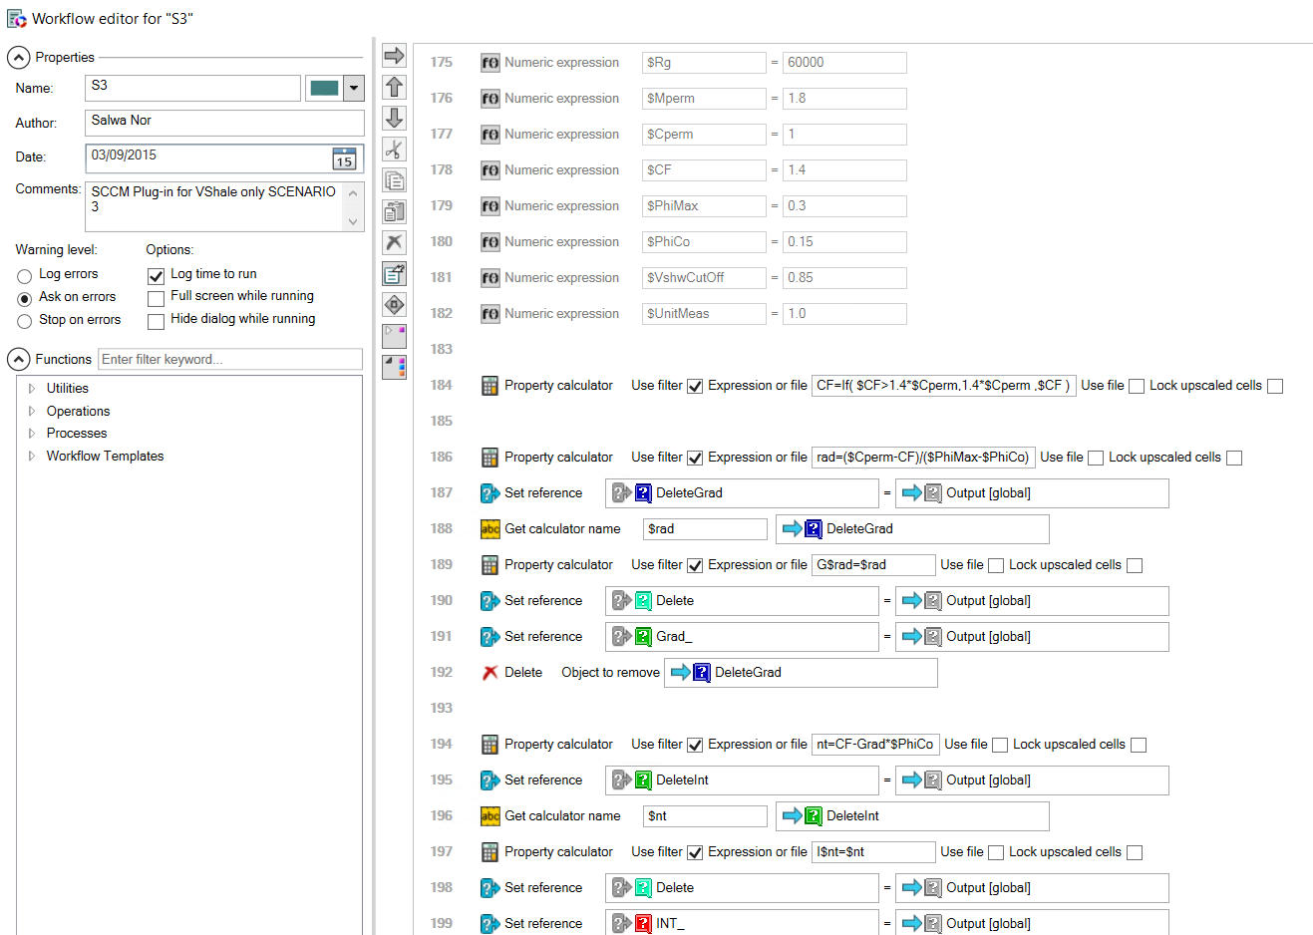

You may notice that some expression in the workflow has been **greyed out (disabled)**. This is because the value needed to be read from the **Petrel plugin (C# plugin project)**. Otherwise, it will act as a constant within the workflow.

Screenshot below shows how **Petrel plugin** pass the value to the workflow.

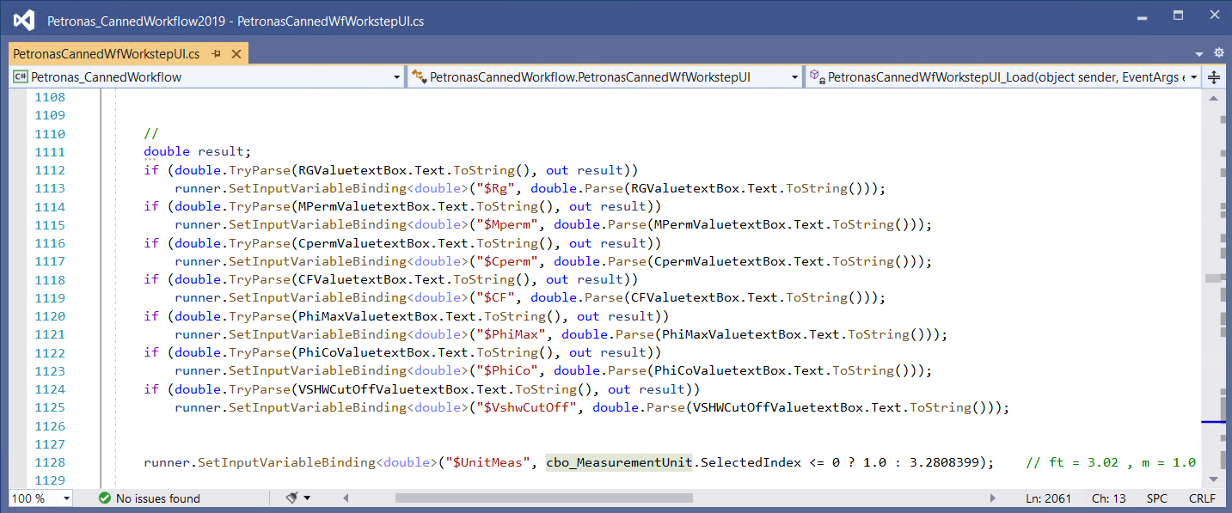

However, not all expression that has been greyed out has the value being passed from the Petrel plugin which is written in C# code. Those greyed out expression are shown in the screenshot below for example. These statements are actually been **disabled,** which means it is no longer executed when the program runs and you can actually delete it if you wish to.

