|  |  |  |  |  |
| --- | --- | --- | --- | --- |
| Subject | : Stabilization Activities |  | Date | : 16th August 2011 |
| Machine | : Taping |  | Prepared | : Zulhisham Tan |
| Section | : PX Line |  | Status | : Machine Running With Condition |

*P*roduction was frequently feedback that the Lots were congested at Taping-OAI process. The main reason is due to machine judgment unstable which result in increasing of Machine’s minor stoppages. In order to address this issue, an activity was setup to stabilize and target to improve the efficiency of the machine. And this report reserved the right in reporting the machine efficiency as well as accuracy for future reference. It will also impact to the future machine development in selecting an appropriate Vision System in the system integration.

How well is the machine will judge is based on the data return from the Vision System. Hence, the Vision system plays an ultimate important role here. Basically, Vision system had divide into several classes which purposely designed for specific kind of application. Regardless of the type of the system, however…, the accuracy of a Vision system is solely depends on the image it had captured to process the image data. Listed in the following are the factor that effect the accuracy of a Vision System

1. **The resolution of the Camera** to capture an image for processing.
2. **The Size of an image,** However, it depends on the resolution of the camera and the focus lens being selected.
3. **The lighting system** which helps sharpens an image to be processed.
4. **The color of the lighting** system will effect to the binary data of an image.
5. The target (object) itself for example its color and size.
6. The background color.

Logically, the better the image, the better the accuracy of a vision system, however, few consideration needs to be take into consideration during design time especially investment cost for a vision system. However, this can be solved by a solid study on the application that’s how well it is to be fulfilled a requirement. Higher resolution of a camera system would definitely put the Return on Investment period longer. It is same apply to the selection of Lighting system as well as the camera accessories.

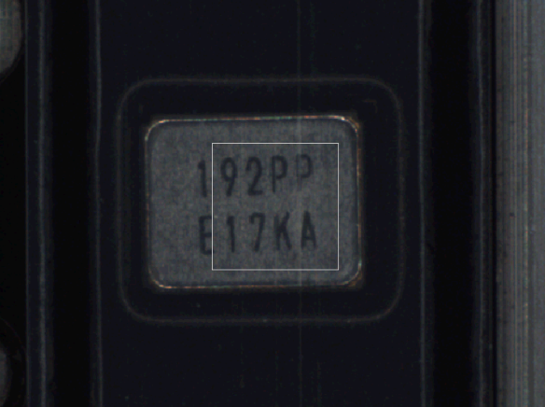Well, the target object plays a significant important role in order to prevent a wrong data returns from a Vision system. Now, let takes an example on the following image. As being highlighted, the character ‘P’ is being interrupted by a tiny line on the Top-Tape. This is particularly difficult to avoid since the target (object) by which the camera trying to capture is at behind an additional object which is not more than 95% transparent. In this case, the Taping-OAI machine fails to perform in normal condition, it will frequently return alert saying that the Marking Data is incorrect. This situation might take an hour to inspect a Lot. As such, I would urge **PE & Production to control the Top-Tape quality**.

Taping-OAI machine is being integrated with Omron FZ-3 series vision system. The machine has no full control on the system. This is the limitation on selecting the modular package of a Vision system compare to the typical PC-Based system which has full access to a particular parameter setting. A software is written and runs independently on the Vision Controller itself. The measurement result is then transfer to the machine control via a serial communication device. The flow of the piece of software will not be covered here. However, the setting has significant impact to the performance of the machine. Let take an example for a case study.

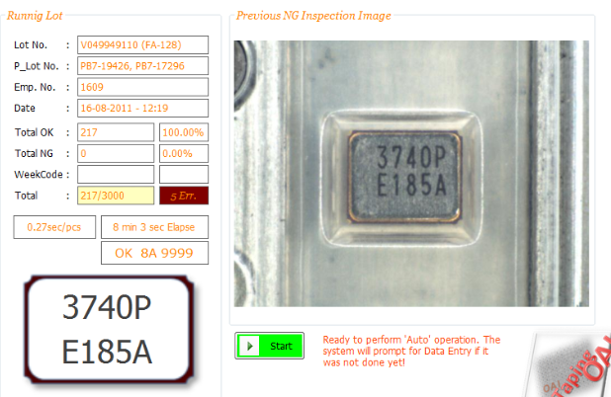

**Normal Data Format: OK 3740 E185A 9999**

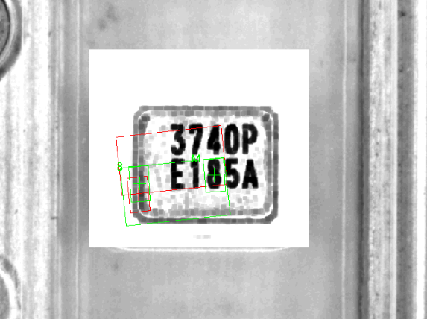The example above shows an example of incorrect data returns from the Vision System. In gone through a details checking which should not be performed by any PM member, it could be cause by several reason. Technically, it is due to the searching character is not in the region of interest in the image. The screen shot on the right shown the situation – The red color rectangular box indicates the searching object is out from the region of interest. The reason why the searching character is out from the region of interest is roughly shown in the following ‘Why-why analysis’ diagram.

Now, why the region of interest is out of its position? Through the simple why-why chart above, we have several reason which make sense to the case study. However, there is nothing can be done on the gap that exists between the object and the Tape. In this case, the only thing can be done is re-adjust the position of region of interest. To do that, follow the following step.

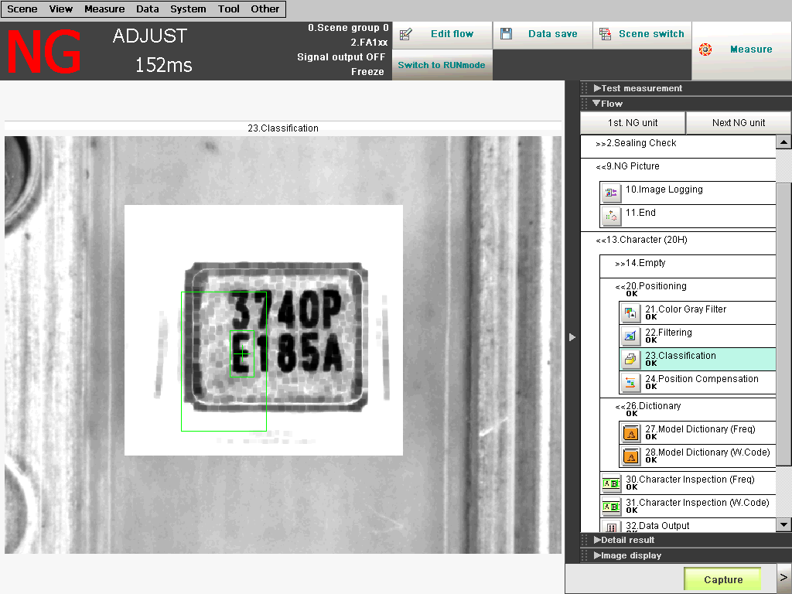

In the adjustment mode, click on the ‘Classification’ icon as shown in the screen shoot at previous page. A new screen pop-up shows the current setting as shown below.

Click the button to edit the Region of Interest.

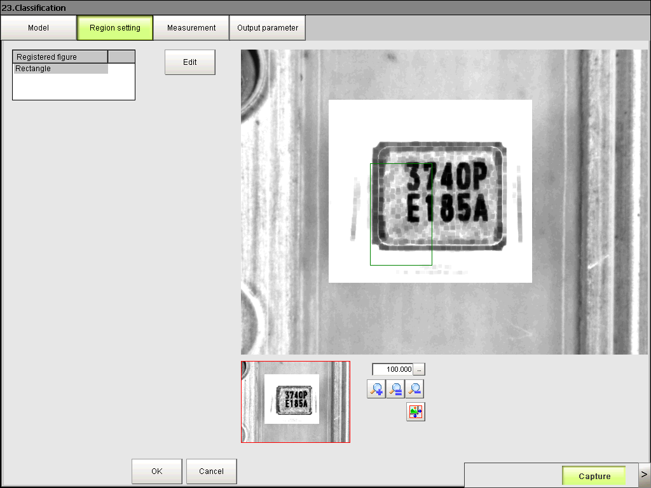

Notice a green color rectangular box highlighted, which is the current setting for the region of interest. Well, the program takes the ‘E” character as its searching object within the searching region. If the character ‘E’ is not within the region of interest, then it is our responsible to re-setting the region of interest.

Now, click on the ‘Edit’ button as shown in the screen shot above. The edit windows pop-up, simply drag the small gray box to set the new position of the Region of Interest. This can be done as easy as drawing a box in Microsoft Excel application. Once done, click the ‘OK’ button to finish the editing process (refer to the screen shot located next page).

Well, the Machine was integrated with the Omron Vision system which is wired up by a serial communication commanding. However, Omron does not provide a full access of the Editing function by using the serial communication. As a result, the operator will stop the machine if this happened. The impact of this is the FA-128 as well as FA-118 product which physically is very small in size. This is the reason why FA-128 and FA-118 is congested at Taping OAI in a particular time.

This report has drafted the step to re-setting the Region of Interest and particularly to me…, it should be downstream training to PM staff in order to maintain the machine performance. Due to the limitation of the Vision System capability, the Taping OAI machine can’t automate the edit process.

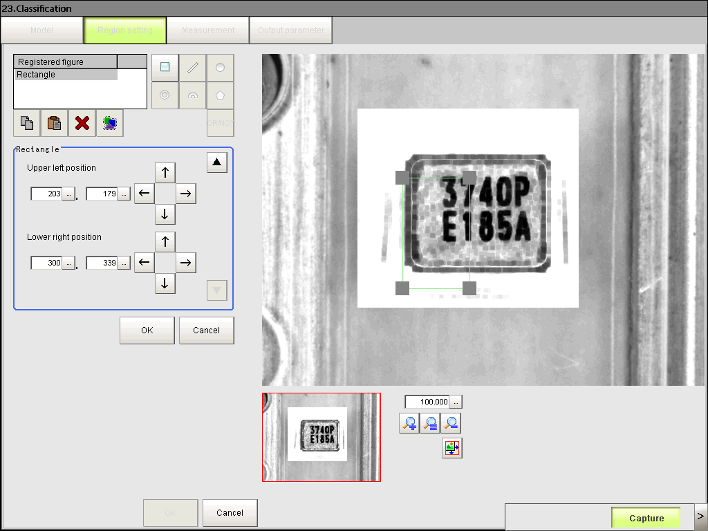

Click the button once done.

As a result, we should think of different technology such as the PC-Based Vision system in order to fully automate the entire process to achieve system reliability.

Marking shift is another main concern which is due to the machine design structure. However, it is still under acceptable condition. With the existing design structure, nothing can be done because there is a gap between the product and the Tray. No mechanism to self-align the product inside the Tray.

Regards the moving pitch of the transportation unit of Taping-OAI, the major concern point is the mechanical backlash. The backlash exists due to the usage of motor gear head. The backlash is about 1 degree. From the naked eye, nothing much different, but under the camera, there is about 15 to 20 pixel shifted. In addition, the origin point is also shifted by 1 degree.

In order to address the backlash issue, the PC software has been modified. Listed below are the modification items that had been done.

1. Serial Modulation Controller‘s (SMC) – The operating mode has been changed from acceleration mode to normal mode. Cycle time is not affected.
2. Movement Parameter – Slower acceleration. Cycle time not affected.
3. Motor Driver – Maximized the Holding current.

**After the action had been taken, the shift is less however there is still 15 to 20 pixel shifted. As such, in conclusion, the know-how to adjust the region of interest is important and it is only can be done manually.**

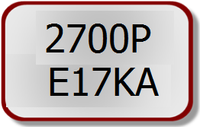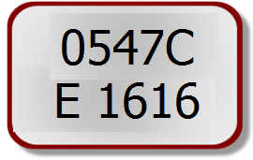Well, even all the concern in the above has been verified, the machine minor stoppages still exists. From the Lot End Record (not attached here), there are many data shows that 1 Lot (especially FA-128) takes about an hour to finish which has a huge gap compare to DR2 result. The DR2 result is the data from TSX product which is quite stable running at the machine. I will explain why TSX code is stable. During the setup time, the machines were only setup to run TSX and FA20H, so we can’t see the actual problem until we setup FA-128 which is smaller in size. Regardless the size of the material. Let take a look at the marking on these product.

Block 1

Block 2

FA-20H, FA-128, FA-23

TSX

Figure above shows two different marking patterns. Both having the same number of data blocks. However, the data contain inside the block is different. But the data contain inside block 1 is not much different for both of the marking pattern which is contain only a numeric character from 0 to 9 with a single alphabet character “C” for TSX and “P” for FA. So, only 11 characters need to be recognized by the Vision system. The critical point comes in 2nd Block. The Data contain in the block for TSX is still 11 characters, that is an “E” character and 0 to 9 numeric characters. As a result, not much problems occur. Now let examine the 2nd block data for FA product. The first character is an “E” which is fixed, the following 3 characters is a week code (Year, Month, Day) and the 5th character is an “A” which is also fixed. Now, the week code eventually contain from 0 to 9 as well as from “A” to “Z”. Well, how does this causing machine minor stoppage? Before I answer the question, let me explain how a Vision system works.

As shown in the figure on your right. A block of character in a vision system memory is divided into several sub blocks as shown in the figure. The vision system used a statistical calculus to recognize the character by calculating the distribution of the white pixel and black pixel and then compare a list of master data. The vision system will then return the closest match to the PC for further judgment. Due to this, an “A” can become ‘4”, an “8” can become “B”, a “T” can become “1” or “7”. At this point, since the 2nd block data contain all the characters, the vision system produce wrong measurement and give impact to the machine judgment causing minor stoppages to increase.

|  |  |
| --- | --- |
| No. | Data |
| 1 | ETTKA |
| 2 | E1TK4 |
| 3 | E17K4 |
| 4 | ET7KA |
| 5 | ET7K4 |

The table listed all the possible data that might return from the Vision system. The machine will stop and returns an alert when a single character is not match compare with the marking data.

Again, in order to handle this issue, we need to manually re-register the master pattern inside the Vision system. Well, to do this, switch the Vision System to adjust mode and the follow the following steps.

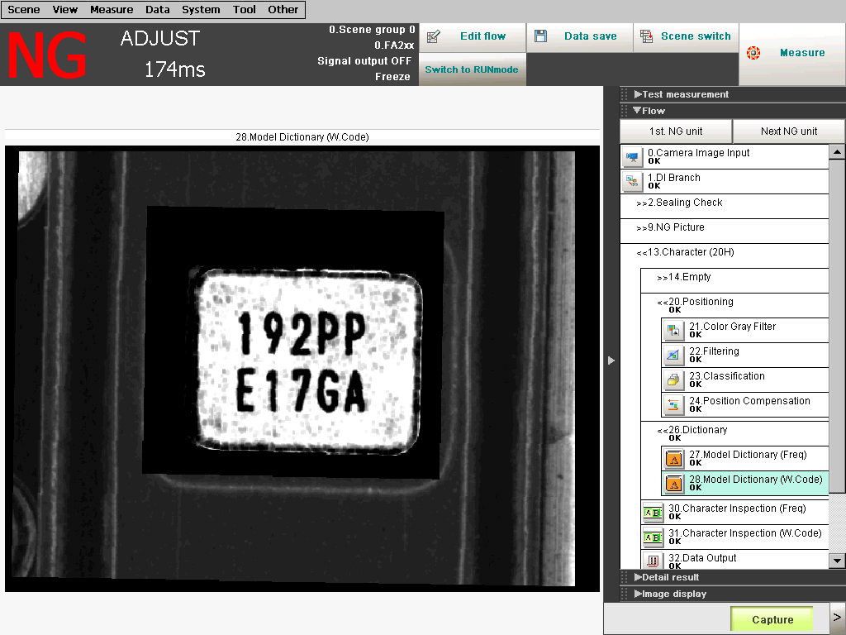

Click on the icon.

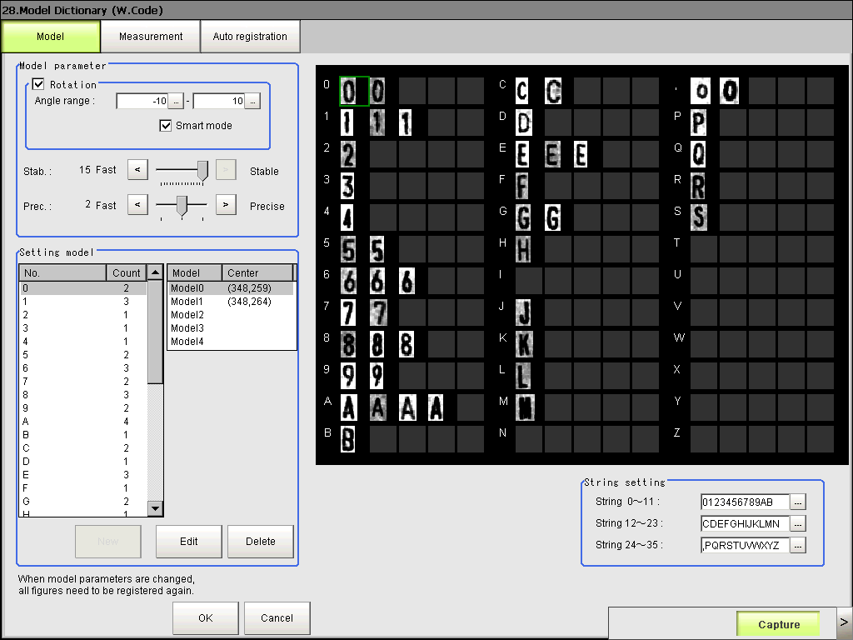

Click on the ‘Auto Registration’ button.

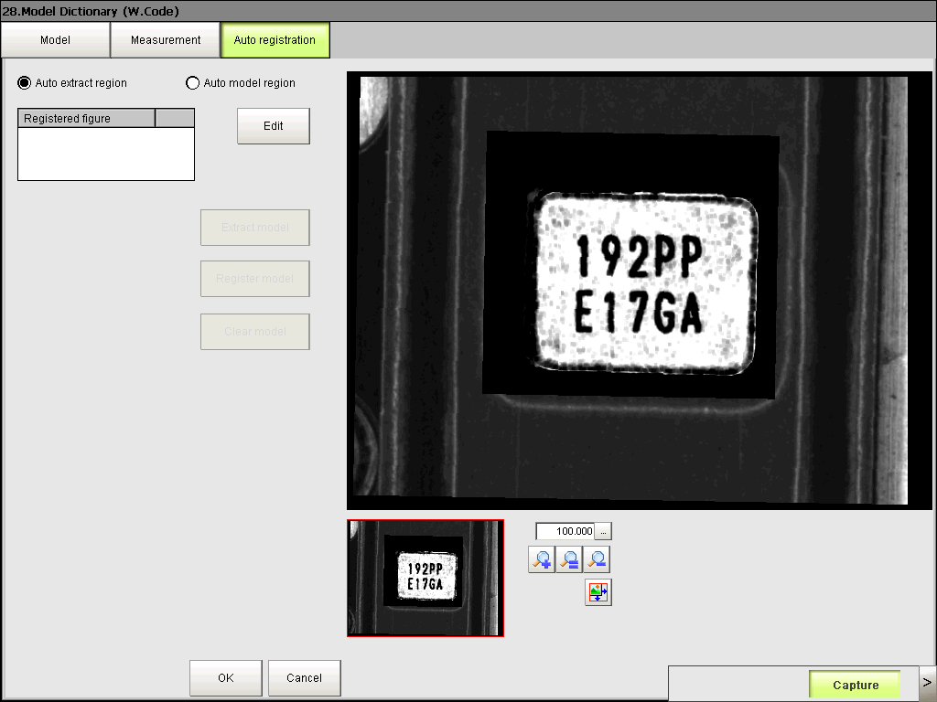

Click on the ‘Edit’ button.

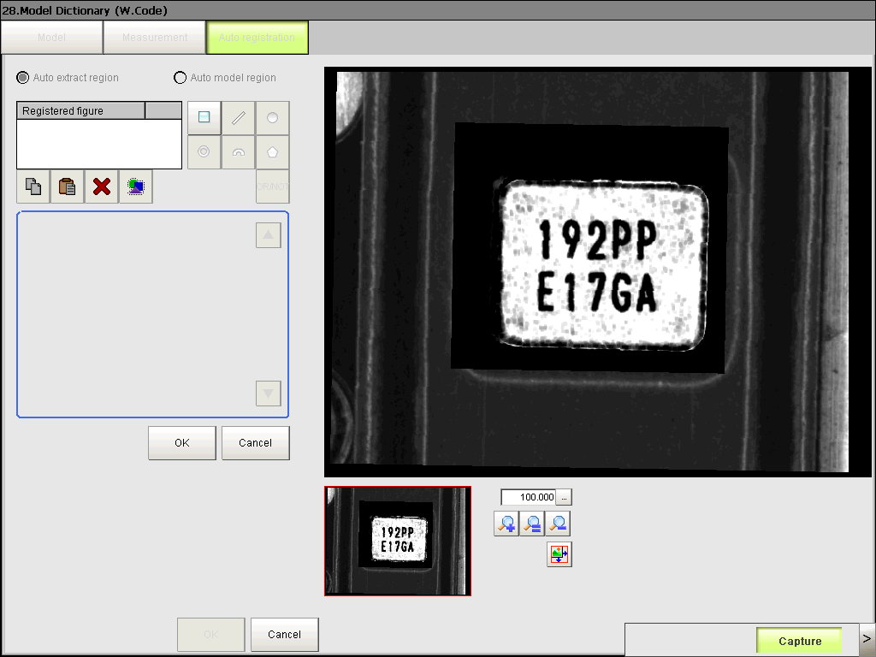

Click on the ‘Rectangular’ button.

Until here, I hope the reader of this report has no problem to follow the steps so far. It is quite straightforward to Windows user as it is only a click to do that. Well, let move on…

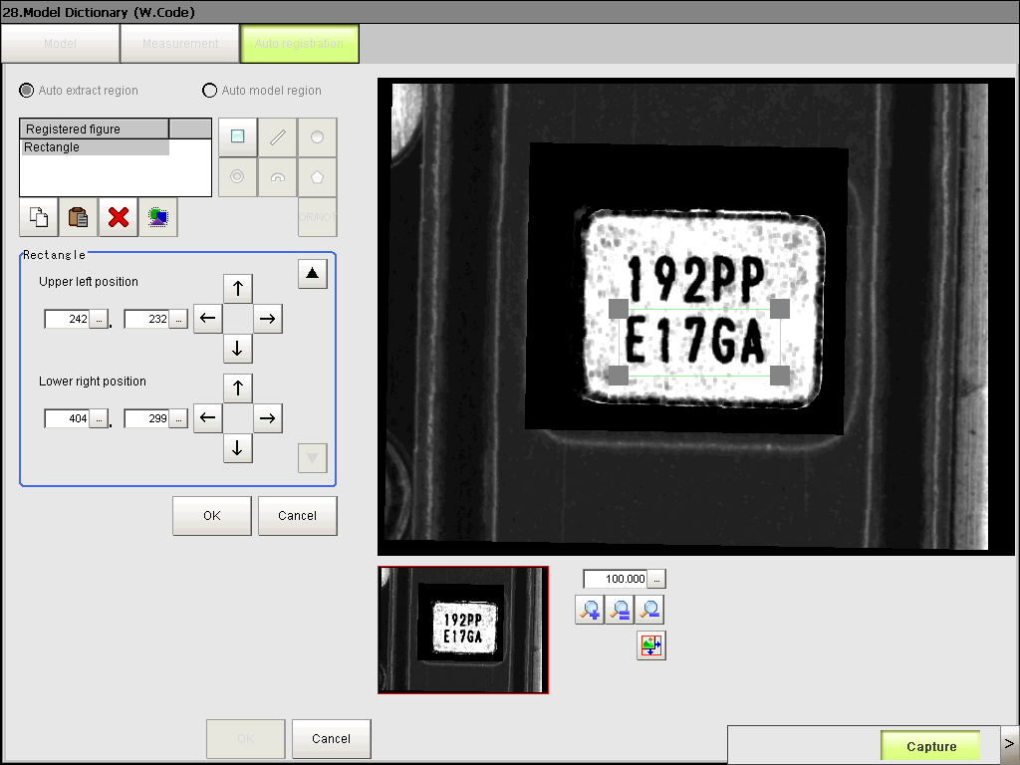

1. Draw a rectangular box as shown.
2. Once done, press ‘OK’ button to finish.

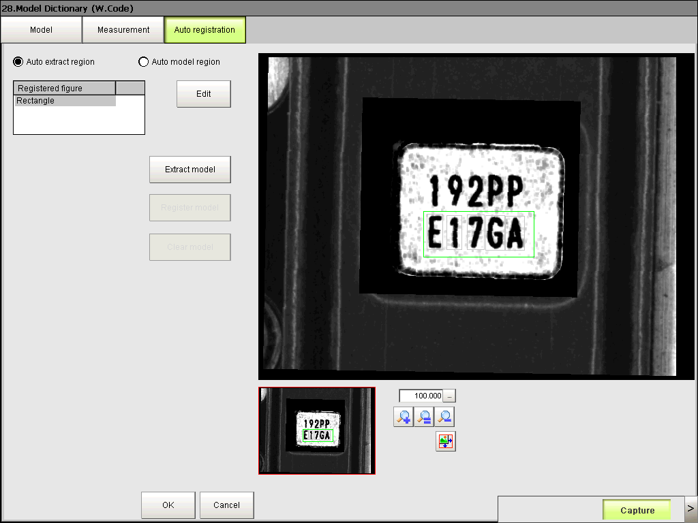

Press the ‘Extract Model’ button to let the system automatic recognize a character.

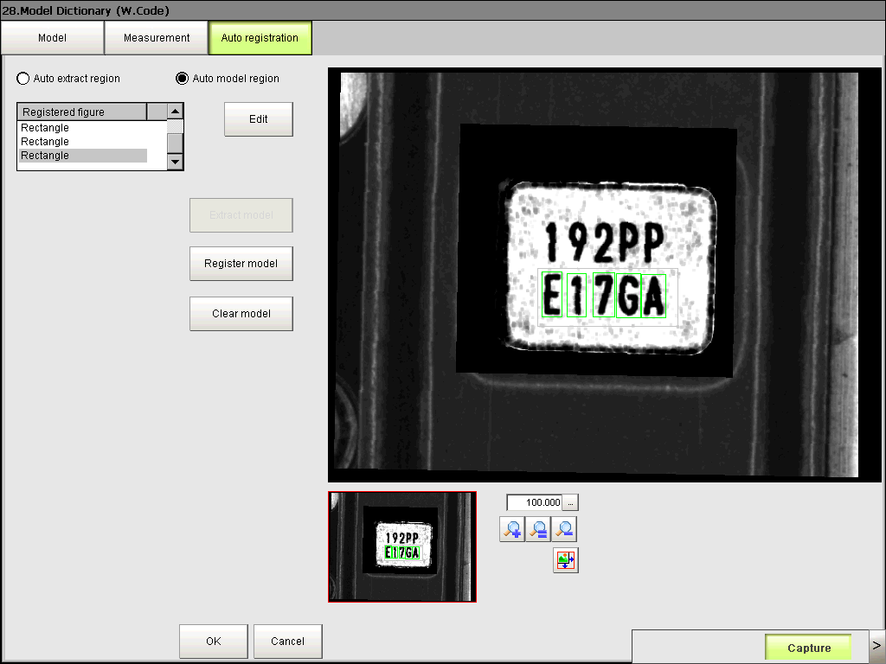  


Switch to ‘Auto Region Model’ by turn ON the radio button as shown.

Click on the area within the green color box. A list of character will showed. Select the appropriate character to register. Repeat the step to all the character highlighted in the green box.



Once done, click the ‘Register Model’ button. And then Click ‘OK’ to finish it.



Click ‘Data Save’ to save the new setting.

Again, the registration process could not be automated using the PC control. It is only can be perform manually. The operators are not encouraged to do this since wrong registration might result in wrong judgment. Hence, Poka-Miss happened.

Well, in order to reduce the machine error, the PC software is modified to handle wrong data coming from Vision System.



0,1,2,3,4,5,6,7,8,9,A,B,C, D, E, F, G, H, J, K, L, M, N, O, P, Q, R, S, T, U, V

0,1,2,3,4,5,6,7,8,9,X, Y, Z

0,1,2,3,4,5,6,7,8,9

To do this, the PC software has been modified to examine the data character by character. As the first data is an “E”, so the machine will continue it operation even through Vision data shows “F”, “1”, or “S”. The same concept is apply to others character block except the 4th block which is the “Day” data of a week code. It is because, all the character is used in the block, no any assumption can be made otherwise week jumping is unable to identified. Anyway, with the modification, the minor stoppages are reduced about 10%.

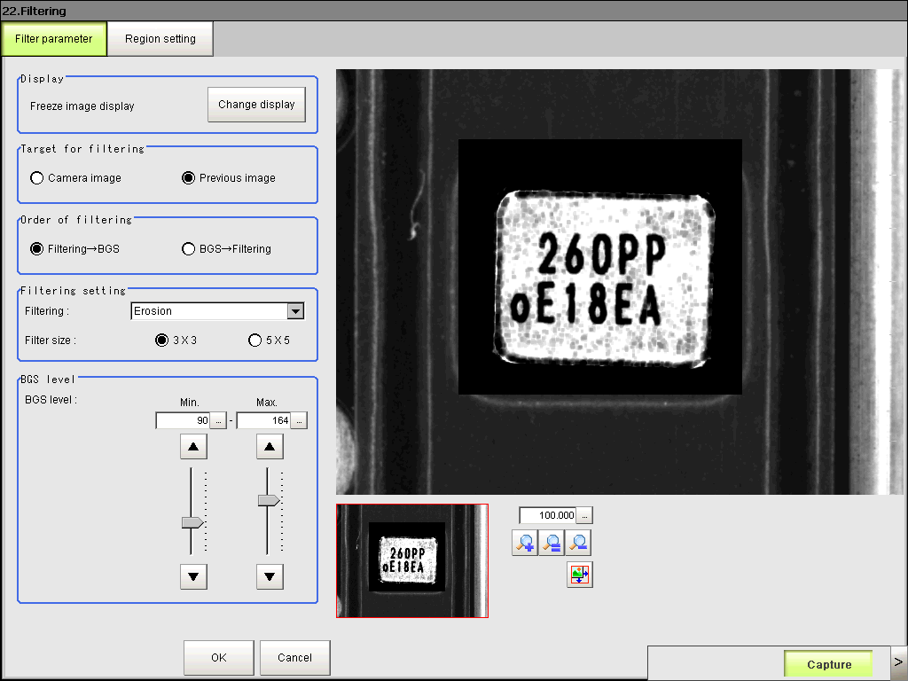Last but not least, as have also been mentioned at the very beginning of this report. The sharpness of an image is depends on the lighting system as well. However, the software can also be helps to fine tune and filter unwanted noise. How well it is register to the system is solely depends on the object. It is quite subjective where the setting might frequently changed and update since the reflected light density is depends on the object.

In conclusion, to keep the Taping OAI in good performance, the following criteria might need to take in to concern. This is also done through by a several interview session with the operator of the machine.

1. **Manually inspection when the Top-Tape has been scratched.**
2. **Choose appropriate week code (those that without “E”, “7”, “B”, “8”, etc…) to run.**
3. **One week code**

As has been explain clearly above, application like this shall integrated with typical PC-based Vision system in order to take full control of the Vision system. MI/MM will take this concern into the future development such as the OGI as well as Tray OAI machine. We probably can’t produce an effective system to handle multiple product code. Budget should need to properly setup in selecting an appropriate Vision system on the investment.

Finally, I would hereby like to conclude that the Taping OAI machine can only be effectively performed **(<20 minutes per Lot**) based on the terms and condition mentioned above even through the machine has been setup for the following product code.

1. **TD3225N**
2. **FA-20H**
3. **FA-20HDOT**
4. **FA-23**
5. **FA-23A**
6. **FA-128**

We can’t guaranty that the machine is not required to update the parameter setting of the Vision system from time to time. This is because those parameter setting such as the filtering condition, model registration and well as re-register the region of interest can only be perform manually which had been confirm with Omron technical support. It might need a PM staff to maintain the setting.

Taping process including Mounting and Sport Welding process does not facing this issue because the Vision is not used to perform character inspection (OCR – Optical Character Recognition). As such, for those applications, the modular type Vision system is suitable since the parameter setting is fixed. The object to be search is not as subjective as OCR inspection.

Anyhow, we still do our best to further improve the system from time to time. It might have some further investment and we are doing some analysis and study the software library algorithm from others vendor such as the National Instrument to integrate to the current system for double inspection method. Please be patient as we are working out a solution.

Thank you for reading this report ☺

*Things have been done throughout the activities:*

|  |  |  |
| --- | --- | --- |
| **No.** | **Modification** | **Description** |
| 1. | PC Software | To handle unwanted data – reduce machine error. |
| 2. | Mechanical Hardware | To prevent Taping Tape jump out. |

This page purposely leave blank