|  |  |  |  |  |
| --- | --- | --- | --- | --- |
| Subject | : Stabilization Activities |  | Date | : 18th August 2011 |
| Machine | : Taping |  | Prepared | : Zulhisham Tan |
| Section | : PX Line |  | Status | : Machine Running With Condition |

My previous report would be a bit in Technical, Theory as well as System Design in addressing the minor stoppage issue. Anyway, in order to improve the machine running rate by a minimum requirement of 1 Lot within 20 minutes, the following condition must be address in term of management arrangement or suggestion to have further investment or modification.

**Case Study 1: Eliminate to run scratch Top-Tape**

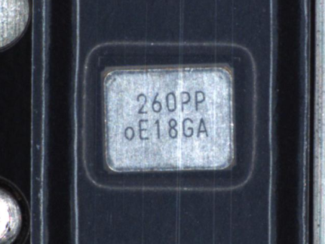

Well, take a look at the screen shot above, the Top is scratch, it happen to be blocking partially the character “P” which result is wrong judgment and impact to machine error. For this case, nothing can be done on the Vision system parameter since the scratch line is not at the same position.

The problem solving for this issue in order to improve the machine running rate high is:

1. Top-Tape that has been scratch need to arrange to do manual inspection.
2. 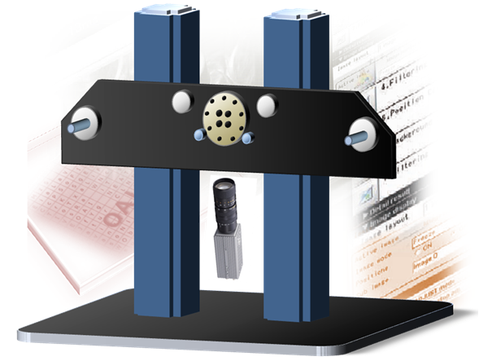Modify the machine so that the Camera is at down position as illustrated in the following figure. The reason to do this is to minimize the gap that exists between the Top-Tape and the surface of the crystal. The theory for this is actually similar looking a picture which is behind a glass. If the picture is far from the glass, the image is slightly interrupt by the glass which due to the refraction of light. However, if the picture stick to the glass, the image is improved, perhaps a finger print also could not be seen by a naked eye. Please note that, this is only a theory, practically it either work or not should give a try. A little study has been done with mechanical engineer, moving the camera cost nothing but time for modification and some electrical wiring might take 2 to 3 days. As a result, we are making up a schedule and will inform later. Thanks to **Mr. Iguchi** for his suggestion and idea. Anyway, we will use magnet to simply the job for testing purpose.

**Case Study 2: Increase the measurement effectiveness by increasing the searching angle**

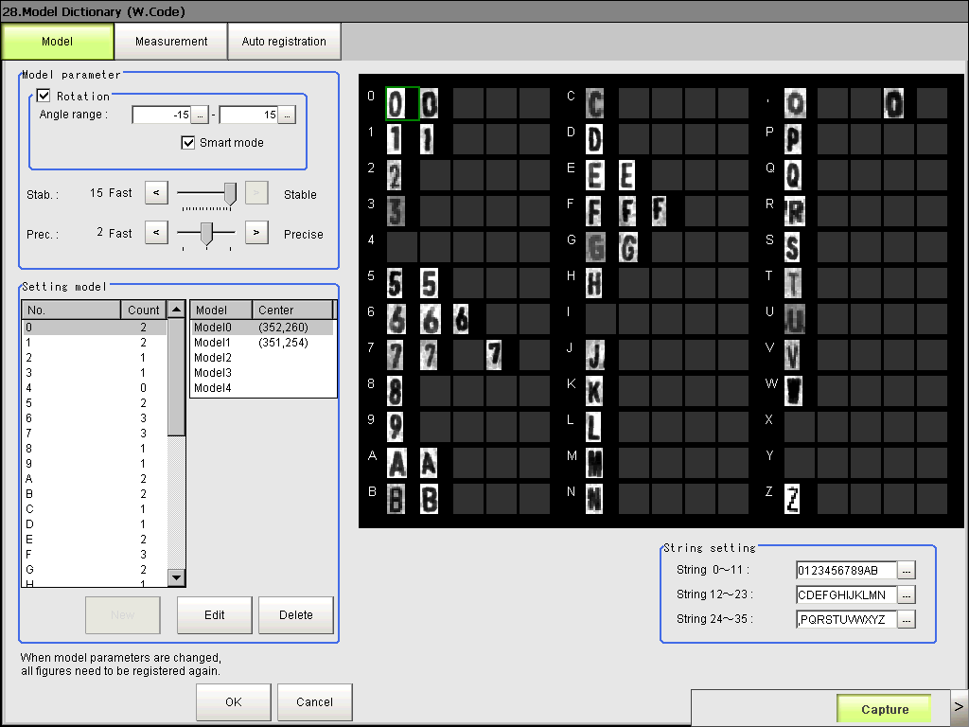

Setting suggestion: -15 to 15

Purpose of this suggestion is to widen the search of a character since the crystal can be get rotate and also shifted within the pocket of the Tape. Analysis has been done; cycle time does not get affected when the searching angle is increase. Anyhow, by keeping the Vision system measurement time within 230 milliseconds, the Lot which contained 3000pcs is able to finish within 20 minutes.

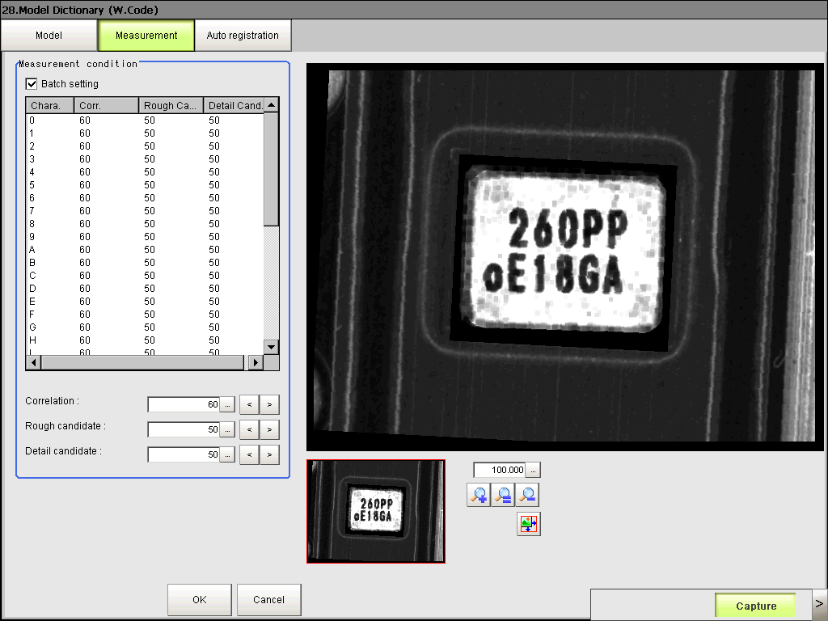**Case Study 3: Increase the measurement accuracy**

Purpose of this suggestion is to minimize the wrong judgment by the Vision system. Message from the Omron‘s Technical Sales Personnel. The combination of these 3 parameters setting could increase the accuracy of the measurement. ‘Rough Candidate’ means minimum level of match that the vision system recognized a character set. So, the setting suggestion for this is 50 to 60. In my case study, I used 55. Whereas for the ‘Details Candidate’ means, the series of closest matching in an OCR measurement. An example for this is… says for a search of an “A” character. The series of closest match would a character of “A”, “H”, “N” and “4”. The Vision system will takes the highest score with compare to the ‘Correlation’ setting. And for my case study, setting suggestion for ‘Correlation’ is 65 and 60 for ‘Details Candidate’. Kindly to be noted that these setting especially “Rough Candidate’ could significantly affect the measurement time. By adjusted the ‘Rough Candidate’ below 45 could cause the measurement time increase by 50 to 80 milliseconds.

Adjust these setting will affect the machine cycle time

**Case Study 3: Improvement Laser Marking process to strictly control on Marking Shift.**

I have made a report regarding the design structure of the Marking machine could cause Marking shift during the Laser Marking machine setup in year 2005. Please click on the PDF icon (or here) in order to obtain a copy of the report. This report has been given to all the Japanese setup member during the PX Line is setting up at ETMY. Sadly, the design of the Laser Marking machine doesn’t make any improvement. From FA-238 to FA-118T, from PX Line down to Sensing Device (SD) and FC, including ETTH Laser Marking machine, the design structure were never had any improvement.

The Gap that exists between the Tray and the Crystal is definitely huge when look under the microscope. CP-3225 Package as well as CP-365 package Laser Marking comes with a mechanism where the Crystal inside the Tray will be realign before Marking. This technique is practically proven effective since we have built our own Laser Marking Machine in Year 2007 for CP-365 Package. The marking machine is also integrated with a Camera system to prevent ‘Double’ Marking. I hereby strongly urge management to look into this statement where Japan (ETC, Machine Makers) should consider our proposal and suggestion before making a machine.

For the time being, operators, PM, PE, Production and MM/MI shall work together in order to maintain the marking quality at every marking machines at PX Line. Of cause, it is not easy as a piece of cake. However, action must be taken either re-design the mechanism, modification or control method needs to be established in order to reduce the Marking Shift issue. Well, proper investment would return soonest profits and confident in quality. So the decision making to invest all the suggestion mentioned above just for the Taping and Taping OAI process shall leave to the management committee.

I would hereby to highlight some important control point at Laser Marking Process.

1. Control the Laser Parameter such as the setting of Q-SW, Laser Power as well as the Laser Speed. Any changes make to these parameters shall proceed to Jobsetup.
2. Dummy marking inspection shall be inspected by a Vision System not under a microscope. The image by looking under the microscope is totally different when it is capture by a Vision system. All the Laser Parameter setting must follow Vision System image quality not by feeling.
3. Taping as well as Taping OAI process shall have a system to feedback Abnormal Marking Quality to Marking process so that immediate action can be consider to take. Since our Taping OAI is connected to the Network, it can be easily established.
4. Mechanical alignment of all Laser Marking machine shall be re-confirm especially the parallelism between the Laser Head and the Marking Tray. Incorrect alignment could cause serious problem to this ‘None Value Added’ process. However, Marking is also means our company Image.
5. At the time of writing this report, I manage to capture an event where the machine returns 30 errors and total of almost 2 hours has been gone just to complete 1281 inspection out of 3000. Please refer to the following screen shot (see next page). The root cause is the “D” character which is treated as “0” under the Vision System. However, we can also clearly notice that the character “D” and “0” is nearly similar. Well, here is the zero cost suggestion, it may look a little non-sense, but to me I would give a try to propose to abolish the use of character “D” by replace with a character such as “X” since the character “X” haven’t been used in the ‘Day’ series of Week Code ‘YMD’. Modification of the Barcode system to abolish the usage of character “D” is just a simple few clicks in the software coding – No investment cost needed. Anyway, I leave it to PE to decide and if necessary make a negotiation with ETC Japan.

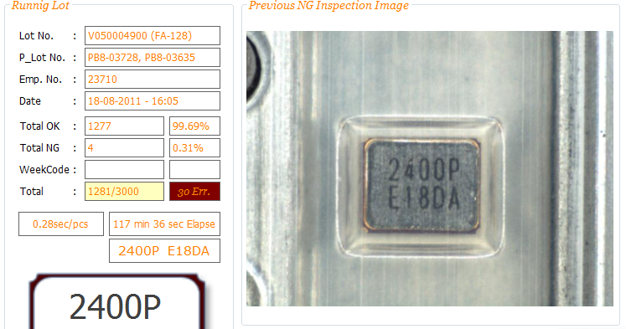

1. Changing the Marking Font to OCR is also a good idea. However, we need to refer back to all the customer which could probably takes years to come to a conclusion. Eventually the OCR character set is design for digital reader. I not guarantee it will work since we compress the character so that maximum of 6 characters can fit into a Marking Block. Once the character is being compress, will the OCR character set of “D” would still look like a “0” should give a try.

In conclusion, the Taping OAI machine’s running rate is high with the following condition.

1. Top-Tape no scratch.
2. Marking not being shifted.
3. No character “D” in the week code series.

Thank you ☺