*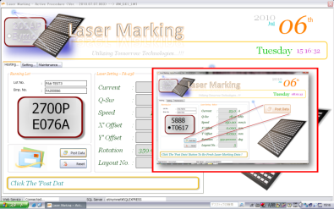Enhancement*

Thanks for the valuable feedback. With those feedbacks, we have made the system even better. I have learnt a lot of things during the GKL setup. A lot of unexpected circumstances occur.

Well, with all the feedback, I have made several changes to enhance the system. Below are some of the details.

1. As the screenshot shown above, after all the data has entered into the system, the system would require the operator use the mouse click to click on the image or ‘Post Data’ button to post the marking data to the Laser Unit. The improvement that has been made for this is using either the ‘Enter’ button at the Keyboard or the mouse click on the image. This enhancement is to make operator’s work easier.
2. Well, if the ‘Blinking Windows’ goes off (which means the application lost its focus to the operating system), the Barcode system will automatic post the data to the machine after 10sec. However, the system will check the Laser Marking status before the data is sent to the Laser Maker in order to prevent wrong marking.
3. 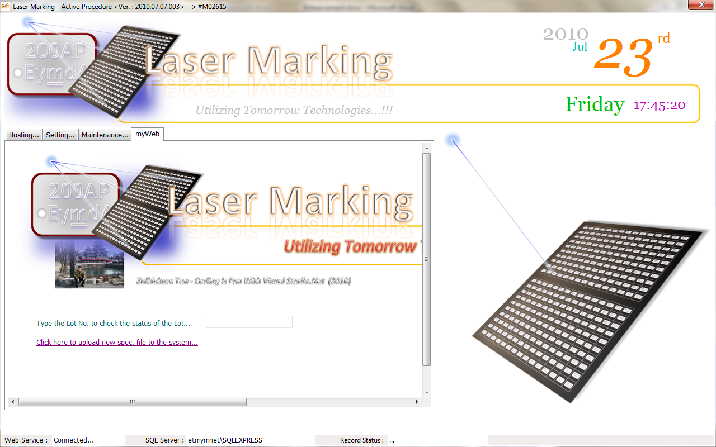To stay compatible with the older version. The system allows you to retrieve older records from the Web based application which can be directly reached within the application as shown in the figure above. Just key-in the Lot No. and then press ‘Enter’. If the Lot record is found, the system displays all the details. Otherwise, the system will tell that the record does not found.
4. You may also upload new spec. file into the system by click the Hyperlink. The browser will redirect you to a new interface. Click the ‘Browse’ button to locate the new spec. file and then click the ‘Go…’ link. Just simple as that to upload a spec. to the server now hah!!!
5. As the Add-In function is a Web Based Application, Internet Explorer can be use to access the system function as shown in the figure below. Well, with this capability, you will no longer need to travel to the production floor just to check some data. Just sit at the office to do this.

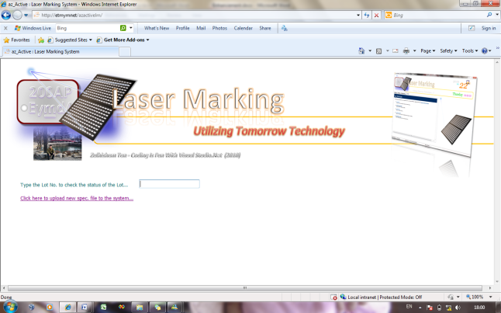

You may also upload the new spec. file using this web application.

Use the following link to reach the web site <<Http://etmymnet/azactivelm>>