SNOWFLAKE

1.How many customers take trip from same location

Query

Answer

2.What is the priority for each ride category from each location

Query

Answer

3.What are the longest locations of customer travelled

Query

Answer

4. Driver who completed ride with non-vaccinated customers

Query

Answer

5. How many vaccinated customers have travelled

Query

Answer

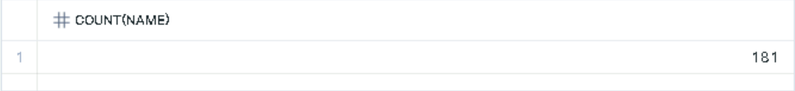6. Customers who completed with non-vaccinated drivers

Query

Answer

7. Who is the customer completed highest no of rides

Query

Answer

8. Who is the driver completed highest no of rides

Query

Anwer

9. What are the first 10 age groups which uses uber service mostly

Query

Answer



10. What is the count of different destination location from same start location and also completed ride

Query

Answer

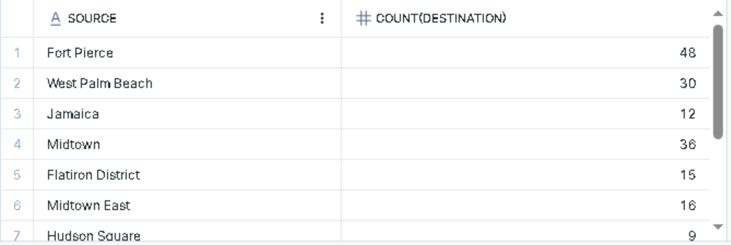

11. What is the most expensive drive

Query

Answer

