Assignment#1 – Delegate

Due Date: Midnight of January 20 (Friday)

Purpose: The purpose of this assignment is to help you:
- Understand delegation
- Become familiar with GUI

Instructions: Be sure to read the following general instructions carefully:
This assignment should be completed individually by all the students. You are encouraged to demonstrate your solution during lab session, and submit your solution through the dropbox. You must name your submission according to the following rule: studentID(yourlastname)_ASSnumber.zip. e.g., 300123456(smith)_ASS#1.zip

Rubric

Functionality | Marks
GUI | 2
Add unsubscribe() for SendViaEmail and SendViaMobile | 1*2
When Subscribe button is clicked, an object of SendViaEmail or/and an object of SendViaMobile is/are instantiated , and add to corresponding collection(s) | 2*2
When UnSubscribe button is clicked, removed the corresponding object of SendViaEmail or/and an object of SendViaMobile from corresponding collection(s) | 2*2
Validate email | 2
Validate mobile | 2
Publish notification | 2
Correctly declare collections to hold SendViaEmail objects and SendViaMobile objects respectively | 2

Question[20 marks]

In the real world, the notification management system consists of two parts, one is to enable clients to subscribe/unsubscribe the notification, and another part is to facilitate administrator(s) to publish the notification. This assignment simplifies the problem, and merges two parts as one. In this assignment, you are asked to implement a C# application to mimic notification management system. You are required to use delegate.

Your app enables clients to subscribe/unsubscribe notification as well as send notification to all subscribers. Your App needs to make sure that the provided email address is valid, and provided cell phone number is followed the specified format.

After the application launched, following GUI (or similar one) will be presented.

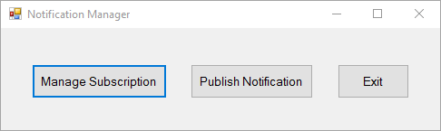

After Manage Subscription button clicked, following GUI (or similar one) will be provided for clients to subscribe or unsubscribe notification.

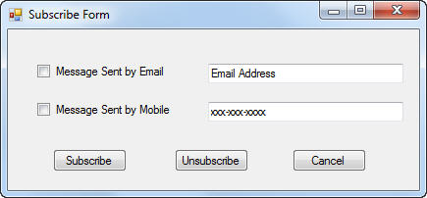

After Publish Notification button clicked, following GUI will be presented to facilitate notification publish.
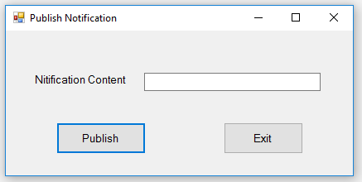
Make sure that your app should be able to deal with multiple subscribers. [hint: you can use collection to hold the subscription information]

