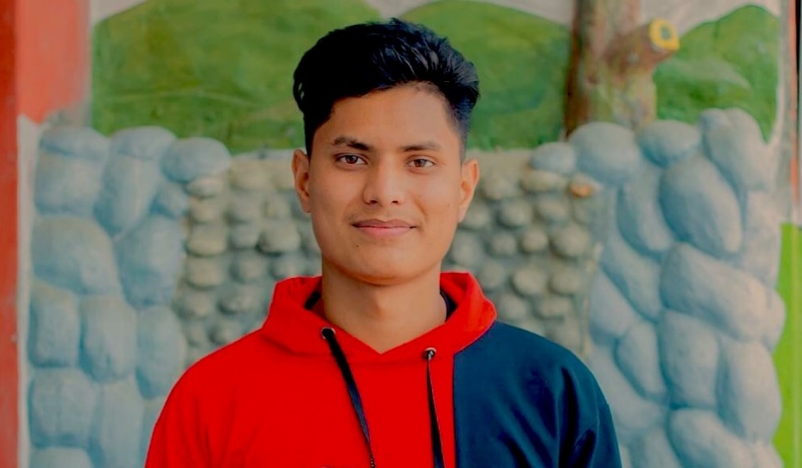

**BIBEK**

GHIMIRE

**Web Developer**

**Education Sources**

-

-

**My Experiences**

I have no experience as a official projects but I have done many personal projects.]

These are the programming language that I’ve learnt.

C++, JavaScript, CSS, HTML, Photoshop and Premier Pro.

Also I’ve basic knowledge about react, bootstrap and WordPress

**PERSONAL BACKGROUND**

I am a CSIT student currently on my 3rd semester. Beside my studies, I have learnt basic of web development.

**ACHIEVEMENTS**

I’ve learnt HTML CSS and JavaScript on my own from YouTube and web sources. And I am ready to join as a intern or a junior Developer.

**GET IN TOUCH WITH ME**

Home: 9805116277

Cell: 9805116255

Email: binekghimire555@gmail.com

Website: www.bibekghimire1.com.np

Facebook: @binek.ghimire.555

Instagram: @bibek.ghimire_

**PREVIOUS EDUCATION**

**REHDON EDU FOU.**

**Nepalaya, College**

*+2 Science, graduated in 2020*

*B.Sc. CSIT, graduated in 2024*

* Code with Harry.
* Coder Coder
* Codecademy
* Coddy
* Hashnode