2. Describe the procedure of sharing folders on Windows Client OS. Provide detailed procedure with screenshots (or video).

1. Find out if your computer is part of a homegroup by clicking the "Start" button or Windows logo in the bottom-left corner of your screen. Click on "Control Panel." In the search box in the upper-right corner, type in "Network" and click on the "Network and Sharing Center" link when the search results appear. Check the status next to the "Homegroup" field. If the status is "Joined," then your computer belongs to a homegroup.
If status is “Ready to create”, then you have to create homegroup, and every pc that you want to use shared folders in it, must be in same homegroup.

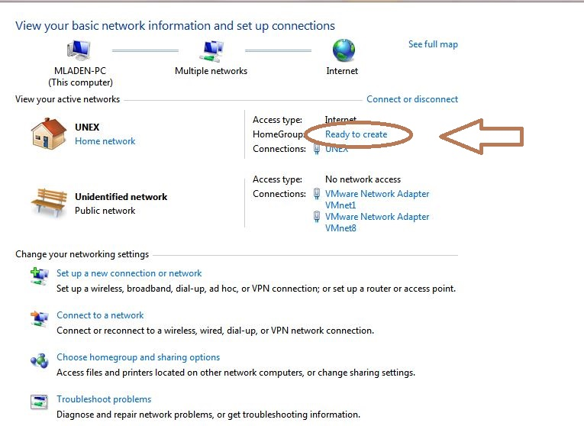

2. Add a shared folder to a homegroup. Locate the folder you want to share and right-click on it. Point to "Share with" and choose your desired sharing option from Homegroup (Read), Homegroup (Read/Write), or Specific People.
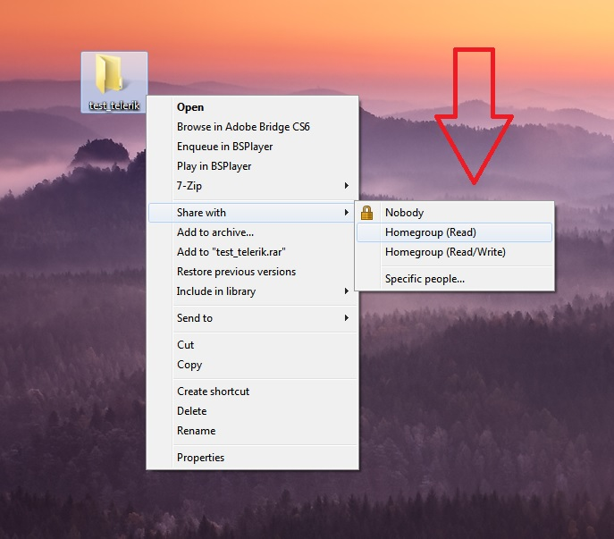

- Select "Homegroup (Read)" to share the folder with every computer in the homegroup in a read-only format. Nobody else will have the ability to modify or delete the folder and its contents.
- Select "Homegroup (Read/Write)" to give every computer in the homegroup permission to read, modify and delete the folder and its contents.
- Select "Specific People" to open the File Sharing Wizard, which will allow you to designate the users you want to share files with. When the wizard opens, type in a user's name or click on the arrow to display a drop-down menu that displays all names in the homegroup. Designate the desired permission level by choosing from "Read" or "Read/Write." "Read" will allow users to read the files but will not allow them to modify or delete them. "Read/Write" will allow users to read, modify, and delete the files. Click on the "Share" button at the bottom of the wizard to finish.

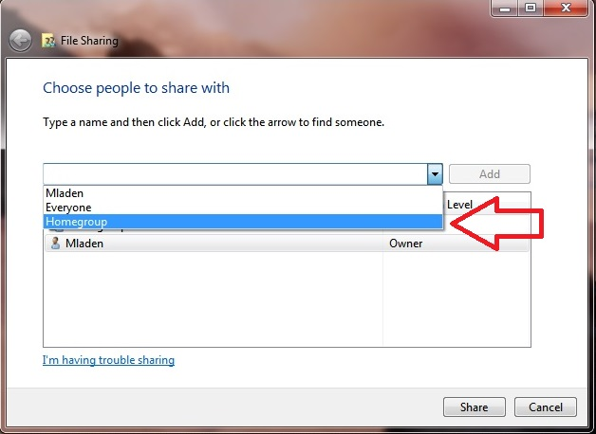
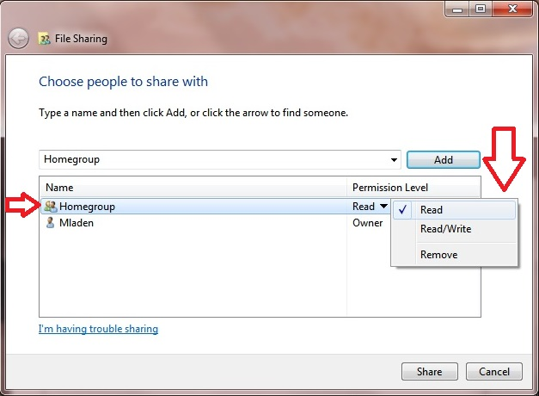
3. Add a shared folder to a workgroup or domain. Locate the folder you want to share and right-click on it. Point to "Share with" and then click "Specific People" to open the File Sharing Wizard.
- If you have a workgroup computer, click on the arrow next to the text box and select the correct name from the list. Click "Add" to add a shared folder to that workgroup.
- If your computer is part of a domain, click on the arrow next to the text box and select "Find People." Type the correct name into the dialog box next to "Select Users or Groups" and click "Check Names." Click on "OK" to proceed.
- Designate the desired permission level by choosing from "Read" or "Read/Write." Under the "Permission Level" column, designate the desired option. "Read" will allow users to read the files but will not allow them to modify or delete them. "Read/Write" will allow users to read, modify, and delete the files. Click on the "Share" button at the bottom of the wizard to proceed. Depending on how the network is set up, you may be prompted to enter an administrator password or provide confirmation.
- Notify the users you've shared with of the new shared items. Click on "E-mail" to send users a link to the shared folder if you have an e-mail program installed or click "Copy" to copy the displayed link to the Windows Clipboard and paste it into an e-mail, instant message, or other program. Click "Done" to finish the process of adding a shared folder to the domain.

4. Remove shared folders. If you want to stop sharing a folder, right-click the folder you want to stop sharing, click on "Share with," then click "Nobody."

Оценка и коментар:
-> 7
-> Добре описана процедура, но според мен е по-добре да се опише метода за Advanced Sharing + Security options. Успех

