Project Proposal

Wearable Signals for Motorcycling

Ben Buckley

ELT-2720, Electrical Project
Spring, 2022

Proposed Project

I will be building a materially flexible array of WS2811 LED pixels and a control board for that array. The controller will pull 12V Left Turn, Right Turn, Brake and Power signals from an external source (the motorcycle) and assemble an array of 24-bit color and brightness signals to send to the array. The entire system will eventually be embedded in a textile garment that can be worn while riding, giving the rider a second set of animated traffic signals that respond in time with the bike’s built-in signals.

The heart of the control board will be an Arduino Nano microcomputer that will translate the input signals into animation frames for the array of LED pixels. By using a microcontroller to signal the LEDs, I will provide the user the ability to select between multiple animations and even to provide custom animation programs for the vest. While this iteration of the project will only operate on the bike, the ability to re-program the Nano opens up the possibility of integrating a battery pack and using the vest off-bike for aesthetic effects.

Rationale

Motorcycling is a potentially very dangerous mode of transportation. The primary source of danger for most riders is themselves. The second biggest source of danger is other drivers, and to that end, riders usually take steps to be as visible as possible to other motorists. Extra lighting elements, extra brightness from the existing lights, eye-catching light patters, and reflective gear are all common strategies for added visibility. The wearable signal system I’m building will provide all of these benefits while also using that extra lighting to enlarge and clarify the rider’s ability to telegraph their intentions to other motorists.

While the original design intention is to provide entertaining safety gear for motorcyclists, bicycle riders are even more vulnerable road users. With some modifications to the signalling system and the addition of a battery pack, this design could easily be translated into safety gear for these commuters.

Design and Original Contributions

The direct inspiration for this project is the garment design and construction work of Jane Hansen, i.e. Enlighted Designs. Hansen uses addressable LED arrays to create art garments with animated light patterns. Stumbling on her design work gave me the inspiration to create a wearable set of motorcycling traffic signals.

The material basis for this project is the coursework done with WS2811 addressable LEDs in ELT-2050. In that course, we wrote software for NXP’s KLZ125-based Freedom Development Board to assemble and send animation frames to a 60 x 6 array of LED pixels. User input was taken either from the development board’s on-board inputs (push buttons and potentiometer) or a serial terminal to select and control a set of pre-programmed animations.

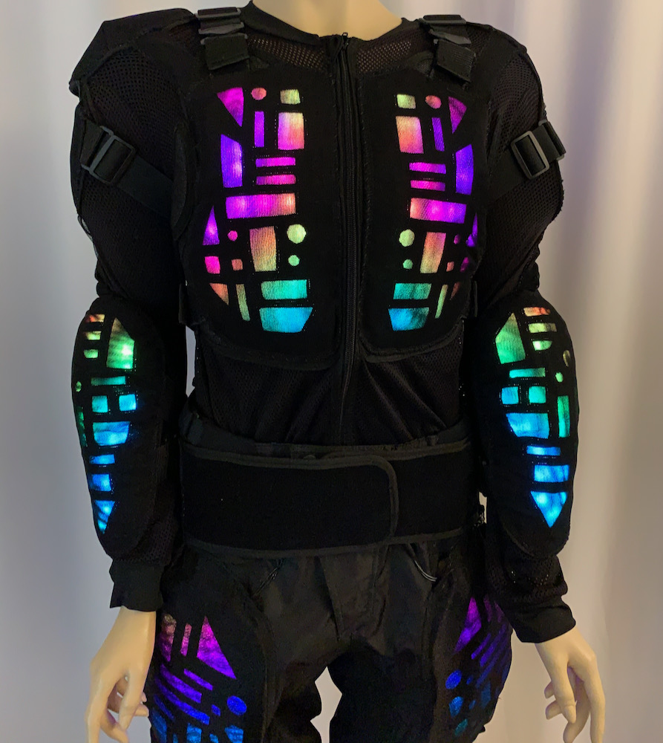Figure 1: Abtract Geomteric LED Suit .  More images and animations at https://enlighted.com/p/abstract-geometric-led-suit | 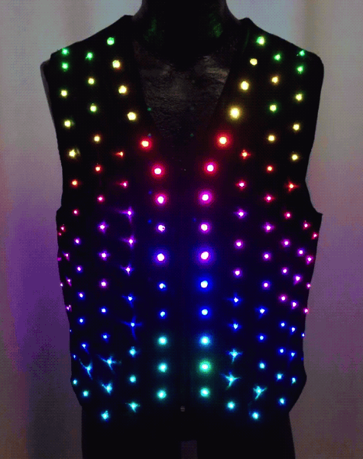Figure 2: Elighted Party Vest.  More images and animations at https://enlighted.com/p/enlighted-party-vest
Examples of Janet Hansen’s wearable LED art works.

My original contributions will come in two areas. The first is in providing control inputs from a motorcycle’s built-in signals. These signals are nominally 12V, with an actual voltage range of 11 – 15 V, and provide as much current as the on-bike lighting elements they drive. To make them safely usable by the Arduino controller, I will need to regulate the voltage and limit the current of these signals. I will also pull 12V power from the bike, which will need to be split into a 12 V branch for the LEDs and a branch regulated to at most 12 V in order to safely power the Arduino.

The second piece of original work will come in porting the software written for the Freedom Board to the Arduino Nano. While the core routines for assembling animation frames are already written, all of the timing, input, and interrupt handling routines are hardware-specific. I will re-write them Arduino Nano. The original software was written to handle single inputs independently, so I will need to add facilities for assembling animation frames dynamically based on multiple inputs. The original Freedom Board firmware is attached as Appendix 1.

Given time and resources, some other features I’d like to implement include:

- Physical, real-time “remote control” for the wearer to change patterns “on-the-fly”
- Switchable LED power so the controller can “talk to” both 12V and 5V LED pixel arrays
- Battery-pack so the garment can be lit when not connected to the bike

Table 1: Feature List with Ranked, Prioritized Objectives
Feature | Priority | Implementation
Feature | Priority | Minimal | Target | Aspirational
Input and power from the bike to the control board | High | Nominal 12V signals and power stepped down to 5V | Current regulation on input signals and board-power to ensure safe operation of the microcontroller | Board-power switches on signal circuits, guaranteeing no current to board inputs when the board is off
Firmware port | High | Functional direct port existing firmware to Arduino | Patch frame-assembly routines to respond to all three inputs dynamically | Modularize and functionalize animation routines so animations can be modified w/o reprogramming the firmware
Remote Control | Medium | System power switch | “Up” and “Down” buttons for cycling through animations | Timing and brightness controls
External Battery Pack | Low | Board operates on external battery | Board and pixel array operate on external power | Microcontroller autodetects on/off-bike status and swaps available animations for “safety” vs “aesthetic” modes of operation
Multiple outputs voltages and communications protocols | Low | Hardware switch to select between 12V and 5V arrays | Hardware switch activates software control of output voltage | Software control of the array communications protocol

In practice, I will focus the bulk of my effort on the High Priority tasks, while incorporating provisions that will ease the implementation of lower priority tasks in future iterations of the design.
Figure 3 demonstrates the logic and power flow through the LED controller and array.
Figure 4 is a Gantt chart laying out the proposed timeline for the project and identifying sub-tasks

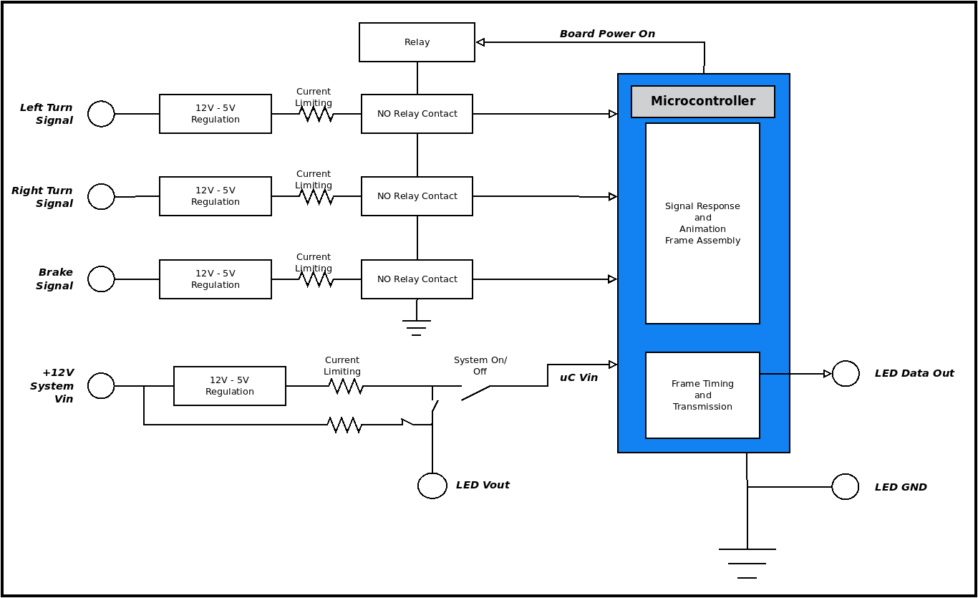Figure 3: Block diagram of Wearable Signal Circuit Controller

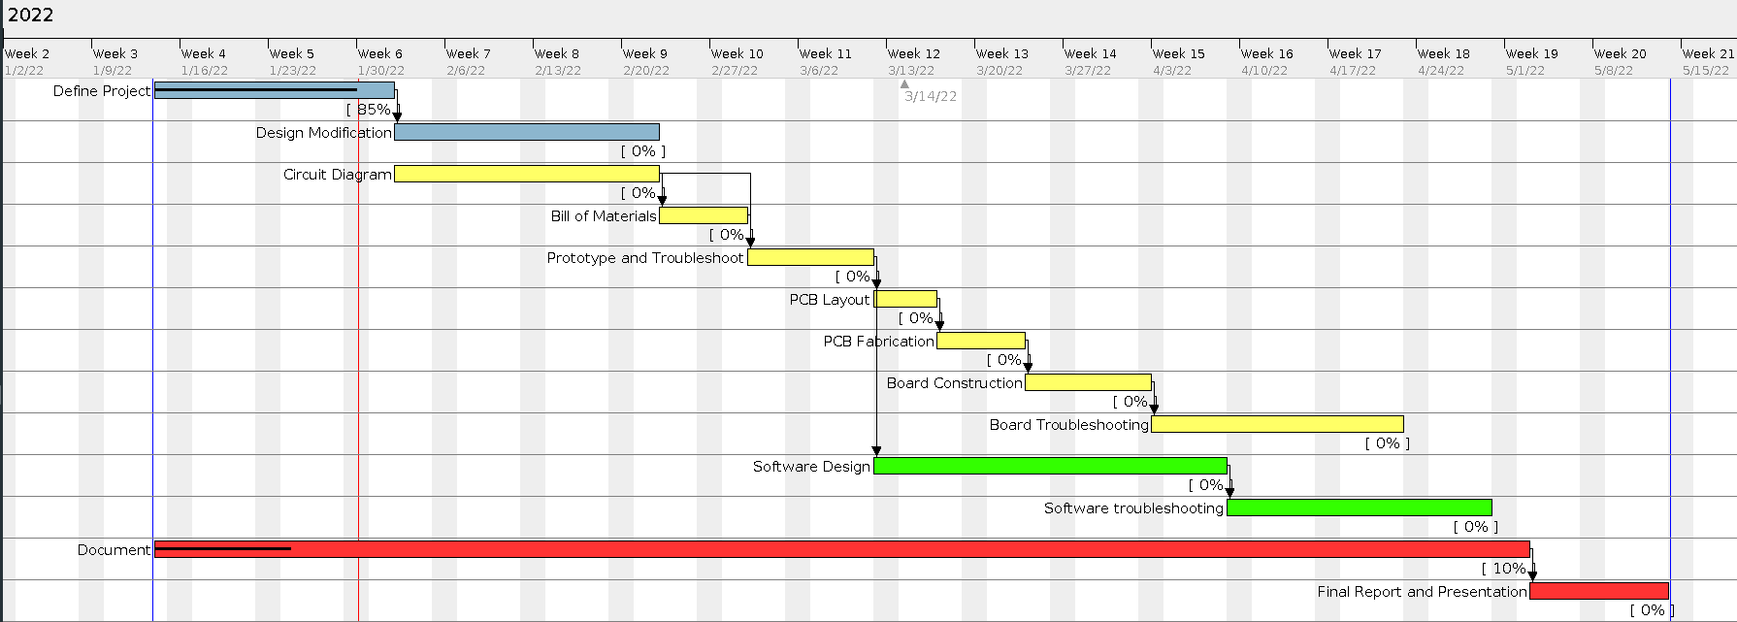Figure 4: Gantt chart of the timeline for the proposed battery charger project

Schematic (First Pass)

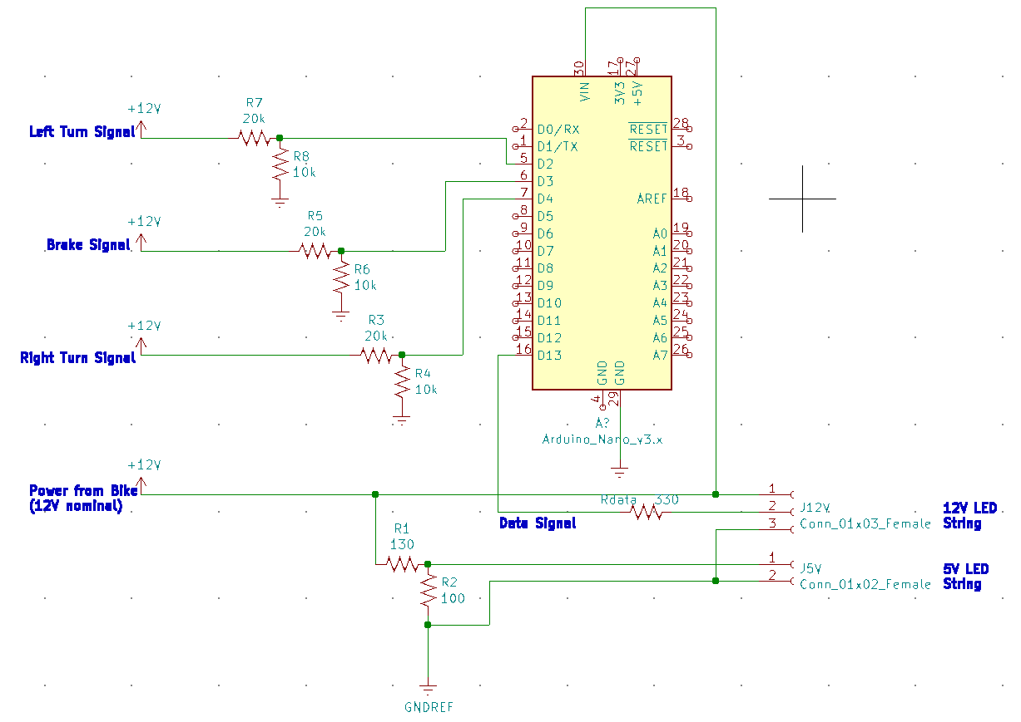

Bill of Materials:
Component | Qty |  | Availability | Price
Resistors
100 | 1 |  | On-hand | –
130 | 1 |  | On-hand | –
330 | 1 |  | On-hand | –
10k | 4 |  | On-hand | –
20k | 4 |  | On-hand | –
Connectors
3-pin JST connector (In) | 6 |  | On-hand/Readily available | *
3-pin JST connector (Out) | 6 |  | On-hand/Readily available | $9.99
Microcontroller
Arduino Nano | 1 |  | On-hand/Readily available | $17.99
LED Pixels
12v WS2811 RGB LED and driver | 50 |  | On-hand; I will supply | $27.70
5V WS2811 RGB LED and driver | 50 |  | On-hand; I will supply | $30.00
Total |  |  |  | $85.68
My Contribution |  |  |  | $57.70
Balance to  VT Tech |  |  |  | $27.98

Conclusion
When finished, this project will result in a functional piece of safety equipment for motorcycling. This is my first attempt at implementing a fully functional electronic system of my own design. Nevertheless, I’m working from a project I’ve already carried to completion. My original contributions to the project rely on the skills I’ve learned through my course work, particularly in circuit theory, electronics, and microcontroller techniques. I look forward to the opportunity to put my education into practice with this project.

Pack of 20, In and Out; https://www.amazon.com/ALITOVE-Female-Connector-WS2812B-SK6812-RGBW/dp/B071H5XCN5
Pack of 3; https://www.amazon.com/AITRIP-Arduino-ATmega328P-Controller-ArduinoIDE/dp/B08C9ZVF51
Per string of 50; https://www.amazon.com/Individually-Addressable-Diffused-Changing-Waterproof/dp/B08L8WXP7T
Per string of 50; Ebay vendor, prices vary.

