*Updates from Gina on building the new Fosstodon team* *and a call for a fellow admin*  
  
  
Hi all, Gina here 👋  
  
Hope you’re all well! Just some quick updates. If you’ve never heard the phrase *“shaving the yak”*, let me introduce you to a concept that has become very familiar since stepping into the admin role at Fosstodon.  
  
**Shaving the yak**  
Yak shaving describes the phenomenon where a seemingly simple task turns into a series of increasingly complicated, often unrelated tasks. Say you want to write a blogpost for hub.fosstodon.org on your personal laptop —but first you need to do another thing, such as [fixing your personal laptop](https://fosstodon.org/@Gina/114584297672268080). And to do that, you need to do yet another thing, like checking if your SSD even works anymore. Before you know it, you're in a field somewhere, shaving a yak. Or in my case, deep in my storage unit digging through my spare toolbox to find my miniature philips screw driver. All because I wanted to write a post. Taking over the admin duties at Fosstodon has involved a fair amount of yak shaving. **Mod training**First! Mod training is going really well😊  
  
When I put out the call for moderators, over 40 Fosstodon users responded (and many more offered their technical expertise)! The potential mods were invited to fill out a survey to assess their availability, commitment, mod experience, and alignment with Fosstodon’s values. Shout out to our friends at [Limesurve](https://www.limesurvey.org/)y for helping us out. See the survey below:

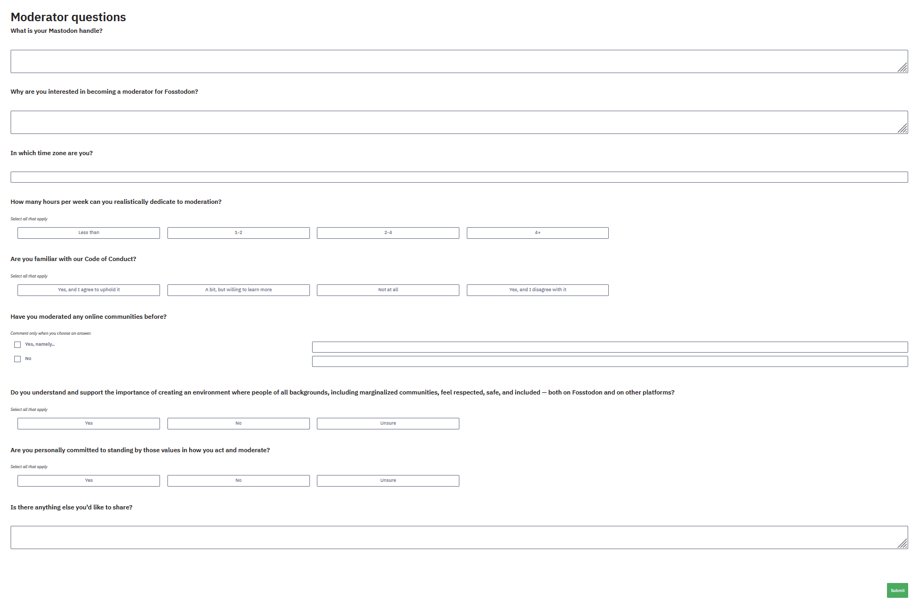  
From those 42 responses, 23 people joined our Mattermost channel to begin training. Some hadn’t filled out the survey, a few opted out to step up as [admins on their own server](https://toot.community/@support/114519606415733028)🙌 , and others were a better fit for different roles. Thanks again to everyone who offered to help.  
  
Since then, the new mod team has been busy! They’ve:

* Read and discussed the Code of Conduct
* Worked through a new training guide
* Completed 20 example scenarios*(link to example scenario’s pdf)*
* And are discussing anonymized real world reports this week.

As of next week, their introductions will start to appear on [hub.fosstodon.org](http://hub.fosstodon.org/). They’ll move into a trial period where they’ll have full mod privileges, but continue to check in and discuss reports with the team before taking action. This lets everyone build confidence while keeping moderation consistent. From the start, we’ve put care into making sure this team is diverse - not just in identities, but also in time zones, backgrounds, age, and experience levels. I’m very proud of how this team is coming together. **Admin duties**Meanwhile, I’ve been busy behind the scenes with classic admin tasks. One big thing: I didn’t want Fosstodon’s finances mixed with my personal finances. If there’s one thing that strikes fear in the heart of a Dutch person, it’s dealing with the *Belastingdient* (Dutch tax agency). In order to responsibly take over finances from Kev, it’ll be necessary to set up a separate legal entity for Fosstodon.  
  
Initially I looked into [OpenCollective](https://opencollective.com/), but they don’t support recurring expenses; meaning Fosstodon’s monthly expenses would still come from my bank account and I’d be reimbursed later. Not a great option. The alternative is setting up a non-profit. Which again opens a yak-shaving subquest: which bank do we go for? Triodos (Dutch only), or Bunq (international but terrible AI support)? Since we don’t have an official address and I don’t want my personal address in our legal statutes, should we use a virtual office address? Or can we use the address of a befriended foundation?  
  
Also, technically I could register the non-profit and open the bank account myself, but ideally we’d have at least one other person involved from the start, for transparency reasons. This means finding a fellow admin. Organizing calls. Doing checks. Sending DM’s. Ultimately, more yak shaving. But, it is time. **📣 Call for a fellow admin 📣**  
So hereby a call for a fellow admin! Have you been active on Fosstodon for a while and do you have a few hours per week for the next year to take on admin duties with me? And would you be okay with being registered as a board member for Fosstodon’s non-profit entity? Then send me a dm!  
  
For now, thanks again all for your trust in me :) The yak is practically bald by now, so we’re on the right track. You know where to find me if you have questions or comments!