Interim report b greer

**1. Project overview**

My project specification is largely based around the design and animation of characters and their models for future use in a narrative game which will depict death and the journey of grief and letting go we find present in most cultures. Modern day media and technology means that we aren’t having the conversations we need to have regarding death and the de-stigmatisation of dying; it is a necessity we often choose to ignore, which leads in itself to unhealthy views on permanence and life in general.

**2. Summary of work to date**Research 3-D animation pipelineOn changing my project scope from a game to an animation, I needed to research the pipeline, since I thought that the two would be fairly different in the way that you approach them. This really helped me to structure my project and to find a more balanced project time-plan.  
  
Research design inspirations  
I replayed Spiritfarer as it was one of the main influences in my design process. I particularly drew inspiration from Stanley’s design, and you can see my progress through the game on my twitch VODs. I used some of the key design parts to refine my character design, including some of the curve influences and the eye style to create a sort of loveable but definitely haunting silhouette.   
  
<https://www.twitch.tv/videos/865895126>  
  
Design process  
Via *Introduction to Modelling and Animation*, I started on designing both some key assets (including the lantern and a lyre) and the main character for the animation. I took inspiration from real/historical places such as the lyre and 1920-40 gas storm lamps, but also from other games like *Hades* and *Spiritfarer* to come up with designs that felt tangible but not real. You can see my process on the git.

Modelling/Rigging/Texturing.  
Again as part of my progress in *Introduction to Modelling and Animation*, I have since modelled, rigged, and animated my designs. The most interesting one is definitely the character, since I learned a lot about fabric simulations and soft-body rigging.   
  
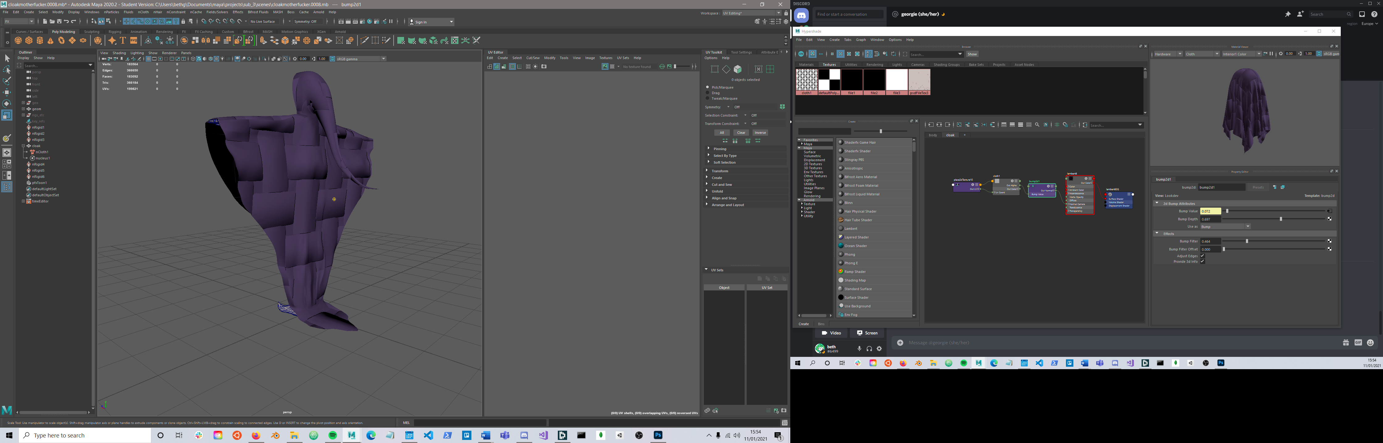

**3. Evaluation**

**Initial Project Plan**

|  |  |
| --- | --- |
| Dates | Tasks |
| Present –  11 / 12 / 2020 | Focused context research into pipeline and scene concepts Initial design principles and mock-ups Review time schedule Narrative/scene writing Storyboard Iteration based on feedback |
| 11 / 12 / 2020 -31/1/2021 | INTERIM REPORT Final design Model progress Blocking animation Gathering more feedback |

I feel I’ve met my milestones well, as I have been using the modules in my course to boost my work, particularly *Introduction to Modelling and Animation* as I have used these opportunities to scope and develop key aspects of my models and work. Therefore, I have completed the focused research, design principles, models and animation knowledge. I have lacked in storyboarding and concepting the animation piece as I honestly don’t know what to do with it- my initial game concept was to use Metroid-vania style environmental design to tell a story, and I didn’t really have any cutscenes in mind. I will have to obviously focus the most on the storyboarding since that is vital for the progression of the animation; I have to know what the end product will be before I can make it.

I’ve so far learned about modelling, animation, rigging, texturing, the animation pipeline, and design principles from games that broach similar topics. I feel my knowledge has expanded significantly with room for more growth, particularly in the modelling/rigging; the techniques we have been taught focus around game characters, where more complex techniques are used for cinematic CGI, where the processing power is much greater (since it is recorded rather than generated).

I think that I’m progressing well despite lacking some of my initial project plan goals. I’ve used my time pretty well, and have been doing my best throughout everything to add a little bit extra as often as I can. There’s definite progression between my first models (the objects) and my character model, in the quality of the model as well as the general animation and use of the 12 principles. I can therefore say that I’m happy with the scope of my project as I am able to make significant progress despite current events. There’s room for improvement but I also feel confident in my ability to deliver despite the various challenges lockdown and distance learning have presented.

**4. Revised project plan**

Include a detailed plan taking you from this point to the final submission date. Include as many milestones as possible. Where you have libraries/platforms to research include links.

|  |  |
| --- | --- |
| Dates | Tasks |
| Present – 31/01/2021 | **Narrative Design StoryBoarding** Import to Unity experimentation – can I animate well? What is the difference in terms of blocking etc?  Shader experimentation – can I use GLSL shaders in this project?  **Model any extra props/learn model imports** |
| Feb 2021 | Animatic Refine animation -> fluidity, textures, details |
| March 2021 | Lighting & rendering- using Maya or unity rigs? FX & compositing– Learn from some Houdini tuts Draft report (26th ) |
| APRIL 2021 | Rendering & refining lights/material simulations  Music(?) |
| MAY 2021 | Project report (14th ) |
|  |  |

My project plan seems empty but is based on the concept that each topic will take me a significant amount of time, since this is not necessarily a project with identifiable tiny pieces. For example, I definitely want to experiment with lights and particle effects with the lantern model, but as of right now I am unsure of the steps I would take- further research is necessary as to whether I would use Maya or Unity to create these effects, and how I should go about compositing them into one coherent piece. Rendering is probably going to take significant amounts of time between iterations as well, as I will be asking my computer to do a lot, so it may be that I change the order of operations and begin with doing the animatic on untextured models, therefore cutting down the processing power needed.

**5. Demo Video**  
  
<https://github.com/b-greer/finalProject/tree/master/videos>  
  
I couldn’t work out the audio for these screen captures, so I will add the commentary that they are showing off my models/assets and their rigs, as well as the animation for the lyre and the character. I would also highlight that these (at time of writing) still need to be ported into Unreal or Unity (I am working on it) and that I really need some storyboarding done so that I can make a simple animatic block of what should be achieved in the narrative context of the scene.

**6. Repository link**

Project repo: https://github.com/b-greer/finalProject