**Project proposal : Elizabeth Greer**

Originally my goal for this project was to make a sample section of a game that I will design. The game is focussed around death and the cultural ways in which we view and mourn the end of life, with a focus on education and de-stigmatisation of this conversation. I believe that as we convert into digital natives and lives get longer, we have to start talking about topics like dying in different ways by creating narratives and focuses for people to relate to. So-called “empathy games” build a sense of surrogate self and focus on recreating experience using design techniques, and I think that these techniques can be utilised to help guide people through grieving.

I would hope eventually to create a “Metroidvania” game, keeping the engaging parts of gameplay in tandem with narrative roles. This engagement factor is a key strength in games as opposed to other media. A game will be far too much scope for me to build in one year, as I have no experience in game design mechanics, and it would be a huge expectation to create a good sample of the end product. Therefore, I am aiming to scope back by creating some designs and models, with the final outcome aim to have a cutscene or short clip that would display the aesthetic principle of the game.

**Technologies and materials**

I will likely be using a mixture of C++, OpenGLSL and C# as my languages for the code aspect of this task. Software will include Unity and Maya, where I will be able to sculpt, animate and apply my code. This is a software based project, so I don’t need any extra equipment.

In terms of techniques, I hope to be able to experiment with a variety of shaders and use generative techniques like noise or procedural shaders. I would like to also include some physics representation in terms of creating visually engaging aspects of design such as key elements like cloth and light reflections.

**Context and research**

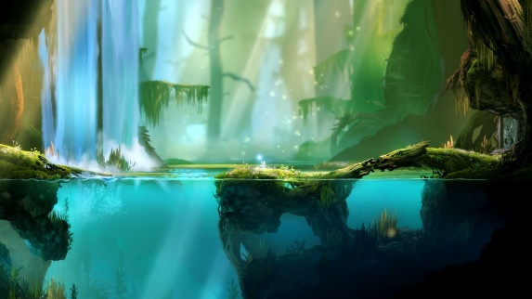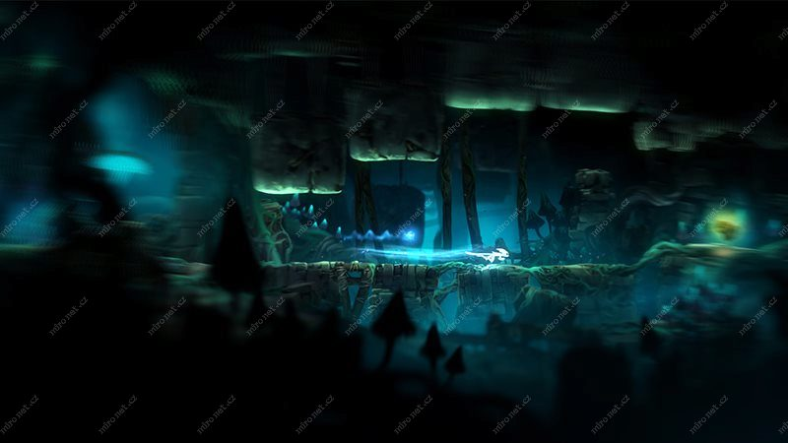

*Ori and the Blind Forest*

Inspiring works include *Ori and the Blind Forest* and *Spiritfarer*, two games which have engaging mechanics but also a focus on telling an emotional story. *Spiritfarer* in particular is an inspiration point as it tells a story also about dying; you play as a Charon-esque character, who ferries souls to the afterlife. The emphasis lies in the relationship with these spirits in a resource-management game, which is a beautiful story and gets acclaim for its story and emotional lore.

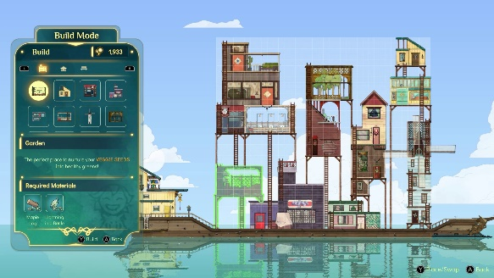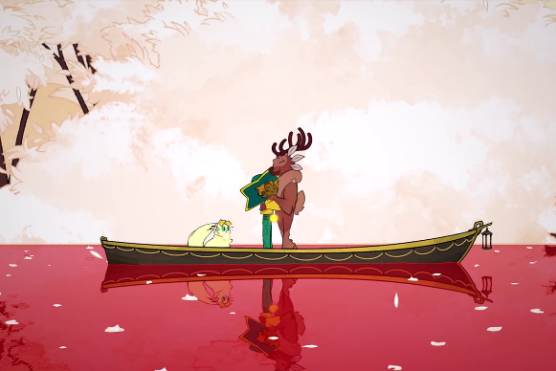

*Spiritfarer*

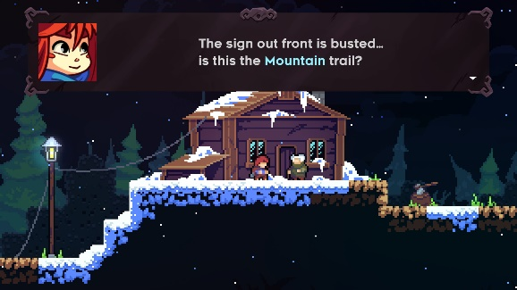Another example would be *Celeste*, which was renowned in how it handled the main characters struggle with depression, combined with engaging platformer mechanics. The game won awards for best indie game and ranked highly on many “game of the year” lists as it was an emotional game that retained a very “gamified” aspect- that is to say it didn’t reduce to a walking sim, which empathy-games are often likely to do.

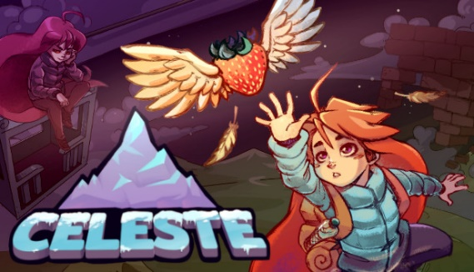

*Celeste*

In extra research, I have also been communicating with an American group of “death doulas”- social workers who deal with end-of-life care. I wanted to do some real research into dealing with such a topic and what would actually be a realistic context for this game to handle.

**Existing knowledge**

A variety of my past modules have influenced my interest into interaction and games. Particularly, modules *Designing Digital Interactions* and *Perception and Multimedia Computing* have been instrumental in building an interest into the human aspect of games and media- that is, how we relate to different media and how it physically can affect us.

From a design point of view, I will draw on not only past experience with art foundation work, but also the *Graphics and* *Introduction to Modelling and Animation* modules, which will inform my practise and technique. I expect to be blending these modules and using shader knowledge from Graphics combined with the modelling and animation principles I am currently learning in IMA.

**New knowledge**

For new skills, I will need to learn animation technique, as well as refine my knowledge of design and the pipeline of design for animation. I will do this by finding resources online and watching the process that different animation studios have followed- for example, I have books regarding the development of *How To Train Your Dragon,* where I can find some examples of the pipeline process, which, whilst obviously a different scale and level, I can hopefully apply some aspects of into my own work and planning. I have completed a summer course in an *Introduction to VFX*, which gives me a good start in weighting and understanding soft body animation, but I will need to do extra research for material and shader knowledge, which I will find online- *BlenderGuru* on YouTube does similar content in Blender, but I would like to find some Maya specific channels.

I also need to learn more about Unity and the software. I am currently learning about it in *Games AI Programming*, and will be finding more resources, as well as asking my peers in Games Programming who are familiar with the software for advice.

**Timeline and milestones**

As a contingency, I will adapt my plan in terms of timing and level of polish. I would like to at least create a blocked-out animation, even if textures and physics are not refined to the level that I would expect of myself. I will aim to finish this project by the end of April, two weeks before the deadline, in order to allow for unforeseen external influence, such as a breakage or the developing pandemic situation. I think that this is a reasonable approach as I should then allow for enough that I hope to not need to re-scope to minimum viable.

|  |  |
| --- | --- |
| Dates | Tasks |
| Present –  11 / 12 / 2020 | Focused context research into pipeline and scene concepts Initial design principles and mock-ups Review time schedule Narrative/scene writing Storyboard Iteration based on feedback |
| 11 / 12 / 2020 -31/1/2020 | INTERIM REPORT Final design Model progress Blocking animation Gathering more feedback |
| 2/2020 | Animation work |
| 3/2020 | DRAFT REPORT Shaders  Texturing |
| 4/2020 | FINAL |
| 5/2020 | PROJECT REPORT SHOWCASE DEMOS |

Project repo: https://github.com/b-greer/finalProject

**Bibliography**

Thunder Lotus Games (2020). *Spiritfarer* [Video game]. Available at https://thunderlotusgames.com/spiritfarer/ (Downloaded: 25 October 2020).

Moon Studios, pub. Microsoft Studios (2015). *Ori and the Blind Forest* [Video game]. Available at <https://store.steampowered.com/app/387290/Ori_and_the_Blind_Forest_Definitive_Edition/> (Downloaded: 3 February 2018).

Matt Makes Games (2018). *Celeste* [Video game]. Available at <https://store.steampowered.com/app/504230/Celeste/>

Schlussel, A. (2020). *Introduction to VFX Short Course*, NFTS Scotland.

Byser, J., 2014. Making Sense Of Metroidvania Game Design. [online] Gamasutra.com. Available at: https://www.gamasutra.com/blogs/JoshBycer/20140623/219621/Making_Sense_of_Metroidvania_Game_Design.php [Accessed 5 November 2020].

Wolff, D., n.d. Opengl 4 Shading Language Cookbook - Third Edition. 3rd ed. Birmingham: Packt.

Johnson, A., 2019. Using Empathy Games In The Social Sciences. [online] Educause. Available at: https://er.educause.edu/articles/2019/11/using-empathy-games-in-the-social-sciences [Accessed 5 November 2020].

Sunshine, L., 2020. The Art Of How To Train Your Dragon: The Hidden World. 1st ed. Milwaukie: Dark Horse Books.