Requirements Analysis Document
KombatSolitaire Client Application
Team: X Marks the Spot
Bryan Hobbs, Sarah Schultz, Skyler Whorton, Yining Zhang
February 27, 2012

1. Introduction

1.1 Purpose of the system
The system is designed to provide a multi-player platform for people to play games (KombatSolitaire, KombatSudoku and KombatWordSteal) and their variations of those games together.

1.2 Scope of the system
The game client connects the user to a multi-player server allowing up to 400 concurrent users over the Internet. A user may engage in multiple games per session, but only one game at a time.

1.3 Objectives and success criteria of the project
The following are core objectives to serve as measures of the system’s implementation success:
- Client will be launched as a Java application on a user’s computer.
- Client should be able to connect to either other Cluster’s Server application successfully, with the same capabilities and behaviors.
- Client may accept any future KombatSolitaire game variation modules following the standard protocol.

1.4 Glossary of Terms
To avoid ambiguity in the design description, we’ve defined the following standardized terms throughout the application documentation.

Player | Generic term for an authenticated user of the application
Registrant | A person attempting to create an account with the KombatGames server application
Administrator | Someone who can kick, ban, and delete troublesome users
Moderator | Player in charge of the table with unilateral control of players on the table, requests, invitations and table settings
Password | Stored and passed as hashed string (like MD5)
Display Name | User-defined text name, need not be unique
Rating | Overall, persistent number that increases when a Player wins a Game or decreases if they Lose
User ID | System-defined unique numeric ID for the user
Ban | Disable an account
Unban | Re-enable an account that was previously banned
Terminate Account | Completely remove an account from the database
Table | Location for players to join, chat, and begin a game
Public | Type of Table that anyone may join without permission provided the room is not full
Private | Type of Table where Player makes a Request and Moderator approves or denies
ByInvitation | Type of Table where players must be invited by the moderator in order to join
Empty | Table which has 0/4 players. Table is Public by default and anyone may join.
Full | Table which has 4/4 players. Nobody else may join.
In Play | Table which is no longer open because the Player(s) are engaged in a Game.
Join | Act of transitioning from being only in the LobbyRoom to also being present at a particular Table
Invitation | Represents a Moderator offering to a Player to Join a ByInvitation Table
Request | Represents a Player asking permission to Join a Private Table
Kick | Moderator forcibly ejects a Player from a Table
Game | An instance of a round of KombatGames, specifically KombatSolitaire for this client
Game Variant | Specific type of Solitaire, e.g. Klondike, Spider, etc.
Score | Running total of points earned in a given Game round
Time Limit | Amount of time allowed for a game. Game ends when time runs out
LobbyRoom | Main area for joining a Table, chatting publicly, viewing player info and changing settings
Registration Screen | GUI interface allowing a Player to register a brand new account
Login Screen | First GUI interface presented to user on application startup where Player can login, register a new account, or quit
Account Options Screen | GUI interface presented to user for changing Display Name, terminating account, etc.
GameWindow | GUI window containing all elements of the Table that the Player has joined, and once the Game starts.
LobbyRoomWindow | GUI window containing all elements of the LobbyRoom including the TablesFrame, UsersFrame and LobbyRoomChat
Public Chat | General broadcast chat visible to everyone in the LobbyRoom
TableChat | The Chat area in the GameWindow where Table Scope messages are sent and received and system notices are displayed
Private Chat | Specific chat message sent to one or more selected Players from the UsersFrame
LobbyRoomChat | The Chat area in the LobbyRoomWindow where LobbyRoom Scope and Private Chat messages are sent and received and system notices are displayed
LobbyRoom Scope | The context of Public Chat among all Players in the LobbyRoom
Table Scope | The context of Public Chat among all Players on a single Table
Private Scope | The context of Private Chat and associated individual recipient Players

2. Current System
The current system in place includes the KombatSolitaire implementation itself, however this software has no means of connecting players, providing community or any competitive capabilities among players.

3. Proposed System

3.1 Overview

The goal of KombatSolitaire is to provide a Client-side portal to the exhilarating world of competitive online Solitaire (in all conceivable variations). The Client will provide the following features:
- Multi-player up to 400 concurrent users
- Persistent password-protected user accounts with customizable display names and KombatSolitaire competitive rating values
- Control user membership by banning, unbanning and deleting accounts
- Practice a game alone or with up to three opponents
- Moderator may control who plays on a table using private or invitation-only tables and by kicking unwanted players
- Customizable game settings including time limit and game variation

3.2 Functional Requirements
The Client supports a new user and three general types established players with slightly different abilities:

3.2.1 Registrant
- A new user to the system can create a new account

3.2.2 Player
- May chat with other players
- May send private chat messages to players
- May browse lists of tables and users
- May see specific win/loss and rating information for individual players
- May join and at any time leave a table
- May become a Moderator of a table
- May play KombatSolitaire games

3.2.3 Moderator
A Moderator can control the people and settings on a table:
- May perform same actions as a player
- May kick unwanted players from the table
- May set the table to be public, private or invitation-only
- May invite players or accept/reject join requests
- May set the table’s time limit
- May specify the table’s KombatSolitaire variation
- May start the game

3.2.4 Administrator
An Administrator can manage the users of the application:
- May perform same actions as a player
- May ban or unban a player’s account

3.3 Non-Functional Requirements
There are certain behaviors in the software that aren’t explicit in the Client-Server interactions described in this document. An optimisitic, non-exhaustive list of these NFRs follows:

- Player who has requested to join a Private Table or who has been invited to a ByInvitation Table forfeits and consumes all such options as soon as they join any Table, regardless of whether it corresponds to a Table among those Requests or Invitations.
- Player who sends two or more join requests to different Private Tables will join the Table to which they are accepted first.
- A Table with four Players is considered Full and no Invitations or Requests may be made or accepted.
- When a Moderator who sends more than N Invitations on a ByInvitation Table, where N is the number of empty seats, the first N players to join will come aboard the table. When the table is Full, the other invitations are destroyed.
- As long as a Moderator exists at a Table and the Table is not Full, all Invitations from and Requests directed to that Table persist, and the current Moderator continues to manage them wherever applicable.
- When the last Player (and Moderator) leaves a Table, all options revert to defaults. The Table becomes Public. All outstanding Requests and Invitations corresponding to that Table are destroyed and anyone may join that Table.
- A Moderator has no ability to withdraw an Invitation already made to a Player.
- A Player has no ability to simply withdraw a Request to join a Private Table. They have no ability to simply reject an Invitation.
- When a Player’s score changes during a game, the new score value should be updated in real time among all Players at that game to engender a fast-past competition.

3.4 System Models

3.4.1 Use Case Model
The following use cases are initiated by the user and interact with the system.

Use Case: Player creates new account
Participating Actors: Player
Entry Condition(s):
- Player is unauthenticated
- Player is viewing the Login Screen
Exit Criteria:
- A new Player account is added to the system
- Player is authenticated
- Player enters the LobbyRoom
Flow of Events:
- Player selects “Registration” from the Login Screen.
- System presents Player with the Registration Screen.
- Player enters their desired password (twice, in separate fields to verify) and selects
“Register”.
- System adds a new account with the designated password and logs the Player into the
system.

Use Case: Player logs in
Participating Actors: Player
Entry Condition(s):
- Player is unauthenticated
Exit Criteria:
- Player is authenticated
- Player enters the LobbyRoom
Flow of Events:
- Player enters their User ID and password in the Login Screen and submits the form.
- System responds by matching entered credentials against database records. If their
credentials are correct, the Player is authenticated and presented the LobbyRoomWindow. Otherwise, they’re given an invalid login error message and may attempt to log in again.

Use Case: Player changes Display Name
Participating Actors: Player
Entry Condition(s):
- Player is authenticated
- Player is viewing the LobbyRoomWindow
Exit Criteria:
- Player’s Display Name is changed to the submitted string
Flow of Events:
- Player selects “Account Options” from the LobbyRoomWindow.
- System displays the Account Options screen in a modal window overlaying the
LobbyRoomWindow.
- Player enters their new Display Name and submits the form.
- System updates the Player’s display name and returns them to the LobbyRoomWindow.

Use Case: Player terminates account
Participating Actors: Player
Entry Condition(s):
- Player is authenticated
Exit Criteria:
- Player is logged out of KombatGames and their account is totally removed from the system
Flow of Events:
- Player chooses “Account Options” from the LobbyRoomWindow.
- System displays the Account Options Screen in a modal window overlaying the
LobbyRoomWindow.
- Player chooses the “Terminate Account” option.
- System prompts the Player with a modal confirmation window with a required password
field.
- Player fills in their password and selects “OK”, or “Cancel”
- System responds by returning the Player to the Account Options window if they cancel.
Otherwise, it logs the Player out and removes their account from the system.

Use Case: Player joins an empty Table
Participating Actors: Player
Entry Condition(s):
- Player is authenticated and viewing the LobbyRoomWindow
- There is a Table available with no other Players present
Exit Criteria:
- Player joins the chosen Table
- Player becomes Moderator of the chosen Table
Flow of Events:
- Player selects an empty Table in the TablesFrame and uses the “Join” option.
- System adds the Player to the Table and determines them to be the Moderator.

Use Case: Player joins a Public Table with other Players
Participating Actors: Player
Entry Condition(s):
- Player is authenticated and viewing the LobbyRoomWindow
- There is a Public Table not In Play available that has one to three Players
Exit Criteria:
- Player joins the chosen Table
Flow of Events:
- Player selects a Table in the TablesFrame and uses the “Join” option.
- System adds the Player to the Table.

Use Case: Player makes a Request to join a Private Table
Participating Actors: Player, Moderator
Entry Condition(s):
- Player is authenticated and viewing the LobbyRoomWindow
- There is a Private Table not In Play available with one to three other Players
Exit Criteria:
- Request is sent to Table Moderator
Flow of Events:
- Player selects a Private Table in the Table Manager and uses the Join option.
- System creates a Request and sends it to that Table for the Moderator to accept or
reject.

Use Case: Moderator accepts Request to join a Private Table
Participating Actors: Moderator, Player
Entry Condition(s):
- Player is not currently on any Table
- Moderator is in control of a Private Table not In Play with one or two other Players
- Moderator has received a Request from Player to join their Private Table
Exit Criteria:
- Player joins the Private Table
Flow of Events:
- Moderator selects the “Accept” option for the Player.
- System immediately adds the Player to the Private Table.

Use Case: Moderator declines Request to join a Private Table
Participating Actor: Moderator, Player
Entry Condition:
- Moderator receives an request to join the table in Game Frame on Game Window.
- Player who sends the request is authenticated and still in the lobby.
Exit Criteria: Request to join a Private Table is declined.
Flow of Events:
- Moderator chooses “decline” for the request in GameFrame on the GameWindow.
- Player who sends the request receives the message like “you are declined by table 007”
in his/her LobbyRoom Chat.
- The status of the table in this player’s LobbyRoom Window changes (change “wait” back
to “request” ).

Use Case: Moderator sends an Invitation for a ByInvitation Table to a Player
Participating Actors: Moderator, Player
Entry Condition(s):
- Moderator is in control of a ByInvitation Table not In Play with one or two others Players
- Player is not currently on any Table
Exit Criteria:
- Player receives Invitation to join the ByInvitation Table
Flow of Events:
- Moderator selects a Player from the LobbyRoomWindow and chooses the “Invite” option.
- System creates an Invitation for the given ByInvitation Table and notifies the Player in
their LobbyRoomChat output of the invitation. The System updates the Player’s GUI such that the “Join” option becomes available for the corresponding ByInvitation Table.

Use Case: Player accepts Invitation to a ByInvitation Table
Participating Actors: Player
Entry Condition(s):
- Player is authenticated and viewing the LobbyRoomWindow
- Player is not currently joined to any Table
- Player has received an Invitation to a ByInvitation Table
- The ByInvitation Table is not In Play and has one to three Players
Exit Criteria:
- Player joins the ByInvitation Table
Flow of Events:
- Player chooses the “Join” option for the ByInvitation Table in the TablesFrame.
- System immediately adds the Player to the ByInvitation Table.

Use Case: Player leaves a table
Participating Actors: Player
Entry Condition(s):
- Player (not a Moderator) is authenticated and currently on a Table
- Table is currently not In Play
Exit Criteria:
- Player is removed from the Table and remains in the LobbyRoom
Flow of Events:
- Player selects the “Leave Table” option from the GameWindow
- System removes Player from the Table, and frees one space at the Table.

Use Case: Moderator leaves a table
Participating Actors: Moderator, Player(s)
Entry Condition(s):
- Actor is an authenticated Moderator in control of a Table
Exit Criteria:
- Moderator is removed from the Table and remains in the LobbyRoom
- New Moderator is assigned or empty Table results
Flow of Events:
- Moderator selects the “Leave Table” option from the GameWindow
- System removes Moderator from the Table, frees one space at the Table, and selects a
new Moderator from remaining Players at the Table. If there are no Players left on the Table, no Moderator is selected and the Table becomes empty.

Use Case: Player switches their chat context to LobbyRoom Scope
Participating Actors: Player
Entry Condition(s):
- Player is authenticated and is viewing the LobbyRoomWindow
Exit Criteria:
- System identifies the Player’s chat scope as “LobbyRoom”
Flow of Events:
- Player selects the LobbyRoom Scope in the LobbyRoomChat.
- System deselects any Players identified in a Private Scope, if applicable, and defines the
Player’s new scope as LobbyRoom Scope.

Use Case: Player sends Chats in the Room
Participating Actors: Player
Entry Condition(s):
- Player is authenticated and is viewing the Room screen
- Player has the LobbyRoom Scope selected
Exit Criteria:
- Player sees their sent chat messages in the LobbyRoom output
Flow of Events:
- Player types Chat text in the Chat Manager box and submits it
- System sends the Public Chat text to all Players in the LobbyRoom and the Chat text
also appears in the sending Player’s output in the LobbyRoomChat.

Use Case: Player switches their chat context to Table Chat scope
Participating Actors: Player
Entry Condition(s):
- Player is authenticated and currently on a Table
- Player is viewing the GameWindow
Exit Criteria:
- System identifies the Player’s chat scope as “Table”
Flow of Events:
- Player selects the Table Scope in the TableChat.
- System deselects any Players identified in a Private Scope, if applicable, and defines the
Player’s new scope as Table Scope.

Use Case: Player sends Chats at a Table
Participating Actors: Player
Entry Condition(s):
- Player is authenticated and viewing the GameManager
- Player has already selected the Table Scope
Exit Criteria:
- Players at that Table see the sent messages
Flow of Events:
- Player types Chat text in the Chat Manager box and submits it.
- System sends the Chat text to all Players currently at the Table.

Use Case: Player selects a Private Chat scope
Participating Actors: Player
Entry Condition(s):
- Player is authenticated and is viewing the LobbyRoomWindow
Exit Criteria:
- System identifies the Player’s Chat scope as “Private” and identifies the selected Players
Flow of Events:
- Player selects one or more names of Players from the UsersFrame in the
LobbyRoomWindow.
- System identifies the Player’s Chat scope as “Private” and identifies the selected Players
as the intended recipients of future chat messages sent by the Player.

Use Case: Player sends a Private Chat
Participating Actors: Sending Player, Recipient Player(s)
Entry Condition(s):
- Sending Player and Recipient Player(s) are authenticated and viewing the LobbyRoomWindow
- Sending Player has already selected Private Scope
Exit Criteria:
- Recipient Players identified in the Sending Player’s Private Chat scope receive the Chat
text
Flow of Events:
- Player enters and sends Chat text in the LobbyRoomChat.
- System sends the Private Chat text to the Recipient Player(s).
- Sending Player and Recipient Player(s) all see the Private Chat text displayed in their
LobbyRoomChat output.

Use Case: Moderator submit Game Options
Participating Actor: Moderator
Entry Condition:
- Moderator is determined successfully.
- Game hasn’t started.
- Moderator clicks the button “Submit” in Settings Frame on Game Window.
Exit Criteria: Game options are settled. And corresponding changes are made.
Flow of Events:
- Moderator selects their preferred Table type, Time Limit, and/or Game Variant and selects “Submit Settings”.
- System records what is chosen and shows it to all players on each player’s Game
Window, and meanwhile changes the status of this Table in the LobbyRoomWindow.

Use Case: Moderator kicks player
Participating Actor: Moderator
Entry Condition:
- Game has not started.
- Moderator enters one player’s name in the blank in the SettingsFrame on GameWindow and clicks “Submit”.
Exit Criteria: Player selected by moderator leaves the table.
Flow of Events:
- System removes this player from this table and notifies other players at the table of the change in game chat like “Bob leaves the table”.
- Game Window of the player who is kicked disappears and the player is back to
LobbyRoom Window.
- System updates information in player list in the user Frame in the LobbyRoom Window.
- System changes the table status (free space ) in the LobbyRoom Window.

Use Case: Moderator starts the game
Participating Actor: Moderator
Entry Condition:
- Moderator is determined successfully.
- Game hasn’t started.
Exit Criteria:
- Game starts and Table status changes into “In Play”.
Flow of Events:
- Moderator selects “Start Game” in the GameWindow
- System presents new game on every Player’s GameFrame and starts each client’s game timer. System changes Table status into “In Play” (no one can send request or join) in the LobbyRoom Window. System eliminates all the requests and invitations to join this table.

Use Case: Administrator bans player
Participating Actor: Administrator, Player
Entry Condition:
- Administrator is identified and authenticated.
- Administrator selects “ban player” on the menu in the LobbyRoomWindow.
Exit Criteria:
- System records what the administrator wants.
Flow of Events:
- System presents ban player windows in the LobbyRoom Window
- Administrator enters the player’s name and confirm.
- Five cases:
  - If the player is at a table but not in play and is not a moderator, system deals with the situation as the use case “Player leaves a table” and then forces the player to log out.
  - If the player is at a table but not in play and is a moderator, system deals with the situation as the use case “Moderator leaves a table” and then forces the player to log out.
  - If the player is at a table and in play and is not a moderator, system deals with the situation as the use case “Player leaves table after game starting” and then forces the player to log out.
  - If the player is at a table and in play and is a moderator, system deals with the situation as the use case “Moderator leaves table after game starting” and then forces the player to log out.
  - If the player is in the lobby, system forces the player to log out.
- System disables the account of this player from login ever again.

Use Case: Player leaves table after game starting
Participating Actor: Player
Entry Condition:
- Game has started but is not over
- Player is currently playing in the Game
Exit Criteria:
- Player leaves the table.
Flow of Events:
- Player selects “Leave Table” in the GameWindow.
- System removes this player from the table and notifies other players at the table of the change in Game Chat window.
- System updates the number of players present on the Table.
- Two cases:
  - Only one player left at the table. Game ends, and system determines the last player as winner. System calculates both players’ scores and updates their information in the Users Frame in the LobbyRoom Window.
  - More than one player left at the table. Game goes on.
- If the Player was the Table’s Moderator, the next Player that joined after the Moderator is determined the new Moderator for the Table.

Use Case: Player logs out
Participating Actor: Player
Entry Condition:
- Player is identified and authenticated
- Player is viewing the LobbyRoomWindow
Exit Criteria:
- Player logs out.
Flow of Events:
- Player selects “Log Out” from the LobbyRoomWindow menus.
- System closes LobbyRoomWindow for the Player and removes them from the UsersFrame in the LobbyRoomWindow. System eliminates all of this player’s requests and invitations.

3.4.2 Analysis Object Model

Entities
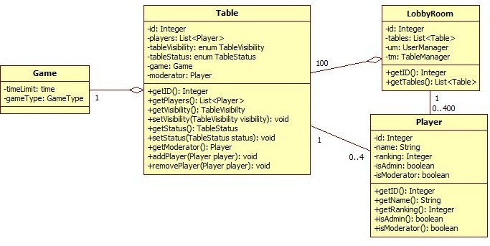

Above are the main entities of the model. The system is comprised of a room, table, player and game. The system has a maximum of 100 tables, each of which can have 0 to 4 players and a maximum of 400 players may be in a room at the same time. Each table is able to choose and play one game.

Managers
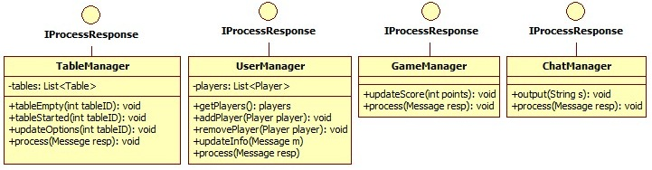

Above are the managers of our model. These managers are in charge of processing incoming messages for letting the client know to update parts of the GUI.

Controllers
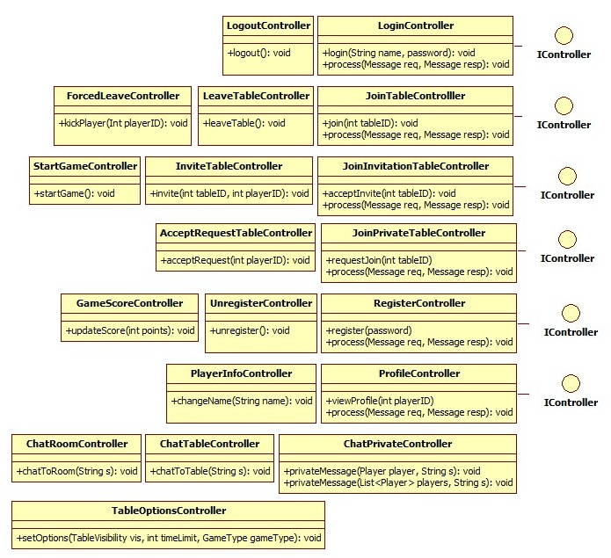
Above are the controllers of our model. These controllers correspond to the functional use cases and the actions that a user should be able to accomplish while using the system. A controller that implements IController sends a message to the server and expects a response back from the server.
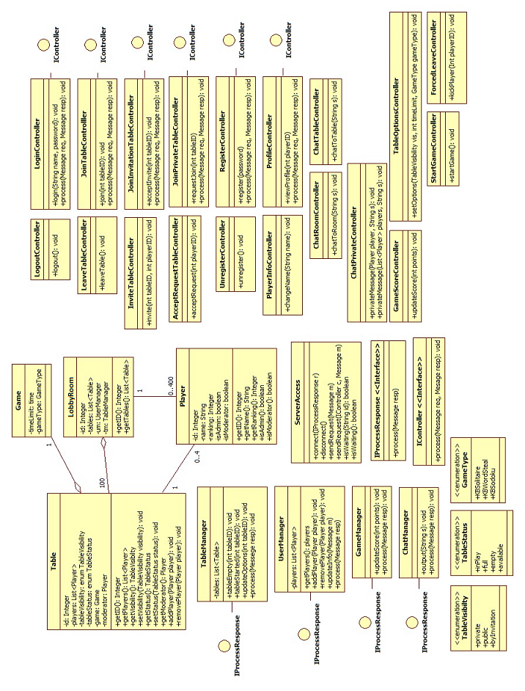

3.4.3 User Interface

Figure 1: Registration screen

This screen is where a new user can register an account by selecting a password, typing it in twice, and clicking the “Register” button. The user is then given his or her unique player ID and logged in. If a user reaches this screen by accident, (s)he can also click “Go Back” to return to the Login Screen.
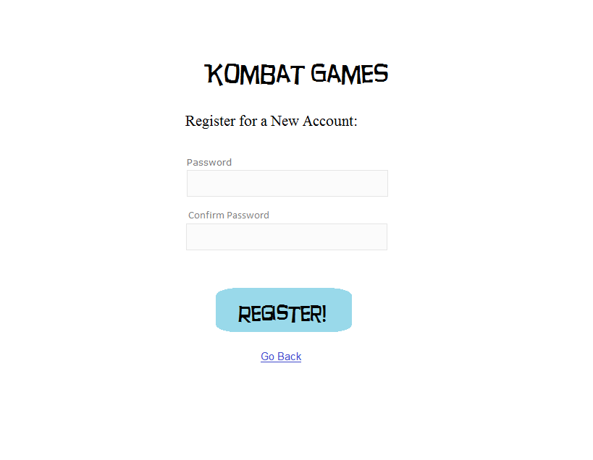

Figure 2: Login Screen

This screen is where a Player can login to the system by typing in his or her User ID and password and then clicking the “Log In” button. A new user can also click the “Register” button to navigate to the Registration Screen.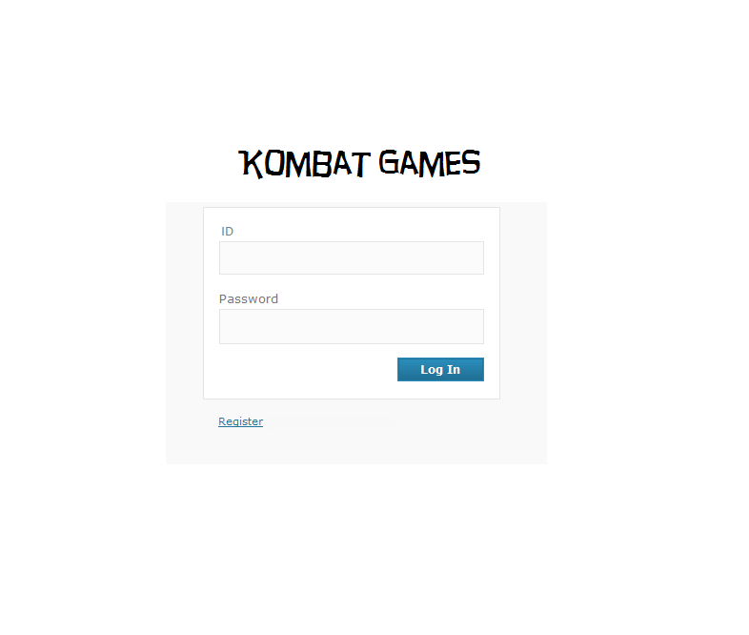

Figure 3: LobbyRoomWindow

Here, a Player can see the Tables in the LobbyRoom in the TablesFrame, the list of Players in the LobbyRoom in the UsersFrame, and chat with the other Players in the LobbyRoomChat. In the TablesFrame, the Player can click the “Join” button in order to join any Open Table (that is not Full or In Play) or click the “Request to Join” button in order to request to join any Closed Table (that is not Full or In Play). In order to chat privately with other Players, a Player can select the speech bubble icon next to the information of the other Player(s) with whom (s)he wishes to chat. In order to send a chat after typing it in the box, a Player presses the “Enter” or “Return” button on his or her keyboard. In order to view the detailed information of a Player in the LobbyRoom, a user may double click on the other Player’s name. A user may also use the Options Menu to select “View Player Info” and enter the ID of any Player in order to view that Player’s detailed information. If the Moderator of a ByInvitation Table invites the Player to the Table, then the Player will see a message in his or her LobbyRoomChat informing him or her of this and the Join button for that Table will become enabled.

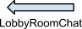
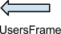
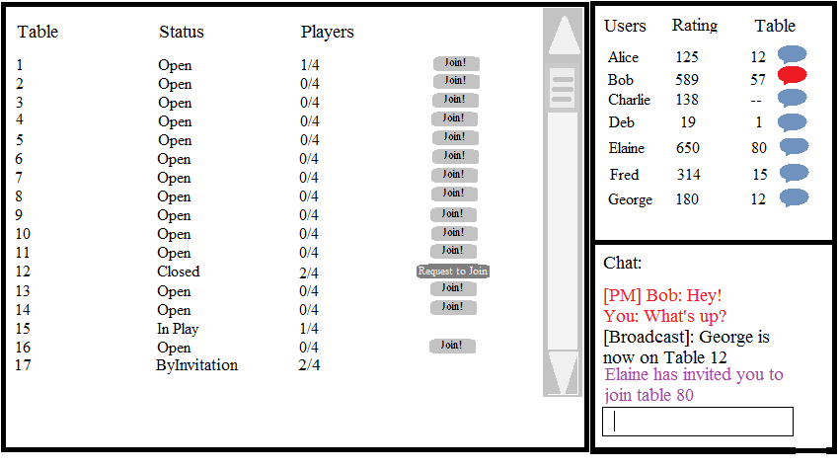

Figure 4:

GameWindow (Player view while not In Play)

This is what a Player who is not the Moderator will see when on a Table that is not engaged In Play. The LobbyRoomWindow remains open, as well. Players will be able to chat with the others on the Table using the TableChat. Within the GameFrame, each Player can see whether the Table is Public, Private, or ByInvitation, and which type of Game and Variant they will be playing (if the Moderator has decided), as well as the amount of time the Game will last. There is also a “Leave Table” button within the GameFrame so that a Player may leave the Table at any time. In the Players frame, each Player will see the list of Players at the Table. The Players are identified by their Display Name and unique ID.

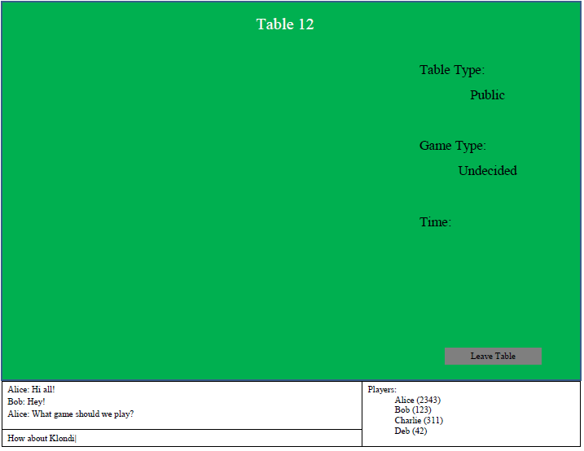





Figure 5: GameWindow (Moderator view while not In Play)

This is what the Moderator of a Table sees when the Table is not engaged In Play. The Moderator has a menu of options, in which (s)he can set the permissions of the Table (Open by default), the Game to be played, and the amount of time the Game will last. The Moderator need not set all of these parameters in order to “Submit Preferences,” however in order to “Begin Game” all parameters need to be set and Submitted. The “Begin Game” button will not be enabled until the Moderator has set a valid Game Variant and Time. If the Table is Closed, the Moderator will receive messages in his or her chat when a Player Requests to Join the Table and the Requests will appear in the GameFrame, where the Moderator can Accept or Reject them. On a ByInvitation Table, the Moderator may select and Invite Players from the LobbyRoomWindow.

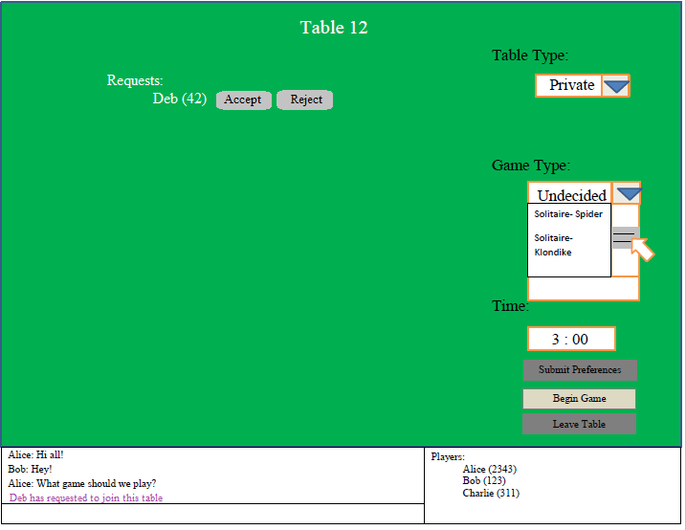

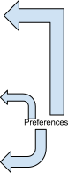


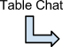

Figure 6: GameWindow (In Play)

All Players have a similar view when the Game is In Play. In the GameFrame, the Player will see his or her Game (at the start of each hand of Solitaire, all Players will have an identical Game, but as each makes different moves, it will be updated separately). Within the GameFrame, a Player can make a move, get a new hand (predetermined so that all Players will always get the same hands in the same order), or undo a move by right-clicking. The TableChat is still in the GameWindow, so Players may continue to chat. In the PlayersFrame, the current score of each Player will now be shown. If a Player wishes to leave a Table while a Game is In Play, (s)he must exit the GameWindow.

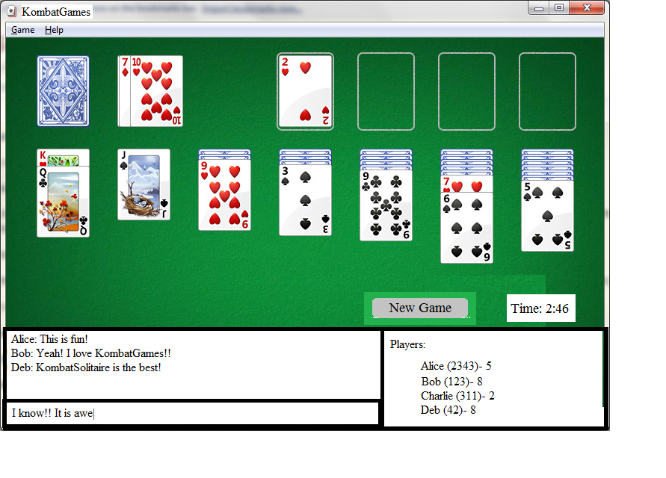

Figure 7: Account Options

In this screen, a user can change his or her Display Name by typing in the New Display Name and his or her Password (this ensures that it is the authenticated user and not someone else trying to change the Display Name) and clicking “Submit.” (S)he will then be returned to the LobbyRoomWindow. The user can also terminate his or her account (and will be prompted to re-enter his or her password in order to do so). Terminating an account will automatically log the user out and delete his or her account. If a user wishes to return to the LobbyRoom from this screen without changing his or her display name, (s)he may click “Return to KombatGames.”

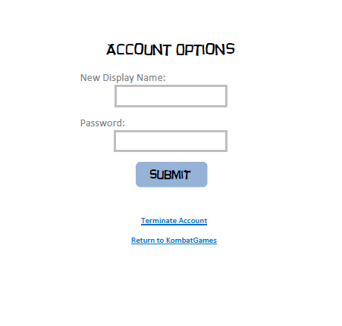

Figure 8: Detailed Player Information

This is what the detailed information page for a Player looks like. Here, we can see the Player’s overall rating, games won, games lost, and total games played, as well as each of these statistics for each of the three types of game. At the bottom of this screen, the Player viewing it can click “Return to KombatGames” in order to return to the LobbyRoom.
