**Stereotest**

We present four targets in front of the observer. For one of the targets, we present slightly dispar images to the left and the right eye, resulting in a perception of depth when stereovision is intact (Figure 1).

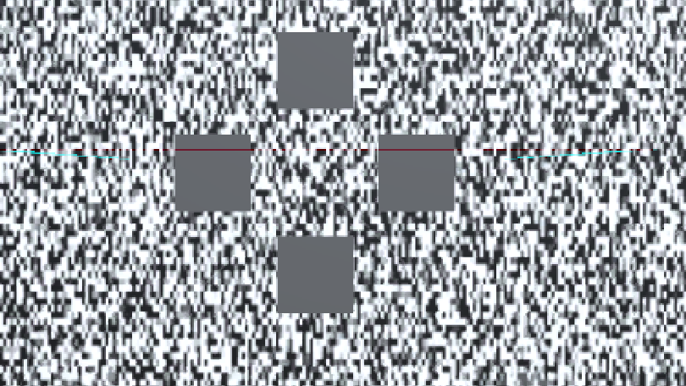

Figure

To compute the stereo acuity, measured in arc sec, we compare the visual angle (Figure 2, red, “gamma”) for regular viewing, to the visual cone elicited by the dispar images (Figure 3, red, gamma).

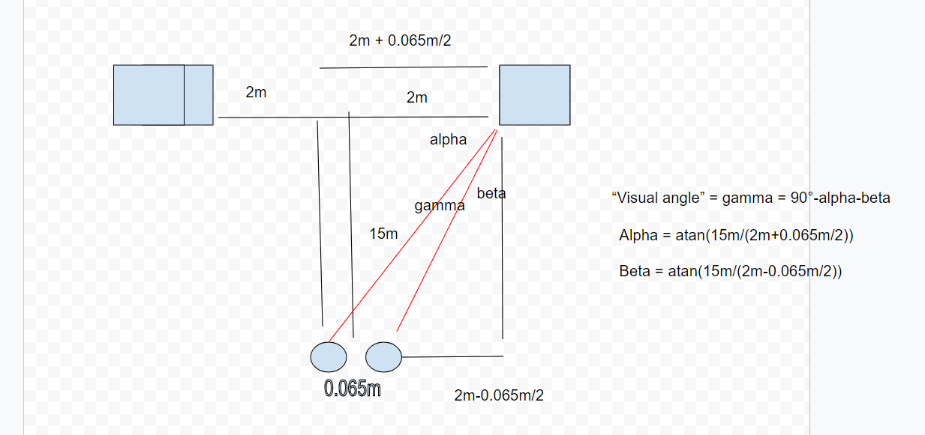

Figure

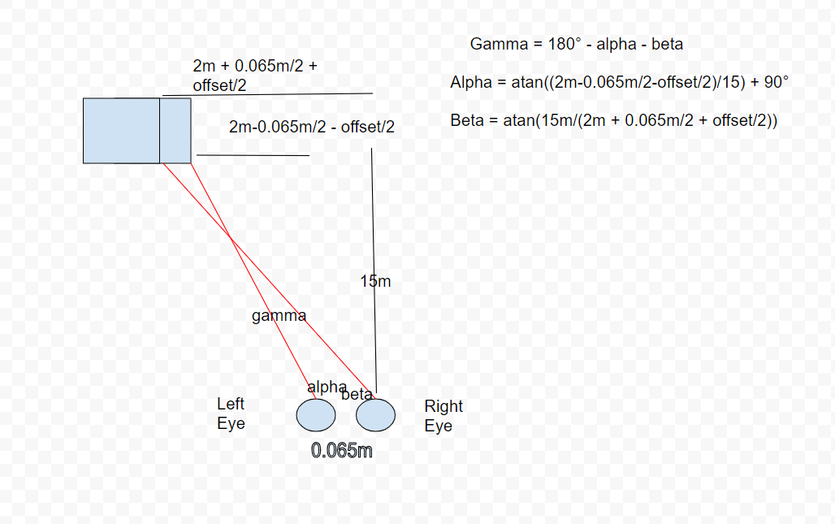

Figure

Figure 2: <https://docs.google.com/drawings/d/1F159vs0guK0SRgo6UBiK4uAMNTdwxRTj31LTSCfmPYU/edit>

Figure 3:

https://docs.google.com/drawings/d/16JvPORpUgWgdGjW8lE9xuz9hsiug8__Wp4X0xcT5_ds/edit