Hey this is where I deep down into the technical details of the current project

**Schematics and how to connect the Arduino**

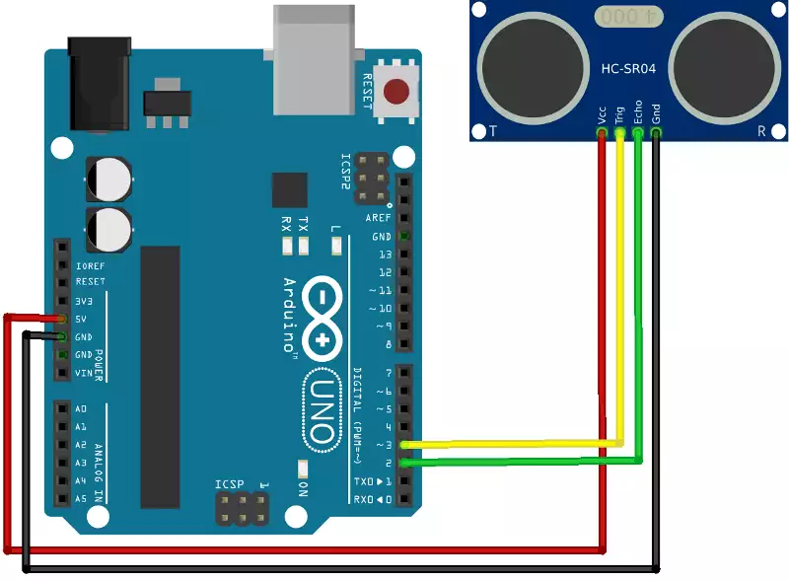

As we see above, the HC-SR04 sensor has 4 pins, VCC, TRIG, ECHO, and GND pin.

VCC = +5V ping

GND = 0V potential

TRIG = The ultrasonic transducer (emits the pulse)

ECHO = detects the time taken to detect the reflected pulse

**Technicalities**

So, the Arduino Ultrasonic Sensor (HC-SR04) is quite different from how other frequency related like buzzers work. The frequencies generated by the sensor cannot be controlled by unlike components such as passive buzzers, which can change frequency based on the delay between the HIGH and LOW SIGNALS.

* It emits 8 pulses of 40kHz which lasts for about 200µs.
* Requires a trigger time of at least 10µs to generate the pulse.
* The ranging detectable distance is from 2cm-400cm.
* A resolution of 0.3cm.
* Its practical test of performance operates at 30-degree angle.

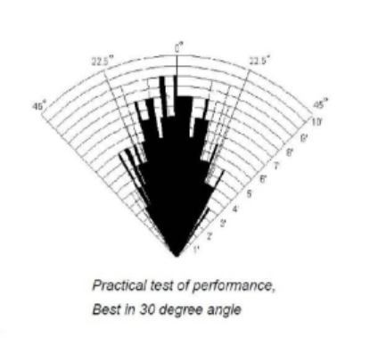

Design of the sensor used.

Initiation:

When the HC-SR04 is given a HIGH pulse for at least 10µs and above. It starts to generate the pulses using its internal Ultrasonic transducer. It needs to have a trigger signal of at least 10µs, or else the transducer doesn’t detect it as a legitimate signal. We can establish similarities of this with a doorbell mechanism. If someone rings your doorbell for maybe just half a second, you might not notice and may shrug it off as some interference or noise from outside or your neighbour’s doorbell even. However, when you hear your doorbell ringing for 5 seconds continuously, you would immediately rush to the door. Now to trigger that 5 seconds doorbell, the person outside, must press the button for at least a second, otherwise, the internal house bell may not trigger, and the person inside won’t be aware.  
  
Distance Calculation

The ultrasonic sensor does not automatically give us the distance measurement, it will only give us the time taken between the ultrasonic pulse was sent out and when the echo pin in our ultrasonic sensor received the pulse. Since between initiation and detection of the pulse is twice the distance between the object and the sensor. When the waves is emitted from the sensor, the echo signal turns HIGH, and when it receives the reflected signal back, it becomes LOW, so the time between when the Echo pin stays high represents the time of the journey.

The equation follows:

$$d=v*\frac{t}{2}$$

$$d=distance between sensor and object \\ v=speed of sound in air \\ t=time taken between propogation and detection of pulse$$