Enumerator – A python package for the virtual generation of chemical space

Babak Mahjour

**Abstract**

The enumeration of chemical structures is a common task in cheminformatics.

**Introduction**

**Implementation**

* Original 320 Amine Acid
* Abstracted Cross Coupler
  + From templates

temp1 = Chem.MolFromSmarts("[C;H0;+0:1](=[O;H0;+0:2])-[O;H0;+0:3]")

temp2 = Chem.MolFromSmarts("[C;H2;+0:4]-[N;H2;+0:5]")

mol1, mol2, products, hit_bonds = enumerate_bonds_between_templates(temp1,temp2)

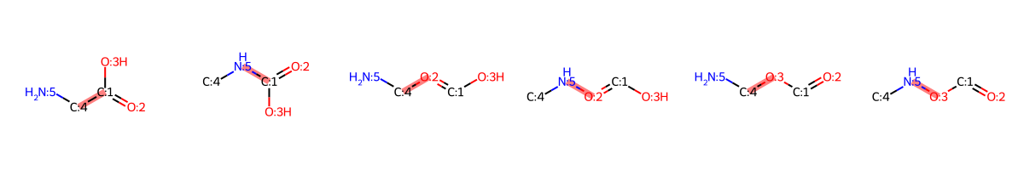

* + From Maximum Common Substructure

amines = ["NC(C(C)=O)=C", "CN"]

acids = ["CC(O)=O", "ClC(O)=O"]

mol1, mol2, products, hit_bonds = combinate(amines,acids)

* Fusion Coupler



* Bond order enumerator

mol = Chem.MolFromSmiles("O=C(C(C)C)C1=C(CCC2=CC=CC=C2)C(NC3=CC=CC=N3)=CC=C1")

mols, new_bonds = bond_order_enumerator(mol, initial_bond_order="single", target_bond_order="double")

* Skeletal Editor
  + Atom swapper

mol = Chem.MolFromSmiles("O=C(C(C)C)C1=C(CCC2=CC=CC=C2)C(NC3=CC=CC=N3)=CC=C1")

mols, new_bonds = atom_swap(mol, "N")

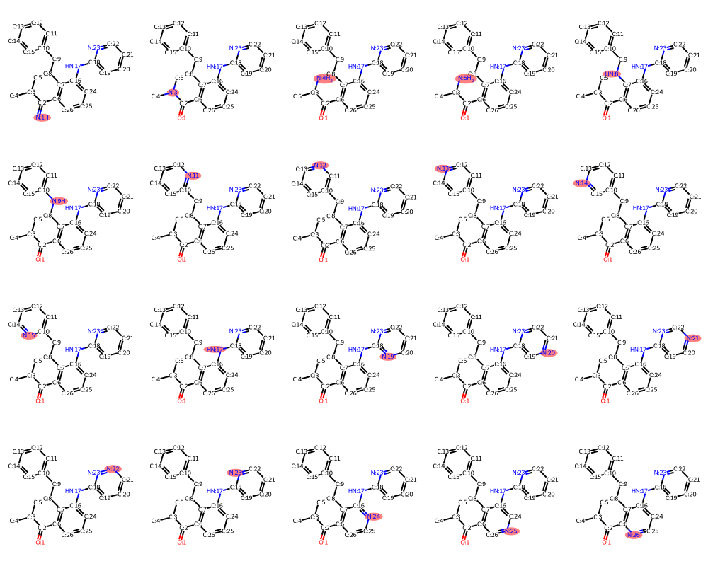

* + Atom remover

mol = Chem.MolFromSmiles("O=C(C(C)C)C1=C(CCC2=CC=CC=C2)C(NC3=CC=CC=N3)=CC=C1")

new_molecules, mapped_mol, bond_counter, removed = deleteAtom(mol)



* + R-Walker

mol = Chem.MolFromSmiles("C=C[C@H]1C[N@@]2CC[C@H]1C[C@H]2[C@@H](C3=CC=NC4=CC=C(C=C34)OC)O")

mols, new_bonds = atom_walk(mol, "C")

* Bag of Atoms
* Forward Predictors
  + VF
  + MCR enumeration of ASKCOS models
* Enzymatic templates??

**Results**

**Conclusion**