Supporting Information for

*One-Step Retrosynthesis of Drug Molecules Leveraging C–H Coupling Reactions with Commercially Available Building Blocks*

Babak Mahjour, Kaitlyn M. Flynn, Shannon Stahl*, Tim Cernak*

1. Department of Medicinal Chemistry, University of Michigan, Ann Arbor, MI, USA
2. Department of Chemistry, University of Wisconsin-Madison, Madison, WI, USA

Table of Contents

1. Examples of one-step synthesis to drugs
2. Building block occurrence in hypothetical single step reactions to DrugBank
3. Histogram of most common cross coupling reactions used in single step syntheses of molecules in DrugBank
4. Example input parameters for the reaction targeting script

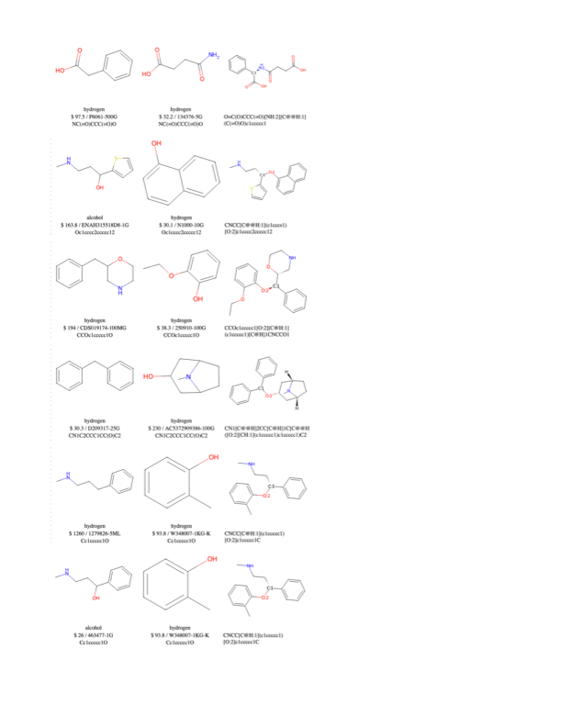

**Figure S1.** Six examples of one step syntheses from two synthons (first two columns) to form a drug found in DrugBank (third column). All reactions are benzylic cross couplings with amines or alcohols.

**Figure S2.** Building block occurrence in hypothetical single step reactions to DrugBank. Six examples of building blocks found in the analysis and their frequencies of occurrence are shown.

**Figure S3.** Histogram of most common cross coupling reactions used in single step syntheses of molecules in DrugBank. Three examples of reactions identified are shown and labeled at the appropriate bin in the histogram.

**Figure S4.** Example input parameters for the reaction targeting script. The script can be run via the command line or in a notebook by importing the ‘run’ function.