## Retrieve all player information for a specific club.

select club.club_name, team.team_name, player.name as player_name, player.birth_date, player.nationality, player.shirt_num

from club, team, team_player, player

where player.player_id = team_player.player_id

and team.club_id = team_player.club_id

and team.team_id = team_player.team_id

and club.club_id = team.club_id

order by club.club_name, team.team_name

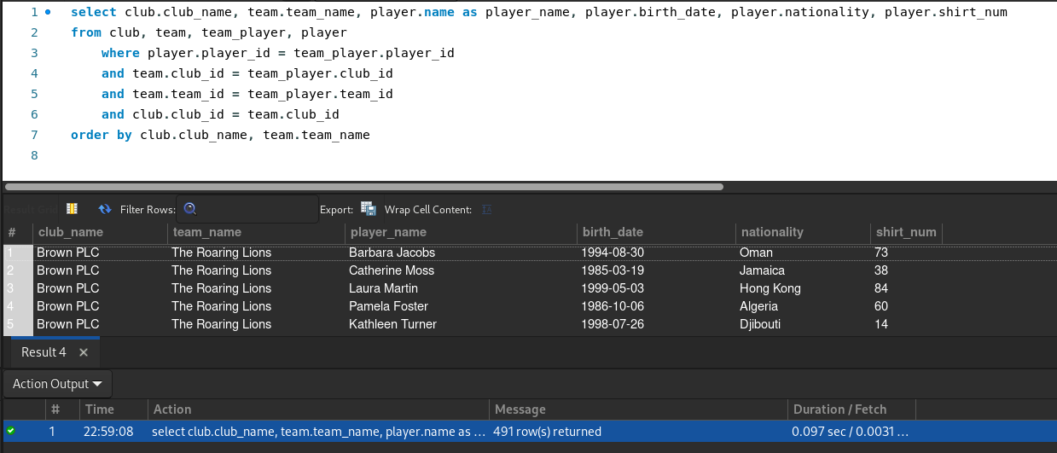

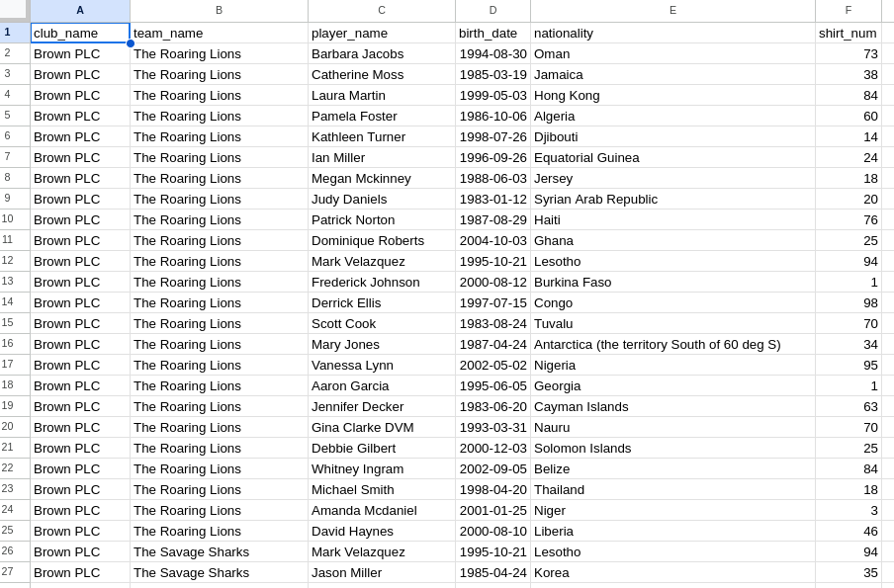

## Find the three top goal scorer in the league.

DROP PROCEDURE IF EXISTS ROWPERROW;

DELIMITER ;;

CREATE PROCEDURE ROWPERROW()

BEGIN

DECLARE n INT DEFAULT 0;

DECLARE i INT DEFAULT 0;

DECLARE l_name VARCHAR(100) DEFAULT "";

DECLARE _id INT DEFAULT 0;

SELECT COUNT(*) FROM league INTO n;

SET i=0;

WHILE i<n DO

SELECT (league_id) FROM league LIMIT i,1 INTO _id;

SELECT (league.league_name) FROM league LIMIT i,1 INTO l_name;

SELECT l_name, player.name as player_name, player_status.goals_scored

FROM player, player_status

WHERE player_status.player_id = player.player_id

and player_status.league_id = _id

ORDER BY player_status.goals_scored DESC LIMIT 3;

SET i = i + 1;

END WHILE;

End;

;;

DELIMITER ;

CALL ROWPERROW();

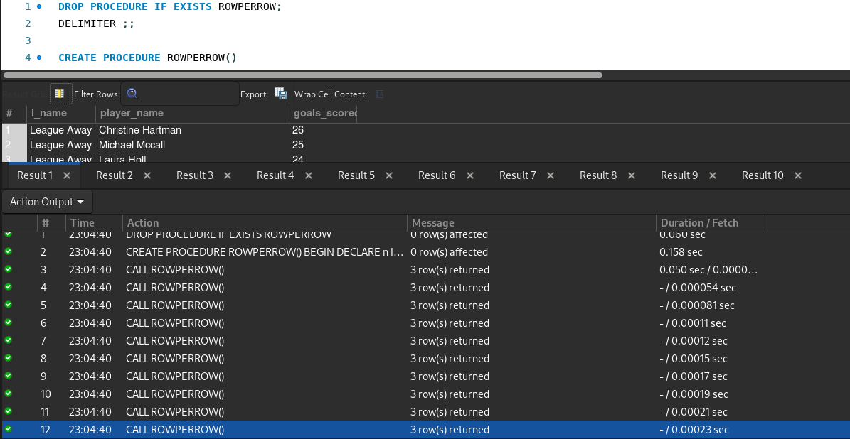

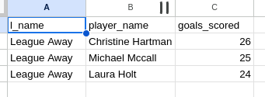

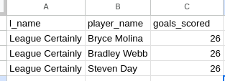

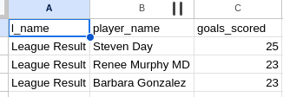

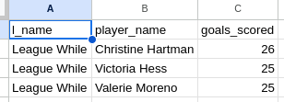

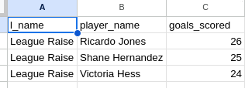

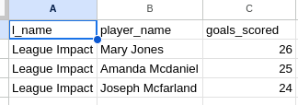

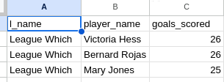

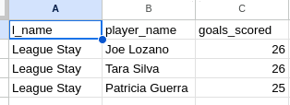

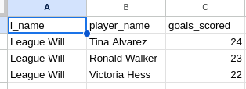

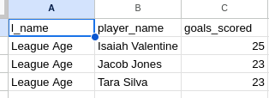

## List all matches played at a particular venue

select stadium.stadium_name, tmatch.tmatch_id, tmatch.date_match

from stadium, tmatch

where stadium.stadium_id = tmatch.stadium_id

order by stadium.stadium_name, tmatch.tmatch_id

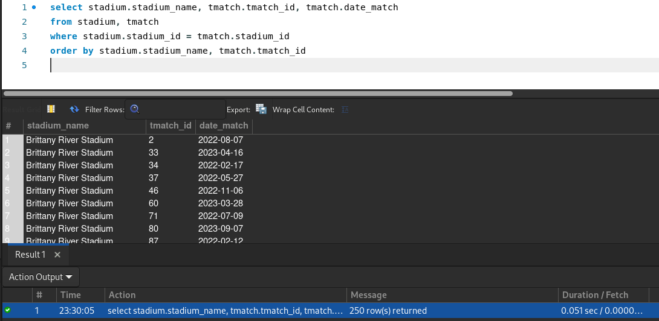

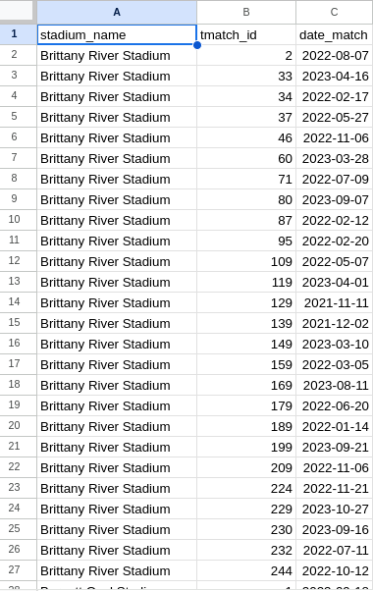

## List all clubs and their total points in the league

select league.league_name, club.club_name, team.team_name, standing.points as total_points

from league, club, team, standing

where club.club_id = standing.club_id

and team.club_id = standing.club_id

and team.team_id = standing.team_id

and league.league_id = standing.league_id

order by league.league_name, club.club_name, team.team_name

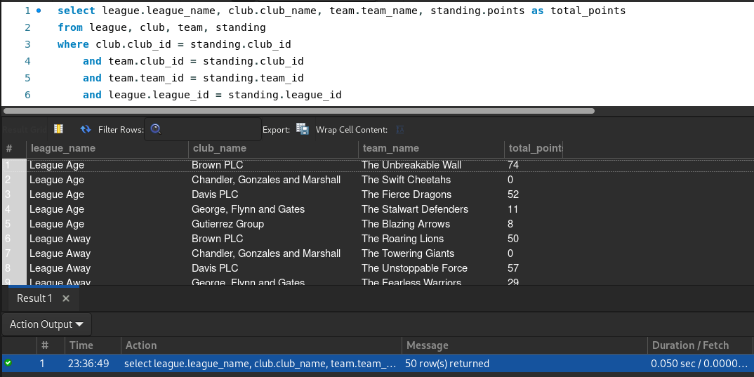

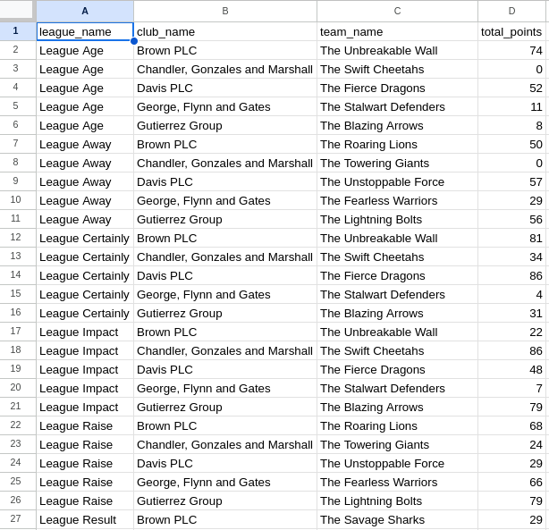

## Retrieve the match schedule for a specific date

select

league.league_name

,tmatch.date_match

,tmatch.time_match

,tmatch.week_day

,match_team_names.t_name_1 as team_1

,match_team_names.t_name_2 as team_2

,stadium.stadium_name

,referee.name as referee_name

from league, tmatch, stadium, referee,

(select match_team_ids.league_id

, match_team_ids.match_id

, teams.t_name_1

, teams.t_name_2

from

(select team.team_id as t_id_1

, t.team_id as t_id_2

, team.team_name as t_name_1

, t.team_name as t_name_2

from team, team as t

where team.team_id < t.team_id) as teams,

(select team_tmatch.league_id as league_id

, team_tmatch.tmatch_id as match_id

, team_tmatch.team_id as team_id_1

, tt.team_id as team_id_2

from team_tmatch inner join team_tmatch as tt

using (league_id, tmatch_id)

where team_tmatch.team_id < tt.team_id) as match_team_ids

where teams.t_id_1 = match_team_ids.team_id_1 and teams.t_id_2 = match_team_ids.team_id_2) as match_team_names

where

tmatch.league_id = match_team_names.league_id

and tmatch.tmatch_id = match_team_names.match_id

and league.league_id = tmatch.league_id

and tmatch.stadium_id = stadium.stadium_id

and tmatch.referee_id = referee.referee_id

order by date_match

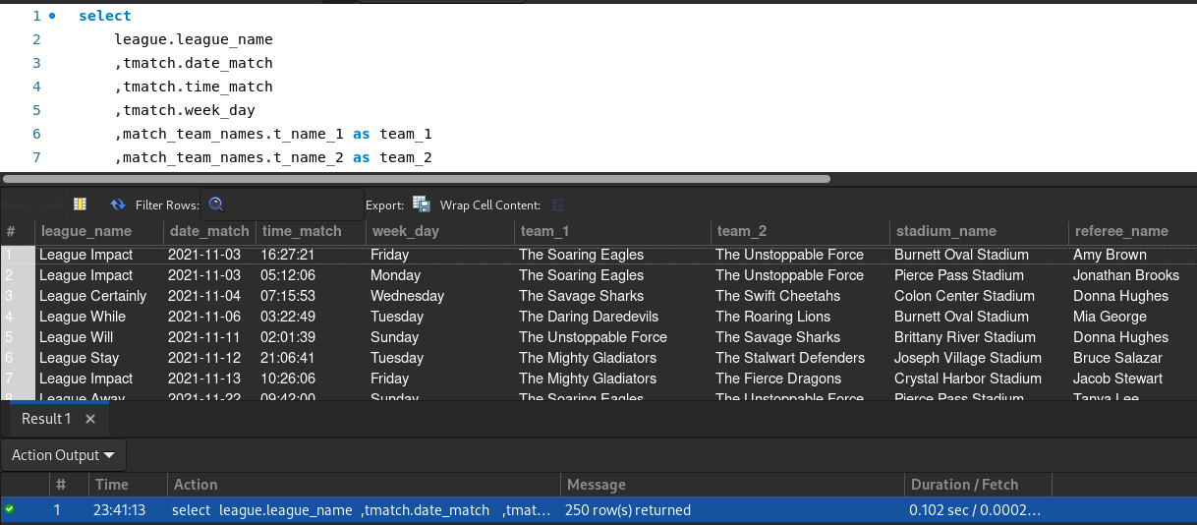

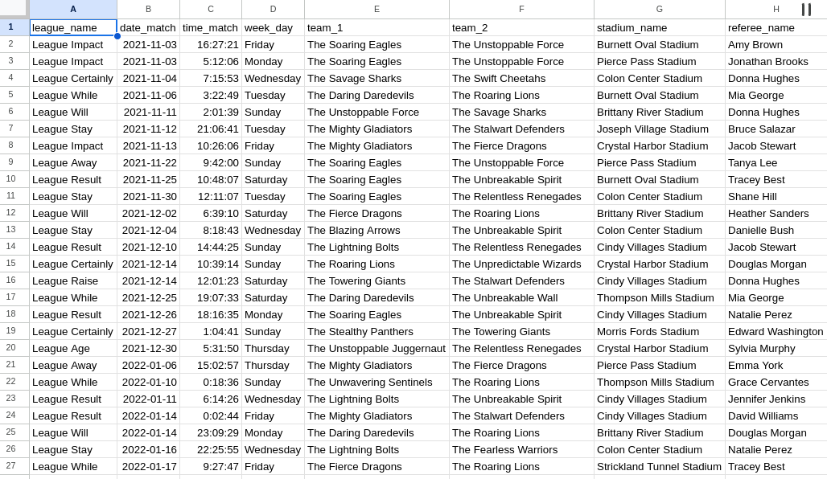

## Find clubs that have at least one player with more than 10 goals

select club.club_name, team.team_name, player.name, player_status.goals_scored

from club, team, player, team_player, player_status

where player.player_id = player_status.player_id

and player.player_id = team_player.player_id

and team_player.club_id = team.club_id

and team_player.team_id = team.team_id

and club.club_id = team.club_id

and player_status.goals_scored > 10

order by club.club_name

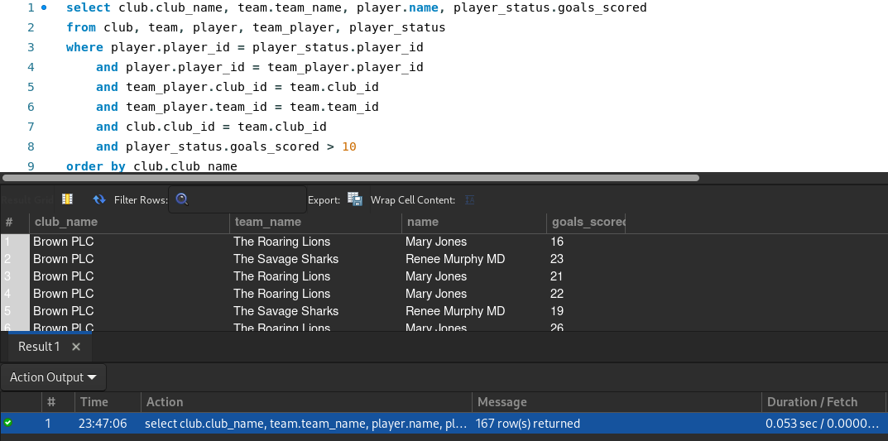

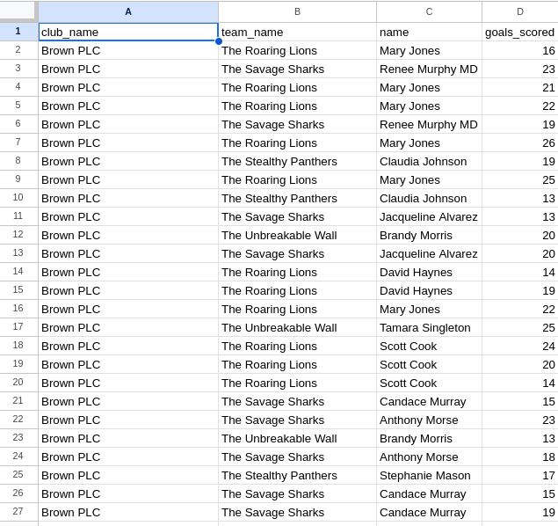

## List matches where the total goals scored is above the average

select

league.league_name

,tmatch.date_match

,match_team_names.t_name_1 as team_1

,match_team_names.t_name_2 as team_2

,match_team_names.team_1_score as team_1_score

,match_team_names.team_2_score as team_2_score

from league, tmatch,

(select match_team_ids.league_id

, match_team_ids.match_id

, teams.t_name_1

, match_team_ids.team_1_score

, teams.t_name_2

, match_team_ids.team_2_score

from

(select team.team_id as t_id_1

, t.team_id as t_id_2

, team.team_name as t_name_1

, t.team_name as t_name_2

from team, team as t

where team.team_id < t.team_id) as teams,

(select team_tmatch.league_id as league_id

, team_tmatch.tmatch_id as match_id

, team_tmatch.team_id as team_id_1

, tt.team_id as team_id_2

, team_tmatch.goals_scored as team_1_score

, tt.goals_scored as team_2_score

from team_tmatch inner join team_tmatch as tt

using (league_id, tmatch_id)

where team_tmatch.team_id < tt.team_id) as match_team_ids

where teams.t_id_1 = match_team_ids.team_id_1 and teams.t_id_2 = match_team_ids.team_id_2) as match_team_names

where

tmatch.league_id = match_team_names.league_id

and tmatch.tmatch_id = match_team_names.match_id

and league.league_id = tmatch.league_id

and ( (team_1_score + team_2_score) > (select avg(goals_scored) from team_tmatch) )

order by date_match

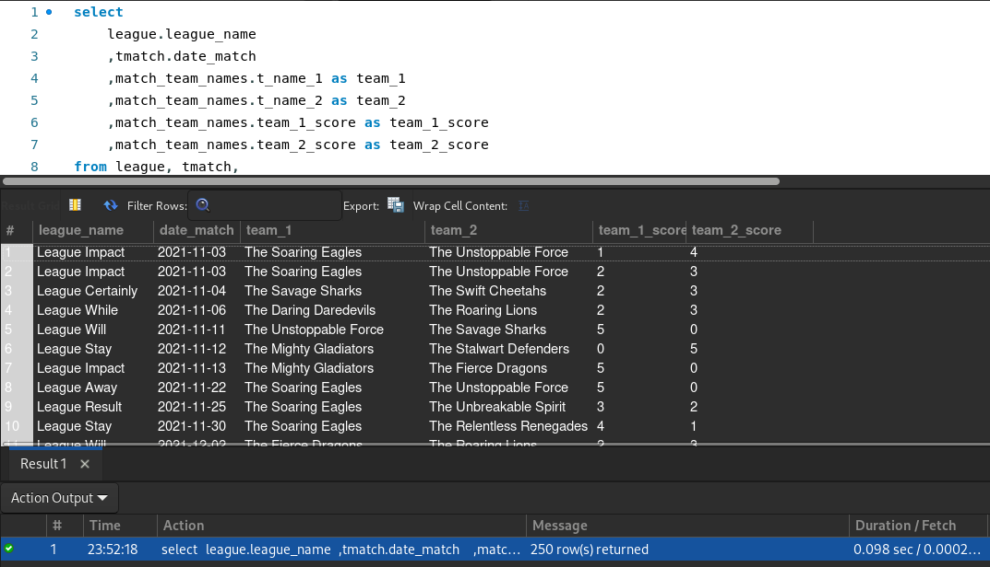

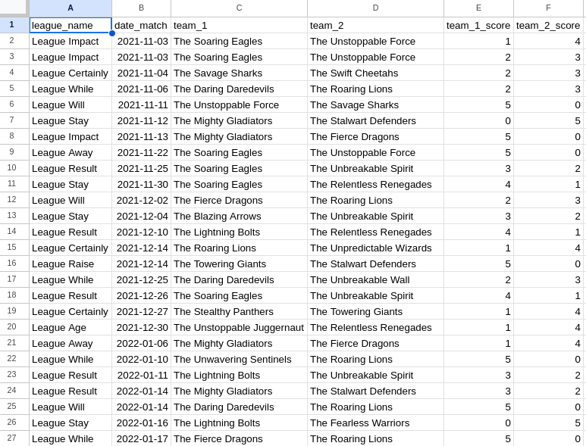

## Retrieve players from a specific club who have scored the most goals

select club.club_name, team.team_name, player.name as player_name, player_status.goals_scored

from club, team, player, team_player, player_status

where player_status.player_id = player.player_id

and team_player.player_id = player_status.player_id

and team_player.club_id = team.club_id

and team_player.team_id = team.team_id

and club.club_id = team.club_id

and (player.name, player_status.goals_scored) IN

(select player.name, player_ids_max_score._max_score

from player,

(select player_status.player_id as _id, team_ids_max_scores.max_score as _max_score

from player_status, team_player,

(select team_player.club_id as c_id

,team_player.team_id as t_id

,max(player_status.goals_scored) as max_score

from player_status, team_player

where player_status.player_id = team_player.player_id

group by club_id, team_id

order by club_id, team_id) as team_ids_max_scores

where team_ids_max_scores.c_id = team_player.club_id

and team_ids_max_scores.t_id = team_player.team_id

and team_player.player_id = player_status.player_id

and player_status.goals_scored = team_ids_max_scores.max_score) as player_ids_max_score

where player.player_id = player_ids_max_score._id

)

order by club.club_name, team.team_name

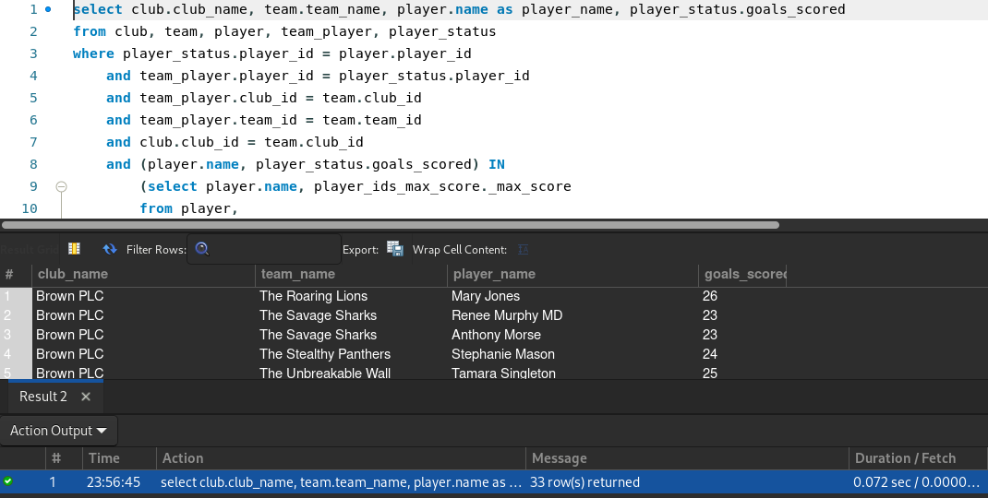

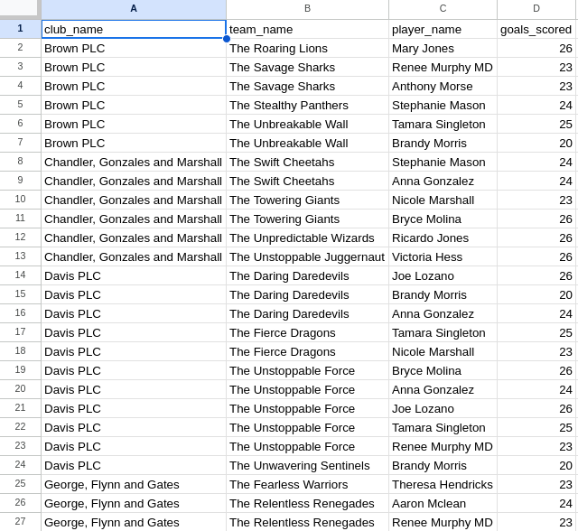

## Retrieve information about matches officiated by a specific referee

select

referee.name as referee_name

,league.league_name

,tmatch.date_match

,tmatch.time_match

,tmatch.week_day

,match_team_names.t_name_1 as team_1

,match_team_names.t_name_2 as team_2

,stadium.stadium_name

from league, tmatch, stadium, referee,

(select match_team_ids.league_id

, match_team_ids.match_id

, teams.t_name_1

, teams.t_name_2

from

(select team.team_id as t_id_1

, t.team_id as t_id_2

, team.team_name as t_name_1

, t.team_name as t_name_2

from team, team as t

where team.team_id < t.team_id) as teams,

(select team_tmatch.league_id as league_id

, team_tmatch.tmatch_id as match_id

, team_tmatch.team_id as team_id_1

, tt.team_id as team_id_2

from team_tmatch inner join team_tmatch as tt

using (league_id, tmatch_id)

where team_tmatch.team_id < tt.team_id) as match_team_ids

where teams.t_id_1 = match_team_ids.team_id_1 and teams.t_id_2 = match_team_ids.team_id_2) as match_team_names

where

tmatch.league_id = match_team_names.league_id

and tmatch.tmatch_id = match_team_names.match_id

and league.league_id = tmatch.league_id

and tmatch.stadium_id = stadium.stadium_id

and tmatch.referee_id = referee.referee_id

order by referee_name

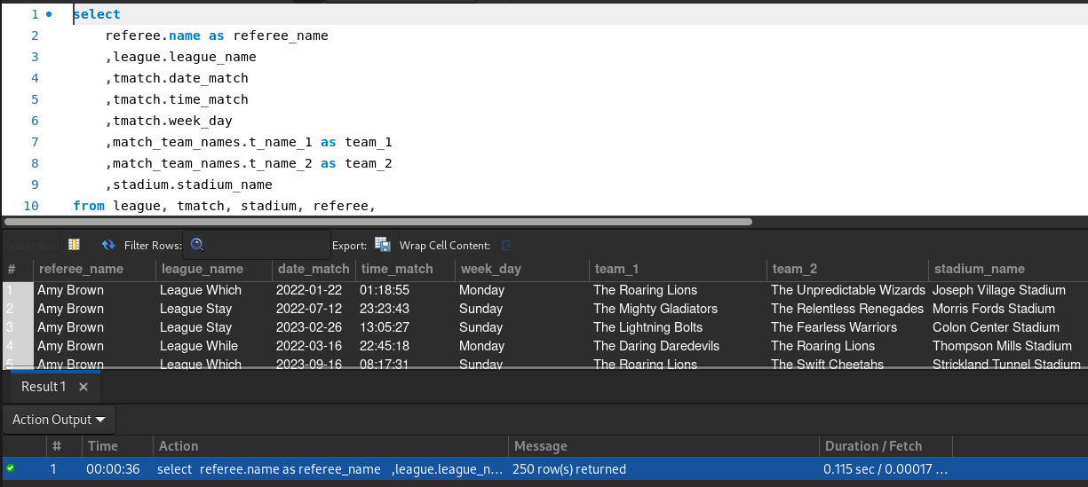

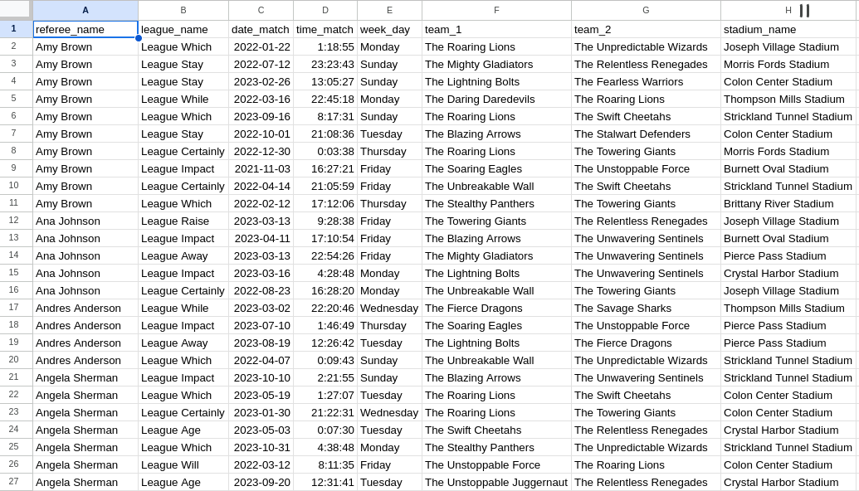

## List all matches played at a specific venue within a certain date range

select

stadium.stadium_name

,referee.name as referee_name

,league.league_name

,tmatch.date_match

,tmatch.time_match

,tmatch.week_day

,match_team_names.t_name_1 as team_1

,match_team_names.t_name_2 as team_2

from league, tmatch, stadium, referee,

(select match_team_ids.league_id

, match_team_ids.match_id

, teams.t_name_1

, teams.t_name_2

from

(select team.team_id as t_id_1

, t.team_id as t_id_2

, team.team_name as t_name_1

, t.team_name as t_name_2

from team, team as t

where team.team_id < t.team_id) as teams,

(select team_tmatch.league_id as league_id

, team_tmatch.tmatch_id as match_id

, team_tmatch.team_id as team_id_1

, tt.team_id as team_id_2

from team_tmatch inner join team_tmatch as tt

using (league_id, tmatch_id)

where team_tmatch.team_id < tt.team_id) as match_team_ids

where teams.t_id_1 = match_team_ids.team_id_1 and teams.t_id_2 = match_team_ids.team_id_2) as match_team_names

where

tmatch.league_id = match_team_names.league_id

and tmatch.tmatch_id = match_team_names.match_id

and league.league_id = tmatch.league_id

and tmatch.stadium_id = stadium.stadium_id

and tmatch.referee_id = referee.referee_id

and (tmatch.date_match between '2022-01-01' and '2022-12-31')

order by stadium.stadium_name

