Benjamin Rothschild

MACS 30200

Problem Set #1

Data Section Write Up

The dataset is derived from inspections of restaurants and other food establishments in Chicago from January 1, 2010 to the present and includes 146,955 observations.[1] Observations are collected from trained staff from the Chicago Department of Public Health’s Food Protection Division[2] whose purpose is to promote public health in areas of food safety and sanitation. Inspections are done on food establishments such as restaurants, grocery stores, bakeries, hospitals, and schools among others. The department focuses their inspections on food handling practices, food temperature, personal hygiene, and pest control. For each inspection, an establishment can get a status of:

* **Pass**: establishment meets the minimum requirements of municipal codes and does not have any serious or critical violations
* **Pass with Conditions**: the establishment has Serious or Critical violations that are corrected during the inspection or the certified Food Service Sanitation Manager is not present as the time of the Inspection
* **Fail**: the establishment has Serious violations that cannot be corrected during the inspection. The business must correct the Serious violations promptly and pass a re-inspection to remain open. Note: the business can also have its license suspended until it passes re-inspection.

In addition, each establishment is given a Risk Code which categorizes the establishment as Risk 1 (high risk, with complex menus and food handling practices) to Risk 3 (low-risk, food is packaged or nonperishable). In general Risk 1 establishments are inspected twice per calendar year, Risk 2 once per year, and Risk 3 once every two years.

A description of the columns in the dataset

|  |  |  |
| --- | --- | --- |
| Column | Description | Sample Value |
| Inspection Number | Unique identifier for inspection | 1286320 |
| DBA Name | Business Name | CRUST EAT REAL |
| AKA Name | Business Alias | CRUST EAT REAL |
| License # | Unique value for license | 87098 |
| Facility Type | Type of facility | Restaurant, School, etc |
| Risk | Risk level of establishment | Risk 1, Risk 2, Risk 3 |
| Address | Includes street, city, state, zip, latitude longitude |  |
| Inspection Date | Date inspection was conducted | 7/22/10 |
| Inspection Type | Why the inspection was conducted | Canvas, Complaint, etc |
| Results | Results of inspection | Pass, Fail, Pass w/Conditions |
| Violations | List of violations | 18. NO EVIDENCE OF RODENT OR INSECT OUTER OPENINGS PROTECTED/RODENT PROOFED, A WRITTEN LOG SHALL BE MAINTAINED AVAILABLE TO THE INSPECTORS - Comments: Violation #18 now corrected. |

A summary of relevant dataset values are below.

|  |  |
| --- | --- |
| **Food Establishment Inspections January 1, 2010 - present** | |
| Observations | 146,955 |
| Unique Establishments | 32,053 |
| **Risk Level Results** | |
| Risk 1 | 102,249 |
| Risk 2 | 30,518 |
| Risk 3 | 14,107 |
| Missing | 81 |
| **Inspection Results** | |
| Fail | 28,478 |
| Out of Business | 13,412 |
| Pass | 86,580 |
| Pass w/Conditions | 13,843 |
| Other | 30,518 |
|  |  |
| Avg. Inspections Per Day | 2,661 |

The coverage of the inspections are detailed in the map below.

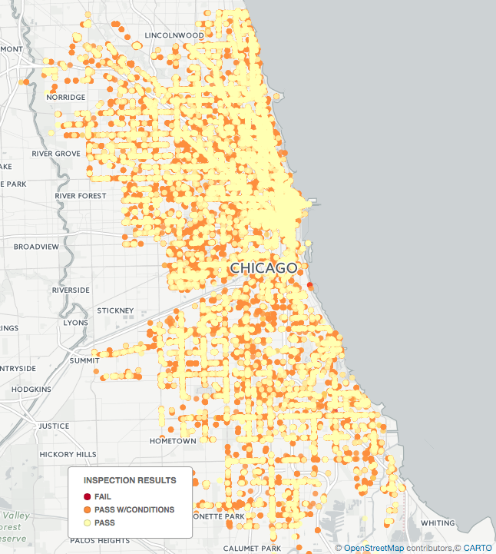

Previous research using this data source tried to predict which food establishments would have the most critical violations to prioritize what establishments food inspectors should go towards first.[3] The purpose of this study was to more efficiently allocate food inspectors across the 15,000 food establishments in Chicago. In this study, a dozen variables had substantial relationship with the likelihood of an establishment failing a food inspection such as if the establishment has previous failed inspections or its location and nearby sanitation complaints made through 311. In addition, research has been done using similar datasets from other cities. For example, researchers have successfully merged food establishment inspection databases with online reviews to predict the likelihood of a food violations[4] and online review sites like Yelp have included food inspection results to improve their product.[5]

1. Data can be accessed through the Chicago Data Portal (<https://data.cityofchicago.org/Health-Human-Services/Food-Inspections/4ijn-s7e5/data)> and is available in multiple formats (csv, json, xml) and through a Socrata REST API. Data was accessed April 19th, 2017
2. http://webapps1.cityofchicago.org/healthinspection/General_Info.jsp
3. The methodology for the study is explained here <https://chicago.github.io/food-inspections-evaluation/> and the code is open sourced here https://github.com/chicago/food-inspections-evaluation/
4. Kang, Jun Seok, et al. *Using Text Analysis to Target Government Inspections: Evidence from Restaurant Hygiene Inspections and Online Reviews*. No. 14-007. Harvard Business School, 2013.
5. Booth, Darryl. "Yelp partners with health departments to improve food safety." *Journal of environmental health* 76.8 (2014): 52-56.