**Our Energy Future**

**Jatropha**

Jatropha, a plant grown in tropic and sub-tropic areas that does not tolerate freezing temperatures, is used to produce renewable energy similar to more common sources (at least in the US) like soy, algae or sunflowers.

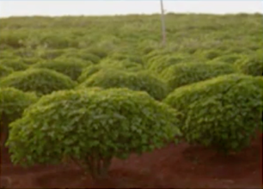Some quick facts about the plant itself:

* Perennial small tree or large shrub growing to 2-4m
* Can reproduce through simple stem cuttings
* Flowers are pollinated by insects
* 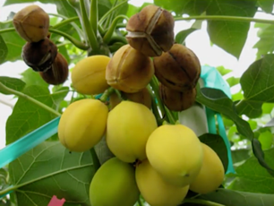Rapid generation time, from 4-9 months, which lends itself for genetic improvement as we further our understanding of how to produce to best strain of the plant to be used for fuel
* The fruits jatropha produces contain seeds with a high oil contents, roughly 35%

There are two important characteristics of biodiesel called *cloudpoint* and *oxidative stability*.

*Cloudpoint ­*– Temperature of the fuel where small solid crystals can be observed as the fuel cools.

*Oxidative Stability* – The ability of a fuel to resist oxidation during storage and use.

As seen in the table below, jatropha oil produces high quality biodiesel because of its relatively low cloudpoint and its high oxidative stability.

|  |  |  |
| --- | --- | --- |
| **Feedstock** | **Cloudpoint (CO)** | **Hrs @ 110OC** |
| Jatropha | 3 | 13.1 |
| Palm | 13 | 13.37 |
| Soy | 0.9 | 5.3 |
| Rapeseed | -3.3 | 14.1 |

When comparing sources of biodiesel with petro-diesel, there are a few properties that are important to understand and measure.

*Viscosity* – How thick a fuel is. The viscosity of diesel must be high enough to provide sufficient lubrication for the engine parts but low enough to flow at operational temperature

*Caloric Value* – The amount of energy produced by a fuel’s combustion

*Flash Point* – The lowest temperature at which it will produce sufficient vapor to produce a flammable mixture in the air. The lower the flash point, the easier it is to ignite. The higher the flash point, the safer the material is to handle.

*Pour Point* – The temperature below which the liquid loses its flow characteristics.

|  |  |  |  |  |  |
| --- | --- | --- | --- | --- | --- |
| **Parameter** | **Jatropha** | **Rapeseed** | **Palm** | **Soybean** | **Petro-Diesel** |
| Viscosity at 40C | 4.8 | 4.5 | 4.42 | 4.08 | 2.6 |
| Caloric Value (MJ/kg) | 39.23 | 37 | 36.7 | 39.76 | 42 |
| Flash Point (C) | 135 | 170 | 182 | 69 | 68 |
| Pour Point (C) | 2 | -12 | 15 | -3 | -20 |

Based on these definitions, you can see that the viscosity of biodiesel sources are an issue compared to petro-diesel, along with pour point. However, the biodiesels have very low levels of sulfur oxide emissions which resut in acid rain