Movie Recommender System
Project Report
Brian Cooper
Programming for Machine Learning — Spring 2026

1. Background
The goal of this project is to build a personalized movie recommendation app. The app takes a user’s Letterboxd ratings export as input and returns top-N film recommendations drawn from a curated community of critic-level Letterboxd users. The project was developed iteratively, beginning with a simple prototype and progressively improving model accuracy and performance.

1.1 Data
The community dataset consists of scraped ratings from top Letterboxd users, sourced from Kaggle (credit to Sam Learner). Input data is structured as long-form ratings tables with user IDs, movie IDs, and ratings. The user’s own ratings are exported directly from Letterboxd in CSV format and merged with the community data before modeling.

1.2 Pre-Processing
Two data sources required alignment before modeling:
- Loader functions were written to ingest both the user and community rating files.
- Movie ID conventions were standardized (Letterboxd title slugs) and ratings were normalized from a 0–5 scale to 0–10.

A memory error was encountered when attempting to build the full user-item matrix from the raw community data:
Memory Error: Unable to allocate 15.9 GiB for an array with shape (286,070 × 7,478)
Two solutions were considered: using a sparse matrix library or filtering the data before building the matrix. The preferred solution was to filter upfront, which also served a secondary purpose of restricting recommendations to a meaningful, quality-controlled subset of films.

Filtering strategy
Two filtering steps were applied:
- Community density filter kept only movies rated by at least 0.5% of community users. This reduced the movie count from 286k to 12k.
- Metadata filter: applied runtime constraints (80–240 min) and other TMDB-based criteria. Final dataset: 938 users × 8,048 movies, density 21.89%.

This design decision introduced a fork: filtering could happen before or after the recommendation step. Filtering before was chosen to reduce matrix dimensions upfront and maximize model training signal on a consistent, well-covered set of films. A second round of user-facing filters (genre, runtime, language) was planned as a later UI feature.

2. Methodology

2.1 Similarity measures
Measure | Description | Used for
Cosine similarity | Angle between rating vectors; bounded 0–1 | Item similarity (primary)
Pearson correlation | Linear correlation; implicitly mean-centered | User similarity (primary)
Mean-centered cosine | Cosine applied to bias-corrected vectors | Item similarity (final)
Significance-scaled cosine | Weights down pairs with few co-raters | Item similarity (final)

2.2 Approach
Both item-based and user-based collaborative filtering were evaluated. Item-based CF computes similarity between films based on how they are co-rated; user-based CF computes similarity between users based on their rating histories. Given more items than users in the dataset, user-based filtering was expected to be a stronger signal.
For each approach, two estimation methods were compared:
- Standard weighted average: prediction is a weighted means of all co-rated items/users.
- k-Nearest Neighbors (kNN): prediction uses only the top-k most similar items or users, with optional minimum similarity threshold.

2.3 Evaluation
Model performance was measured with k-fold cross-validation (k=5) using MAE as the primary loss function. To reduce runtime, a sampling strategy was introduced: x% of observed ratings are sampled and then split into k folds. At x=5% and k=5, full evaluation completes in approximately 6 minutes vs. 143 minutes for the full dataset, with negligible MAE difference (~0.001).
Mean Error (signed) was also computed to detect systematic prediction bias. RMSE was used for the final evaluation.

3. Development and Results

3.1 Baseline attempts
Two initial baseline attempts were run using a simple item-based cosine similarity (no mean-centering) on successively filtered datasets.
Attempt | Data filter | Sim matrix time | Avg MAE (5-fold)
Attempt 1 | 5% rating threshold | 48 min 54 sec | N/A (eval timeout)
Attempt 2 | 8% rating threshold | 39 min 32 sec | 1.5406

Key observations from the baseline:
- Cosine similarities were near 1.0 on average (mean: 0.96), indicating insufficient discrimination.
- Predicted ratings clustered tightly around the user’s mean rating with very little variance.
- Recommendations were dominated by niche, critically acclaimed arthouse films.
- Performance was far too slow for iterative development.

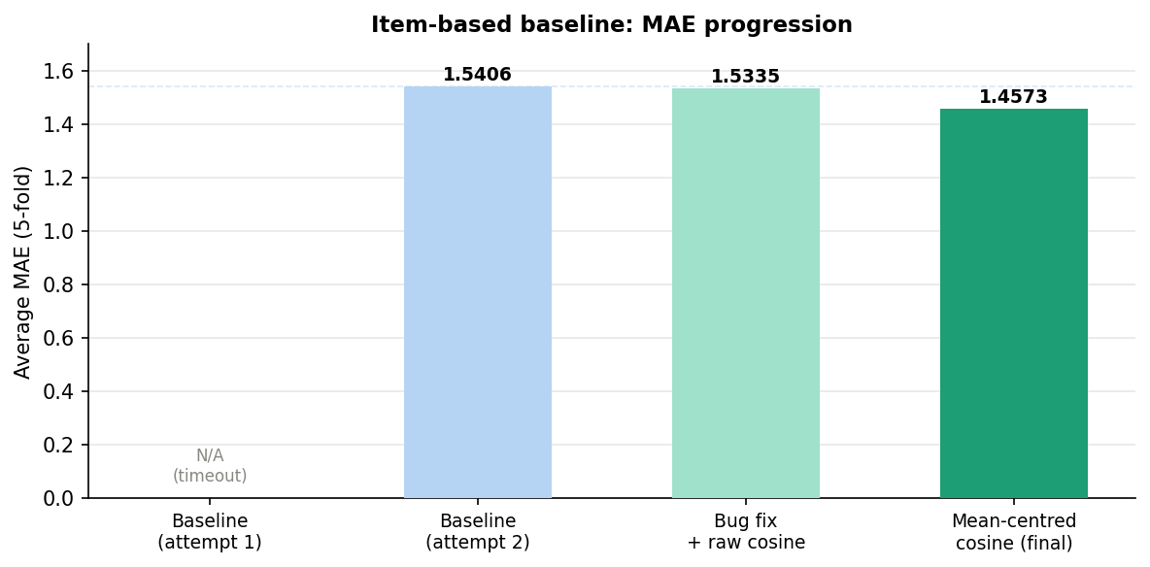
Figure 1: MAE progression across baseline and item similarity development stages.

3.2 Item similarity method selection
Five similarity methods were evaluated against domain-knowledge test cases (e.g. Eat Pray Love vs. Transformers films should have low similarity; Transformers films should be mutually high):
Method | Test pair sim (ET vs TF) | Min sim | Max sim
Cosine (not centered) | 0.94 | 0.50 | 1.00
Cosine (mean centered) | 0.73 | ~0.00 | 1.00
Cosine (centered + sig. scaled) | 0.57 | 0.15 | 0.98
Pearson (NaN ignored) | 0.68 | 0.20 | 0.99
Pearson (NaN → 0) | 0.50 | 0.35 | 0.97

Method 3 (mean-centered, significance-scaled cosine) was selected. It produced the widest similarity range, showed the best alignment with domain intuition, and was the fastest to compute. Switching to this method reduced MAE from 1.5335 to 1.4573 and substantially improved recommendation quality.

Recommendations before final similarity method:
sunset-boulevard, the-400-blows, chinatown, blue-velvet, eraserhead, mulholland-drive, breathless … (heavy Lynch/Kubrick bias)
Recommendations after final similarity method:
the-favourite, kill-bill-vol-1, toy-story-2, pans-labyrinth, apocalypse-now, toy-story-3, inside-llewyn-davis, ex-machina, casino-royale-2006, sound-of-metal

3.3 User similarity method selection
For the user-based step, Pearson and cosine similarity were compared. Mean-centering was not evaluated separately for Pearson as it implicitly normalizes.
Method | Avg MAE (20% sample, 5-fold)
Pearson | 1.2336
Cosine | 1.2354

Pearson was selected based on the marginally lower MAE and established reliability for user-to-user comparison.

3.4 Method comparison and kNN tuning
Four estimation strategies were evaluated after implementing kNN:

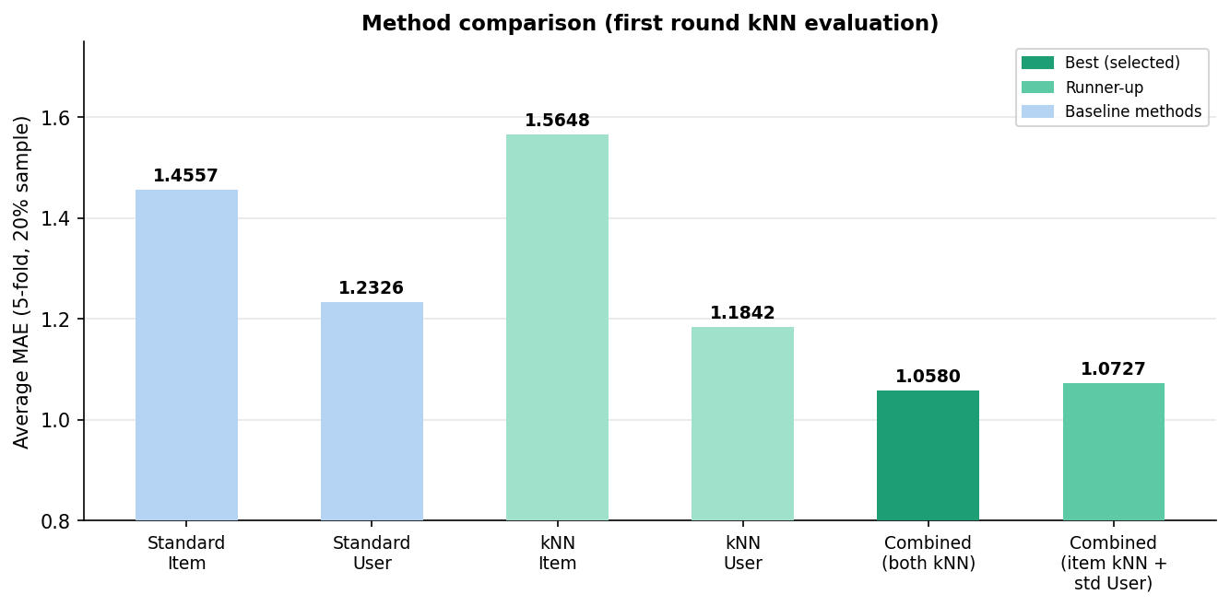
Figure 2: MAE comparison across estimation methods (20% sample, 5-fold CV).

kNN parameter tuning (k and minimum similarity threshold) produced significant improvements, particularly for item-based kNN:

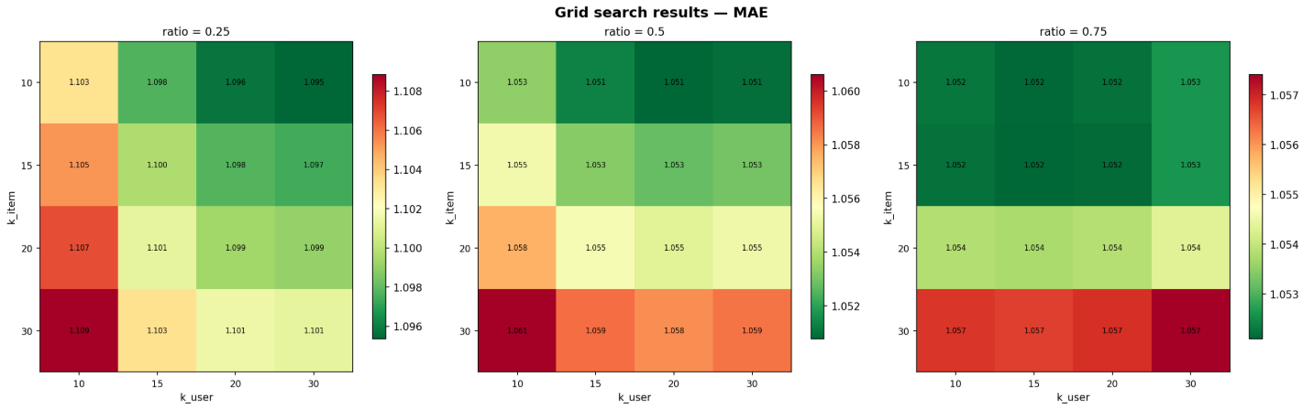
Figure 3: Parameter tuning grid search performed on final methods (kNN for item and user) The .25 ratio means the item-based collaborative filter is given 1/3 the weight of the user-based.

Based on the parameter tuning, k=20 for the user-based kNN and k=10 for item-based kNN were chosen as the final parameters and a ratio of .5 was set by default.

Bias check
Mean Error (signed) was computed to check for systematic prediction bias:
Method | Avg Mean Error | Interpretation
Standard item-based | +0.0283 | Slight positive bias
Standard user-based | −0.0009 | Effectively unbiased
kNN item-based | +0.1721 | Significant positive bias
kNN user-based | +0.0268 | Slight positive bias

The kNN item-based method showed clear positive bias: by keeping only the most similar items, the pool skews toward films the user already rated highly, inflating predictions. This bias was deemed unavoidable based on the item similarity method chosen and ignored because the accuracy of kNN item-based was still strong.

3.5 Final method selection
Five candidate methods were evaluated at 20% sample to select the final modeling approach:
Method | Avg MAE (20% sample, x-validated)
Standard user-based | 1.2348
kNN user-based | 1.1858
kNN item-based | 1.0977
Combined: item kNN + standard user | 1.0727
Combined: both kNNs | 1.0580

The combined kNN model (item kNN + user kNN) was selected as the final method. The blend ratio is exposed as a user-facing slider so the balance between item-based and user-based predictions can be adjusted at inference time.

3.6 Final evaluation
The final model was evaluated against a simple mean-rating baseline using full cross-validation and per-user MAE:

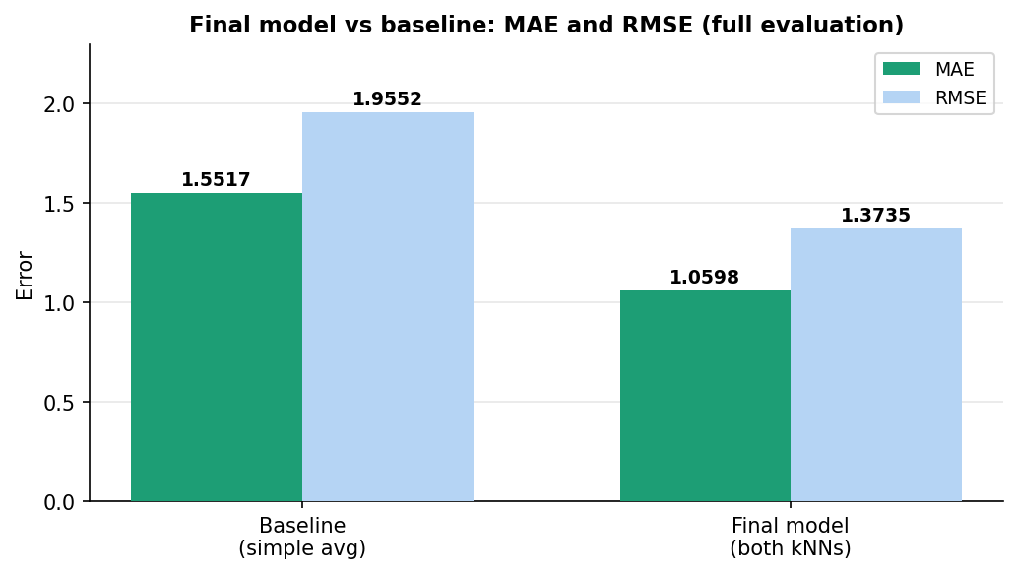
Figure 4: Final model vs baseline — MAE and RMSE (full 5-fold CV).

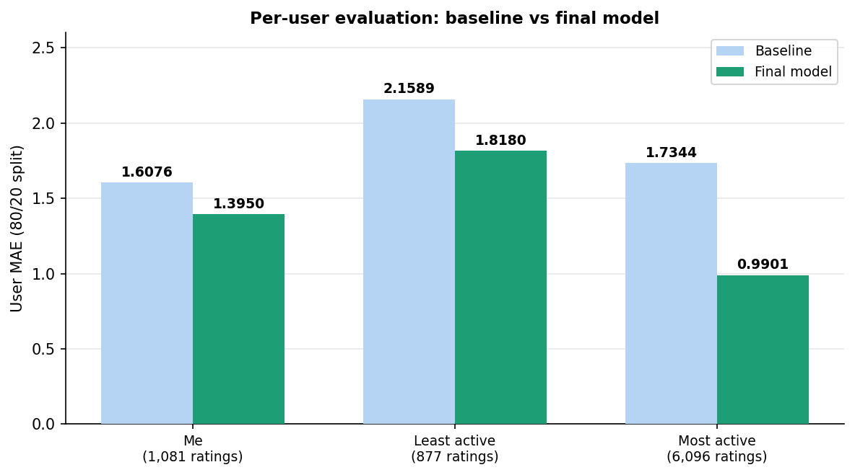
Figure 5: Per-user evaluation — baseline vs final model (80/20 train/test split).

User | Baseline MAE | Final model MAE | Improvement | Final Recommendations (top 6)
Me (1,081 ratings) | 1.6076 | 1.3950 | −13.2% | Mommy; Dear Zachary: A Letter to a Son About His Father; Minding The Gap; Dune; Short Term 12; Some Like it Hot
Least active (877 ratings) | 2.1589 | 1.8180 | −15.8% | They Shoot the Horses Don’t They; Le Trou; Johnny Guitar; Bo Burnham: Inside; Only Angels Have Wings; Hoop Dreams
Most active (6,096 ratings) | 1.7344 | 0.9901 | −42.9% | To Be or Not to Be, A Man Escaped, The Shop Around the Corner, Charluta, A Touch of Zen, The Story of the Last Chrysanthemum

The model improves substantially over the baseline for all users. The gain is most pronounced for the most active user, confirming that the model benefits significantly from richer rating histories. Performance for low-activity users is weaker, which is an identified limitation.

4. Limitations and Future Work

4.1 Known limitations
- Low-activity users receive weaker recommendations. With few ratings, user-based CF degrades toward globally popular films with limited personalization.
- The model reflects biases in the community data. The critic-skewed user base produces recommendations that lean toward arthouse and prestige cinema.
- Coverage is limited to films released up to 2023 and present in the community dataset.
- The item similarity matrix is precomputed on community data only; a new user’s ratings do not update it. The accuracy hit from this was evaluated and found to be negligible at the current dataset scale.

4.2 Future work
- Content-based filtering: incorporate TMDB semantic metadata (plot summaries, cast/crew) to improve recommendations for users with sparse rating histories and to address the cold-start problem.
- UI improvements: genre/language/runtime filters post-recommendation; confidence scoring per recommendation using the evaluate_user function; cold-start onboarding flow for users without Letterboxd data.
- Popularity filter: optional mode to constrain recommendations to mainstream titles for users who prefer broadly popular films.

5. Useful Links
1. Web URL to App hosted on Streamlit: https://movierecommender-b-oops.streamlit.app/
2. Kaggle data: https://www.kaggle.com/datasets/samlearner/letterboxd-movie-ratings-data/data?select=ratings_export.csv
3. Letterboxd: https://letterboxd.com/
4. TMDB: https://www.themoviedb.org/
5. YouTube Demo: https://youtu.be/MXlN38Yo_48

