**Project 2: Graphs from raw data**

Input:

* A data file of type JSON (***KitDOM.JSON***)
* HTML page(***index.html + CSS and images***)

**Task 1**: On top of the given HTML page, draw a single curve. The raw data for the curve should be taken from the JSON file.

Create a page that will look like this:

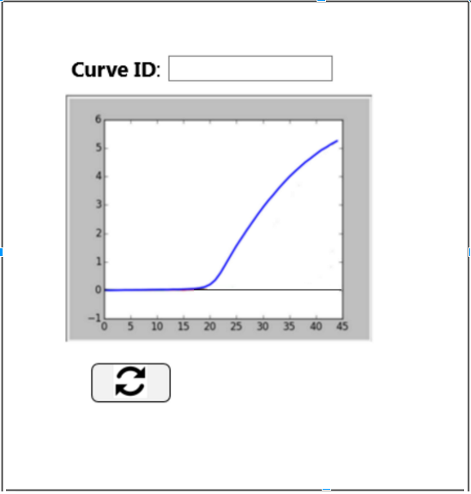

(Add the missing GUI elements to the html received in this project brief and ignore the rest of the GUI elements available on the page).

The user fills in a MixChannel ID and curve ID and the software draws the curve via the JS graphing library (e.g. plotly.js).

For more details see the implementation notes section for *How to get curve raw data given curve ID*.

**Task 2:** Given curve ID, draw the curve along with its background curves.

In the Web page, in addition to locating the curve raw data and drawing it, locate the curve’s background curves’ raw data and draw them as well. The result should look like this (scroll to the next page):

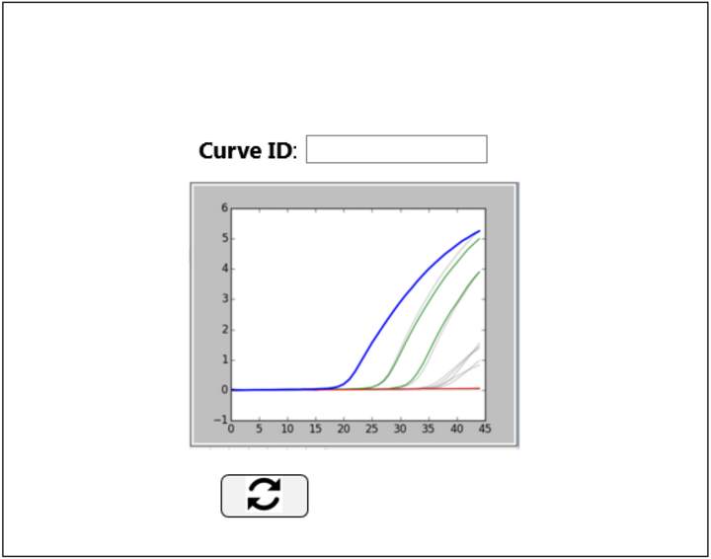

For more details see the implementation notes section for *How to obtain background curves’ raw data given curve ID*.

**Task 3:** Plot a ‘cloud’ of dots in 2-dimensional and 3-dimensional axes.

Enhance the Web page and put a 2-dimensional axes on the left of the above curve and a 3-dimensional axes. The page should look like this (scroll to the next page):

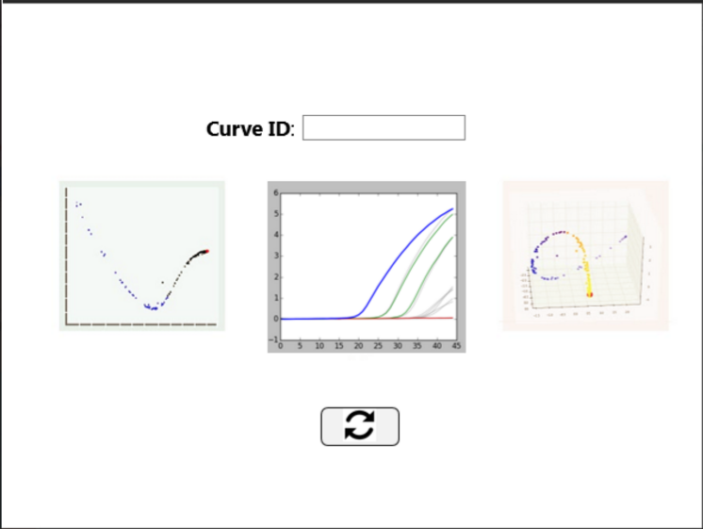

Both left-hand and right-hand diagram should display all dots in the system (each dot represents a curve). when viewing a certain curve, its respective dot should be highlighted on both axes.

As you’ll see in the JSON file, a dot has many dimensions. By default, on the 2-dimensional view show the dot by their first 2 dimensions and on the 3-dimensional view show the dot by their first 3 dimensions.

For more details see the implementation notes section for:

*How to get a curve-representative dot given curve ID*

*How to get representative dots for all curves in the current MixChannel*.

**Task 4:** allow changing the dimensions for the left-hand and right-hand axes.

Under each of the side diagrams, add the dimensions configuration UI. Under the 2-dimension diagram add configuration for the x-axis and y-axis. Under the 3-dimension diagram add configuration for the x-axis, y-axis and z-axis. Input from each axis will be one of n dimensions marked as Y1..Yn while n is the maximal dimension number defined for that MixChannel.

See illustration below:

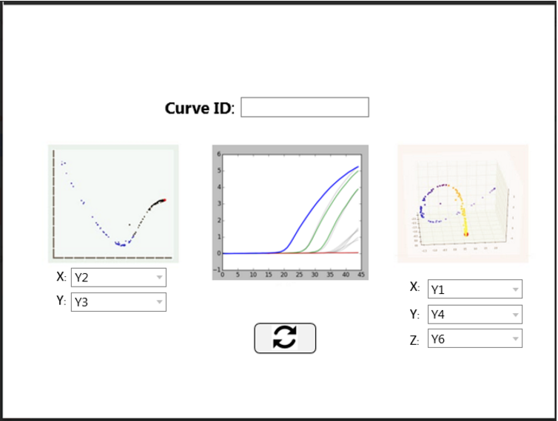

As mentioned above, the default view of this page should be ***Y1*** and ***Y2*** for the 2-dimensional view and ***Y1****,* ***Y2*** and ***Y3*** for the 3-dimensional view.

Opening the drop down list from the respective axis will allow changing the dimension and will result in the coordinate input taken from the selected dimension. See illustration below:

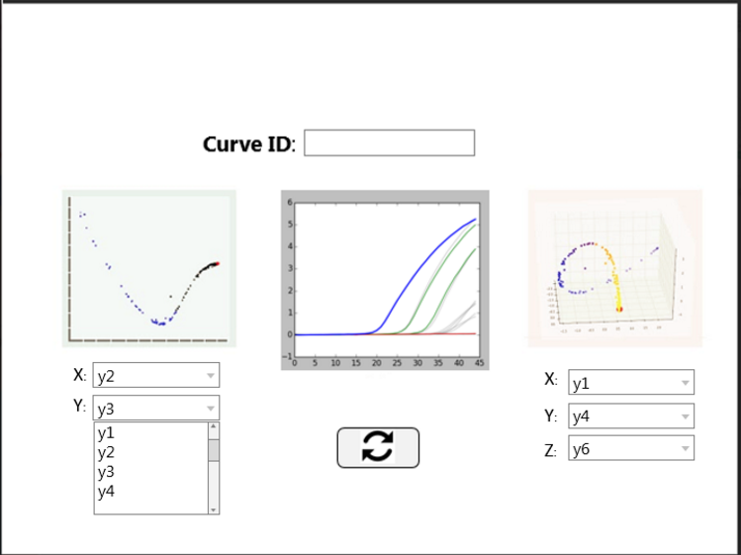

Refreshing the page after changing a dimension will draw the diagram again based on the new selected dimensions.

For more details see the implementation notes section for:

*How to track a curve-representative dot given curve ID and dimensions*

*How to get representative dots for all curves in the current MixChannel given curve ID and dimensions*

**Implementation notes:**

*How to get curve raw data given curve ID*

First note to make is that *curve ID* is called *observation ID* in the JSON file.

Follow the below steps:

1. Go to Observations and look for the observation whose *observationID* field matches the given curve ID.
2. In that observation, go to *Readings* field. This is the field that holds the raw data needed for drawing the curve.

*How to obtain background curves’ raw data given curve ID*

1. Go to Observations and look for the observation whose *observationID* field matches the given curve ID.
2. In that observation, take note of the *RunID* field.
3. Go to Observations and iterate on all observations. Each observation whose RunID matches the RunID noted in step #2 is a “background curve” and should be drawn along with the main curve.
4. For each of the relevant observations, look at the *Role* field. If the value in the *Role* field is *“PTC*”, the respective curve should be drawn in green. If the value in the *Role* field is *“NTC*”, the respective curve should be drawn in red. In all other cases the respective curve should be drawn in black.

*How to get a curve-representative dot given curve ID*

1. Go to Observations and look for the observation whose *observationID* field matches the given curve ID.
2. In that observation, go to the “*Features*” field. This is an array of ~6 items, each value in the array represent one coordinate (dot) dimension.
3. Draw the dot on the 2-dimensional and 3-dimensional views. Take the first 2 dimensions or 3 dimensions respectively and consider them for the axis.

*How to get representative dots for all curves in the current MixChannel*

1. Go to Observations and look for the observation whose *observationID* field matches the given curve ID.
2. In that observation, take note of the *MixChannelID* field.
3. Go to Observations and iterate on all observations. Each observation whose MixChannelID matches the MixChannelID noted in step #2 is an observation for which a dot should be figured out and drawn.
4. Draw each dot on the 2-dimensional and 3-dimensional views. Take the first 2 dimensions or 3 dimensions respectively and consider them for the axis.

*How to track a curve-representative dot given curve ID and dimensions*

1. Follow steps 1 and 2 from the *How to get a curve-representative dot given curve ID* section (above)
2. For the axis consider the dimensions received as input (rather than the first 2 or 3 dimensions)

*How to get representative dots for all curves in the current MixChannel given curve ID and dimensions*

1. Follow steps 1, 2 and 3 from the *How to get representative dots for all curves in the current MixChannel* section (above)
2. For the axis consider the dimensions received as input (rather than the first 2 or 3 dimensions)