Designing a prompt-based ASL translation animation model using JASigning

Project Proposal

Briana Rosado

Mentored by Jarick Cammarato

Advised by Sarah Ashley

There are currently many barriers to communication between a hearing employee and a Deaf customer. Some of these barriers could be slow interactions, miscommunication, awkward or uncomfortable interactions, and/or a lack of employee training to handle accommodations for the Deaf community. An automated system to translate text to American Sign Language would help remove some of those barriers, by allowing the customer a more detailed description of the services in a language they are comfortable with, thus improving the customer experience. A system for text-to-ASL translations will be designed that allows users to select from a database of phrases to generate a corresponding ASL translation using an avatar signing in American Sign Language. The project is divided into several phases that will be carried out over a seven-month period: creating the text phrase library, translating to American Sign Language, transcribing the signs into HamNoSys, converting HamNoSys into SiGML, inputting SiGML into JASigning software to generate animations, developing a local application, and testing among users. The final application will be on a tablet for easy portability and use. The system will be tested on 15 hearing users and 10 Deaf signers to receive feedback on the quality of the translation, functionality of the system, and usefulness in a retail setting. The system will not only bring awareness to the importance of inclusivity in customer service, but it will also help Deaf customers feel more comfortable and improve their understanding of the service.

**KEY TERMS:** American Sign Language, animation generation, local application, JASigning, HamNoSys, SiGML

1. **Purpose**

To design a prompt text-to-ASL translation system using an animated model to facilitate communication between a Deaf customer and a hearing employee.

1. **Background Information**

American Sign Language (ASL) is a visual-based language dependent on several factors including hand shape, movement, hand location, and facial expressions (National Association of the Deaf, n.d.). There have been several developments in translations from spoken language to sign language such as the Hamburg Notation System, Signing Gesture Markup Language, and JASigning. Hamburg Notation System (HamNoSys) is a symbol-based notation method used to record signs in a written format. In HamNoSys, each geometric shape is assigned a specific hand shape, movement, location relative to the body, or facial expression used in signing. By combining several symbols together, HamNoSys can represent a conversation in ASL (Smith, 2023). An example of the notation can be seen in Figure 1. Signing Gesture Markup Language (SiGML) is an “XML application that […] builds on HamNoSys,” which is taken as input for the JASigning software (Virtual Humans, 2021). Each symbol in HamNoSys corresponds to one or several commands in SiGML, as seen in Figure 2. JASigning, seen in Figure 2, “synthesizes natural sign language” via an animated avatar (Virtual Humans, 2021). Users can input either a URL to the SiGML XML file or directly input SiGML text onto the JASigning website. The JASigning software will read through the SIGML and generate an animation of the ASL translation.

There have been several research projects focused on using the JASigning software. In a 2016 study carried out by Sarah Ebling and John Glauert, they designed and tested a system to translate German train announcements into Swiss German sign language (DSGS). Many German train announcements, like those regarding train cancelations or delays, are only conveyed verbally, thus leaving Deaf travelers unaware of the information. The developers strived to use the JASigning software to display animations of the translated DSGS in real time onto a screen in the station. They first translated German train announcements into DSGS and made several recordings of a researcher signing the translations. The recordings were used to manually transcribe the signs into HamNoSys which was then converted into SiGML and fed into the JASigning software to generate the animations. Figure 3 shows an example of one of the developers’ translations from German into HamNoSys and SiGML. The system was presented to a focus group comprised of seven Deaf signers who gave feedback on how to improve the translations. They suggested several improvements such as adjusting the camera angle to face the avatar more, changing the avatar's clothing to make movements more viewable, and slightly adjusting the timing of the signs (Ebling & Glauert, 2016).

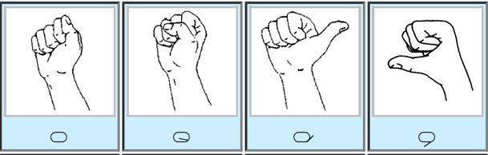

Figure 1 (above): These are 4 examples of HamNoSys symbols, each representing a different hand shape (Smith 2023).

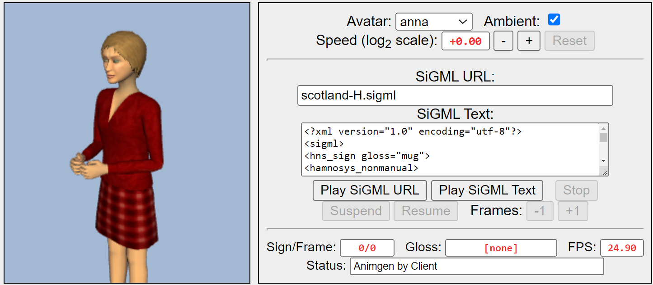

Figure 2 (above): This is the JASigning software. Users can input their own SiGML text or URL to customize the animation (Virtual Humans Group, 2021).

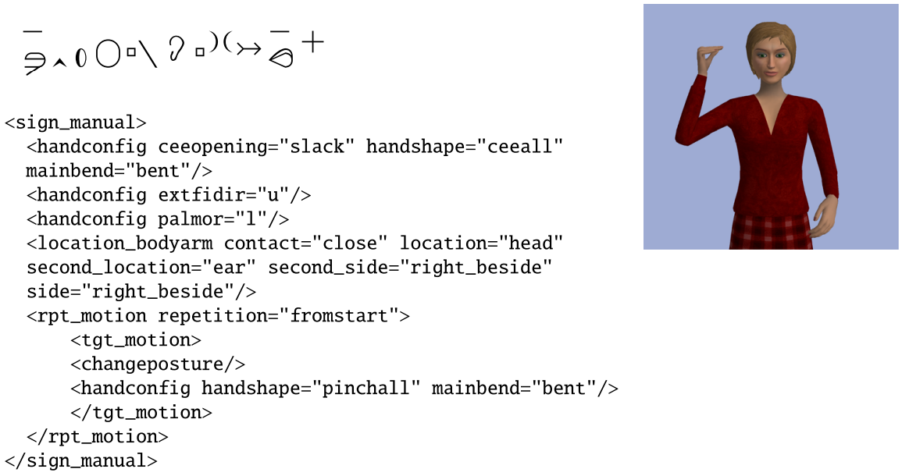

Figure 3 (above): The HamNoSys transcription and SiGML translation for the word “Loudspeaker” in DSGS (Sarah & Ebling, 2016).

1. **Objectives**

The project is intended to allow the user to translate English phrases into American sign language and display the translation using a virtual animation. The system will have a database of phrases that the hearing user can select from. The selected prompt will then play the corresponding ASL animation onto a screen that is viewable by the Deaf customer. The screen will also show the English translation below the animation and will allow the deaf user to replay the message.

I have narrowed down the applicability of my project to be used in retail settings when a hearing employee is aiding a customer who is hard of hearing or deaf. This allows me to create prompts specific to the situation, for example, “Would you like a bag for your groceries?” or “Your total is…”. This allows the deaf customer to experience a more authentic interaction rather than having to rely on writing down messages, which can take longer, or lip-reading, which can be inaccurate and is not used by all Deaf customers. Additionally, I have also decided to focus on essentially a one-way translation. Ideally, the hearing user would be able to select prompts to translate into ASL while the deaf user would be able to respond using ASL which would then be translated into English. However, due to the limited time of the project, I am unable to make the ASL-to-English translation application.

One factor challenging my progress is that I do not understand ASL myself and currently, there are no ASL users working to develop this software with me. This could possibly affect the accuracy of the translations, but I will be using a large ASL dictionary created by ASL signers for the translations, and I am striving to connect with Deaf and ASL volunteers.

The materials I am using include a computer, the HamNoSys manual, HamNoSys Palette, eSIGN Editor, HamNoSys2SiGML, JASigning software, Visual Studio Code, and a tablet to display the application.

1. **Application**

American Sign Language (ASL) is used by around 500,000 citizens throughout the United States of America and Canada, according to the Commission on the Deaf and Hard of Hearing of Rhode Island (2023). Although learning ASL has become more popular in recent years, retail workers still struggle to communicate with Deaf customers due to the language barrier. Oftentimes, the employee is inexperienced with interacting with a Deaf customer and, as a result, the interaction ends up much slower, and sometimes workers omit questions due to the difficulty, thus minimizing the customer experience.

For example, in drive-thrus, Deaf customers and hearing employees communicate by passing a paper back and forth through the window (Disability Rights TN, 2020). Additionally, many restaurants do not have paper and pens on hand in drive-thrus, further slowing the interaction. An application that could display ASL translations would expedite the conversation because it limits the inconvenience of passing a paper through the window and it would offer the customer a better understanding of specific products, product availability, and possible promotions that the customer would otherwise never be informed of.

With a prompt-based animation system, employees can more easily fulfill the customers’ needs quicker and more efficiently, therefore benefiting the company and the customer. Rather than taking 10 minutes to write back and forth, an employee can directly communicate the service to the customer in ASL, thus streamlining the conversation. The involved parties would no longer have to look down and pause mid-conversation to write down their requests.

Furthermore, the implementation of this system would bring about awareness of accommodations for the Deaf community and would prompt companies to improve employee training in providing a more comfortable service to Deaf customers. This system can help to bridge the gap between the Deaf community and the hearing community and can be a step towards the process of inclusivity.

1. **Design Strategy**

As summarized in Figure 4, the main phases of my project include the English library creation, ASL translation, HamNoSys transcription, SiGML translation, JASigning video generation, application development, and user testing.

During the library creation phase, I will choose about 20 English phrases used in retail settings that will be translated. For the initial translations, the phrases will be simple, such as “Hello” and “How are you?” As the project continues and I become more comfortable with the translation process, the phrases will become more complex, and more phrases will be translated.

Next, I will find the ASL translation for each phrase. The translations will be sourced from online ASL dictionaries, such as Signing Savvy, as well as from volunteers who know ASL.

Once I have videos for the ASL translation of each phrase, I will manually transcribe each phrase into HamNoSys. This phase will be carried out using documentation on how to use the notation system, written by Robert Smith (2013), as well as the HamNoSys Palette, developed by Thomas Hanke in 2021. As seen in Figure 5, the HamNoSys Palette allows users to concatenate HamNoSys symbols to form ASL signs on the computer and also provides a font to view the HamNoSys online.

There are several existing programs to carry out the HamNoSys to SiGML translation such as eSIGN Editor, created by the same developers as the JASigning software, and HamNoSys2SiGM, a GitHub package. eSIGN Editor is a well-researched program, however, it was created in 2003 so it is outdated and not well-documented. HamNoSys2SiGML was created by an individual user, so it is less tested and researched. I will be exploring both options for my HamNoSys to SiGML translation. Both programs function by having users input HamNoSys notation and the programs output the corresponding SiGML translation, which I can then input into the JASigning site.

The developers of JASigning specifically created a method to export the generated animation videos. I will download the video for each phrase and input it into my own application.

To develop my own application, I will be coding in Visual Studio Code. I will use HTML and CSS for the front-end development. JASigning was mainly developed in JavaScript so I will be using JavaScript to interact with the program. The program will be converted into a web application so it can be downloaded onto a tablet.

Throughout development, volunteers will be prompted to watch the generated JASigning video translations to verify the accuracy of the translations. Similar to the German researchers who translated German train announcements in 2016, the final system will be tested among deaf and hearing volunteers who will then complete an online survey to provide feedback on the system.

A similar process for the translation from spoken language to sign language was used in a 2016 study by Kaur and Kumar called “HamNoSys to SiGML Conversion System for Sign Language Automation.” In the study, researchers generated animations of Indian Sign Language using HamNoSys, SiGML converters, and JASigning software. Their process can be seen in Figure 5.

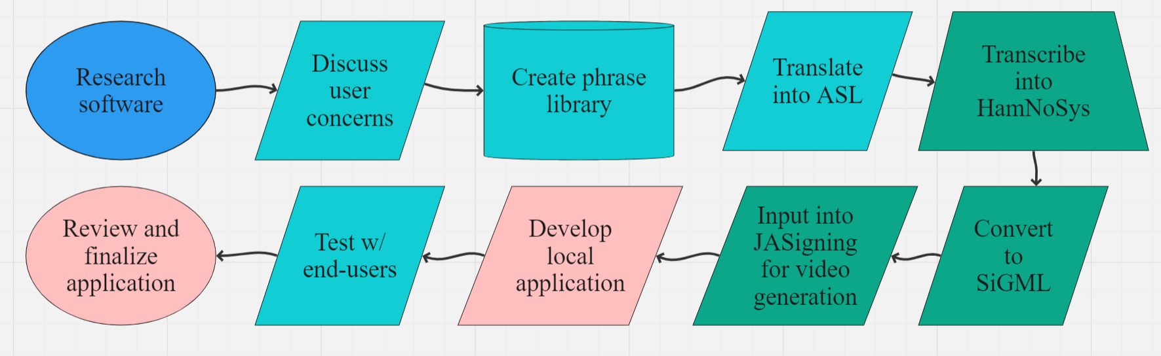

Figure 4 (above): This is the development process for my project. In the beginning of my project, I will interview hearing employees and Deaf ASL signers to understand their concerns and suggested features for my system. Symbols colored teal indicate that the setup will involve volunteer input, for example, an ASL user giving feedback on the ASL translations. Green symbols indicate the use of pre-existing software such as HamNoSys Palette, eSIGN Editor, and JASigning. Pink symbols represent the development of the final application.

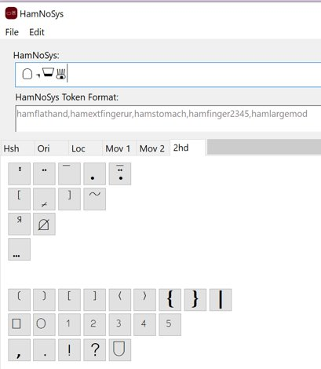

Figure 5 (above): This is an example of the process of translating a word from ASL to HamNoSys using the HamNoSys Palette application. Users would select each symbol individually, corresponding to each action in the sign (Hanke, 2021).

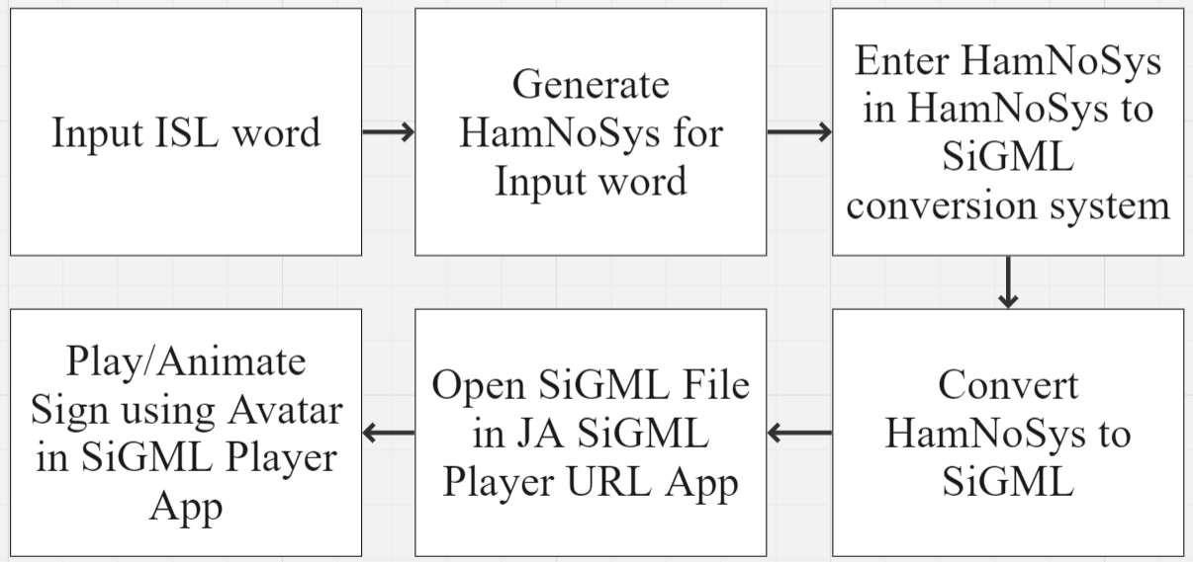

Figure 6 (above): The translation process for converting Indian Sign Language (ISL) into an animation using JASigning (<https://doi.org/10.1016/j.procs.2016.06.063>).

1. **Verification**

I plan to test my system among users who are both hearing and Deaf and most of my resulting data will be qualitative. I plan on testing the accuracy of the translations by having Deaf users watch and provide feedback on the videos generated by the JASigning software. Users would then answer a survey asking them to rate the system and provide any comments regarding improving the system. This can include suggestions to adjust the speed of the signs, changes in the duration of pauses between signs, changes in movements, adjustments to the avatar’s facial expressions, adjustments to the avatar’s character design, etc. I aim to have at least 10 Deaf users interact with my system.

For hearing users, I plan to individually present my system to them and re-enact a scenario in which they are a retail employee who is serving a Deaf customer. Users would then have to navigate my application to successfully communicate with the customer. After navigating the system for 10 minutes, users will be presented with a survey in which they will rate the functionality and usability of my system. They will also be asked a series of questions about their experience using it including whether they have any improvements or suggestions. I would like to get at least 15 hearing volunteers to participate in this survey.

References

Disability Rights TN. (2020) *Make Fast-Food Drive Thru Services Accessible*. https://www.disabilityrightstn.org/make-fast-food-drive-thru-services-accessible/

Ebling, S., & Glauert, J. (2016). Building a Swiss German sign language avatar with JASigning and evaluating it among the deaf community. *Universal Access in the Information Society, 15*(4), 577-587. https://doi.org/10.1007/s10209-015-0408-1

Hanke, T. (2021). *HamNoSys*. Universität of Hamburg. https://www.fdr.uni-hamburg.de/record/9725

Kaur, K., & Kumar, P. (2016). HamNoSys to SiGML Conversion System for Sign Language Automation. *Procedia Computer Science, 89*(1), 794-803. https://doi.org/10.1016/j.procs.2016.06.063

National Association of the Deaf. (n.d.). *What is American Sign Language?* Retrieved October 19, 2023, from https://www.nad.org/resources/american-sign-language/what-is-american-sign-language/#:~:text=American%20Sign%20Language%20(ASL)%20is,important%20parts%20in%20conveying%20information.

Smith, R. (2013). “HamNoSys 4.0 User Guide.” Institute of Technology Blanchardstown. https://robertsmithresearch.files.wordpress.com/2012/10/hamnosys-user-guide-rs-draft-v3-0.pdf

State of Rhode Island Commission on the Deaf and Hard of Hearing. (n.d.). *American Sign Language.* https://cdhh.ri.gov/information-referral/american-[sign-language.php](https://cdhh.ri.gov/information-referral/american-sign-language.php)

Virtual Humans Group. (2021). *JASigning*. https://vh.cmp.uea.ac.uk/index.php/JASigning