***Kubernetes***

Kubernetes installation steps. I created 3 ubuntu machines in same vnet.

**K8s-master** (ubuntu,4 GB RAM,2 vCPU) – master node or control plane – Need to install docker runtime, kubeadm, kubectl

**K8s-node01** (ubuntu,1 GB RAM,1 vCPU) – worker node01 – need to install docker runtime, kubelet

**K8s-node02** (ubuntu,1 GB RAM,1 vCPU) – worker node02 – need to install docker runtime, kubelet.

**Below ports need to be opened:**

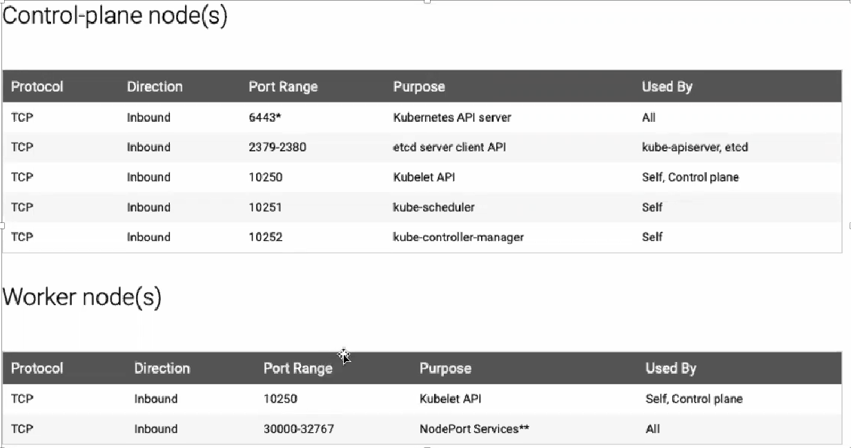

Installation steps start here, once the servers are ready.

# Must logged in as root user because all commands needs to be executed with “sudo” permissions.

***In All Nodes:***

**Updating the apt repository**

apt update

apt-get update

**Install and enable docker**

apt install docker.io -y

usermod -aG root buramana

systemctl restart docker

systemctl enable docker.service

**Turn off swap space. We should swap turn off to Kubernetes functionate correctly.**

swapoff -a

sed -i '/ swap /s/^\(.*\)$/#\1/g' /etc/fstab

**Install required packages and apt keys**

apt-get install -y apt-transport-https curl

curl -s https://packages.cloud.google.com/apt/doc/apt-key.gpg |sudo apt-key add -

cat <<EOF | tee /etc/apt/sources.list.d/kubernetes.list

deb https://apt.kubernetes.io/ kubernetes-xenial main

EOF

**Again, need to update the registry**

apt-get update -y

**Install kubeadm, kubelet and kubectl**

apt-get install -y kubelet kubeadm kubectl

**enable and start kubelet service**

systemctl daemon-reload

systemctl start kubelet

systemctl enable kubelet.service

**#### steps only for master node ###**

**Switch to root user**

sudo su -

**Initialize the master node by executing the below command**

kubeadm init

**exit as a root user & execute as a normal user below commands**

exit

mkdir -p $HOME/.kube

sudo cp -i /etc/kubernetes/admin.conf $HOME/.kube/config

sudo chown $(id -u):$(id -g) $HOME/.kube/config

**To verify, if kubectl is working or not, run the following command**

kubectl get pods -o wide -n kube-system

If you will notice from the previous command, that all the pods are running except one: core-dns. for resolving this we will install a pod network. To install the weave pod network, run the following command:

kubectl apply -f https://cloud.weave.works/k8s/net?k8s-version=$(kubectl version| base64 |tr -d '\n')"

Once completed above command . need to check again the status node and pods

kubectl get nodes

kubectl get pods –all-namespaces

Now, If you observe that node and pods will be ready and Master node is ready to use.

We should generate one token to add worker nodes to kubernetes cluster by running below command in master node.

kubeadm token create --print-join-command

Once we execute the above command, it will generate token and command snippet as well.

Example output:

***kubeadm join <masternodip>:6443 --token <token> --discovery-token-ca-cert-hash <certificate data>***

need to execute this in worker nodes.