Classification Algorithm
Rules Set after training model:
Party A
score = -11.1 pts ← base points (starting score) + 0.039×Age + 1.83×Govt. satisfaction − 0.945×Urban voter
Party T
score = 11.7 pts ← base points (starting score) − 0.112×Age − 1.71×Govt. satisfaction + 1.21×Urban voter
Party C
score = 0.985 pts ← base points (starting score) + 0.115×Age − 1.12×Govt. satisfaction − 1.22×Urban voter
Undecided
score = 1.50 pts ← base points (starting score) − 0.009×Age + 0.143×Govt. satisfaction − 0.273×Urban voter
a) Age <30 and Govt satisfaction less ,urban
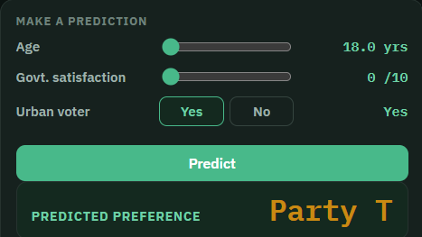
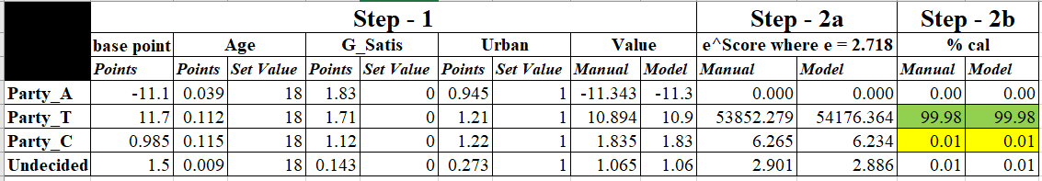
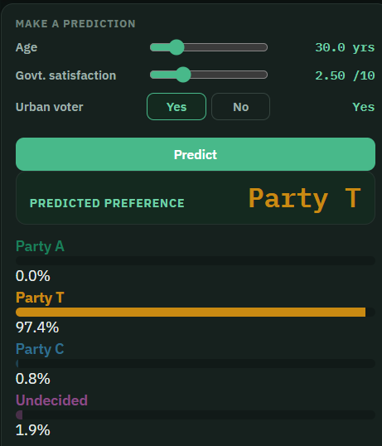
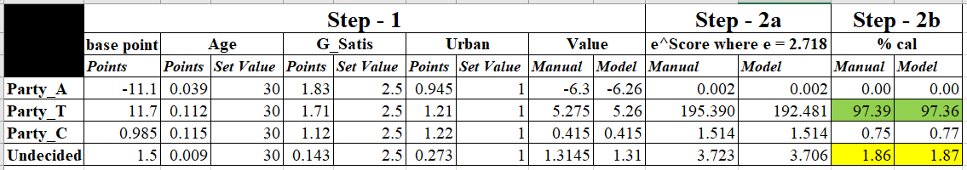
b) Age >50 and Govt satisfaction less ,non urban
