Linear regerssion
a) QA Salary
Rule Set after training model
Salary_LPA in LPA = 3.10 LPA ← base salary (minimum) + 0.966 LPA per year × Experience + 1.34 LPA per point × Skill rating
Set Val: Exp = 0 & Skill = 1 3.10 + (0.996*0) + (1.34*1) 3.10 + 0 + 1.34 4.44
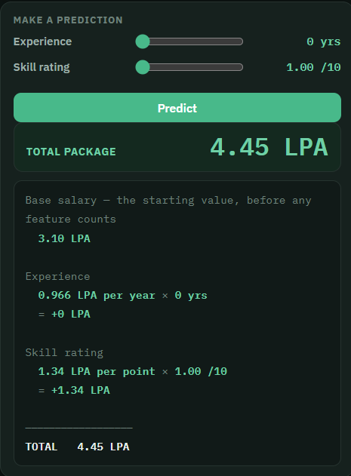

b) Food Delivery time
Rule set after training model:
Delivery_Minutes in min = 7.56 min ← base time (minimum) + 2.40 min per km × Distance + 3.16 min per point × Traffic
Set Values: Dist = 1 & Traffic = 1 7.56 + (2.40*1) + (3.16*1) 7.56 + 2.4 + 3.16 13.12
