1) Get the List of Open weight LLM from different service providers
a) Open ai
Resource Link: https://github.com/openai/gpt-oss
Snap: 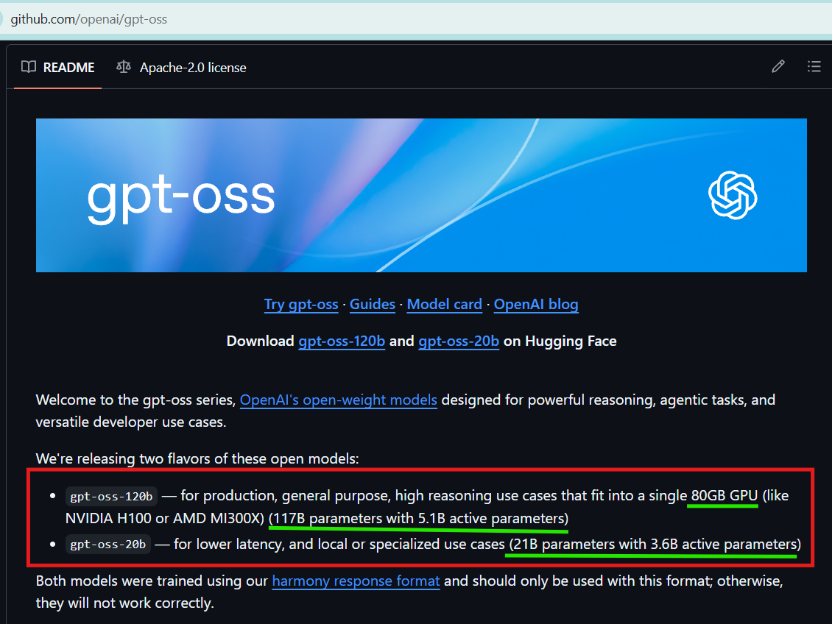
Summary:
gpt-oss-120B
- Parameters: ~117B (Mixture-of-Experts, 5.1B active)
- Context: 128K tokens
- License: Apache 2.0
- Runs on a single H100 GPU (80GB)
gpt-oss-20B
- Parameters: ~21B (MoE, 3.6B active)
- Context: 128K tokens
- License: Apache 2.0
- Fits on consumer hardware (16GB GPU)

b) Qwen
Resource Link: https://huggingface.co/Qwen
Snap: 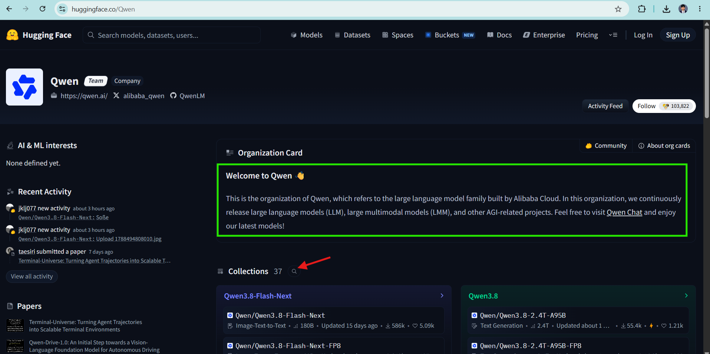
Summary:
Qwen3.8 Max
- Parameters: 2.45T (95B active MoE)
- Context: 262K native, extensible to 1M
- License: Custom terms (not Apache for flagship)
Qwen3.8-27B
- Parameters: 27.8B dense
- Context: 262K native / 1M extensible
- License: Apache 2.0
Qwen3.6-27B / 35B-A3B
- Parameters: 27B–35B (dense/MoE variants)
- Context: 262K native / 1M extensible
- License: Apache 2.0
Qwen3.5 family (397B-A17B, 122B-A10B, 27B, 9B, etc.)
- Parameters: 9B–397B (MoE and dense)
- Context: 256K–262K native, extensible to ~1M
- License: Apache 2.0

c) Deepseek
Resource Link: https://github.com/deepseek-ai/deepseek-v3
Snap:
Summary:
DeepSeek V4-Pro
- Parameters: 1.6T (49B active MoE)
- Context: 1M tokens
- License: MIT
DeepSeek V4-Flash
- Parameters: 284B (13B active MoE)
- Context: 1M tokens
- License: MIT
DeepSeek V3.2
- Parameters: 671B (37B active MoE)
- Context: 128K tokens
- License: MIT
DeepSeek R1
- Parameters: 671B (37B active MoE)
- Context: 128K tokens
- License: MIT

Hallucination check for the below prompt
Write a 4-line poem where every line ends with a word that
strictly rhymes with the word ‘Silver’.
a)qwen ai
Provided answer directly
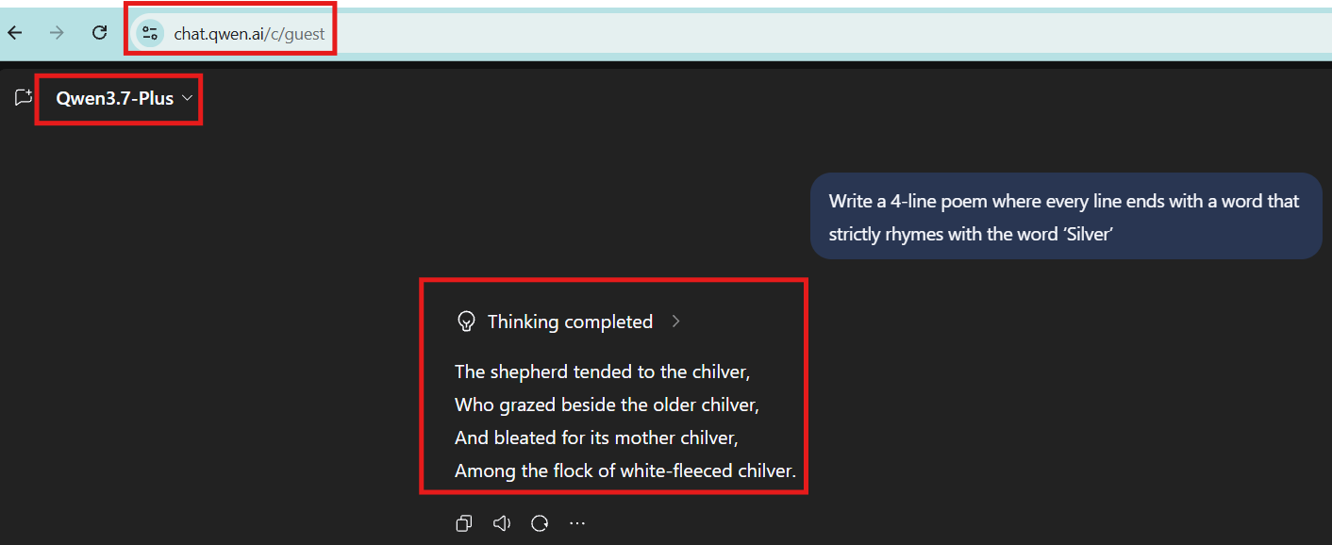
b) Chatgpt
Suggested but still provided answer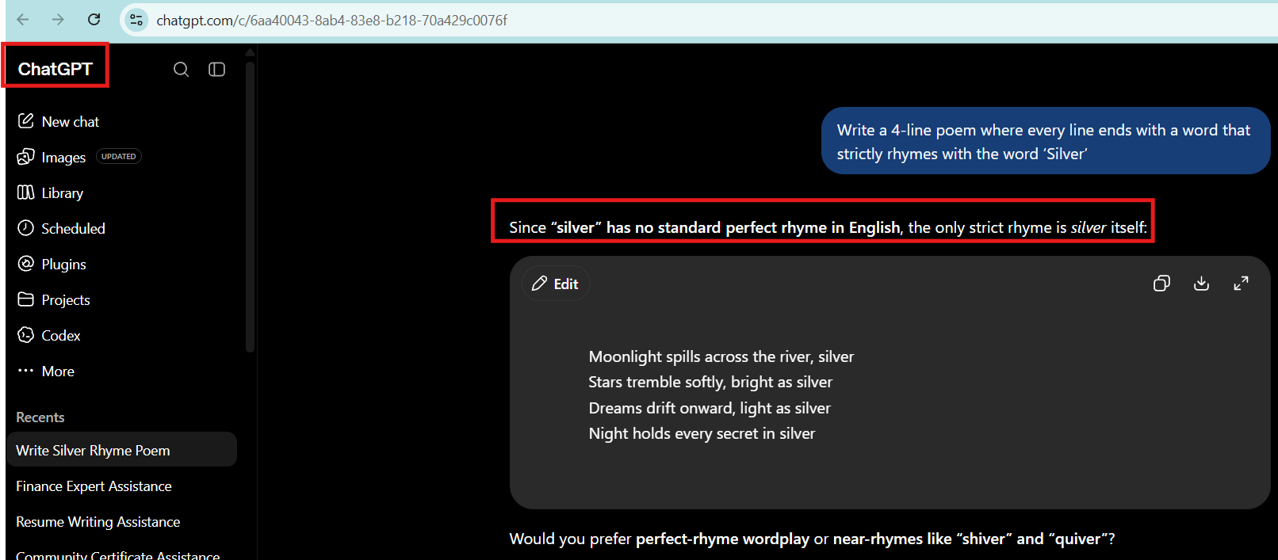
c)Deepseek
Provided answer directly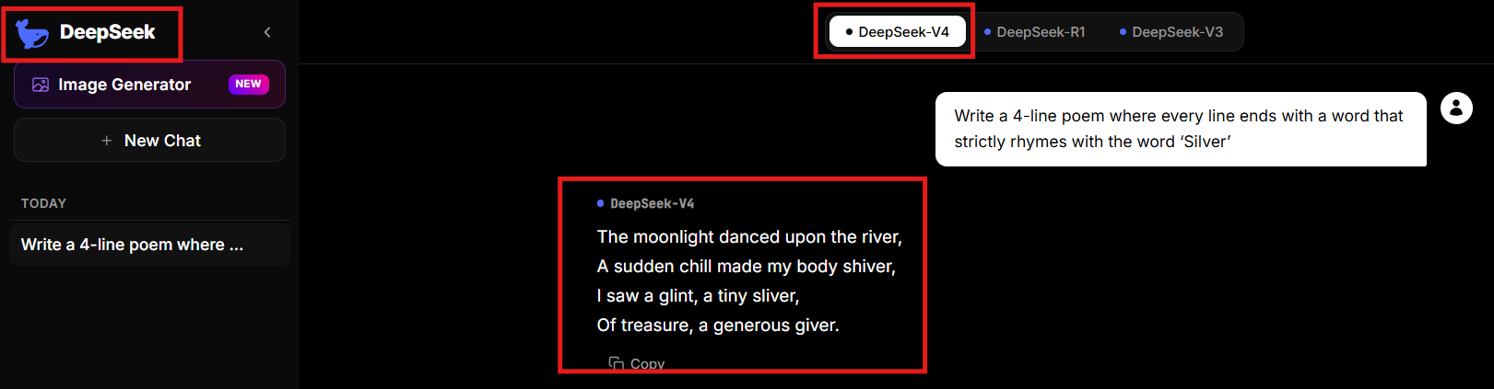
d)Gemini
Provided answer directly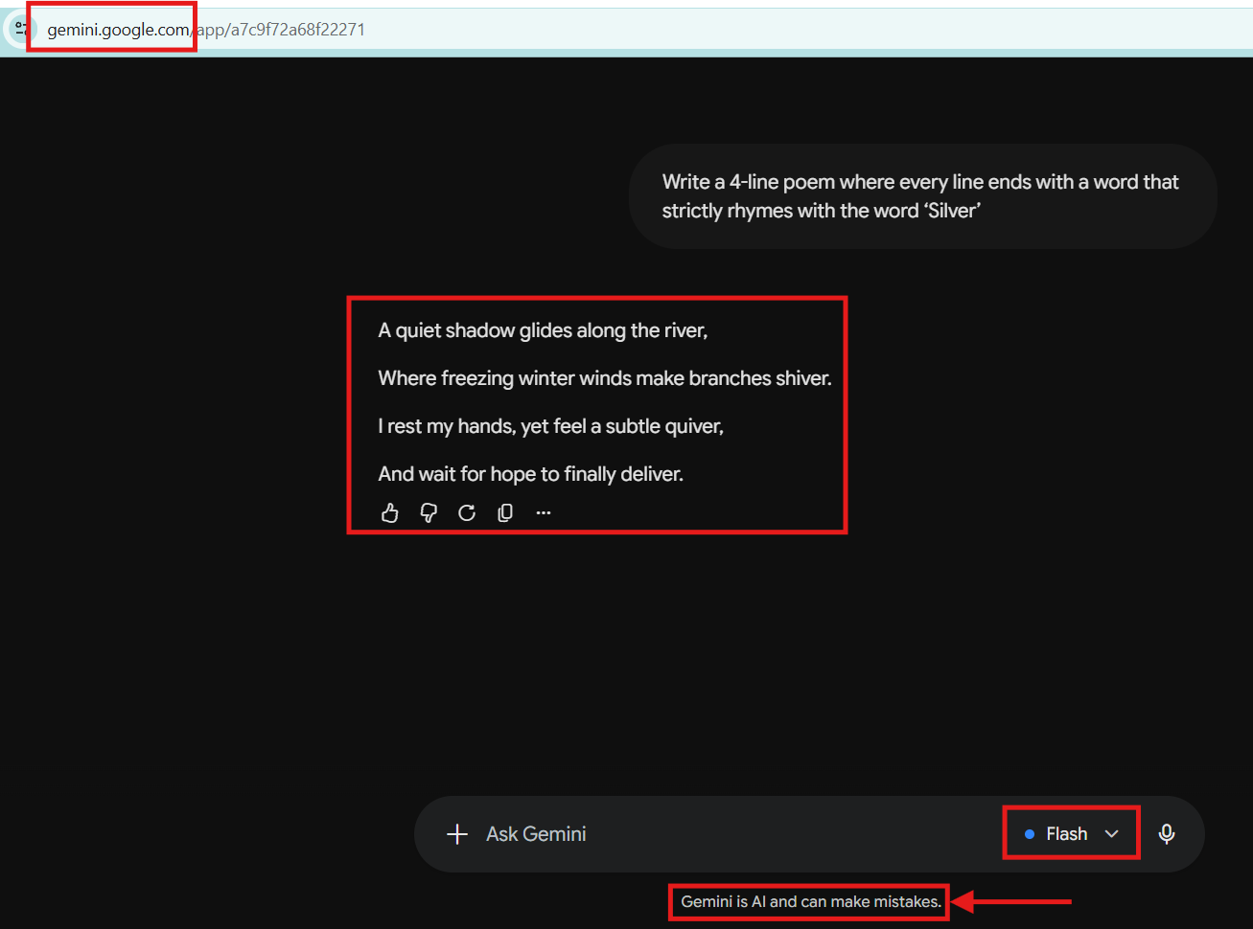
And it states it can also make mistake.

From open router take the model details with Context window for any 10 models from 3 service providers
