SMART PARKING SYSTEM
STM32F401CCU6 with ESP32 Wi-Fi Pre-Booking
CASE STUDY SUBMISSION
Course: 23CSE304 – Embedded Systems
Mentor: Dr. A. Baskar
Department of Computer Science and Engineering
School of Computing, Amrita Vishwa Vidyapeetham, Coimbatore, India

Submitted by
Bharatheesha S CB.SC.U4CSE24505
Manasha P Y CB.SC.U4CSE24525
Mithuraa S CB.SC.U4CSE24527
S Srinithi CB.SC.U4CSE24542

1. Problem Statement

In conventional parking areas, drivers may spend time searching for vacant spaces because parking availability is not always displayed clearly. Manual allocation can also lead to conflicting reservations, while manually operated barriers can slow vehicle entry. The problem addressed by this case study is to develop a low-cost embedded parking prototype that senses parking-space occupancy, communicates slot status, provides a local indication of availability, and automates vehicle entry.
The supplied implementation also demonstrates Wi-Fi-based pre-booking through an ESP32 web server, with booking and occupancy information exchanged between the ESP32 and the STM32F401CCU6 controller.

2. Solution implemented

The Smart Parking System is a miniature embedded-system prototype designed to monitor parking-space availability and automate vehicle entry. The STM32F401CCU6 acts as the primary controller and performs the local sensing, decision-making and actuation. Infrared sensors are used to detect vehicles in parking spaces and at the entrance. An SSD1306 I²C OLED displays parking and access messages, LEDs indicate slot status, a buzzer provides audible feedback, and a servo motor operates the entry barrier using PWM.
The supplied STM32 firmware currently monitors three parking slots through IR inputs and detects an approaching vehicle through an entrance sensor. The controller reads a digital light-sensor output and controls two lighting outputs. The OLED is connected through I²C1, while the servo signal is generated using TIM3 Channel 1. The buzzer and slot-indicator outputs are controlled through GPIO.
For remote pre-booking, an ESP32 Dev Module hosts a lightweight webpage over Wi-Fi. A user can enter a vehicle registration number, select an available slot, create a booking or cancel an existing booking. The ESP32 sends booking flags to the STM32 and receives occupancy status through USART2 using newline-terminated serial messages. The UART link is configured for 115200 baud, 8 data bits, no parity and one stop bit. The webpage periodically refreshes the slot status.
The current code provides a working foundation for sensor-based parking status, local display, audible indication, one servo-controlled entry barrier and ESP32-based booking communication.

3. Flow chart
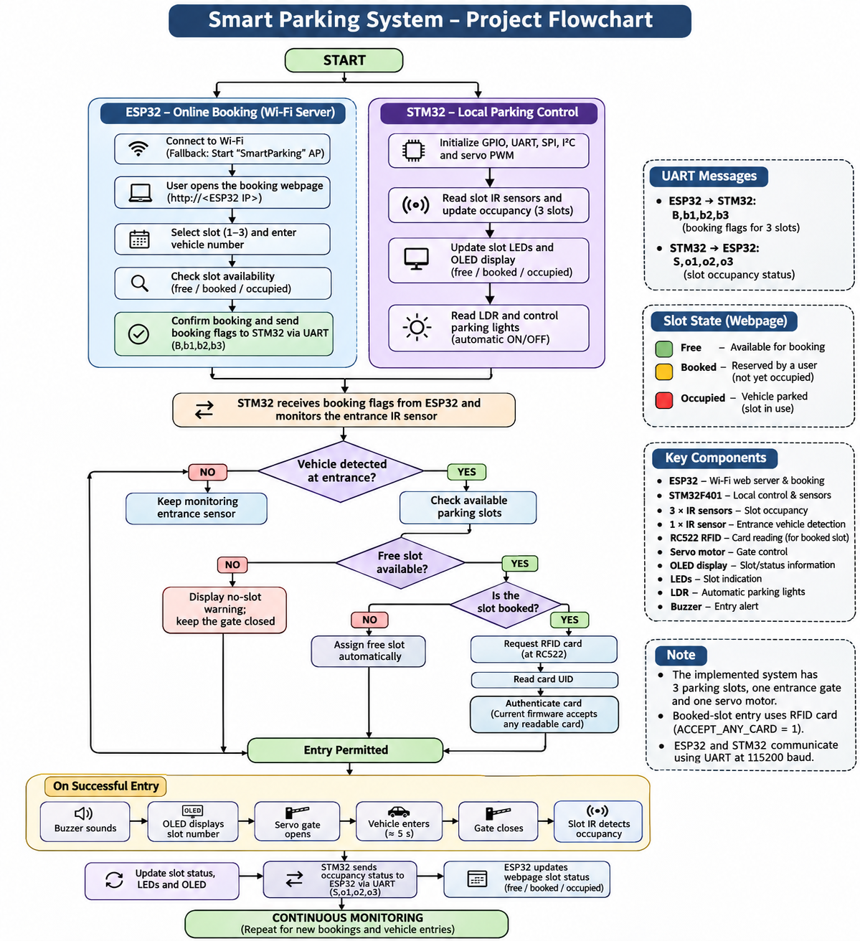

4. Circuit Diagram
The following connection diagram is based on the pin assignments present in the supplied STM32 firmware and ESP32 sketch. It is a functional wiring/block diagram.
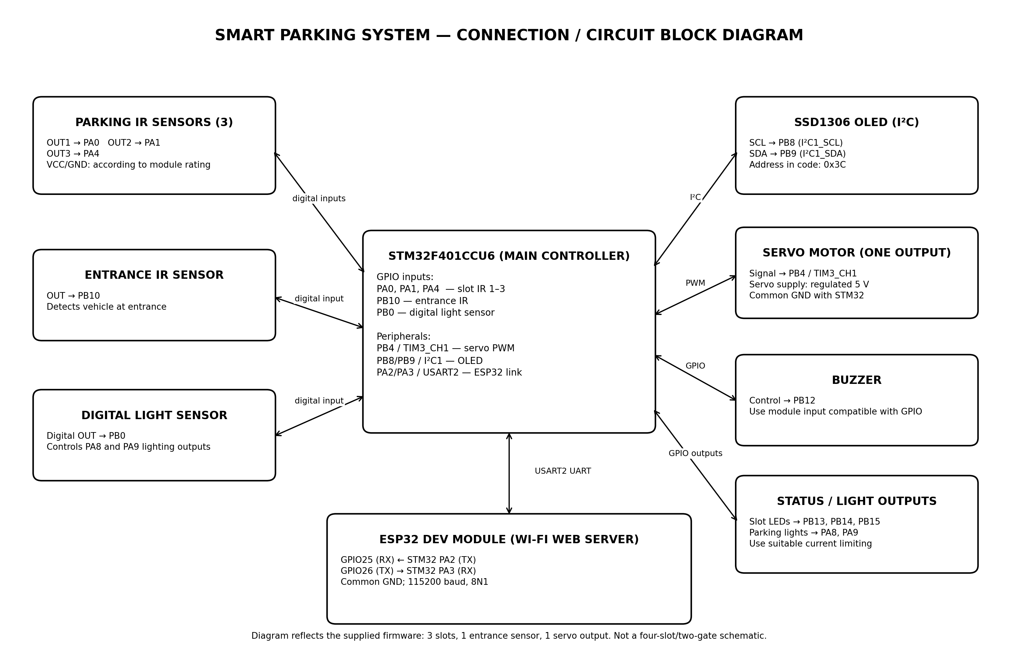

Pin Connections from the Supplied Source
Module / signal | STM32 pin | Function
Parking IR sensor 1 | PA0 | Slot 1 digital input
Parking IR sensor 2 | PA1 | Slot 2 digital input
Parking IR sensor 3 | PA4 | Slot 3 digital input
Entrance IR sensor | PB10 | Vehicle-at-entry input
Digital light sensor | PB0 | Dark/bright digital input
Buzzer | PB12 | Buzzer control output
Slot indicator LEDs | PB13, PB14, PB15 | One indicator output per slot
Parking light outputs | PA8, PA9 | Digital lighting outputs
Servo signal | PB4 / TIM3_CH1 | PWM control for one servo
OLED SCL / SDA | PB8 / PB9 | I²C1
UART TX / RX | PA2 / PA3 | USART2, 115200 8N1
ESP32 UART RX / TX | GPIO25 / GPIO26 | Receives PA2 TX; transmits to PA3 RX

4. Image of the prototype

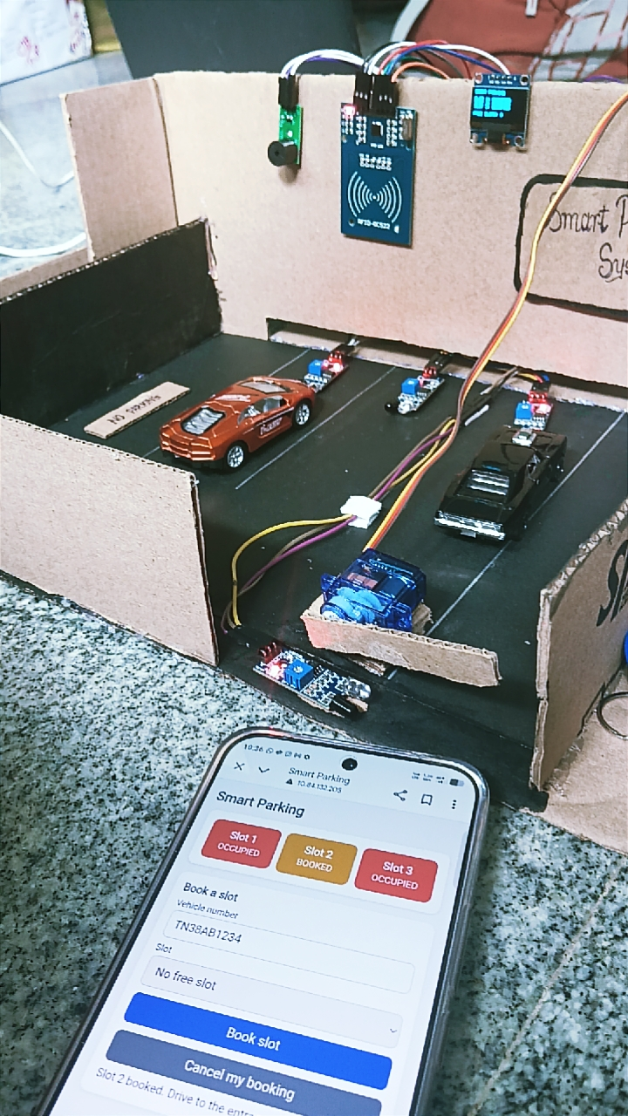
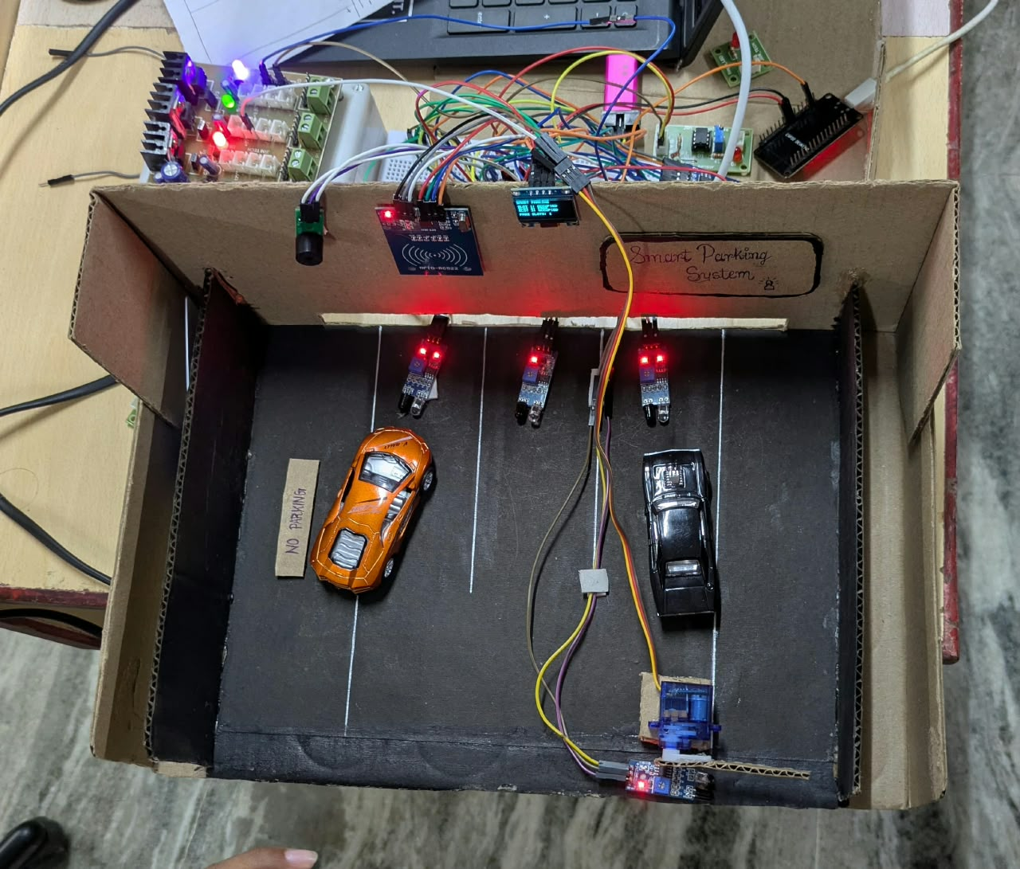
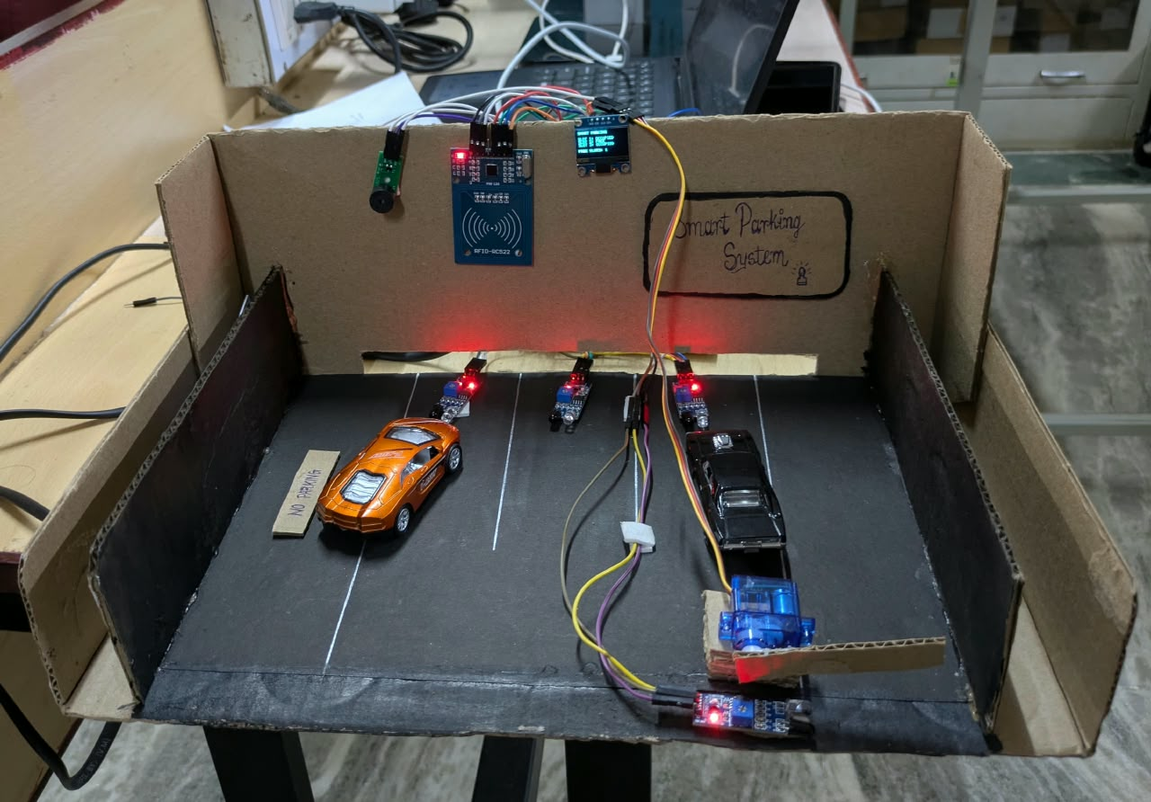

5. Acknowledgement
We express our sincere gratitude to Dr. A. Baskar, our mentor for 23CSE304 – Embedded Systems, for his guidance and support throughout this case study. We also acknowledge the Department of Computer Science and Engineering, School of Computing, Amrita Vishwa Vidyapeetham, Coimbatore, India, for providing the academic environment and opportunity to undertake this project.

