IMU-Only Indoor Positioning: Calibration, ESKF and Zero-Velocity Updates
Problem 4: IMU-based indoor positioning for drones and robots
Team: Pineapple | Date: 25 October 2026

1. Summary
We estimate position using only an inertial measurement unit (accelerometer and gyroscope), with no GPS. Integrating the raw IMU twice makes the position drift without bound: on our phone recording the raw estimate ended 211 m from the start after a 9.36 m walk. We built a pipeline in stages, and measured what each stage adds:
- Six-position accelerometer calibration and gyro bias removal.
- Orientation estimation with a Mahony filter.
- Zero-velocity updates (ZUPT) at every stop.
- A 15-state error-state Kalman filter (ESKF) that estimates position, velocity, orientation and both sensor biases.
- A per-leg drift correction at each stop ("leg de-drift"), and an optional declared aid: taped floor marks at the corners.
On the phone walk (square, 2.34 m sides, 9.36 m total) the best honest result is the leg de-drift (ESKF) run: a mean stop error of 0.72 m (7.7% of the path) and a final return-to-start error of 0.59 m (6.3%). This meets the Core tier (error under 1 m in the first 30 s) but does not meet the Main tier (3%) or the Bonus tier (0.3 m) on this test. Section 7 reports this honestly, including what limits the result.
On the EuRoC V1_01 drone dataset (58.58 m path, 145 s), no un-aided run is usable: the best ends 287 m from the truth. With simulated position fixes every 5 s the ESKF reaches 0.36 m (0.6%) at the end and passes Core and Main; with simulated UWB ranges it reaches 0.16 m (0.3%) but still misses the 0.3 m Bonus limit (max 0.43 m).
Where each problem-statement deliverable is shown.
Problem statement item | Where it is in this report
Code and the calibration procedure | Section 4 (procedure and results, Figure 1); Section 12 (run order and settings)
Trajectory plot against ground truth | Phone walk: Figures 4 and 5 (against the ideal square). EuRoC: Figures 12 and 14 (against the real ground truth).
Error versus time | Phone walk: Figure 7. EuRoC: Figures 13, 15 and 16.
Error versus distance | Phone walk: Figure 6. EuRoC: Figures 13 and 15.
Short drift analysis | Section 9, with the log-log fits in Figures 9 and 11.
Filter and fusion design | Section 5, with the block diagram in Figure 2.
Allowed aiding, stated exactly | Section 2.
Performance tiers (Core, Main, Bonus) | Section 7, and the EuRoC tier check in Section 8.
Real-time embedded implementation | Section 10. Not implemented; stated as future work.

2. Aids used (stated exactly, as the task requires)
Run family | Outside information used
raw, bias removed, bias + Mahony, bias + ZUPT, all combined | None. IMU only.
ESKF (no aiding) | None. Uses gravity direction and zero-velocity at stops, both derived from the IMU itself.
leg de-drift (Mahony / ESKF) | None, but each leg is corrected when the next stop is detected, so it is not real-time (see limitations).
ESKF + corner marks, leg de-drift + corner marks | Declared aid: taped floor marks at corners 1, 2 and 3 (position fix, sigma 0.05 m) and a flat-floor assumption (height stays at the start height). The last stop (back at the start) is not given to the filter, so its error is an independent test.
For the EuRoC dataset runs, the position fixes, UWB ranges and barometer are simulated (ground truth plus noise), and the report must say so wherever those results appear.

3. Data and test setup
Device and recording. A smartphone IMU, resampled to a common 60 Hz clock (accelerometer including gravity, and uncalibrated gyroscope). One recording, 79.7 s, 4782 samples.
Test. A square walk with 2.34 m sides, measured with a tape: five stops (start, four corners, back at the start), total path 9.36 m. The phone was held still at each corner. The ideal path is the only ground truth; it gives the true position at the five stops, not between them.
Important limitation. The direction of the first leg in the room frame is fitted from our own data (71 degrees, fit quality 0.99), because the room frame has no absolute heading reference. This makes the stop errors slightly flattering.
Public dataset. EuRoC MAV V1_01 was used for development and as a second evaluation with real ground truth (Section 8).

4. Calibration procedure
A six-position test places the phone still with each axis pointing up and then down. In each still position the accelerometer must read exactly one gravity (9.80665 m/s^2) in length. We fit three biases and three scale factors so that this holds in all six positions. Gyro bias is the mean gyro reading over all still stretches, where the true rotation rate is zero.
Procedure (reproducible):
- Record about 15 s per position (z up, z down, x up, x down, y up, y down), holding still.
- Run the calibration cell. It finds still stretches by low wiggle (not by the length of the vector, because an uncalibrated sensor is off by design), trims 0.5 s from each end, and fits bias and scale by least squares.
- A cross-check applies the simple per-axis formula, bias = (up + down) / 2 and scale = (up - down) / (2g). The two results should agree.
Result:
Parameter | x | y | z
accelerometer bias (m/s^2) | 0.0053 | -0.0447 | 0.2462
accelerometer scale | 0.9985 | 0.9966 | 0.9952
gyro bias (rad/s) | 0.0244 | 0.0076 | -0.0071
Measured noise densities used by the filter: accelerometer 2.24e-3 m/s^2/sqrt(Hz), gyro 5.1e-4 rad/s/sqrt(Hz).
Check in each position: the length of the acceleration vector minus 9.80665 m/s^2.
Position | Before calibration (m/s^2) | After calibration (m/s^2)
z up | +0.199 | 0.0000
z down | -0.294 | 0.0000
x down | -0.009 | 0.0000
x up | -0.012 | 0.0000
y down | +0.025 | 0.0000
y up | -0.053 | 0.0000
rms | 0.147 | 0.0000
Independent cross-check (simple per-axis formula, bias = (up + down) / 2, scale = (up - down) / (2g)):
 | x | y | z
bias, least-squares fit (m/s^2) | 0.0053 | -0.0447 | 0.2462
bias, per-axis formula (m/s^2) | 0.0065 | -0.0577 | 0.2461
scale, least-squares fit | 0.9985 | 0.9966 | 0.9952
scale, per-axis formula | 0.9980 | 0.9940 | 0.9951
The two methods agree to about 0.01 m/s^2 in bias and 0.003 in scale. The largest error before calibration was the z axis (+0.199 up, -0.294 down), which is a bias of about 0.25 m/s^2. Gyro bias differs between positions by up to 0.0029 rad/s, so it is stable. The up and down readings of y use the shortest still stretches (y up lasted only about 2.5 s), which limits how well y is determined.
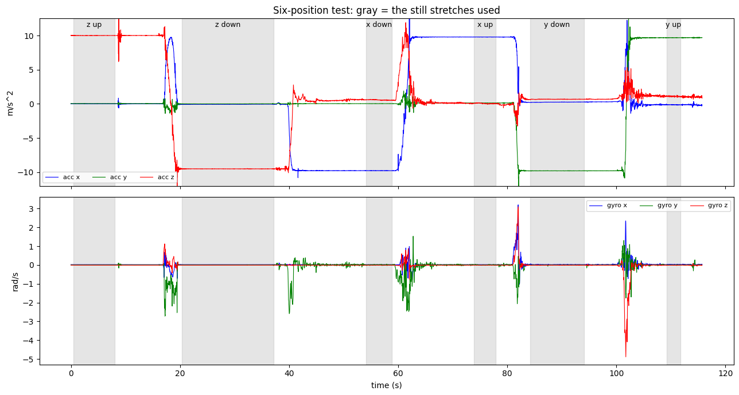
Figure 1. Six-position test: the still stretches used for each orientation (the plot at the end of the calibration cell output).
Honest notes.
- Six positions determine six unknowns, so the fit is exact and "after = 0" proves nothing by itself. The independent check is the per-axis cross-check, which should agree with the fit.
- Misalignment (crooked axes, off-diagonal terms) is not calibrated. Six static holds cannot determine it.
- Gyro scale and gyro misalignment are not calibrated (no known-rotation test). Only the gyro bias is.
- The phone provides a processed accelerometer, not a raw one, so we calibrate that processed signal.
- The problem statement's Core tier names misalignment; this is a gap we state openly.

5. Filter design
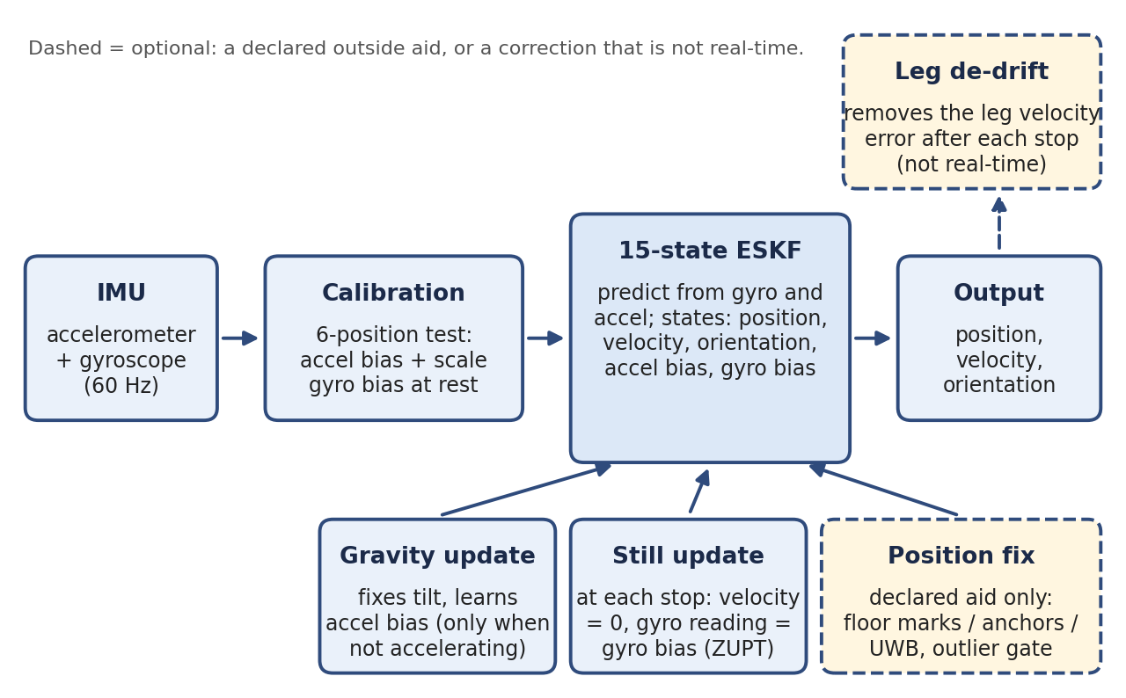
Figure 2. Filter design. Calibrated IMU data feed a 15-state ESKF, which is corrected by gravity updates, still (zero-velocity) updates and, in declared-aid runs only, position fixes. The leg de-drift step is optional and not real-time.
Stage A: plain integration. Rotate each accelerometer sample into the room frame using the gyro-integrated orientation, subtract gravity, integrate twice (trapezoid rule). Any bias or tilt error grows as time squared in position.
Stage B: Mahony orientation filter. The gyro is integrated, and the accelerometer pulls the tilt gently back toward "up" whenever its length is close to gravity (gain Kp = 0.5). This stops the tilt from drifting.
Stage C: zero-velocity updates (ZUPT). When the gyro is quiet (below 0.05 rad/s), the accelerometer length is near gravity (within 0.3 m/s^2) for at least 0.2 s, the velocity is set to zero.
Stage D: error-state Kalman filter (ESKF). Fifteen error states: position, velocity, orientation (three each), accelerometer bias and gyro bias. Updates:
- Gravity update: fixes tilt and learns accelerometer bias. It is used only when the sensor is not accelerating much (length gate 0.5 m/s^2, filter acceleration gate 1.0 m/s^2), at most every 0.5 s, and it distrusts itself more when the filter thinks it is accelerating.
- Still update: when the stop test passes, velocity is forced to zero (sigma 0.02 m/s) and the gyro reading is treated as its bias (sigma 0.01 rad/s). The stop test also requires the accelerometer to be flat over the window (standard deviation below 0.15 m/s^2).
- Position fix: used only for the declared floor-mark runs, with an outlier gate (chi-square 99%).
- Sensor noise densities are inflated (accelerometer x20, gyro x10) because datasheet noise describes only clean white noise, not vibration or model error. These factors are engineering guesses, not fitted values.
- At start-up, tilt and accelerometer bias cannot be told apart (the start orientation is built from the same still accelerometer reading). The filter is told this with one virtual measurement so its covariance has the correct correlation.
Stage E: leg de-drift. Between two stops the phone really moves, but at both stops its velocity is truly zero. The velocity at the end of a leg is therefore pure error. We model it as a constant acceleration error over the leg and remove it, and hold the position still at each stop. With corner marks, the arrival position is also known, so the error is modelled as a constant plus a ramp and both constraints (end velocity zero, arrive at the mark) are solved.
Stop detection. A "still" stretch counts as a stop if it lasts at least 0.8 s. Short non-still blips inside a stop (hand tremor) up to 1.0 s are ignored. The square test requires exactly five stops. On our recording this gave: 8.0-11.1 s, 17.2-28.7 s, 33.4-45.5 s, 51.1-61.4 s, 67.6-79.7 s.

6. Results on the phone walk
Error at a stop is the distance from the estimated position, read 0.3 s after arriving, to the ideal corner. Mean stop error is the average over the four arrivals and is a fairer number than the final stop alone.
Run | Stop 1 | Stop 2 | Stop 3 | Stop 4 (end) | Mean stop error | Mean % of path | Final %
raw | 1.26 | 18.03 | 68.44 | 143.92 | 57.91 m | 618.7% | 1537.6%
bias removed | 6.08 | 91.37 | 378.52 | 797.78 | 318.44 m | 3402.1% | 8523.3%
bias + Mahony | 7.41 | 42.48 | 95.82 | 125.57 | 67.82 m | 724.6% | 1341.5%
bias + ZUPT | 4.87 | 17.04 | 38.16 | 56.27 | 29.08 m | 310.7% | 601.2%
all combined | 6.60 | 11.48 | 8.81 | 1.96 | 7.21 m | 77.0% | 20.9%
ESKF (no aiding) | 2.88 | 1.42 | 1.27 | 1.15 | 1.68 m | 18.0% | 12.2%
leg de-drift (Mahony) | 0.74 | 0.43 | 0.88 | 1.04 | 0.77 m | 8.3% | 11.2%
leg de-drift (ESKF) | 0.93 | 0.29 | 1.09 | 0.59 | 0.72 m | 7.7% | 6.3%
ESKF + corner marks | 2.88* | 1.08* | 1.37* | 1.12 | 1.61 m | 17.2% | 12.0%
leg de-drift + corner marks | 0.00* | 0.00* | 0.00* | 0.66 | not meaningful | not meaningful | 7.0%
* given to the filter as a mark, so this error is not an independent test. For the last row, the mean of 0.16 m is not a valid result, because three of its four stops are the marks themselves; only the final stop (0.66 m) is an honest test.
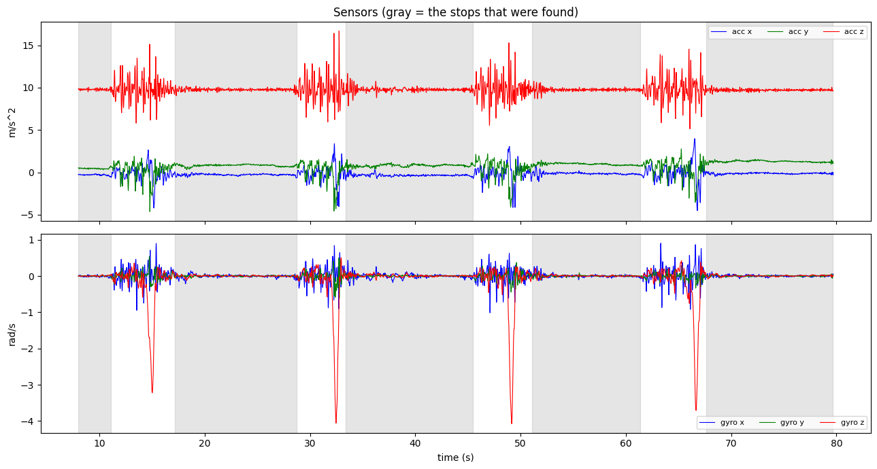
Figure 3. Sensor traces of the phone walk with the five stops shaded gray (Cell 3, first plot). The four large gyro-z dips are the four turns.
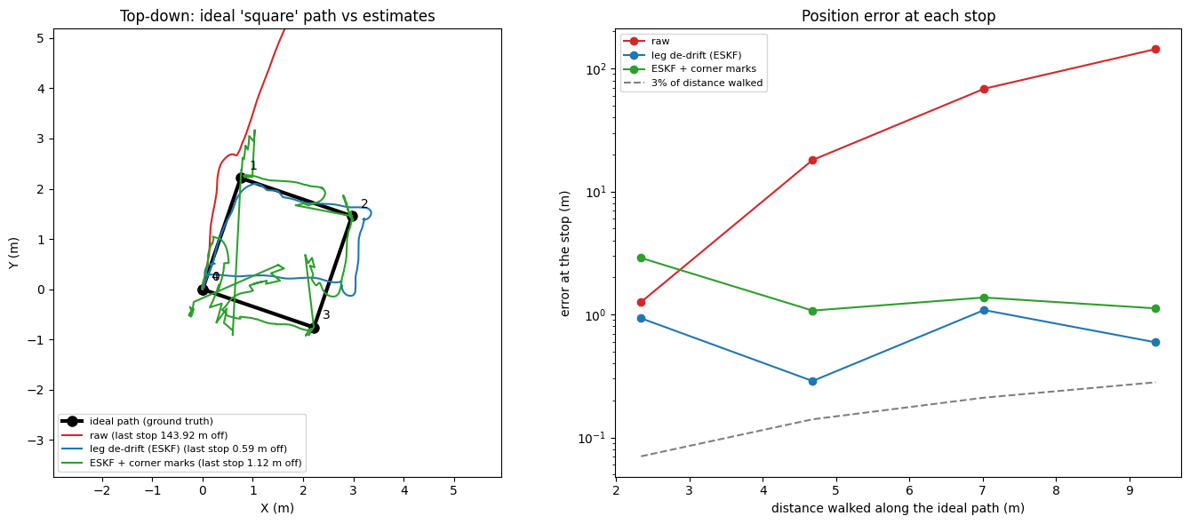
Figure 4. Top-down view: the ideal square against the raw, leg de-drift (ESKF) and ESKF + corner marks paths, with the error at each stop on the right (Cell 2 plot).
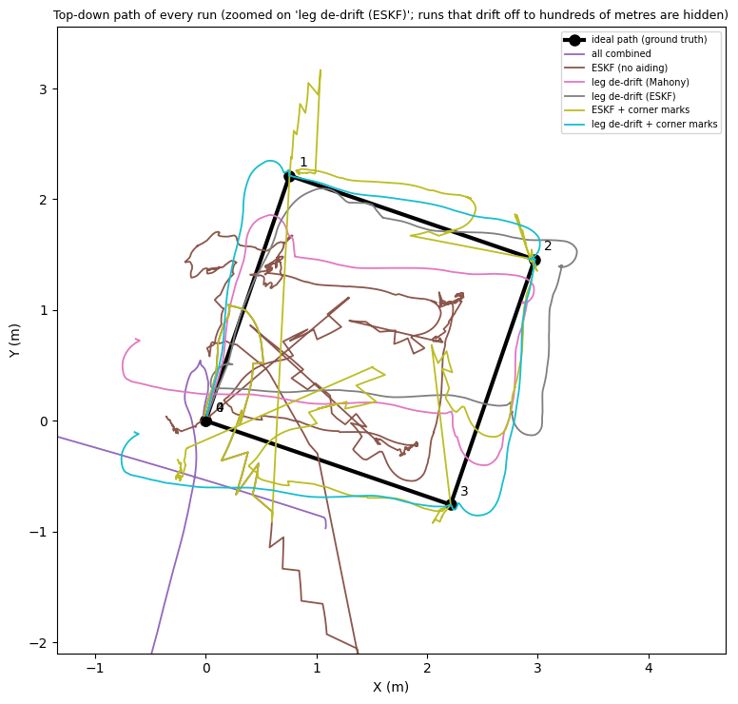
Figure 5. Top-down path of every run that stays within a few metres, with the ideal square (Cell 3, second plot).
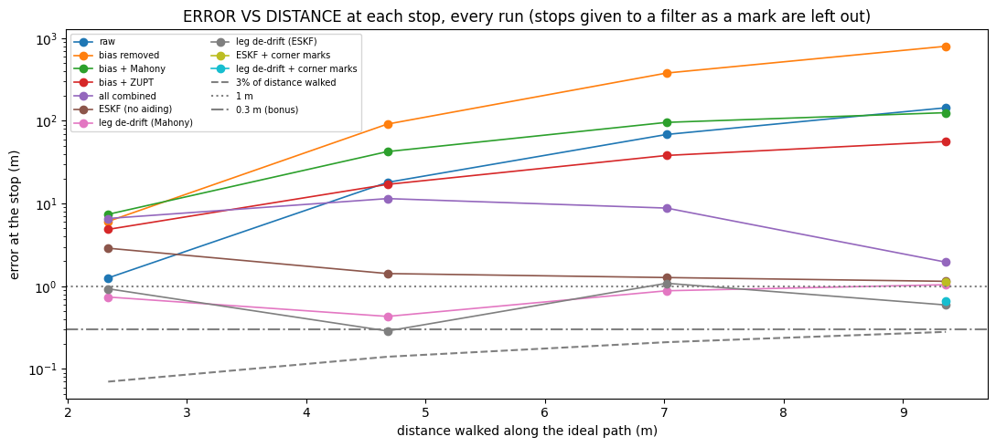
Figure 6. Error against distance walked at each stop, every run, with the 3% line, 1 m and 0.3 m lines (Cell 3 error-vs-distance plot).
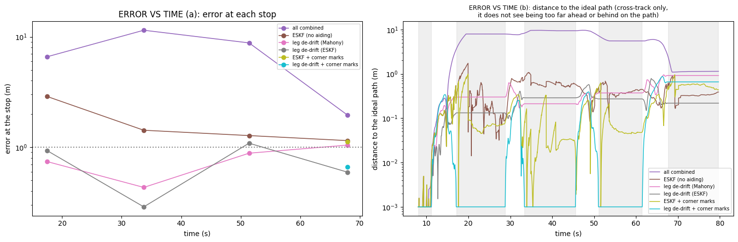
Figure 7. Error against time: (a) error at each stop, (b) distance to the ideal path (Cell 3, the two-panel plot).
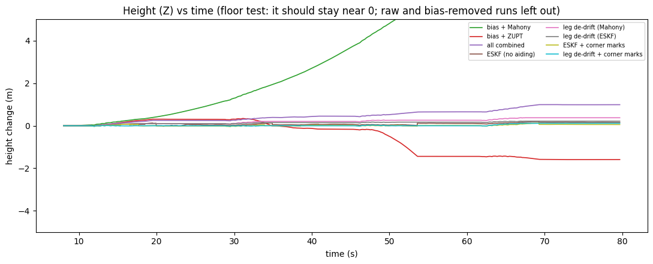
Figure 8. Height against time. On a floor test it should stay near 0 (Cell 3 height plot).
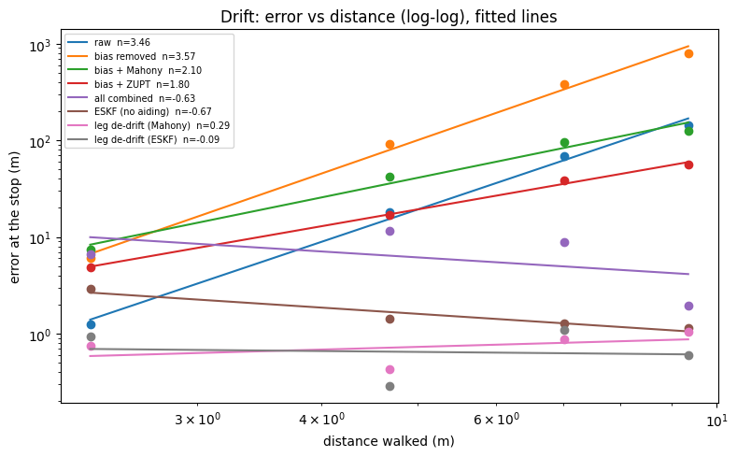
Figure 9. Drift: error against distance on a log-log scale with the fitted lines (Cell 3, last plot).
What each stage contributed. Removing bias alone made the result worse (the integrated acceleration error grows quickly), which shows how sensitive double integration is. Adding Mahony stops tilt drift, ZUPT caps velocity error at each stop, and combining them reduced the final error from about 1538% to 21% of the path. The ESKF, which also learns the biases, brought the stop errors to about 1 to 3 m. The per-leg correction cut the mean stop error to about 0.7 m.
Internal consistency checks (no ground truth needed): the final tilt check agrees with the accelerometer to 0.66 degrees; the ESKF applied 1370 still-updates with 0 measurements rejected by the gate; the fitted direction of the test had quality 0.99.

Robustness: start time
Moving the filter start from 2.0 s to 8.0 s (the phone was handled before the walk began) changed the best honest mean stop error only slightly, from 0.68 m to 0.72 m. We conclude that the start time was not the dominant error source, and we report the 8.0 s run because its start window is closer to a true still moment.

Instability of the marks run
The ESKF + corner marks result was not stable across our two configurations: its final stop error was 0.29 m in one run and 1.12 m in the other. Its path shows sharp spikes where the marks pull the estimate. We therefore report mean stop errors and do not quote the 0.29 m figure as a result.

Leg lengths
The estimated leg lengths between stops, against the ideal 2.34 m:
Run | Leg 1 | Leg 2 | Leg 3 | Leg 4
ESKF (no aiding) | 0.78 | 1.91 | 0.90 | 0.83
leg de-drift (Mahony) | 1.69 | 2.13 | 1.21 | 2.93
leg de-drift (ESKF) | 2.43 | 1.67 | 1.32 | 2.57
Leg lengths are inconsistent by up to about 1 m, even where the stop error looks good. The estimated shape is a rough, wobbly square rather than a clean one.

Effect of calibration (same walk, calibration off)
Calibration changes the plain runs enormously and the filtered runs very little. We ran the same recording a second time with the calibration table switched off (everything else unchanged: start 8.0 s, five stops found, fitted heading 66 degrees, fit quality 0.98).
Run | Mean stop error, calibrated (m) | Mean stop error, calibration off (m) | Final stop, calibrated (m) | Final stop, calibration off (m)
raw | 57.91 | 1493.84 | 143.92 | 3627.41
bias removed | 318.44 | 359.85 | 797.78 | 903.21
bias + Mahony | 67.82 | 68.49 | 125.57 | 127.15
bias + ZUPT | 29.08 | 32.50 | 56.27 | 63.53
all combined | 7.21 | 7.08 | 1.96 | 1.88
ESKF (no aiding) | 1.68 | 1.64 | 1.15 | 1.10
leg de-drift (Mahony) | 0.77 | 0.80 | 1.04 | 1.05
leg de-drift (ESKF) | 0.72 | 0.92 | 0.59 | 0.74
The corner-marks runs end at 1.12 m (calibrated) against 0.89 m (calibration off) for ESKF + corner marks, and 0.66 m against 0.64 m for leg de-drift + corner marks. Their means are not meaningful, because the marked stops count as zero.
- Raw run: about 25 times worse. Without calibration the phone reads 9.995 m/s^2 at rest instead of 9.81, and the z bias is about 0.25 m/s^2, so double integration grows the error to 3627 m at the last stop (144 m with calibration).
- Filtered runs: nearly the same. The ESKF and the stop-based corrections estimate the gyro bias and gravity from the start window, learn the accelerometer bias while running, and reset the velocity at every stop, so they largely calibrate themselves. The unaided ESKF changes from 1.68 m to 1.64 m mean error.
- Best run: slightly worse without calibration (0.72 m to 0.92 m). With one recording per case we cannot tell how much of that 0.2 m is real. Earlier we saw a 0.04 m change from moving the start time alone.
- Core tier: with calibration both de-drift runs pass (0.74 m and 0.93 m in the first 30 s). Without it only leg de-drift (Mahony) passes (0.79 m); leg de-drift (ESKF) misses by 0.01 m (1.01 m). The Core pass of the ESKF run is therefore marginal.
- Main and Bonus: neither is met with or without calibration.
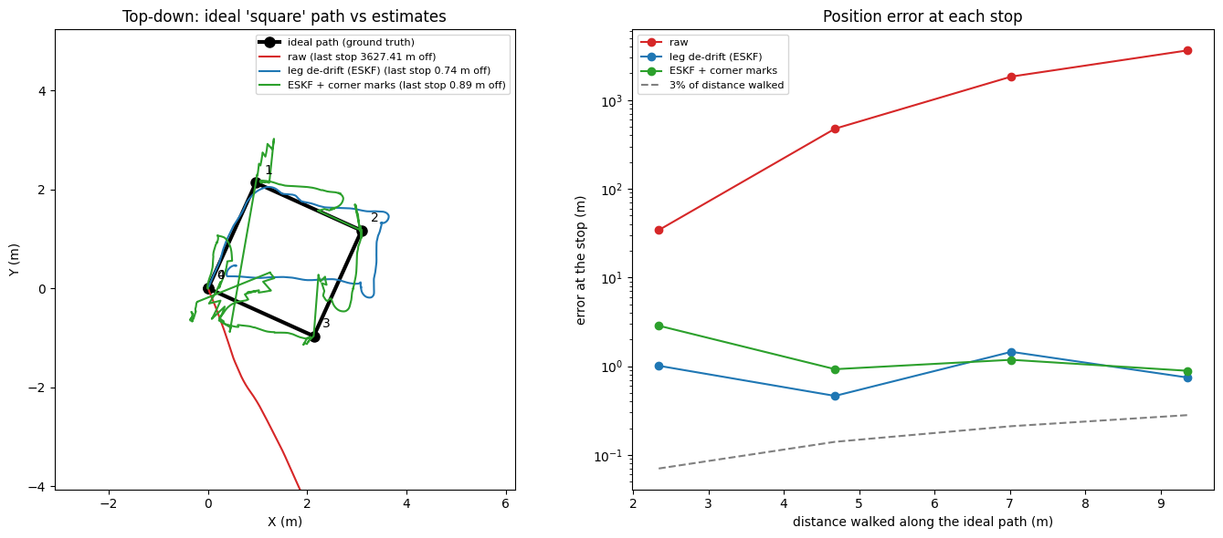
Figure 10. Calibration off: top-down ideal square against the estimates, with the error at each stop (Cell 2 plot of the calibration-off run).
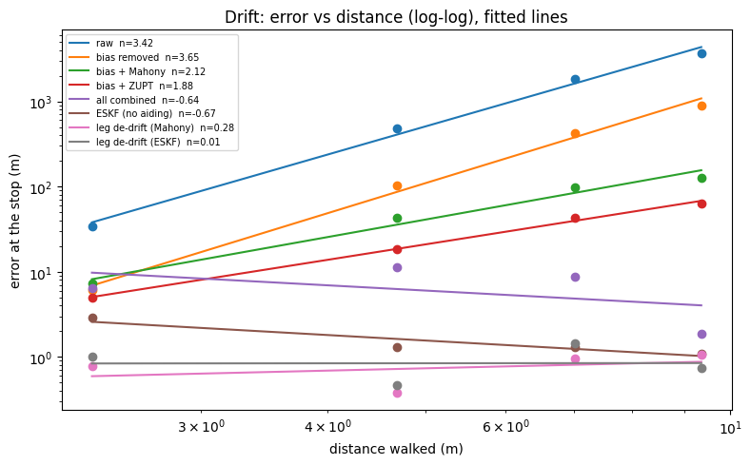
Figure 11. Calibration off: drift log-log plot with the fitted lines (Cell 3, last plot of the calibration-off run).

7. Performance tiers (honest assessment)
Tier | Target | Our result
Core | Calibration (bias, scale, misalignment), orientation estimation, error under 1 m in the first 30 s of motion | Bias and scale calibrated; misalignment not calibrated. Orientation by Mahony and ESKF. Error under 1 m at the stops in the first 30 s: passed by leg de-drift (Mahony) 0.74 m, leg de-drift (ESKF) 0.93 m and leg de-drift + marks. Failed by the unaided ESKF (2.88 m).
Main | 3% of distance on a marked 50 m path, return-to-start error reported | Our test path is 9.36 m, so 3% is 0.28 m. Best final stop error 0.59 m (6.3%). Not met. Return-to-start errors are reported in the table above. We did not have a 50 m path or the organisers' recorded traces.
Bonus | Add a low-cost aid to keep error under 0.3 m, or run fixed-point on a microcontroller | Not met. With floor marks the final stop error was 0.66 m. No microcontroller implementation was done.
The leg de-drift runs correct each leg only when the next stop is detected, so their Core pass applies after a delay and is not a real-time result. The unaided ESKF is the real-time-capable run.

8. Results on EuRoC V1_01 (real ground truth)
The un-aided runs were matched to the truth heading over the first 30 s of motion, which is a best-case alignment and must be stated. Aided runs use simulated sensors (truth plus noise).
On EuRoC, every run without outside aid fails: the best ends 287 m from the truth after a 58.58 m flight, while the aided ESKF runs end within 0.16 to 0.41 m. Error is measured against the real ground-truth file; the aiding sensors are simulated.
Run | Error at 10 s (m) | Error at 30 s (m) | End error (m) | End error % of path | Return-to-start (m)
raw | 247.18 | 2256.39 | 75322.93 | 128570.7% | 75323.16
bias removed | 2.25 | 31.97 | 2979.24 | 5085.3% | 2979.65
bias + Mahony | 1.67 | 11.97 | 287.73 | 491.1% | 287.84
bias + ZUPT | 2.20 | 31.84 | 2972.48 | 5073.8% | 2972.88
all combined | 1.66 | 11.89 | 286.84 | 489.6% | 286.94
ESKF (no aiding) | 8.49 | 80.51 | 2194.80 | 3746.4% | 2194.82
aided (simple KF) | 0.79 | 1.10 | 0.70 | 1.2% | 0.48
ESKF + position fixes | 1.12 | 0.34 | 0.36 | 0.6% | 0.72
ESKF + fixes, low-pass IMU | 0.43 | 0.33 | 0.39 | 0.7% | 0.71
ESKF + fixes, no gravity update | 0.85 | 0.37 | 0.41 | 0.7% | 0.75
ESKF + UWB ranges (gated) | 0.12 | 0.08 | 0.16 | 0.3% | 0.45
ESKF + UWB ranges (no gate) | 0.09 | 0.10 | 0.28 | 0.5% | 0.48
The six un-aided runs had their heading matched to the truth over the first 30 s of motion, which is a best-case alignment. The aided runs use the room frame directly.
Calibration on EuRoC. No offline calibration table was applied (the notebook prints "calibration: OFF"), because the six-position table describes the phone, not the drone's IMU. The drone data comes pre-corrected by the dataset, and we could not run our own six-position test on it. What was done instead: the gyro bias is measured from a short start-up window (the start window is not perfectly still, accelerometer wiggle 0.158 m/s^2), and the ESKF learns both biases online. The "bias removed" runs remove the gyro bias only. Accelerometer scale and axis misalignment are not calibrated or estimated for EuRoC, so the Core tier's calibration item is met only in part here. A check against the ground truth suggests the accelerometer scale is not exactly right (per-axis fits of about +14%, -22% and -6%), but that fit is rough, so we do not use those values.
Tier check on EuRoC (error statistics are over the time after motion starts at 5.2 s):
Run | Mean (m) | 95th percentile (m) | Max (m) | Core: error at 30 s under 1 m | Main: end error at most 3% | Bonus: max under 0.3 m
raw | 24826.29 | 68503.33 | 75322.93 | fail | fail | fail
bias removed | 727.99 | 2522.70 | 2979.24 | fail | fail | fail
bias + Mahony | 90.87 | 258.11 | 287.73 | fail | fail | fail
bias + ZUPT | 727.71 | 2522.18 | 2972.48 | fail | fail | fail
all combined | 90.65 | 257.65 | 286.84 | fail | fail | fail
ESKF (no aiding) | 726.99 | 1966.25 | 2194.80 | fail | fail | fail
aided (simple KF) | 0.97 | 2.76 | 5.27 | fail (1.10 m) | PASS (0.70 m) | fail
ESKF + position fixes | 0.48 | 1.10 | 1.95 | PASS (0.34 m) | PASS (0.36 m) | fail
ESKF + fixes, low-pass IMU | 0.46 | 1.08 | 1.73 | PASS (0.33 m) | PASS (0.39 m) | fail
ESKF + fixes, no gravity update | 0.48 | 1.11 | 1.91 | PASS (0.37 m) | PASS (0.41 m) | fail
ESKF + UWB ranges (gated) | 0.12 | 0.24 | 0.43 | PASS (0.08 m) | PASS (0.16 m) | fail
ESKF + UWB ranges (no gate) | 0.19 | 0.40 | 0.80 | PASS (0.10 m) | PASS (0.28 m) | fail
All aided rows use simulated anchors, UWB and barometer (truth plus noise): they show what the filter can do with an idealised aid, not a measurement on real hardware.
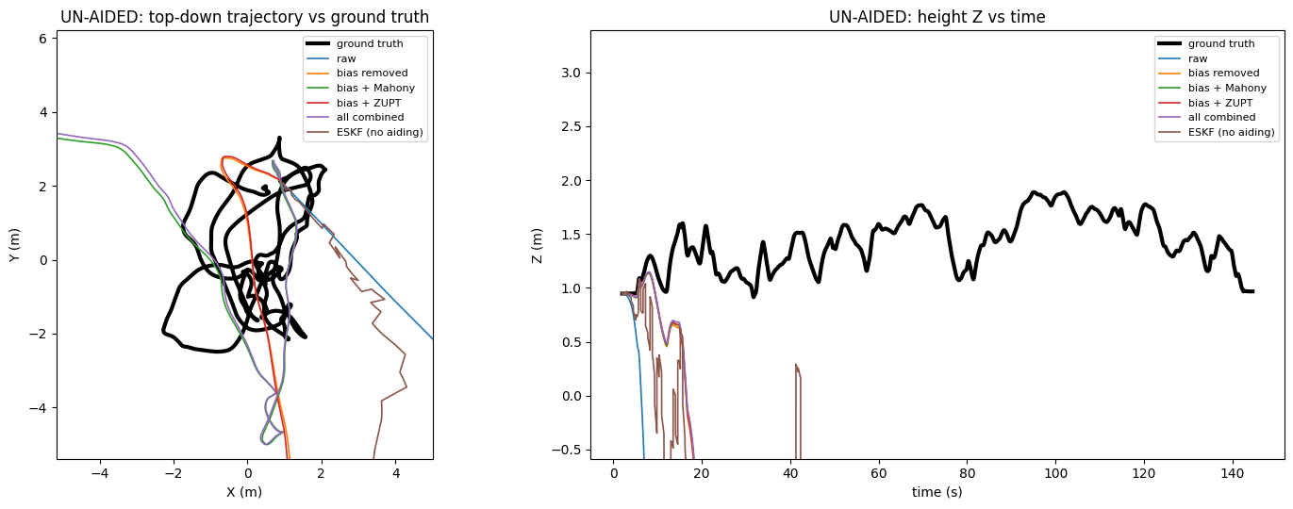
Figure 12. Un-aided runs: top-down trajectory against ground truth (left) and height against time (right) (Cell 2, first figure).
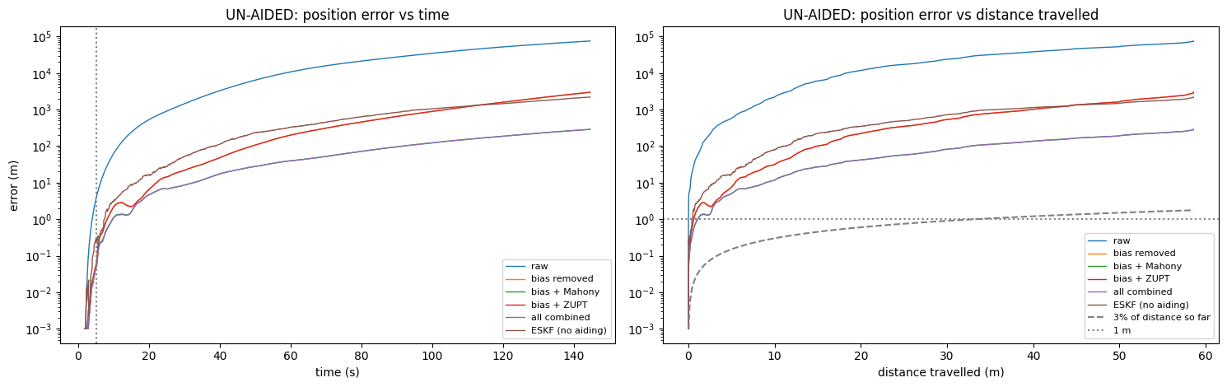
Figure 13. Un-aided runs: position error against time and against distance travelled, with the 3% line (Cell 2, second figure).
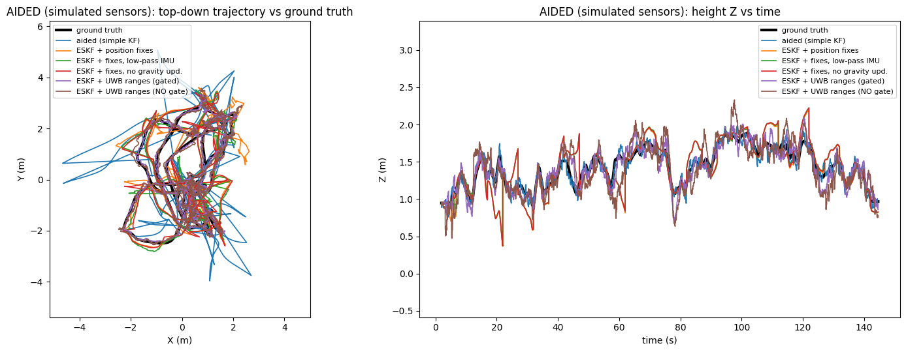
Figure 14. Aided runs (simulated sensors): top-down trajectory against ground truth and height against time (Cell 2, third figure).
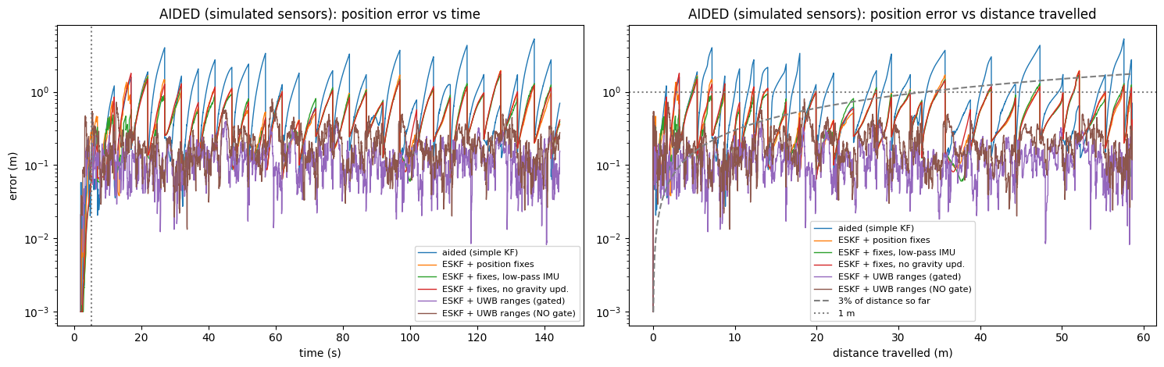
Figure 15. Aided runs (simulated sensors): position error against time and against distance travelled (Cell 2, fourth figure).
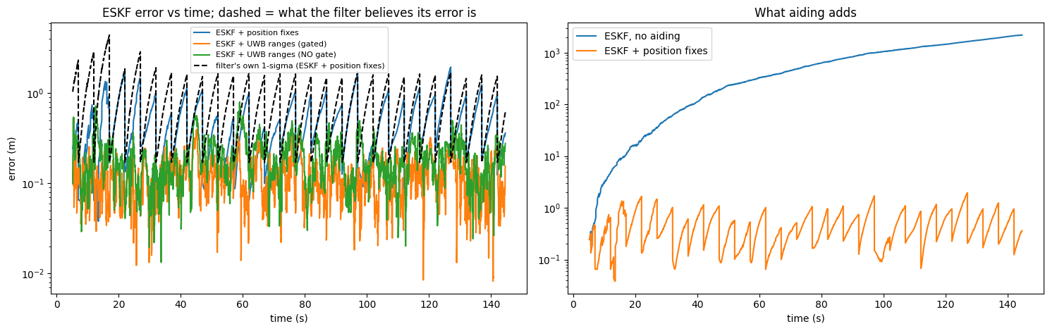
Figure 16. ESKF error against time with the filter's own 1-sigma (dashed), and what aiding adds compared with no aiding.
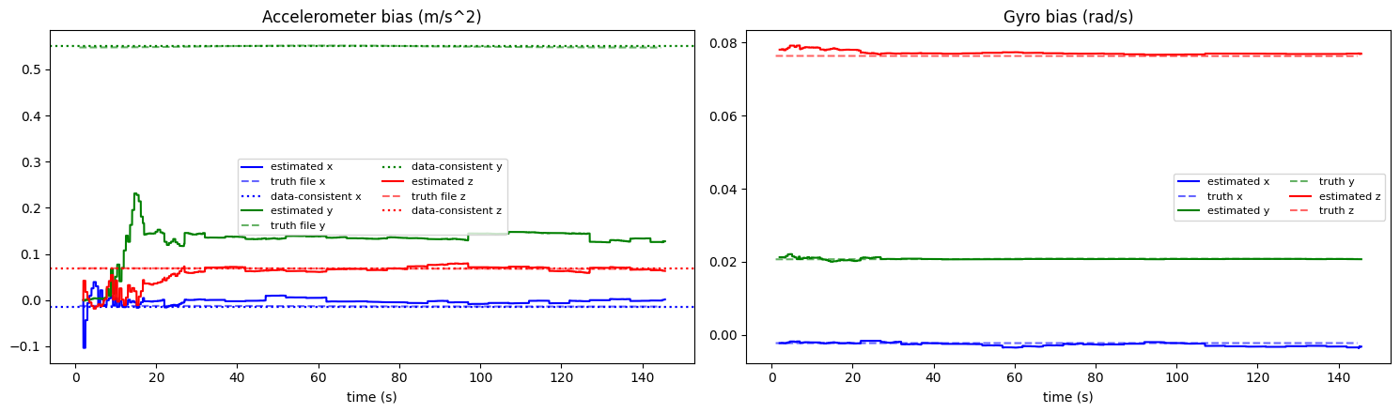
Figure 17. Estimated accelerometer and gyro bias against the truth file.
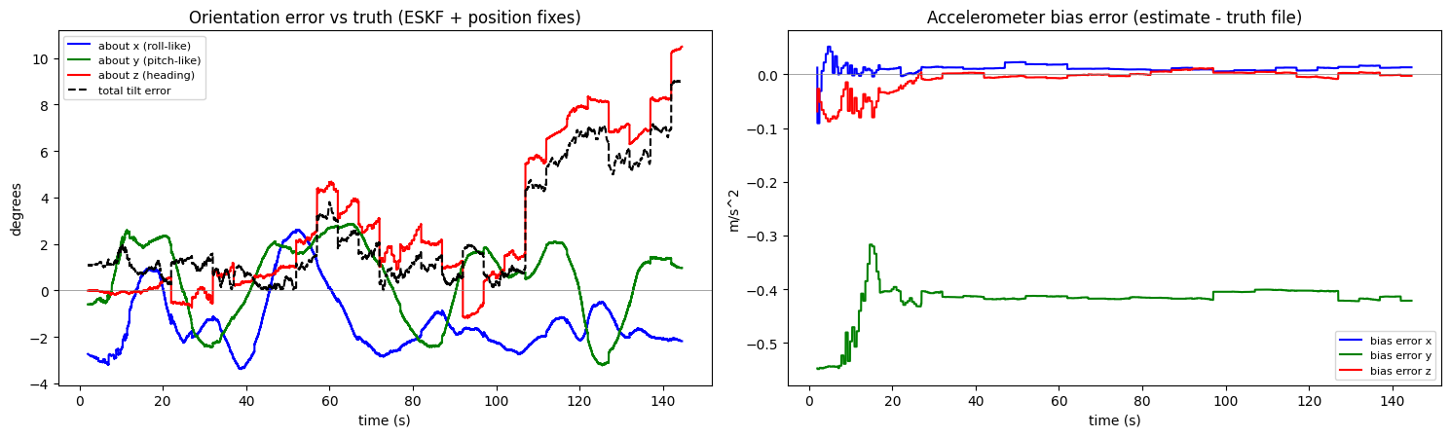
Figure 18. Orientation error against truth, and accelerometer bias error (estimate minus truth file).
Reading the EuRoC results.
- Un-aided: all tiers failed. The best un-aided runs (Mahony, all combined) end about 287 m away. The un-aided ESKF is worse than Mahony alone (80.5 m against 12.0 m at 30 s). The reason is the drone never stops: the ESKF stop test passed on only 1% of samples and applied just 101 still-updates, so the zero-velocity updates that help on the phone walk do nothing here.
- Aided: Core and Main passed, Bonus missed. With simulated fixes every 5 s (sigma 0.10 m) the ESKF has 0.34 m at 30 s and 0.36 m at the end (0.6%). Between fixes the error grows like a saw-tooth up to a maximum of 1.95 m, so the 0.3 m Bonus limit is not met.
- Best result: simulated UWB ranges with the outlier gate. Mean error 0.12 m, maximum 0.43 m, which misses the Bonus by 0.13 m. The gate rejected 297 readings; without the gate the maximum rises to 0.80 m, so the gate helps.
- The filter knows its uncertainty. In the position-fix run, the filter's own 1-sigma curve mostly stays above the actual error.
- Remaining weaknesses. The estimated y accelerometer bias is 0.13 m/s^2 while the recording supports about 0.55 m/s^2, so it stays under-estimated (tilt and bias are hard to tell apart at start-up). Mean tilt error is 2.45 degrees, and the heading error grows to about 10 degrees at the end because nothing in the filter constrains heading.
- Unexplained detail. The un-aided ESKF path jumps back to about 70 m from the start in the last samples of the recording, after the ground-truth file ends. The table above reads the end error before that jump, so it was not counted as a result.
No aid, simulated or not, was used for the six un-aided runs. A real aid (real UWB, markers) would have to be tested before claiming these aided numbers on hardware.

9. Drift analysis
Without outside aid, position error grows with distance walked. Fitting error = c x (distance)^n, the exponent n tells the cause: n near 1 means a steady velocity error; n near 2 means a constant acceleration error (a bias, or gravity leaking in through a tilt error); n above 2 means the tilt error itself keeps growing.
- Raw run: the error grows from 1.3 m at 2.3 m walked to 144 m at 9.4 m walked, far faster than linearly. This is the signature of a constant acceleration error and a growing tilt error, which double integration turns into rapid growth.
- ZUPT and Mahony: each removes part of that growth (velocity reset at stops, tilt held to up), but only combined do they bring the error down to the tens of metres.
- ESKF and de-drift runs: the error stays roughly flat at 0.3 to 3 m from stop to stop instead of growing, because the stops keep resetting the velocity error and the filter keeps estimating the biases.
EuRoC drift exponents (error grows like time since motion start to the power n):
Run | n | Reading
raw | 2.23 | constant acceleration error plus tilt leakage
bias removed | 2.59 | tilt error itself keeps growing (final tilt check 6.5 degrees)
bias + Mahony | 1.85 | tilt held (final tilt check 0.26 degrees), mostly constant acceleration error
bias + ZUPT | 2.60 | tilt error keeps growing, ZUPT rarely fires on a flying drone
all combined | 1.86 | same as Mahony alone
ESKF (no aiding) | 2.13 | constant acceleration error, tilt only partly held
All six are close to or above 2, as expected when double integration of an acceleration error dominates. The two runs with Mahony have n below 2 because the tilt is held, which is the clearest evidence in the data that tilt correction matters. Phone walk, calibration off (fitted on only four stops, so a rough guide): raw 3.42, bias removed 3.65, bias + Mahony 2.12, bias + ZUPT 1.88. The combined, ESKF and leg de-drift runs have n between -0.7 and 0.3, which means their error does not grow with distance, because every stop resets the velocity error. Phone walk, calibrated: raw 3.46, bias removed 3.57, bias + Mahony 2.10, bias + ZUPT 1.80, all combined -0.63, ESKF (no aiding) -0.67, leg de-drift (Mahony) 0.29, leg de-drift (ESKF) -0.09. Calibration does not change the pattern. See Figure 9 and Figure 11.
The remaining error, about 0.7 m after a 9 m walk, comes from (a) the unmodelled accelerometer misalignment and gyro scale, (b) heading drift from the gyro during turns, which is not corrected because no magnetometer or aid constrains heading, (c) hand motion at the stops, which makes the stop detector and ZUPT less certain, and (d) the phone's processed accelerometer signal.

10. Real-time and embedded considerations
The Kalman filter processes one sample at a time with fixed-size matrices (15 x 15), and the sensor rate is 60 Hz, so the main loop could be ported to a microcontroller. We did not implement or test this: the notebook runs in floating point in Python. A fixed-point port would require scaling the covariance matrix, replacing the matrix solve with a fixed number of operations, and verifying numerical stability. This is future work, and no embedded result is claimed.

11. Limitations
- Only one recording was evaluated, so there are no error bars. Differences of about 0.1 m between configurations are within the noise.
- The ground truth is four tape-measured corners; it is not a continuous truth, and the heading of the ideal path is fitted from the data.
- The Main tier was evaluated on a 9.36 m path, not the 50 m path in the problem statement.
- Leg de-drift is not real-time.
- Several filter parameters (noise inflation factors, gates, thresholds) were chosen by judgement and were adjusted while looking at this recording, so the reported errors may be optimistic for new data.
- The phone walk is hand-held; foot-mounted sensors give a still moment every step and would likely do better.

12. How to reproduce (documentation)
Files, run in this order in Google Colab:
- Setup cell: mount Google Drive and unzip the EuRoC data.
- Calibration cell: six-position test; writes calibration.json.
- Cell 1: loads data, finds stops, runs all filters, prints the checks, draws the simple plot.
- Cell 2: scoring (EuRoC: simulated aiding and truth scoring; device: ideal-path scoring and corner marks).
- Cell 3: all report plots (sensors, every-run paths, error against distance and time, drift fit, report table).
Key settings in Cell 1: SOURCE ("euroc" or "device"), TEST ("square", "slide", "none"), USE_CALIBRATION, DEVICE_T_START (8.0 s for the square), STOP_MIN_S = 0.8, STOP_BRIDGE_S = 1.0, ZUPT_STD = 0.15. Cell 2: USE_MARKS, MARK_SIGMA = 0.05, MARK_STOPS = "intermediate".
Checks that the run is healthy: the square test needs stops found (5); the ESKF stop test should pass on a large share of samples; hundreds to thousands of still-updates should be applied; the tilt check should be below about 2 degrees; the heading fit quality should be at least 0.6.

13. Conclusion
A single IMU, double-integrated, drifts to hundreds of metres within seconds. Calibration, tilt correction, zero-velocity updates and a Kalman filter that learns the sensor biases reduce the error by two to three orders of magnitude, to about 0.7 m on a 9 m walk. A per-leg correction at each stop gives the best result but works with a delay, and floor marks did not give a stable improvement. We did not reach the 3% Main target or the 0.3 m Bonus target on this test, and the report states what limits the result and what we would do next: calibrate misalignment, test on a longer marked path, mount the sensor on a foot, and evaluate a fixed-point implementation.

Appendix: figure checklist
- ☐ Figure 1: six-position calibration plot
- ☐ Figure 2: filter design diagram (block diagram, no notebook output needed)
- ☐ Figure 3: phone sensor traces with stops shaded
- ☐ Figure 4: phone top-down ideal square against estimates, with error at each stop
- ☐ Figure 5: phone top-down path of every run
- ☐ Figure 6: phone error against distance
- ☐ Figure 7: phone error against time (two panels)
- ☐ Figure 8: phone height against time
- ☐ Figure 9: phone drift log-log plot (calibrated)
- ☐ Figure 10: phone top-down with error at each stop (calibration off)
- ☐ Figure 11: phone drift log-log plot (calibration off)
- ☐ Figures 12 to 15: EuRoC un-aided and aided trajectories and errors
- ☐ Figure 16: EuRoC ESKF error with the filter's 1-sigma, and what aiding adds
- ☐ Figure 17: EuRoC bias estimates
- ☐ Figure 18: EuRoC orientation and bias error

