**Celine Loise**

**22-2314**

**Principles of Programming Languages.**

**V LANGUAGE PROJECT**

**PERSONAL FINANCE MANAGEMENT SYSTEM.**

I am working on a console application i.e A personal Finance Management System that enables users to manage their expenses, budget, and savings efficiently. The PFMS will help users to input their daily transactions, categorize expenses, track financial patterns, view transaction details and even set savings goals.

**Screenshots of where I am at currently**

Module handling transactions.

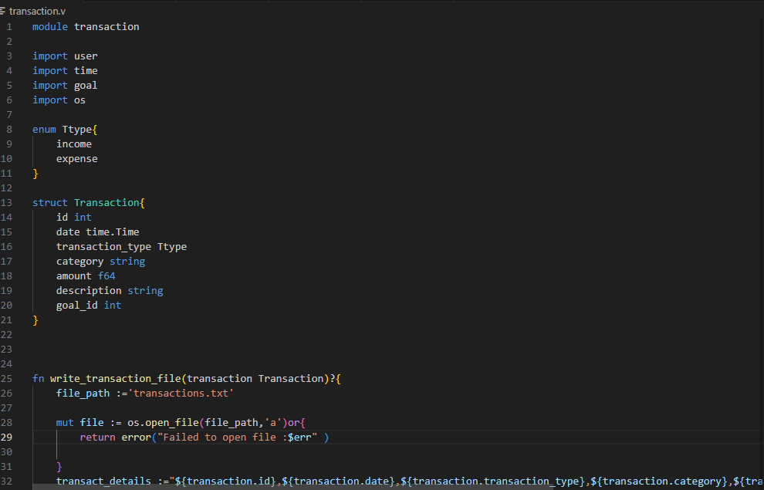

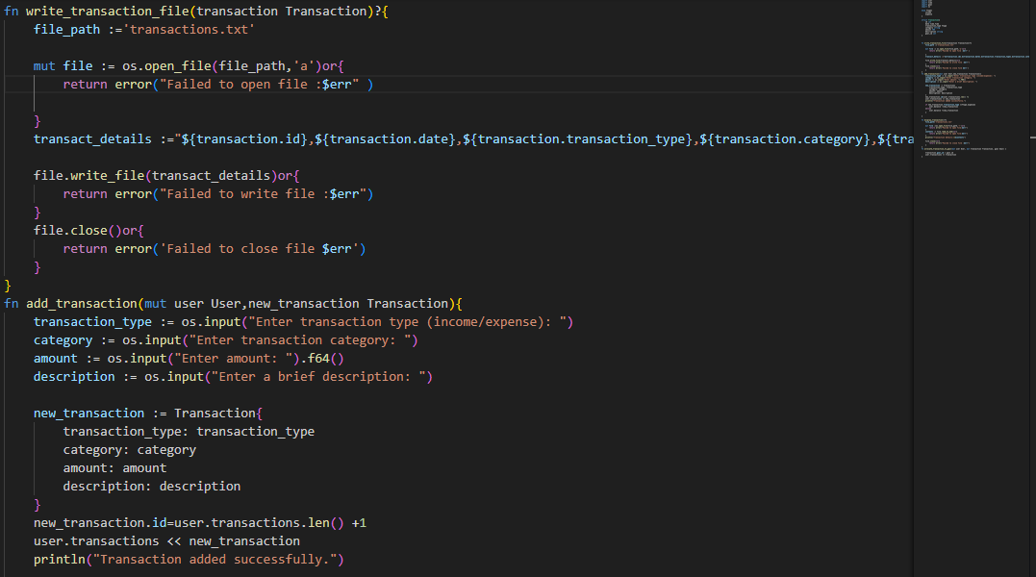

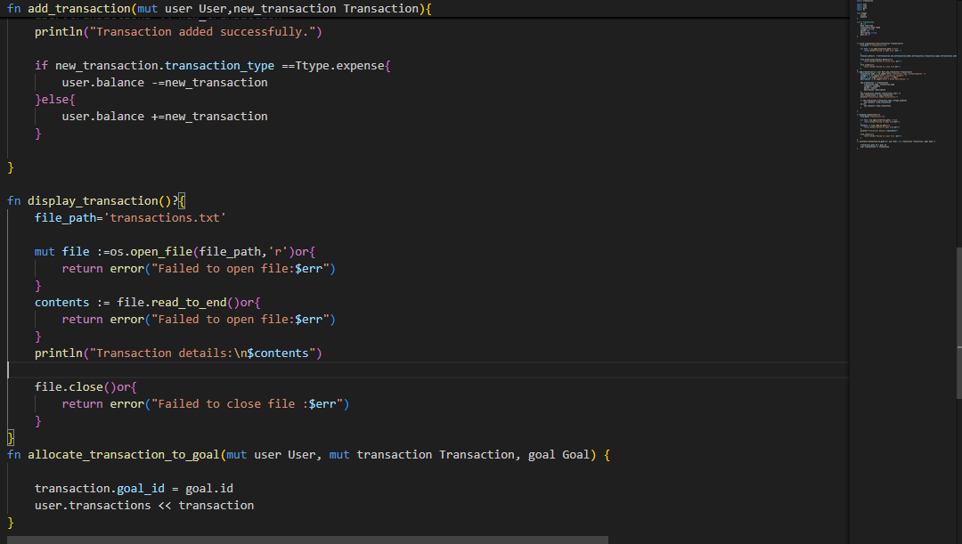

Users module handling module for users

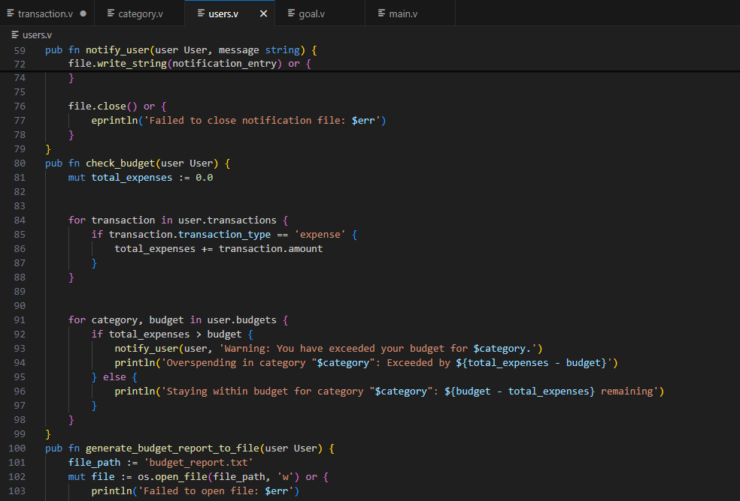

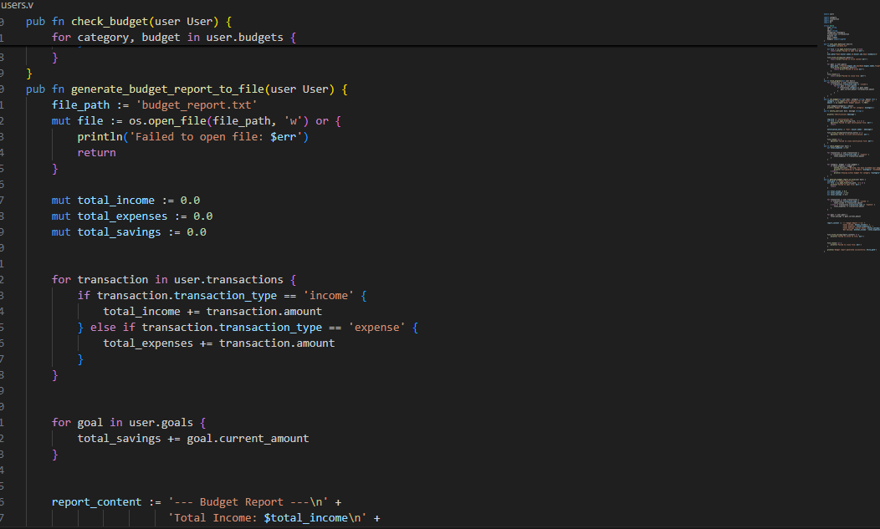

Goal module to handle Goals.

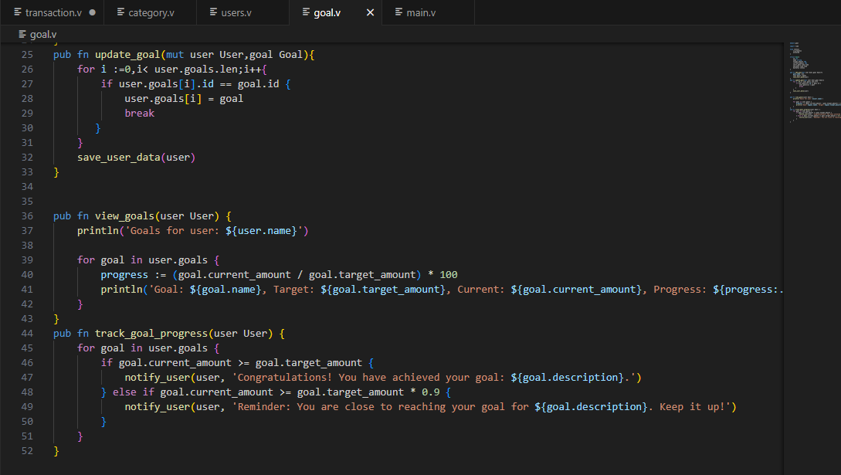

Main file

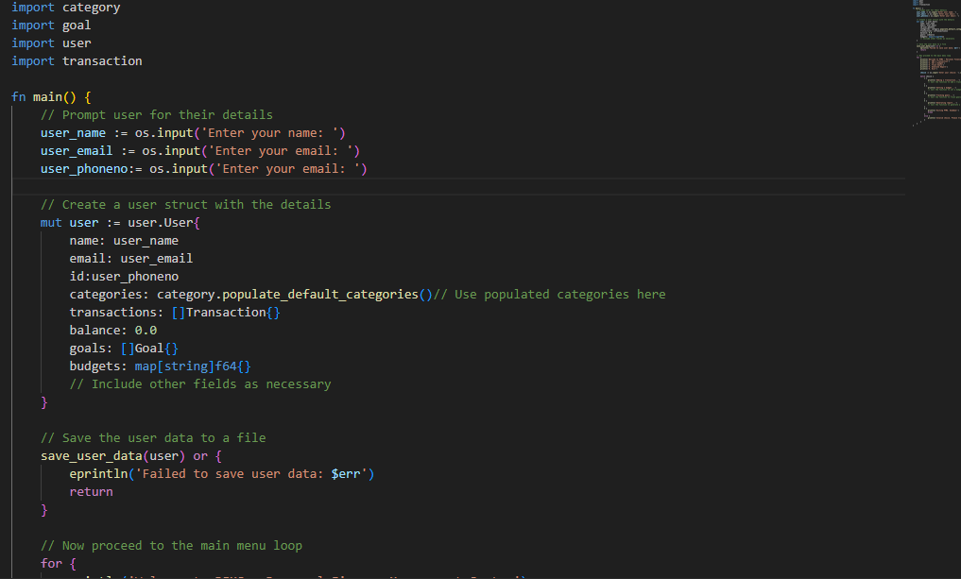

Category module to handle categories.

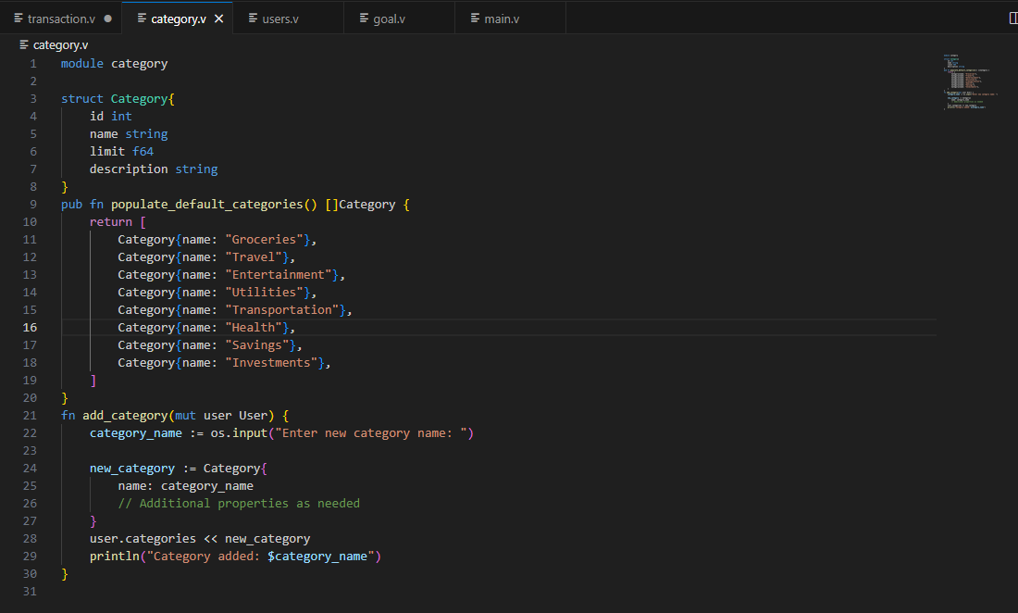

I am still handling all the other processes .