SHRI VAISHNAV VIDYAPEETH VISHWAVIDYALAYA

Shri Vaishnav Institute of Information Technology and Science

Department of Computer Science and Engineering

(Session : March 2023 – July 2023)

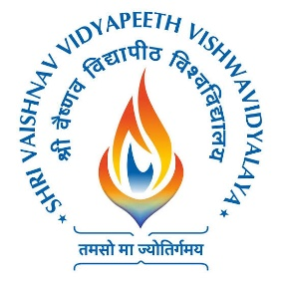

Practical File

Name : Utkarsh Pathak

Enrollment No. : 22100BTCSE11830

Course Name : Object Oriented Programing

Course Code : BTCS202N

Year/Semester : 1st/II semester

Section : L

Submitted to. : Prof. Sukrati Agrawal

SHRI VAISHNAV VIDYAPEETH VISHWAVIDYALAYA

Shri Vaishnav Institute of Information Technology and Science

Department of Computer Science and Engineering

(Session : March 2023 – July 2023)



Practical File

Name : Utkarsh Pathak

Enrollment No. : 22100BTCSE11830

Course Name : Data Structure and Algorithms

Course Code : BTCS201N

Year/Semester : 1st Year/II semester

Section : L

Submitted to. : Prof. Shubham Kothari