Growing food in conditions of microgravity has been a matter of interest for the scientific community for a long time, mainly because our dream to conquer outer space can only be accomplished if the basic human needs are satisfied.

### **Pleurotus ostreatus and its mycological characteristics**

Currently, there are at least 12,000 species of mushrooms worldwide out of which 2,000 species are reported as edible and only 35 are commercially cultivated, with Agaricus bisporus being the most popular. In this project, we have decided to cultivate Pleurotus ostreatus by considering the time of growth and the availability of mycelium on the market. Known as oyster mushroom, Pleurotus ostreatus is a common saprophyte species of the basidiomycetes group, one of the two main large divisions which form the subkingdom Dikarya within the fungi kingdom. As the name suggests, the species has an offset, tongue-, spatula-, or oyster-shaped pileus spanning 2-30 cm. The colour of the pileus can vary between different shades of grey. The pileus is supported by a short, whitish, eccentric or lateral stripe, and, therefore, its thickness depends on the stripe arrangement. White or cream lamellae occur on the decurrent hymenium whereas the white to lilac-grey spore print shows 8-12 μm ⨯3-4 μm sized, hyaline spores.

In the natural environment, Pleurotus ostreatus thrives on the living or dead parts of plants in temperate and subtropical forests during autumn and winter times, when the temperatures are up to 15℃. High carbon dioxide concentrations, up to 28% of the volume, stimulate the growth.

### **Mushrooms as an ideal source of nutrients**

Either on Earth or in space, a balanced nutrition is crucial in providing the organisms the necessary minerals to maintain high energy levels and, subsequently, good health.

Since antiquity, the fructification of higher fungi has been an integral part of the human diet as it is easily seen with the naked eye, picked by hand, and consumable without processing. The reason for which mushrooms are appearing more and more frequently on our plates is because they represent are source of variety of nutraceutical compounds such as polysaccharides (β-glucans), dietary fibres, terpenes, peptides, glycoproteins, alcohols, mineral elements, unsaturated fatty acids, antioxidants like phenolic compounds, tocopherols, and ascorbic acid. Moreover, the bioactive compounds have proven effects on strengthening the immune system and prevention of heart diseases, hypertension, cerebral stroke and cancers. Mushrooms are also known to exhibit antifungal, anti inflammatory, antitumor, antiviral, antibacterial, hepatoprotective, anti-diabetic, hypolipedemic, antithrombotic and hypotensive activities. Depending on the species, varieties, and the stage of development of the fruiting body, the crude protein content of edible mushrooms ranges from 10% to 35% of dry weight (DW). The dry weight recommended to maintain an optimal nutritional balance in a man weighing 70 kg is 100- 200 g.

Mushrooms are richer in proteins than most vegetables. Specifically, the amount of essential amino acids in mushroom proteins ranges from 30 to 50g/100g protein DW, from which the most important ones are glutamic acid (130–240 mg/g protein DW%), aspartic acid (91–120 mg/g protein DW %) and arginine (37–140 mg/g protein DW%). Besides these, the two unusual amino acids γ-amino butyric acid (GABA), a non- essential amino acid, and ornithine, known for their peculiar physiological activities, have also been found. Similar to proteins, the carbohydrate content in the fruiting bodies comprising of monosaccharides (eg sugars), oligosaccharides (eg trehalose and non-starch polysaccharides), and small amounts of sugar alcohol, such as mannitol and trehalose serve as 50 to 65% on dry weight.

In comparison with carbohydrates and proteins, mushrooms are low in lipids (less than 5% DW). With a total lipid content of 20 to 30 g kg-1 DM, mushrooms contain unsaturated fatty acids, such as linoleic and oleic acids and tocopherol. Whereas tocopherol is an important antioxidant, the linoleic acid has been mentioned to exhibit anti-carcinogenic effects on almost all stages of tumorigenesis in breast, prostate, and colon cancers. The vitamin content of five types of mushrooms are presented in Table 1.

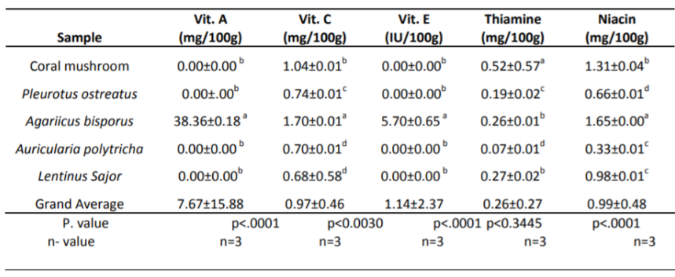

Fig 1: The concentration of vitamins in five species of commercial mushrooms (Afiukwa, Celestine & P.C., Ugwu & Okoli, S.O. & Idenyi, John & Ossai, Emmanuel. (2013). Contents of some vitamins in five edible mushroom varieties consumed in abakaliki metropolis, Nigeria. Research Journal of Pharmaceutical, Biological and Chemical Sciences. 4. 805-812.)

Besides the vitamins mentioned in the table, mushrooms represent a good reservoir of vitamins B and D. When exposed to UV light, fungal sterol, ergosterol, is converted to vitamin D2 through a series of photochemical and thermal reactions, in amounts greatly higher than that of daily requirements.

### **Cultivation of mushrooms: between science and art**

As we have shown in the previous section, mushrooms provide a large variety of nutrients necessary for the good functioning of the human body. Besides their obvious multi-functional medical properties, the fast growing period and the capacity to thrive in spatially-restricted areas may make the spore- bearing fruiting body of fungus the ideal consumable entirely grown on a spaceship.

Annually, the mushroom cultivation market is estimated to be $16.65 billion in 2020 and is expected to reach $22.78 billion by 2028. The popularity of the commercial species, including Pleurotus ostreatus, is attributed to the rapid growing rates, being ready for harvest after 7 days. Moreover, in a controlled environment, due to its high saprophytic colonisation ability, the entire cultivation is more straightforward as the substratum is fastly penetrated.

### **Environmental conditions**

In comparison with the natural requirements, the commercially-produced mycelium should benefit from higher optimal air temperatures. As noticed in the graph, the acceleration of growth occurs between 15 and 20 ℃.

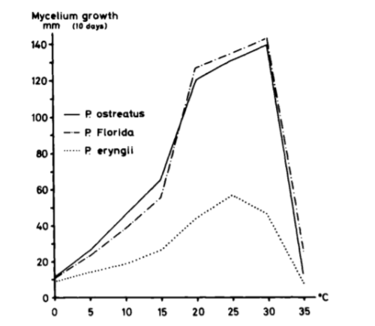

Figure 2: The mycelium growth as a function of temperature (ZADRAŽIL, F., 1978. Cultivation of pleurotus. The Biology and Cultivation of Edible Mushrooms, pp.521–557)

Another reason for which agriculture focuses on the Pleurotus group is that the mushrooms can flourish on artificial substrate on synthetic materials as long as it is associated with the corresponding nutrient solution. The table below shows the concentrations of the nutrients necessary to support mycelium development.

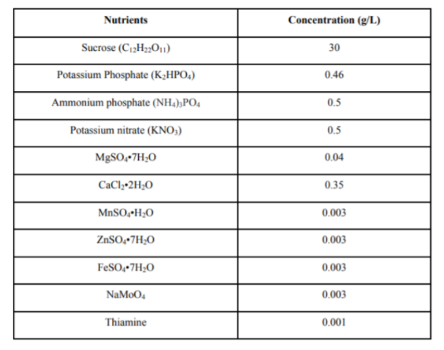

Fig 3: Nutrients and correspondent concentrations for mycelium growth (Prof. Chandra Madramootoo, “Mycelium and Mushroom Production Using a Hydroponic Porous Tube Nutrient Delivery System”, Department of Bioresource Engineering, McGill University, Macdonald Campus, April 2018)

Regarding the amount of oxygen, discussion is more complex considering that the development stages differ in oxygen requirements: mycelial growth demands semianaerobic conditions whereas carpophores develop under the presence of oxygen.

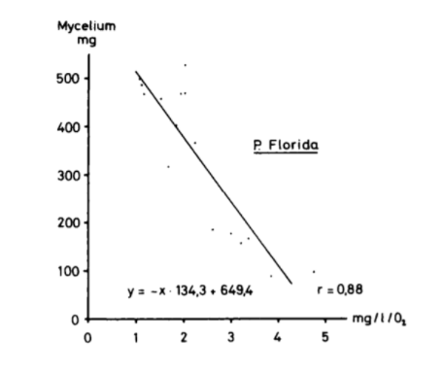

Fig 4: The mycelium growth as a function of oxygen concentration (ZADRAŽIL, F., 1978. Cultivation of pleurotus. The Biology and Cultivation of Edible Mushrooms, pp.521–557)

PH is another parameter which should be taken into account when cultivating mushrooms as acid (pH= 4) and basic (pH= 7) settings inhibit the growth. However, considering that the mycelium growth lowers the pH values quickly, slightly higher values than the optimum can also be accepted as well.