### **Growing mushrooms in space**

GUMS: Growth Unit for Mushrooms in Space is an ingenious mushroom growing hybrid system idea consisting of an electromagnetically treated homogeniser for nutrient mixing and solution sanitising and hydroponic porous ceramic tubes for the nutrient delivery and recycling. The growing environment will be wirelessly monitored via an autonomous sensor system, which transmits the air sensing (air temperature, relative humidity, atmospheric gases concentration, light intensity) and water sensing (solution temperature, pH, electrical conductivity, concentration of oxygen and nutrients) data to a mobile app. Further improvements would include a treatment and dehydration stations.

Our GUMS design has been inspired by NASA’s PTPNDS system. In 2003, T.W. Draschel has published in NASA Technical Memorandum the technical design of a device which utilises a loop to control the delivery of water and nutrients to the roots of super-dwarf wheat and, subsequently, to prevent the anoxic effects experienced by plant rhizospheres in conditions of microgravity. According to the paper, eight porous ceramic tubes with a diameter of 2 cm and 80 cm length are connected to a magnetically coupled impeller at the upstream end and to a peristaltic pipe at the downstream end. These tubes are fed by a 80 litres nutrient tank attached to the upstream end whereas the solution is removed out of the system and recycled at the downstream end. Metal-halide lamps provide the necessary active radiation for photosynthesis and a bracket system is attached to diffuse the liquid nutrient solution under pressure.

### 

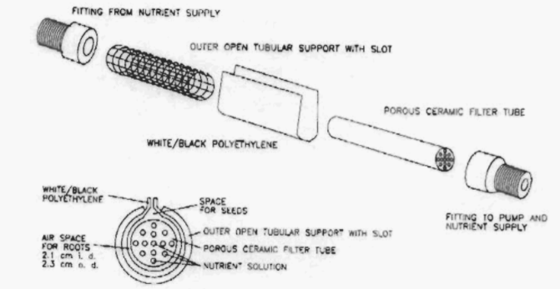Fig 5: Scheme of Porous Tube Plant Nutrient Delivery System (T.W. Draschel, “DEMONSTRATION OF A POROUS TUBE HYDROPONIC SYSTEM TO CONTROL PLANT MOISTURE AND GROWTH”, NASA Technical Memorandum 2004-21 1533, October 2003)

The outline of the system is further developed by the Department of Bioresource Engineering of McGill University, Canada, in order to make it functional for mycelium and mushroom production. GUMS is a modified version of this model which uses an alignment of three porous ceramic tubes, each of 15 mm in outer diameter, 10 mm in inner diameter and 200 mm in length, rather than only one, making the system more suitable for much smaller space. If the growing chamber of McGill University’s porous tube plant for nutrient delivery system needs a 1.09 m in length, 0.59 m in width and 0.52 m in length container for the assembly, GUMS only uses 60 cm in length, 35 cm in width and 40 cm in height. Due to the reduced dimensions of the container, GUMS require less energy to be humidified and heated up, which means that we also save energy, and, therefore, money. Besides the continuous monitoring of multiple environmental parameters amongst which some uncommon ones, such as light intensity, pH and electrical conductivity, GUMS makes use of the newest discoveries in the full solution sterilizing treatments to prevent the contamination noticed in McGill University’s system and, subsequently, the pump clogging.

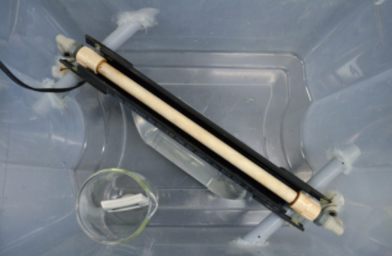

Figure 6: Nutrient Delivery System seen from above (Prof. Chandra Madramootoo, “Mycelium and Mushroom Production Using a Hydroponic Porous Tube Nutrient Delivery System”, Department of Bioresource Engineering, McGill University, Macdonald Campus, April 2018)

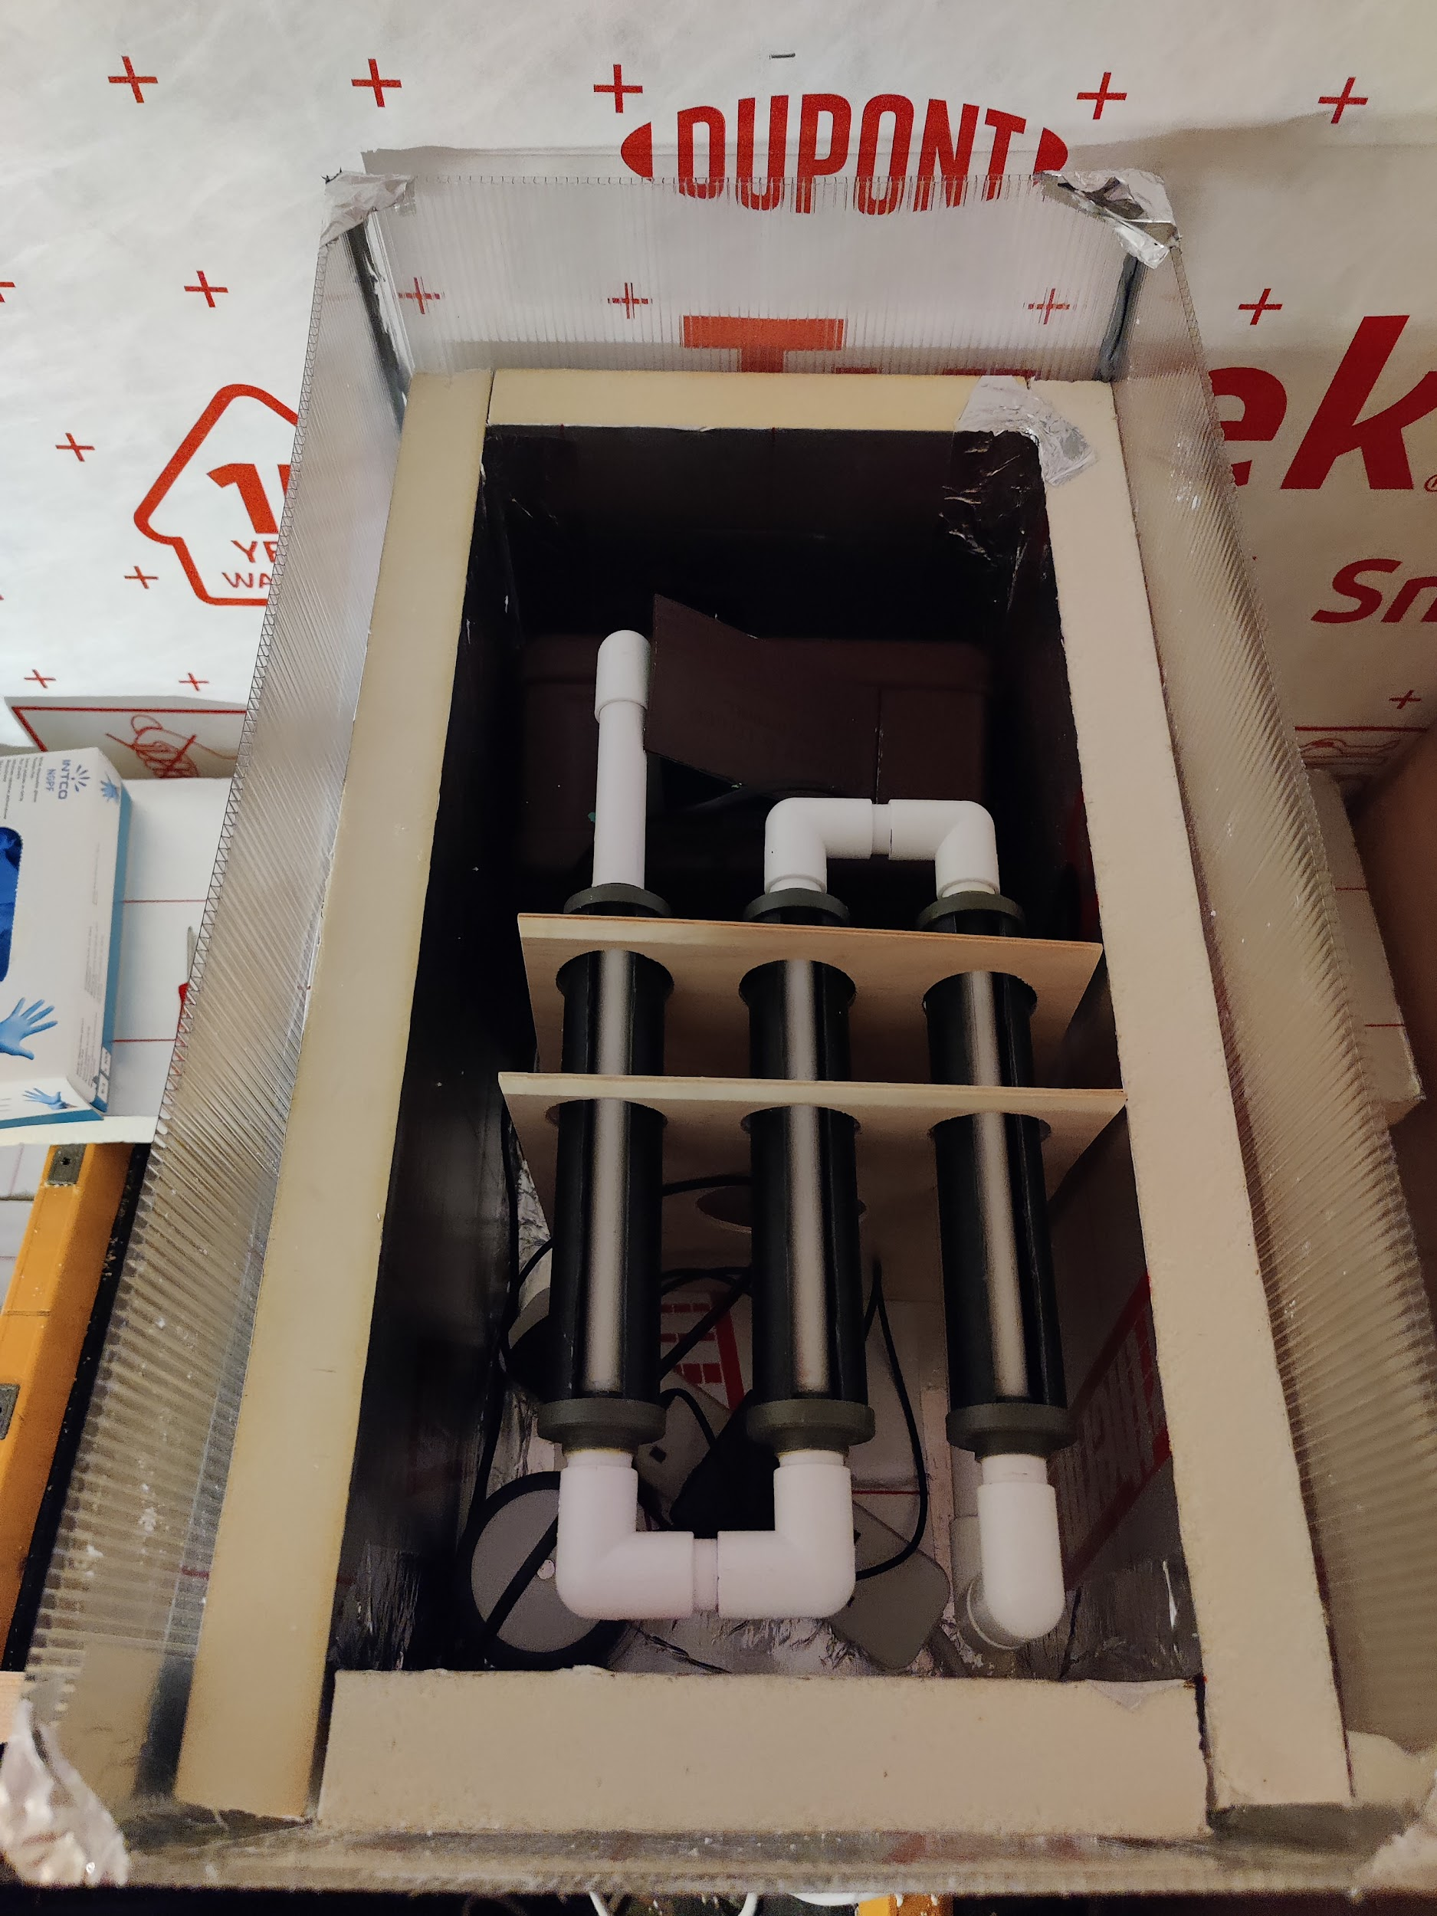

Figure 7: Nutrient Delivery System seen from above (GUMS design)

### **Nutrient delivery system**

An inert substrate of organic brown rice flour, vermiculite and gypsum was sterilized and inoculated with a liquid media containing Pleurotus ostreatus spores. The axenic nutrient solution is dispersed into a bed of nutrient free substrate, encased by ABS pipes around the ceramic tubes. The ceramic tubes are, then, joined to a 5L nutrient tank by opaque, PVC pipes. The opacity of the pipes diminish the chances of internal algal contamination. In the nutrient tank, we added a centrifugal submersible pump, attached to the nutrient tank walls using silicon caps. The remaining solution which circulated through the system is transported downstream to the nutrient tank where the consumed nutrients are replenished.

### **Nutrient mixing and treatment station**

From (Prof. Chandra Madramootoo et al., April 2018), we know that contamination of nutrient and water solution may be an issue, especially during the mixing. From this, we propose a system may be to mix the water and nutrient solution inside a sealed mixing chamber. This will allow for the inlet of nutrients at high pressure to mix directly with the water, creating an even distribution of components.

The homogenization will occur in a venturi space, where mechanical mixers are placed. The surface of the venturi chamber is circularly-ridged to promote further physical and chemical reactions in the aqueous media. The inlets to the chamber of the mixer as well as the nutrient tank include a jacket insulation to keep the temperatures of the liquid solutions below room temperature, and, subsequently, to increase the dissolution of oxygen and nitrogen.

In comparison with other subsystems, the venturi chamber should be treated with maximum care as there are high chances for contamination, despite UV sterilising the water before connecting to the inlet. The risk of contamination can be drastically reduced by utilising EMF solution treatment. EMF has been widely used for centuries to mitigate bacterial contamination, but also to assist the electrocoagulation and advanced oxidation processes. In comparison with electrolysis for which the presence of electrodes in the nutrient solution tank is mandatory, in the EMF treatment technique, solenoid coils are attached in the proximity of the venturi chamber to induce an electromagnetic field of high intensity and less homogeneous waveform in the liquid. Moreover, as electrodes need to be frequently checked and periodically changed, electrolysis is associated with high maintenance cost, which cannot be said about our treatment unit.

### **Growth chamber**

The growing chamber is our own customised polycarbonate bin, supported on a wooden base, measuring 60cm in length, 35cm in width and 40cm in height. We included the ceramic tubes inside the bin whereas the nutrient mixing and treatment station is kept outside the bin. The openings cut in the polycarbonate sheets to connect the subsystems have been surrounded by flexible silicone adhesive in order to forbid the air flow transfer between the bin and the outer space. The stability of the ceramic tubes is given by plastic fittings. The whole chamber is surrounded in 40mm PIR insulation to trap heat and moisture inside and reduce the energy requirements of the system.

### **Heating system**

The heating system comprises a 2L soda bottle, partially filled with water in which an aquarium heater is glued with silicone adhesive. The heater has incorporated a thermostat so as we are able to change the temperature to accommodate different growing stages. Currently, as our system is in the mycelial growth stage, we keep the temperature higher, at 25 degrees Celsius and the humidity at 85%.

### **Wireless environmental monitoring**

To monitor the environment around our system, alongside the environment inside our system, we propose that a series of sensors could be used to monitor all aspects of the fungi growth. This system would be controlled by a central computer, which would receive many inputs from sensors, and output the calculated result to the actuators.

The air parameters FUNGUY decided to monitor are air temperature, relative humidity, atmospheric gases concentration, light intensity. The light is provided by a 4.5W 2700K LED bulb. The state of the nutrient solution is communicated by water sensors, such as the solution temperature, pH, electrical conductivity, and concentration of oxygen and nutrients.

These sensors should be wireless, enabling a clean wire-free connection from inside each individual growth chamber, to the main monitoring computer. Alongside this, the actuators would also be wireless. These actuators would be pump output, humidifier output, heater output, and LED bulb output.

### **Modular design**

GUMS has been designed to sit on two rails and be rack mounted. At the back of the bin there is a input/output port, allowing for power inside the chamber alongside nutrient solution to be filled. If for any reason a GUMS unit fails, it can be quickly swapped out with a functional unit to ensure that enough food is continuously being grown onboard the craft. A system failure would automatically be noticed by the wireless environment monitoring, and personnel would be notified via the mobile app that a unit has malfunctioned.

### **State Machine Diagram**

## System Architecture

