Lab_1

Brooke Wheeler

1/12/2022

library(tidyverse)

## ── Attaching packages ─────────────────────────────────────── tidyverse 1.3.1 ──

## ✓ ggplot2 3.3.5 ✓ purrr 0.3.4  
## ✓ tibble 3.1.6 ✓ dplyr 1.0.7  
## ✓ tidyr 1.1.4 ✓ stringr 1.4.0  
## ✓ readr 2.1.1 ✓ forcats 0.5.1

## ── Conflicts ────────────────────────────────────────── tidyverse_conflicts() ──  
## x dplyr::filter() masks stats::filter()  
## x dplyr::lag() masks stats::lag()

# Part One Working with Probability Density Functions

## 1 Plot the density function for the t-distribution with 44 degrees of freedom, or t(44).

curve(dt(x,44), from = -4, to = 4, ylab = "density")

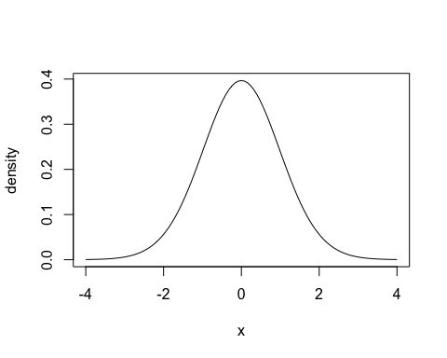

## 2. Find the 75th percentile for the t-distribution with 44 degrees of freedom (df=44). Report your answer as t(p;df)=q, filling in values for p,df and q.

qt(p= .75, df= 44)

## [1] 0.6801065

# t(.75;44)=.680

## 3. Consider a t-distribution with df=44. 96% of values will fall between which two values of t (that is find the values that satisfy P(______<t(44)<______=0.96)? Report both answers as t(p;df)=q.

qt(p= .02, df= 44)

## [1] -2.116438

# t(.02;44)=-2.11  
  
qt(p= .98, df= 44)

## [1] 2.116438

#t(.98;44)=2.11  
  
# P(-2.11 <t(44)< 2.11= .96)

## 4. Consider a t-distribution with df=44. Find P(t(44)≤-1.5).

pt(q=-1.5, df=44)

## [1] 0.07037815

## 5. Consider a t-distribution with df=44. Find P(t(44)≥2).

pt(q=2, df= 44)

## [1] 0.9741517

# Part 2: Descriptive Statistics and Basic Graphs

getwd()

## [1] "/Users/brookewheeler/Desktop/Regression/Labs"

nationals <- read.table("../Data/nationalsdata2014.csv", header = TRUE, sep = ",")  
  
nationals %>%  
 select(Salary) -> salary  
salary

## Salary  
## 1 20571429  
## 2 14000000  
## 3 8600000  
## 4 7500000  
## 5 7200000  
## 6 6500000  
## 7 6500000  
## 8 5875000  
## 9 5000000  
## 10 3975000  
## 11 3500000  
## 12 3450000  
## 13 3000000  
## 14 2700000  
## 15 2150000  
## 16 2095000  
## 17 1675000  
## 18 1350000  
## 19 1250000  
## 20 950000  
## 21 900000  
## 22 540850  
## 23 506100  
## 24 504300  
## 25 501400

## histogram

summary(salary)

## Salary   
## Min. : 501400   
## 1st Qu.: 1250000   
## Median : 3000000   
## Mean : 4431763   
## 3rd Qu.: 6500000   
## Max. :20571429

hist(nationals$Salary, xlab = "Salary (USD)", main = "Histogram of 2014 Salaries")

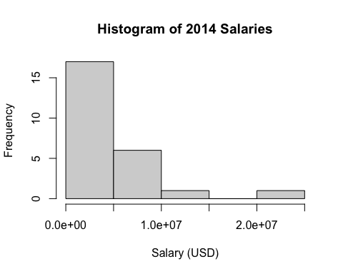

## boxplot

boxplot(nationals$Salary, horizontal = TRUE, main = "Boxplot of 2014 Salaries")

