Computer Architecture course,

Quantum Computing part,

a.y. 2021/2022

6/06/2022

**Exercise 1**

Given the following quantum circuit, compute all the intermediate 2-qubit states $\left|ψ_{1}\right\rangle ,\left|ψ_{2}\right\rangle ,\left|ψ_{3}\right\rangle ,\left|ψ_{4}\right\rangle$ and the final measurement probabilities (the measurement is along the standard basis $\{\left|00\right\rangle ,\left|01\right\rangle , \left|10\right\rangle ,\left|11\right\rangle \}$).

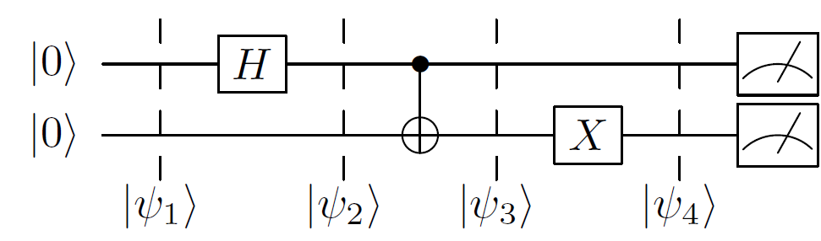

The student can **optionally** implement the above circuit using the Qiskit platform and compare the results obtained theoretically with those estimated by the *qasm_simulator*.

Recall that:

$$H= \frac{1}{\sqrt{2}}\left[\begin{matrix}1 & 1 \\ 1 & -1\end{matrix}\right], X= \left[\begin{matrix}0 & 1 \\ 1 & 0\end{matrix}\right]$$