# Overview

Deploying machine learning algorithms into an IT production environment is a challenging task to undertake due to the inherit complexity in setting up an iterative cyclic pipeline. In this paper, a novel approach for for deploying ML applications is presented; loosely based on the Cross-Industry Standard Process for Data Mining (CRISP-DM) as shown in Figure 1.

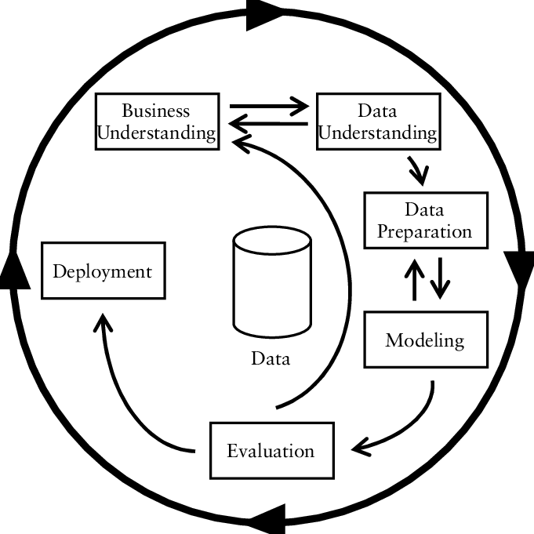Illustration 1: CRISP-DM

The main goal is to simplify the deployment process by imagining a simple architecture that would allow for continuous integration and deployment of ML applications; and allowing separate teams to collaborate efficiently by decoupling system dependencies using containerized solutions (Kubernetes / Docker).

## Approach

In order to adhere to an agile solution, only readily available resources and systems will be used; listed below.

|  |  |
| --- | --- |
| **Requirment** | **Tool** |
| **Containerization** | Docker |
| **In Memory Database** | Redis |
| **Scalability** | Kubernetes |

## Architecture

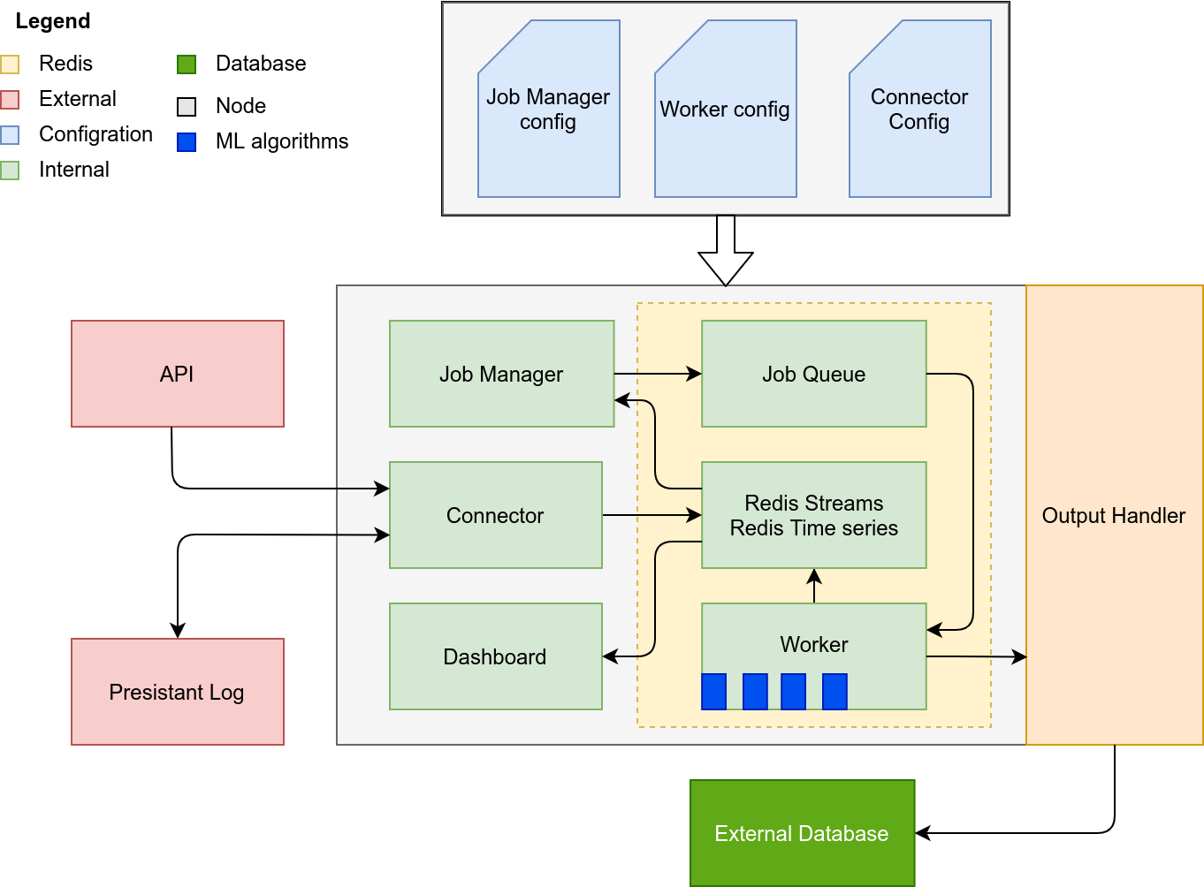

**Connector**: Pulls batch data from an API, inserts only new records to the streamed

**Job Manager**: Compares the event time of the last processed record and new records, if a time delta condition is matched, a new job is deployed

**Job** **Queue**: A simple redis job queue that holds information regarding jobs that need to be deployed

**Worker**: a set of workers with special ML functions that can monitor the job queue to process data based on the request of the job manager.

**Dashboard**: a containerized Bokeh (python) dashboard server

# Code Documentation

## Connector

The connector component is written purely in python. It connects to a dummy external (Sensibo) API using the OpenAPI standard. Passing configuration to the program is handled by the python3 Confuse Library. The code below shows the init function to the connector class.

### Initialization:

def __init__(self):

# get current working directory

cwd = os.getcwd()

logging.warn('Current Working Directory: {0}'.format(cwd))

self.MSEC=1

self.SEC=self.MSEC*1000

self.MIN=60*self.SEC

self.HOUR=60*self.MIN

self.DAY=24*self.HOUR

# When deploying this container, connector name must be specified as

# an enviroment variable in order to pull the configuration

try:

if 'CONNECTORNAME' in os.environ:

logging.info('Connector name: {0}'.format(os.environ['CONNECTORNAME']))

self.appname=os.environ['CONNECTORNAME']

self.config=confuse.LazyConfig(self.appname)

logging.warn('Configuration enviroment loaded\nDetected Keys : {0}'.format(self.config.keys()))

if self.config.keys()==[]:

logging.warn('No keys detected, please ensure that a configmap is configured.')

self._debug_config()

else:

raise ValueError('Enviroment variable not set: CONNECTORNAME')

except ValueError as e:

exit(e)

# Log File Detection

filename=self.config['LOG_DIR'].get()

self.key=self.config['DATABASE_KEY'].get()

if os.path.exists(filename):

logging.warn('Log File Detected!')

# Initialize the API client

self.api_instance=self._init_api()

# Intialize Redis Time Series Client

self.rts=self._init_rts()

# Create a key if it doesnt exists

try:

self.rts.create(self.key,retention_msecs=7*self.DAY)

except ResponseError as e:

s = str(e)

logging.warning(s)

pass

First the current working directory for the connector is printed out in order to help in debugging the program once deployed in a kubernetes container. Second, some constants are defined for defining time values for the redis time series structure.

The connector/application name is then queried in the environment variables. This variable is critical as it sets the directory for the configuration file. [*./config/appname*].

**Note: when mounting a configmap using kubernetes, the directories must match.**

Next, configuration variables are loaded such as the log file directory and redis database key that data will be streamed to. Finally the API client is initialized and a redis connection is established.

### Pulling Data:

def pull(self):

try:

HistoricalData, _, _=self.api_instance.get_pods_hist_with_http_info('MK3RxMtR',

days=self.config['days'].get(int))

temperature=HistoricalData.result.temperature

parse_time=lambda datetime_str: int(mktime(datetime.strptime(datetime_str,"%Y-%m-%dT%H:%M:%SZ" ).timetuple()))

temperature_value,temperature_time=zip(*[[x.value,parse_time(x.time)] for x in temperature])

except:

logging.warn('-----------------------Connection Error-----------------------')

exit('CRITICAL ERROR')

finally:

return temperature_time,temperature_value

In this application, the data consists of time series data. We query the API and return a tuple that contains two values, Time (unix epoch) and value (float). This element can be modified to accommodate connecting to different systems other than REST APIs.

### Pushing Data

def push(self):

stream=self.config['STREAM'].get()

filename=self.config['LOG_DIR'].get()

if os.path.exists(filename):

with open(filename,'r') as log:

# open log file and grab the id of the last messege

last_line = log.readlines()[-1]

# query and grab the last timestamp and parse it

last_record=con.rts.xrevrange(stream,min='-',max=last_line,count=1)

if last_record==[]:

logging.critical('log file exists; last id cannot be recoverd from stream.')

exit('critical ERROR')

last_time=last_record[0][1]['time']

# pull new data

time,temp=con.pull()

#compare new data with previously consumed timestamp

idx = [i for i,x in enumerate(time) if x>int(last_time)]

# if the new data has new samples parse it and update the log file

if idx!=[]:

new_time=time[idx[0]::]

new_temp=temp[idx[0]::]

ID=[con.rts.xadd(stream, dict(temp=x,time=y)) for x,y in zip(new_temp,new_time)]

out=[(self.key,time,value) for time,value in zip(time,temp)]

self.rts.madd(out)

with open(filename, 'a') as log:

log.write(os.linesep+ID[-1])

logging.warn('Records added: {0}'.format(len(ID)))

else:

logging.warn('No new records')

# if the log file is missing, create a new one and pull data

else:

logging.warn('Could not locate log file, pulling data ...')

os.makedirs(os.path.dirname(filename), exist_ok=True)

time,temp =con.pull()

ID=[con.rts.xadd(stream, dict(temp=x,time=y)) for x,y in zip(temp,time)]

out=[(self.key,time,value) for time,value in zip(time,temp)]

self.rts.madd(out)

with open(filename, 'w') as log:

log.write(ID[-1])

In order to push the data to redis, a the following steps are taken to maintain the offset.

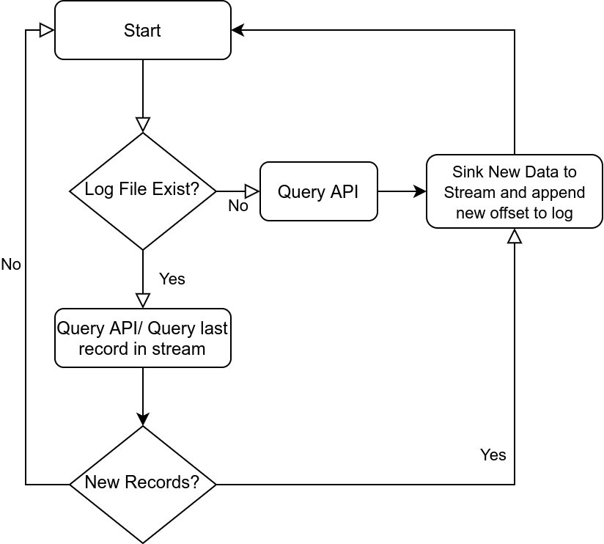

This logic is reflected by the push function in the previous page.

In case a log file exists and no data is available in the stream. A critical error is raised. This could mean that the endpoints are not setup correctly or the stream has been corrupted. Furthermore, the data is pushed both to redis streams as and redis time series struct in order to both maintain the state and the ability to query the timeseries efficiently for later use cases.

### Main function

The program is scheduled run every two minutes (or any configurable value) as shown below.

if __name__=="__main__":

con=connector()

import schedule

import time

schedule.every(2).minutes.do(con.push)

while True:

schedule.run_pending()

time.sleep(1)

## Job manager

def start(self,start_time):

self.start_time=self.config['START_TIME'].get()

self.stream=self.config['STREAM'].get()

self.stream_log_filename=self.config['STREAM_LOG_DIR'].get()

self.proc_log_filename=self.config['PROC_LOG_DIR'].get()

if os.path.exists(self.stream_log_filename) & os.path.exists(self.proc_log_filename):

with open(self.stream_log_filename,'r') as stream_log,open(self.proc_log_filename,'r') as proc_log:

# read and update stream pointer and record and read stream

self.stream_pointer=stream_log.readlines()[-1]

self.new_records=self.rts.xread({self.stream: self.stream_pointer},100,1*self.SEC)

if self.new_records!=[]:

# grab proc record and pointer

self.proc_pointer=proc_log.readlines()[-1]

self.proc_record=self.rts.xrange(self.stream,min=self.proc_pointer,max=self.proc_pointer,count=1)

self.proc_record=self.proc_record[0]

self.stream_record=self.new_records[0][1][-1]

self.stream_pointer=self.stream_record[0]

# log how many new records were read from the stream

n_records=len(self.new_records[0][1])

# save the stream pointer

with open(self.stream_log_filename, 'a') as log:

log.write(os.linesep+self.stream_pointer)

logging.warn('Records added: {0}'.format(n_records))

# invoke the job creation

self.create(self.frequency)

else:

logging.warning('No New Records')

else:

logging.warning('Could not locate log files, scaning all available \

data in the stream and deploying redis jobs from the beginning of the stream')

# os.makedirs(os.path.dirname(filename), exist_ok=True)

# consume the stream from the beggining

self.new_records=self.rts.xread({self.stream: '0-0'},15,0)

#### drop them into the redis time sereis!##################

# grab the data from the latest record

self.stream_record=self.new_records[0][1][-1]

# grab the data from the earliest record

self.proc_record=self.new_records[0][1][0]

# create a pointer for the end of the stream

self.stream_pointer=self.stream_record[0]

#create a pointer for the jobs at the beggining of the stream

self.proc_pointer=self.proc_record[0]

# open the log file

with open(self.stream_log_filename,'w') as stream_log,open(self.proc_log_filename,'w') as proc_log:

# save the location of the pointer processing

stream_log.write(self.stream_pointer)

proc_log.write(self.proc_pointer)

# invoke the job creation function

self.create(self.frequency)

The job manager has two main functions:

1. Deploy jobs if new records are detected in the stream

2. Maintain the processing record

The jobs are deployed based on event time. It can be configured to deploy a job based on the time delta between events. The logic is very similar to the connector with the addition of pointers that indicate when the last job was deployed and the current status of the stream.

If a log file for the stream exists. The stream is consumed and the stream pointer is updated. Then the processing log is accessed and the record that corresponds to the last processed job is pulled. The event time is compared between the last processed record and the stream location. If the time delta condition is satisfied. A job is deployed and the processing pointer is updated.

In case a processing log file doesn't exist the stream is consumed incrementally and jobs are deployed until the end of the stream. This technique ensures that in the event of failure, all jobs are re-deployed. Furthermore, the start time can be used to override the processing log and start deploying jobs at a specified time.

Notice that a job is deployed to redis queue via reference. This is done because the job manager does not contain the source code for the deployed job. This adds flexibility where multiple specialized workers can be deployed and called based on the required job via reference.

def create(self,k):

# open the processing log

with open(self.proc_log_filename,'a') as proc_log:

# iterate through the records and create a job based on k

for i,x in enumerate(self.new_records[0][1]):

t=int(x[1]['time'])

t0=int(self.proc_record[1]['time'])

if (t-t0)>=k:

self.deploy_job(self.start_time,t,t0)

# update the location of the processing pointer

self.proc_record=self.new_records[0][1][i]

self.proc_pointer=self.proc_record[0]

proc_log.write(os.linesep+self.proc_pointer)

def deploy_job(self,target_time,t,t0):

''' logic: you can stop jobs from being deployed during fail event by supply the required start time'''

if t0>=target_time:

job = self.q.enqueue('prophet_algorithm.job.predict',args= (self.host,self.port,t0))

logging.warning('JOB DEPLOYED tdelta={0}, event time start: {1}'.format(t-t0,t0))

logging.warning(job)

## Worker

The worker is a simple Redis Queue worker. The jobs are invoked via reference. The reference represents the python file in the working directory.

from redis import Redis

from rq import Queue, Worker

from os import environ

redis = Redis(host=environ['REDIS_HOST'],port=environ['REDIS_PORT'])

queue = Queue(connection=redis)

worker = Worker([queue], connection=redis)

worker.work()