AI2AI Human Pilot — Data Report
First real-human Prolific pilot. Analytical sample = the 40 participants who received the final completion code. Exploratory / descriptive throughout — small N; no confirmatory claims. Snapshot 2026-05-15.
1. Sample & flow
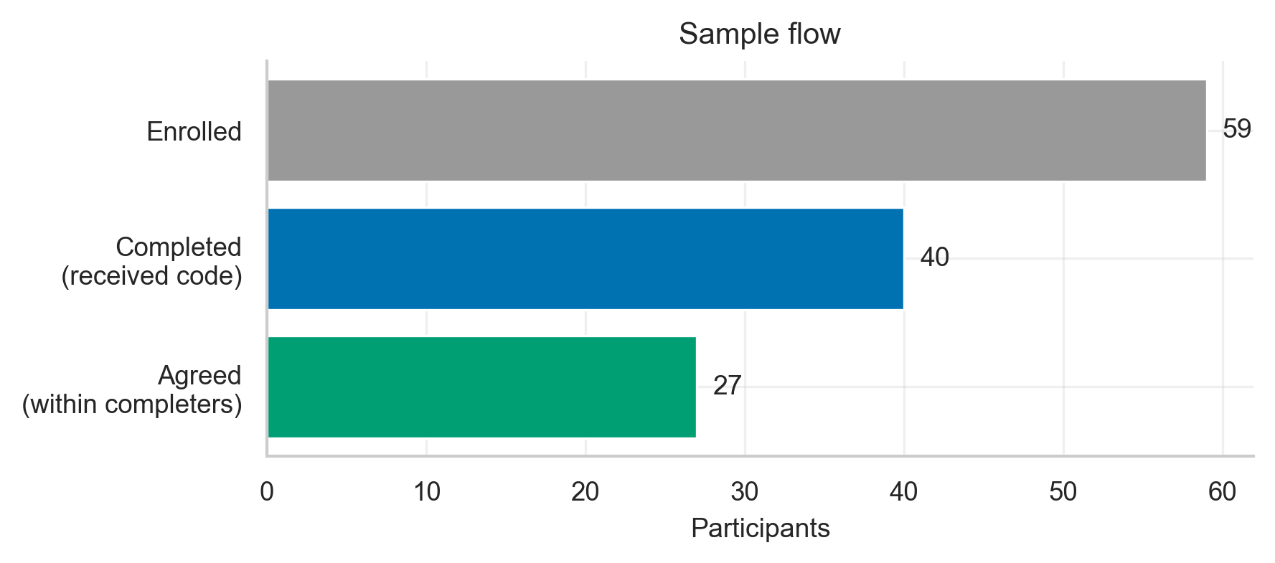
Figure 1.1 — Sample flow.
Of 59 enrolled, 40 received the completion code (the analytical sample); 27 of those reached an agreement. Non-completers are not analysed beyond this count.
Table 1.1 — Sample composition (mode × role × personality).
experiment_mode | role | opponent_personality | n
agent | buyer | easygoing | 4
agent | buyer | moderate | 3
agent | buyer | tough | 3
agent | seller | easygoing | 4
agent | seller | moderate | 2
agent | seller | tough | 4
human_buyer | buyer | easygoing | 3
human_buyer | buyer | moderate | 4
human_buyer | buyer | tough | 3
human_seller | seller | easygoing | 4
human_seller | seller | moderate | 4
human_seller | seller | tough | 2

The design is balanced at 10 participants per mode×role cell; opponent personality is roughly even (easygoing 15 / moderate 13 / tough 12).
2. Demographics
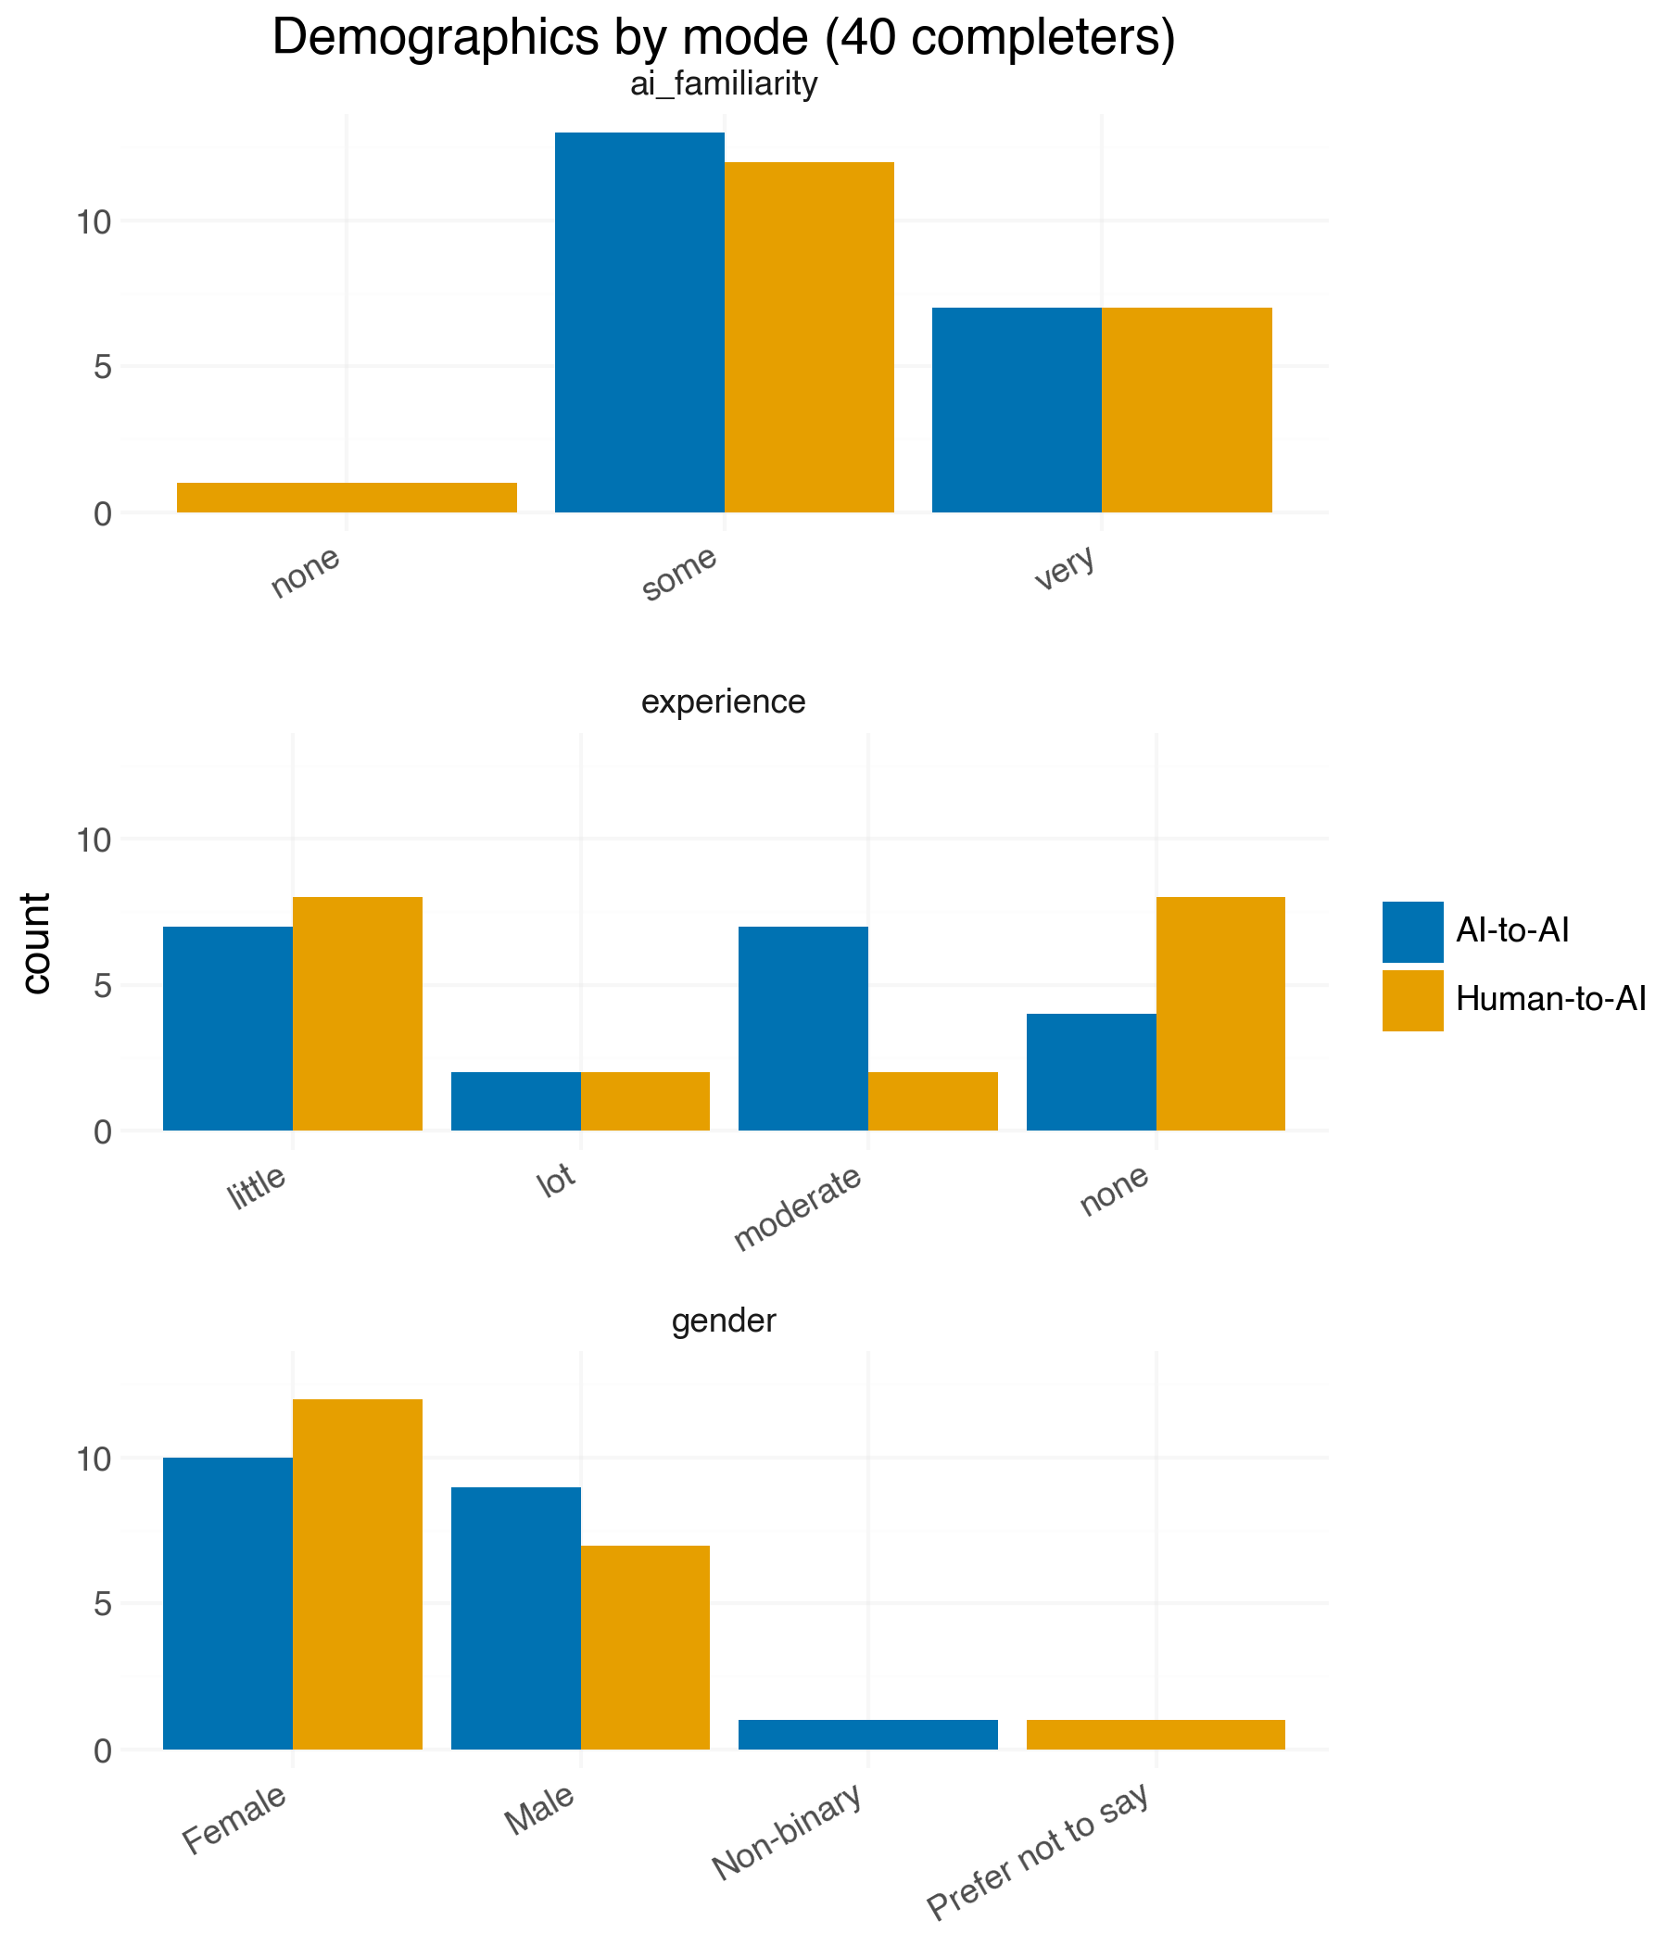
Figure 2.1 — Gender, experience, AI-familiarity by mode.
Demographic make-up is broadly similar across AI-to-AI and Human-to-AI arms, supporting comparability of the two groups.
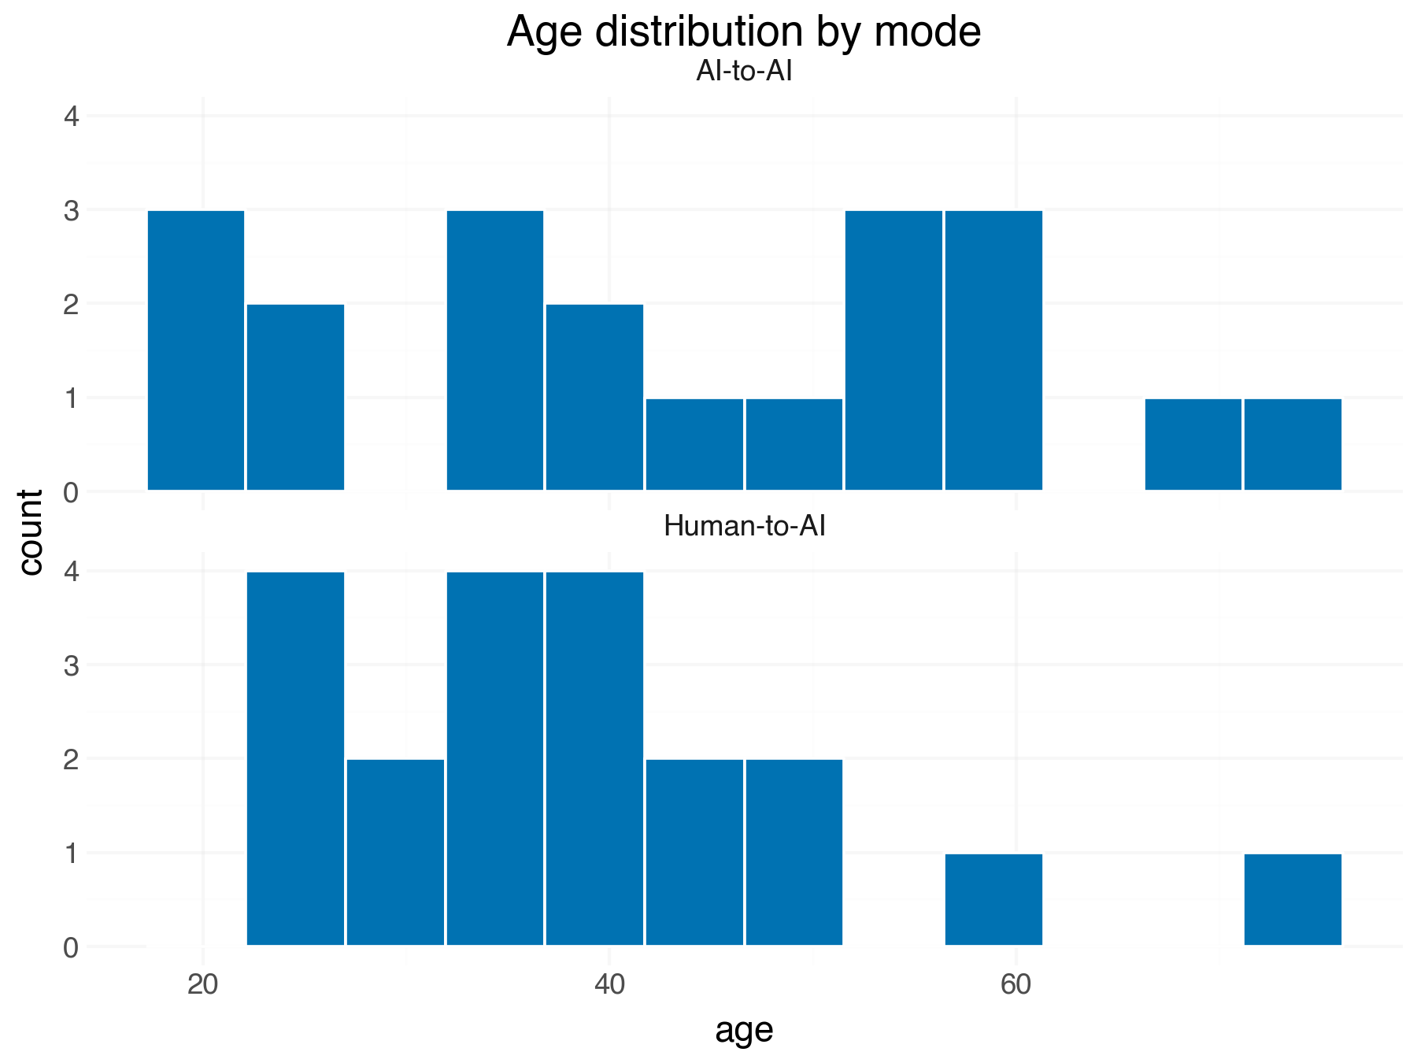
Figure 2.2 — Age distribution by mode.
Age spans 19–73 (mean ≈ 41). No gross age skew between arms.
Table 2.1 — Who participated (n, % per level).
variable | level | n | pct
gender | Female | 22 | 55.0
gender | Male | 16 | 40.0
gender | Prefer not to say | 1 | 2.5
gender | Non-binary | 1 | 2.5
experience | little | 15 | 37.5
experience | none | 12 | 30.0
experience | moderate | 9 | 22.5
experience | lot | 4 | 10.0
ai_familiarity | some | 25 | 62.5
ai_familiarity | very | 14 | 35.0
ai_familiarity | none | 1 | 2.5
age | mean (SD) | 40 | 41.0 (14.7)

Descriptive composition of the 40 completers.
3. Negotiation outcomes (descriptive)
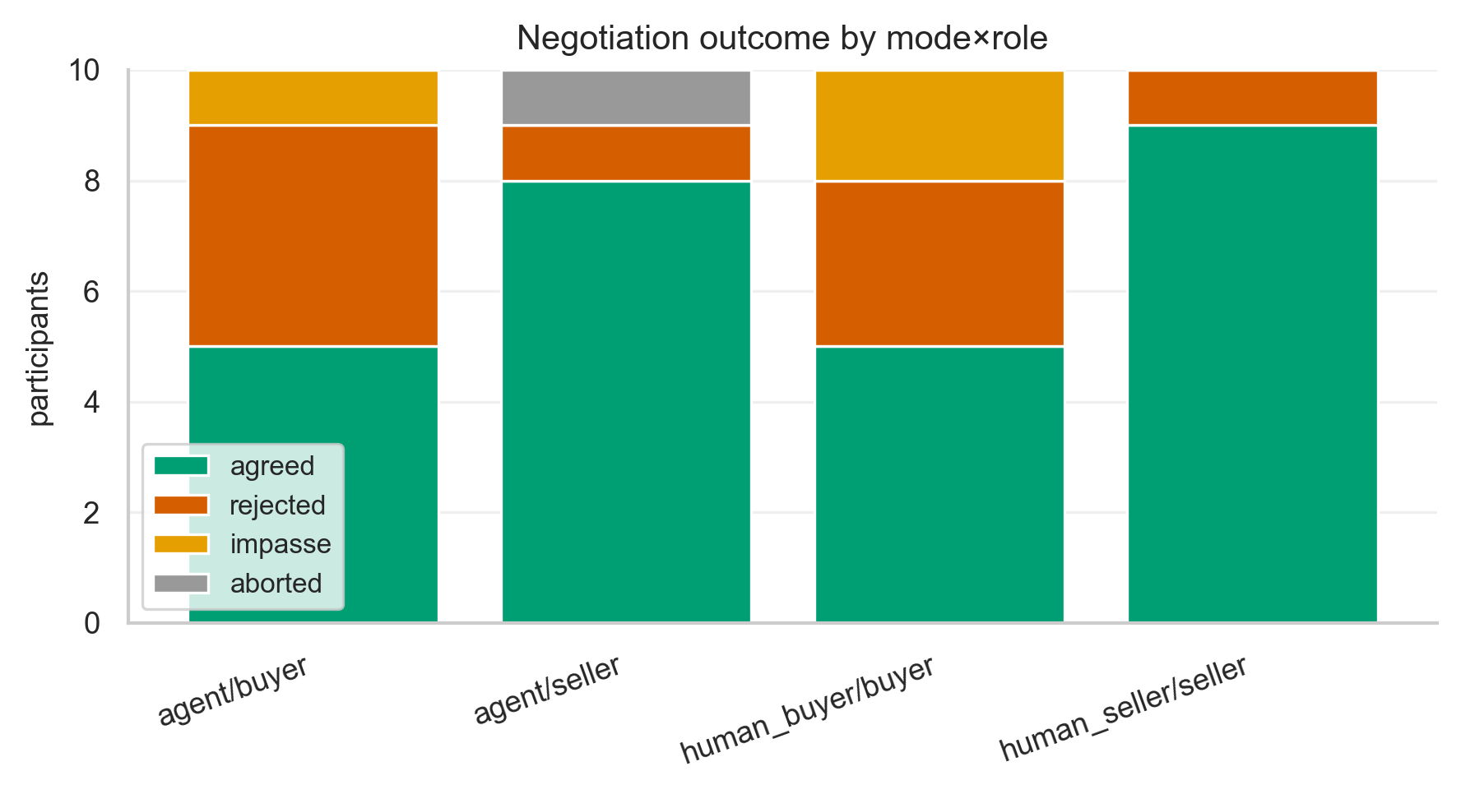
Figure 3.1 — Outcome type by mode×role.
Most negotiations reached agreement (27/40); rejections and impasses are spread across cells. Descriptive only — N too small per cell for inference here.
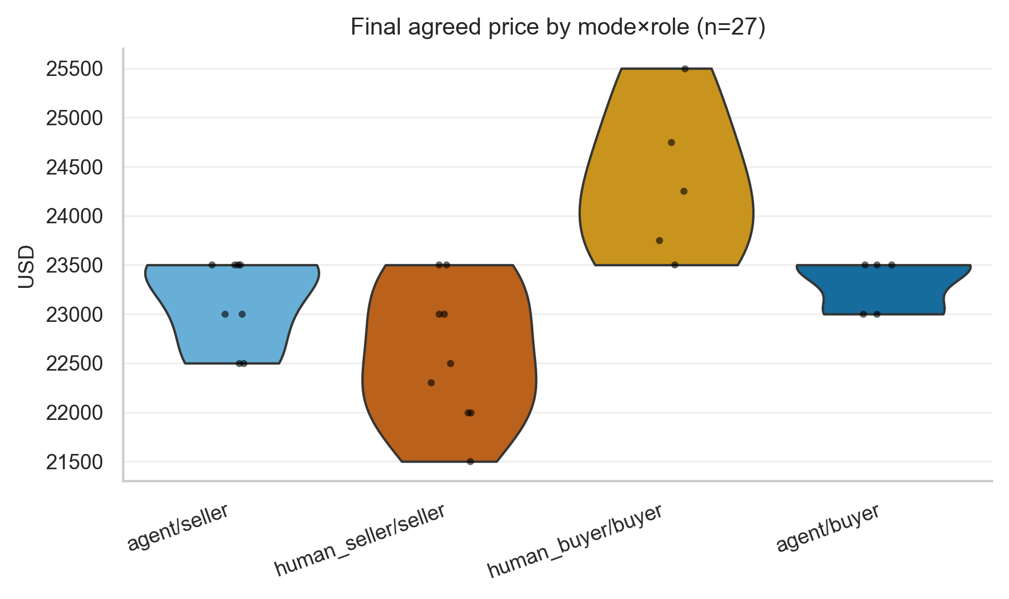
Figure 3.2 — Final agreed price by mode×role (n=27).
Agreed prices cluster in the $22–24k band; cell medians differ modestly. Treated as descriptive (no test at n≈7/cell).
Table 3.1 — Outcome descriptives by cell.
experiment_mode | role | n | agreement_rate | price_median | price_iqr | turns_median | time_median_s
agent | buyer | 10 | 0.5 | 23500.0 | 23000-23500 | 13.5 | 150.4195
agent | seller | 10 | 0.8 | 23250.0 | 22875-23500 | 16.0 | 163.6255
human_buyer | buyer | 10 | 0.5 | 24250.0 | 23750-24750 | 9.0 | 388.8565
human_seller | seller | 10 | 0.9 | 22500.0 | 22000-23000 | 9.5 | 349.4945

Agreement rate, price/turns/time medians per mode×role. No p-values in this section by design.
4. Post-experience survey (9 items)
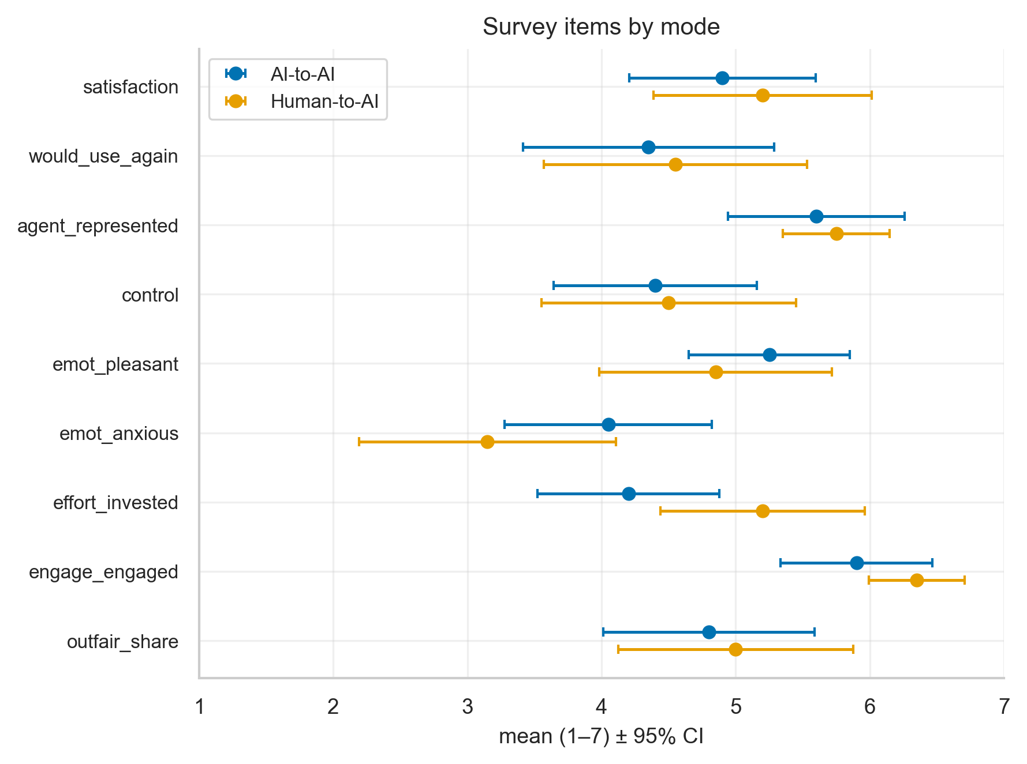
Figure 4.1 — Item means ± 95% CI by mode.
Item-level means with 95% CIs. CIs are wide at this N; overlap is the norm. Items reported individually (no subscales).
Table 4.1 — Per-item descriptives by mode.
item | mode2 | n | M | SD | Mdn | IQR
agent_represented | AI-to-AI | 20 | 5.6 | 1.5 | 6.0 | 5-7
agent_represented | Human-to-AI | 20 | 5.75 | 0.91 | 6.0 | 5-6
control | AI-to-AI | 20 | 4.4 | 1.73 | 5.0 | 3-6
control | Human-to-AI | 20 | 4.5 | 2.16 | 4.5 | 3-7
effort_invested | AI-to-AI | 20 | 4.2 | 1.54 | 4.5 | 3-5
effort_invested | Human-to-AI | 20 | 5.2 | 1.74 | 5.0 | 5-6
emot_anxious | AI-to-AI | 20 | 4.05 | 1.76 | 4.0 | 3-5
emot_anxious | Human-to-AI | 20 | 3.15 | 2.18 | 2.0 | 1-5
emot_pleasant | AI-to-AI | 20 | 5.25 | 1.37 | 6.0 | 5-6
emot_pleasant | Human-to-AI | 20 | 4.85 | 1.98 | 5.5 | 4-6
engage_engaged | AI-to-AI | 20 | 5.9 | 1.29 | 6.0 | 5-7
engage_engaged | Human-to-AI | 20 | 6.35 | 0.81 | 7.0 | 6-7
outfair_share | AI-to-AI | 20 | 4.8 | 1.79 | 5.0 | 4-6
outfair_share | Human-to-AI | 20 | 5.0 | 2.0 | 5.5 | 4-7
satisfaction | AI-to-AI | 20 | 4.9 | 1.59 | 5.0 | 4-6
satisfaction | Human-to-AI | 20 | 5.2 | 1.85 | 6.0 | 4-6
would_use_again | AI-to-AI | 20 | 4.35 | 2.13 | 5.0 | 3-6
would_use_again | Human-to-AI | 20 | 4.55 | 2.24 | 5.5 | 2-6

M, SD, median, IQR for each of the 9 v2 items, split AI vs Human.
5. Group comparisons (exploratory)
5A — Human-to-AI vs AI-to-AI (20 vs 20)
Agreement rate: AI-to-AI 65% vs Human-to-AI 70%; Fisher's exact p = 1.000 (OR = 0.80). Exploratory; small sample.
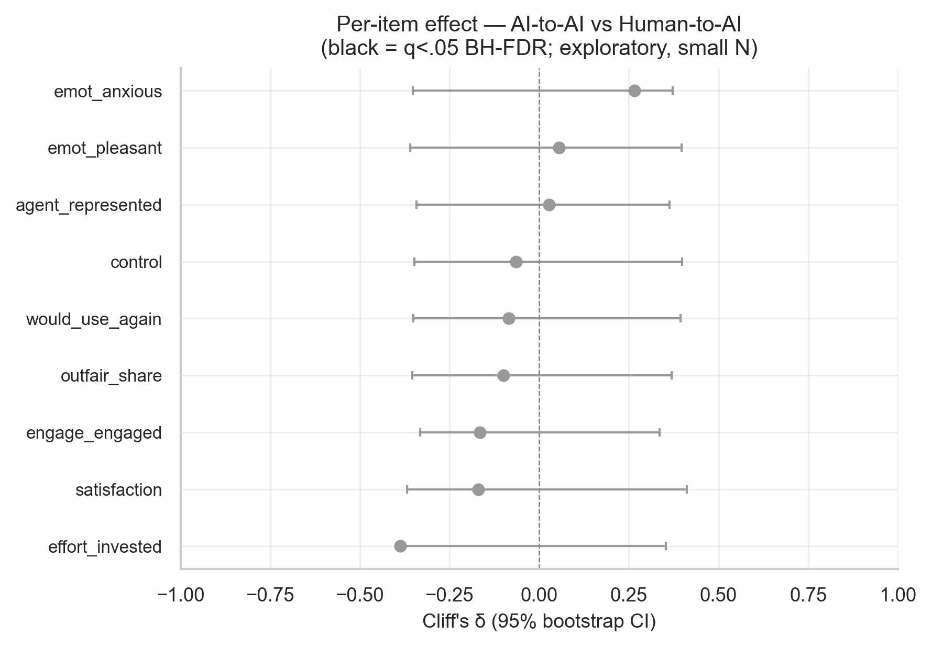
Figure 5A.1 — Per-item Cliff's δ, AI vs Human (BH-FDR).
Black points survive BH-FDR at q<.05; grey do not. Interpret as exploratory signal, not confirmation, given 20 per arm.
Table 5A.1 — Per-item δ, 95% CI, MW p, BH-FDR q.
item | n_a | n_b | delta | ci_lo | ci_hi | p_mw | q_bh
satisfaction | 20 | 20 | -0.17 | -0.369 | 0.411 | 0.354 | 0.796
would_use_again | 20 | 20 | -0.085 | -0.351 | 0.394 | 0.65 | 0.865
agent_represented | 20 | 20 | 0.028 | -0.343 | 0.363 | 0.888 | 0.888
control | 20 | 20 | -0.065 | -0.348 | 0.399 | 0.731 | 0.865
emot_pleasant | 20 | 20 | 0.055 | -0.36 | 0.396 | 0.769 | 0.865
emot_anxious | 20 | 20 | 0.265 | -0.353 | 0.373 | 0.15 | 0.676
effort_invested | 20 | 20 | -0.388 | -0.376 | 0.353 | 0.032 | 0.291
engage_engaged | 20 | 20 | -0.165 | -0.333 | 0.335 | 0.342 | 0.796
outfair_share | 20 | 20 | -0.1 | -0.354 | 0.369 | 0.591 | 0.865

Effect direction: positive δ ⇒ higher under AI-to-AI.
5B — Buyer vs Seller (20 vs 20)
Agreement rate: buyer 50% vs seller 85%; Fisher's exact p = 0.041 (OR = 0.18). Exploratory; small sample.
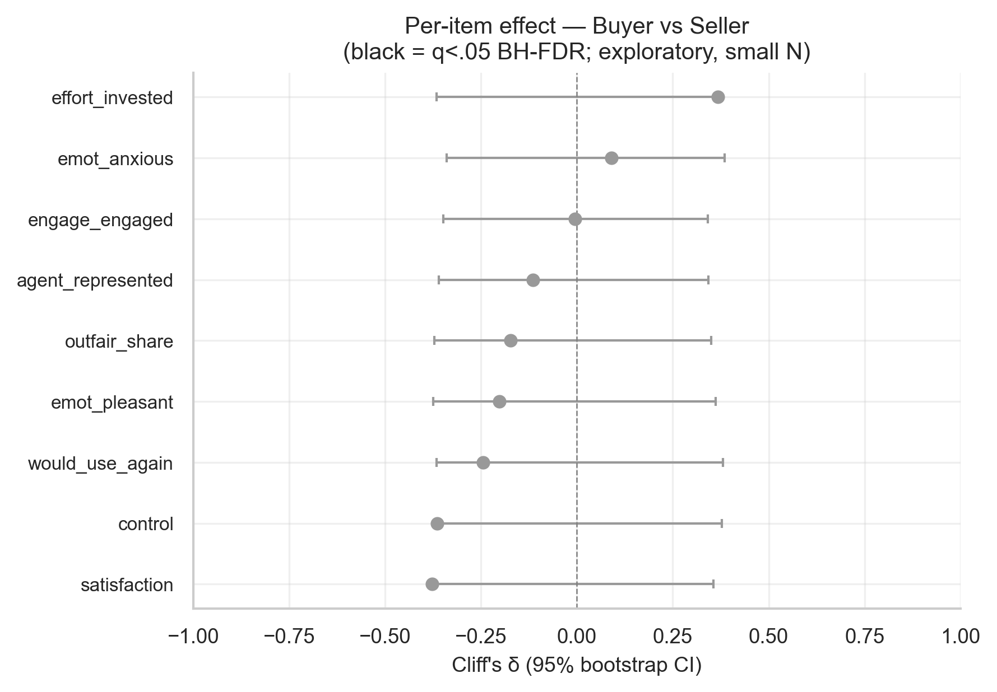
Figure 5B.1 — Per-item Cliff's δ, Buyer vs Seller (BH-FDR).
Same format as 5A.1. Positive δ ⇒ higher under buyer role.
Table 5B.1 — Per-item δ, 95% CI, MW p, BH-FDR q.
item | n_a | n_b | delta | ci_lo | ci_hi | p_mw | q_bh
satisfaction | 20 | 20 | -0.378 | -0.354 | 0.356 | 0.038 | 0.14
would_use_again | 20 | 20 | -0.245 | -0.366 | 0.381 | 0.183 | 0.411
agent_represented | 20 | 20 | -0.115 | -0.36 | 0.343 | 0.527 | 0.677
control | 20 | 20 | -0.365 | -0.368 | 0.378 | 0.047 | 0.14
emot_pleasant | 20 | 20 | -0.202 | -0.375 | 0.362 | 0.263 | 0.474
emot_anxious | 20 | 20 | 0.09 | -0.34 | 0.386 | 0.632 | 0.711
effort_invested | 20 | 20 | 0.368 | -0.366 | 0.365 | 0.042 | 0.14
engage_engaged | 20 | 20 | -0.005 | -0.348 | 0.341 | 0.988 | 0.988
outfair_share | 20 | 20 | -0.172 | -0.371 | 0.35 | 0.348 | 0.522

Role-based item differences, exploratory.
5C/5D — 4 groups & Mode×Role interaction
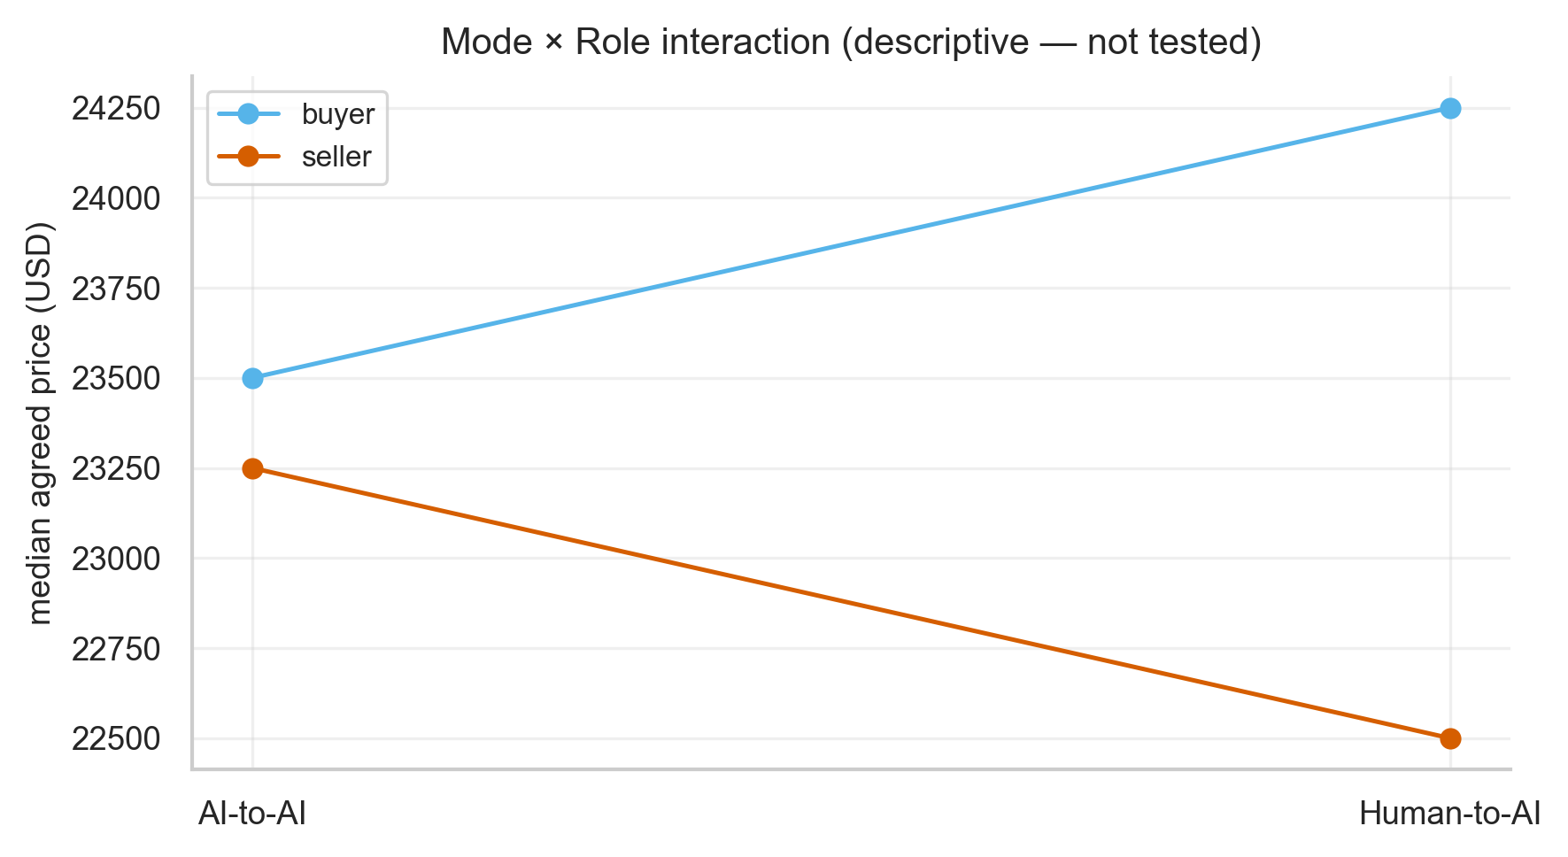
Figure 5D.1 — Mode × Role on median agreed price.
Descriptive interaction pattern only — the interaction is NOT tested (n≈7 agreed per cell). Main effects are the 20-vs-20 contrasts in 5A/5B.
6. Data quality & operational
Table 6.1 — Data-quality & operational metrics.
metric | value
participants with any clipboard/right-click attempt | 18
total clipboard/right-click events | 107
behavior prompts (agent modes) | 20
behavior prompt length median (chars) | 230

Clipboard/right-click attempts were blocked + logged; behaviour prompts captured for agent-mode completers.
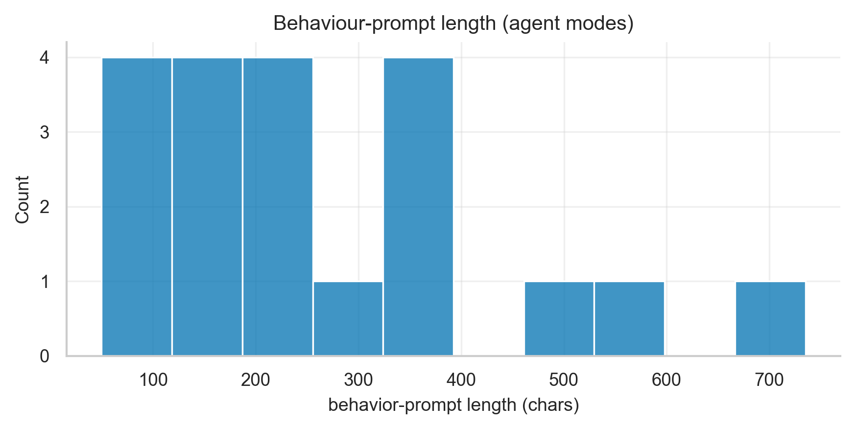
Figure 6.1 — Behaviour-prompt length (agent modes).
Distribution of authored agent-instruction lengths.
7. What you can do with this data
Table 7.1 — Analysable variables: now vs. when N grows.
variable | n | now | when_n_grows
experiment_mode (mode2) | 40 | descriptive + 20v20 exploratory test | powered mode contrast
role | 40 | descriptive + 20v20 exploratory test | powered role contrast
opponent_personality | 40 | descriptive only (≈13/level) | 3-group KW
final_price | 27 | descriptive (agreed only) | price modelling
9 survey items | 40 | per-item δ + CI, FDR (exploratory) | powered item tests + subscales
mode × role × personality | 40 | NOT analysable (cells 2-4) | 3-way once ≥~15/cell

At current N the report supports descriptives + the two 20-vs-20 exploratory contrasts. Powered cell-level and 3-way analyses require a larger sample.
8. Qualitative analysis
LLM-assisted coding disclosure: themes, taxonomy and comment sentiment were coded once on 2026-05-15 with claude-sonnet-4-6 against the fixed codebook. n=20 behaviour prompts / 20 comments. Codes are illustrative and hypothesis-generating, NOT theoretically saturated; no inter-rater reliability. The full coding sheet (qual_coding_sheet.csv) is committed for spot-checking.
8A — Strategy themes (behaviour prompts, inductive)
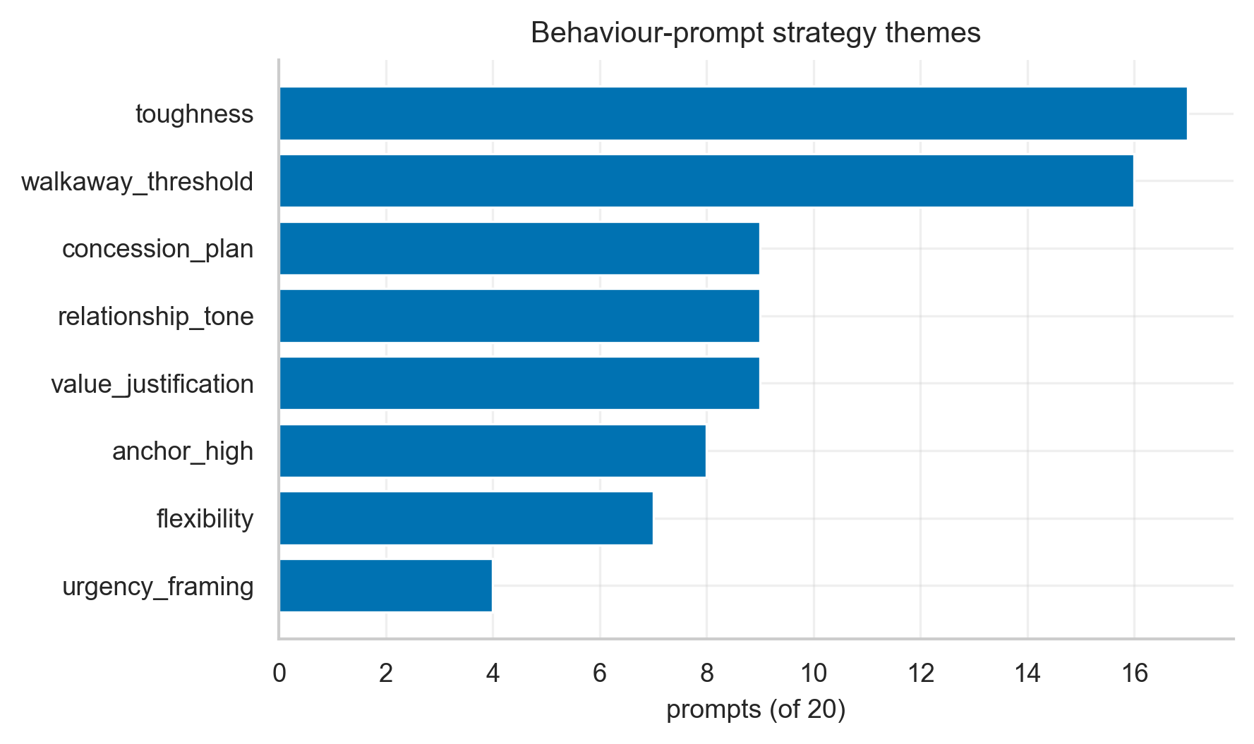
Figure 8A.1 — Theme prevalence across 20 agent-mode prompts.
How often each negotiation-strategy theme appears in participants' instructions to their delegated agent. Illustrative; n=20.
Table 8A.1 — Theme prevalence (count, %).
theme | n | pct
toughness | 17 | 85.0
walkaway_threshold | 16 | 80.0
concession_plan | 9 | 45.0
relationship_tone | 9 | 45.0
value_justification | 9 | 45.0
anchor_high | 8 | 40.0
flexibility | 7 | 35.0
urgency_framing | 4 | 20.0

Most-instructed strategies first.
8B — Strategy taxonomy (deductive)
Table 8B.1 — Taxonomy frequencies by role.
dimension | level | role | n
orientation | distributive | buyer | 9
orientation | distributive | seller | 7
orientation | integrative | buyer | 1
orientation | integrative | seller | 1
orientation | mixed | buyer | 0
orientation | mixed | seller | 2
anchor | high | buyer | 1
anchor | high | seller | 8
anchor | moderate | buyer | 6
anchor | moderate | seller | 0
anchor | none | buyer | 2
anchor | none | seller | 2
threshold_stated | yes | buyer | 7
threshold_stated | yes | seller | 8
threshold_stated | no | buyer | 3
threshold_stated | no | seller | 2
politeness_instructed | yes | buyer | 2
politeness_instructed | yes | seller | 6
politeness_instructed | no | buyer | 8
politeness_instructed | no | seller | 4
info_strategy | emphasize_value | buyer | 3
info_strategy | emphasize_value | seller | 6
info_strategy | conceal | buyer | 0
info_strategy | conceal | seller | 1
info_strategy | neutral | buyer | 7
info_strategy | neutral | seller | 3

Distributive vs integrative orientation, anchor strength, threshold/politeness/info-strategy — buyer vs seller counts. Descriptive; no test (n=20).
8C — Study-comment sentiment
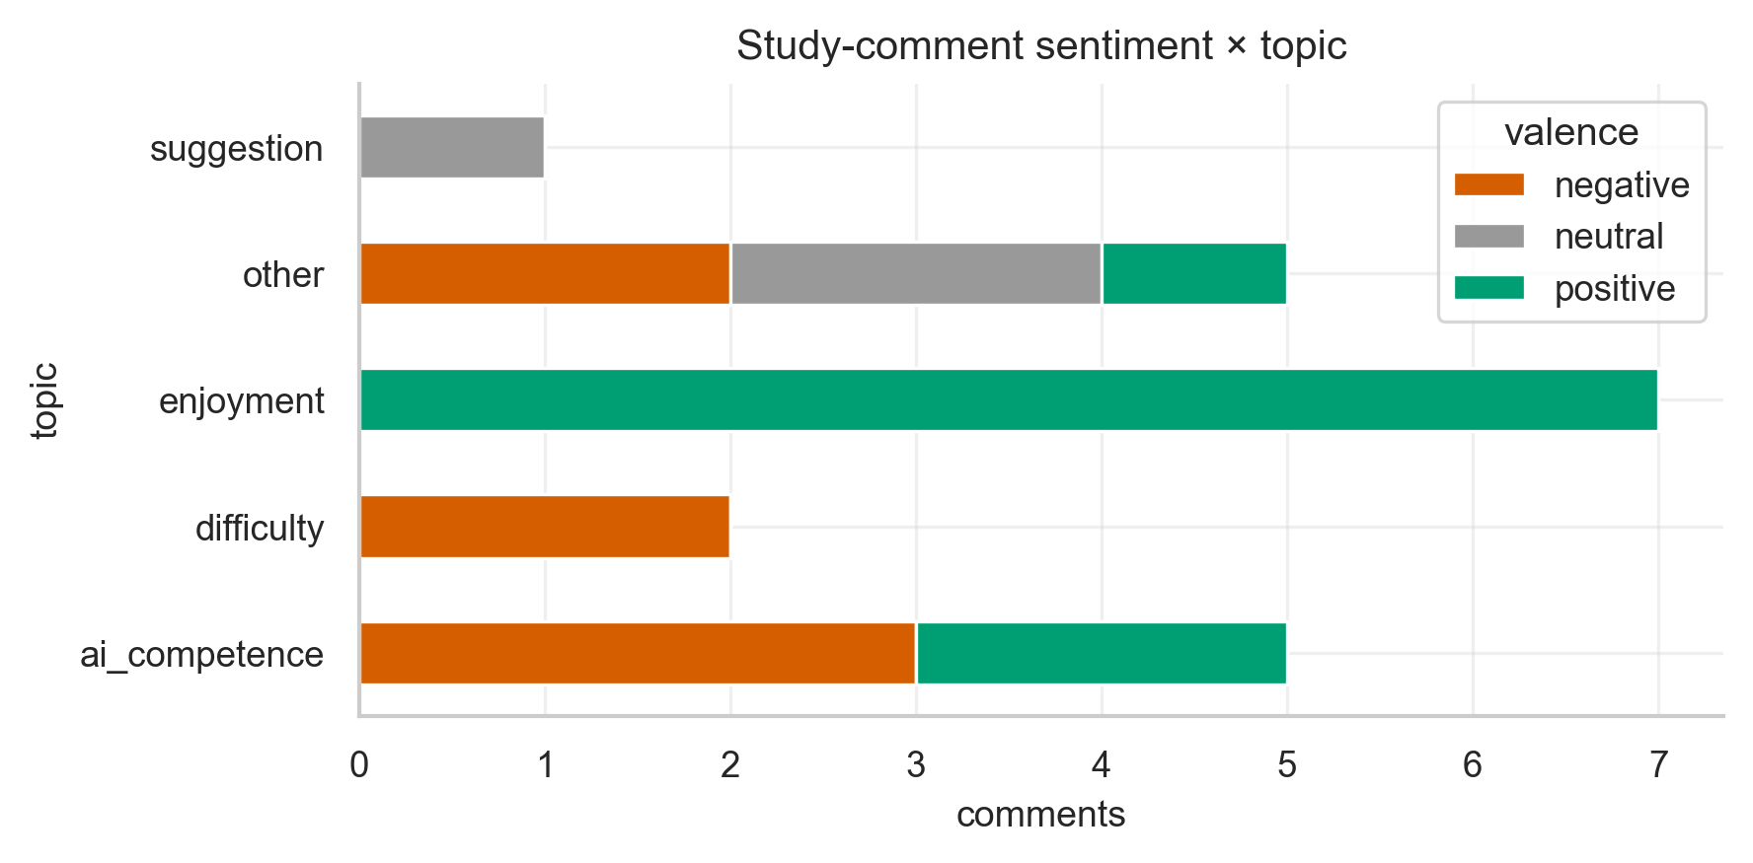
Figure 8C.1 — Comment valence × topic (n=20, all non-blank).
Tone and focus of the open-ended study comments.
8D — Human-turn language (deterministic)
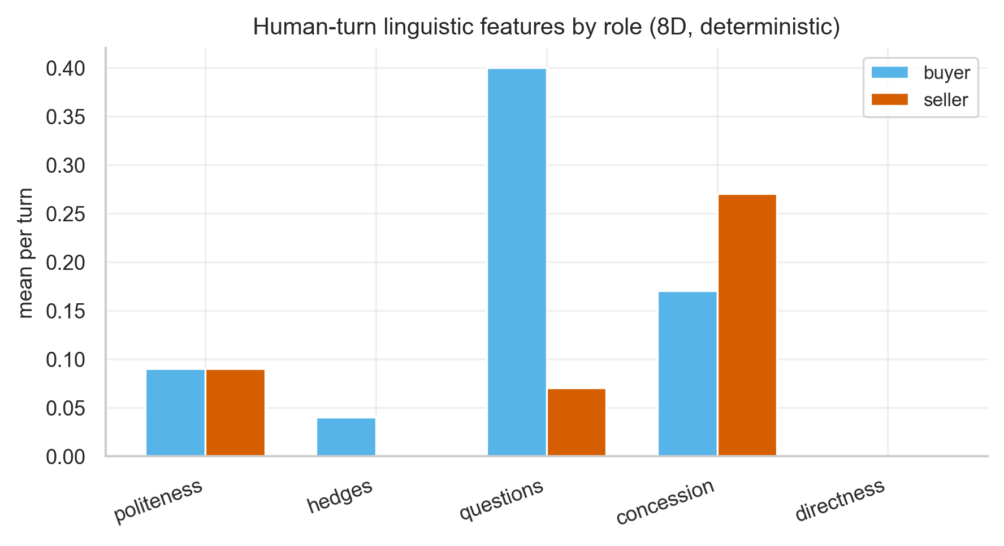
Figure 8D.1 — Linguistic features, buyer vs seller (human modes).
Politeness, hedging, questions, concession and directness per typed turn. Lexicon-based, fully reproducible, no LLM.
Table 8D.1 — Linguistic feature means by role.
role | n | char_len_med | politeness_mean | hedges_mean | questions_mean | concession_mean | directness_mean
buyer | 53 | 57.0 | 0.09 | 0.04 | 0.4 | 0.17 | 0.0
seller | 44 | 48.5 | 0.09 | 0.0 | 0.07 | 0.27 | 0.0

Per-turn means for human-mode participants.
8E — Qualitative × quantitative link
Table 8E.1 — Outcomes by strategy / sentiment.
link | group | n | price_median
price~orientation | distributive | 9 | 23000.0
price~orientation | integrative | 2 | 23500.0
price~orientation | mixed | 2 | 23000.0
satisfaction~comment_sentiment | negative | 7 | 4.0
satisfaction~comment_sentiment | neutral | 3 | 5.0
satisfaction~comment_sentiment | positive | 10 | 6.5

Agreed-price median by prompt orientation; satisfaction median by comment sentiment. Descriptive, illustrative, hypothesis-generating only — n is small.

