Delegating a Negotiation to Artificial Intelligence: A Comprehensive Four-Experiment Exploratory Analysis of the AI2AI Human Pilot

Faraz Ghodratizadeh
ESSEC Business School
AI2AI Negotiation Platform — Comprehensive Pilot Report

Author Note
Conducted at ESSEC Business School under the supervision of Amir Sepehri (ESSEC Business School).
Comprehensive exploratory analysis of the first human pilot. This is a small-sample legacy pilot (n = 10 per experiment). Opponent personality was randomised, not controlled; the economic-utility and judge-score tables are empty; no attention check was recorded. Every inferential statement is exploratory and hypothesis-generating — never a pre-registered confirmatory result.
Correspondence: Faraz Ghodratizadeh, ESSEC Business School (b00833647@essec.edu).

Abstract
When a person can delegate a negotiation to an artificial-intelligence agent instead of conducting it themselves, what happens to the deal and to how they feel about it? This report is a comprehensive, exploratory analysis of the first human pilot of the AI2AI platform — a controlled single-issue price negotiation over a used Toyota Camry. The design crosses Mode (delegated; direct) with Role (buyer; seller), yielding four experiments (X1 delegated-buyer, X2 delegated-seller, X3 direct-buyer, X4 direct-seller), each n = 10. Across forty-five analysis families the report presents every measure at four levels: each experiment one-by-one, the 2×2 factorial with structured pairwise contrasts, the pooled sample, and an integrative review. Of 40 completers, 27 reached agreement; settlements concentrated inside the zone of possible agreement (19/27 (70%)). The primary measure, satisfaction, showed a small Mode effect (p = .354, Cliff's δ = −.17). This is a small-sample legacy pilot (n = 10 per experiment). Opponent personality was randomised, not controlled; the economic-utility and judge-score tables are empty; no attention check was recorded. Every inferential statement is exploratory and hypothesis-generating — never a pre-registered confirmatory result.
Keywords: human–AI negotiation, delegation, automated negotiation, algorithm aversion, four-experiment design, exploratory pilot

Table of Contents

(In Word: select all and press F9 to populate page numbers.)

List of Tables

(In Word: select all and press F9 to populate page numbers.)

List of Figures

(In Word: select all and press F9 to populate page numbers.)

Part I — Foundations

Data Provenance
The analysed database is the frozen snapshot data/ai2ai-human-pilot-2026-05-15.db. Reservation values were verified uniform from every session's scenario pack. Two base tables (outcomes, scores) are empty and cannot be analysed.
Table . Participant Flow
Stage | n | %
Enrolled | 59 | 100%
Consented | 58 | 98%
Completed (analysed) | 40 | 68%
Reached agreement | 27 | 68%

The Four-Experiment Framework
Table . The Four Experiments (Mode × Role cells)
Experiment | Label | Mode | Role | n
X1 | X1 · Delegated · Buyer | delegated | buyer | 10
X2 | X2 · Delegated · Seller | delegated | seller | 10
X3 | X3 · Direct · Buyer | direct | buyer | 10
X4 | X4 · Direct · Seller | direct | seller | 10
Note. Every applicable analysis is reported one-by-one (each experiment), as a 2×2 factorial with structured pairwise contrasts, pooled overall, and an integrative review.

Methodology

Participants
Fifty-nine participants enrolled via Prolific; 40 received the completion code and constitute the analysed sample, balanced at 10 per experiment (X1–X4). No participant is flagged excluded or test data; the attention-check field was never populated.

Design
A 2 (Mode: delegated, direct) × 2 (Role: buyer, seller) between-subjects factorial defines the four experiments. Opponent personality (easygoing, moderate, tough) was randomised and is unbalanced across cells — an uncontrolled covariate, not a designed block; no clean three-way is possible.

Materials and Apparatus
A single-issue distributive price negotiation over a 2023 Toyota Camry. Reservation values were verified uniform from the scenario pack: buyer aspiration $21,500, buyer ceiling $23,500; seller listing $25,500, seller floor $22,500; ZOPA $22,500–$23,500 (a fixed $1,000 pie). Delegated participants briefed an LLM agent that negotiated AI-to-AI; direct participants typed turns against the LLM. An orchestrator mediated turns.

Measures
Nine post-experience 1–7 items (satisfaction is primary), negotiation outcomes, a derived distributive-surplus model, transcript-based process metrics, 6,601 client instrumentation events, mode-specific behaviour, and open text. Utility and judge-score tables are empty and excluded.

Data-Analysis Approach
Modern, nonparametric, effect-size-focused: Mann–Whitney with Cliff's δ and bootstrap CIs (scipy.stats.bootstrap), Scheirer–Ray–Hare 2×2, Kruskal–Wallis (opponent, sensitivity), Fisher's exact, Spearman, Cronbach's α, Benjamini–Hochberg, Bayesian t and TOST equivalence (pingouin), survival (lifelines), clustering/factor structure (scikit-learn). The quad runner applies the four levels uniformly. Deterministic and offline. This is a small-sample legacy pilot (n = 10 per experiment). Opponent personality was randomised, not controlled; the economic-utility and judge-score tables are empty; no attention check was recorded. Every inferential statement is exploratory and hypothesis-generating — never a pre-registered confirmatory result.

Honesty & Limitations Charter
This is a small-sample legacy pilot (n = 10 per experiment). Opponent personality was randomised, not controlled; the economic-utility and judge-score tables are empty; no attention check was recorded. Every inferential statement is exploratory and hypothesis-generating — never a pre-registered confirmatory result.

Part II — The Four Experiments (One by One)
Each experiment receives the identical metric battery below, presented side-by-side so X1–X4 are directly comparable. This is the ‘distinct / one-by-one’ lens; factorial, pooled, and review lenses follow in Parts III–IV.
Table . Standardised Experiment Dossier (X1–X4, side by side)
Metric | X1 | X2 | X3 | X4
n | 10 | 10 | 10 | 10
Agreement rate | 50% | 80% | 50% | 90%
Settlement Mdn (USD) | 23500 | 23250 | 24250 | 22500
Satisfaction M | 4.60 | 5.20 | 4.40 | 6.00
Would-use-again M | 3.70 | 5.00 | 4.20 | 4.90
Perceived control M | 4.30 | 4.50 | 3.40 | 5.60
Anxious affect M | 4.90 | 3.20 | 2.60 | 3.70
Outcome fairness M | 4.60 | 5.00 | 4.70 | 5.30
Turns Mdn | 14 | 16 | 9 | 10
Active time Mdn (s) | 635 | 682 | 630 | 504
Concessions Mdn | 2 | 4 | 2 | 1
Anchor dist Mdn | 0 | 0 | 500 | 2250
Note. Per-experiment battery; n = 10 each, so values are descriptive.

Figure . Outcome type by experiment.
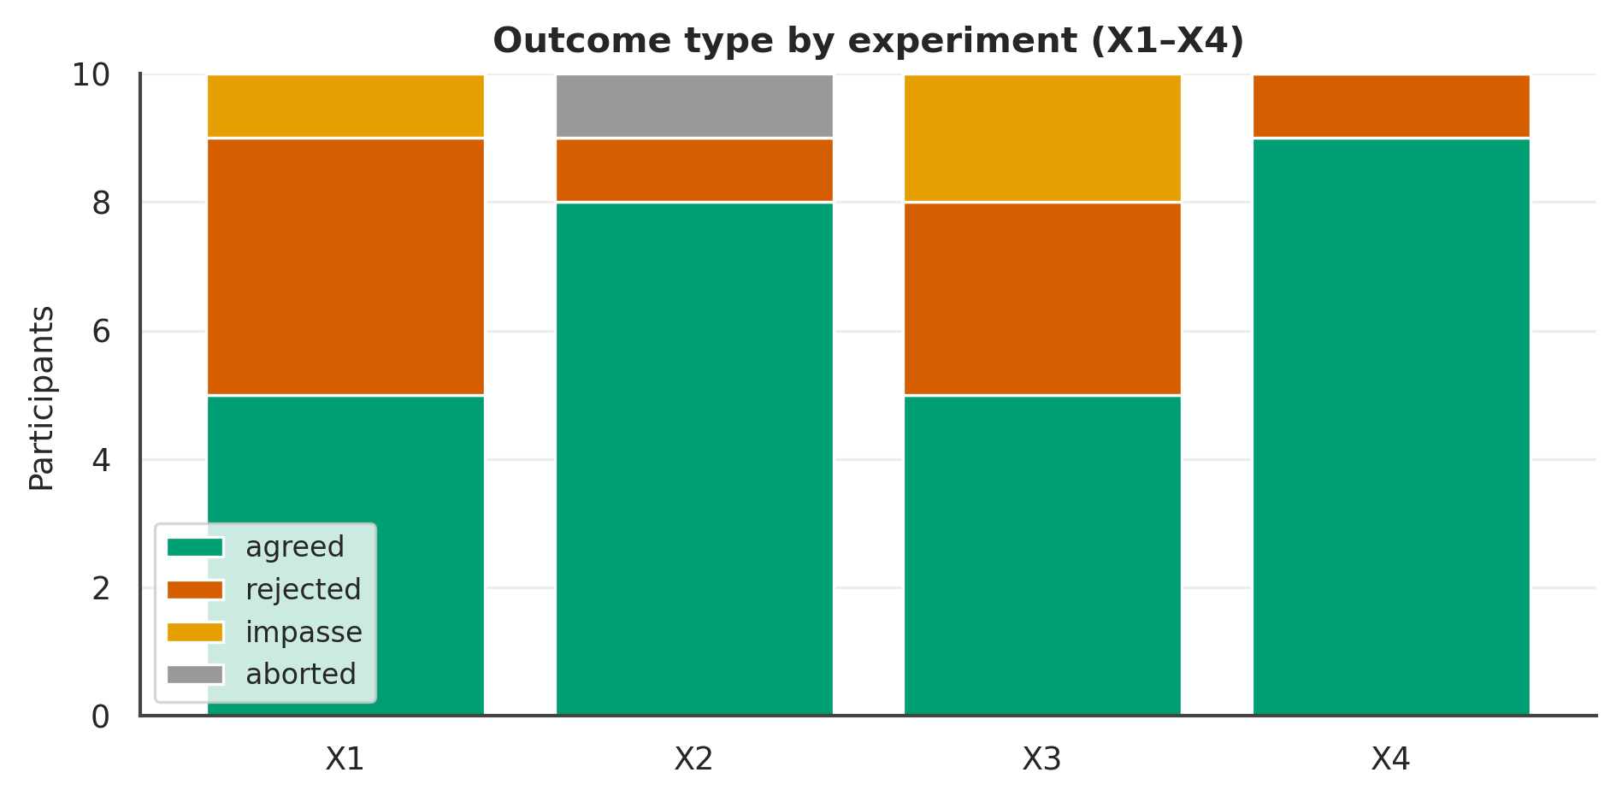

Figure . Each subjective measure by experiment.
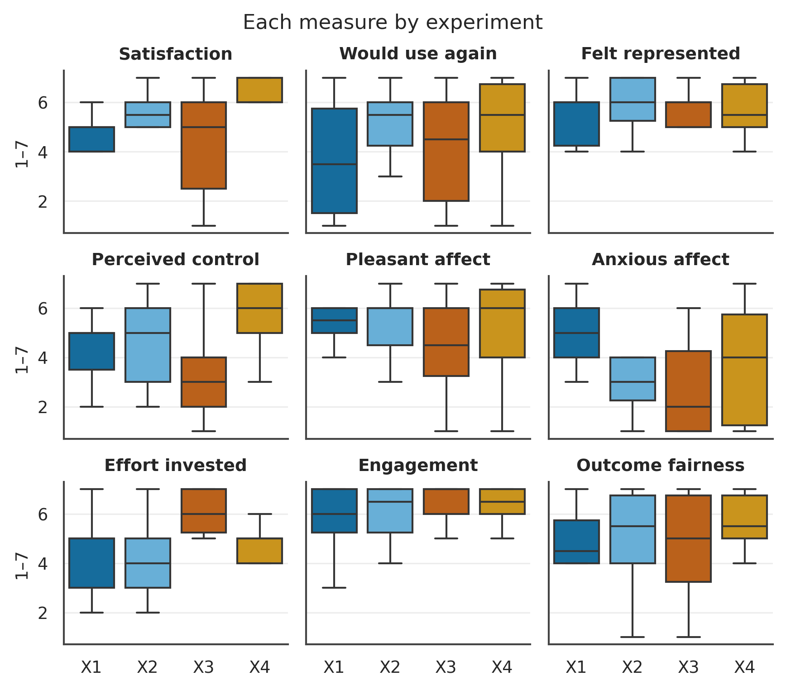

Figure . Offer trajectories by experiment (ZOPA shaded).
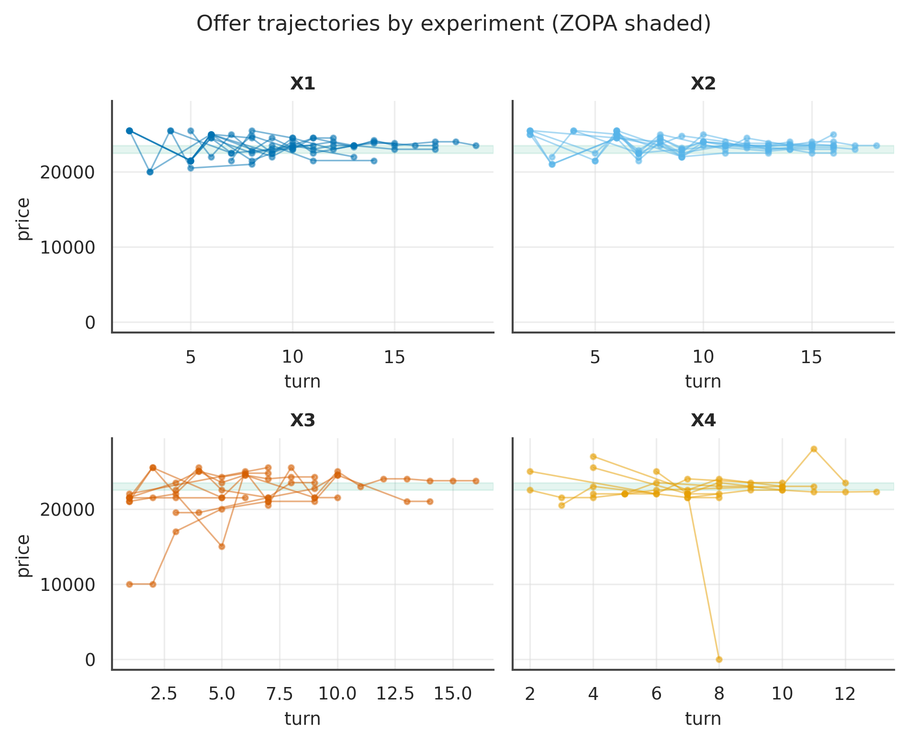
Note. One line per session; price vs turn.

Part III — The Forty-Five Analyses
Each analysis group is reported at all four levels: L1 distinct (per experiment), L2 2×2 + pairwise, L3 overall, L4 review. Effect sizes and intervals carry the interpretation; p-values are exploratory.

Chapter 1. Sample, Flow & Validity

G01 · Recruitment & Flow
19 non-completers enter only the funnel.
Balanced 10 per experiment (X1–X4).
Table . G01 — Funnel
Stage | n | %
Enrolled | 59 | 100%
Consented | 58 | 98%
Completed (analysed) | 40 | 68%
Reached agreement | 27 | 68%

Table . G01 — Analysed by experiment
exp | n
X1 | 10
X2 | 10
X3 | 10
X4 | 10

L4 review. Reported descriptively at the cohort level; exploratory and hypothesis-generating only.

G02 · Demographic Composition
Age is quaded; categoricals are descriptive.
Table . G02 — Composition
Variable | Level | n | %
gender | Female | 22 | 55.0
gender | Male | 16 | 40.0
gender | Non-binary | 1 | 2.5
gender | Prefer not to say | 1 | 2.5
experience | little | 15 | 37.5
experience | none | 12 | 30.0
experience | moderate | 9 | 22.5
experience | lot | 4 | 10.0
ai_familiarity | some | 25 | 62.5
ai_familiarity | very | 14 | 35.0
ai_familiarity | none | 1 | 2.5
os | Windows | 28 | 70.0
os | macOS | 8 | 20.0
os | Unknown | 3 | 7.5
os | Linux | 1 | 2.5
browser | Chrome | 37 | 92.5
browser | Safari | 2 | 5.0
browser | Edge | 1 | 2.5
timezone | America/New_York | 22 | 55.0
timezone | America/Chicago | 8 | 20.0
timezone | America/Los_Angeles | 5 | 12.5
timezone | America/Denver | 3 | 7.5
timezone | America/Phoenix | 2 | 5.0
age | M(SD); range | 40 | 41.0(14.7); 19–73

Table . G02 — L1 Distinct (mean per experiment)
Measure | X1 | X2 | X3 | X4 | N
age | 51.10 | 35.50 | 39.00 | 38.30 | 40

Table . G02 — L2 2×2 + Pairwise (Mode/Role/Mode×Role; best pairwise)
Measure | Mode p | Mode δ | Mode 95%CI | Role p | M×R p | Opp p | Top pairwise | that p
age | .401 | .16 | [−.22, .53] | .130 | .074 | .986 | Role | Delegated (X1 vs X2) | .037
Note. Mode/Role via Mann–Whitney + Cliff's δ (95% bootstrap CI); Mode×Role and opponent via SRH/Kruskal–Wallis.

Table . G02 — L3 Overall (pooled / Mode / Role)
Measure | Overall M(SD) | Delegated | Direct | Buyer | Seller
age | 40.98 (14.72) | 43.30 | 38.65 | 45.05 | 36.90

Table . G02 — Pairwise detail: age
Contrast | n | U | p | Cliff δ | 95% CI | band | q (BH)
Mode | Buyer (X1 vs X3) | 10/10 | 72 | p = .112 | .43 | [.00, .94] | medium | .224
Mode | Seller (X2 vs X4) | 10/10 | 41 | p = .520 | −.18 | [−.74, .34] | small | .596
Role | Delegated (X1 vs X2) | 10/10 | 78 | p = .037 | .56 | [.20, 1.02] | large | .123
Role | Direct (X3 vs X4) | 10/10 | 42 | p = .596 | −.15 | [−.69, .36] | small | .596
Diagonal (X1 vs X4) | 10/10 | 78 | p = .041 | .55 | [.16, 1.03] | large | .123
Diagonal (X2 vs X3) | 10/10 | 42 | p = .545 | −.17 | [−.72, .31] | small | .596
Note. Six structured contrasts among X1–X4; q = BH-adjusted.

Figure . G02: distribution of age across X1–X4.
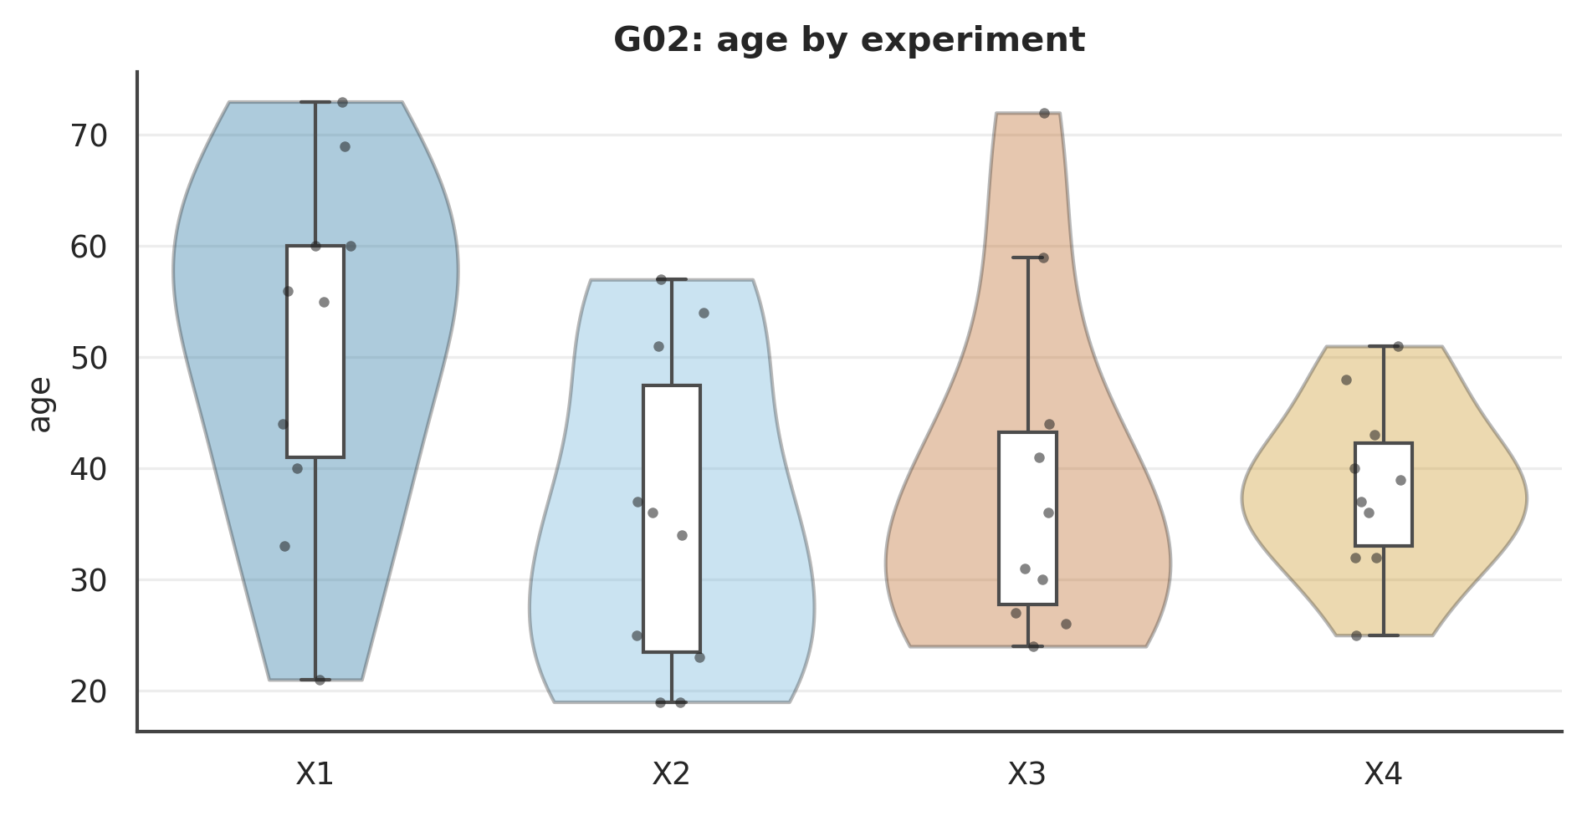

Figure . G02: age Mode×Role interaction.
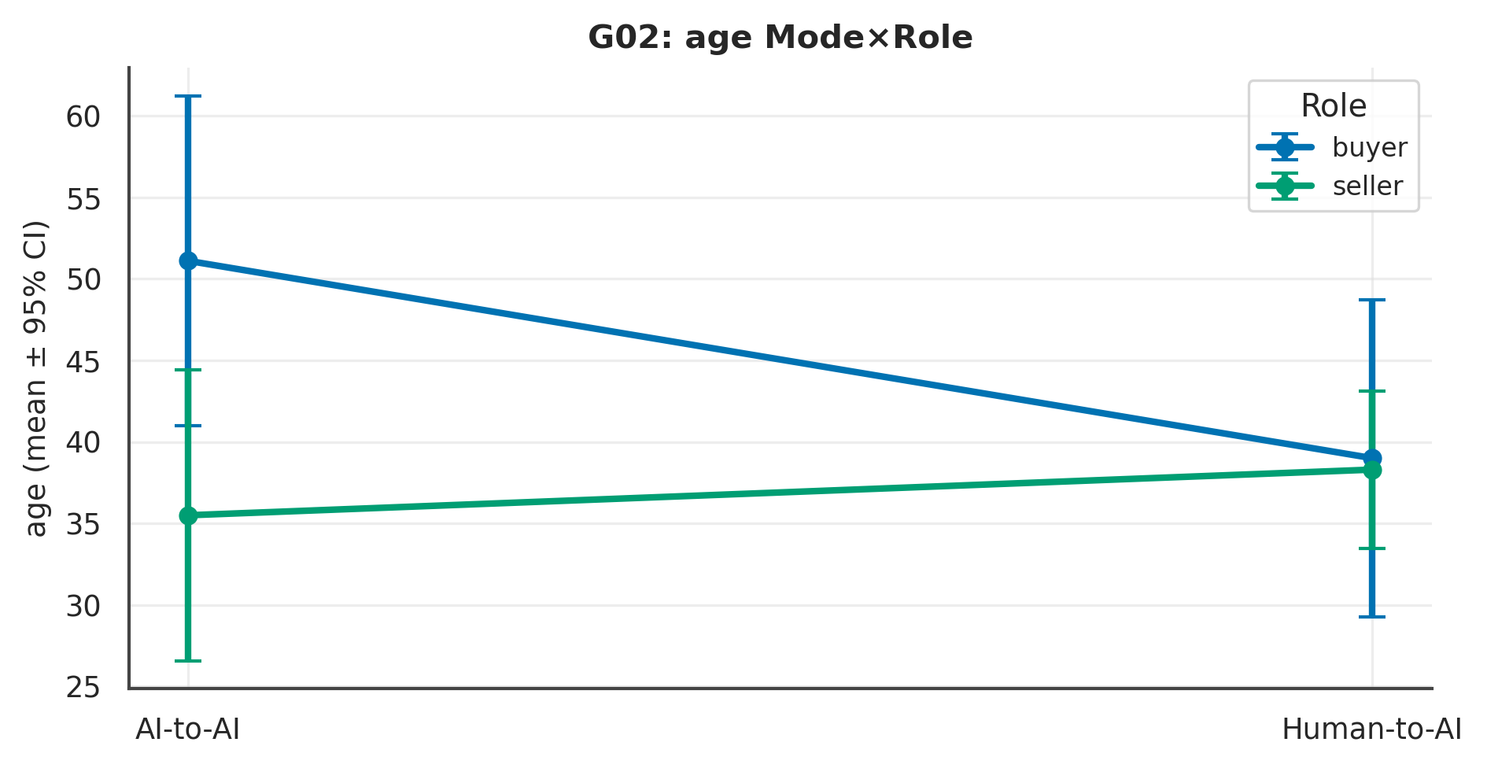

L4 review. Across 1 measure(s), the largest Mode signal was on ‘age’ (p = .401, Cliff's δ = .16 [−.22, .53], small); the Role contrast there was p = .130 and the Mode×Role interaction p = .074. At ~10 per experiment these are exploratory and hypothesis-generating; effect sizes and intervals, not p-values, carry the interpretation.

G03 · Randomisation & Comparability Checks
Comparability checks only; not hypotheses.
Table . G03 — Comparability
Check | p | Cliff δ | band
age × mode | 0.401 | 0.16 | small
age × role | 0.130 | 0.28 | small
gender × Mode | 0.488 | χ² | V=0.25
experience × Mode | 0.243 | χ² | V=0.32
ai_familiarity × Mode | 0.595 | χ² | V=0.16

L4 review. Reported descriptively at the cohort level; exploratory and hypothesis-generating only.

G17 · Manipulation & Instrumentation Fidelity
Table . G17 — Fidelity audit
Check | Result
opponent (engine vs brief) consistent | 40/40
role present in engine participants | 40/40
completers with exactly one session | 40/40

L4 review. Reported descriptively at the cohort level; exploratory and hypothesis-generating only.

G30 · Prolific Data-Integrity
Table . G30 — Integrity
Metric | Value
distinct prolific_pid (completers) | 40
duplicate prolific_pid | 0
distinct prolific_study_id | 4
referrer present | 58
completers via paste event (prompt authenticity) | 2

L4 review. Reported descriptively at the cohort level; exploratory and hypothesis-generating only.

G31 · Engine Reliability & Abandoned Sessions
Turn-cap vs genuine impasse cannot be fully separated without the scenario turn limit; flagged.
Table . G31 — Reliability
Metric | Value
sessions (all) | 46
status=running (abandoned) | 5
degraded sessions (all) | 2
degraded among completers | 2
max turns_consumed | 19

L4 review. Reported descriptively at the cohort level; exploratory and hypothesis-generating only.

G36 · System-Prompt & Scenario Standardisation Audit
System prompts vary only by the injected brief; the 21st behaviour-prompt row is reconciled.
Table . G36 — Standardisation
Audit | Value
distinct scenario_id | 1
distinct system_prompt (Buyer) | 17
distinct system_prompt (Seller) | 18
behavior_prompts rows vs delegated completers | 21 vs 20

L4 review. Reported descriptively at the cohort level; exploratory and hypothesis-generating only.

Chapter 2. Outcomes & Economic Efficiency

G03o · Negotiation Outcomes
Table . G03o — Outcome counts by experiment
exp | aborted | agreed | impasse | rejected
X1 | 0 | 5 | 1 | 4
X2 | 1 | 8 | 0 | 1
X3 | 0 | 5 | 2 | 3
X4 | 0 | 9 | 0 | 1

Table . G03o — L1 Distinct (rate per experiment)
Experiment | n | k | rate
X1 | 10 | 5 | 50%
X2 | 10 | 8 | 80%
X3 | 10 | 5 | 50%
X4 | 10 | 9 | 90%

Table . G03o — L2 2×2 (Fisher/χ²)
Term | detail | p | effect
Mode (Fisher) | 65% vs 70% | p = 1.000 | OR=0.80
Role (Fisher) | 50% vs 85% | p = .041 | OR=0.18
Opponent (χ²) | χ² | p = .439 | V=.20

Table . G03o — Pairwise (Fisher, BH)
Contrast | rate | OR | p | q (BH)
Mode | Buyer (X1 vs X3) | 50% vs 50% | 1.00 | p = 1.000 | 1.000
Mode | Seller (X2 vs X4) | 80% vs 90% | 0.44 | p = 1.000 | 1.000
Role | Delegated (X1 vs X2) | 50% vs 80% | 0.25 | p = .350 | .525
Role | Direct (X3 vs X4) | 50% vs 90% | 0.11 | p = .141 | .423
Diagonal (X1 vs X4) | 50% vs 90% | 0.11 | p = .141 | .423
Diagonal (X2 vs X3) | 80% vs 50% | 4.00 | p = .350 | .525

Table . G03o — L3 Overall
View | n | k | rate
Overall | 40 | 27 | 68%
Mode=delegated | 20 | 13 | 65%
Mode=direct | 20 | 14 | 70%
Role=buyer | 20 | 10 | 50%
Role=seller | 20 | 17 | 85%

L4 review. Binary outcome; exploratory at n = 10 per experiment — interpret rates descriptively.

G03e · Economic Efficiency & Distributive Split
Single-issue fixed pie ($1,000) — efficiency = settling within ZOPA; only agreed sessions (n≈27); per-cell n is very small.
Table . G03e — Economic summary
Metric | Value
Within ZOPA | 19/27 (70%)
Settlement price (Mdn) | 23500
Buyer share of pie (Mdn) | 0.00

Table . G03e — L1 Distinct (mean per experiment)
Measure | X1 | X2 | X3 | X4 | N
settlement_price | 23,300.00 | 23,125.00 | 24,350.00 | 22,588.89 | 27
buyer_share | 0.20 | 0.38 | 0.00 | 0.40 | 19
settle_vs_mid | 300.00 | 125.00 | 1,350.00 | -411.11 | 27

Table . G03e — L2 2×2 + Pairwise (Mode/Role/Mode×Role; best pairwise)
Measure | Mode p | Mode δ | Mode 95%CI | Role p | M×R p | Opp p | Top pairwise | that p
settlement_price | .960 | .02 | [−.45, .47] | .003 | .023 | .743 | Role | Direct (X3 vs X4) | .005
buyer_share | .923 | −.04 | [−.55, .49] | .309 | .520 | .037 | Diagonal (X1 vs X4) | .488
settle_vs_mid | .960 | .02 | [−.45, .47] | .003 | .023 | .743 | Role | Direct (X3 vs X4) | .005
Note. Mode/Role via Mann–Whitney + Cliff's δ (95% bootstrap CI); Mode×Role and opponent via SRH/Kruskal–Wallis.

Table . G03e — L3 Overall (pooled / Mode / Role)
Measure | Overall M(SD) | Delegated | Direct | Buyer | Seller
settlement_price | 23205.56 (838.65) | 23192.31 | 23217.86 | 23825.00 | 22841.18
buyer_share | 0.32 (0.38) | 0.31 | 0.33 | 0.17 | 0.38
settle_vs_mid | 205.56 (838.65) | 192.31 | 217.86 | 825.00 | -158.82

Table . G03e — Pairwise detail: settlement_price
Contrast | n | U | p | Cliff δ | 95% CI | band | q (BH)
Mode | Buyer (X1 vs X3) | 5/5 | 2 | p = .023 | −.88 | [−1.16, −.76] | large | .046
Mode | Seller (X2 vs X4) | 8/9 | 53 | p = .101 | .47 | [.06, .97] | medium | .122
Role | Delegated (X1 vs X2) | 5/8 | 24 | p = .571 | .20 | [−.32, .75] | small | .571
Role | Direct (X3 vs X4) | 5/9 | 44 | p = .005 | .96 | [.91, 1.11] | large | .025
Diagonal (X1 vs X4) | 5/9 | 36 | p = .073 | .60 | [.24, 1.07] | large | .109
Diagonal (X2 vs X3) | 8/5 | 2 | p = .008 | −.90 | [−1.15, −.80] | large | .025
Note. Six structured contrasts among X1–X4; q = BH-adjusted.

Figure . G03e: distribution of settlement_price across X1–X4.
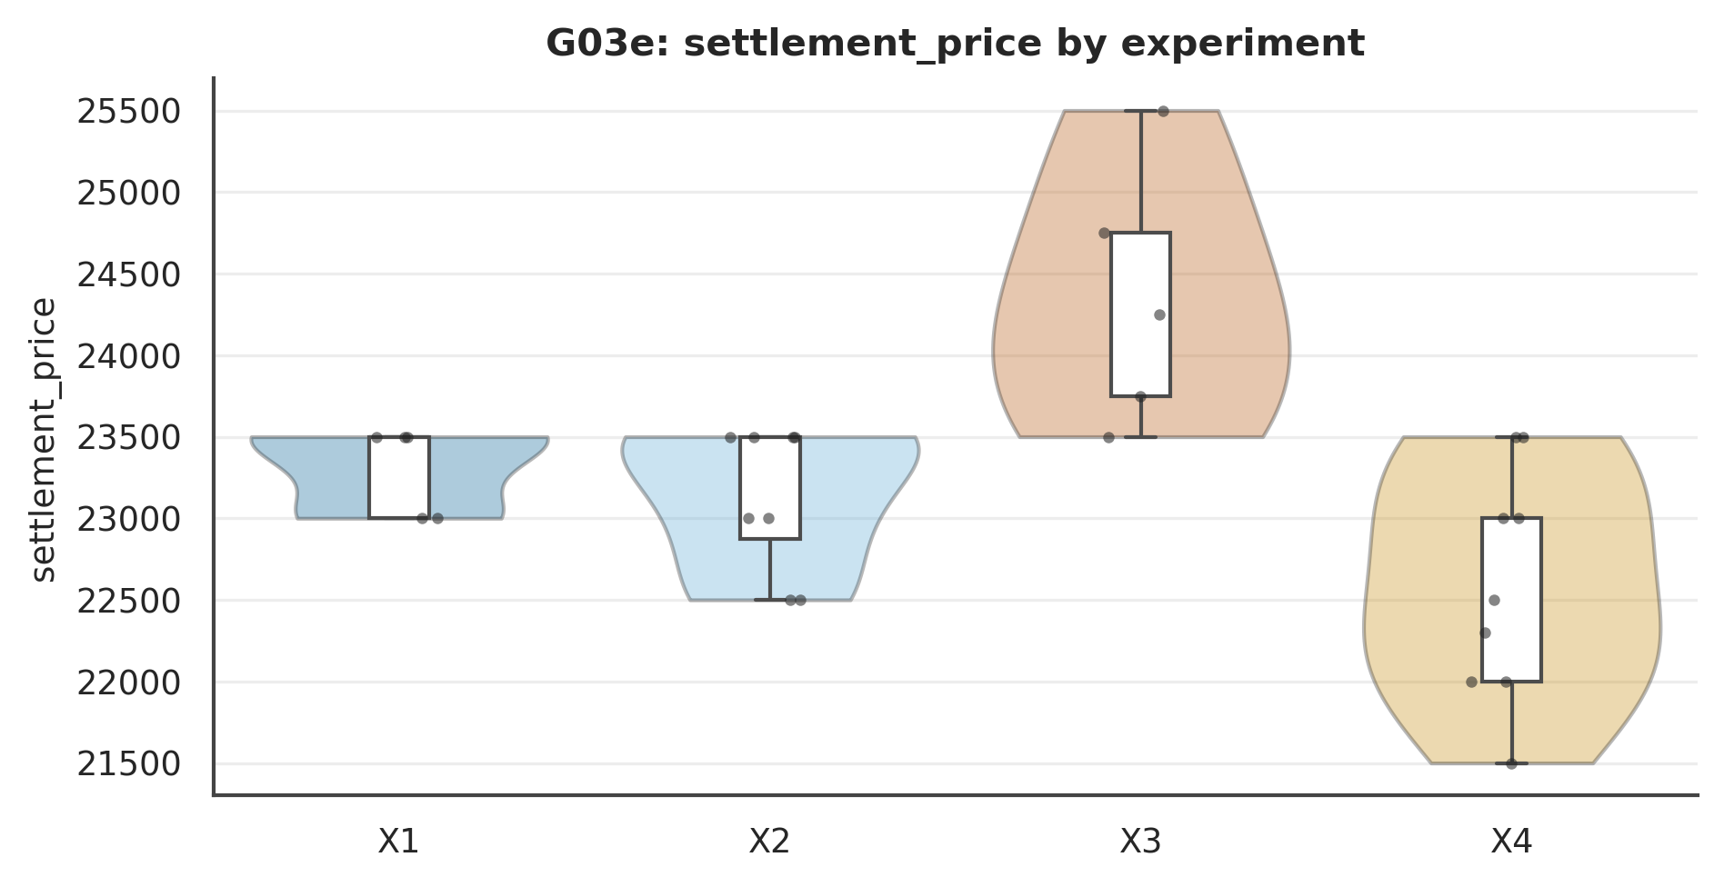

Figure . G03e: settlement_price Mode×Role interaction.
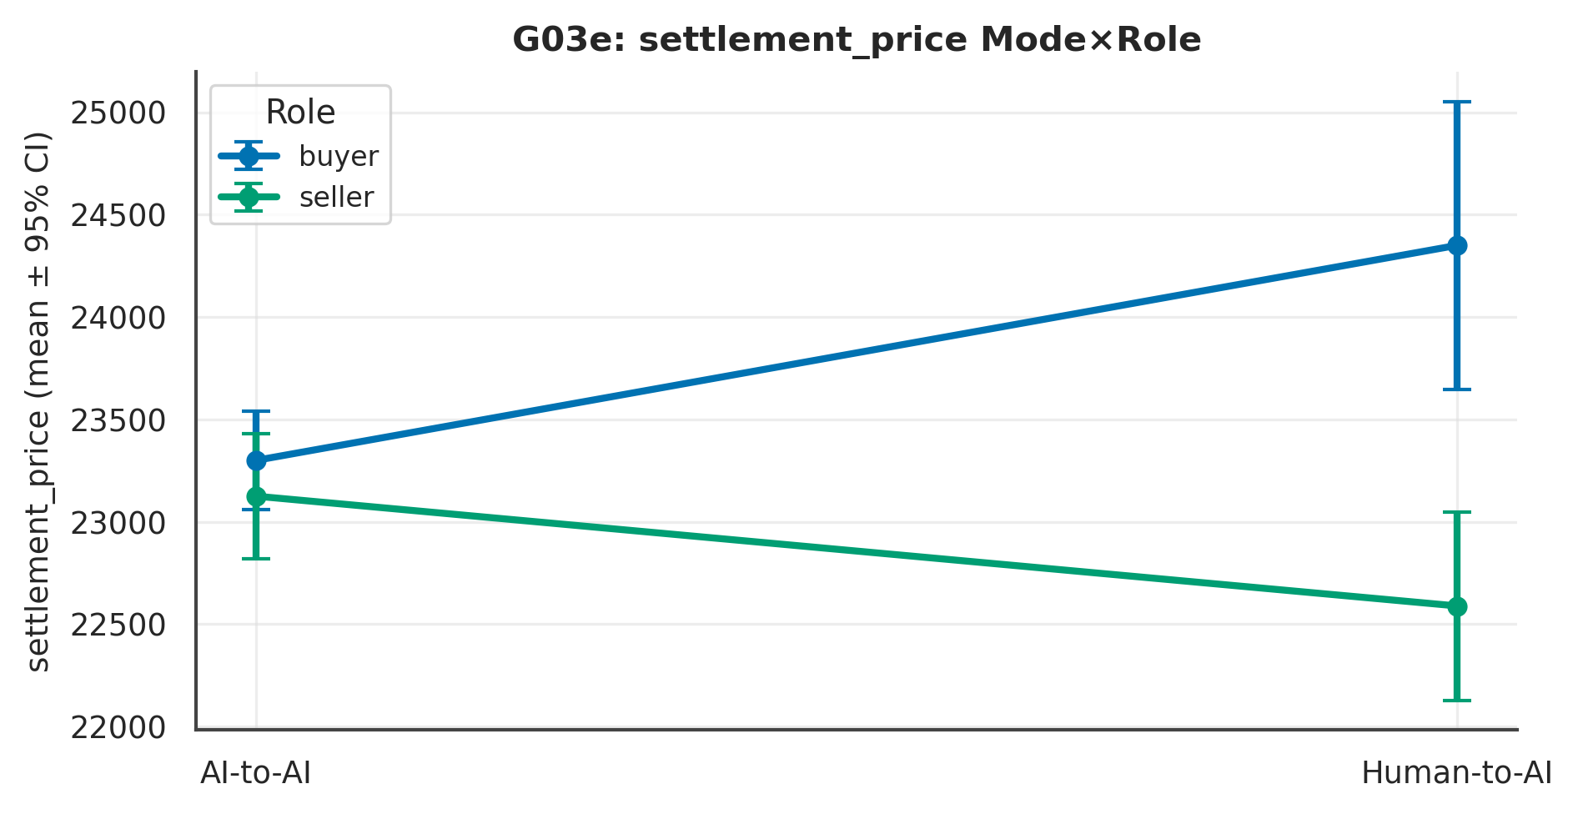

L4 review. Across 3 measure(s), the largest Mode signal was on ‘buyer_share’ (p = .923, Cliff's δ = −.04 [−.55, .49], negligible); the Role contrast there was p = .309 and the Mode×Role interaction p = .520. At ~10 per experiment these are exploratory and hypothesis-generating; effect sizes and intervals, not p-values, carry the interpretation.

G03p · Operational Cost & Duration
2 sessions ran degraded (flagged in Ch.1).
Table . G03p — L1 Distinct (mean per experiment)
Measure | X1 | X2 | X3 | X4 | N
turns_consumed | 14.10 | 15.70 | 10.10 | 9.50 | 40
session_sec | 148.97 | 163.07 | 472.36 | 324.42 | 40
study_sec | 635.28 | 688.31 | 698.15 | 612.14 | 40
tokens_total | 82,041.10 | 97,434.90 | 32,695.10 | 26,140.00 | 40
tokens_orchestrator | 60,448.70 | 72,366.10 | 27,723.90 | 21,951.20 | 40

Table . G03p — L2 2×2 + Pairwise (Mode/Role/Mode×Role; best pairwise)
Measure | Mode p | Mode δ | Mode 95%CI | Role p | M×R p | Opp p | Top pairwise | that p
turns_consumed | < .001 | .82 | [.68, 1.02] | .664 | .302 | .732 | Mode | Seller (X2 vs X4) | < .001
session_sec | < .001 | −.79 | [−1.05, −.58] | .797 | .083 | .901 | Mode | Buyer (X1 vs X3) | < .001
study_sec | .636 | .09 | [−.28, .45] | .735 | .245 | .679 | Mode | Seller (X2 vs X4) | .241
tokens_total | < .001 | .96 | [.92, 1.04] | .675 | .279 | .788 | Mode | Seller (X2 vs X4) | < .001
tokens_orchestrator | < .001 | .94 | [.89, 1.05] | .675 | .224 | .805 | Mode | Seller (X2 vs X4) | < .001
Note. Mode/Role via Mann–Whitney + Cliff's δ (95% bootstrap CI); Mode×Role and opponent via SRH/Kruskal–Wallis.

Table . G03p — L3 Overall (pooled / Mode / Role)
Measure | Overall M(SD) | Delegated | Direct | Buyer | Seller
turns_consumed | 12.35 (3.63) | 14.90 | 9.80 | 12.10 | 12.60
session_sec | 277.21 (184.51) | 156.02 | 398.39 | 310.66 | 243.75
study_sec | 658.47 (247.56) | 661.79 | 655.15 | 666.72 | 650.23
tokens_total | 59577.78 (35597.39) | 89738.00 | 29417.55 | 57368.10 | 61787.45
tokens_orchestrator | 45622.47 (25546.77) | 66407.40 | 24837.55 | 44086.30 | 47158.65

Table . G03p — Pairwise detail: turns_consumed
Contrast | n | U | p | Cliff δ | 95% CI | band | q (BH)
Mode | Buyer (X1 vs X3) | 10/10 | 82 | p = .019 | .63 | [.30, 1.08] | large | .028
Mode | Seller (X2 vs X4) | 10/10 | 100 | p < .001 | .99 | [.98, 1.04] | large | .001
Role | Delegated (X1 vs X2) | 10/10 | 32 | p = .181 | −.36 | [−.90, .11] | medium | .217
Role | Direct (X3 vs X4) | 10/10 | 52 | p = .909 | .04 | [−.47, .58] | negligible | .909
Diagonal (X1 vs X4) | 10/10 | 91 | p = .002 | .82 | [.65, 1.11] | large | .004
Diagonal (X2 vs X3) | 10/10 | 92 | p = .002 | .83 | [.66, 1.12] | large | .004
Note. Six structured contrasts among X1–X4; q = BH-adjusted.

Figure . G03p: distribution of turns_consumed across X1–X4.
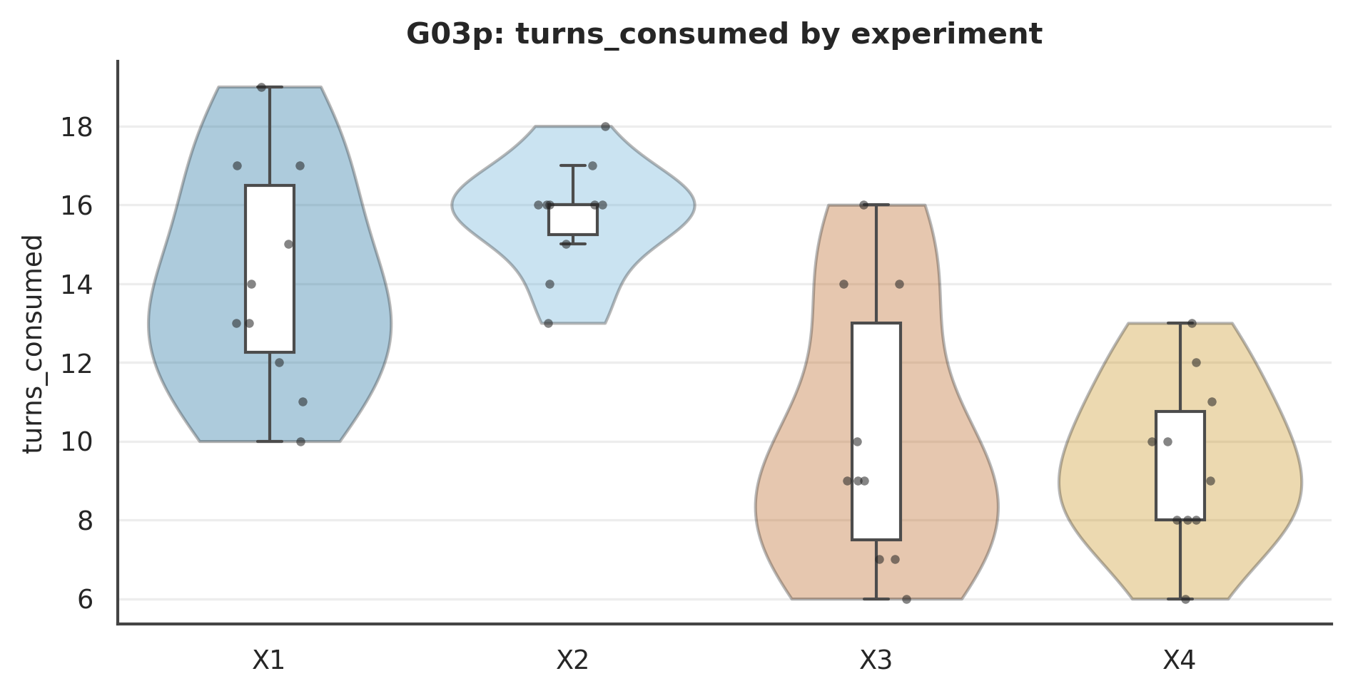

Figure . G03p: turns_consumed Mode×Role interaction.
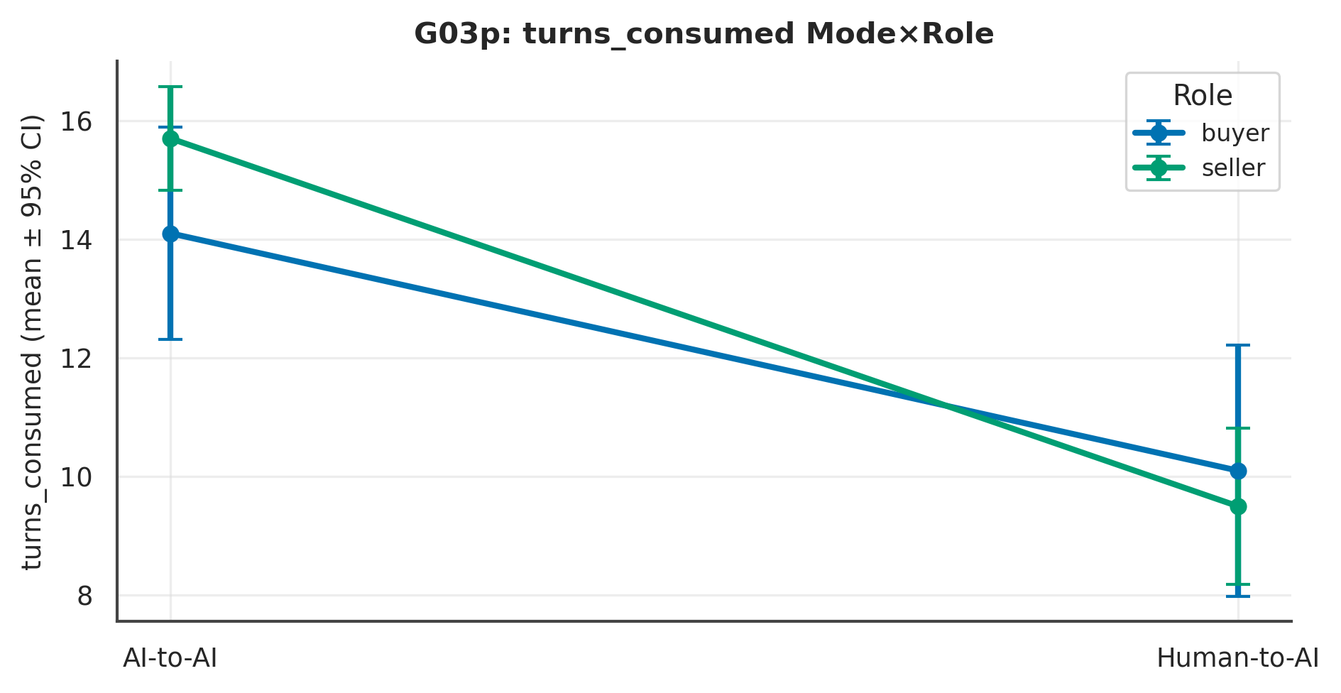

L4 review. Across 5 measure(s), the largest Mode signal was on ‘tokens_total’ (p < .001, Cliff's δ = .96 [.92, 1.04], large); the Role contrast there was p = .675 and the Mode×Role interaction p = .279. At ~10 per experiment these are exploratory and hypothesis-generating; effect sizes and intervals, not p-values, carry the interpretation.

Chapter 3. Subjective Experience

G04 · Subjective Experience — Nine Measures
α is a coherence descriptor only (distinct constructs; anxious is reverse-valenced). EFA fragile at n=40.
Table . G04 — Reliability
Cronbach α (omnibus, coherence only) | 95% CI | k | n
0.71 | [0.55, 0.83] | 9 | 40

Table . G04 — Spearman inter-correlations
Item | satisfaction | would_use_again | agent_represented | control | emot_pleasant | emot_anxious | effort_invested | engage_engaged | outfair_share
Satisfaction | 1.00 | 0.79 | 0.58 | 0.78 | 0.78 | -0.52 | -0.04 | 0.25 | 0.74
Would use again | 0.79 | 1.00 | 0.61 | 0.73 | 0.67 | -0.52 | -0.05 | 0.17 | 0.60
Felt represented | 0.58 | 0.61 | 1.00 | 0.56 | 0.58 | -0.49 | 0.09 | 0.43 | 0.44
Perceived control | 0.78 | 0.73 | 0.56 | 1.00 | 0.72 | -0.33 | -0.02 | 0.21 | 0.64
Pleasant affect | 0.78 | 0.67 | 0.58 | 0.72 | 1.00 | -0.51 | 0.03 | 0.32 | 0.61
Anxious affect | -0.52 | -0.52 | -0.49 | -0.33 | -0.51 | 1.00 | -0.16 | -0.24 | -0.42
Effort invested | -0.04 | -0.05 | 0.09 | -0.02 | 0.03 | -0.16 | 1.00 | 0.33 | 0.14
Engagement | 0.25 | 0.17 | 0.43 | 0.21 | 0.32 | -0.24 | 0.33 | 1.00 | 0.16
Outcome fairness | 0.74 | 0.60 | 0.44 | 0.64 | 0.61 | -0.42 | 0.14 | 0.16 | 1.00

Table . G04 — Exploratory factor loadings
item | F1 | F2
satisfaction | -0.96 | 0.14
would_use_again | -0.78 | 0.26
agent_represented | -0.46 | 0.70
control | -0.79 | 0.23
emot_pleasant | -0.78 | 0.28
emot_anxious | 0.38 | -0.46
effort_invested | 0.09 | 0.18
engage_engaged | -0.08 | 0.42
outfair_share | -0.78 | 0.09

Table . G04 — L1 Distinct (mean per experiment)
Measure | X1 | X2 | X3 | X4 | N
satisfaction | 4.60 | 5.20 | 4.40 | 6.00 | 40
would_use_again | 3.70 | 5.00 | 4.20 | 4.90 | 40
agent_represented | 5.20 | 6.00 | 5.80 | 5.70 | 40
control | 4.30 | 4.50 | 3.40 | 5.60 | 40
emot_pleasant | 5.10 | 5.40 | 4.50 | 5.20 | 40
emot_anxious | 4.90 | 3.20 | 2.60 | 3.70 | 40
effort_invested | 4.30 | 4.10 | 6.10 | 4.30 | 40
engage_engaged | 5.80 | 6.00 | 6.40 | 6.30 | 40
outfair_share | 4.60 | 5.00 | 4.70 | 5.30 | 40

Table . G04 — L2 2×2 + Pairwise (Mode/Role/Mode×Role; best pairwise)
Measure | Mode p | Mode δ | Mode 95%CI | Role p | M×R p | Opp p | Top pairwise | that p
satisfaction | .354 | −.17 | [−.53, .17] | .038 | .498 | .271 | Diagonal (X1 vs X4) | .040
would_use_again | .650 | −.09 | [−.44, .27] | .183 | .660 | .300 | Role | Delegated (X1 vs X2) | .205
agent_represented | .888 | .03 | [−.34, .37] | .527 | .391 | .440 | Role | Delegated (X1 vs X2) | .326
control | .731 | −.07 | [−.43, .29] | .047 | .124 | .150 | Role | Direct (X3 vs X4) | .034
emot_pleasant | .769 | .06 | [−.30, .41] | .263 | .834 | .026 | Diagonal (X2 vs X3) | .371
emot_anxious | .150 | .27 | [−.08, .64] | .632 | .028 | .423 | Mode | Buyer (X1 vs X3) | .014
effort_invested | .032 | −.39 | [−.72, −.09] | .042 | .165 | .947 | Diagonal (X2 vs X3) | .004
engage_engaged | .342 | −.17 | [−.50, .15] | .988 | .640 | .339 | Mode | Buyer (X1 vs X3) | .348
outfair_share | .591 | −.10 | [−.45, .23] | .348 | .989 | .937 | Diagonal (X1 vs X4) | .230
Note. Mode/Role via Mann–Whitney + Cliff's δ (95% bootstrap CI); Mode×Role and opponent via SRH/Kruskal–Wallis.

Table . G04 — L3 Overall (pooled / Mode / Role)
Measure | Overall M(SD) | Delegated | Direct | Buyer | Seller
satisfaction | 5.05 (1.71) | 4.90 | 5.20 | 4.50 | 5.60
would_use_again | 4.45 (2.16) | 4.35 | 4.55 | 3.95 | 4.95
agent_represented | 5.67 (1.23) | 5.60 | 5.75 | 5.50 | 5.85
control | 4.45 (1.93) | 4.40 | 4.50 | 3.85 | 5.05
emot_pleasant | 5.05 (1.69) | 5.25 | 4.85 | 4.80 | 5.30
emot_anxious | 3.60 (2.01) | 4.05 | 3.15 | 3.75 | 3.45
effort_invested | 4.70 (1.70) | 4.20 | 5.20 | 5.20 | 4.20
engage_engaged | 6.12 (1.09) | 5.90 | 6.35 | 6.10 | 6.15
outfair_share | 4.90 (1.88) | 4.80 | 5.00 | 4.65 | 5.15

Table . G04 — Pairwise detail: satisfaction
Contrast | n | U | p | Cliff δ | 95% CI | band | q (BH)
Mode | Buyer (X1 vs X3) | 10/10 | 49 | p = .969 | −.02 | [−.55, .52] | negligible | .969
Mode | Seller (X2 vs X4) | 10/10 | 34 | p = .224 | −.32 | [−.81, .11] | small | .414
Role | Delegated (X1 vs X2) | 10/10 | 36 | p = .276 | −.29 | [−.80, .17] | small | .414
Role | Direct (X3 vs X4) | 10/10 | 26 | p = .063 | −.48 | [−.93, −.13] | large | .189
Diagonal (X1 vs X4) | 10/10 | 23 | p = .040 | −.54 | [−1.01, −.14] | large | .189
Diagonal (X2 vs X3) | 10/10 | 60 | p = .461 | .20 | [−.25, .72] | small | .553
Note. Six structured contrasts among X1–X4; q = BH-adjusted.

Figure . G04: distribution of satisfaction across X1–X4.
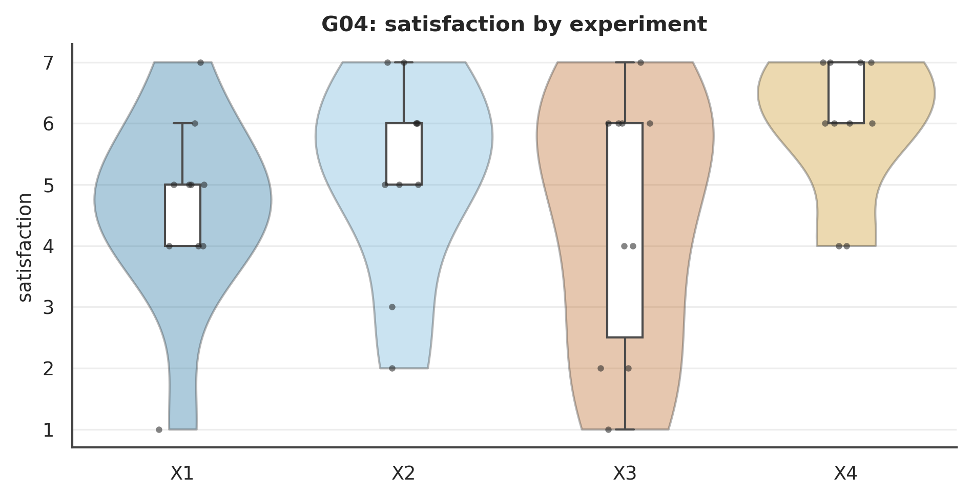

Figure . G04: satisfaction Mode×Role interaction.
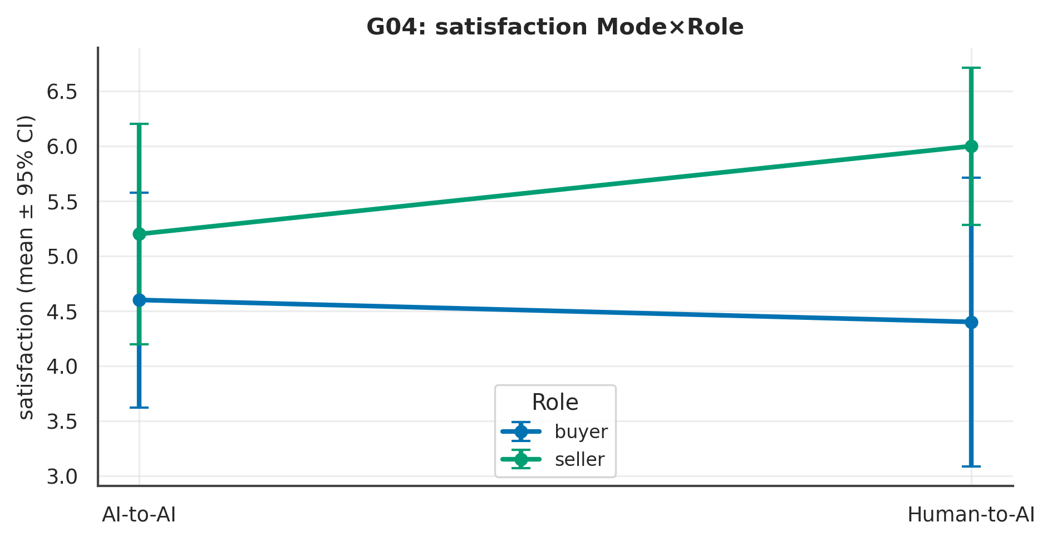

L4 review. Across 9 measure(s), the largest Mode signal was on ‘effort_invested’ (p = .032, Cliff's δ = −.39 [−.72, −.09], medium); the Role contrast there was p = .042 and the Mode×Role interaction p = .165. At ~10 per experiment these are exploratory and hypothesis-generating; effect sizes and intervals, not p-values, carry the interpretation.

Chapter 4. Negotiation Process & Strategy

G05 · Bargaining Process & Strategy
Table . G05 — L1 Distinct (mean per experiment)
Measure | X1 | X2 | X3 | X4 | N
opening_anchor | 21,350.00 | 25,400.00 | 20,100.00 | 21,600.00 | 40
anchor_distance | 450.00 | 100.00 | 1,700.00 | 4,200.00 | 40
opening_spread | 4,000.00 | 3,600.00 | 2,666.67 | -200.00 | 39
n_proposals | 7.50 | 8.90 | 6.20 | 4.40 | 40
n_messages | 6.60 | 6.80 | 3.90 | 5.10 | 40
n_concessions | 2.60 | 3.50 | 1.80 | 1.00 | 40
mean_concession | 790.83 | 633.33 | 2,428.65 | 1,595.24 | 35
rounds_to_close | 7.50 | 8.90 | 6.20 | 4.40 | 40

Table . G05 — L2 2×2 + Pairwise (Mode/Role/Mode×Role; best pairwise)
Measure | Mode p | Mode δ | Mode 95%CI | Role p | M×R p | Opp p | Top pairwise | that p
opening_anchor | .132 | .28 | [−.05, .65] | < .001 | .359 | .460 | Role | Delegated (X1 vs X2) | < .001
anchor_distance | < .001 | −.60 | [−.89, −.36] | .659 | .066 | .648 | Mode | Seller (X2 vs X4) | < .001
opening_spread | .013 | .46 | [.15, .82] | .107 | .571 | .488 | Diagonal (X1 vs X4) | .005
n_proposals | < .001 | .69 | [.48, .95] | .754 | .036 | .726 | Mode | Seller (X2 vs X4) | < .001
n_messages | .002 | .56 | [.30, .86] | .260 | .631 | .142 | Diagonal (X2 vs X3) | .010
n_concessions | < .001 | .64 | [.41, .92] | .912 | .087 | .392 | Mode | Seller (X2 vs X4) | .001
mean_concession | < .001 | −.76 | [−1.03, −.56] | .280 | .527 | .319 | Diagonal (X2 vs X3) | .001
rounds_to_close | < .001 | .69 | [.48, .95] | .754 | .036 | .726 | Mode | Seller (X2 vs X4) | < .001
Note. Mode/Role via Mann–Whitney + Cliff's δ (95% bootstrap CI); Mode×Role and opponent via SRH/Kruskal–Wallis.

Table . G05 — L3 Overall (pooled / Mode / Role)
Measure | Overall M(SD) | Delegated | Direct | Buyer | Seller
opening_anchor | 22112.50 (4595.83) | 23375.00 | 20850.00 | 20725.00 | 23500.00
anchor_distance | 1612.50 (4340.46) | 275.00 | 2950.00 | 1075.00 | 2150.00
opening_spread | 2512.82 (4280.44) | 3800.00 | 1157.89 | 3368.42 | 1700.00
n_proposals | 6.75 (2.54) | 8.20 | 5.30 | 6.85 | 6.65
n_messages | 5.60 (2.22) | 6.70 | 4.50 | 5.25 | 5.95
n_concessions | 2.23 (1.49) | 3.05 | 1.40 | 2.20 | 2.25
mean_concession | 1281.07 (1242.17) | 712.08 | 2039.72 | 1518.75 | 1029.41
rounds_to_close | 6.75 (2.54) | 8.20 | 5.30 | 6.85 | 6.65

Table . G05 — Pairwise detail: opening_anchor
Contrast | n | U | p | Cliff δ | 95% CI | band | q (BH)
Mode | Buyer (X1 vs X3) | 10/10 | 61 | p = .405 | .22 | [−.26, .74] | small | .405
Mode | Seller (X2 vs X4) | 10/10 | 82 | p = .012 | .64 | [.30, 1.10] | large | .015
Role | Delegated (X1 vs X2) | 10/10 | 0 | p < .001 | −1.00 | [−1.00, −1.00] | large | .000
Role | Direct (X3 vs X4) | 10/10 | 12 | p = .005 | −.75 | [−1.16, −.50] | large | .007
Diagonal (X1 vs X4) | 10/10 | 12 | p = .004 | −.75 | [−1.17, −.50] | large | .007
Diagonal (X2 vs X3) | 10/10 | 100 | p < .001 | 1.00 | [1.00, 1.00] | large | .000
Note. Six structured contrasts among X1–X4; q = BH-adjusted.

Figure . G05: distribution of opening_anchor across X1–X4.
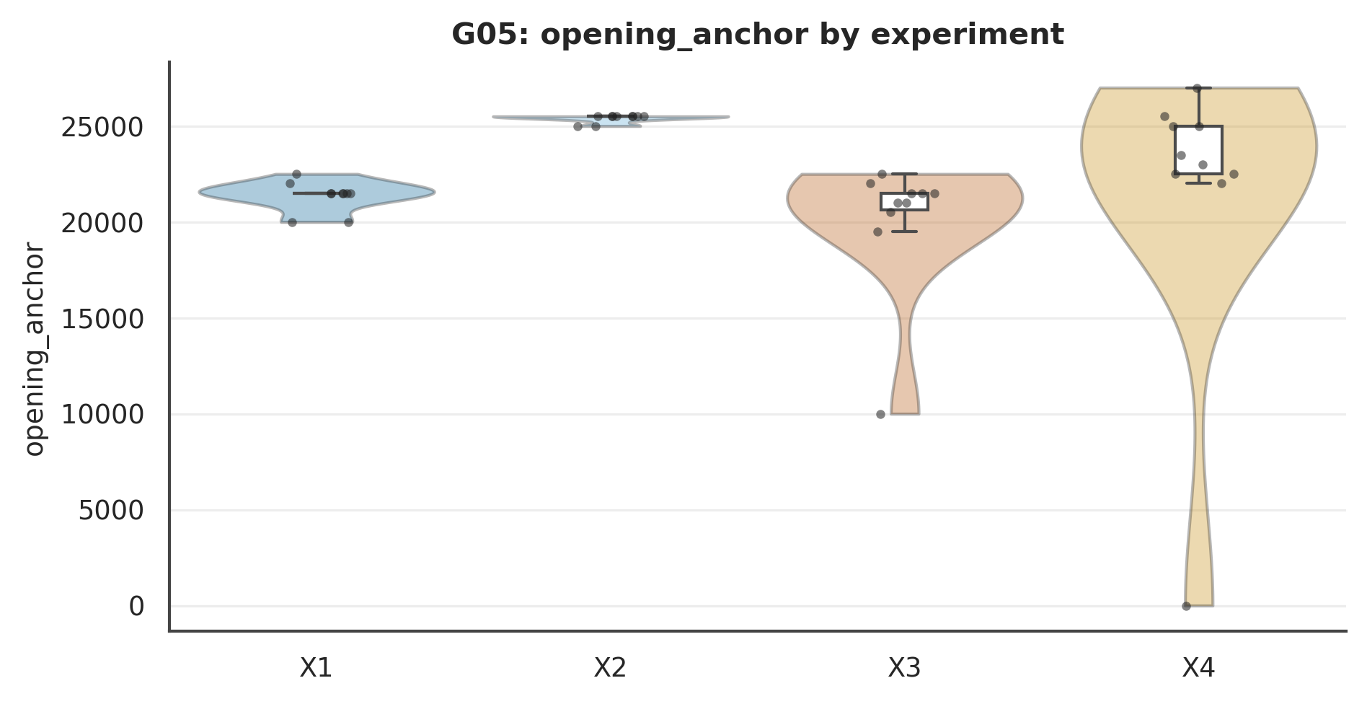

Figure . G05: opening_anchor Mode×Role interaction.
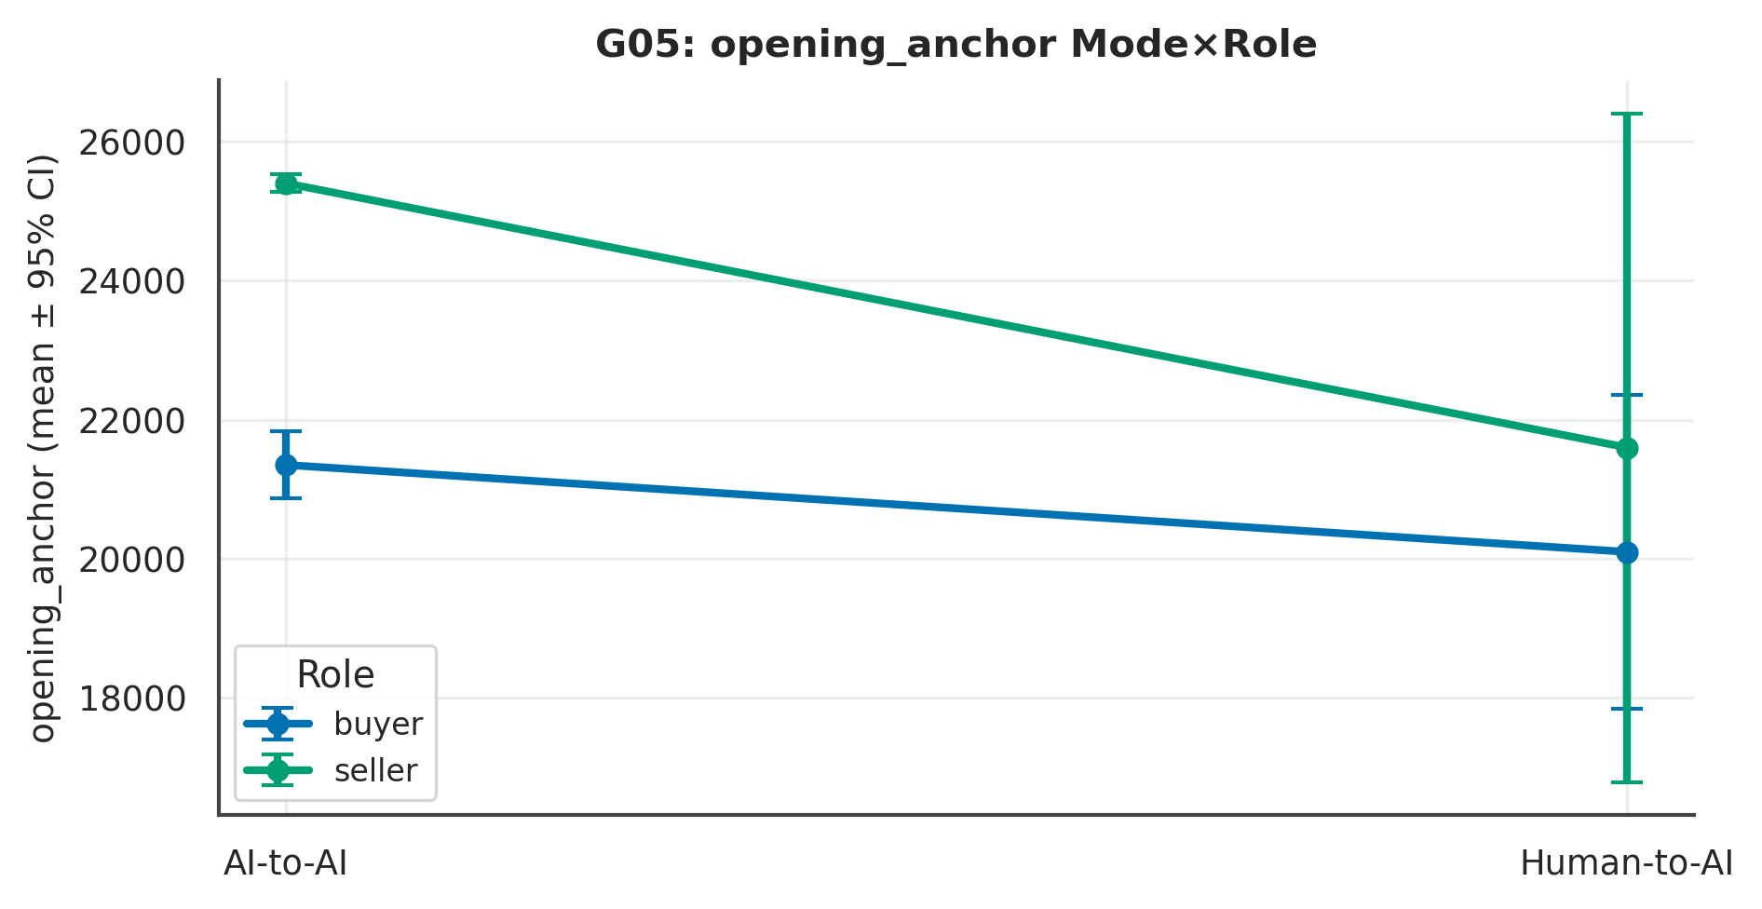

L4 review. Across 8 measure(s), the largest Mode signal was on ‘mean_concession’ (p < .001, Cliff's δ = −.76 [−1.03, −.56], large); the Role contrast there was p = .280 and the Mode×Role interaction p = .527. At ~10 per experiment these are exploratory and hypothesis-generating; effect sizes and intervals, not p-values, carry the interpretation.

G22 · Dialogue Content & Argumentation
Own-side turns only; deterministic lexicons.
Table . G22 — L1 Distinct (mean per experiment)
Measure | X1 | X2 | X3 | X4 | N
msg_words | 103.93 | 121.03 | 19.23 | 16.62 | 40
questions | 0.50 | 0.44 | 0.42 | 0.07 | 40
politeness | 0.86 | 1.06 | 0.19 | 0.15 | 40
threats | 0.11 | 0.01 | 0.09 | 0.04 | 40
standards_appeal | 0.38 | 0.49 | 0.04 | 0.02 | 40
price_refs | 1.56 | 2.47 | 0.78 | 0.62 | 40

Table . G22 — L2 2×2 + Pairwise (Mode/Role/Mode×Role; best pairwise)
Measure | Mode p | Mode δ | Mode 95%CI | Role p | M×R p | Opp p | Top pairwise | that p
msg_words | < .001 | 1.00 | [1.00, 1.00] | .655 | .267 | .857 | Mode | Seller (X2 vs X4) | < .001
questions | .013 | .46 | [.14, .81] | .035 | .085 | .486 | Diagonal (X1 vs X4) | < .001
politeness | < .001 | .96 | [.93, 1.04] | .722 | .420 | .936 | Diagonal (X2 vs X3) | < .001
threats | .899 | .02 | [−.30, .33] | .014 | .246 | .363 | Role | Delegated (X1 vs X2) | .007
standards_appeal | < .001 | .84 | [.70, 1.03] | .528 | .296 | .586 | Mode | Seller (X2 vs X4) | < .001
price_refs | < .001 | .97 | [.95, 1.04] | .490 | .176 | .884 | Mode | Seller (X2 vs X4) | < .001
Note. Mode/Role via Mann–Whitney + Cliff's δ (95% bootstrap CI); Mode×Role and opponent via SRH/Kruskal–Wallis.

Table . G22 — L3 Overall (pooled / Mode / Role)
Measure | Overall M(SD) | Delegated | Direct | Buyer | Seller
msg_words | 65.20 (50.52) | 112.48 | 17.92 | 61.58 | 68.82
questions | 0.36 (0.29) | 0.47 | 0.24 | 0.46 | 0.26
politeness | 0.56 (0.47) | 0.96 | 0.17 | 0.52 | 0.60
threats | 0.06 (0.10) | 0.06 | 0.07 | 0.10 | 0.03
standards_appeal | 0.23 (0.28) | 0.43 | 0.03 | 0.21 | 0.26
price_refs | 1.36 (0.93) | 2.01 | 0.70 | 1.17 | 1.54

Table . G22 — Pairwise detail: msg_words
Contrast | n | U | p | Cliff δ | 95% CI | band | q (BH)
Mode | Buyer (X1 vs X3) | 10/10 | 100 | p < .001 | 1.00 | [1.00, 1.00] | large | .000
Mode | Seller (X2 vs X4) | 10/10 | 100 | p < .001 | 1.00 | [1.00, 1.00] | large | .000
Role | Delegated (X1 vs X2) | 10/10 | 21 | p = .031 | −.58 | [−1.04, −.20] | large | .037
Role | Direct (X3 vs X4) | 10/10 | 62 | p = .384 | .24 | [−.24, .78] | small | .384
Diagonal (X1 vs X4) | 10/10 | 100 | p < .001 | 1.00 | [1.00, 1.00] | large | .000
Diagonal (X2 vs X3) | 10/10 | 100 | p < .001 | 1.00 | [1.00, 1.00] | large | .000
Note. Six structured contrasts among X1–X4; q = BH-adjusted.

Figure . G22: distribution of msg_words across X1–X4.
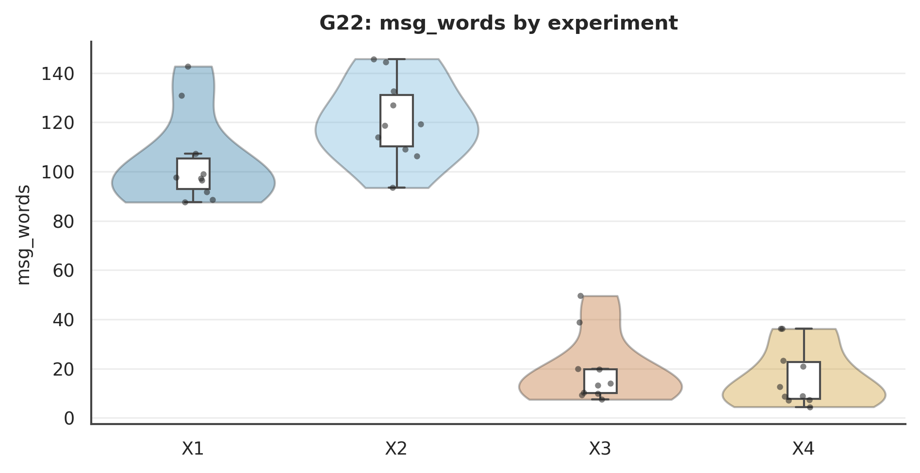

Figure . G22: msg_words Mode×Role interaction.
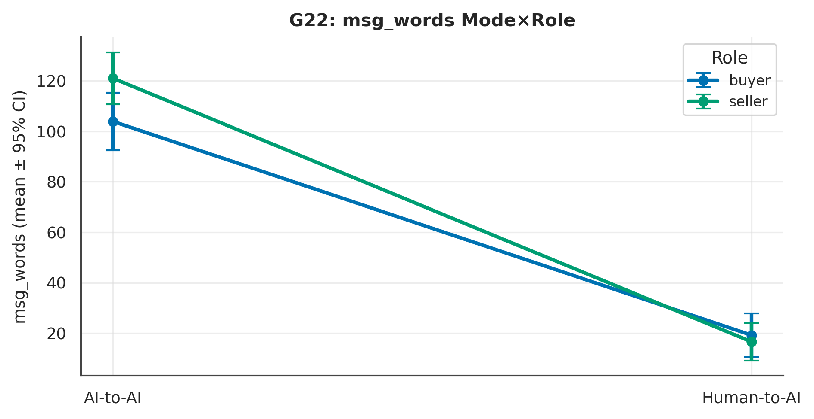

L4 review. Across 6 measure(s), the largest Mode signal was on ‘msg_words’ (p < .001, Cliff's δ = 1.00 [1.00, 1.00], large); the Role contrast there was p = .655 and the Mode×Role interaction p = .267. At ~10 per experiment these are exploratory and hypothesis-generating; effect sizes and intervals, not p-values, carry the interpretation.

G23 · Closing Sequence & Bargaining Micro-dynamics
Anchoring (opening↔settlement) reported in the review; tit-for-tat proxied by concession count.
Table . G23 — L1 Distinct (mean per experiment)
Measure | X1 | X2 | X3 | X4 | N
total_concession | 1,880.00 | 2,050.00 | 3,570.00 | 1,375.00 | 40
rounds_to_close | 7.50 | 8.90 | 6.20 | 4.40 | 40

Table . G23 — L2 2×2 + Pairwise (Mode/Role/Mode×Role; best pairwise)
Measure | Mode p | Mode δ | Mode 95%CI | Role p | M×R p | Opp p | Top pairwise | that p
total_concession | .935 | −.02 | [−.42, .40] | .293 | .026 | .097 | Role | Direct (X3 vs X4) | .061
rounds_to_close | < .001 | .69 | [.48, .95] | .754 | .036 | .726 | Mode | Seller (X2 vs X4) | < .001
Note. Mode/Role via Mann–Whitney + Cliff's δ (95% bootstrap CI); Mode×Role and opponent via SRH/Kruskal–Wallis.

Table . G23 — L3 Overall (pooled / Mode / Role)
Measure | Overall M(SD) | Delegated | Direct | Buyer | Seller
total_concession | 2218.75 (1949.38) | 1965.00 | 2472.50 | 2725.00 | 1712.50
rounds_to_close | 6.75 (2.54) | 8.20 | 5.30 | 6.85 | 6.65

Table . G23 — Pairwise detail: total_concession
Contrast | n | U | p | Cliff δ | 95% CI | band | q (BH)
Mode | Buyer (X1 vs X3) | 10/10 | 34 | p = .238 | −.32 | [−.88, .18] | small | .249
Mode | Seller (X2 vs X4) | 10/10 | 68 | p = .179 | .36 | [−.12, .92] | medium | .249
Role | Delegated (X1 vs X2) | 10/10 | 28 | p = .080 | −.45 | [−.94, −.02] | medium | .231
Role | Direct (X3 vs X4) | 10/10 | 75 | p = .061 | .50 | [.09, 1.00] | large | .231
Diagonal (X1 vs X4) | 10/10 | 66 | p = .249 | .31 | [−.16, .84] | small | .249
Diagonal (X2 vs X3) | 10/10 | 29 | p = .116 | −.42 | [−1.04, .16] | medium | .231
Note. Six structured contrasts among X1–X4; q = BH-adjusted.

Figure . G23: distribution of total_concession across X1–X4.
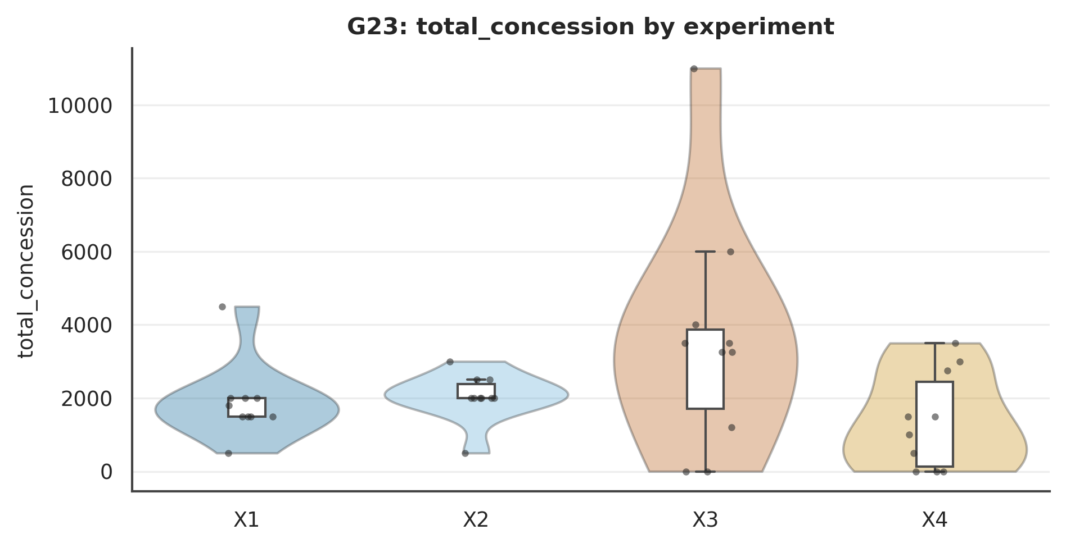

Figure . G23: total_concession Mode×Role interaction.
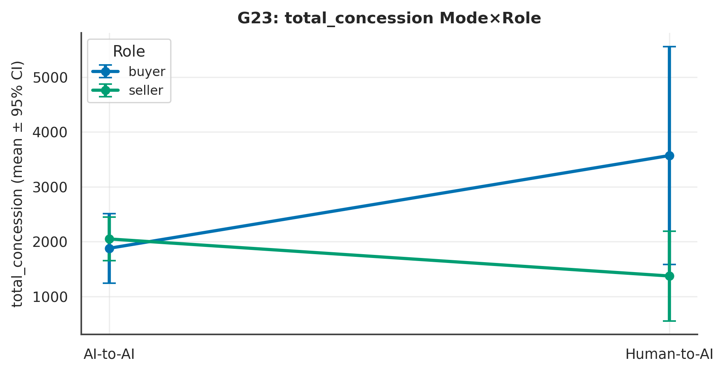

L4 review. Across 2 measure(s), the largest Mode signal was on ‘rounds_to_close’ (p < .001, Cliff's δ = .69 [.48, .95], large); the Role contrast there was p = .754 and the Mode×Role interaction p = .036. At ~10 per experiment these are exploratory and hypothesis-generating; effect sizes and intervals, not p-values, carry the interpretation.

G38 · Action Sequence & Transition Structure
Table . G38 — L1 Distinct (mean per experiment)
Measure | X1 | X2 | X3 | X4 | N
action_transitions | 2.00 | 2.70 | 4.40 | 2.00 | 40
n_actions | 7.50 | 8.90 | 6.20 | 4.40 | 40

Table . G38 — L2 2×2 + Pairwise (Mode/Role/Mode×Role; best pairwise)
Measure | Mode p | Mode δ | Mode 95%CI | Role p | M×R p | Opp p | Top pairwise | that p
action_transitions | .277 | −.19 | [−.55, .16] | .151 | .008 | .171 | Mode | Buyer (X1 vs X3) | .004
n_actions | < .001 | .69 | [.48, .95] | .754 | .036 | .726 | Mode | Seller (X2 vs X4) | < .001
Note. Mode/Role via Mann–Whitney + Cliff's δ (95% bootstrap CI); Mode×Role and opponent via SRH/Kruskal–Wallis.

Table . G38 — L3 Overall (pooled / Mode / Role)
Measure | Overall M(SD) | Delegated | Direct | Buyer | Seller
action_transitions | 2.77 (1.75) | 2.35 | 3.20 | 3.20 | 2.35
n_actions | 6.75 (2.54) | 8.20 | 5.30 | 6.85 | 6.65

Table . G38 — Pairwise detail: action_transitions
Contrast | n | U | p | Cliff δ | 95% CI | band | q (BH)
Mode | Buyer (X1 vs X3) | 10/10 | 15 | p = .004 | −.70 | [−1.10, −.40] | large | .026
Mode | Seller (X2 vs X4) | 10/10 | 64 | p = .263 | .29 | [−.14, .79] | small | .365
Role | Delegated (X1 vs X2) | 10/10 | 40 | p = .304 | −.20 | [−.60, .20] | small | .365
Role | Direct (X3 vs X4) | 10/10 | 82 | p = .014 | .65 | [.34, 1.05] | large | .042
Diagonal (X1 vs X4) | 10/10 | 55 | p = .688 | .10 | [−.40, .60] | negligible | .688
Diagonal (X2 vs X3) | 10/10 | 28 | p = .088 | −.45 | [−.94, −.04] | medium | .176
Note. Six structured contrasts among X1–X4; q = BH-adjusted.

Figure . G38: distribution of action_transitions across X1–X4.
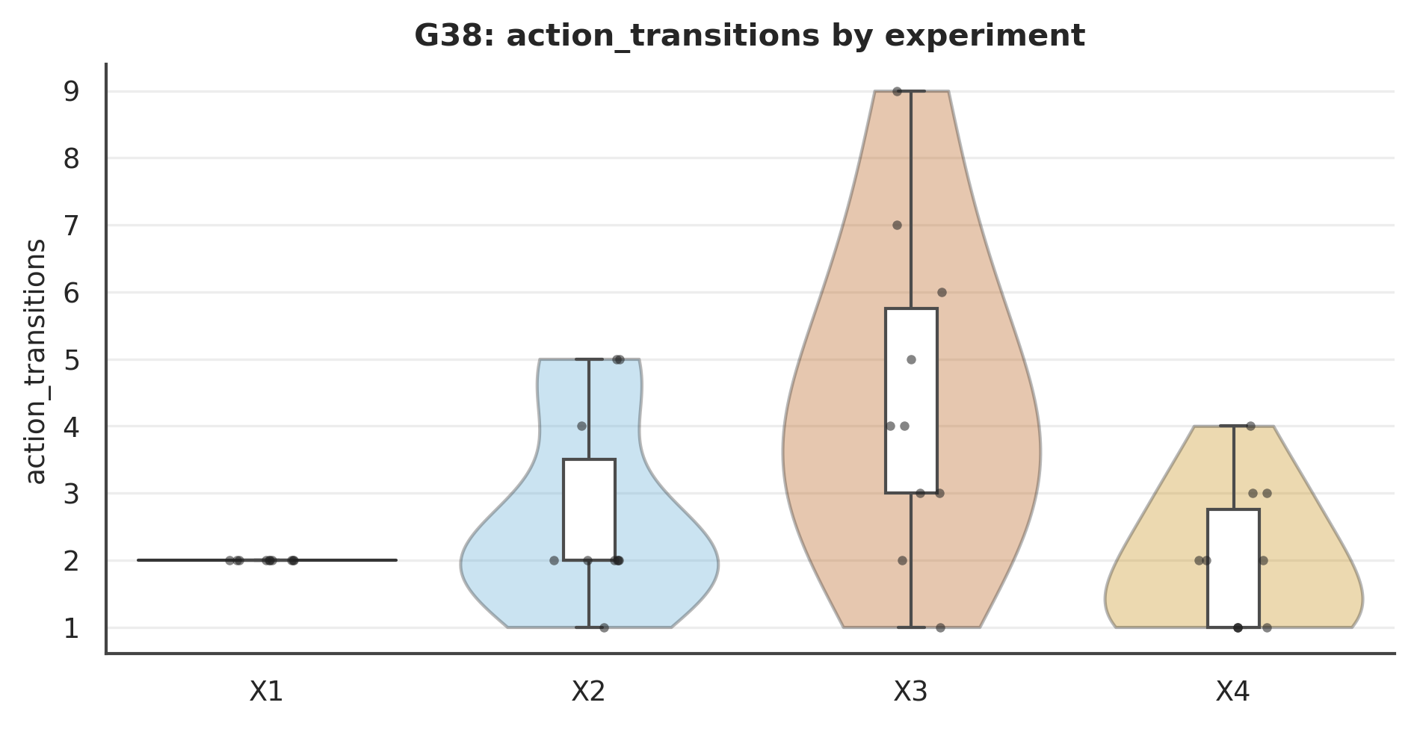

Figure . G38: action_transitions Mode×Role interaction.
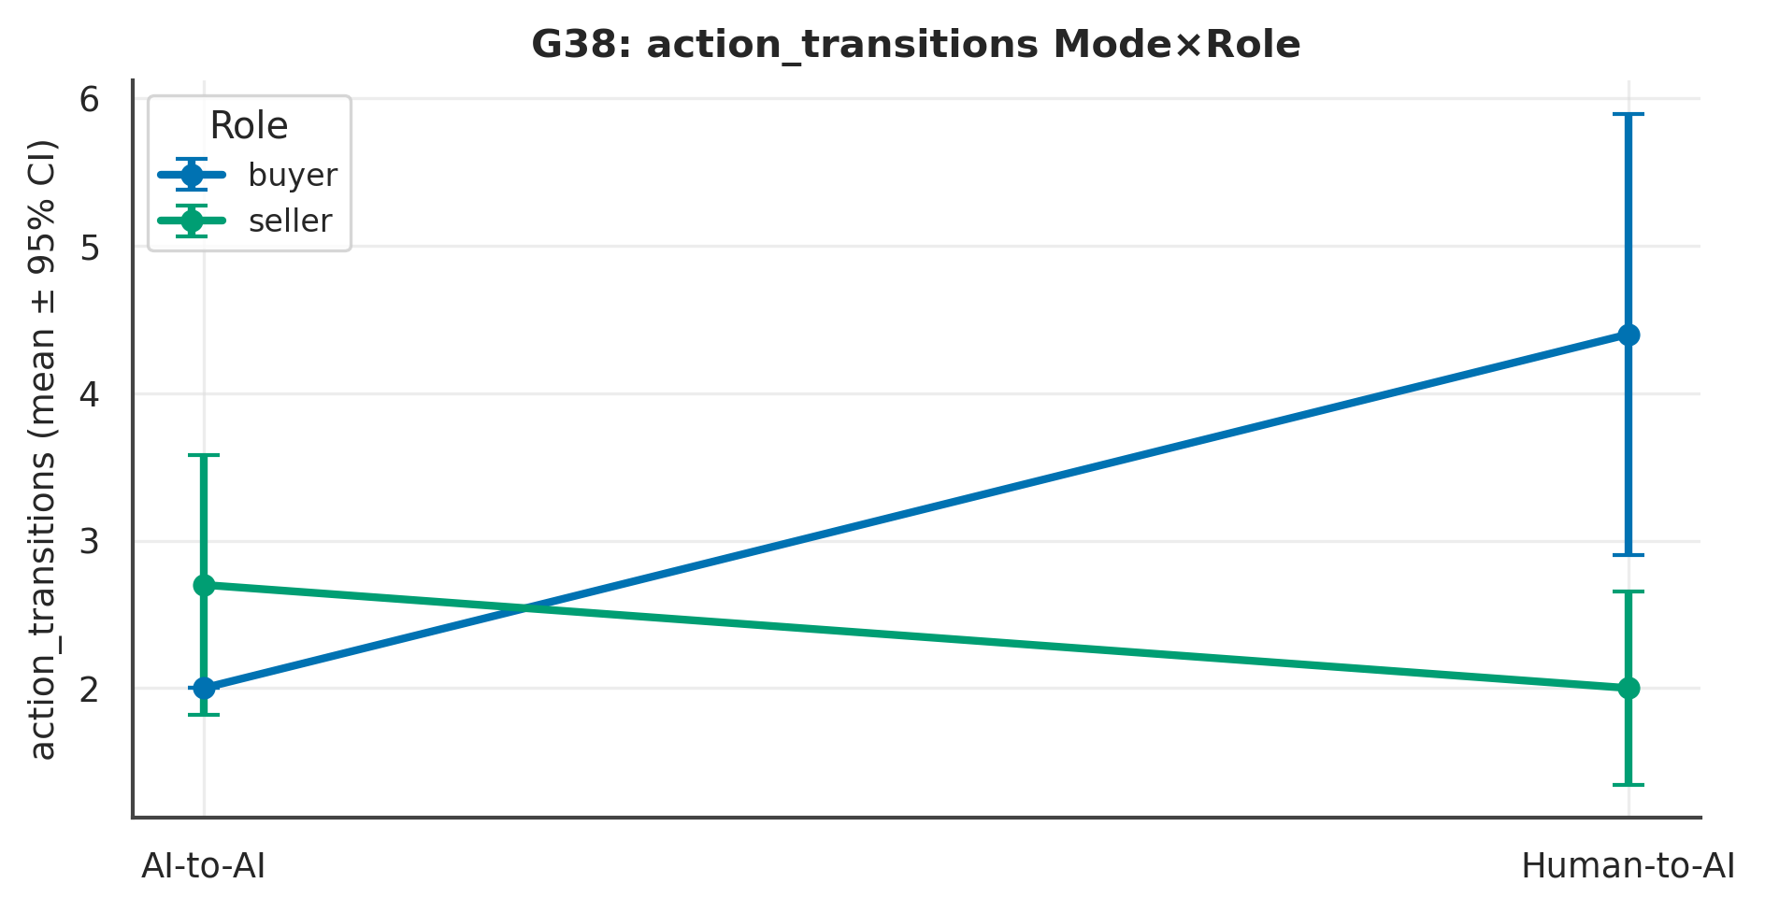

L4 review. Across 2 measure(s), the largest Mode signal was on ‘n_actions’ (p < .001, Cliff's δ = .69 [.48, .95], large); the Role contrast there was p = .754 and the Mode×Role interaction p = .036. At ~10 per experiment these are exploratory and hypothesis-generating; effect sizes and intervals, not p-values, carry the interpretation.

G39 · Dyadic Convergence & Efficiency Frontier
Convergence proxied by opening spread and rounds to close (partner is an LLM).
Table . G39 — L1 Distinct (mean per experiment)
Measure | X1 | X2 | X3 | X4 | N
opening_spread | 4,000.00 | 3,600.00 | 2,666.67 | -200.00 | 39
rounds_to_close | 7.50 | 8.90 | 6.20 | 4.40 | 40

Table . G39 — L2 2×2 + Pairwise (Mode/Role/Mode×Role; best pairwise)
Measure | Mode p | Mode δ | Mode 95%CI | Role p | M×R p | Opp p | Top pairwise | that p
opening_spread | .013 | .46 | [.15, .82] | .107 | .571 | .488 | Diagonal (X1 vs X4) | .005
rounds_to_close | < .001 | .69 | [.48, .95] | .754 | .036 | .726 | Mode | Seller (X2 vs X4) | < .001
Note. Mode/Role via Mann–Whitney + Cliff's δ (95% bootstrap CI); Mode×Role and opponent via SRH/Kruskal–Wallis.

Table . G39 — L3 Overall (pooled / Mode / Role)
Measure | Overall M(SD) | Delegated | Direct | Buyer | Seller
opening_spread | 2512.82 (4280.44) | 3800.00 | 1157.89 | 3368.42 | 1700.00
rounds_to_close | 6.75 (2.54) | 8.20 | 5.30 | 6.85 | 6.65

Table . G39 — Pairwise detail: opening_spread
Contrast | n | U | p | Cliff δ | 95% CI | band | q (BH)
Mode | Buyer (X1 vs X3) | 10/9 | 58 | p = .297 | .29 | [−.17, .84] | small | .440
Mode | Seller (X2 vs X4) | 10/10 | 83 | p = .013 | .66 | [.36, 1.09] | large | .038
Role | Delegated (X1 vs X2) | 10/10 | 62 | p = .367 | .24 | [−.21, .73] | small | .440
Role | Direct (X3 vs X4) | 9/10 | 58 | p = .323 | .28 | [−.23, .87] | small | .440
Diagonal (X1 vs X4) | 10/10 | 87 | p = .005 | .74 | [.49, 1.12] | large | .032
Diagonal (X2 vs X3) | 10/9 | 50 | p = .739 | .10 | [−.43, .67] | negligible | .739
Note. Six structured contrasts among X1–X4; q = BH-adjusted.

Figure . G39: distribution of opening_spread across X1–X4.
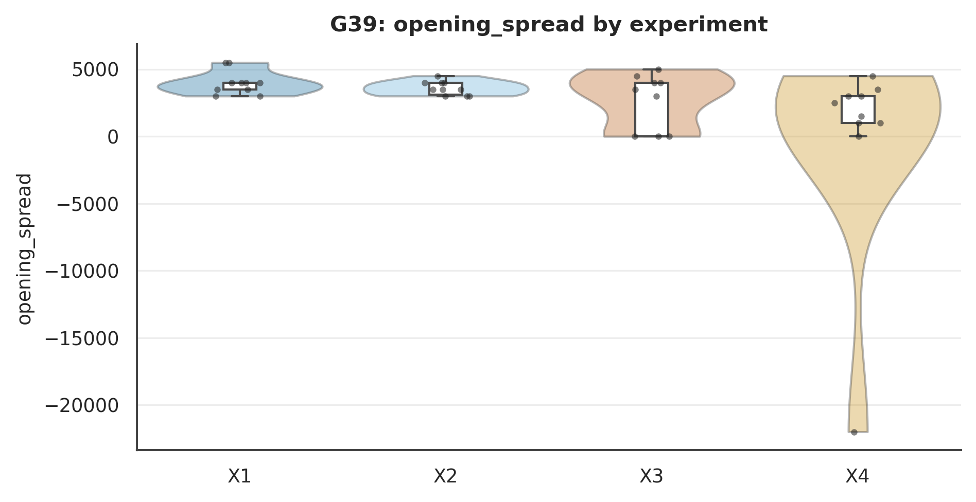

Figure . G39: opening_spread Mode×Role interaction.
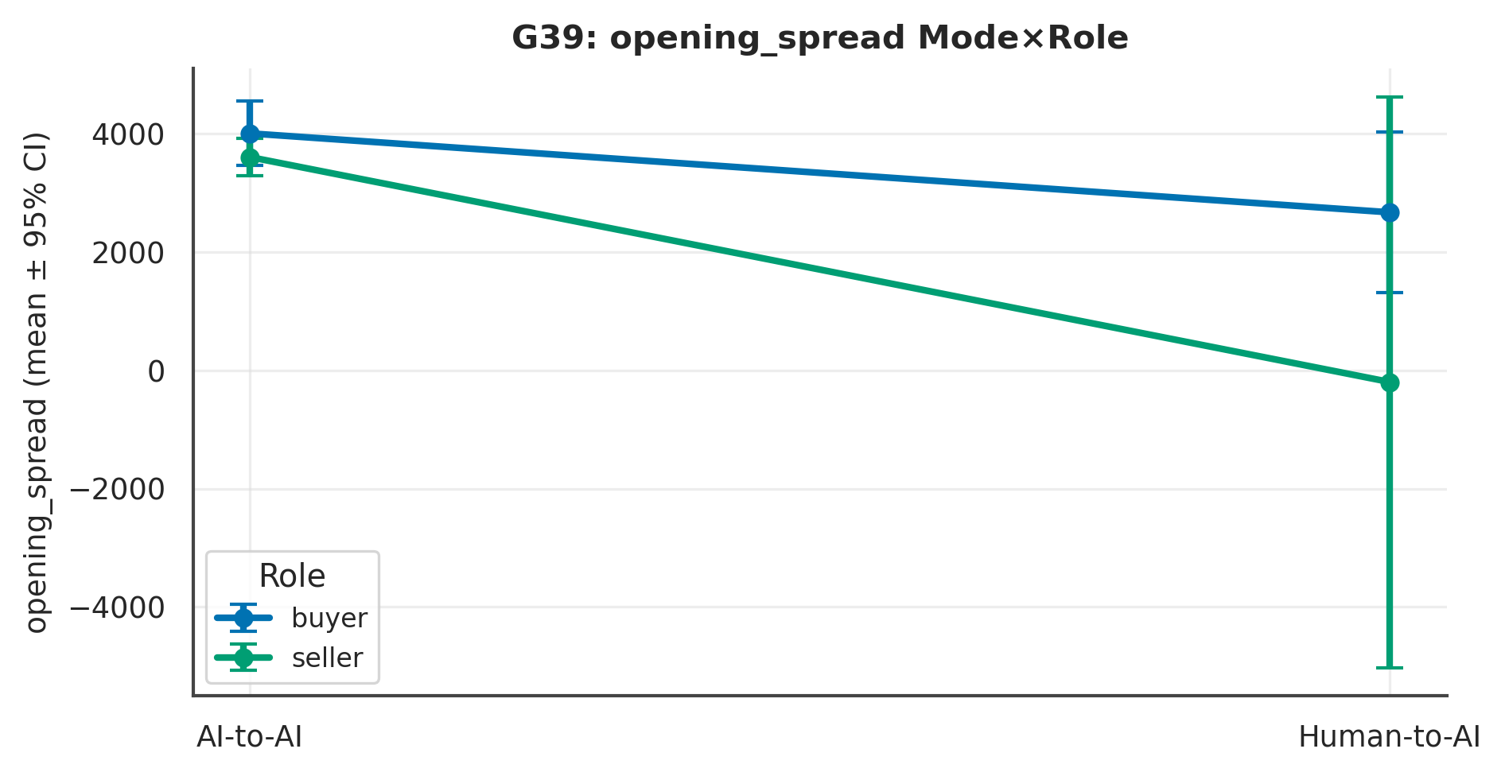

L4 review. Across 2 measure(s), the largest Mode signal was on ‘rounds_to_close’ (p < .001, Cliff's δ = .69 [.48, .95], large); the Role contrast there was p = .754 and the Mode×Role interaction p = .036. At ~10 per experiment these are exploratory and hypothesis-generating; effect sizes and intervals, not p-values, carry the interpretation.

Chapter 5. System & Orchestrator

G06 · Orchestrator Activity & Cost
Table . G06 — L1 Distinct (mean per experiment)
Measure | X1 | X2 | X3 | X4 | N
n_decisions | 15.20 | 16.70 | 11.10 | 10.80 | 40
n_request_turn | 14.10 | 15.70 | 10.10 | 9.50 | 40
orch_tokens | 60,448.70 | 72,366.10 | 27,723.90 | 21,951.20 | 40
rationale_len | 23.50 | 19.19 | 35.20 | 27.92 | 40

Table . G06 — L2 2×2 + Pairwise (Mode/Role/Mode×Role; best pairwise)
Measure | Mode p | Mode δ | Mode 95%CI | Role p | M×R p | Opp p | Top pairwise | that p
n_decisions | < .001 | .81 | [.67, 1.02] | .615 | .422 | .812 | Mode | Seller (X2 vs X4) | < .001
n_request_turn | < .001 | .82 | [.68, 1.02] | .664 | .302 | .732 | Mode | Seller (X2 vs X4) | < .001
orch_tokens | < .001 | .94 | [.89, 1.05] | .675 | .224 | .805 | Mode | Seller (X2 vs X4) | < .001
rationale_len | .010 | −.48 | [−.82, −.18] | .057 | .465 | .341 | Diagonal (X2 vs X3) | .002
Note. Mode/Role via Mann–Whitney + Cliff's δ (95% bootstrap CI); Mode×Role and opponent via SRH/Kruskal–Wallis.

Table . G06 — L3 Overall (pooled / Mode / Role)
Measure | Overall M(SD) | Delegated | Direct | Buyer | Seller
n_decisions | 13.45 (3.59) | 15.95 | 10.95 | 13.15 | 13.75
n_request_turn | 12.35 (3.63) | 14.90 | 9.80 | 12.10 | 12.60
orch_tokens | 45622.47 (25546.77) | 66407.40 | 24837.55 | 44086.30 | 47158.65
rationale_len | 26.45 (11.59) | 21.35 | 31.56 | 29.35 | 23.55

Table . G06 — Pairwise detail: n_decisions
Contrast | n | U | p | Cliff δ | 95% CI | band | q (BH)
Mode | Buyer (X1 vs X3) | 10/10 | 82 | p = .017 | .64 | [.32, 1.08] | large | .025
Mode | Seller (X2 vs X4) | 10/10 | 98 | p < .001 | .97 | [.94, 1.08] | large | .002
Role | Delegated (X1 vs X2) | 10/10 | 35 | p = .265 | −.30 | [−.82, .19] | small | .318
Role | Direct (X3 vs X4) | 10/10 | 48 | p = .909 | −.04 | [−.56, .48] | negligible | .909
Diagonal (X1 vs X4) | 10/10 | 90 | p = .003 | .79 | [.59, 1.12] | large | .006
Diagonal (X2 vs X3) | 10/10 | 92 | p = .002 | .83 | [.66, 1.12] | large | .005
Note. Six structured contrasts among X1–X4; q = BH-adjusted.

Figure . G06: distribution of n_decisions across X1–X4.
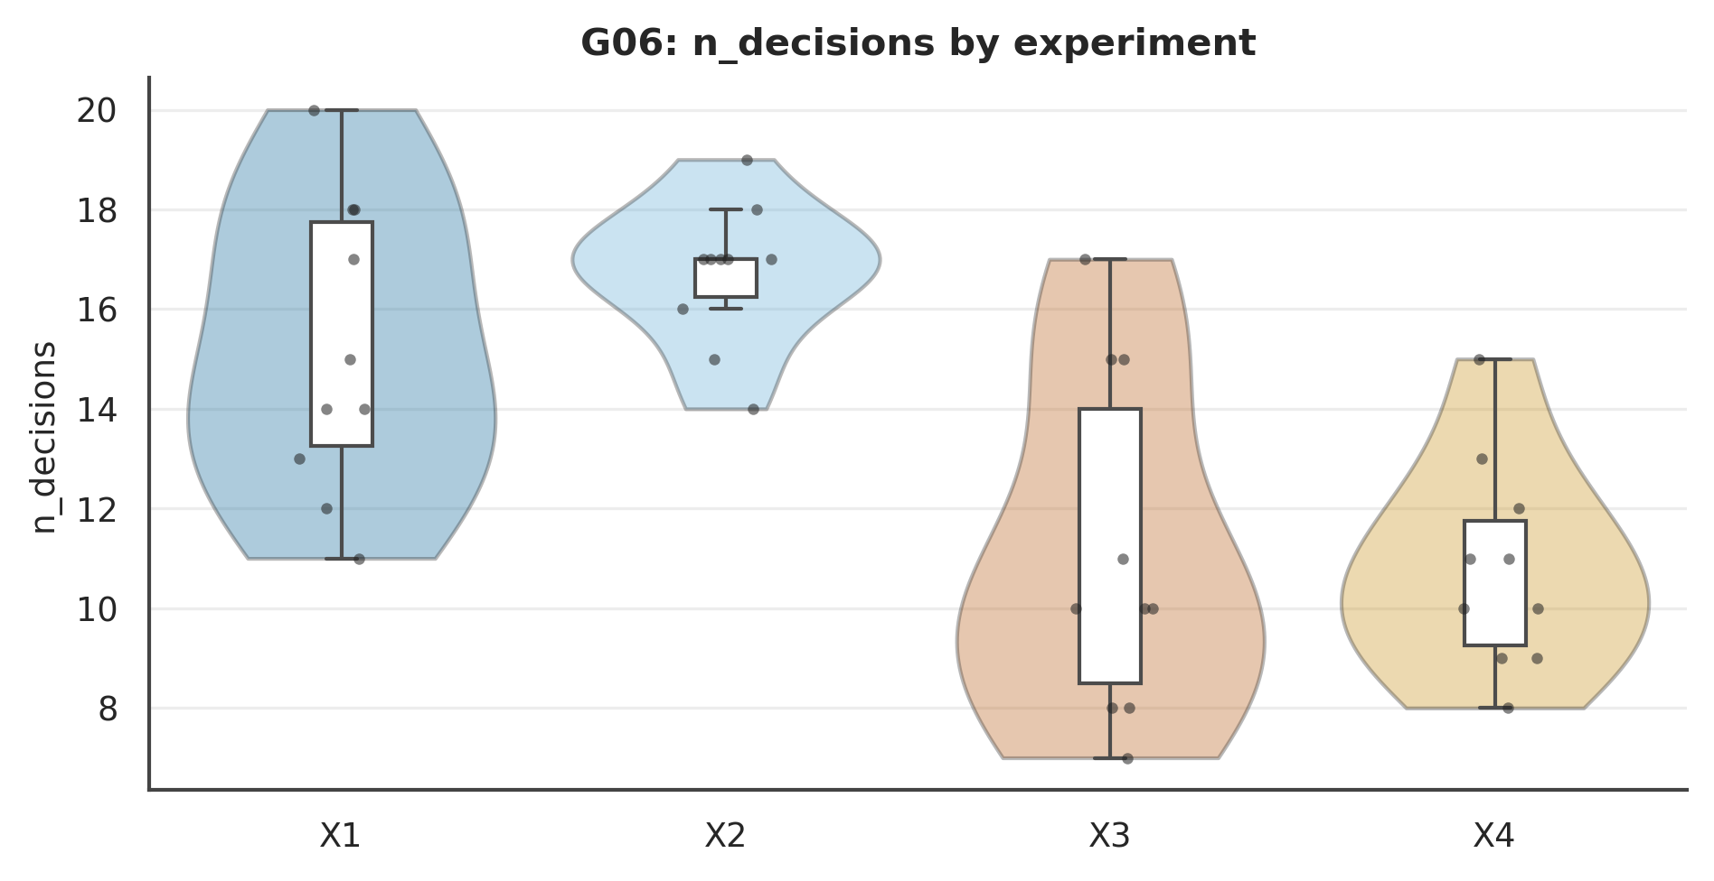

Figure . G06: n_decisions Mode×Role interaction.
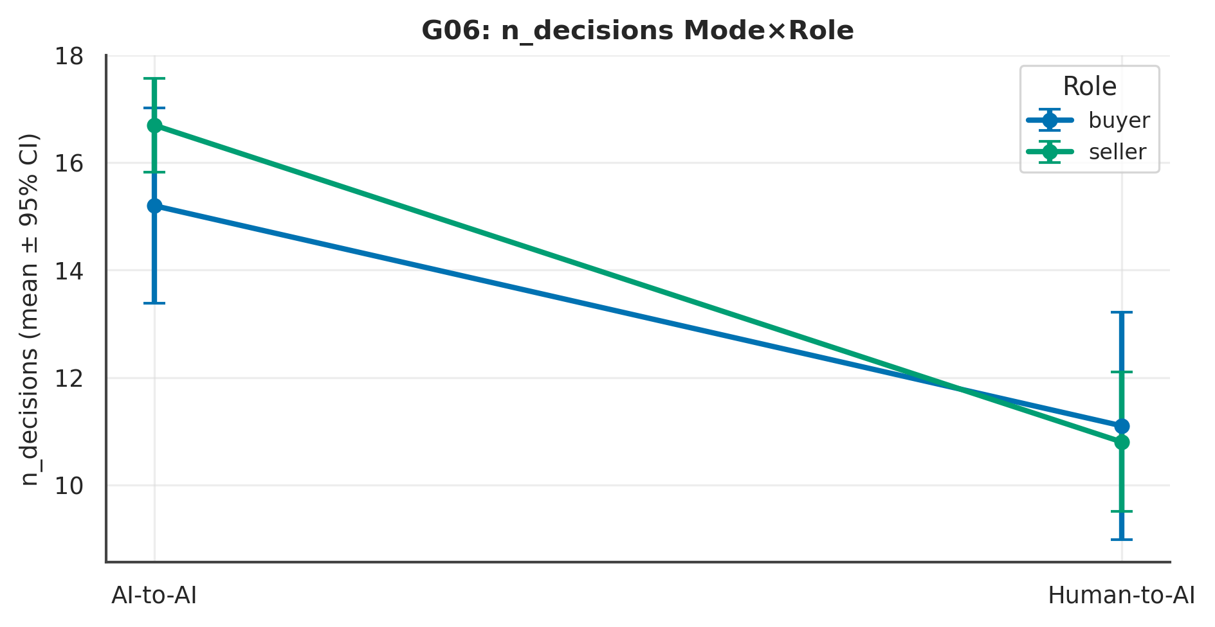

L4 review. Across 4 measure(s), the largest Mode signal was on ‘orch_tokens’ (p < .001, Cliff's δ = .94 [.89, 1.05], large); the Role contrast there was p = .675 and the Mode×Role interaction p = .224. At ~10 per experiment these are exploratory and hypothesis-generating; effect sizes and intervals, not p-values, carry the interpretation.

G16 · Agent Reasoning-Trace Volume
Table . G16 — L1 Distinct (mean per experiment)
Measure | X1 | X2 | X3 | X4 | N
think_chars | 0.00 | 0.00 | 0.00 | 0.00 | 40
think_to_msg | 0.00 | 0.00 | 0.00 | 0.00 | 40

Table . G16 — L2 2×2 + Pairwise (Mode/Role/Mode×Role; best pairwise)
Measure | Mode p | Mode δ | Mode 95%CI | Role p | M×R p | Opp p | Top pairwise | that p
think_chars | 1.000 | .00 | [.00, .00] | 1.000 | NA | < .001 | — | 1.000
think_to_msg | 1.000 | .00 | [.00, .00] | 1.000 | NA | < .001 | — | 1.000
Note. Mode/Role via Mann–Whitney + Cliff's δ (95% bootstrap CI); Mode×Role and opponent via SRH/Kruskal–Wallis.

Table . G16 — L3 Overall (pooled / Mode / Role)
Measure | Overall M(SD) | Delegated | Direct | Buyer | Seller
think_chars | 0.00 (0.00) | 0.00 | 0.00 | 0.00 | 0.00
think_to_msg | 0.00 (0.00) | 0.00 | 0.00 | 0.00 | 0.00

Table . G16 — Pairwise detail: think_chars
Contrast | n | U | p | Cliff δ | 95% CI | band | q (BH)
Mode | Buyer (X1 vs X3) | 10/10 | 50 | p = 1.000 | .00 | [.00, .00] | negligible | 1.000
Mode | Seller (X2 vs X4) | 10/10 | 50 | p = 1.000 | .00 | [.00, .00] | negligible | 1.000
Role | Delegated (X1 vs X2) | 10/10 | 50 | p = 1.000 | .00 | [.00, .00] | negligible | 1.000
Role | Direct (X3 vs X4) | 10/10 | 50 | p = 1.000 | .00 | [.00, .00] | negligible | 1.000
Diagonal (X1 vs X4) | 10/10 | 50 | p = 1.000 | .00 | [.00, .00] | negligible | 1.000
Diagonal (X2 vs X3) | 10/10 | 50 | p = 1.000 | .00 | [.00, .00] | negligible | 1.000
Note. Six structured contrasts among X1–X4; q = BH-adjusted.

Figure . G16: distribution of think_chars across X1–X4.
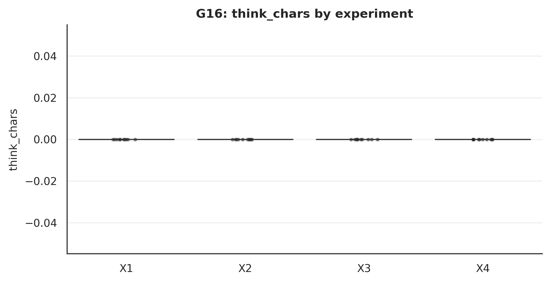

Figure . G16: think_chars Mode×Role interaction.
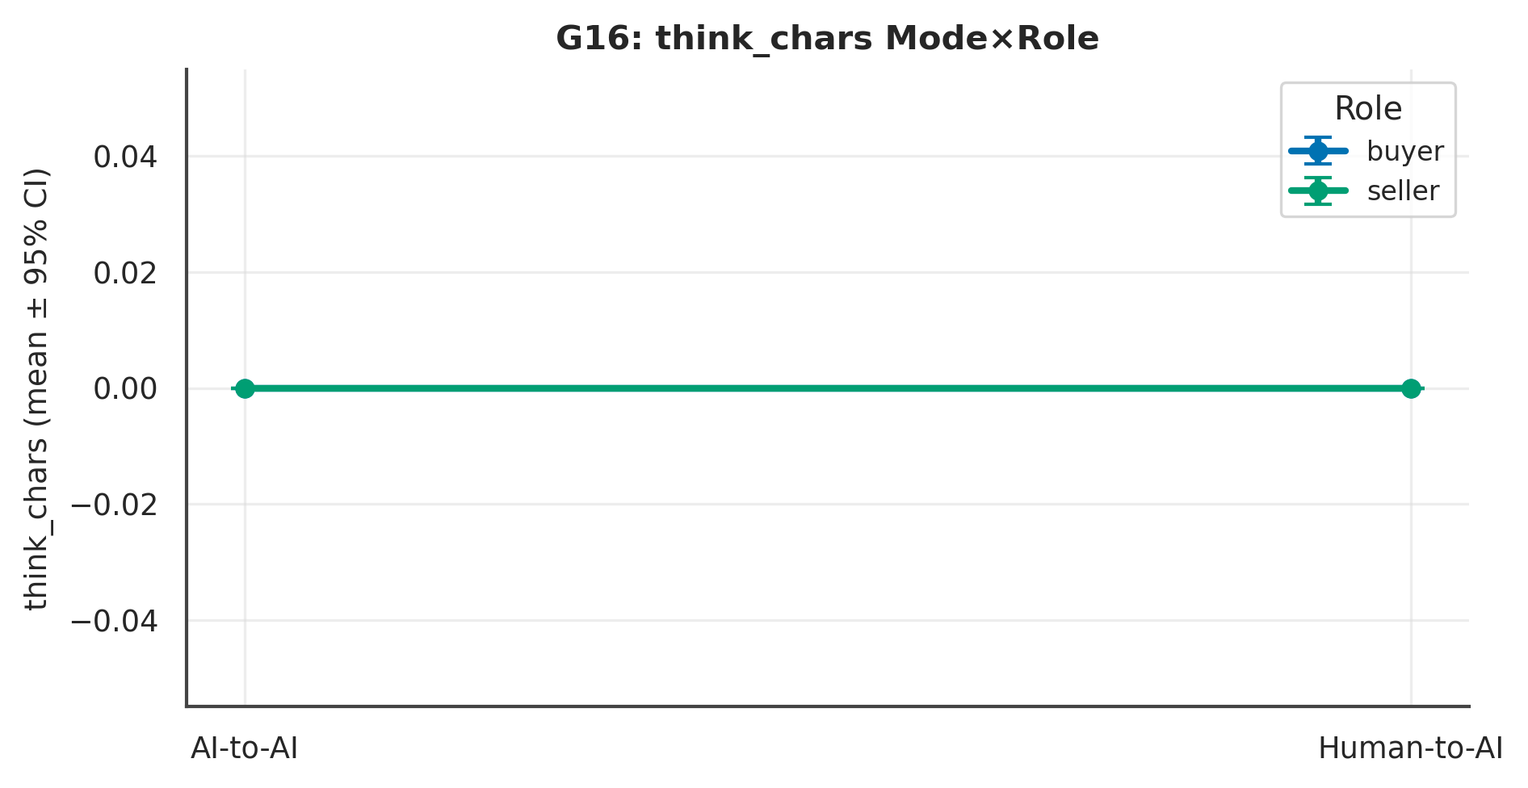

L4 review. Across 2 measure(s), the largest Mode signal was on ‘think_chars’ (p = 1.000, Cliff's δ = .00 [.00, .00], negligible); the Role contrast there was p = 1.000 and the Mode×Role interaction p = NA. At ~10 per experiment these are exploratory and hypothesis-generating; effect sizes and intervals, not p-values, carry the interpretation.

G34 · Orchestrator Decision Content
Table . G34 — Decision tool mix
tool_name | count
request_turn | 537
declare_outcome | 40
broadcast_to | 4
pause | 1

L4 review. Reported descriptively at the cohort level; exploratory and hypothesis-generating only.

G35 · Turn Provenance & Tool-Use Taxonomy
Table . G35 — Provenance
emitter | emitter_id | model | turns
human | buyer | human | 53
human | seller | human | 44
participant | buyer | claude-sonnet-4-6 | 204
participant | seller | claude-sonnet-4-6 | 193

L4 review. Reported descriptively at the cohort level; exploratory and hypothesis-generating only.

Chapter 6. Instrumentation & Engagement

G07 · Engagement & Attention Instrumentation
No attention check exists; these are the only data-quality signals.
Table . G07 — L1 Distinct (mean per experiment)
Measure | X1 | X2 | X3 | X4 | N
active_s | 639.98 | 719.76 | 705.25 | 521.19 | 40
idle_s | 198.00 | 198.37 | 160.37 | 88.84 | 40
scroll_depth | 88.71 | 86.74 | 90.74 | 97.65 | 40
n_clicks | 42.30 | 42.50 | 52.80 | 46.10 | 40
n_tab_away | 1.20 | 0.40 | 2.70 | 1.10 | 40
integrity_attempts | 2.00 | 2.90 | 5.10 | 0.70 | 40
n_likert_changes | 9.80 | 9.90 | 10.90 | 9.80 | 40

Table . G07 — L2 2×2 + Pairwise (Mode/Role/Mode×Role; best pairwise)
Measure | Mode p | Mode δ | Mode 95%CI | Role p | M×R p | Opp p | Top pairwise | that p
active_s | .351 | .17 | [−.18, .53] | .490 | .088 | .778 | Mode | Seller (X2 vs X4) | .076
idle_s | .014 | .46 | [.16, .79] | .695 | .705 | .178 | Diagonal (X1 vs X4) | .038
scroll_depth | .152 | −.25 | [−.57, .07] | .456 | .174 | .770 | Mode | Seller (X2 vs X4) | .067
n_clicks | .104 | −.30 | [−.66, .03] | .104 | .194 | .831 | Mode | Buyer (X1 vs X3) | .021
n_tab_away | .461 | −.11 | [−.40, .17] | .384 | .920 | .690 | Diagonal (X2 vs X3) | .281
integrity_attempts | .049 | .33 | [.04, .65] | .644 | .710 | .653 | Mode | Buyer (X1 vs X3) | .087
n_likert_changes | .501 | −.12 | [−.46, .21] | .398 | .422 | .252 | Role | Direct (X3 vs X4) | .263
Note. Mode/Role via Mann–Whitney + Cliff's δ (95% bootstrap CI); Mode×Role and opponent via SRH/Kruskal–Wallis.

Table . G07 — L3 Overall (pooled / Mode / Role)
Measure | Overall M(SD) | Delegated | Direct | Buyer | Seller
active_s | 646.54 (223.90) | 679.87 | 613.22 | 672.61 | 620.47
idle_s | 161.39 (151.45) | 198.18 | 124.61 | 179.18 | 143.60
scroll_depth | 90.96 (13.89) | 87.73 | 94.19 | 89.73 | 92.19
n_clicks | 45.92 (13.14) | 42.40 | 49.45 | 47.55 | 44.30
n_tab_away | 1.35 (3.09) | 0.80 | 1.90 | 1.95 | 0.75
integrity_attempts | 2.67 (8.03) | 2.45 | 2.90 | 3.55 | 1.80
n_likert_changes | 10.10 (1.35) | 9.85 | 10.35 | 10.35 | 9.85

Table . G07 — Pairwise detail: active_s
Contrast | n | U | p | Cliff δ | 95% CI | band | q (BH)
Mode | Buyer (X1 vs X3) | 10/10 | 45 | p = .734 | −.10 | [−.64, .40] | negligible | .880
Mode | Seller (X2 vs X4) | 10/10 | 74 | p = .076 | .48 | [.10, .98] | large | .312
Role | Delegated (X1 vs X2) | 10/10 | 38 | p = .385 | −.24 | [−.78, .22] | small | .577
Role | Direct (X3 vs X4) | 10/10 | 72 | p = .104 | .44 | [.04, .94] | medium | .312
Diagonal (X1 vs X4) | 10/10 | 66 | p = .241 | .32 | [−.12, .86] | small | .483
Diagonal (X2 vs X3) | 10/10 | 50 | p = 1.000 | .00 | [−.54, .52] | negligible | 1.000
Note. Six structured contrasts among X1–X4; q = BH-adjusted.

Figure . G07: distribution of active_s across X1–X4.
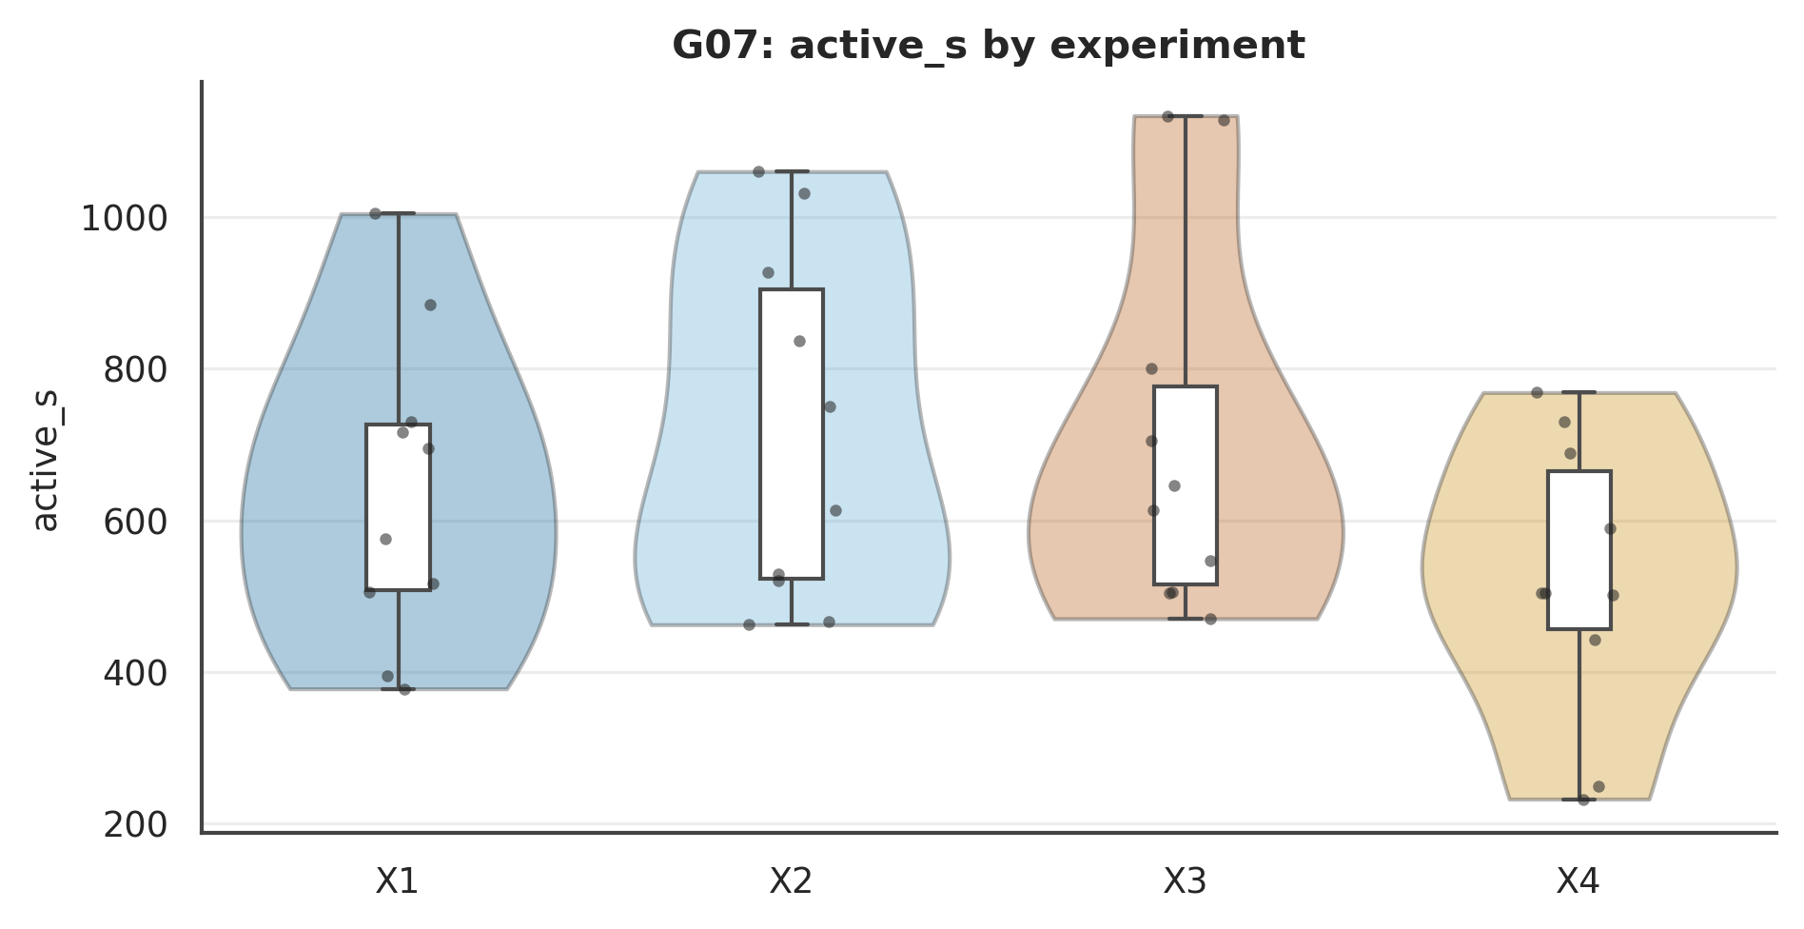

Figure . G07: active_s Mode×Role interaction.
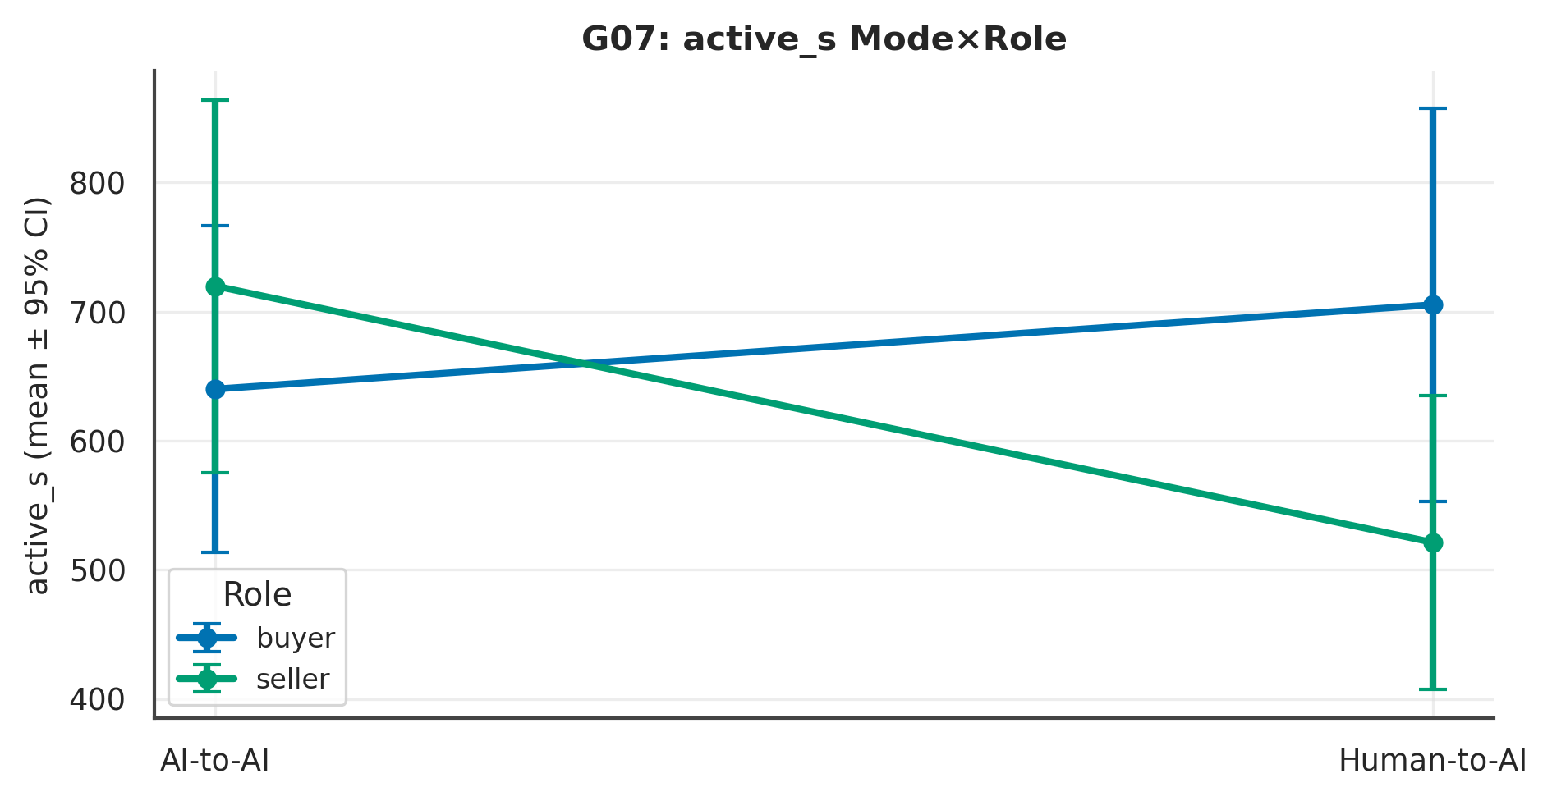

L4 review. Across 7 measure(s), the largest Mode signal was on ‘idle_s’ (p = .014, Cliff's δ = .46 [.16, .79], medium); the Role contrast there was p = .695 and the Mode×Role interaction p = .705. At ~10 per experiment these are exploratory and hypothesis-generating; effect sizes and intervals, not p-values, carry the interpretation.

G32 · UI Interaction Mining
Table . G32 — L1 Distinct (mean per experiment)
Measure | X1 | X2 | X3 | X4 | N
n_screen_revisits | 10.00 | 10.00 | 8.00 | 8.80 | 40
n_resize | 0.20 | 0.00 | 0.70 | 0.10 | 40
n_focus | 7.50 | 7.50 | 12.80 | 11.50 | 40

Table . G32 — L2 2×2 + Pairwise (Mode/Role/Mode×Role; best pairwise)
Measure | Mode p | Mode δ | Mode 95%CI | Role p | M×R p | Opp p | Top pairwise | that p
n_screen_revisits | < .001 | .90 | [.80, 1.10] | .655 | .643 | .929 | Mode | Buyer (X1 vs X3) | < .001
n_resize | .165 | −.15 | [−.35, .05] | .138 | .572 | .693 | Diagonal (X2 vs X3) | .078
n_focus | < .001 | −.78 | [−1.03, −.58] | .204 | .785 | .632 | Mode | Buyer (X1 vs X3) | < .001
Note. Mode/Role via Mann–Whitney + Cliff's δ (95% bootstrap CI); Mode×Role and opponent via SRH/Kruskal–Wallis.

Table . G32 — L3 Overall (pooled / Mode / Role)
Measure | Overall M(SD) | Delegated | Direct | Buyer | Seller
n_screen_revisits | 9.20 (1.49) | 10.00 | 8.40 | 9.00 | 9.40
n_resize | 0.25 (0.71) | 0.10 | 0.40 | 0.45 | 0.05
n_focus | 9.82 (4.34) | 7.50 | 12.15 | 10.15 | 9.50

Table . G32 — Pairwise detail: n_screen_revisits
Contrast | n | U | p | Cliff δ | 95% CI | band | q (BH)
Mode | Buyer (X1 vs X3) | 10/10 | 100 | p < .001 | 1.00 | [1.00, 1.00] | large | .000
Mode | Seller (X2 vs X4) | 10/10 | 90 | p < .001 | .80 | [.60, 1.20] | large | .001
Role | Delegated (X1 vs X2) | 10/10 | 50 | p = 1.000 | .00 | [.00, .00] | negligible | 1.000
Role | Direct (X3 vs X4) | 10/10 | 45 | p = .368 | −.10 | [−.20, .10] | negligible | .442
Diagonal (X1 vs X4) | 10/10 | 90 | p < .001 | .80 | [.60, 1.20] | large | .001
Diagonal (X2 vs X3) | 10/10 | 100 | p < .001 | 1.00 | [1.00, 1.00] | large | .000
Note. Six structured contrasts among X1–X4; q = BH-adjusted.

Figure . G32: distribution of n_screen_revisits across X1–X4.
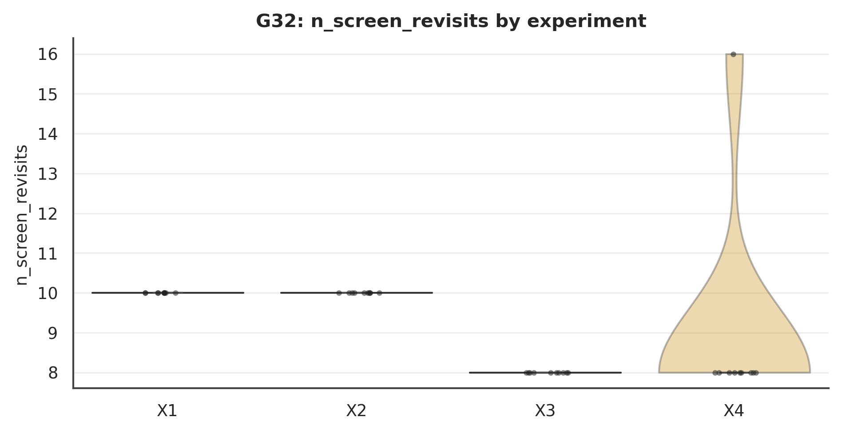

Figure . G32: n_screen_revisits Mode×Role interaction.
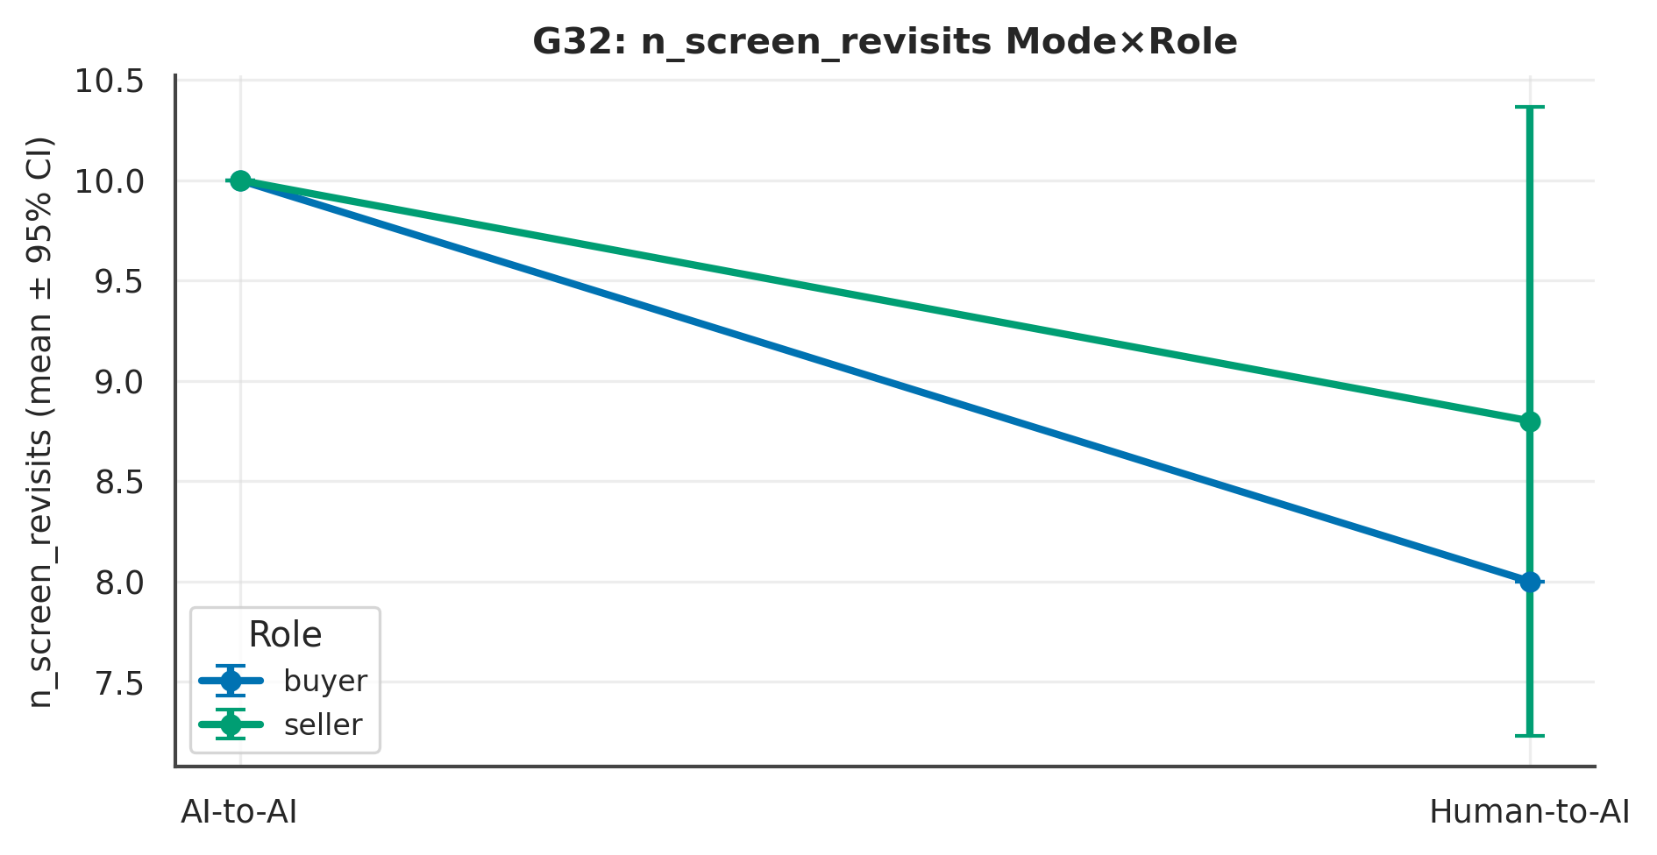

L4 review. Across 3 measure(s), the largest Mode signal was on ‘n_screen_revisits’ (p < .001, Cliff's δ = .90 [.80, 1.10], large); the Role contrast there was p = .655 and the Mode×Role interaction p = .643. At ~10 per experiment these are exploratory and hypothesis-generating; effect sizes and intervals, not p-values, carry the interpretation.

G33 · Outcome-Reaction Timing
Table . G33 — L1 Distinct (mean per experiment)
Measure | X1 | X2 | X3 | X4 | N
outcome_dwell_s | 14.55 | 9.84 | 5.86 | 6.06 | 40

Table . G33 — L2 2×2 + Pairwise (Mode/Role/Mode×Role; best pairwise)
Measure | Mode p | Mode δ | Mode 95%CI | Role p | M×R p | Opp p | Top pairwise | that p
outcome_dwell_s | .425 | .15 | [−.21, .50] | .882 | .829 | .350 | Mode | Seller (X2 vs X4) | .427
Note. Mode/Role via Mann–Whitney + Cliff's δ (95% bootstrap CI); Mode×Role and opponent via SRH/Kruskal–Wallis.

Table . G33 — L3 Overall (pooled / Mode / Role)
Measure | Overall M(SD) | Delegated | Direct | Buyer | Seller
outcome_dwell_s | 9.08 (13.89) | 12.20 | 5.96 | 10.21 | 7.95

Table . G33 — Pairwise detail: outcome_dwell_s
Contrast | n | U | p | Cliff δ | 95% CI | band | q (BH)
Mode | Buyer (X1 vs X3) | 10/10 | 56 | p = .678 | .12 | [−.40, .68] | negligible | .970
Mode | Seller (X2 vs X4) | 10/10 | 61 | p = .427 | .22 | [−.28, .76] | small | .970
Role | Delegated (X1 vs X2) | 10/10 | 49 | p = .970 | −.02 | [−.54, .52] | negligible | .970
Role | Direct (X3 vs X4) | 10/10 | 52 | p = .910 | .04 | [−.50, .58] | negligible | .970
Diagonal (X1 vs X4) | 10/10 | 59 | p = .521 | .18 | [−.30, .72] | small | .970
Diagonal (X2 vs X3) | 10/10 | 54 | p = .791 | .08 | [−.42, .64] | negligible | .970
Note. Six structured contrasts among X1–X4; q = BH-adjusted.

Figure . G33: distribution of outcome_dwell_s across X1–X4.
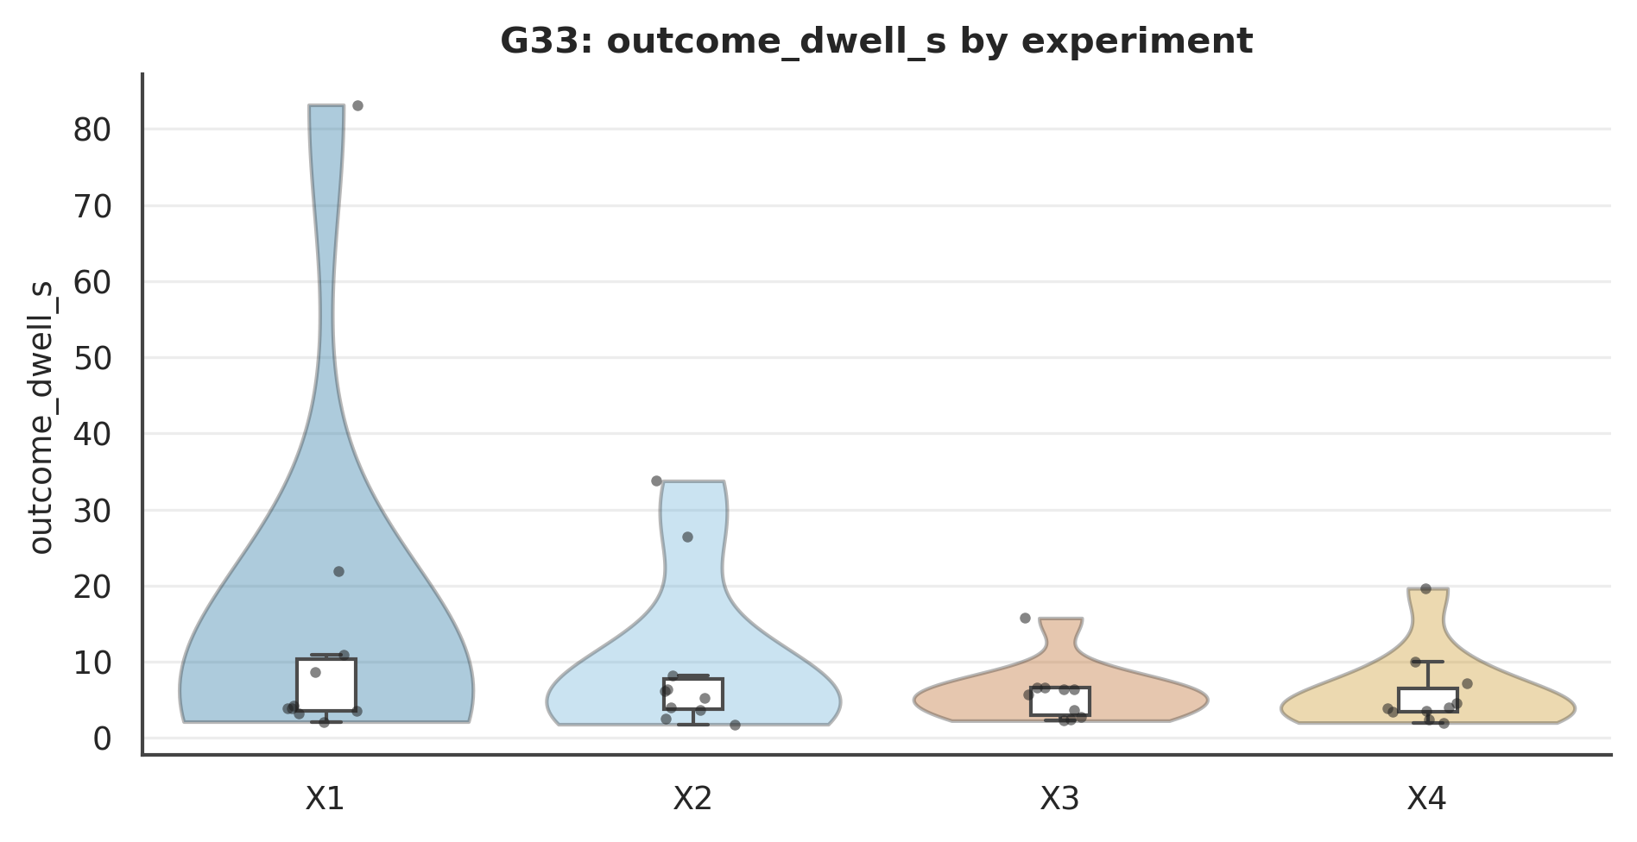

Figure . G33: outcome_dwell_s Mode×Role interaction.
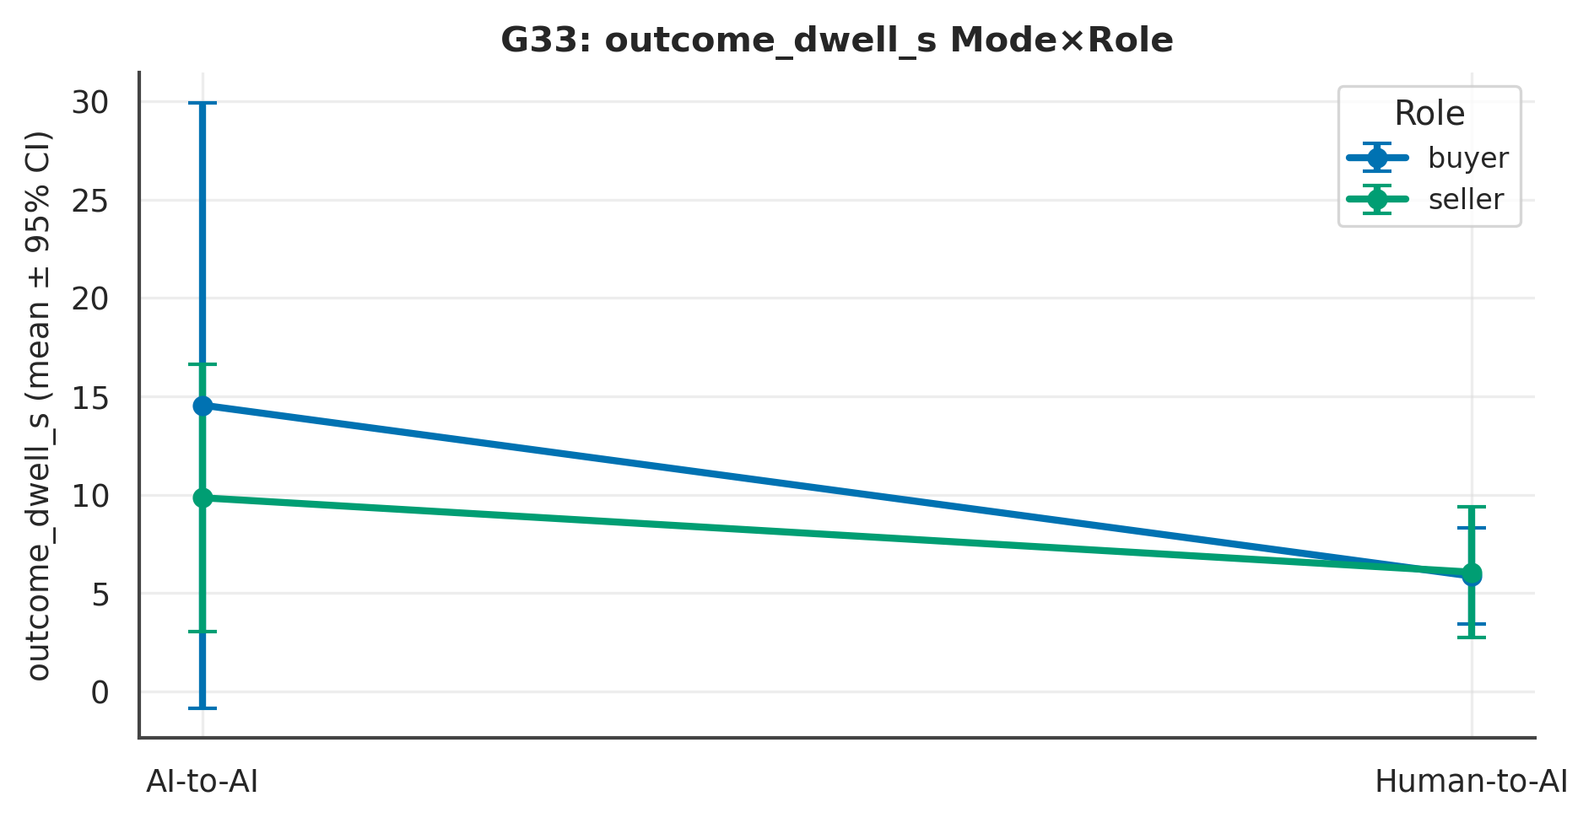

L4 review. Across 1 measure(s), the largest Mode signal was on ‘outcome_dwell_s’ (p = .425, Cliff's δ = .15 [−.21, .50], small); the Role contrast there was p = .882 and the Mode×Role interaction p = .829. At ~10 per experiment these are exploratory and hypothesis-generating; effect sizes and intervals, not p-values, carry the interpretation.

G44 · Survey–Behaviour Incongruence
Stated effort vs logged active time; correlation reported in the review.
Table . G44 — L1 Distinct (mean per experiment)
Measure | X1 | X2 | X3 | X4 | N
active_s | 639.98 | 719.76 | 705.25 | 521.19 | 40
stated_vs_active | 4.30 | 4.10 | 6.10 | 4.30 | 40

Table . G44 — L2 2×2 + Pairwise (Mode/Role/Mode×Role; best pairwise)
Measure | Mode p | Mode δ | Mode 95%CI | Role p | M×R p | Opp p | Top pairwise | that p
active_s | .351 | .17 | [−.18, .53] | .490 | .088 | .778 | Mode | Seller (X2 vs X4) | .076
stated_vs_active | .032 | −.39 | [−.72, −.09] | .042 | .165 | .947 | Diagonal (X2 vs X3) | .004
Note. Mode/Role via Mann–Whitney + Cliff's δ (95% bootstrap CI); Mode×Role and opponent via SRH/Kruskal–Wallis.

Table . G44 — L3 Overall (pooled / Mode / Role)
Measure | Overall M(SD) | Delegated | Direct | Buyer | Seller
active_s | 646.54 (223.90) | 679.87 | 613.22 | 672.61 | 620.47
stated_vs_active | 4.70 (1.70) | 4.20 | 5.20 | 5.20 | 4.20

Table . G44 — Pairwise detail: active_s
Contrast | n | U | p | Cliff δ | 95% CI | band | q (BH)
Mode | Buyer (X1 vs X3) | 10/10 | 45 | p = .734 | −.10 | [−.64, .40] | negligible | .880
Mode | Seller (X2 vs X4) | 10/10 | 74 | p = .076 | .48 | [.10, .98] | large | .312
Role | Delegated (X1 vs X2) | 10/10 | 38 | p = .385 | −.24 | [−.78, .22] | small | .577
Role | Direct (X3 vs X4) | 10/10 | 72 | p = .104 | .44 | [.04, .94] | medium | .312
Diagonal (X1 vs X4) | 10/10 | 66 | p = .241 | .32 | [−.12, .86] | small | .483
Diagonal (X2 vs X3) | 10/10 | 50 | p = 1.000 | .00 | [−.54, .52] | negligible | 1.000
Note. Six structured contrasts among X1–X4; q = BH-adjusted.

Figure . G44: distribution of active_s across X1–X4.
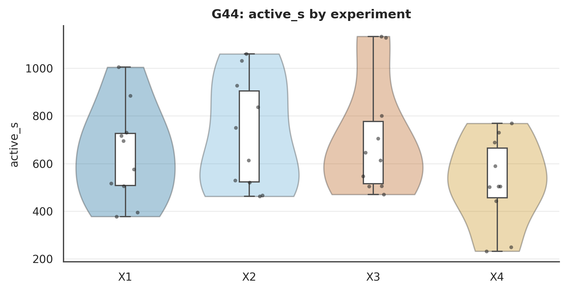

Figure . G44: active_s Mode×Role interaction.
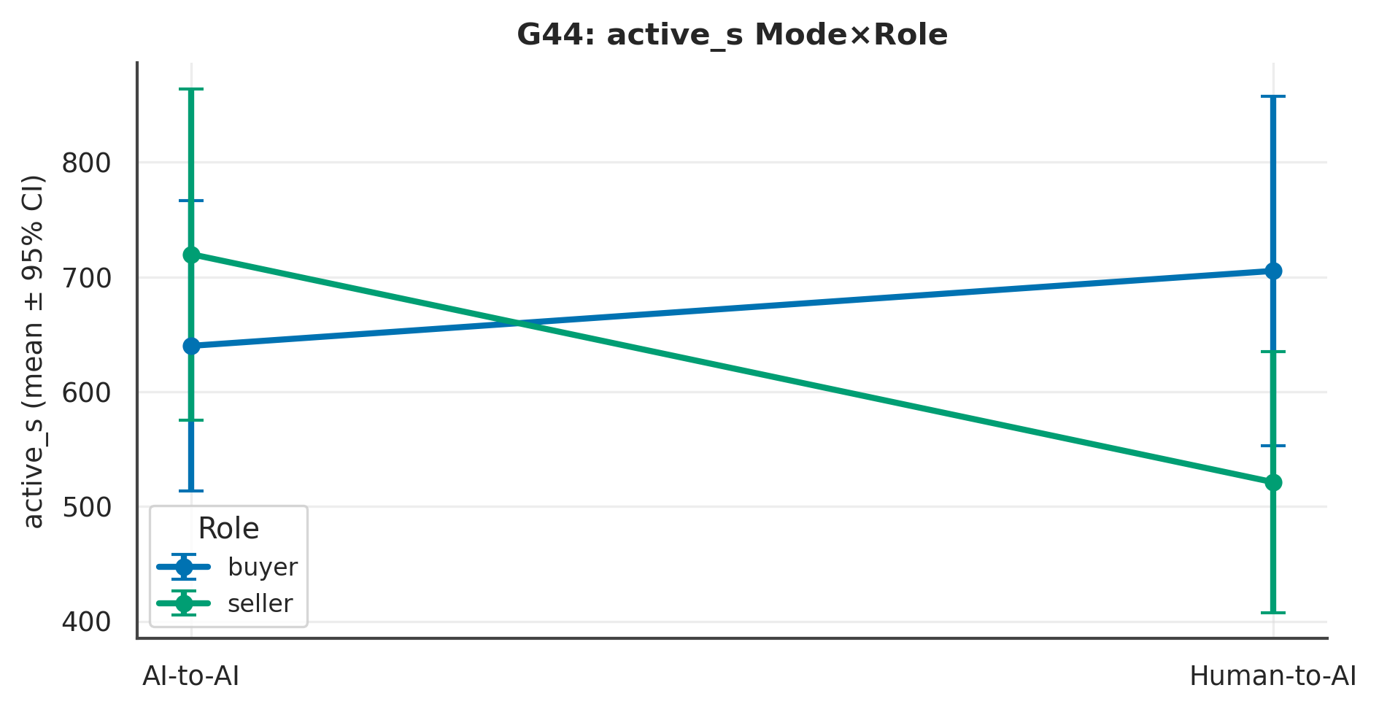

L4 review. Across 2 measure(s), the largest Mode signal was on ‘stated_vs_active’ (p = .032, Cliff's δ = −.39 [−.72, −.09], medium); the Role contrast there was p = .042 and the Mode×Role interaction p = .165. At ~10 per experiment these are exploratory and hypothesis-generating; effect sizes and intervals, not p-values, carry the interpretation.

Chapter 7. Mode-Specific Behaviour

G08 · Direct-Mode Typed-Turn Behaviour
Defined only for X3, X4 (direct). Mode contrast not defined; Role (X3 vs X4) is.
Table . G08 — L1 Distinct (mean per experiment)
Measure | X1 | X2 | X3 | X4 | N
mean_charcount |  |  | 92.63 | 84.20 | 20
priced_turn_rate |  |  | 0.28 | 0.23 | 20
mean_compose_s |  |  | 92.75 | 57.17 | 20

Table . G08 — L2 2×2 + Pairwise (Mode/Role/Mode×Role; best pairwise)
Measure | Mode p | Mode δ | Mode 95%CI | Role p | M×R p | Opp p | Top pairwise | that p
mean_charcount | NA | NA | [NA, NA] | .597 | NA | .813 | Role | Direct (X3 vs X4) | .597
priced_turn_rate | NA | NA | [NA, NA] | .565 | NA | .385 | Role | Direct (X3 vs X4) | .565
mean_compose_s | NA | NA | [NA, NA] | .473 | NA | .252 | Role | Direct (X3 vs X4) | .473
Note. Mode/Role via Mann–Whitney + Cliff's δ (95% bootstrap CI); Mode×Role and opponent via SRH/Kruskal–Wallis.

Table . G08 — L3 Overall (pooled / Mode / Role)
Measure | Overall M(SD) | Delegated | Direct | Buyer | Seller
mean_charcount | 88.41 (63.50) | nan | 88.41 | 92.63 | 84.20
priced_turn_rate | 0.26 (0.19) | nan | 0.26 | 0.28 | 0.23
mean_compose_s | 74.96 (57.80) | nan | 74.96 | 92.75 | 57.17

Table . G08 — Pairwise detail: mean_charcount
Contrast | n | U | p | Cliff δ | 95% CI | band | q (BH)
Mode | Buyer (X1 vs X3) | 0/10 | NA | p = NA | NA | [NA, NA] | NA | NA
Mode | Seller (X2 vs X4) | 0/10 | NA | p = NA | NA | [NA, NA] | NA | NA
Role | Delegated (X1 vs X2) | 0/0 | NA | p = NA | NA | [NA, NA] | NA | NA
Role | Direct (X3 vs X4) | 10/10 | 58 | p = .597 | .15 | [−.34, .68] | small | .597
Diagonal (X1 vs X4) | 0/10 | NA | p = NA | NA | [NA, NA] | NA | NA
Diagonal (X2 vs X3) | 0/10 | NA | p = NA | NA | [NA, NA] | NA | NA
Note. Six structured contrasts among X1–X4; q = BH-adjusted.

Figure . G08: distribution of mean_charcount across X1–X4.
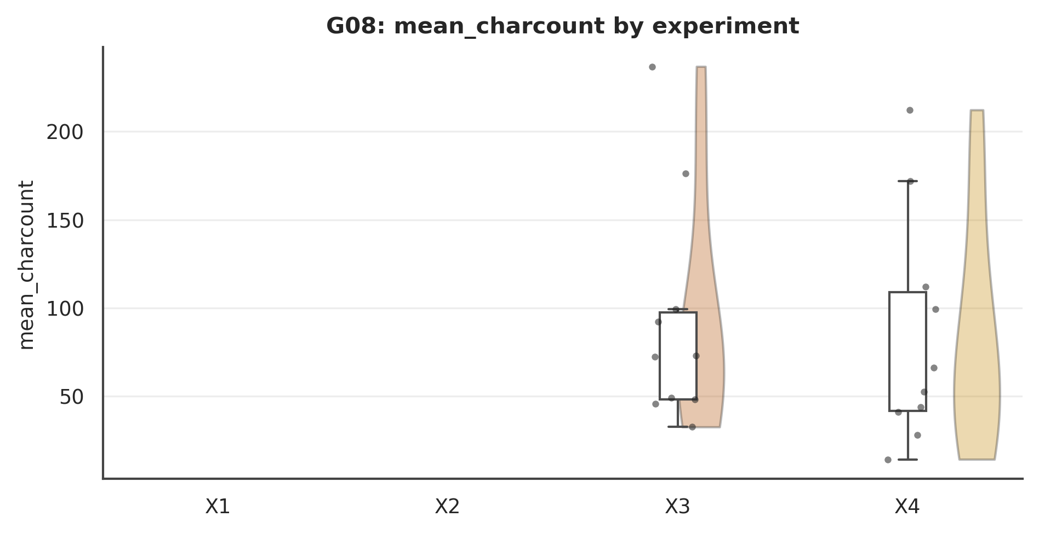

Figure . G08: mean_charcount Mode×Role interaction.
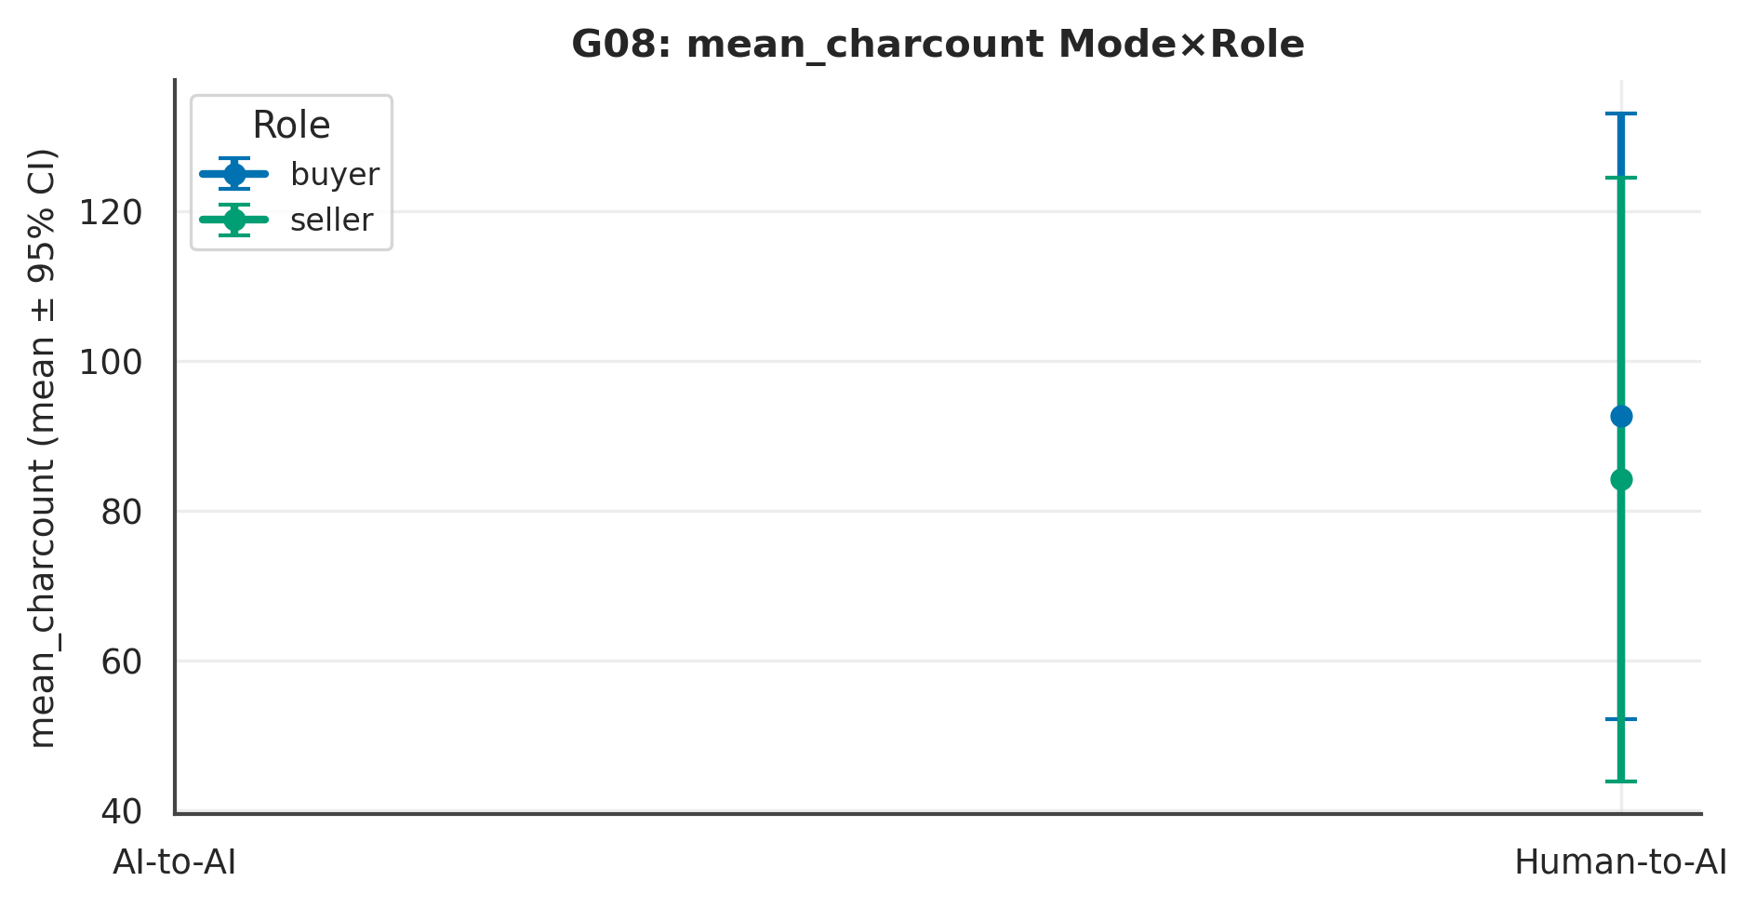

L4 review. Across 3 measure(s), the largest Mode signal was on ‘mean_charcount’ (p = NA, Cliff's δ = NA [NA, NA], NA); the Role contrast there was p = .597 and the Mode×Role interaction p = NA. At ~10 per experiment these are exploratory and hypothesis-generating; effect sizes and intervals, not p-values, carry the interpretation.

G09 · Delegated-Mode Prompt Authoring
Defined only for X1, X2 (delegated). match_rating / mapped_signals are NULL — only raw text usable.
Table . G09 — L1 Distinct (mean per experiment)
Measure | X1 | X2 | X3 | X4 | N
prompt_words | 39.80 | 70.00 |  |  | 20
prompt_threat | 0.10 | 0.30 |  |  | 20
prompt_polite | 0.30 | 0.40 |  |  | 20
prompt_price_refs | 1.50 | 2.00 |  |  | 20
context_chars | 278.40 | 349.80 |  |  | 20

Table . G09 — L2 2×2 + Pairwise (Mode/Role/Mode×Role; best pairwise)
Measure | Mode p | Mode δ | Mode 95%CI | Role p | M×R p | Opp p | Top pairwise | that p
prompt_words | NA | NA | [NA, NA] | .054 | NA | .844 | Role | Delegated (X1 vs X2) | .054
prompt_threat | NA | NA | [NA, NA] | .301 | NA | .249 | Role | Delegated (X1 vs X2) | .301
prompt_polite | NA | NA | [NA, NA] | .925 | NA | .304 | Role | Delegated (X1 vs X2) | .925
prompt_price_refs | NA | NA | [NA, NA] | .587 | NA | .942 | Role | Delegated (X1 vs X2) | .587
context_chars | NA | NA | [NA, NA] | .273 | NA | .950 | Role | Delegated (X1 vs X2) | .273
Note. Mode/Role via Mann–Whitney + Cliff's δ (95% bootstrap CI); Mode×Role and opponent via SRH/Kruskal–Wallis.

Table . G09 — L3 Overall (pooled / Mode / Role)
Measure | Overall M(SD) | Delegated | Direct | Buyer | Seller
prompt_words | 54.90 (35.58) | 54.90 | nan | 39.80 | 70.00
prompt_threat | 0.20 (0.41) | 0.20 | nan | 0.10 | 0.30
prompt_polite | 0.35 (0.59) | 0.35 | nan | 0.30 | 0.40
prompt_price_refs | 1.75 (1.55) | 1.75 | nan | 1.50 | 2.00
context_chars | 314.10 (144.94) | 314.10 | nan | 278.40 | 349.80

Table . G09 — Pairwise detail: prompt_words
Contrast | n | U | p | Cliff δ | 95% CI | band | q (BH)
Mode | Buyer (X1 vs X3) | 10/0 | NA | p = NA | NA | [NA, NA] | NA | NA
Mode | Seller (X2 vs X4) | 10/0 | NA | p = NA | NA | [NA, NA] | NA | NA
Role | Delegated (X1 vs X2) | 10/10 | 24 | p = .054 | −.52 | [−1.02, −.14] | large | .054
Role | Direct (X3 vs X4) | 0/0 | NA | p = NA | NA | [NA, NA] | NA | NA
Diagonal (X1 vs X4) | 10/0 | NA | p = NA | NA | [NA, NA] | NA | NA
Diagonal (X2 vs X3) | 10/0 | NA | p = NA | NA | [NA, NA] | NA | NA
Note. Six structured contrasts among X1–X4; q = BH-adjusted.

Figure . G09: distribution of prompt_words across X1–X4.
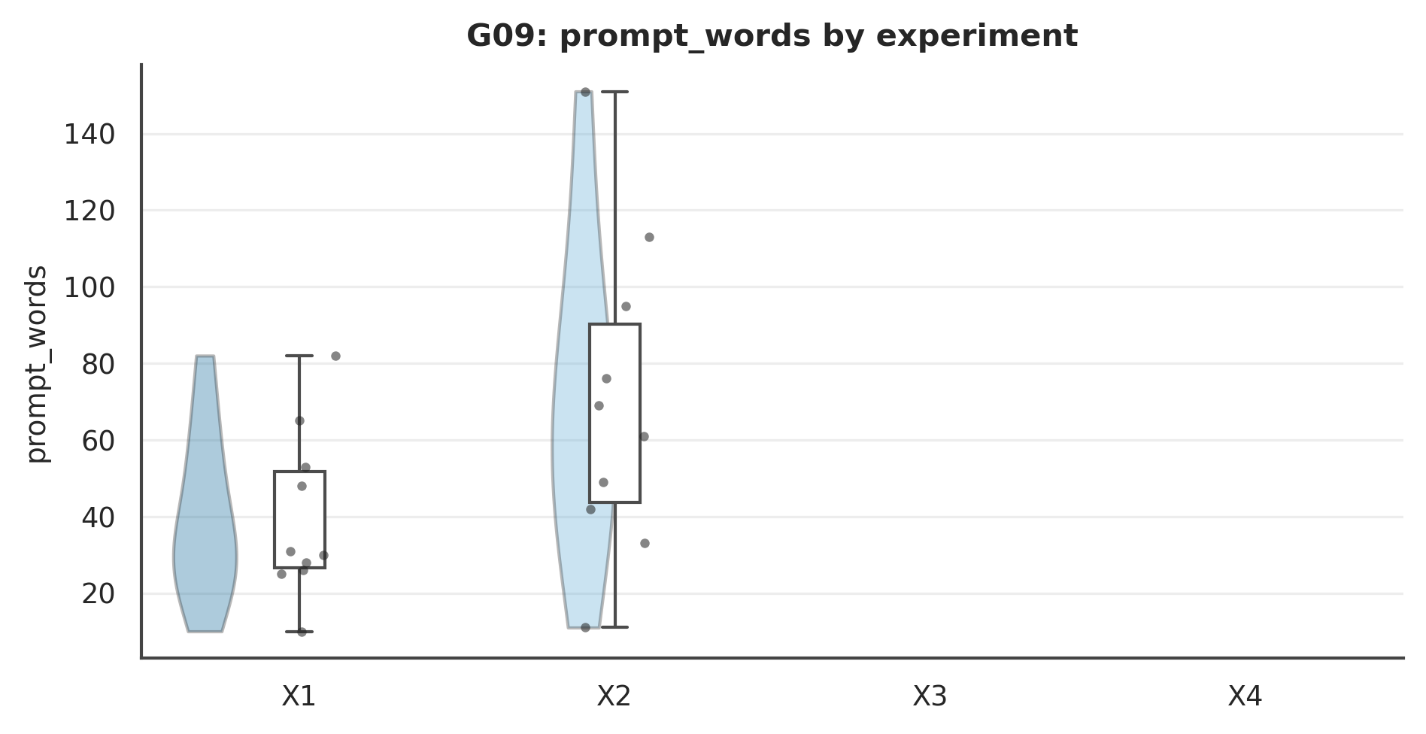

Figure . G09: prompt_words Mode×Role interaction.
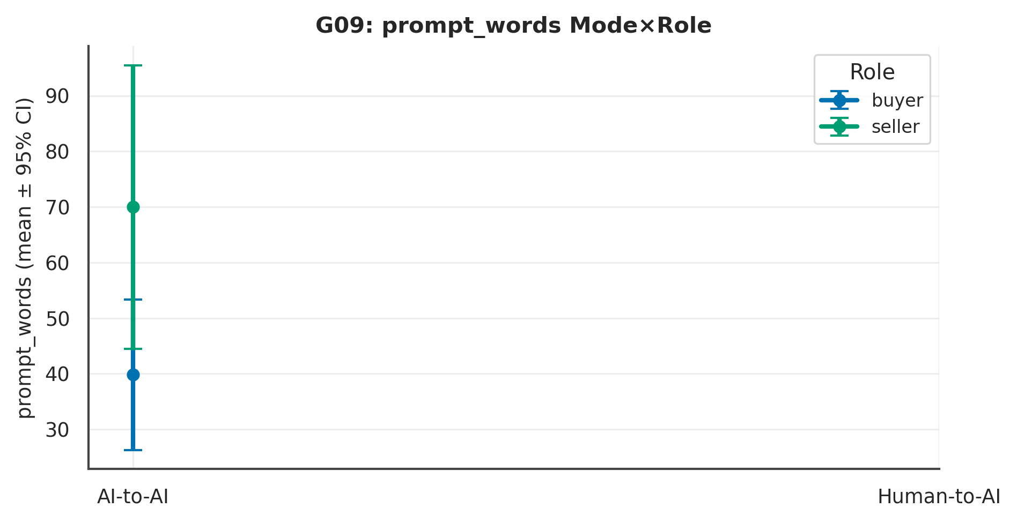

L4 review. Across 5 measure(s), the largest Mode signal was on ‘prompt_words’ (p = NA, Cliff's δ = NA [NA, NA], NA); the Role contrast there was p = .054 and the Mode×Role interaction p = NA. At ~10 per experiment these are exploratory and hypothesis-generating; effect sizes and intervals, not p-values, carry the interpretation.

G21 · Prompt → Agent Instruction-Adherence
Delegated only (X1,X2). Adherence: does prompt specificity track the agent's realised anchor?
Table . G21 — L1 Distinct (mean per experiment)
Measure | X1 | X2 | X3 | X4 | N
prompt_specificity | 1.60 | 2.30 |  |  | 20
prompt_readability_wps | 13.92 | 20.13 |  |  | 20
anchor_distance | 450.00 | 100.00 |  |  | 20

Table . G21 — L2 2×2 + Pairwise (Mode/Role/Mode×Role; best pairwise)
Measure | Mode p | Mode δ | Mode 95%CI | Role p | M×R p | Opp p | Top pairwise | that p
prompt_specificity | NA | NA | [NA, NA] | .512 | NA | .784 | Role | Delegated (X1 vs X2) | .512
prompt_readability_wps | NA | NA | [NA, NA] | .121 | NA | .235 | Role | Delegated (X1 vs X2) | .121
anchor_distance | NA | NA | [NA, NA] | .243 | NA | .264 | Role | Delegated (X1 vs X2) | .243
Note. Mode/Role via Mann–Whitney + Cliff's δ (95% bootstrap CI); Mode×Role and opponent via SRH/Kruskal–Wallis.

Table . G21 — L3 Overall (pooled / Mode / Role)
Measure | Overall M(SD) | Delegated | Direct | Buyer | Seller
prompt_specificity | 1.95 (1.73) | 1.95 | nan | 1.60 | 2.30
prompt_readability_wps | 17.03 (8.81) | 17.03 | nan | 13.92 | 20.13
anchor_distance | 275.00 (499.34) | 275.00 | nan | 450.00 | 100.00

Table . G21 — Pairwise detail: prompt_specificity
Contrast | n | U | p | Cliff δ | 95% CI | band | q (BH)
Mode | Buyer (X1 vs X3) | 10/0 | NA | p = NA | NA | [NA, NA] | NA | NA
Mode | Seller (X2 vs X4) | 10/0 | NA | p = NA | NA | [NA, NA] | NA | NA
Role | Delegated (X1 vs X2) | 10/10 | 41 | p = .512 | −.18 | [−.71, .28] | small | .512
Role | Direct (X3 vs X4) | 0/0 | NA | p = NA | NA | [NA, NA] | NA | NA
Diagonal (X1 vs X4) | 10/0 | NA | p = NA | NA | [NA, NA] | NA | NA
Diagonal (X2 vs X3) | 10/0 | NA | p = NA | NA | [NA, NA] | NA | NA
Note. Six structured contrasts among X1–X4; q = BH-adjusted.

Figure . G21: distribution of prompt_specificity across X1–X4.
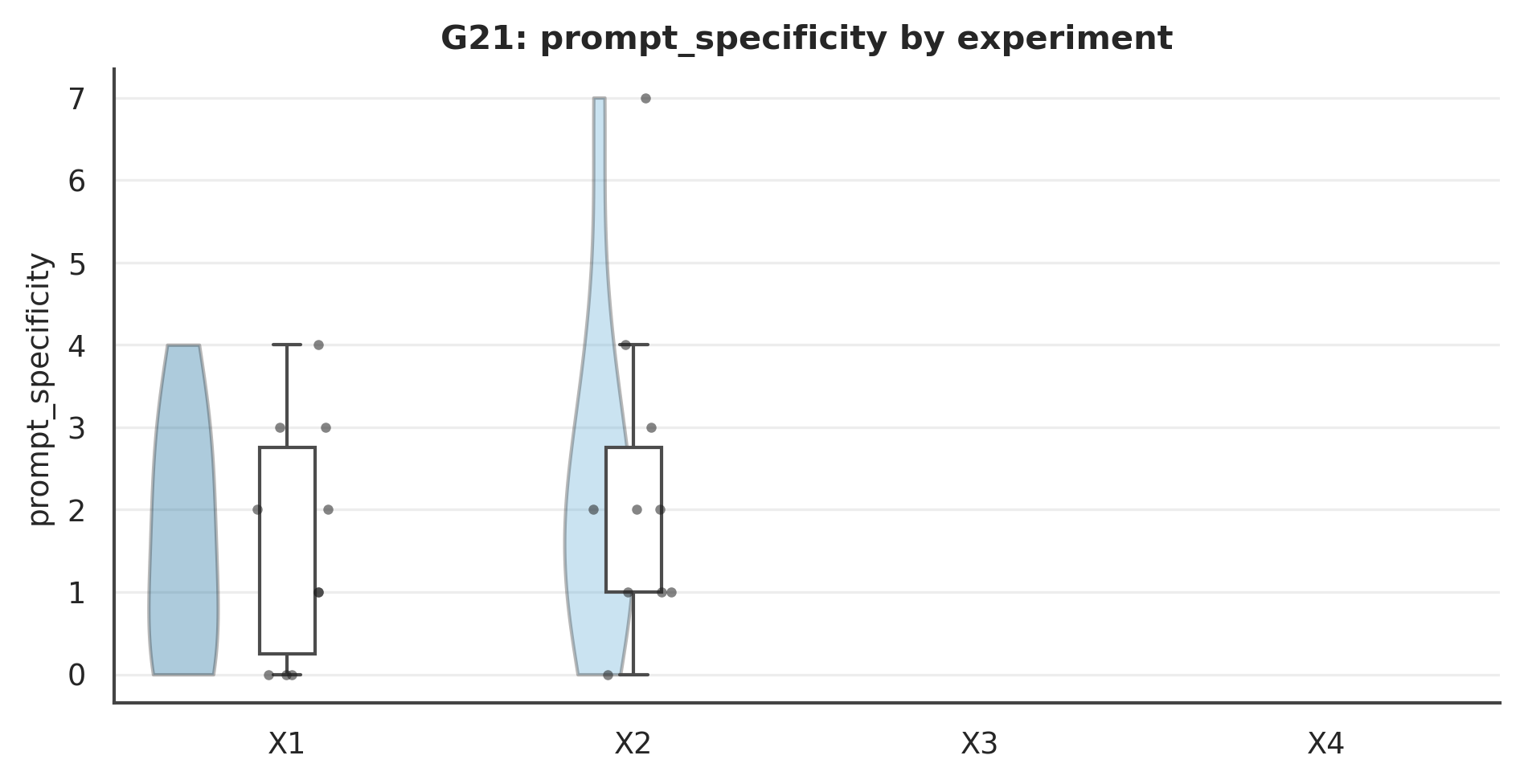

Figure . G21: prompt_specificity Mode×Role interaction.
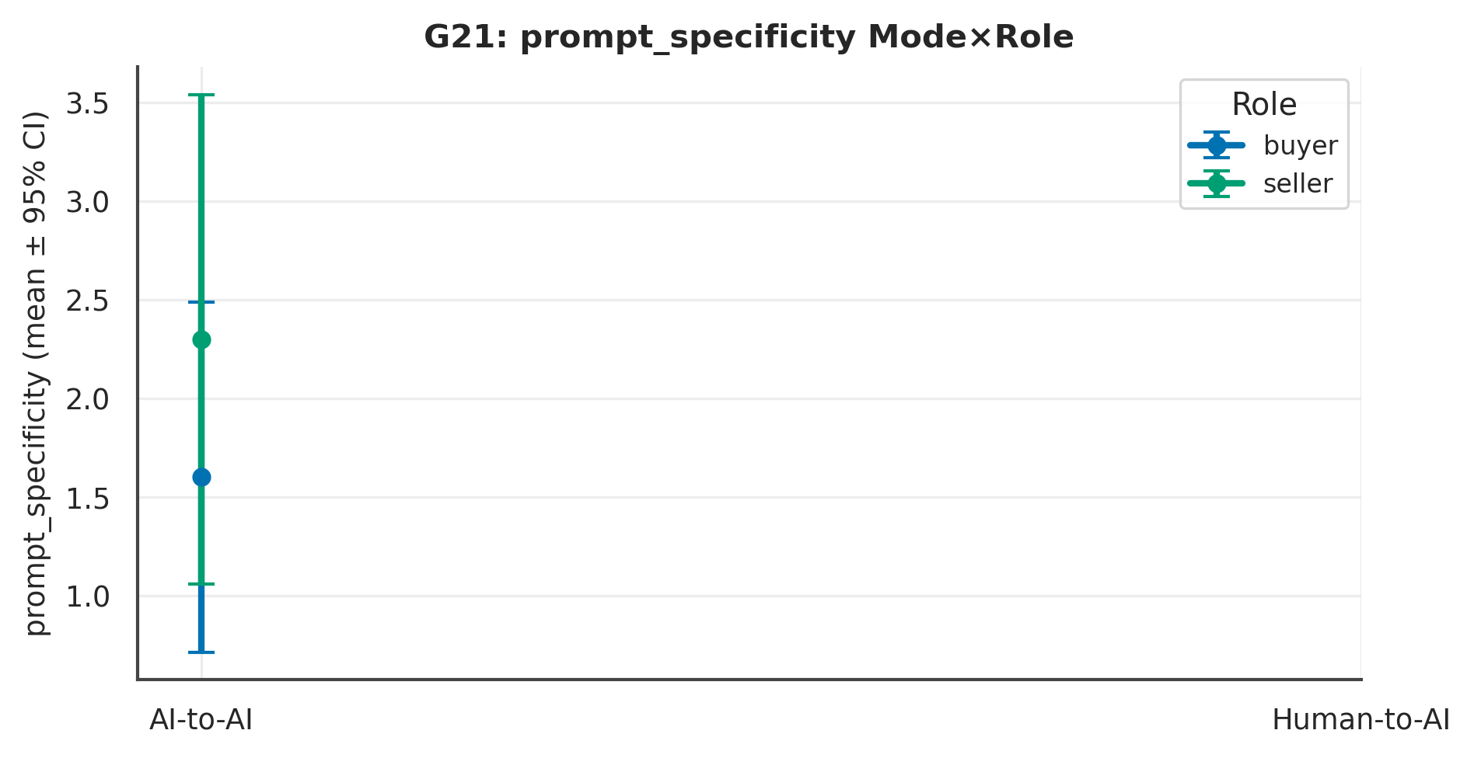

L4 review. Across 3 measure(s), the largest Mode signal was on ‘prompt_specificity’ (p = NA, Cliff's δ = NA [NA, NA], NA); the Role contrast there was p = .512 and the Mode×Role interaction p = NA. At ~10 per experiment these are exploratory and hypothesis-generating; effect sizes and intervals, not p-values, carry the interpretation.

Chapter 8. Qualitative

G10 · Qualitative Open-Text
Deterministic only; no LLM coding.
Table . G10 — Open-text volume
Kind | n | mean_words | with_?
personal context | 20 | 65.90 | 0
study comment | 20 | 14.10 | 1

Table . G10 — Verbatim (anonymised)
ID | kind | exp | role | Verbatim text
P01 | study comment | X4 | seller | the study was well structured
P02 | study comment | X4 | seller | i think debating like that is a fun time, so this was a fun study to do
P03 | study comment | X3 | buyer | Super fun and interesting, I really like the AI negotiator, very skilled!
P04 | study comment | X3 | buyer | None.
P05 | study comment | X3 | buyer | Enjoyable
P06 | study comment | X3 | buyer | The sellers responses are nearly impossible to read as there is a very tiny window of text - like you can only see one line at a time
P07 | study comment | X4 | seller | This was enjoyable. I actually have owned 3 Toyota's so that isn't a fib on my part. I am indeed on my third. I would use an AI tool like this. I would be interested to see what it would look like if it represented the s…
P08 | study comment | X1 | buyer | I said I wanted a white car nor a black car and gave valid reasons. Agent still negotiated in this BLACK car and bought it for me. Would you use this agent?
P09 | study comment | X1 | buyer | I would definitely use this in real life as dealing with car salesman is one of the worst negotiations to deal with. It went very smoothly and I got my price so I'm happy.
P10 | study comment | X2 | seller | The text scrolled too quickly to read. I had to keep going back to keep up. Other than that, very interesting.
P11 | study comment | X1 | buyer | No
P12 | study comment | X1 | buyer | I was surprised that the chatbot started by saying how great the car is, in my experience it isn't great to start by showing such interest and enthusiasm.
P13 | study comment | X2 | seller | I'd rather use this than actual car sales people.
P14 | study comment | X1 | buyer | None.
P15 | study comment | X3 | buyer | The AI was super rude...
P16 | study comment | X3 | buyer | For me, the seller responded so good and believable. I think the interface is very easy and simple to use.
P17 | study comment | X3 | buyer | Very fun to do.
P18 | study comment | X1 | buyer | no
P19 | study comment | X4 | seller | not at this time
P20 | study comment | X2 | seller | None! This was really interesting to experience!
P21 | personal context | X2 | seller | I'm selling because I'm moving soon and don't want to deal with moving the car or keeping up with payments and insurance longer than I need to. The car has been really well taken care of, so I don't want to feel like I g…
P22 | personal context | X2 | seller | I am letting this car go because I need money. Im going to get a cheaper car instead.
P23 | personal context | X2 | seller | I'm recovering from a financial crisis from having to help out and spend thousands for my nephew's physical therapy and chemotherapy for the past 2 years. I would appreciate it if the future owner of the car would take v…
P24 | personal context | X1 | buyer | I've always been a Camry guy. I like this car, but I'm not in such a rush to make the purchase now, as I'm looking for a good deal.
P25 | personal context | X1 | buyer | I have been saving up for a car and really like this one. I have worked overtime to save even more and have made an accomplishment. I am not wealthy or do I have a lot of money. I have a limit on how much I can spend an…
P26 | personal context | X2 | seller | I am a student moving away to start college, i need to make this sale so i can afford tuition and make the move. I really need the money from this sale to afford my education. i need this done quickly and i will not go u…
P27 | personal context | X2 | seller | I am now in the need for a larger car, an SUV, for my growing family. I need to make room for my new SUV, and as much as I hate to let this car go, I want to sell it to a buyer willing to make an offer within my guideli…
P28 | personal context | X1 | buyer | I don't like this car. I live in Florida and don't want a black car because of the sun and heat. Please only show me white cars.
P29 | personal context | X1 | buyer | I lost my last vehicle to an accident, and I realy ned to get a relaible car that doesn't guzzle gas. I've had Toyotas before, and they last forever. I have cash on hand and am willing to make this hasle free and pay rig…
P30 | personal context | X1 | buyer | I am very interested in this car but need to get the price down $4000 to $21,500 ideally. I just graduated college and need a reliable car but will not overpay. I have cash and do not need any form of bank financing. …
P31 | personal context | X2 | seller | I want $25k for the car but I will accept $22.5. It's in immaculate condition which makes it absolutely worth the asking price. If the seller doesn't want it, no pressure, I'll sell it to someone else.
P32 | personal context | X1 | buyer | I'm car shopping and want to pay 21500, but no more than 23500.
P33 | personal context | X1 | buyer | I appreciate your help. I like this car, but I can't do the price. No higher that 23 or I will find something else. I can pay cash so I don't need credit. If you can get it down to 21 that would be amazing. I have a good…
P34 | personal context | X2 | seller | I found a great job in a city where I will not need a car since public transportation is great, but renting in the city is very expensive so selling the car will free up some extra money. I'd like the sale price to be as…
P35 | personal context | X1 | buyer | I can spend up to 23,500 on this car, but I'd like to get it for 21,500 if possible. The car will be used infrequently, as I work from home. I'd like to get this negotiation worked out today, if possible, since I'd like…
P36 | personal context | X1 | buyer | I have been in need for a new car for a while and I am searching for a new job as well. This makes my budget somewhat limited, that's why I am aiming for $21,500 for this car. It is exactly what I am looking for: new, co…
P37 | personal context | X1 | buyer | I’m looking for a reliable, comfortable daily driver that won’t give me maintenance headaches. The Camry stands out for its dependability and value. I’d like to buy soon if the price feels fair and there are no hidden is…
P38 | personal context | X2 | seller | I'm a college sophomore living in NYC, and I have to balance hard courses with responsibilities and everyday city expenses. I am studying criminal justice and working towards a bachelor of science. I tend to be less prac…
P39 | personal context | X2 | seller | I am trying to sell this car now in order to get rid of my credit card debt! I want to be able to use this to pay for any loans that I have outstanding. I am also planning on moving from current location. I would need to…
P40 | personal context | X2 | seller | I just got married and have combined households with my husband, who already has 2 cars. One he uses for work, and the other for personal. So we are just going to share the personal car. I want to sell this car to jumpst…

L4 review. Reported descriptively at the cohort level; exploratory and hypothesis-generating only.

G43 · Computational Text Features
Delegated prompts only; textstat readability.
Table . G43 — L1 Distinct (mean per experiment)
Measure | X1 | X2 | X3 | X4 | N
readability | 82.31 | 73.87 |  |  | 20
lexical_diversity | 0.84 | 0.79 |  |  | 20

Table . G43 — L2 2×2 + Pairwise (Mode/Role/Mode×Role; best pairwise)
Measure | Mode p | Mode δ | Mode 95%CI | Role p | M×R p | Opp p | Top pairwise | that p
readability | NA | NA | [NA, NA] | .140 | NA | .979 | Role | Delegated (X1 vs X2) | .140
lexical_diversity | NA | NA | [NA, NA] | .272 | NA | .807 | Role | Delegated (X1 vs X2) | .272
Note. Mode/Role via Mann–Whitney + Cliff's δ (95% bootstrap CI); Mode×Role and opponent via SRH/Kruskal–Wallis.

Table . G43 — L3 Overall (pooled / Mode / Role)
Measure | Overall M(SD) | Delegated | Direct | Buyer | Seller
readability | 78.09 (14.59) | 78.09 | nan | 82.31 | 73.87
lexical_diversity | 0.81 (0.11) | 0.81 | nan | 0.84 | 0.79

Table . G43 — Pairwise detail: readability
Contrast | n | U | p | Cliff δ | 95% CI | band | q (BH)
Mode | Buyer (X1 vs X3) | 10/0 | NA | p = NA | NA | [NA, NA] | NA | NA
Mode | Seller (X2 vs X4) | 10/0 | NA | p = NA | NA | [NA, NA] | NA | NA
Role | Delegated (X1 vs X2) | 10/10 | 70 | p = .140 | .40 | [−.02, .92] | medium | .140
Role | Direct (X3 vs X4) | 0/0 | NA | p = NA | NA | [NA, NA] | NA | NA
Diagonal (X1 vs X4) | 10/0 | NA | p = NA | NA | [NA, NA] | NA | NA
Diagonal (X2 vs X3) | 10/0 | NA | p = NA | NA | [NA, NA] | NA | NA
Note. Six structured contrasts among X1–X4; q = BH-adjusted.

Figure . G43: distribution of readability across X1–X4.
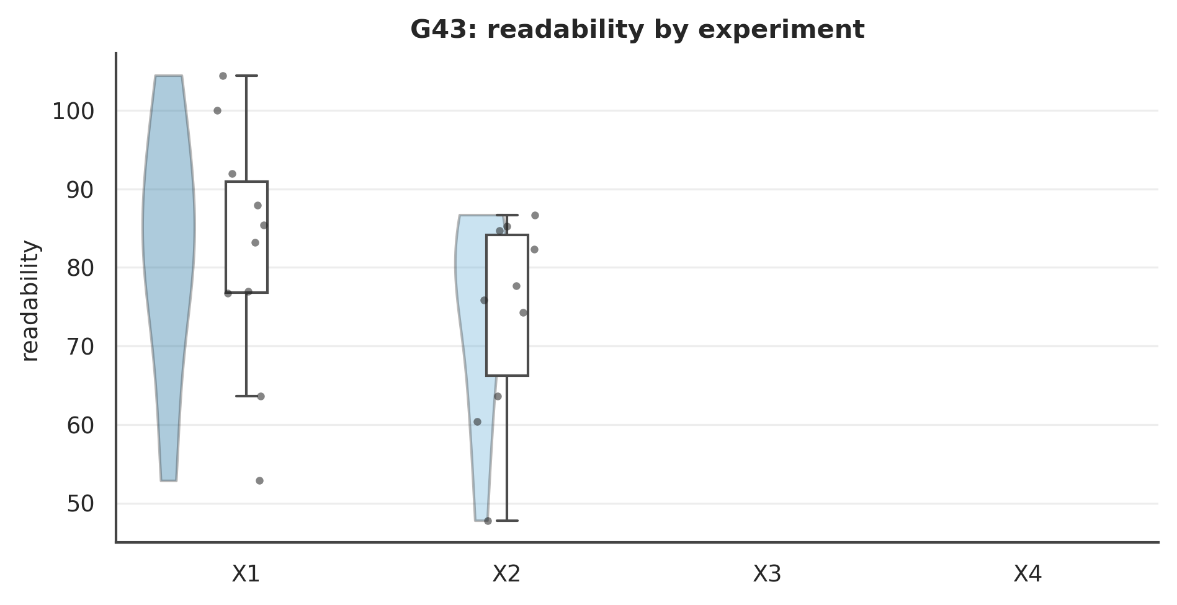

Figure . G43: readability Mode×Role interaction.
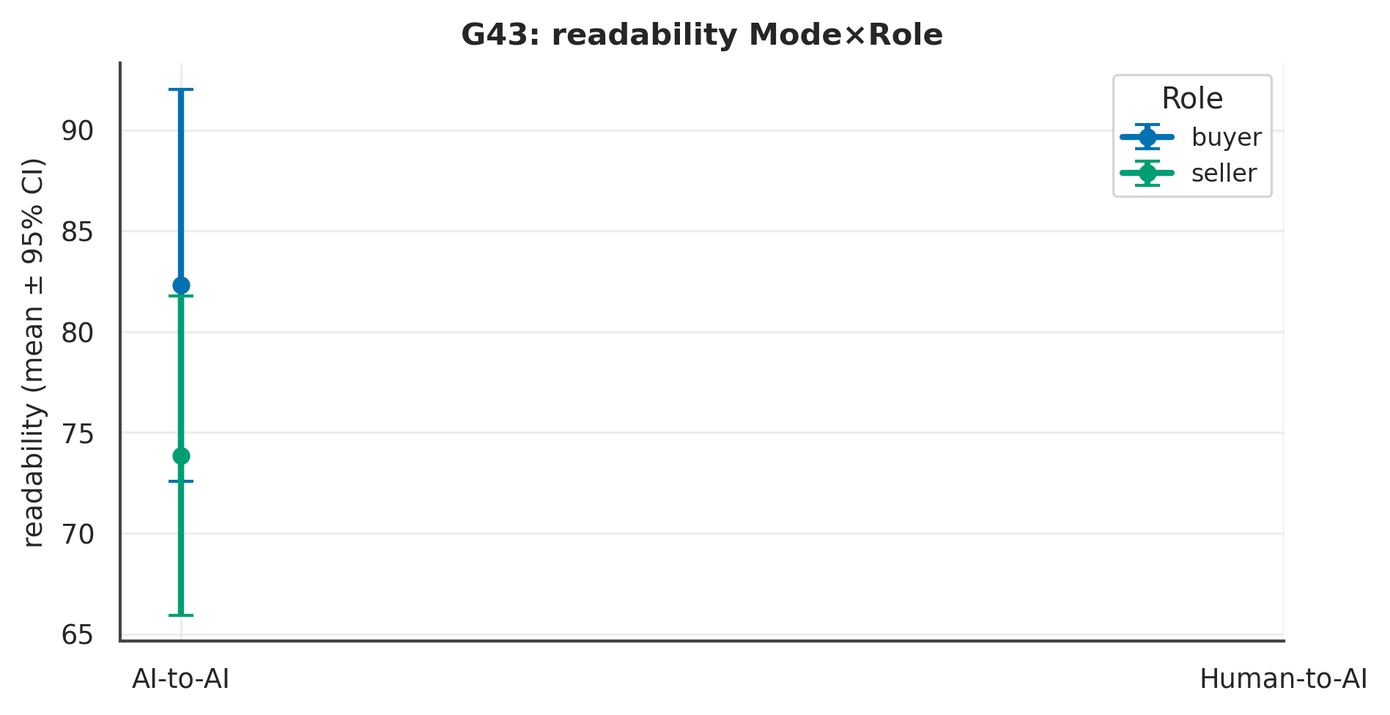

L4 review. Across 2 measure(s), the largest Mode signal was on ‘readability’ (p = NA, Cliff's δ = NA [NA, NA], NA); the Role contrast there was p = .140 and the Mode×Role interaction p = NA. At ~10 per experiment these are exploratory and hypothesis-generating; effect sizes and intervals, not p-values, carry the interpretation.

Chapter 9. Integrative Modelling & Typologies

G11 · Integrative Models (Agreement, Satisfaction)
Descriptive at N=40; not inferential.
Table . G11 — Logistic — agreement
Predictor of agreement | β | p
satisfaction | 3.49 | 0.005
control | -2.54 | 0.011
active_s | 0.00 | 0.423
n_concessions | 0.68 | 0.122

L4 review. Reported descriptively at the cohort level; exploratory and hypothesis-generating only.

G19 · Engagement Typologies (clustering)
k-means, k=3; exploratory and unstable at N=40.
Table . G19 — Cluster profiles
cluster | active_s | idle_s | scroll_depth | n_clicks | n_likert_changes
0 | 548.30 | 90.90 | 98.30 | 45.60 | 9.80
1 | 990.80 | 396.80 | 95.90 | 54.60 | 10.40
2 | 640.90 | 166.30 | 67.50 | 40.10 | 10.60

L4 review. Reported descriptively at the cohort level; exploratory and hypothesis-generating only.

G25 · Fairness Calibration & Delegation Halo
Perceived vs objective fairness; halo = satisfaction beyond objective surplus (review).
Table . G25 — L1 Distinct (mean per experiment)
Measure | X1 | X2 | X3 | X4 | N
obj_buyer_share | 0.20 | 0.62 | -0.85 | 0.09 | 27
perceived_fair | 5.20 | 5.62 | 6.00 | 5.78 | 27

Table . G25 — L2 2×2 + Pairwise (Mode/Role/Mode×Role; best pairwise)
Measure | Mode p | Mode δ | Mode 95%CI | Role p | M×R p | Opp p | Top pairwise | that p
obj_buyer_share | .014 | .55 | [.24, .93] | .038 | .638 | .025 | Diagonal (X2 vs X3) | .006
perceived_fair | .498 | −.15 | [−.57, .25] | .815 | .444 | .271 | Mode | Buyer (X1 vs X3) | .386
Note. Mode/Role via Mann–Whitney + Cliff's δ (95% bootstrap CI); Mode×Role and opponent via SRH/Kruskal–Wallis.

Table . G25 — L3 Overall (pooled / Mode / Role)
Measure | Overall M(SD) | Delegated | Direct | Buyer | Seller
obj_buyer_share | 0.09 (0.76) | 0.46 | -0.25 | -0.33 | 0.34
perceived_fair | 5.67 (1.24) | 5.46 | 5.86 | 5.60 | 5.71

Table . G25 — Pairwise detail: obj_buyer_share
Contrast | n | U | p | Cliff δ | 95% CI | band | q (BH)
Mode | Buyer (X1 vs X3) | 5/5 | 24 | p = .023 | .88 | [.76, 1.16] | large | .070
Mode | Seller (X2 vs X4) | 8/9 | 53 | p = .101 | .47 | [.06, .97] | medium | .124
Role | Delegated (X1 vs X2) | 5/8 | 9 | p = .103 | −.55 | [−1.08, −.15] | large | .124
Role | Direct (X3 vs X4) | 5/9 | 8 | p = .071 | −.62 | [−1.18, −.24] | large | .124
Diagonal (X1 vs X4) | 5/9 | 26 | p = .733 | .13 | [−.42, .76] | negligible | .733
Diagonal (X2 vs X3) | 8/5 | 39 | p = .006 | .95 | [.90, 1.12] | large | .034
Note. Six structured contrasts among X1–X4; q = BH-adjusted.

Figure . G25: distribution of obj_buyer_share across X1–X4.
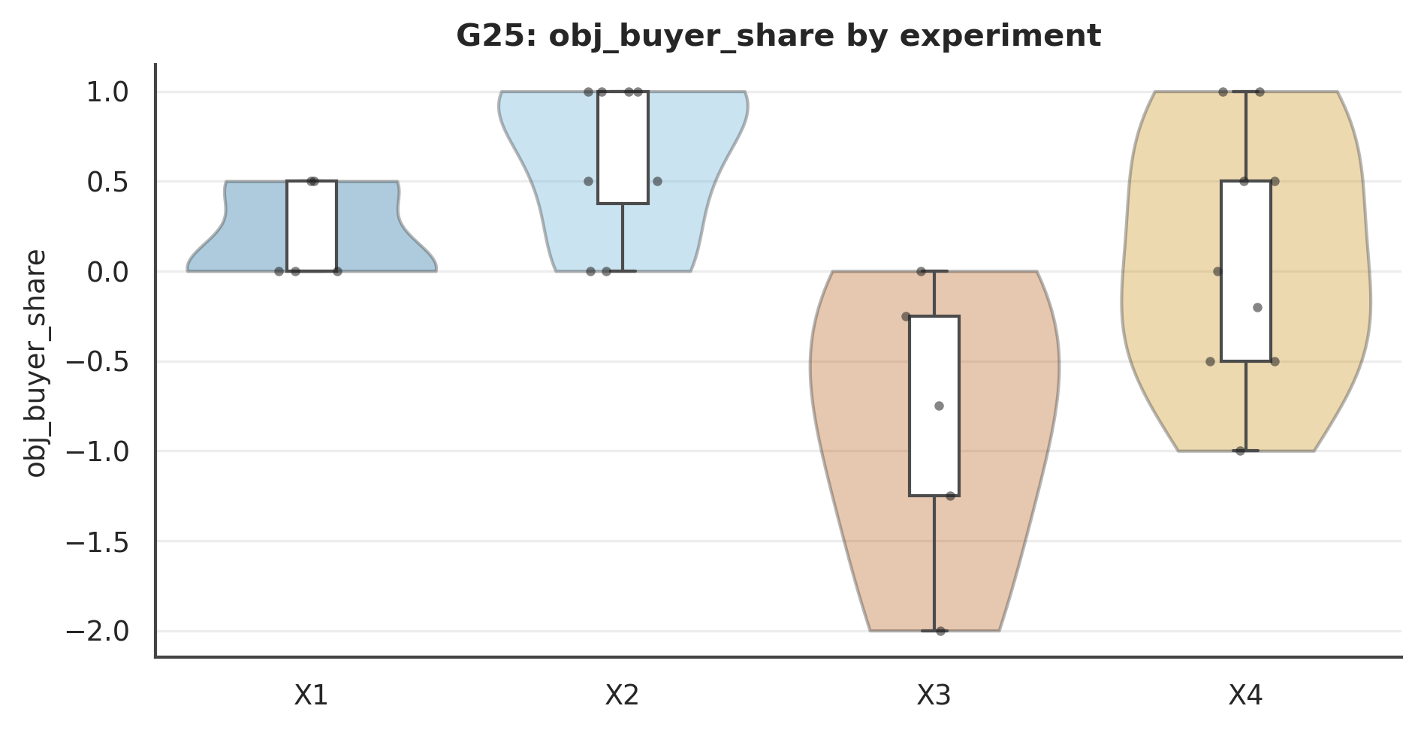

Figure . G25: obj_buyer_share Mode×Role interaction.
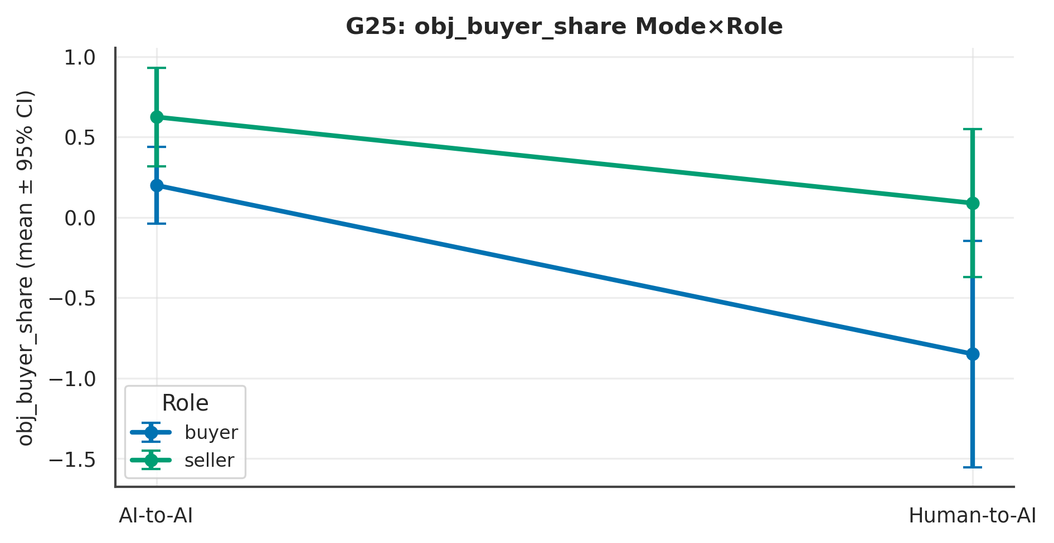

L4 review. Across 2 measure(s), the largest Mode signal was on ‘obj_buyer_share’ (p = .014, Cliff's δ = .55 [.24, .93], large); the Role contrast there was p = .038 and the Mode×Role interaction p = .638. At ~10 per experiment these are exploratory and hypothesis-generating; effect sizes and intervals, not p-values, carry the interpretation.

G26 · Affect Dynamics
Pleasant×anxious 2-D affect space; anxiety-by-Mode is a core hypothesis (exploratory).
Table . G26 — L1 Distinct (mean per experiment)
Measure | X1 | X2 | X3 | X4 | N
emot_pleasant | 5.10 | 5.40 | 4.50 | 5.20 | 40
emot_anxious | 4.90 | 3.20 | 2.60 | 3.70 | 40

Table . G26 — L2 2×2 + Pairwise (Mode/Role/Mode×Role; best pairwise)
Measure | Mode p | Mode δ | Mode 95%CI | Role p | M×R p | Opp p | Top pairwise | that p
emot_pleasant | .769 | .06 | [−.30, .41] | .263 | .834 | .026 | Diagonal (X2 vs X3) | .371
emot_anxious | .150 | .27 | [−.08, .64] | .632 | .028 | .423 | Mode | Buyer (X1 vs X3) | .014
Note. Mode/Role via Mann–Whitney + Cliff's δ (95% bootstrap CI); Mode×Role and opponent via SRH/Kruskal–Wallis.

Table . G26 — L3 Overall (pooled / Mode / Role)
Measure | Overall M(SD) | Delegated | Direct | Buyer | Seller
emot_pleasant | 5.05 (1.69) | 5.25 | 4.85 | 4.80 | 5.30
emot_anxious | 3.60 (2.01) | 4.05 | 3.15 | 3.75 | 3.45

Table . G26 — Pairwise detail: emot_pleasant
Contrast | n | U | p | Cliff δ | 95% CI | band | q (BH)
Mode | Buyer (X1 vs X3) | 10/10 | 57 | p = .613 | .14 | [−.37, .67] | negligible | .736
Mode | Seller (X2 vs X4) | 10/10 | 49 | p = .968 | −.02 | [−.52, .46] | negligible | .968
Role | Delegated (X1 vs X2) | 10/10 | 39 | p = .395 | −.22 | [−.72, .24] | small | .736
Role | Direct (X3 vs X4) | 10/10 | 40 | p = .439 | −.21 | [−.72, .26] | small | .736
Diagonal (X1 vs X4) | 10/10 | 43 | p = .609 | −.14 | [−.68, .37] | negligible | .736
Diagonal (X2 vs X3) | 10/10 | 62 | p = .371 | .24 | [−.22, .75] | small | .736
Note. Six structured contrasts among X1–X4; q = BH-adjusted.

Figure . G26: distribution of emot_pleasant across X1–X4.
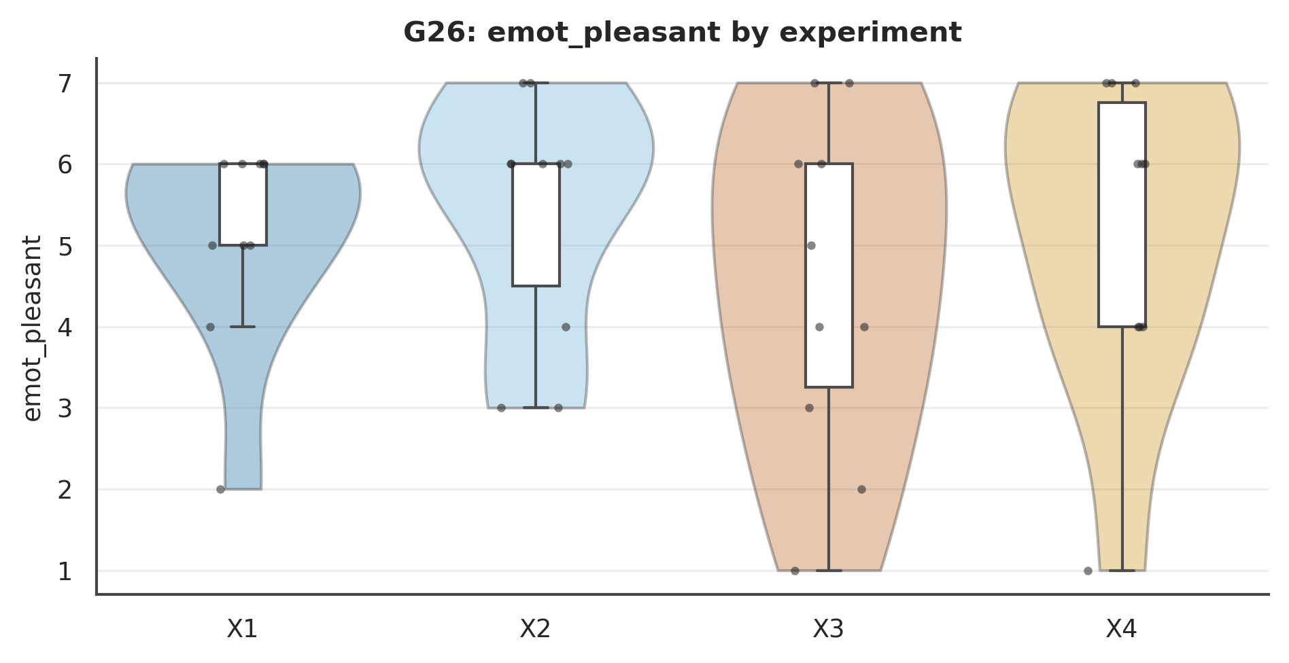

Figure . G26: emot_pleasant Mode×Role interaction.
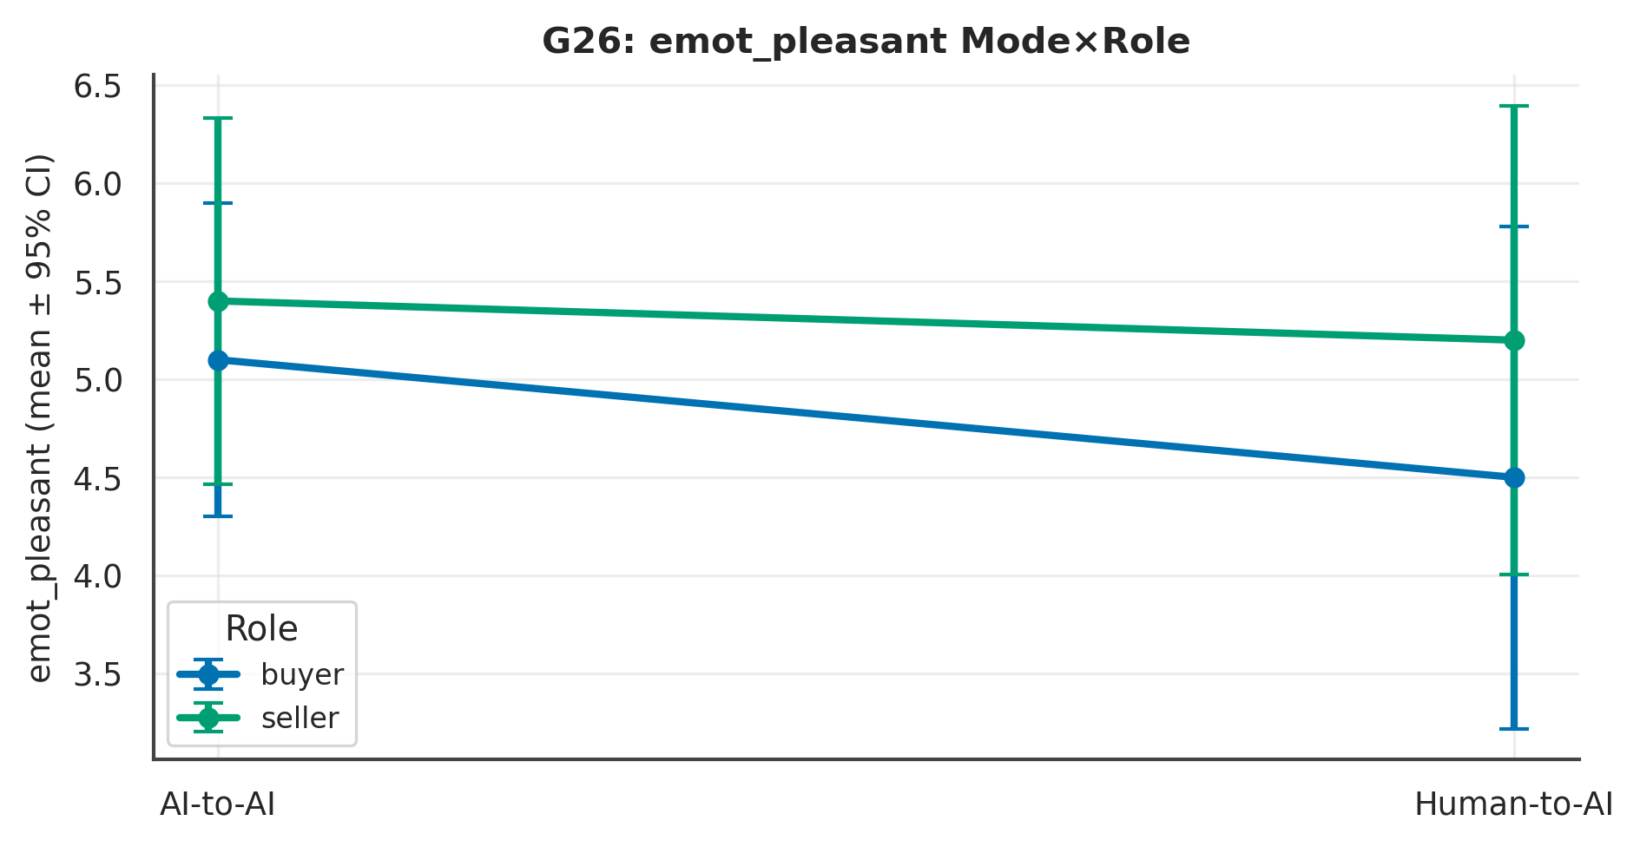

L4 review. Across 2 measure(s), the largest Mode signal was on ‘emot_anxious’ (p = .150, Cliff's δ = .27 [−.08, .64], small); the Role contrast there was p = .632 and the Mode×Role interaction p = .028. At ~10 per experiment these are exploratory and hypothesis-generating; effect sizes and intervals, not p-values, carry the interpretation.

Chapter 10. Temporal, Cost, Robustness & Design

G14 · Temporal & Latency Dynamics
Table . G14 — L1 Distinct (mean per experiment)
Measure | X1 | X2 | X3 | X4 | N
median_latency_ms | 7,148.60 | 7,458.00 | 25,258.90 | 9,318.90 | 40
max_latency_ms | 16,294.40 | 11,426.20 | 151,602.70 | 97,002.70 | 40

Table . G14 — L2 2×2 + Pairwise (Mode/Role/Mode×Role; best pairwise)
Measure | Mode p | Mode δ | Mode 95%CI | Role p | M×R p | Opp p | Top pairwise | that p
median_latency_ms | < .001 | −.84 | [−1.08, −.68] | .218 | .023 | .436 | Mode | Buyer (X1 vs X3) | < .001
max_latency_ms | < .001 | −.97 | [−1.05, −.95] | .776 | .705 | .915 | Mode | Seller (X2 vs X4) | < .001
Note. Mode/Role via Mann–Whitney + Cliff's δ (95% bootstrap CI); Mode×Role and opponent via SRH/Kruskal–Wallis.

Table . G14 — L3 Overall (pooled / Mode / Role)
Measure | Overall M(SD) | Delegated | Direct | Buyer | Seller
median_latency_ms | 12296.10 (11791.21) | 7303.30 | 17288.90 | 16203.75 | 8388.45
max_latency_ms | 69081.50 (87978.76) | 13860.30 | 124302.70 | 83948.55 | 54214.45

Table . G14 — Pairwise detail: median_latency_ms
Contrast | n | U | p | Cliff δ | 95% CI | band | q (BH)
Mode | Buyer (X1 vs X3) | 10/10 | 0 | p < .001 | −1.00 | [−1.00, −1.00] | large | .000
Mode | Seller (X2 vs X4) | 10/10 | 17 | p = .014 | −.66 | [−1.12, −.32] | large | .017
Role | Delegated (X1 vs X2) | 10/10 | 32 | p = .186 | −.36 | [−.88, .10] | medium | .186
Role | Direct (X3 vs X4) | 10/10 | 99 | p < .001 | .98 | [.96, 1.08] | large | .000
Diagonal (X1 vs X4) | 10/10 | 15 | p = .009 | −.70 | [−1.16, −.40] | large | .014
Diagonal (X2 vs X3) | 10/10 | 0 | p < .001 | −1.00 | [−1.00, −1.00] | large | .000
Note. Six structured contrasts among X1–X4; q = BH-adjusted.

Figure . G14: distribution of median_latency_ms across X1–X4.
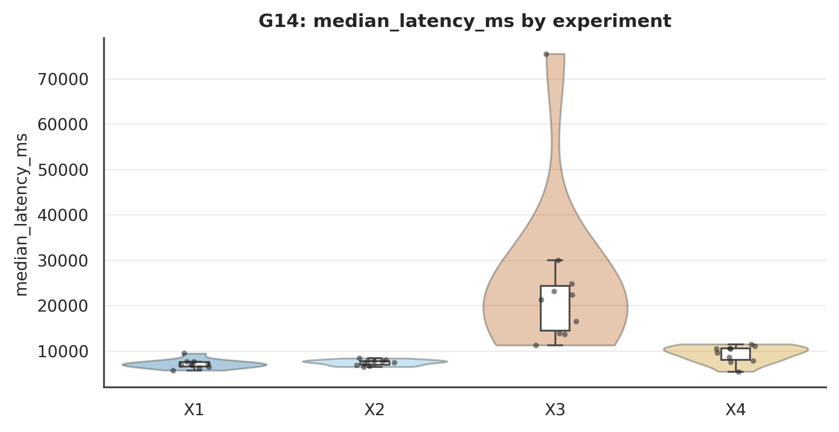

Figure . G14: median_latency_ms Mode×Role interaction.
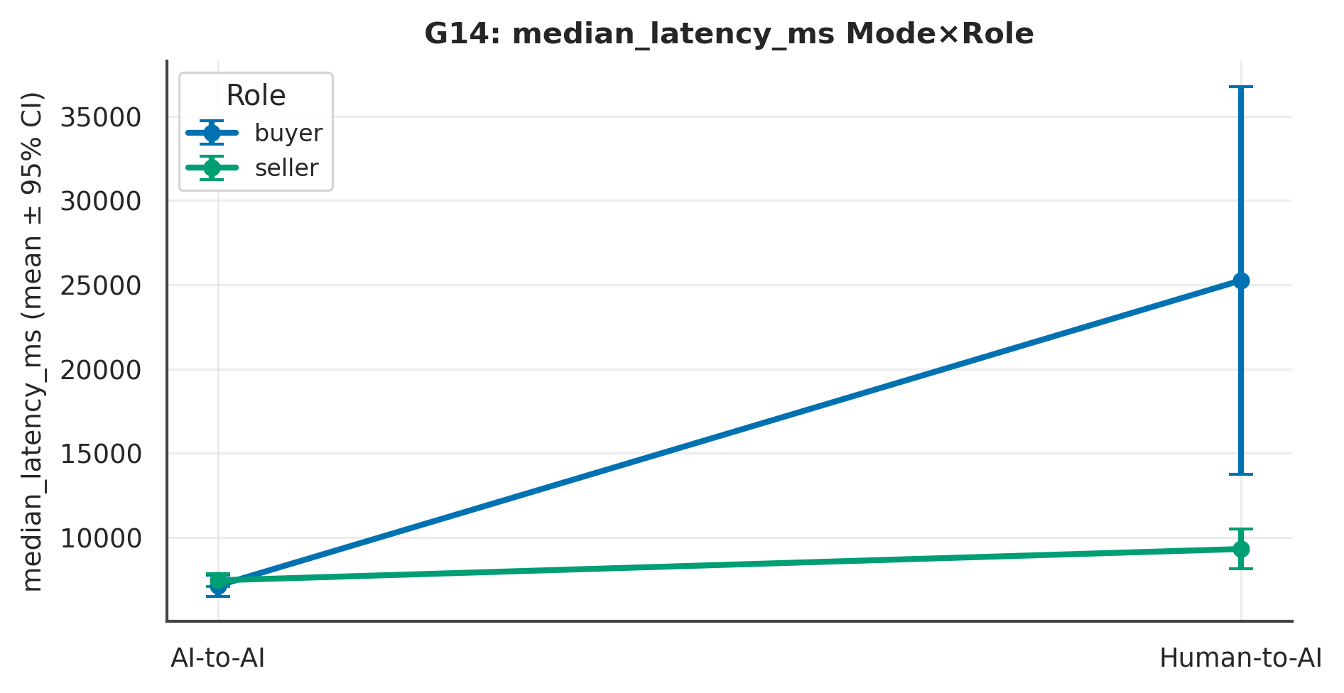

L4 review. Across 2 measure(s), the largest Mode signal was on ‘max_latency_ms’ (p < .001, Cliff's δ = −.97 [−1.05, −.95], large); the Role contrast there was p = .776 and the Mode×Role interaction p = .705. At ~10 per experiment these are exploratory and hypothesis-generating; effect sizes and intervals, not p-values, carry the interpretation.

G15 · Token Economy & Cost Model
Per-turn tokens parsed from tokens_json; confirmatory-N cost projected in the review.
Table . G15 — L1 Distinct (mean per experiment)
Measure | X1 | X2 | X3 | X4 | N
turn_tokens_sum | 223,285.10 | 249,986.70 | 73,799.40 | 77,284.40 | 40

Table . G15 — L2 2×2 + Pairwise (Mode/Role/Mode×Role; best pairwise)
Measure | Mode p | Mode δ | Mode 95%CI | Role p | M×R p | Opp p | Top pairwise | that p
turn_tokens_sum | < .001 | 1.00 | [1.00, 1.00] | .636 | .626 | .653 | Mode | Buyer (X1 vs X3) | < .001
Note. Mode/Role via Mann–Whitney + Cliff's δ (95% bootstrap CI); Mode×Role and opponent via SRH/Kruskal–Wallis.

Table . G15 — L3 Overall (pooled / Mode / Role)
Measure | Overall M(SD) | Delegated | Direct | Buyer | Seller
turn_tokens_sum | 156088.90 (87637.31) | 236635.90 | 75541.90 | 148542.25 | 163635.55

Table . G15 — Pairwise detail: turn_tokens_sum
Contrast | n | U | p | Cliff δ | 95% CI | band | q (BH)
Mode | Buyer (X1 vs X3) | 10/10 | 100 | p < .001 | 1.00 | [1.00, 1.00] | large | .000
Mode | Seller (X2 vs X4) | 10/10 | 100 | p < .001 | 1.00 | [1.00, 1.00] | large | .000
Role | Delegated (X1 vs X2) | 10/10 | 32 | p = .186 | −.36 | [−.90, .12] | medium | .223
Role | Direct (X3 vs X4) | 10/10 | 50 | p = 1.000 | .00 | [−.54, .54] | negligible | 1.000
Diagonal (X1 vs X4) | 10/10 | 100 | p < .001 | 1.00 | [1.00, 1.00] | large | .000
Diagonal (X2 vs X3) | 10/10 | 100 | p < .001 | 1.00 | [1.00, 1.00] | large | .000
Note. Six structured contrasts among X1–X4; q = BH-adjusted.

Figure . G15: distribution of turn_tokens_sum across X1–X4.
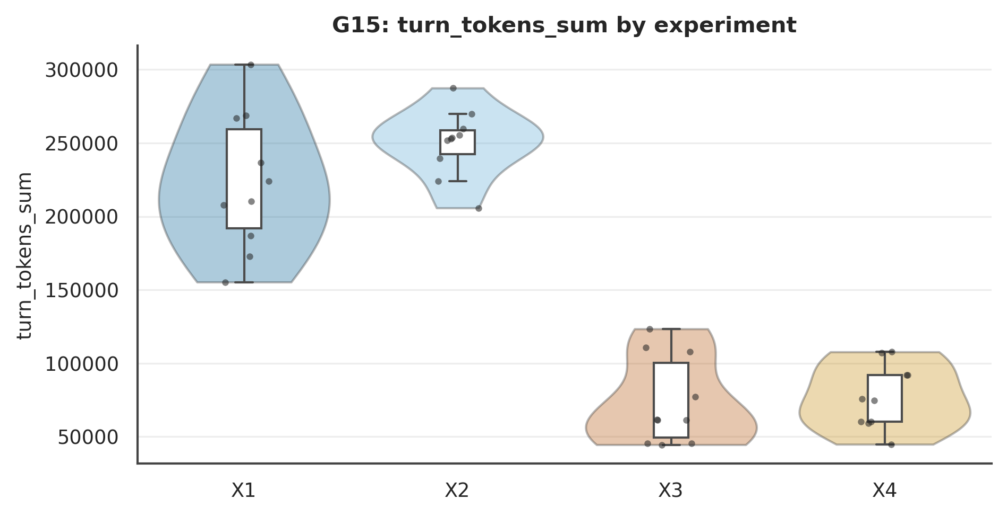

Figure . G15: turn_tokens_sum Mode×Role interaction.
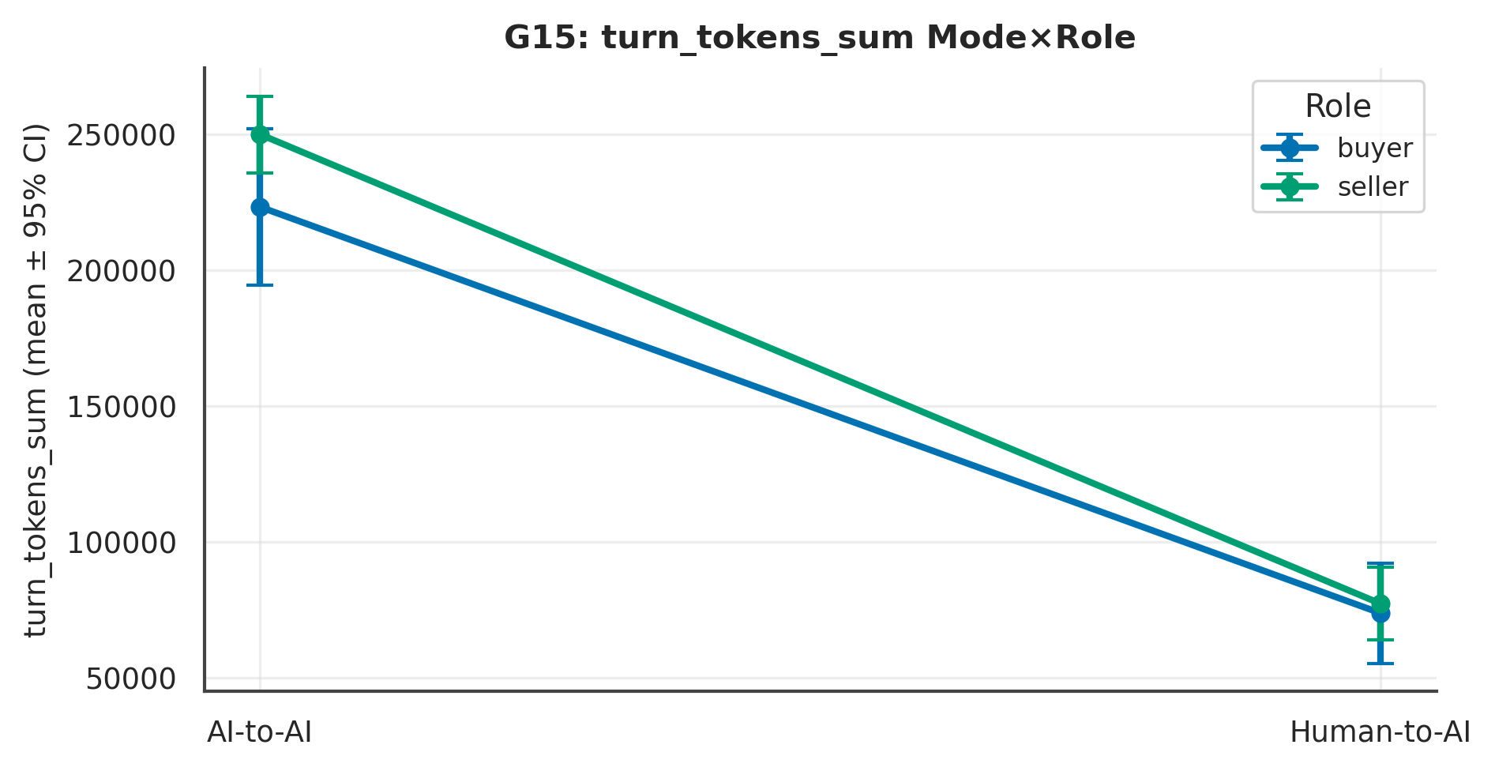

L4 review. Across 1 measure(s), the largest Mode signal was on ‘turn_tokens_sum’ (p < .001, Cliff's δ = 1.00 [1.00, 1.00], large); the Role contrast there was p = .636 and the Mode×Role interaction p = .626. At ~10 per experiment these are exploratory and hypothesis-generating; effect sizes and intervals, not p-values, carry the interpretation.

G28 · Data-Collection Wave / Order Effects
Table . G28 — Temporal drift
Drift check | Spearman ρ | p | n
satisfaction × enrolment order | 0.31 | 0.052 | 40

L4 review. Reported descriptively at the cohort level; exploratory and hypothesis-generating only.

G40 · Survival / Time-to-Agreement
Turns as time; non-agreement censored. lifelines.
Table . G40 — Log-rank
Survival (turns→agreement) | stat | p
by Mode (log-rank) | 16.07 | 0.000
by Role (log-rank) | 1.42 | 0.234

L4 review. Reported descriptively at the cohort level; exploratory and hypothesis-generating only.

G41 · Bayesian & Equivalence Re-estimation
BF₁₀<1 favours the null. Fragile at n=20/arm; interpret as evidence strength, not proof.
Table . G41 — Bayes factor + TOST (Mode)
Measure | BF₁₀ (Mode) | TOST p | equivalent
Satisfaction | 0.35 | 0.358 | False
Would use again | 0.32 | 0.333 | False
Felt represented | 0.33 | 0.189 | False
Perceived control | 0.31 | 0.261 | False
Pleasant affect | 0.38 | 0.427 | False
Anxious affect | 0.69 | 0.736 | False
Effort invested | 1.30 | 0.829 | False
Engagement | 0.61 | 0.442 | False
Outcome fairness | 0.32 | 0.310 | False

L4 review. Reported descriptively at the cohort level; exploratory and hypothesis-generating only.

G42 · Multiverse / Specification Curve
Illustrative multiverse; the pilot lacks the exclusion fields for a full specification curve.
Table . G42 — Specification curve (satisfaction~Mode)
spec | p | δ
excl=none; two-sided | 0.354 | -0.17
excl=drop_degraded; two-sided | 0.354 | -0.17

L4 review. Reported descriptively at the cohort level; exploratory and hypothesis-generating only.

G12 · Event Integrity & Clock Skew
Table . G12 — L1 Distinct (mean per experiment)
Measure | X1 | X2 | X3 | X4 | N
n_events | 117.00 | 119.90 | 158.50 | 138.30 | 40

Table . G12 — L2 2×2 + Pairwise (Mode/Role/Mode×Role; best pairwise)
Measure | Mode p | Mode δ | Mode 95%CI | Role p | M×R p | Opp p | Top pairwise | that p
n_events | .012 | −.47 | [−.80, −.18] | .167 | .099 | .580 | Mode | Buyer (X1 vs X3) | .001
Note. Mode/Role via Mann–Whitney + Cliff's δ (95% bootstrap CI); Mode×Role and opponent via SRH/Kruskal–Wallis.

Table . G12 — L3 Overall (pooled / Mode / Role)
Measure | Overall M(SD) | Delegated | Direct | Buyer | Seller
n_events | 133.43 (39.09) | 118.45 | 148.40 | 137.75 | 129.10

Table . G12 — Pairwise detail: n_events
Contrast | n | U | p | Cliff δ | 95% CI | band | q (BH)
Mode | Buyer (X1 vs X3) | 10/10 | 7 | p = .001 | −.86 | [−1.18, −.72] | large | .008
Mode | Seller (X2 vs X4) | 10/10 | 38 | p = .405 | −.23 | [−.79, .24] | small | .607
Role | Delegated (X1 vs X2) | 10/10 | 50 | p = 1.000 | .00 | [−.56, .54] | negligible | 1.000
Role | Direct (X3 vs X4) | 10/10 | 80 | p = .028 | .59 | [.18, 1.07] | large | .056
Diagonal (X1 vs X4) | 10/10 | 42 | p = .545 | −.17 | [−.70, .30] | small | .654
Diagonal (X2 vs X3) | 10/10 | 20 | p = .023 | −.61 | [−1.07, −.28] | large | .056
Note. Six structured contrasts among X1–X4; q = BH-adjusted.

Figure . G12: distribution of n_events across X1–X4.
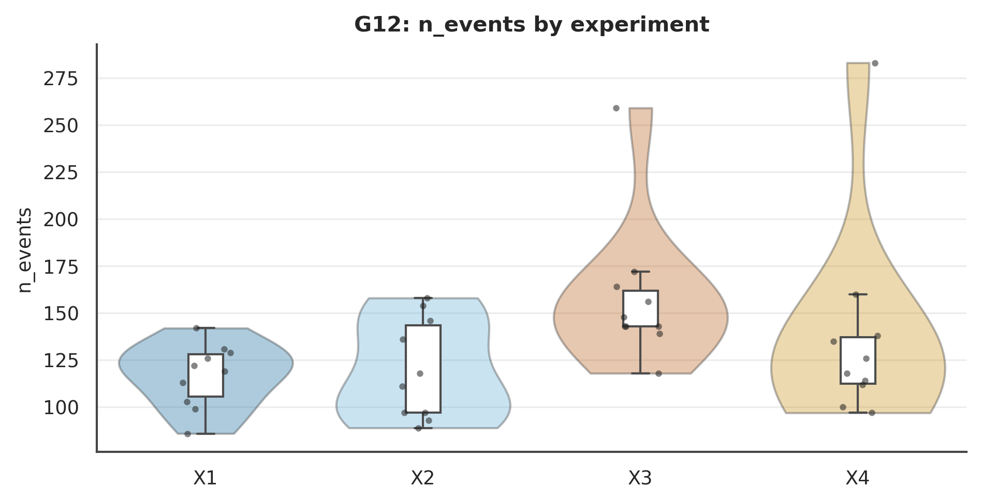

Figure . G12: n_events Mode×Role interaction.
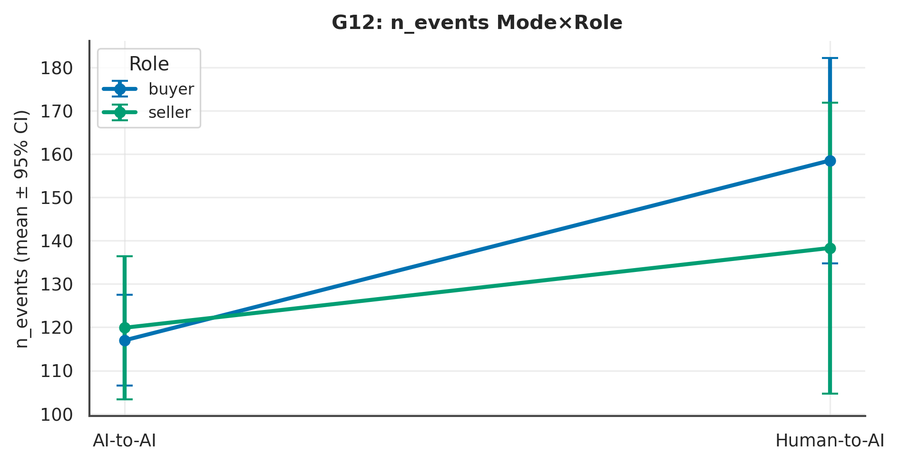

L4 review. Across 1 measure(s), the largest Mode signal was on ‘n_events’ (p = .012, Cliff's δ = −.47 [−.80, −.18], medium); the Role contrast there was p = .167 and the Mode×Role interaction p = .099. At ~10 per experiment these are exploratory and hypothesis-generating; effect sizes and intervals, not p-values, carry the interpretation.

G45 · Composite Data-Quality Screen & Its Impact
Surrogate DQ screen (no attention check exists); shows how much the headline moves.
Table . G45 — Robustness to DQ exclusion
Sample | satisfaction~Mode p | Cliff δ
All (N=40) | 0.354 | -0.17
DQ-clean (n=40) | 0.354 | -0.17

Table . G45 — Flagged participants
flagged | of
0 | 40

L4 review. Reported descriptively at the cohort level; exploratory and hypothesis-generating only.

G27 · Attrition / Dropout (non-completers)
Outside X1–X4 (no completion); funnel-level only.
Table . G27 — Dropout
Non-completers | n
total | 19
mode=delegated | 13
mode=direct | 6

L4 review. Reported descriptively at the cohort level; exploratory and hypothesis-generating only.

G29 · Settlement Focal-Point / Round-Number Bias
Market=24,000; ZOPA 22,500–23,500; clustering at round/focal values.
Table . G29 — Price clustering
Settlement price | n
21,500.00 | 1
22,000.00 | 2
22,300.00 | 1
22,500.00 | 3
23,000.00 | 6
23,500.00 | 10
23,800.00 | 1
24,200.00 | 1
24,800.00 | 1
25,500.00 | 1

L4 review. Reported descriptively at the cohort level; exploratory and hypothesis-generating only.

G37 · Measurement Model (DIF-style, reverse-item)
Full IRT/DIF not identifiable at N=40; mean-shift proxy + reverse-item construct check.
Table . G37 — Item means by Mode (DIF-style)
Item | M delegated | M direct | Δ
Satisfaction | 4.90 | 5.20 | -0.30
Would use again | 4.35 | 4.55 | -0.20
Felt represented | 5.60 | 5.75 | -0.15
Perceived control | 4.40 | 4.50 | -0.10
Pleasant affect | 5.25 | 4.85 | 0.40
Anxious affect | 4.05 | 3.15 | 0.90
Effort invested | 4.20 | 5.20 | -1.00
Engagement | 5.90 | 6.35 | -0.45
Outcome fairness | 4.80 | 5.00 | -0.20

Table . G37 — Reverse-item validity
anxious×satisfaction ρ | p
-0.52 | 0.001

L4 review. Reported descriptively at the cohort level; exploratory and hypothesis-generating only.

G18 · Device & Ergonomics
All desktop; viewport area as an ergonomic covariate.
Table . G18 — L1 Distinct (mean per experiment)
Measure | X1 | X2 | X3 | X4 | N
viewport_area | 1,317,055.80 | 1,765,586.60 | 1,123,594.10 | 1,061,473.60 | 40

Table . G18 — L2 2×2 + Pairwise (Mode/Role/Mode×Role; best pairwise)
Measure | Mode p | Mode δ | Mode 95%CI | Role p | M×R p | Opp p | Top pairwise | that p
viewport_area | .070 | .34 | [.02, .70] | .137 | .465 | .672 | Mode | Seller (X2 vs X4) | .038
Note. Mode/Role via Mann–Whitney + Cliff's δ (95% bootstrap CI); Mode×Role and opponent via SRH/Kruskal–Wallis.

Table . G18 — L3 Overall (pooled / Mode / Role)
Measure | Overall M(SD) | Delegated | Direct | Buyer | Seller
viewport_area | 1316927.52 (703006.96) | 1541321.20 | 1092533.85 | 1220324.95 | 1413530.10

Table . G18 — Pairwise detail: viewport_area
Contrast | n | U | p | Cliff δ | 95% CI | band | q (BH)
Mode | Buyer (X1 vs X3) | 10/10 | 64 | p = .325 | .27 | [−.21, .78] | small | .487
Mode | Seller (X2 vs X4) | 10/10 | 78 | p = .038 | .56 | [.22, 1.04] | large | .192
Role | Delegated (X1 vs X2) | 10/10 | 28 | p = .104 | −.44 | [−.96, −.02] | medium | .208
Role | Direct (X3 vs X4) | 10/10 | 40 | p = .496 | −.19 | [−.77, .34] | small | .595
Diagonal (X1 vs X4) | 10/10 | 51 | p = .970 | .02 | [−.50, .56] | negligible | .970
Diagonal (X2 vs X3) | 10/10 | 75 | p = .064 | .50 | [.10, 1.00] | large | .192
Note. Six structured contrasts among X1–X4; q = BH-adjusted.

Figure . G18: distribution of viewport_area across X1–X4.
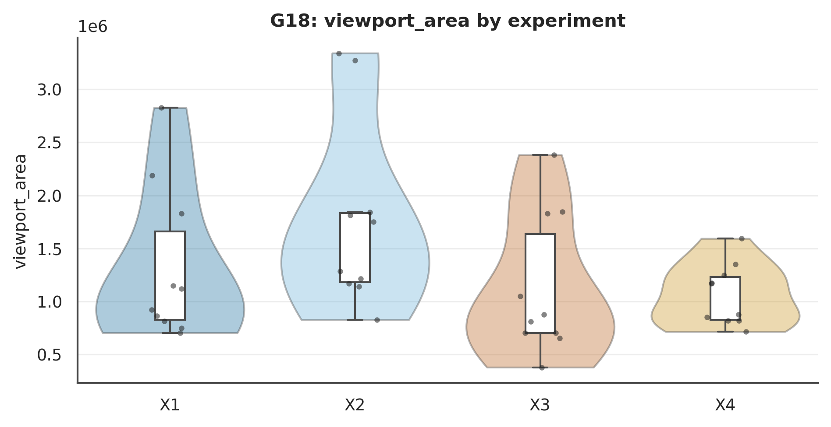

Figure . G18: viewport_area Mode×Role interaction.
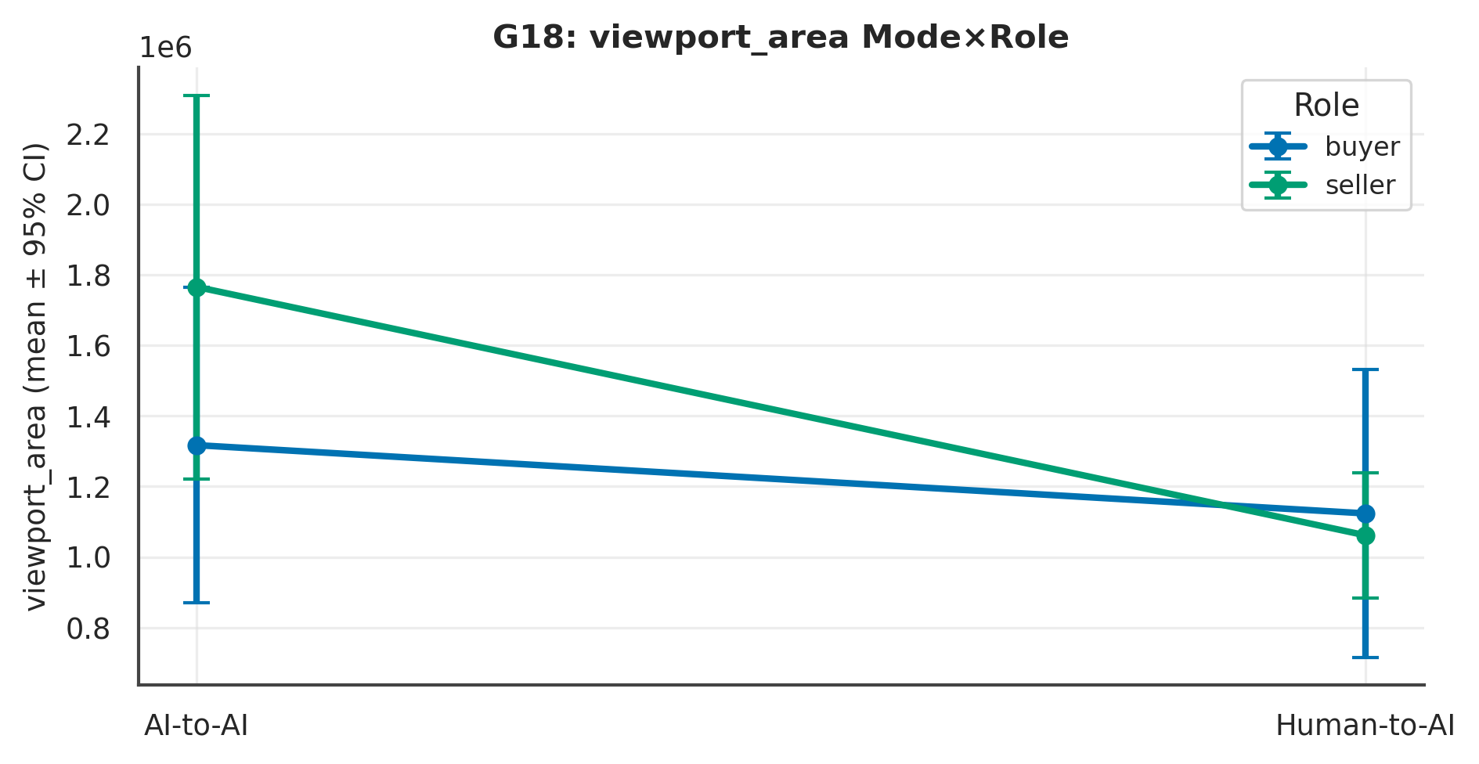

L4 review. Across 1 measure(s), the largest Mode signal was on ‘viewport_area’ (p = .070, Cliff's δ = .34 [.02, .70], medium); the Role contrast there was p = .137 and the Mode×Role interaction p = .465. At ~10 per experiment these are exploratory and hypothesis-generating; effect sizes and intervals, not p-values, carry the interpretation.

G20 · Per-Screen Deliberation Time
Summed response-screen time.
Table . G20 — L1 Distinct (mean per experiment)
Measure | X1 | X2 | X3 | X4 | N
total_screen_ms | 202,835.30 | 186,566.40 | 34,379.50 | 41,649.00 | 40

Table . G20 — L2 2×2 + Pairwise (Mode/Role/Mode×Role; best pairwise)
Measure | Mode p | Mode δ | Mode 95%CI | Role p | M×R p | Opp p | Top pairwise | that p
total_screen_ms | < .001 | .94 | [.89, 1.08] | 1.000 | .850 | .862 | Mode | Buyer (X1 vs X3) | < .001
Note. Mode/Role via Mann–Whitney + Cliff's δ (95% bootstrap CI); Mode×Role and opponent via SRH/Kruskal–Wallis.

Table . G20 — L3 Overall (pooled / Mode / Role)
Measure | Overall M(SD) | Delegated | Direct | Buyer | Seller
total_screen_ms | 116357.55 (101420.58) | 194700.85 | 38014.25 | 118607.40 | 114107.70

Table . G20 — Pairwise detail: total_screen_ms
Contrast | n | U | p | Cliff δ | 95% CI | band | q (BH)
Mode | Buyer (X1 vs X3) | 10/10 | 100 | p < .001 | 1.00 | [1.00, 1.00] | large | .001
Mode | Seller (X2 vs X4) | 10/10 | 94 | p = .001 | .88 | [.76, 1.18] | large | .002
Role | Delegated (X1 vs X2) | 10/10 | 53 | p = .850 | .06 | [−.46, .60] | negligible | .910
Role | Direct (X3 vs X4) | 10/10 | 52 | p = .910 | .04 | [−.48, .56] | negligible | .910
Diagonal (X1 vs X4) | 10/10 | 95 | p < .001 | .90 | [.80, 1.16] | large | .002
Diagonal (X2 vs X3) | 10/10 | 100 | p < .001 | 1.00 | [1.00, 1.00] | large | .001
Note. Six structured contrasts among X1–X4; q = BH-adjusted.

Figure . G20: distribution of total_screen_ms across X1–X4.
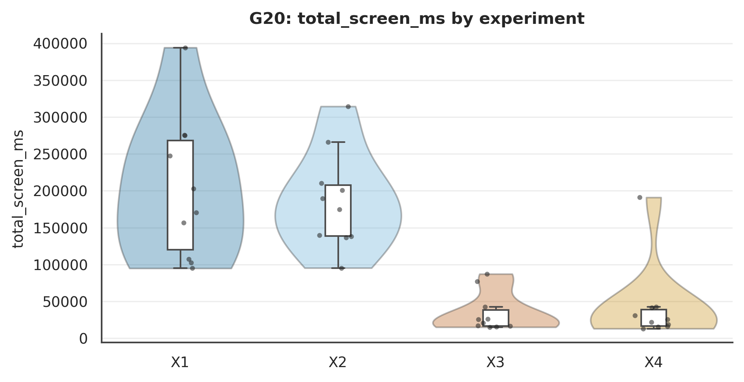

Figure . G20: total_screen_ms Mode×Role interaction.
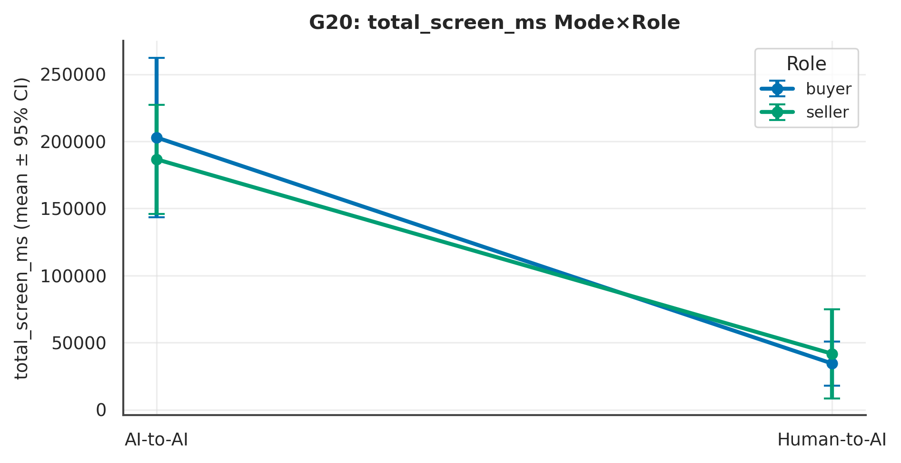

L4 review. Across 1 measure(s), the largest Mode signal was on ‘total_screen_ms’ (p < .001, Cliff's δ = .94 [.89, 1.08], large); the Role contrast there was p = 1.000 and the Mode×Role interaction p = .850. At ~10 per experiment these are exploratory and hypothesis-generating; effect sizes and intervals, not p-values, carry the interpretation.

G24 · AI-Counterpart Behaviour by Counterpart Type
Mode contrast = AI facing an agent (delegated) vs a human (direct) — a genuine AI-behaviour question.
Table . G24 — L1 Distinct (mean per experiment)
Measure | X1 | X2 | X3 | X4 | N
ai_opening | 25,350.00 | 21,800.00 | 22,555.56 | 21,800.00 | 39
ai_n_moves | 3.80 | 4.10 | 2.40 | 2.10 | 40

Table . G24 — L2 2×2 + Pairwise (Mode/Role/Mode×Role; best pairwise)
Measure | Mode p | Mode δ | Mode 95%CI | Role p | M×R p | Opp p | Top pairwise | that p
ai_opening | .173 | .25 | [−.08, .61] | < .001 | .149 | .215 | Diagonal (X1 vs X4) | < .001
ai_n_moves | < .001 | .70 | [.51, .95] | 1.000 | .368 | .564 | Mode | Seller (X2 vs X4) | < .001
Note. Mode/Role via Mann–Whitney + Cliff's δ (95% bootstrap CI); Mode×Role and opponent via SRH/Kruskal–Wallis.

Table . G24 — L3 Overall (pooled / Mode / Role)
Measure | Overall M(SD) | Delegated | Direct | Buyer | Seller
ai_opening | 22884.62 (2841.10) | 23575.00 | 22157.89 | 24026.32 | 21800.00
ai_n_moves | 3.10 (1.43) | 3.95 | 2.25 | 3.10 | 3.10

Table . G24 — Pairwise detail: ai_opening
Contrast | n | U | p | Cliff δ | 95% CI | band | q (BH)
Mode | Buyer (X1 vs X3) | 10/9 | 63 | p = .098 | .40 | [.02, .82] | medium | .196
Mode | Seller (X2 vs X4) | 10/10 | 48 | p = .937 | −.03 | [−.55, .50] | negligible | .937
Role | Delegated (X1 vs X2) | 10/10 | 100 | p < .001 | 1.00 | [1.00, 1.00] | large | .000
Role | Direct (X3 vs X4) | 9/10 | 62 | p = .168 | .38 | [−.24, 1.02] | medium | .202
Diagonal (X1 vs X4) | 10/10 | 100 | p < .001 | 1.00 | [1.00, 1.00] | large | .000
Diagonal (X2 vs X3) | 10/9 | 26 | p = .137 | −.41 | [−.98, .08] | medium | .202
Note. Six structured contrasts among X1–X4; q = BH-adjusted.

Figure . G24: distribution of ai_opening across X1–X4.
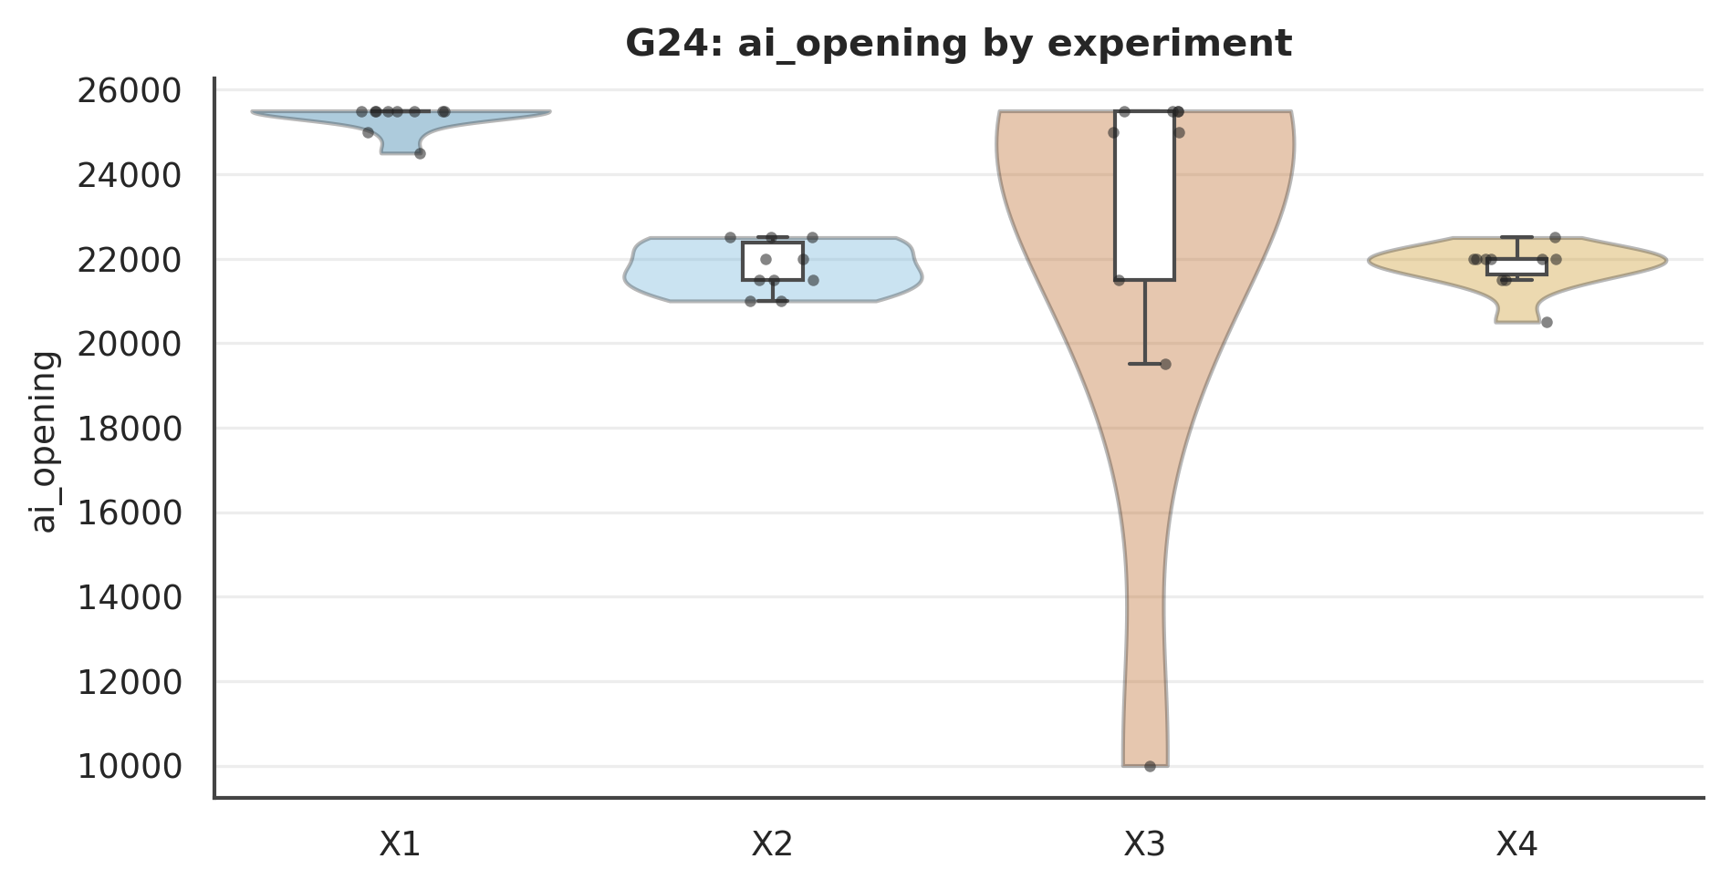

Figure . G24: ai_opening Mode×Role interaction.
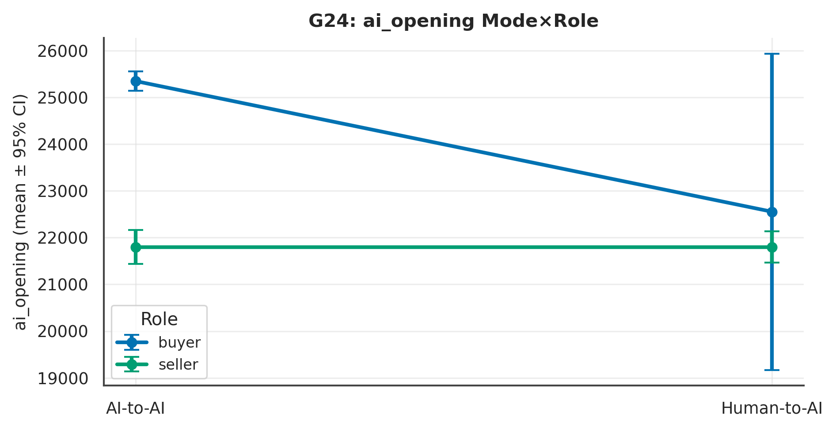

L4 review. Across 2 measure(s), the largest Mode signal was on ‘ai_n_moves’ (p < .001, Cliff's δ = .70 [.51, .95], large); the Role contrast there was p = 1.000 and the Mode×Role interaction p = .368. At ~10 per experiment these are exploratory and hypothesis-generating; effect sizes and intervals, not p-values, carry the interpretation.

G13 · Client–Server Clock Skew
Table . G13 — L1 Distinct (mean per experiment)
Measure | X1 | X2 | X3 | X4 | N
mean_clock_skew_s | 4.68 | 6.60 | 4.19 | 4.04 | 40

Table . G13 — L2 2×2 + Pairwise (Mode/Role/Mode×Role; best pairwise)
Measure | Mode p | Mode δ | Mode 95%CI | Role p | M×R p | Opp p | Top pairwise | that p
mean_clock_skew_s | .337 | .18 | [−.16, .54] | .989 | .935 | .108 | Mode | Buyer (X1 vs X3) | .521
Note. Mode/Role via Mann–Whitney + Cliff's δ (95% bootstrap CI); Mode×Role and opponent via SRH/Kruskal–Wallis.

Table . G13 — L3 Overall (pooled / Mode / Role)
Measure | Overall M(SD) | Delegated | Direct | Buyer | Seller
mean_clock_skew_s | 4.88 (3.40) | 5.64 | 4.12 | 4.44 | 5.32

Table . G13 — Pairwise detail: mean_clock_skew_s
Contrast | n | U | p | Cliff δ | 95% CI | band | q (BH)
Mode | Buyer (X1 vs X3) | 10/10 | 59 | p = .521 | .18 | [−.30, .74] | small | .781
Mode | Seller (X2 vs X4) | 10/10 | 59 | p = .521 | .18 | [−.28, .72] | small | .781
Role | Delegated (X1 vs X2) | 10/10 | 48 | p = .910 | −.04 | [−.56, .48] | negligible | .970
Role | Direct (X3 vs X4) | 10/10 | 51 | p = .970 | .02 | [−.48, .54] | negligible | .970
Diagonal (X1 vs X4) | 10/10 | 59 | p = .521 | .18 | [−.30, .70] | small | .781
Diagonal (X2 vs X3) | 10/10 | 59 | p = .521 | .18 | [−.30, .76] | small | .781
Note. Six structured contrasts among X1–X4; q = BH-adjusted.

Figure . G13: distribution of mean_clock_skew_s across X1–X4.
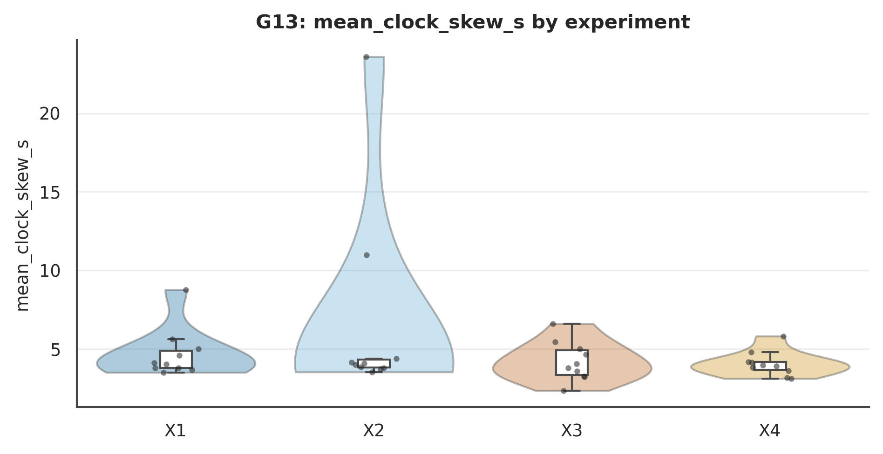

Figure . G13: mean_clock_skew_s Mode×Role interaction.
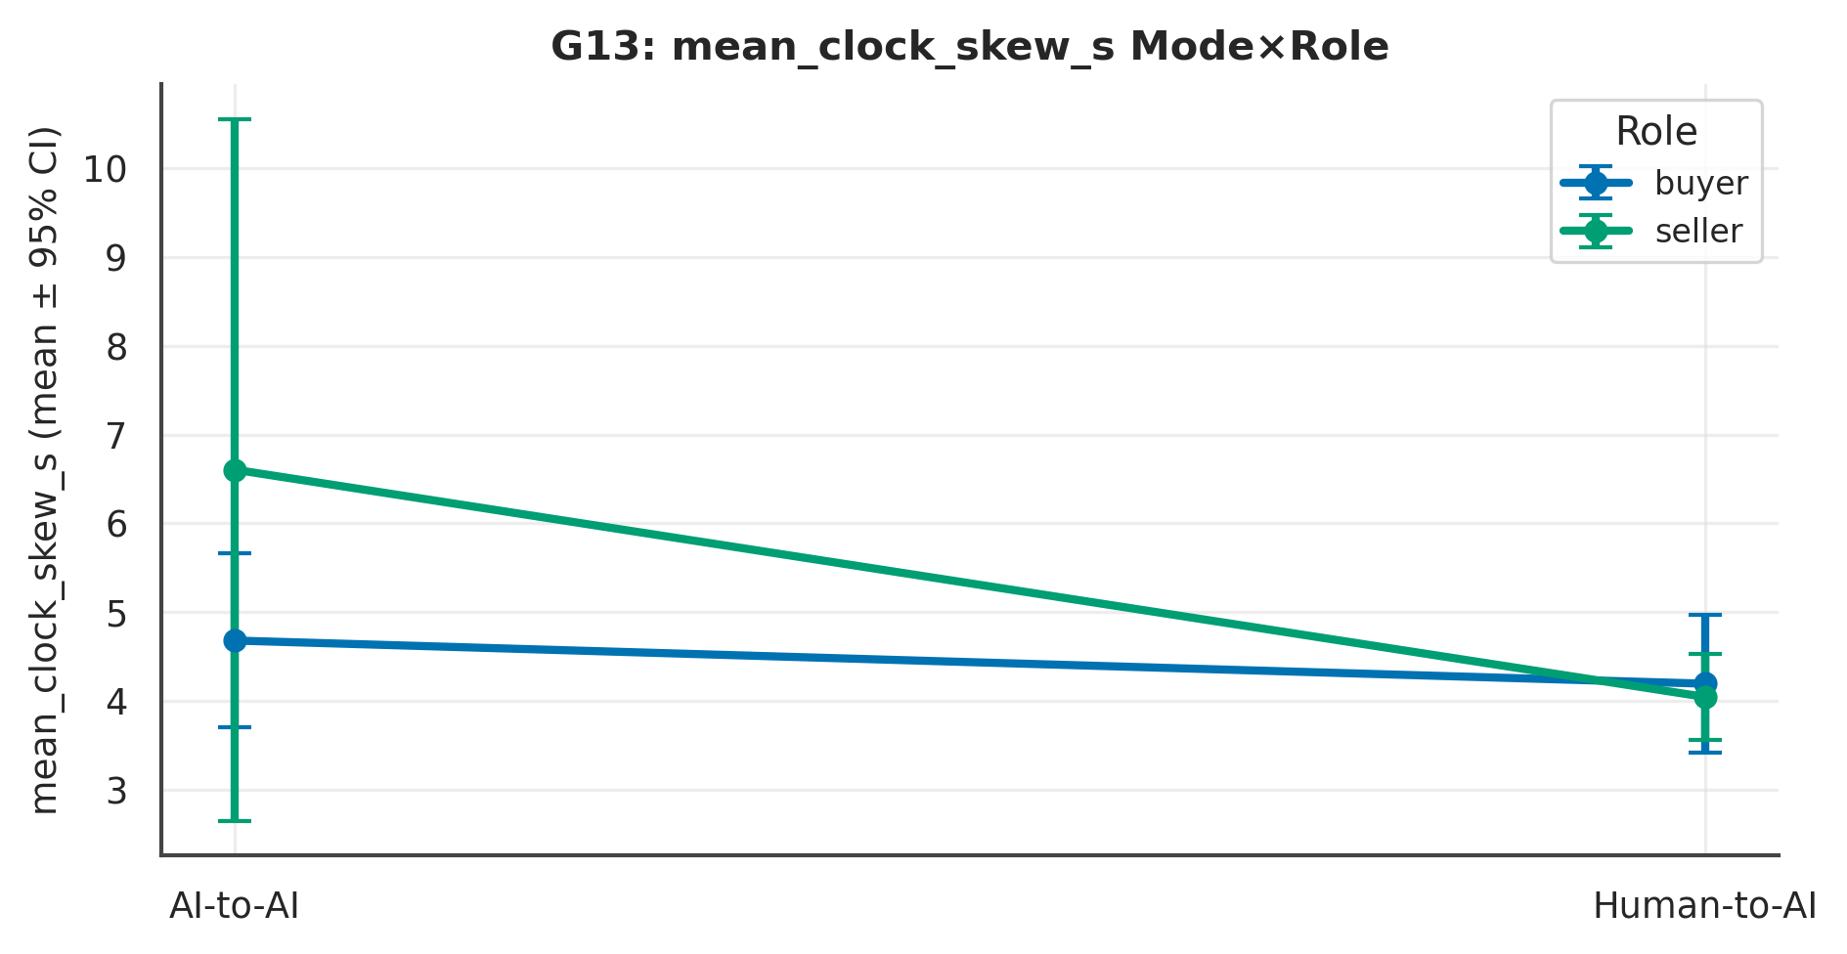

L4 review. Across 1 measure(s), the largest Mode signal was on ‘mean_clock_skew_s’ (p = .337, Cliff's δ = .18 [−.16, .54], small); the Role contrast there was p = .989 and the Mode×Role interaction p = .935. At ~10 per experiment these are exploratory and hypothesis-generating; effect sizes and intervals, not p-values, carry the interpretation.

Part IV — Cross-Experiment Synthesis, Robustness & Confirmatory Roadmap
Figure . Nine measures × four experiments (means).
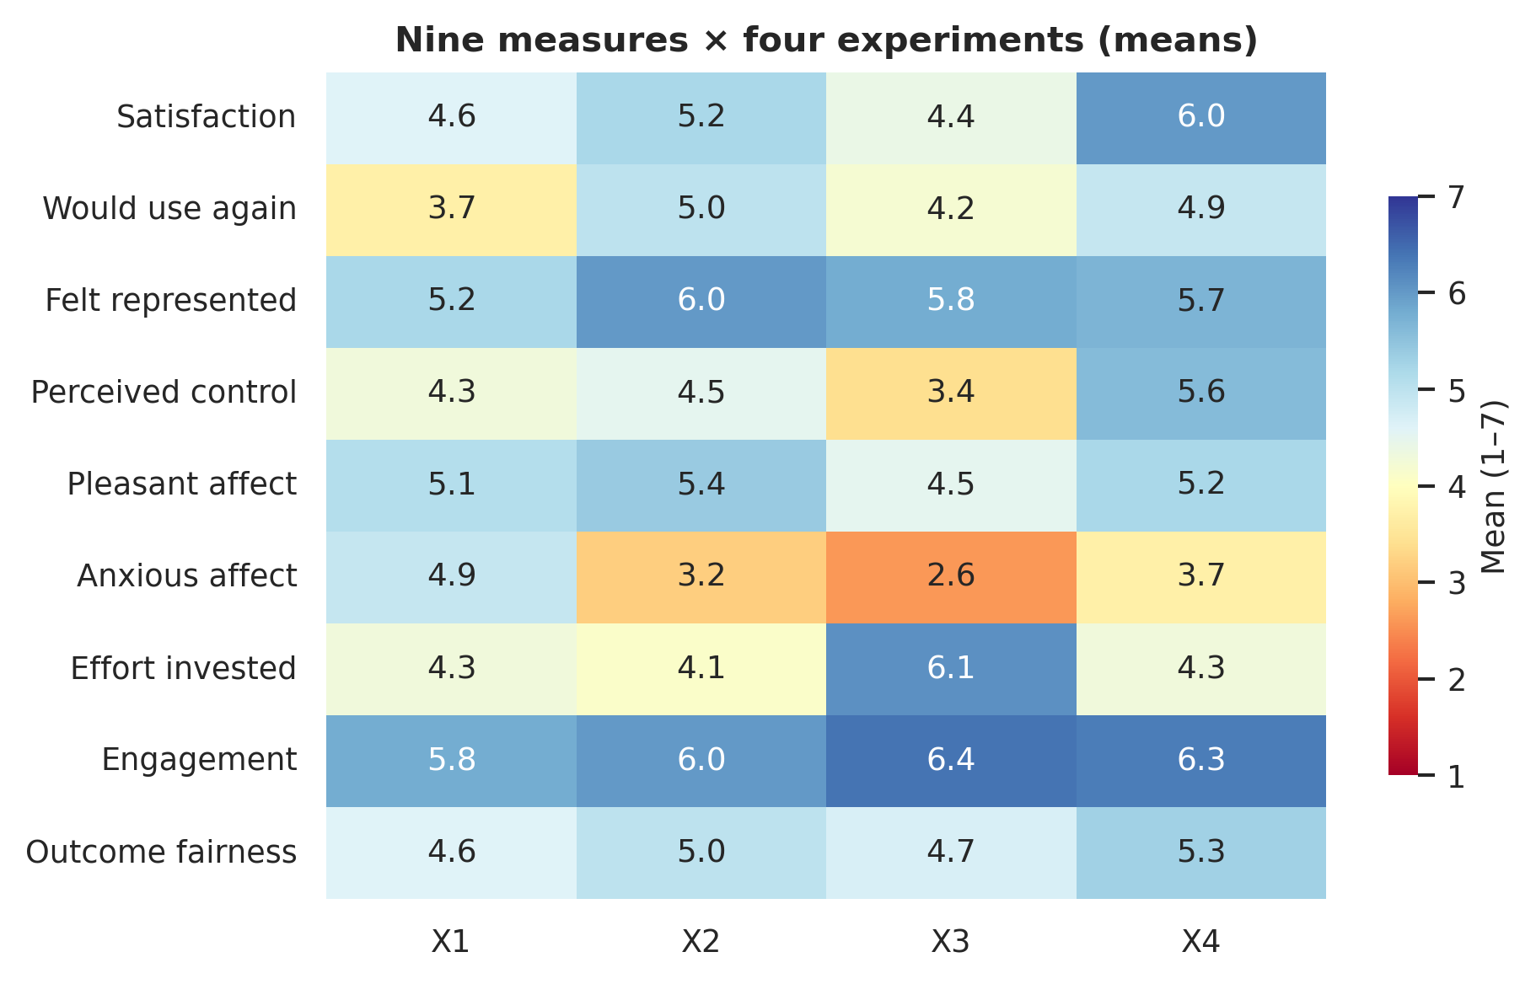

Figure . Affect space (pleasant × anxious) by experiment.
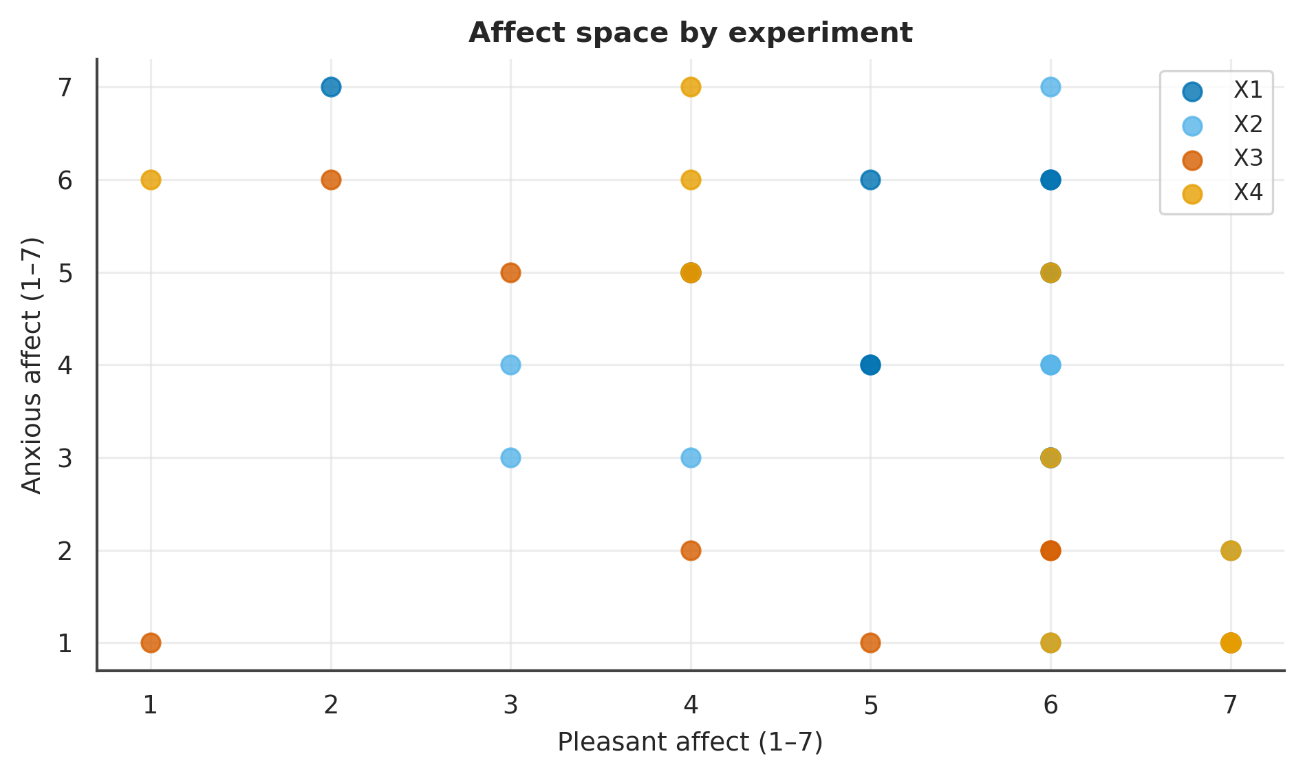

Figure . Engagement instrumentation by experiment.
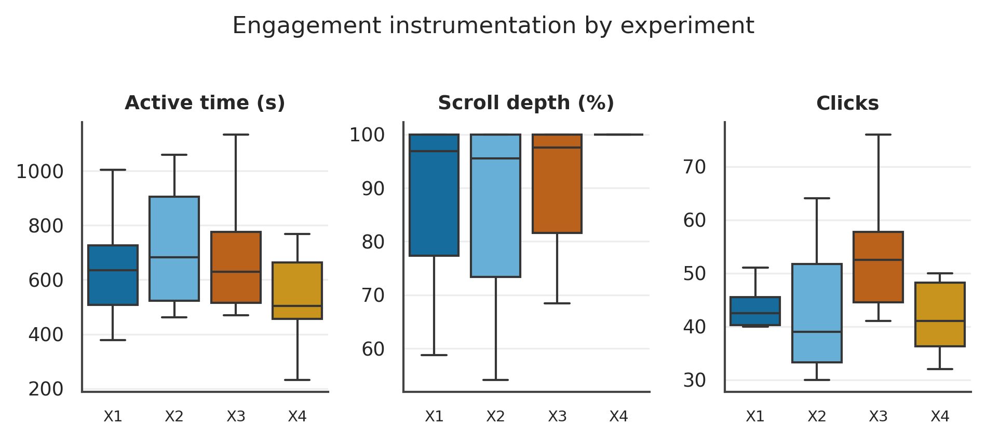

Summary
Agreement dominated (27/40); settlements were economically efficient (within ZOPA) and split near-evenly; the nine subjective measures were broadly comparable across Mode with generally small exploratory effects. No single-experiment or pairwise result should be read as evidence at this sample size.

Strengths
Verified fixed reservations; a balanced four-experiment allocation; dense instrumentation; a modern, fully deterministic and offline pipeline; and a coherent design system so every figure and table is mutually comparable.

Limitations
Decisive: n = 10 per experiment (severely underpowered, p- and q-values illustrative); opponent randomised and unbalanced (a confound); no attention check; empty utility/score tables; a single distributive issue; stochastic LLM agents with two degraded sessions; deterministic-only text analysis. This is a small-sample legacy pilot (n = 10 per experiment). Opponent personality was randomised, not controlled; the economic-utility and judge-score tables are empty; no attention check was recorded. Every inferential statement is exploratory and hypothesis-generating — never a pre-registered confirmatory result.

Implications
The pilot is infrastructurally decisive and generative. A powered confirmatory study should control and balance opponent personality, record the attention check and pre-register exclusions, populate the utility tables, pre-register the primary satisfaction contrast and a corrected secondary family, and recruit to roughly 24 per Mode×Role×opponent stratum.

Conclusion
Whether people obtain better deals, or merely feel better, when they delegate a negotiation to AI remains open. This pilot does not answer it and is not designed to; it demonstrates an analysis-ready platform and a complete, reproducible four-experiment evidentiary pipeline for the confirmatory study to come.

References
Benjamini, Y., & Hochberg, Y. (1995). Controlling the false discovery rate. Journal of the Royal Statistical Society: Series B, 57(1), 289–300.
Cliff, N. (1993). Dominance statistics: Ordinal analyses to answer ordinal questions. Psychological Bulletin, 114(3), 494–509.
Cronbach, L. J. (1951). Coefficient alpha and the internal structure of tests. Psychometrika, 16(3), 297–334.
Dietvorst, B. J., Simmons, J. P., & Massey, C. (2015). Algorithm aversion. Journal of Experimental Psychology: General, 144(1), 114–126.
Kruskal, W. H., & Wallis, W. A. (1952). Use of ranks in one-criterion variance analysis. Journal of the American Statistical Association, 47(260), 583–621.
Lakens, D. (2017). Equivalence tests. Social Psychological and Personality Science, 8(4), 355–362.
Logg, J. M., Minson, J. A., & Moore, D. A. (2019). Algorithm appreciation. Organizational Behavior and Human Decision Processes, 151, 90–103.
Mann, H. B., & Whitney, D. R. (1947). On a test of whether one of two random variables is stochastically larger than the other. The Annals of Mathematical Statistics, 18(1), 50–60.
Romano, J., Kromrey, J. D., Coraggio, J., & Skowronek, J. (2006). Appropriate statistics for ordinal level data. Florida Association of Institutional Research.
Scheirer, C. J., Ray, W. S., & Hare, N. (1976). The analysis of ranked data derived from completely randomized factorial designs. Biometrics, 32(2), 429–434.
Vallat, R. (2018). Pingouin: Statistics in Python. Journal of Open Source Software, 3(31), 1026.

Appendix A — Data Dictionary & Database Profile
Table . Data Dictionary and Caveats
Table | Field | Meaning / caveat
study_participants | completion_code | Non-null ⇒ completer (analysed = 40)
study_participants | experiment_mode | agent⇒delegated; human_*⇒direct
study_participants | role | buyer / seller (→ X1–X4 with Mode)
study_participants | attention_check_pass | ENTIRELY NULL — not captured
study_participants | excluded / test_data | All 0
participant_responses | screen=post_survey | 9 Likert DVs (1–7) + free_text
participant_responses | screen=engine/opponent_personality | Randomised opponent (covariate)
participant_responses | screen=context/personal_context | Delegated context (n=20)
sessions | outcome_type / outcome_terms_json | agreed/rejected/impasse/aborted; {price}
sessions | scenario_pack_json | Fixed ZOPA 22,500–23,500 (pie $1,000)
turns | tool_calls_json | submit_proposal{action,price} / send_message
orchestrator_decisions | tool_name | request_turn/declare_outcome/broadcast/pause
participant_events | event_type/payload_json | dwell/idle/scroll/listing/integrity/human-turn
behavior_prompts | prompt_text | Delegated instructions (match_rating/mapped_signals NULL)
outcomes / scores | (empty) | No utility / judge scores — not analysable

Table . Base-Table Row Counts
Table | Rows
behavior_prompts | 21
orchestrator_decisions | 582
outcomes | 0
participant_events | 6601
participant_responses | 576
participants | 92
scores | 0
sessions | 46
study_participants | 59
turns | 532

Appendix B — Verbatim Open-Text
Table . Anonymised Verbatim Entries
ID | kind | exp | role | Verbatim text
P01 | study comment | X4 | seller | the study was well structured
P02 | study comment | X4 | seller | i think debating like that is a fun time, so this was a fun study to do
P03 | study comment | X3 | buyer | Super fun and interesting, I really like the AI negotiator, very skilled!
P04 | study comment | X3 | buyer | None.
P05 | study comment | X3 | buyer | Enjoyable
P06 | study comment | X3 | buyer | The sellers responses are nearly impossible to read as there is a very tiny window of text - like you can only see one line at a time
P07 | study comment | X4 | seller | This was enjoyable. I actually have owned 3 Toyota's so that isn't a fib on my part. I am indeed on my third. I would use an AI tool like this. I would be interested to see what it would look like if it represented the s…
P08 | study comment | X1 | buyer | I said I wanted a white car nor a black car and gave valid reasons. Agent still negotiated in this BLACK car and bought it for me. Would you use this agent?
P09 | study comment | X1 | buyer | I would definitely use this in real life as dealing with car salesman is one of the worst negotiations to deal with. It went very smoothly and I got my price so I'm happy.
P10 | study comment | X2 | seller | The text scrolled too quickly to read. I had to keep going back to keep up. Other than that, very interesting.
P11 | study comment | X1 | buyer | No
P12 | study comment | X1 | buyer | I was surprised that the chatbot started by saying how great the car is, in my experience it isn't great to start by showing such interest and enthusiasm.
P13 | study comment | X2 | seller | I'd rather use this than actual car sales people.
P14 | study comment | X1 | buyer | None.
P15 | study comment | X3 | buyer | The AI was super rude...
P16 | study comment | X3 | buyer | For me, the seller responded so good and believable. I think the interface is very easy and simple to use.
P17 | study comment | X3 | buyer | Very fun to do.
P18 | study comment | X1 | buyer | no
P19 | study comment | X4 | seller | not at this time
P20 | study comment | X2 | seller | None! This was really interesting to experience!
P21 | personal context | X2 | seller | I'm selling because I'm moving soon and don't want to deal with moving the car or keeping up with payments and insurance longer than I need to. The car has been really well taken care of, so I don't want to feel like I g…
P22 | personal context | X2 | seller | I am letting this car go because I need money. Im going to get a cheaper car instead.
P23 | personal context | X2 | seller | I'm recovering from a financial crisis from having to help out and spend thousands for my nephew's physical therapy and chemotherapy for the past 2 years. I would appreciate it if the future owner of the car would take v…
P24 | personal context | X1 | buyer | I've always been a Camry guy. I like this car, but I'm not in such a rush to make the purchase now, as I'm looking for a good deal.
P25 | personal context | X1 | buyer | I have been saving up for a car and really like this one. I have worked overtime to save even more and have made an accomplishment. I am not wealthy or do I have a lot of money. I have a limit on how much I can spend an…
P26 | personal context | X2 | seller | I am a student moving away to start college, i need to make this sale so i can afford tuition and make the move. I really need the money from this sale to afford my education. i need this done quickly and i will not go u…
P27 | personal context | X2 | seller | I am now in the need for a larger car, an SUV, for my growing family. I need to make room for my new SUV, and as much as I hate to let this car go, I want to sell it to a buyer willing to make an offer within my guideli…
P28 | personal context | X1 | buyer | I don't like this car. I live in Florida and don't want a black car because of the sun and heat. Please only show me white cars.
P29 | personal context | X1 | buyer | I lost my last vehicle to an accident, and I realy ned to get a relaible car that doesn't guzzle gas. I've had Toyotas before, and they last forever. I have cash on hand and am willing to make this hasle free and pay rig…
P30 | personal context | X1 | buyer | I am very interested in this car but need to get the price down $4000 to $21,500 ideally. I just graduated college and need a reliable car but will not overpay. I have cash and do not need any form of bank financing. …
P31 | personal context | X2 | seller | I want $25k for the car but I will accept $22.5. It's in immaculate condition which makes it absolutely worth the asking price. If the seller doesn't want it, no pressure, I'll sell it to someone else.
P32 | personal context | X1 | buyer | I'm car shopping and want to pay 21500, but no more than 23500.
P33 | personal context | X1 | buyer | I appreciate your help. I like this car, but I can't do the price. No higher that 23 or I will find something else. I can pay cash so I don't need credit. If you can get it down to 21 that would be amazing. I have a good…
P34 | personal context | X2 | seller | I found a great job in a city where I will not need a car since public transportation is great, but renting in the city is very expensive so selling the car will free up some extra money. I'd like the sale price to be as…
P35 | personal context | X1 | buyer | I can spend up to 23,500 on this car, but I'd like to get it for 21,500 if possible. The car will be used infrequently, as I work from home. I'd like to get this negotiation worked out today, if possible, since I'd like…
P36 | personal context | X1 | buyer | I have been in need for a new car for a while and I am searching for a new job as well. This makes my budget somewhat limited, that's why I am aiming for $21,500 for this car. It is exactly what I am looking for: new, co…
P37 | personal context | X1 | buyer | I’m looking for a reliable, comfortable daily driver that won’t give me maintenance headaches. The Camry stands out for its dependability and value. I’d like to buy soon if the price feels fair and there are no hidden is…
P38 | personal context | X2 | seller | I'm a college sophomore living in NYC, and I have to balance hard courses with responsibilities and everyday city expenses. I am studying criminal justice and working towards a bachelor of science. I tend to be less prac…
P39 | personal context | X2 | seller | I am trying to sell this car now in order to get rid of my credit card debt! I want to be able to use this to pay for any loans that I have outstanding. I am also planning on moving from current location. I would need to…
P40 | personal context | X2 | seller | I just got married and have combined households with my husband, who already has 2 cars. One he uses for work, and the other for personal. So we are just going to share the personal car. I want to sell this car to jumpst…
Note. Deterministic; no LLM coding.

Appendix C — Reproducibility & Exported Tables
Every table is exported as CSV under docs/reports/tables-grand/. The document rebuilds deterministically via python -m scripts.analysis.grand_report.report. Stack: pandas, scipy (bootstrap/permutation), pingouin (Bayesian/TOST), statsmodels, scikit-posthocs, lifelines, scikit-learn, textstat; figures via matplotlib/seaborn on one shared theme.

