Negotiation Process & Interaction Dynamics
Analytical sample = the 40 Prolific completers (4 balanced Mode x Role cells, n=10). Strictly exploratory; n=10/cell; p uncorrected; no pairwise post-hoc. Limitations: no private agent reasoning (thinking empty); reservation prices from the fixed Camry scenario brief (uniform across all 40); screen dwell from client telemetry. Derived process metrics are auditable via the per-pillar metric dictionaries.

1. Bargaining trajectory & strategy
Table 1.0 — Metric dictionary (§1)
name | definition | source | type
opening_spread | seller_open - buyer_open: distance between the two sides' first priced proposals | turns.tool_calls_json (submit_proposal) | continuous
anchor_distance | |own opening price - own scenario target|: how far the opener anchored from its brief target | turns + fixed Camry scenario brief | continuous
n_concessions | count of the focal side's own moves in the conceding direction across proposal rounds | ordered proposal stream | count
mean_concession | mean |price step| of the focal side's conceding moves (USD) | ordered proposal stream | continuous
concession_rate | focal side's total concession / number of proposal rounds (USD per round) | ordered proposal stream | continuous
buyer_share_concession | buyer total concession / (buyer + seller total concession) | ordered proposal stream | ratio [0,1]
n_proposal_rounds | count of priced submit_proposal calls in the session | turns.tool_calls_json | count
turns_to_deal | turn number of the accept that closed an agreed session (NaN if no deal) | turns.tool_calls_json (accept) | count
n_final_offers | count of proposals flagged is_final=true | turns.tool_calls_json | count
Hand-authored definitions so every derived process metric is auditable.
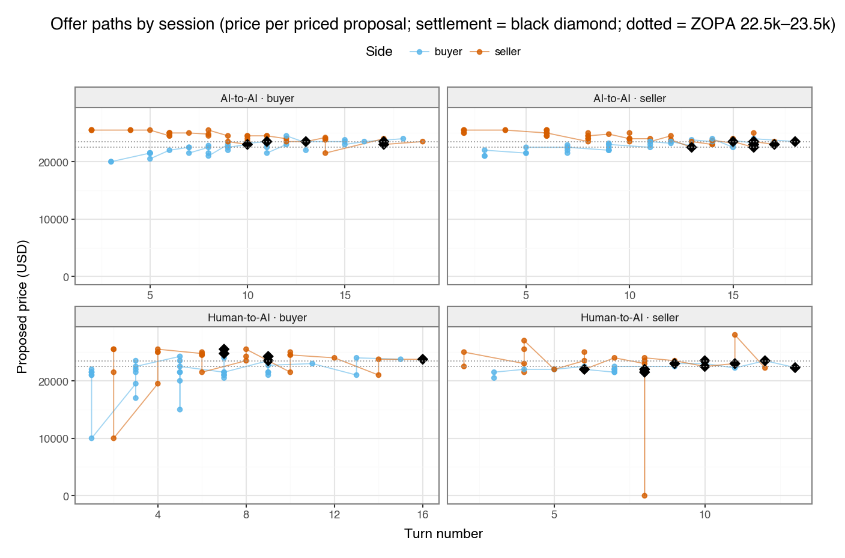
Figure 1.1 — Offer paths by session
Price per priced proposal, faceted by cell; settlement marked; ZOPA band shown — exploratory (exploratory; n=10/cell; uncorrected).
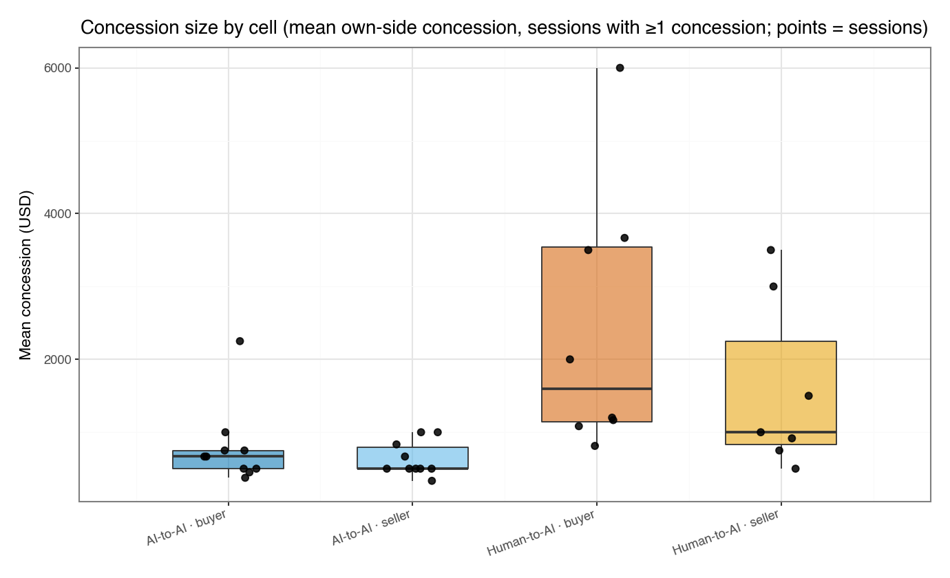
Figure 1.2 — Concession size by cell
Mean own-side concession, sessions with >=1 concession — exploratory (exploratory; n=10/cell; uncorrected).
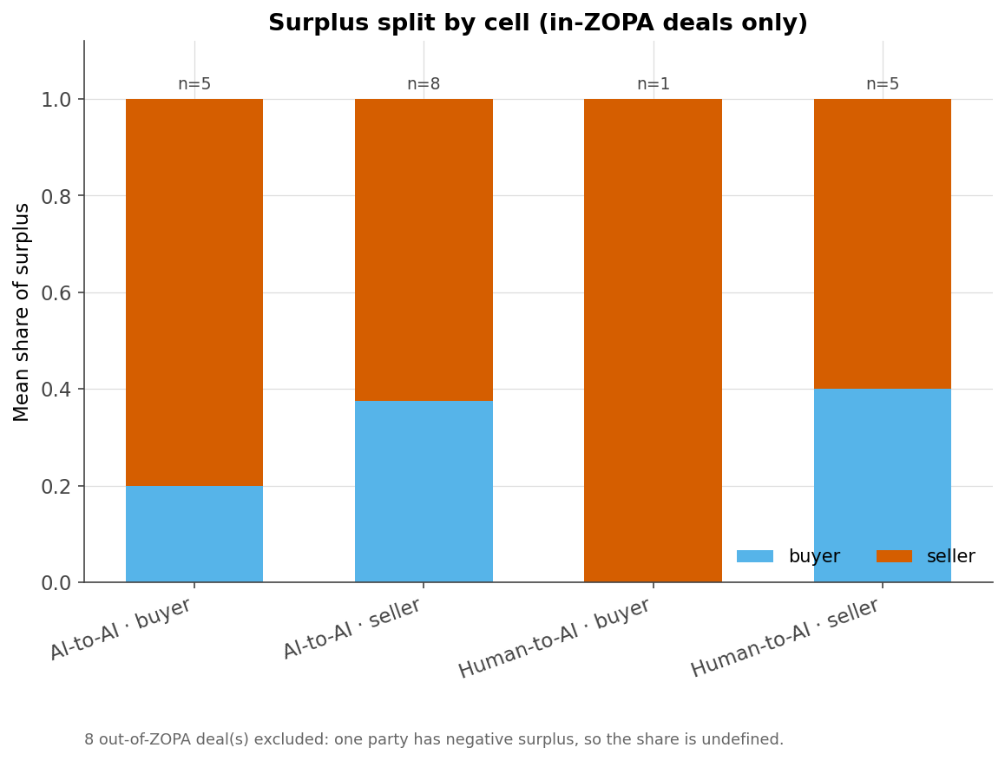
Figure 1.3 — Surplus split by cell
Mean buyer/seller surplus share, in-ZOPA deals only — exploratory (exploratory; n=10/cell; uncorrected).
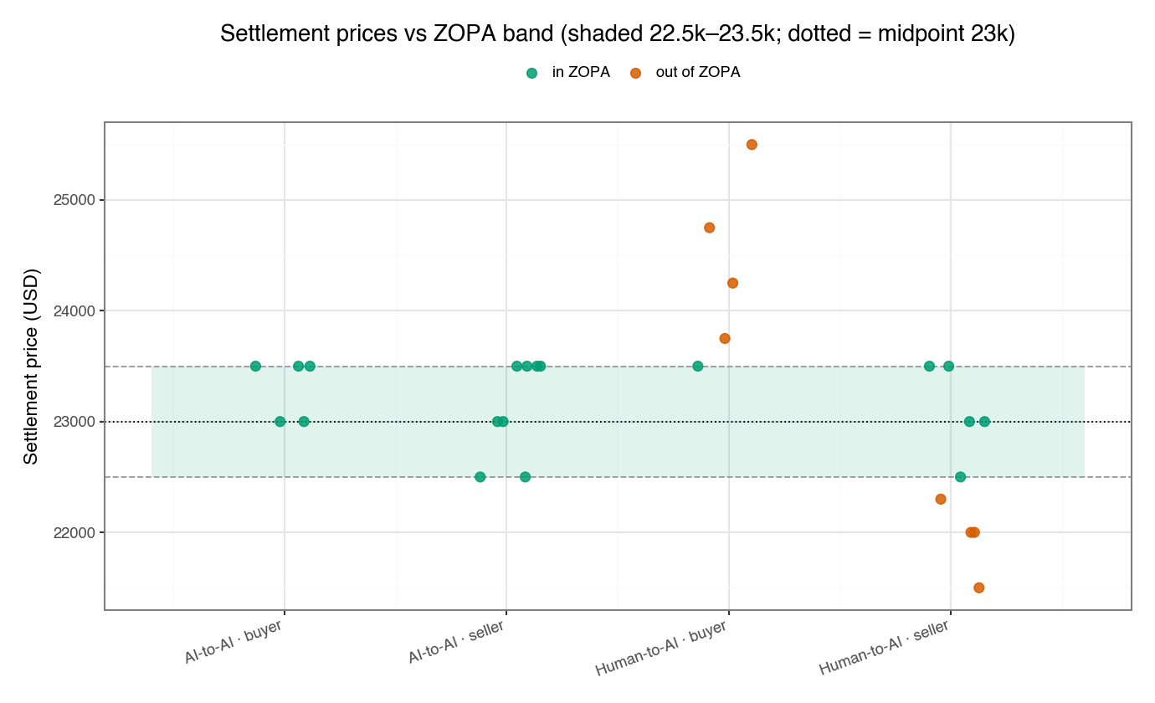
Figure 1.4 — Settlement prices vs ZOPA
Settlement price per deal vs the 22.5k-23.5k ZOPA band — exploratory (exploratory; n=10/cell; uncorrected).
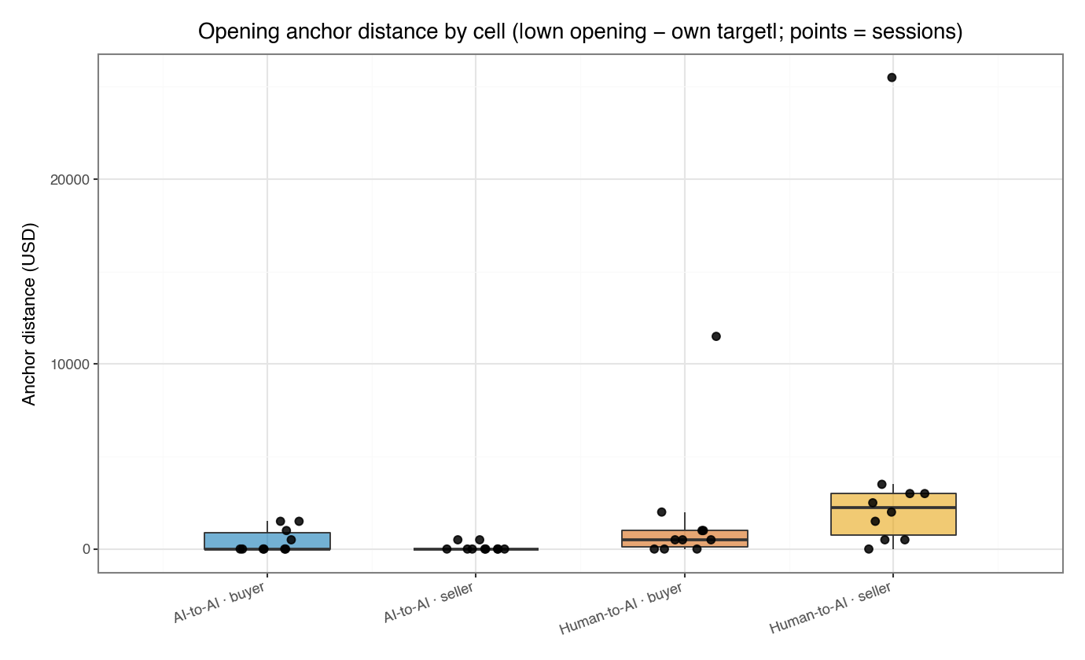
Figure 1.5 — Opening anchor distance by cell
|own opening - own target|; points = sessions — exploratory (exploratory; n=10/cell; uncorrected).
Table 1.1 — Per-cell medians (§1 DVs)
cell | opening_spread | anchor_distance | n_concessions | mean_concession | concession_rate | buyer_share_concession | n_proposal_rounds | turns_to_deal | n_final_offers
AI-to-AI · buyer | 4000.0 | 0.0 | 2.5 | 666.6667 | 218.254 | 0.5 | 7.0 | 13.0 | 1.0
AI-to-AI · seller | 3500.0 | 0.0 | 3.5 | 500.0 | 236.1111 | 0.4202 | 8.5 | 16.0 | 1.0
Human-to-AI · buyer | 3500.0 | 500.0 | 1.5 | 1600.0 | 473.9583 | 0.8125 | 6.0 | 9.0 | 0.0
Human-to-AI · seller | 2000.0 | 2250.0 | 1.0 | 1000.0 | 250.0 | 0.4 | 4.5 | 9.0 | 0.0
Median per study cell (exploratory; n=10/cell; uncorrected).
Table 1.2 — SRH / MW / KW stats (§1 DVs)
dv | n | mode_p | mode_eta2 | role_p | role_eta2 | inter_p | mw_mode_p | mw_mode_delta | ci_lo | ci_hi | mw_role_p | mw_role_delta | kw_p | kw_eps2
opening_spread | 39 | 0.0126 | 0.1636 | 0.1043 | 0.0694 | 0.5711 | 0.0132 | 0.4605 | 0.0974 | 0.7527 | 0.1074 | 0.3 | 0.0298 | 0.2359
anchor_distance | 40 | 0.0007 | 0.2976 | 0.6483 | 0.0053 | 0.0659 | 0.0007 | -0.5975 | -0.8475 | -0.34 | 0.6586 | -0.08 | 0.0017 | 0.3896
n_concessions | 40 | 0.0004 | 0.3182 | 0.9011 | 0.0004 | 0.0867 | 0.0005 | 0.6375 | 0.3625 | 0.855 | 0.912 | 0.0225 | 0.0015 | 0.3938
mean_concession | 35 | 0.0001 | 0.4309 | 0.2726 | 0.0354 | 0.5265 | 0.0001 | -0.76 | -0.9533 | -0.4865 | 0.2799 | 0.2157 | 0.0011 | 0.47
concession_rate | 40 | 0.2968 | 0.0279 | 0.2906 | 0.0286 | 0.2845 | 0.3032 | -0.1925 | -0.5675 | 0.1851 | 0.2968 | 0.195 | 0.3406 | 0.0859
buyer_share_concession | 38 | 0.097 | 0.0744 | 0.0646 | 0.0923 | 0.2085 | 0.1 | -0.3139 | -0.6972 | 0.0862 | 0.0667 | 0.349 | 0.0514 | 0.2095
n_proposal_rounds | 40 | 0.0002 | 0.3586 | 0.7433 | 0.0028 | 0.0356 | 0.0002 | 0.685 | 0.4149 | 0.8826 | 0.7536 | 0.06 | 0.0003 | 0.4746
turns_to_deal | 27 | 0.0001 | 0.6295 | 0.6499 | 0.0079 | 0.5769 | 0.0001 | 0.9121 | 0.7473 | 1.0 | 0.6682 | -0.1059 | 0.0007 | 0.6534
n_final_offers | 40 | 0.0207 | 0.1371 | 0.5309 | 0.0101 | 0.9168 | 0.0216 | 0.3875 | 0.095 | 0.67 | 0.5407 | 0.105 | 0.1243 | 0.1475
Scheirer-Ray-Hare 2x2 (Mode A, Role B, A x B), Mann-Whitney for the Mode & Role contrasts (Cliff's delta + 95% two-sample bootstrap CI on the Mode contrast), Kruskal-Wallis across the 4 cells. exploratory; n=10/cell; uncorrected; n=10/cell. p in [0,1] or NaN.
Surplus split (deal sessions, n=27; 19 in-ZOPA): buyer/seller surplus is computed against the fixed Camry reservations (buyer walk-away $23,500, seller floor $22,500). Shares are only defined for in-ZOPA settlements; see sec1_surplus_frame.csv. Exploratory; n=10/cell; uncorrected.

2. Tempo, latency & token economy
Table 2.0 — Metric dictionary (§2)
name | definition | source | type
median_latency_ms | session median of per-turn latency_ms (think+type for humans, model time for agents) | turns.latency_ms | continuous
mean_latency_ms | session mean of per-turn latency_ms | turns.latency_ms | continuous
negotiation_duration_s | sessions.ended_at - started_at, in seconds | sessions timestamps | continuous
time_to_deal_s | seconds from first turn to the closing accept (NaN if no deal) | turns timestamps | continuous
tokens_total | total LLM tokens consumed in the session | sessions.tokens_total | count
orch_token_share | tokens_orchestrator / tokens_total (referee overhead share) | sessions token fields | ratio [0,1]
tokens_per_turn | tokens_total / turns_consumed | sessions fields | continuous
Hand-authored definitions so every derived process metric is auditable.
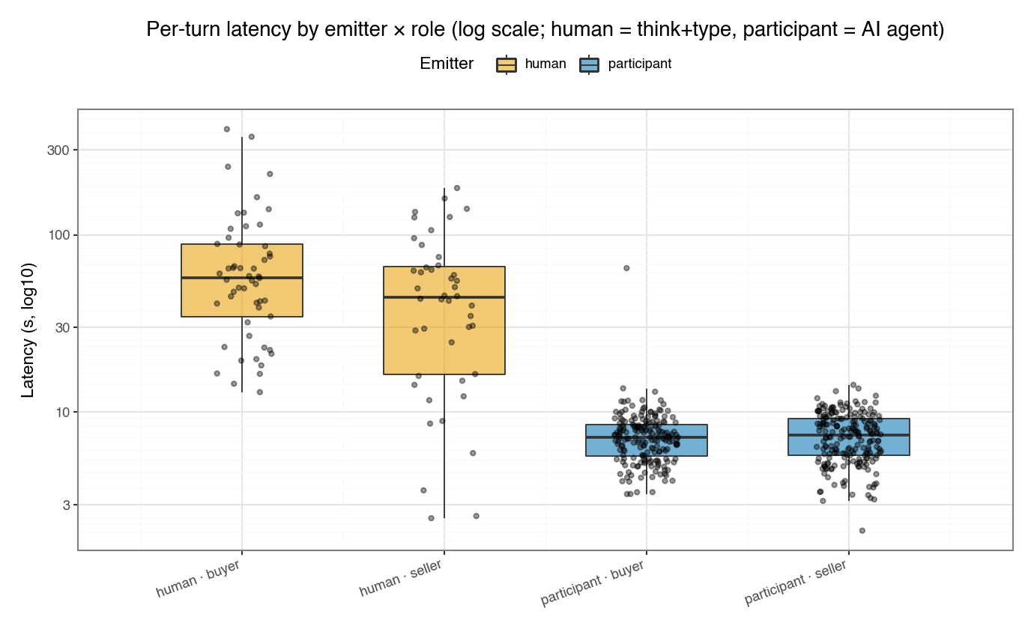
Figure 2.1 — Per-turn latency by emitter x role
Log-scale latency; human = think+type, participant = AI agent — exploratory (exploratory; n=10/cell; uncorrected).
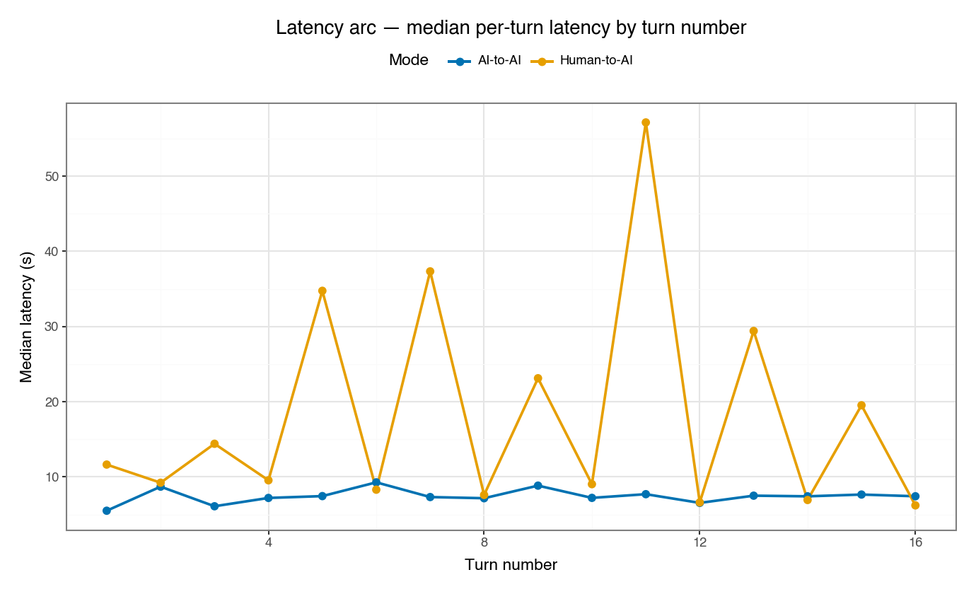
Figure 2.2 — Latency arc by turn number
Median per-turn latency over turn number, by Mode — exploratory (exploratory; n=10/cell; uncorrected).
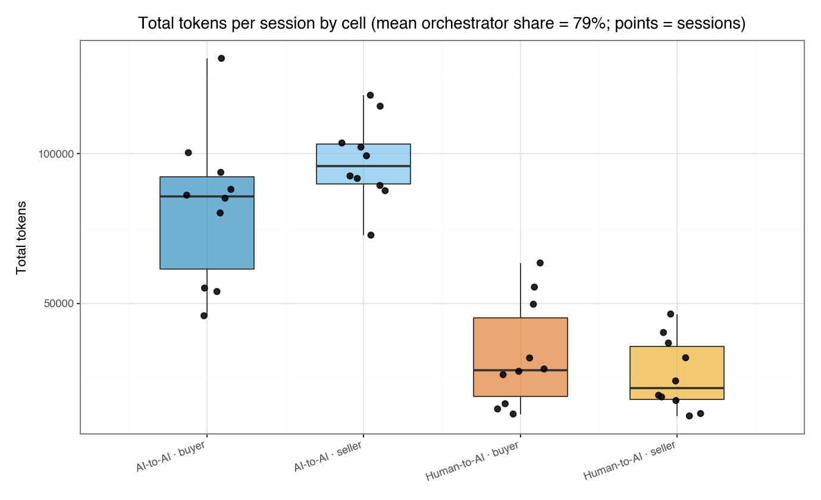
Figure 2.3 — Total tokens per session by cell
Tokens per session with mean orchestrator share — exploratory (exploratory; n=10/cell; uncorrected).
Table 2.1 — Per-cell medians (§2 DVs)
cell | median_latency_ms | mean_latency_ms | negotiation_duration_s | time_to_deal_s | tokens_total | orch_token_share | tokens_per_turn
AI-to-AI · buyer | 7039.5 | 7383.9409 | 150.4195 | 136.367 | 85634.5 | 0.729 | 5787.5412
AI-to-AI · seller | 7625.75 | 7477.4062 | 163.6255 | 150.8195 | 95908.5 | 0.7414 | 6147.3346
Human-to-AI · buyer | 21865.5 | 35940.0 | 388.8565 | 325.345 | 27775.5 | 0.8465 | 3086.1667
Human-to-AI · seller | 10023.0 | 30057.325 | 349.4945 | 300.144 | 21790.5 | 0.8438 | 2555.9167
Median per study cell (exploratory; n=10/cell; uncorrected).
Table 2.2 — SRH / MW / KW stats (§2 DVs)
dv | n | mode_p | mode_eta2 | role_p | role_eta2 | inter_p | mw_mode_p | mw_mode_delta | ci_lo | ci_hi | mw_role_p | mw_role_delta | kw_p | kw_eps2
median_latency_ms | 40 | 0.0 | 0.5295 | 0.2134 | 0.0397 | 0.0231 | 0.0 | -0.84 | -0.995 | -0.5949 | 0.2184 | 0.23 | 0.0 | 0.7016
mean_latency_ms | 40 | 0.0 | 0.6491 | 0.5885 | 0.0075 | 0.304 | 0.0 | -0.93 | -1.0 | -0.76 | 0.5979 | 0.1 | 0.0 | 0.6837
negotiation_duration_s | 40 | 0.0 | 0.4684 | 0.7868 | 0.0019 | 0.0834 | 0.0 | -0.79 | -1.0 | -0.535 | 0.7972 | 0.05 | 0.0001 | 0.5471
time_to_deal_s | 27 | 0.0031 | 0.337 | 0.96 | 0.0001 | 0.0901 | 0.0033 | -0.6703 | -1.0 | -0.2525 | 0.98 | 0.0118 | 0.0087 | 0.4479
tokens_total | 40 | 0.0 | 0.6916 | 0.6652 | 0.0048 | 0.2793 | 0.0 | 0.96 | 0.88 | 1.0 | 0.675 | -0.08 | 0.0 | 0.7265
orch_token_share | 40 | 0.0 | 0.7505 | 0.766 | 0.0023 | 0.4017 | 0.0 | -1.0 | -1.0 | -1.0 | 0.7764 | -0.055 | 0.0 | 0.7708
tokens_per_turn | 40 | 0.0 | 0.743 | 0.9138 | 0.0003 | 0.4328 | 0.0 | 0.995 | 0.97 | 1.0 | 0.9246 | -0.02 | 0.0 | 0.7591
Scheirer-Ray-Hare 2x2 (Mode A, Role B, A x B), Mann-Whitney for the Mode & Role contrasts (Cliff's delta + 95% two-sample bootstrap CI on the Mode contrast), Kruskal-Wallis across the 4 cells. exploratory; n=10/cell; uncorrected; n=10/cell. p in [0,1] or NaN.

3. Orchestrator / referee behavior
Table 3.0 — Metric dictionary (§3)
name | definition | source | type
alternation_rate | fraction of consecutive request_turn routes that switch side | orchestrator_decisions (request_turn) | ratio [0,1]
longest_same_streak | longest run of consecutive routes to the same side | orchestrator_decisions (request_turn) | count
declare_turn | turn_number at the declare_outcome decision | orchestrator_decisions (declare_outcome) | count
declare_latency_s | seconds between the last turn and the declare_outcome decision | orchestrator_decisions + turns ts | continuous
rationale_len | character length of the declare_outcome rationale text | orchestrator_decisions.rationale | count
orch_tokens_per_turn | tokens_orchestrator / turns_consumed (per-turn referee cost) | sessions fields | continuous
degraded | session-level degraded flag (binary; Fisher 2x2) | sessions.degraded | binary
Hand-authored definitions so every derived process metric is auditable.
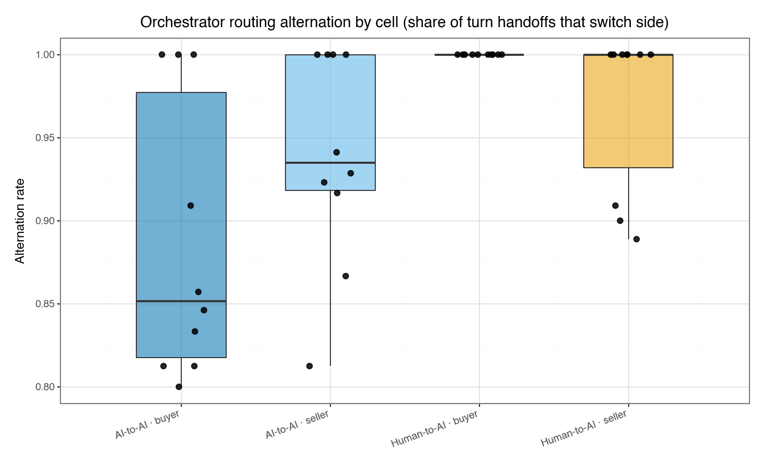
Figure 3.1 — Orchestrator routing alternation by cell
Share of turn handoffs that switch side — exploratory (exploratory; n=10/cell; uncorrected).
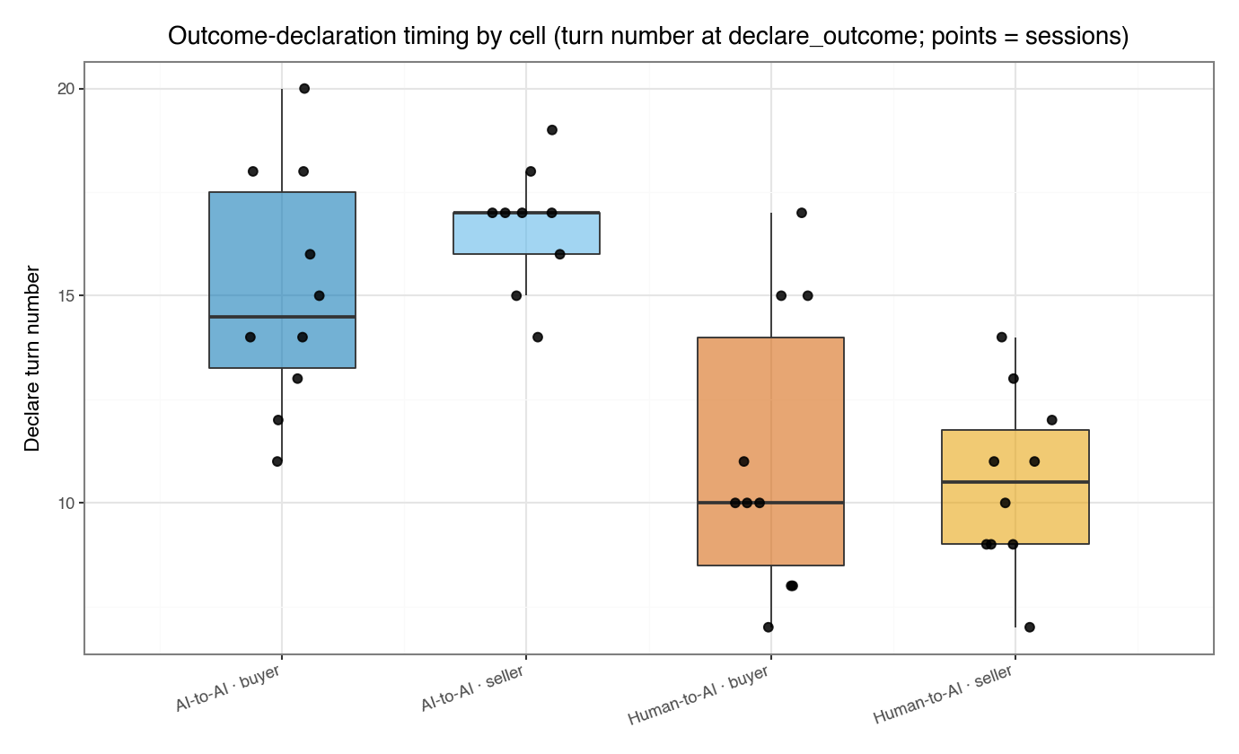
Figure 3.2 — Outcome-declaration timing by cell
Turn number at declare_outcome; points = sessions — exploratory (exploratory; n=10/cell; uncorrected).
Table 3.1 — Per-cell medians (§3 DVs)
cell | alternation_rate | longest_same_streak | declare_turn | declare_latency_s | rationale_len | orch_tokens_per_turn
AI-to-AI · buyer | 0.8516 | 2.0 | 14.5 | 4.888 | 323.0 | 4322.7941
AI-to-AI · seller | 0.9349 | 2.0 | 17.0 | 4.865 | 365.0 | 4611.2279
Human-to-AI · buyer | 1.0 | 1.0 | 10.0 | 4.229 | 363.5 | 2609.5222
Human-to-AI · seller | 1.0 | 1.0 | 10.5 | 4.183 | 247.0 | 2173.6875
Median per study cell (exploratory; n=10/cell; uncorrected).
Table 3.2 — SRH / MW / KW stats (§3 DVs)
dv | n | mode_p | mode_eta2 | role_p | role_eta2 | inter_p | mw_mode_p | mw_mode_delta | ci_lo | ci_hi | mw_role_p | mw_role_delta | kw_p | kw_eps2
alternation_rate | 40 | 0.0013 | 0.2639 | 0.927 | 0.0002 | 0.0764 | 0.0014 | -0.525 | -0.7527 | -0.2547 | 0.9391 | -0.015 | 0.0038 | 0.3447
longest_same_streak | 40 | 0.0014 | 0.2604 | 0.5239 | 0.0104 | 0.2024 | 0.0015 | 0.5 | 0.2 | 0.75 | 0.5343 | -0.1 | 0.0068 | 0.3125
declare_turn | 39 | 0.0 | 0.4964 | 0.7779 | 0.0021 | 0.3142 | 0.0 | 0.8105 | 0.6026 | 0.9501 | 0.7888 | -0.0526 | 0.0002 | 0.5268
declare_latency_s | 39 | 0.0561 | 0.0961 | 0.9105 | 0.0003 | 0.5672 | 0.0579 | 0.3579 | -0.0317 | 0.6791 | 0.9217 | 0.0211 | 0.2637 | 0.1047
rationale_len | 40 | 0.2851 | 0.0293 | 0.0498 | 0.0987 | 0.1367 | 0.2913 | 0.1975 | -0.14 | 0.545 | 0.0514 | 0.3625 | 0.0656 | 0.1848
orch_tokens_per_turn | 40 | 0.0 | 0.7281 | 0.8711 | 0.0007 | 0.3438 | 0.0 | 0.985 | 0.94 | 1.0 | 0.8817 | -0.03 | 0.0 | 0.7518
Scheirer-Ray-Hare 2x2 (Mode A, Role B, A x B), Mann-Whitney for the Mode & Role contrasts (Cliff's delta + 95% two-sample bootstrap CI on the Mode contrast), Kruskal-Wallis across the 4 cells. exploratory; n=10/cell; uncorrected; n=10/cell. p in [0,1] or NaN.
Table 3.3 — Degraded-session rate (Fisher 2x2)
contrast | succ_a | n_a | rate_a | succ_b | n_b | rate_b | odds_ratio | p
Mode (AI-to-AI vs Human-to-AI) | 0 | 20 | 0.0 | 2 | 20 | 0.1 | 0.0 | 0.4872
Role (buyer vs seller) | 0 | 20 | 0.0 | 2 | 20 | 0.1 | 0.0 | 0.4872
Binary `degraded` by the Mode and Role contrasts via Fisher's exact test. exploratory; n=10/cell; uncorrected; n=10/cell.

4. Participant UX & engagement
Table 4.0 — Metric dictionary (§4)
name | definition | source | type
total_active_s | sum of screen_exit.dwellMs over all screens (seconds) | participant_events (screen_exit) | continuous
engine_dwell_s | screen_exit.dwellMs summed on the live-negotiation screen (seconds) | participant_events (screen_exit) | continuous
total_idle_s | sum of idle_end.idleMs (seconds of detected inactivity) | participant_events (idle_end) | continuous
n_tab_away | count of visibility_change events with hidden=true | participant_events (visibility_change) | count
n_thumbnail_views | count of listing_thumbnail_view events | participant_events | count
n_zoom_opens | count of listing_zoom_open events | participant_events | count
n_clicks | count of click events | participant_events | count
mean_scroll_pct | mean of per-screen max scroll.maxPct | participant_events (scroll) | continuous
mean_compose_s | mean seconds from human_turn_input_enabled to the following human_turn_submitted (Human-to-AI only) | participant_events | continuous
mean_charcount | mean charCount of human_turn_submitted (Human-to-AI only) | participant_events | continuous
Hand-authored definitions so every derived process metric is auditable.
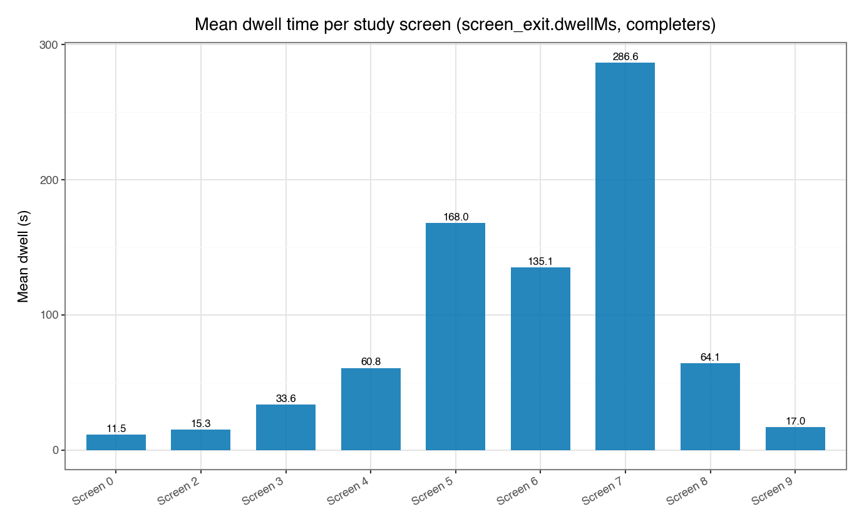
Figure 4.1 — Mean dwell per study screen
screen_exit.dwellMs by screen, completers — exploratory (exploratory; n=10/cell; uncorrected).
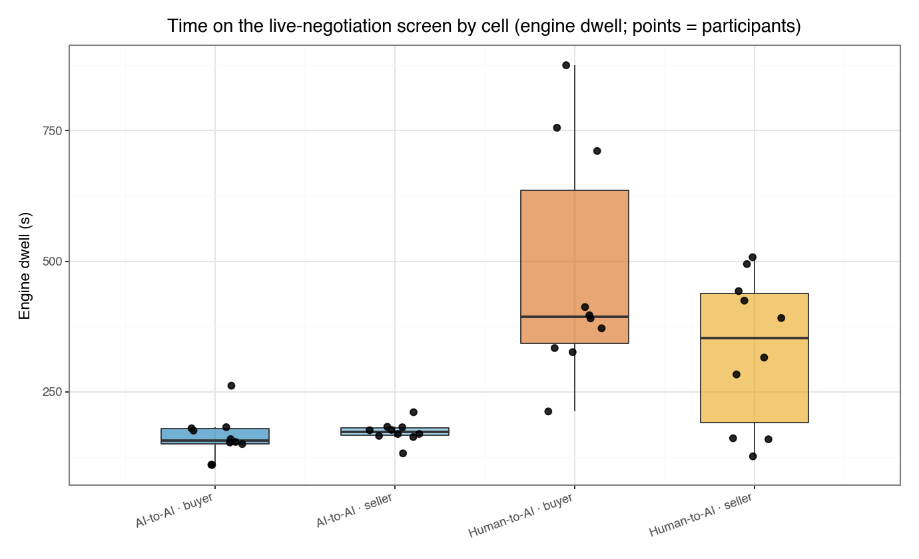
Figure 4.2 — Time on the live-negotiation screen
Engine-screen dwell by cell; points = participants — exploratory (exploratory; n=10/cell; uncorrected).
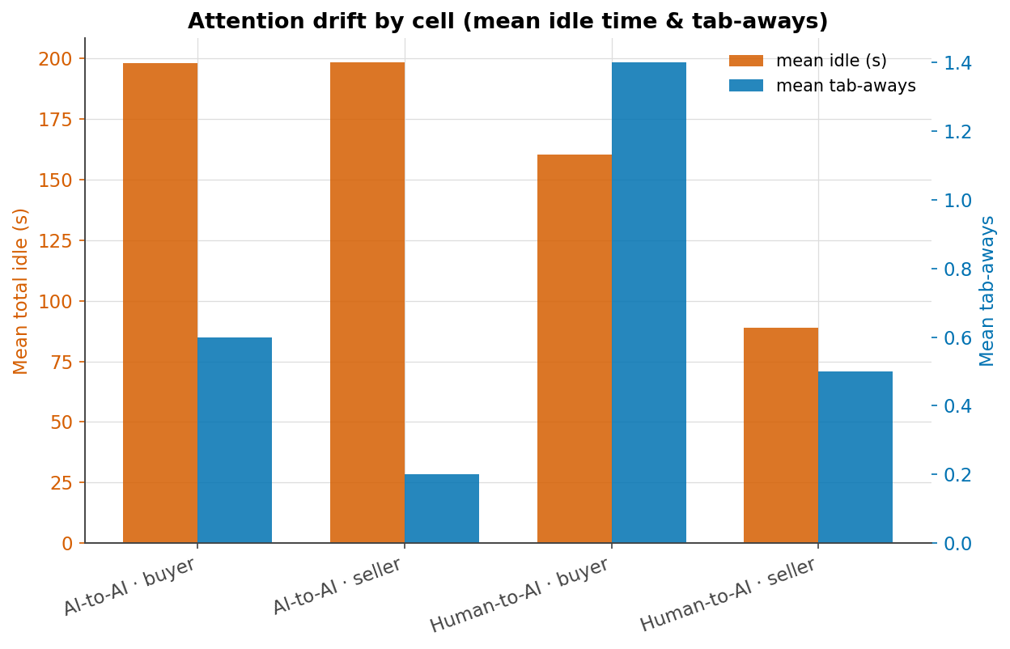
Figure 4.3 — Attention drift by cell
Mean idle time and tab-aways by cell — exploratory (exploratory; n=10/cell; uncorrected).
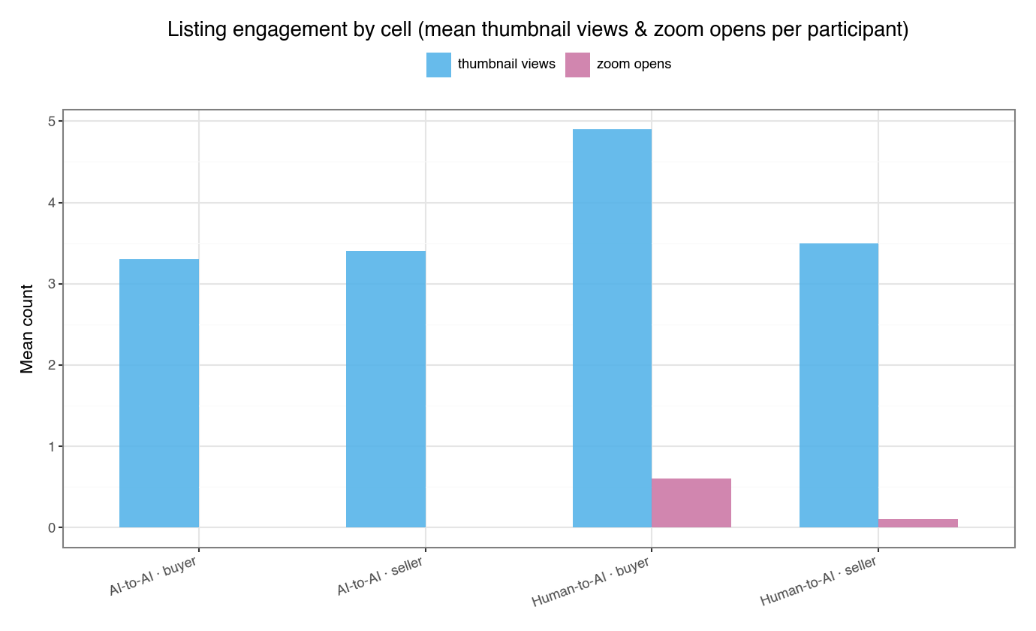
Figure 4.4 — Listing engagement by cell
Mean thumbnail views and zoom opens per participant — exploratory (exploratory; n=10/cell; uncorrected).
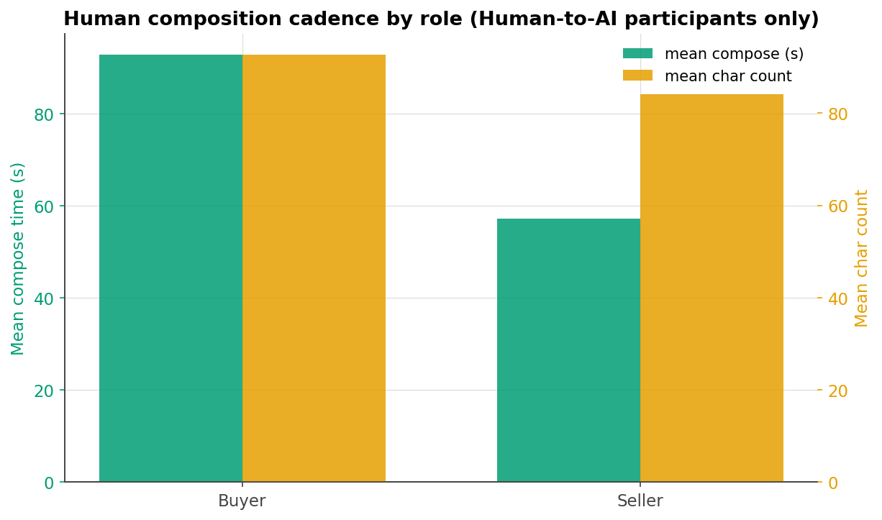
Figure 4.5 — Human composition cadence by role
Mean compose time and char count, Human-to-AI only — exploratory (exploratory; n=10/cell; uncorrected).
Table 4.1 — Per-cell medians (§4 DVs)
cell | total_active_s | engine_dwell_s | total_idle_s | n_tab_away | n_thumbnail_views | n_zoom_opens | n_clicks | mean_scroll_pct
AI-to-AI · buyer | 635.187 | 156.9435 | 176.289 | 0.0 | 2.5 | 0.0 | 42.5 | 96.8571
AI-to-AI · seller | 681.8565 | 173.1255 | 184.755 | 0.0 | 0.0 | 0.0 | 39.0 | 95.4832
Human-to-AI · buyer | 629.831 | 393.705 | 92.316 | 0.0 | 3.5 | 0.0 | 52.5 | 97.5784
Human-to-AI · seller | 504.1685 | 353.525 | 71.593 | 0.0 | 0.0 | 0.0 | 41.0 | 100.0
Median per study cell (exploratory; n=10/cell; uncorrected).
Table 4.2 — SRH / MW / KW stats (§4 DVs)
dv | n | mode_p | mode_eta2 | role_p | role_eta2 | inter_p | mw_mode_p | mw_mode_delta | ci_lo | ci_hi | mw_role_p | mw_role_delta | kw_p | kw_eps2
total_active_s | 40 | 0.3438 | 0.023 | 0.4819 | 0.0127 | 0.0884 | 0.3507 | 0.175 | -0.195 | 0.525 | 0.4903 | 0.13 | 0.2313 | 0.1101
engine_dwell_s | 40 | 0.0 | 0.445 | 0.6652 | 0.0048 | 0.1167 | 0.0 | -0.77 | -1.0 | -0.5049 | 0.675 | 0.08 | 0.0002 | 0.5129
total_idle_s | 40 | 0.0138 | 0.1554 | 0.6849 | 0.0042 | 0.7049 | 0.0143 | 0.455 | 0.115 | 0.755 | 0.6948 | 0.075 | 0.0949 | 0.1633
n_tab_away | 40 | 0.6044 | 0.0069 | 0.2544 | 0.0333 | 0.7298 | 0.6165 | -0.075 | -0.3601 | 0.19 | 0.2617 | 0.165 | 0.64 | 0.0432
n_thumbnail_views | 40 | 0.6033 | 0.0069 | 0.593 | 0.0073 | 0.5427 | 0.6137 | -0.0875 | -0.4101 | 0.2601 | 0.6033 | 0.09 | 0.8191 | 0.0238
n_zoom_opens | 40 | 0.0184 | 0.1425 | 0.1505 | 0.053 | 0.1505 | 0.0196 | -0.25 | -0.45 | -0.05 | 0.1573 | 0.1525 | 0.0214 | 0.2485
n_clicks | 40 | 0.1014 | 0.0688 | 0.1014 | 0.0688 | 0.1937 | 0.1042 | -0.3025 | -0.6375 | 0.0626 | 0.1042 | 0.3025 | 0.0701 | 0.1809
mean_scroll_pct | 40 | 0.1477 | 0.0537 | 0.447 | 0.0148 | 0.1738 | 0.1518 | -0.2475 | -0.5576 | 0.055 | 0.4558 | -0.13 | 0.2102 | 0.116
Scheirer-Ray-Hare 2x2 (Mode A, Role B, A x B), Mann-Whitney for the Mode & Role contrasts (Cliff's delta + 95% two-sample bootstrap CI on the Mode contrast), Kruskal-Wallis across the 4 cells. exploratory; n=10/cell; uncorrected; n=10/cell. p in [0,1] or NaN.
Table 4.3 — Human composition cadence (buyer vs seller MW)
dv | n | mw_p | cliffs_delta | ci_lo | ci_hi
mean_compose_s | 20 | 0.4727 | 0.2 | -0.3405 | 0.68
mean_charcount | 20 | 0.5966 | 0.15 | -0.38 | 0.62
Human-to-AI participants only (single mode -> no SRH/KW): Mann-Whitney buyer vs seller with Cliff's delta + 95% two-sample bootstrap CI. exploratory; n=10/cell; uncorrected; n=10/cell.

Limitations & what this enables
Three standing limitations bound every reading above. (1) No private agent reasoning: turns.thinking is empty for all turns, so strategy is inferred only from the externalized proposal/message stream. (2) Reservation prices come from the fixed Camry scenario brief and are uniform across all 40 sessions, so surplus/ZOPA measures describe positioning within one fixed payoff structure, not preference variation. (3) Screen-dwell and attention metrics derive from client-side telemetry (participant_events). Accordingly, every AI-to-AI vs Human-to-AI process difference reported here is an exploratory signal at n=10/cell, not a confirmatory finding: p-values are uncorrected, there is no pairwise post-hoc, and effect sizes carry wide uncertainty. These dynamics map the process space and motivate powered follow-up; they do not establish it.

