Lab - Configure Administrative Roles

# Topology

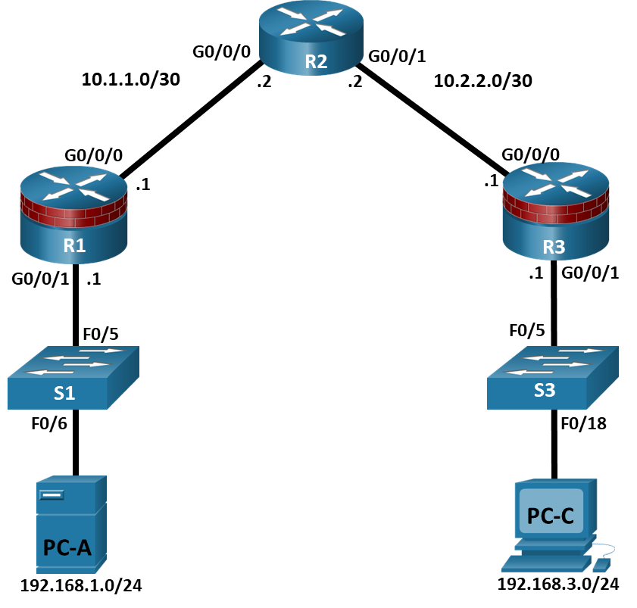

# Addressing Table

| Device | Interface | IP Address | Subnet Mask | Default Gateway | Switch Port |
| --- | --- | --- | --- | --- | --- |
| R1 | G0/0/0 | 10.1.1.1 | 255.255.255.252 | N/A | N/A |
| R1 | G0/0/1 | 192.168.1.1 | 255.255.255.0 | N/A | S1 F0/5 |
| R2 | G0/0/0 | 10.1.1.2 | 255.255.255.252 | N/A | N/A |
| R2 | G0/0/1 | 10.2.2.2 | 255.255.255.252 | N/A | N/A |
| R3 | G0/0/0 | 10.2.2.1 | 255.255.255.252 | N/A | N/A |
| R3 | G0/0/1 | 192.168.3.1 | 255.255.255.0 | N/A | S3 F0/5 |
| PC-A | NIC | 192.168.1.3 | 255.255.255.0 | 192.168.1.1 | S1 F0/6 |
| PC-C | NIC | 192.168.3.3 | 255.255.255.0 | 192.168.3.1 | S3 F0/18 |

Blank Line, No additional information

# Objectives

Part 1: Configure Basic Device Settings

* Cable the network as shown in the topology.
* Configure basic IP addressing for routers and PCs.
* Configure OSPF routing.
* Configure PC hosts.
* Verify connectivity between hosts and routers.

Part 2: Configure Administrative Roles

* Create multiple role views and grant varying privileges.
* Verify and contrast views.

# Background / Scenario

The router is a critical component in any network. It controls the movement of data into and out of the network and between devices within the network. It is particularly important to protect network routers because the failure of a routing device could make sections of the network, or the entire network, inaccessible. Controlling access to routers and enabling reporting on routers is critical to network security and should be part of a comprehensive security policy.

In this lab, you will build a multi-router network and configure the routers and hosts. You will configure administrative roles with different privilege levels.

**Note**: The routers used with hands-on labs are Cisco 4221 with Cisco IOS XE Release 16.9.6 (universalk9 image). The switches used in the labs are Cisco Catalyst 2960+ with Cisco IOS Release 15.2(7) (lanbasek9 image). Other routers, switches, and Cisco IOS versions can be used. Depending on the model and Cisco IOS version, the commands available and the output produced might vary from what is shown in the labs. Refer to the Router Interface Summary Table at the end of the lab for the correct interface identifiers.

**Note**: Before you begin, ensure that the routers and the switches have been erased and have no startup configurations.

# Required Resources

* 3 Routers (Cisco 4221 with Cisco XE Release 16.9.6 universal image or comparable with a Security Technology Package license)
* 2 Switches (Cisco 2960+ with Cisco IOS Release 15.2(7) lanbasek9 image or comparable)
* 2 PCs (Windows OS with a terminal emulation program, such as PuTTY or Tera Term installed)
* Console cables to configure Cisco networking devices
* Ethernet cables as shown in the topology

# Instructions

## Configure Basic Device Settings

In this part, set up the network topology and configure basic settings, such as interface IP addresses.

### Cable the network.

Attach the devices, as shown in the topology diagram, and cable as necessary.

### Configure basic settings for each router.

Open configuration window

* + - 1. Console into the router and enable privileged EXEC mode.

Router> **enable**

Router# **configure terminal**

Configure host names as shown in the topology.

R1(config)# **hostname R1**

Configure interface IP addresses as shown in the IP Addressing Table.

R1(config)# **interface g0/0/0**

R1(config-if)# **ip address 10.1.1.1 255.255.255.0**

R1(config-if)# **no shutdown**

R1(config)# **interface g0/0/1**

R1(config-if)# **ip address 192.168.1.1 255.255.255.0**

R1(config-if)# **no shutdown**

* + - 1. To prevent the router from attempting to translate incorrectly entered commands as though they were host names, disable DNS lookup. R1 is shown here as an example.

R1(config)# **no ip domain-lookup**

### Configure OSPF routing on the routers.

* + - 1. Use the **router ospf** command in global configuration mode to enable OSPF on R1.

R1(config)# **router ospf 1**

* + - 1. Configure the **network** statements for the networks on R1. Use an area ID of 0.

R1(config-router)# **network 192.168.1.0 0.0.0.255 area 0**

R1(config-router)# **network 10.1.1.0 0.0.0.3 area 0**

* + - 1. Configure OSPF on R2 and R3.

R2(config)# **router ospf 1**

R2(config-router)# **network 10.1.1.0 0.0.0.3 area 0**

R2(config-router)# **network 10.2.2.0 0.0.0.3 area 0**

R3(config)# **router ospf 1**

R3(config-router)# **network 10.2.2.0 0.0.0.3 area 0**

R3(config-router)# **network 192.168.3.0 0.0.0.255 area 0**

* + - 1. Issue the **passive-interface** command to change the G0/0/1 interface on R1 and R3 to passive.

R1(config)# **router ospf 1**

R1(config-router)# **passive-interface g0/0/1**

R3(config)# **router ospf 1**

R3(config-router)# **passive-interface g0/0/1**

### Verify OSPF neighbors and routing information.

* + - 1. Issue the **show ip ospf neighbor** command to verify that each router lists the other routers in the network as neighbors.

R1# **show ip ospf neighbor**

Neighbor ID Pri State Dead Time Address Interface

10.2.2.2 1 FULL/BDR 00:00:37 10.1.1.2 GigabitEthernet0/0/0

* + - 1. Issue the **show ip route** command to verify that all networks display in the routing table on all routers.

R1# **show ip route**

Codes: L - local, C - connected, S - static, R - RIP, M - mobile, B - BGP

D - EIGRP, EX - EIGRP external, O - OSPF, IA - OSPF inter area

N1 - OSPF NSSA external type 1, N2 - OSPF NSSA external type 2

E1 - OSPF external type 1, E2 - OSPF external type 2

i - IS-IS, su - IS-IS summary, L1 - IS-IS level-1, L2 - IS-IS level-2

ia - IS-IS inter area, * - candidate default, U - per-user static route

o - ODR, P - periodic downloaded static route, H - NHRP, l - LISP

a - application route

+ - replicated route, % - next hop override, p - overrides from PfR

Gateway of last resort is not set

10.0.0.0/8 is variably subnetted, 3 subnets, 2 masks

C 10.1.1.0/30 is directly connected, GigabitEthernet0/0/0

L 10.1.1.1/32 is directly connected, GigabitEthernet0/0/0

O 10.2.2.0/30 [110/2] via 10.1.1.2, 00:01:11, GigabitEthernet0/0/0

192.168.1.0/24 is variably subnetted, 2 subnets, 2 masks

C 192.168.1.0/24 is directly connected, GigabitEthernet0/0/1

L 192.168.1.1/32 is directly connected, GigabitEthernet0/0/1

O 192.168.3.0/24 [110/3] via 10.1.1.2, 00:01:07, GigabitEthernet0/0/0

### Configure PC host IP settings.

Configure a static IP address, subnet mask, and default gateway for PC-A and PC-C as shown in the IP Addressing Table.

### Verify connectivity between PC-A and PC-C.

* + - 1. Ping from R1 to R3.

If the pings are not successful, troubleshoot the basic device configurations before continuing.

* + - 1. Ping from PC-A, on the R1 LAN, to PC-C, on the R3 LAN.

If the pings are not successful, troubleshoot the basic device configurations before continuing.

**Note**: If you can ping from PC-A to PC-C you have demonstrated that OSPF routing is configured and functioning correctly. If you cannot ping but the device interfaces are up and IP addresses are correct, use the **show run, show ip ospf neighbor,** and **show ip route** commands to help identify routing protocol-related problems.

### Save the basic running configuration for each router.

Save the basic running configuration for the routers as text files on your PC. These text files can be used to restore configurations later in the lab.

Close configuration window

## Configure Administrative Roles

In this part of lab, you will:

* Create multiple administrative roles, or views, on routers R1 and R3.
* Grant each view varying privileges.
* Verify and contrast the views.

The role-based CLI access feature allows the network administrator to define views, which are a set of operational commands and configuration capabilities that provide selective or partial access to Cisco IOS EXEC and configuration (config) mode commands. Views restrict user access to the Cisco IOS CLI and configuration information. A view can define which commands are accepted and what configuration information is visible.

**Note**: Perform all tasks on both R1 and R3. The procedures and output for R1 are shown here.

If an administrator wants to configure another view to the system, the system must be in root view. When a system is in root view, the user has the same access privileges as a user who has level-15 privileges, but the root view user can also configure a new view and add or remove commands from the view. When you are in a CLI view, you have access only to the commands that have been added to that view by the root view user.

### Enable AAA on router R1.

Open configuration window

To define views, enable AAA on the router.

R1# **configure terminal**

R1(config)# **aaa new-model**

### Configure privileged EXEC mode password.

A privileged EXEC mode password is required to access the root view. The password **cisco12345** is used in this example.

R1(config)# **enable secret cisco12345**

R1# **exit**

### Enable the root view.

Use the command **enable view** to enable the root view.

R1# **enable view**

Password: **cisco12345**

### Create the admin1 view, establish a password, and assign privileges.

* + - 1. The admin1 user is the top-level user below root that is allowed to access this router. It has the most authority. The admin1 user can use all **show**, **config**, and **debug** commands. Use the following command to create the admin1 view while in the root view.

R1# **configure terminal**

R1(config)# **parser view admin1**

R1(config-view)#

**Note**: To delete a view, use the command **no parser view *viewname***.

* + - 1. Associate the admin1 view with an encrypted password.

R1(config-view)# **secret admin1pass**

R1(config-view)#

* + - 1. Review the commands that can be configured in the admin1 view. Use the **commands ?** command to see available commands. The following is a partial listing of the available commands.

R1(config-view)# **commands ?**

RITE-profile Router IP traffic export profile command mode

RMI Node Config Resource Policy Node Config mode

RMI Resource Group Resource Group Config mode

RMI Resource Manager Resource Manager Config mode

RMI Resource Policy Resource Policy Config mode

SASL-profile SASL profile configuration mode

aaa-attr-list AAA attribute list config mode

aaa-user AAA user definition

accept-dialin VPDN group accept dialin configuration mode

accept-dialout VPDN group accept dialout configuration mode

address-family Address Family configuration mode

<output omitted>

* + - 1. Add all **config**, **show**, and **debug** commands to the admin1 view and then exit from view configuration mode.

R1(config-view)# **commands exec include all show**

R1(config-view)# **commands exec include all config terminal**

R1(config-view)# **commands exec include all debug**

R1(config-view)# **end**

* + - 1. Verify the admin1 view.

R1# **enable view admin1**

Password: **admin1pass**

R1# **show parser view**

Current view is ‘admin1’

* + - 1. Examine the commands available in the admin1 view.

R1# **?**

Exec commands:

<0-0>/<0-4> Enter card slot/sublot number

configure Enter configuration mode

debug Debugging functions (see also 'undebug')

do-exec Mode-independent "do-exec" prefix support

enable Turn on privileged commands

exit Exit from the EXEC

show Show running system

**Note**: There may be more EXEC commands available than are displayed. This depends on your device and the IOS image used.

* + - 1. Examine the **show** commands available in the admin1 view.

R1# **show ?**

aaa Show AAA values

access-expression List access expression

access-lists List access lists

acircuit Access circuit info

adjacency Adjacent nodes

aliases Display alias commands

alignment Show alignment information

appfw Application Firewall information

archive Archive functions

arp ARP table

<output omitted>

### Create the admin2 view, establish a password, and assign privileges.

* + - 1. The admin2 user is a junior administrator in training who is allowed to view all configurations but is not allowed to configure the routers or use debug commands.
      2. Use the **enable view** command to enable the root view, and enter the enable secret password **cisco12345**.

R1# **enable view**

Password: **cisco12345**

* + - 1. Use the following command to create the admin2 view.

R1# **configure terminal**

R1(config)# **parser view admin2**

* + - 1. Associate the admin2 view with a password.

R1(config-view)# **secret admin2pass**

* + - 1. Add all **show** commands to the view, and then exit from view configuration mode.

R1(config-view)# **commands exec include all show**

R1(config-view)# **end**

* + - 1. Verify the admin2 view.

R1# **enable view admin2**

Password: **admin2pass**

R1# **show parser view**

Current view is ‘admin2’

* + - 1. Examine the commands available in the admin2 view.

R1# **?**

Exec commands:

<0-0>/<0-4> Enter card slot/sublot number

do-exec Mode-independent "do-exec" prefix support

enable Turn on privileged commands

exit Exit from the EXEC

show Show running system information

**Note**: There may be more EXEC commands available than are displayed. This depends on your device and the IOS image used.

#### Question:

What is missing from the list of admin2 commands that is present in the admin1 commands?

Type your answers here.

### Create the tech view, establish a password, and assign privileges.

* + - 1. The tech user typically installs end-user devices and cabling. Tech users are only allowed to use selected **show** commands.
      2. Use the enable **view** command to enable the root view, and enter the enable secret password **cisco12345**.

R1# **enable view**

Password: **cisco12345**

* + - 1. Use the following command to create the tech view.

R1(config)# **parser view tech**

* + - 1. Associate the tech view with a password.

R1(config-view)# **secret techpasswd**

* + - 1. Add the following **show** commands to the view and then exit from view configuration mode.

R1(config-view)# **commands exec include show version**

R1(config-view)# **commands exec include show interfaces**

R1(config-view)# **commands exec include show ip interface brief**

R1(config-view)# **commands exec include show parser view**

R1(config-view)# **end**

* + - 1. Verify the tech view.

R1# **enable view tech**

Password: **techpasswd**

R1# **show parser view**

Current view is ‘tech’

* + - 1. Examine the commands available in the tech view.

R1# **?**

Exec commands:

<0-0>/<0-4> Enter card slot/sublot number

do-exec Mode-independent "do-exec" prefix support

enable Turn on privileged commands

exit Exit from the EXEC

show Show running system information

**Note**: There may be more EXEC commands available than are displayed. This depends on your device and the IOS image used.

* + - 1. Examine the **show** commands available in the tech view.

R1# **show ?**

banner Display banner information

flash0: display information about flash0: file system

flash1: display information about flash1: file system

flash: display information about flash: file system

interfaces Interface status and configuration

ip IP information

parser Display parser information

usbflash0: display information about usbflash0: file system

version System hardware and software status

**Note**: There may be more EXEC commands available than are displayed. This depends on your device and the IOS image used.

* + - 1. Issue the **show ip interface brief** command.

#### Question:

Were you able to do it as the tech user? Explain.

Type your answers here.

* + - 1. Issue the **show ip route** command.

#### Question:

Were you able to do it as the tech user?

Type your answers here.

* + - 1. Return to root view with the **enable view** command.

R1# **enable view**

Password: **cisco12345**

* + - 1. Issue the **show run** command to see the views you created.

#### Question:

For tech view, why are the **show** and **show ip** commands listed as well as **show ip interface** and **show ip interface brief**?

Type your answers here.

* + - 1. Configure the same administrative roles on router R3.

### Save the configuration on routers R1 and R3.

Save the running configuration to the startup configuration from the privileged EXEC prompt.

Close configuration window

# Router Interface Summary Table

| Router Model | Ethernet Interface #1 | Ethernet Interface #2 | Serial Interface #1 | Serial Interface #2 |
| --- | --- | --- | --- | --- |
| 1900 | Gigabit Ethernet 0/0 (G0/0) | Gigabit Ethernet 0/1 (G0/1) | Serial 0/0/0 (S0/0/0) | Serial 0/0/1 (S0/0/1) |
| 2900 | Gigabit Ethernet 0/0 (G0/0) | Gigabit Ethernet 0/1 (G0/1) | Serial 0/0/0 (S0/0/0) | Serial 0/0/1 (S0/0/1) |
| 4221 | Gigabit Ethernet 0/0/0 (G0/0/0) | Gigabit Ethernet 0/0/1 (G0/0/1) | Serial 0/1/0 (S0/1/0) | Serial 0/1/1 (S0/1/1) |
| 4300 | Gigabit Ethernet 0/0/0 (G0/0/0) | Gigabit Ethernet 0/0/1 (G0/0/1) | Serial 0/1/0 (S0/1/0) | Serial 0/1/1 (S0/1/1) |

Blank Line, No additional information

**Note**: To find out how the router is configured, look at the interfaces to identify the type of router and how many interfaces the router has. There is no way to effectively list all the combinations of configurations for each router class. This table includes identifiers for the possible combinations of Ethernet and Serial interfaces in the device. The table does not include any other type of interface, even though a specific router may contain one. An example of this might be an ISDN BRI interface. The string in parenthesis is the legal abbreviation that can be used in Cisco IOS commands to represent the interface.

end of document