課 程 ：網路科學

教 授 ：謝宏昀 老師

題 目 ：Homework Assignment #1

學 生 : 陳璽文

學 號 : B02901017

日 期 : 20160404

github : [link](https://github.com/b02901017/NS2017/tree/master/hw1)

1. (20%) Surf VisualComplexity.com to find out what the website is about. Pick two projects from two different categories that interest you most. Describe the formation of networks (e.g. what do nodes and links represent, are links directed or weighted?) and what the network is used for. Explain what interests you most about the networks.

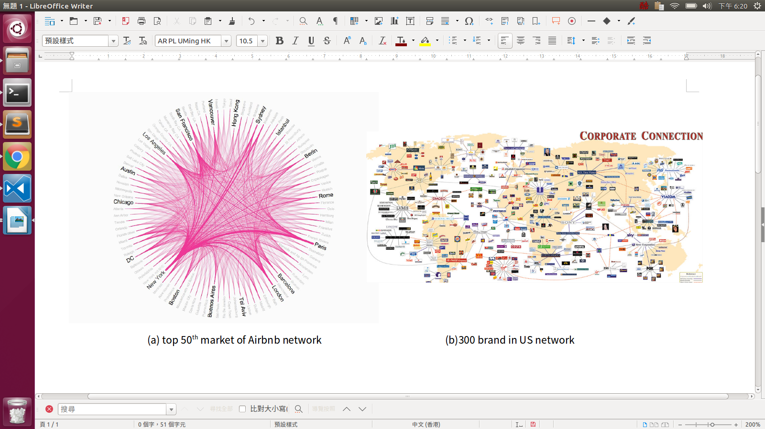

* 1. Case I : Airbnb [link](http://www.visualcomplexity.com/vc/project.cfm?id=934)

The right graph represent the airbnb service usage in the top 50th markets all over the world. Each nodes represent a cities, with the thickness of the lines corresponding to the relative volume of travels between each pair. The Reason why they use the circle layout is that there are few nodes, and the transactions between each cities are more like pair to pair rather than a serial of nodes. In this case, we can found out that the most Asia cities have less willingness to share there house except Hong Kong. Besides, the popular tourist attraction have stronger edge.

* 1. Case II : Corporate Connection [link](http://www.visualcomplexity.com/vc/project_details.cfm?id=283&index=17&domain=Business Networks)

tis network describe the connection between 3 celebrities, 35 corporations, 40 subsidiaries and more than 300 brands. It’s an undirected graph. It’s really obvious that the it form a close cooperation between each brands. It draw as a spring layout because there is several local center in this network, which is the cooperations . Besides, there is still some interesting issue. For example, this network can separate to several communities through industries. And the closest community to the media is the food industry. It’s quite similar to Taiwan.

1. (60%) Download the Amazon product co-purchase dataset and first use any text editor to open it. Each line of the dataset represents one undirected link between two products indexed by their product IDs, meaning that the two products are frequently co-purchased based on the user purchase history maintained by Amazon. To probe for useful information from the dataset, open the dataset using any network analysis and/or visualization tools of your choice. Note that the dataset contains a total of 334,863 nodes and 925,872 links, so you need to choose a tool that can handle such a network size.
   1. Provide statistics to describe the entire network, including the degree distribution (together with mean, min, max), network density, diameter, mean geodesic distance, clustering coefficient, assortativity coefficient (degree correlation coefficient), and so on. What do these numbers tell us about the product co-purchase network?

Form our data set we can summarize as the following form:

|  |  |  |  |  |  |  |  |  |  |  |  |  |  |  |  |  |
| --- | --- | --- | --- | --- | --- | --- | --- | --- | --- | --- | --- | --- | --- | --- | --- | --- |
|  | | All | | | | Book | | | | Music | | | DVD | | | |
| value | | time(s) | | value | | time(s) | | value | time(s) | | value | | time(s) | |
| #nodes | | 334863 | | 7.8e-06 | | 126219 | | 5.0e-06 | | 27676 | 6.9e-06 | | 5891 | | 5.0e-06 | |
| #edges | | 925872 | | 1.001 | | 180283 | | 0.0744 | | 35549 | 0.0147 | | 5263 | | 0.005 | |
| network density | | 1.65e-05 | | 0.995 | | 2.263e-05 | | 0.0752 | | 9.283e-05 | 0.0155 | | 3.1e-04 | | 0.0039 | |
| assortativity | | -0.0588 | | 4.350 | | -0.069 | | 1.0131 | | 0.0385 | 0.2112 | | 0.0203 | | 0.0345 | |
| diameter | | X | | X | | X | | X | | infinite | 0.304 | | infinite | | 0.229 | |
| mean geodesic distance | | X | | X | | X | | X | | infinite | 0.316 | | infinite | | 0.226 | |
| Degree | max | | 549 | | 0.987 | | 123 | | 1.272 | 46 | | 0.0165 | | 34 | | 0.0047 |
| min | | 1 | | 0 | | 0 | | 0 | |
| mean | | 5.53 | | 2.857 | | 2.568 | | 1.789 | |
| Betweenness | max | | X | | X | | X | | X | 0.0531 | | 2621.42 | | 0.0115 | | 71.89 |
| min | | X | | X | | 0.0 | | 0.0 | |
| mean | | X | | X | | 0.0002 | | 0.0001 | |
| Closeness | max | | X | | X | | X | | X | 0.0467 | | 286.79 | | 0.0124 | | 0.860 |
| min | | X | | X | | X | 0.0 | | 0.0 | |
| mean | | X | | X | | X | 0.0159 | | 0.0018 | |
| eigenvector | max | | X | | X | | X | | X | 0.4497 | | 8.916 | | 0.4567 | | 0.382 |
| min | | X | | X | | X | 0.0 | | 0.0 | |
| mean | | X | | X | | X | 0.0003 | | 0.0013 | |
| clustering | max | | 1.0 | | 6.571 | | 1.0 | | 1.077 | 1.0 | | 0.171 | | 1.0 | | 0.027 |
| min | | 0.0 | | 0.0 | | 0.0 | | 0.0 | |
| mean | | 0.396 | | 0.277 | | 0.3058 | | 0.1984 | |

The ‘X’ means that it takes more than 2 hours. As the function have implement the shortest path Alg. The time complexity is in O(V2), which is really hard to calculate. As a result I cut the graph through the meta data in to three categories : Book, DVD and Music. The main different is that after cutting the graph become a none connected graph. As a result, there not only might be some important nodes to connect each categories In this network, but also some node connect between two same categorie’s products.

Besides, after cutting, the assortativity change the sign after we build the three subgraphs. It seems that there might be several edge between the popular node in each categories link to not frequently purchasing node in other categories. However, in one categories the central nodes tend to link each others .

* 1. Identify “special” nodes based on different node-based measures introduced in class including the centrality measures and local clustering coefficient. What do these numbers tell us from different perspectives about the specialty of these products? Download the Amazon product metadata file regarding the names of these products and provide your reasoning why the products identified in (b) are so special?

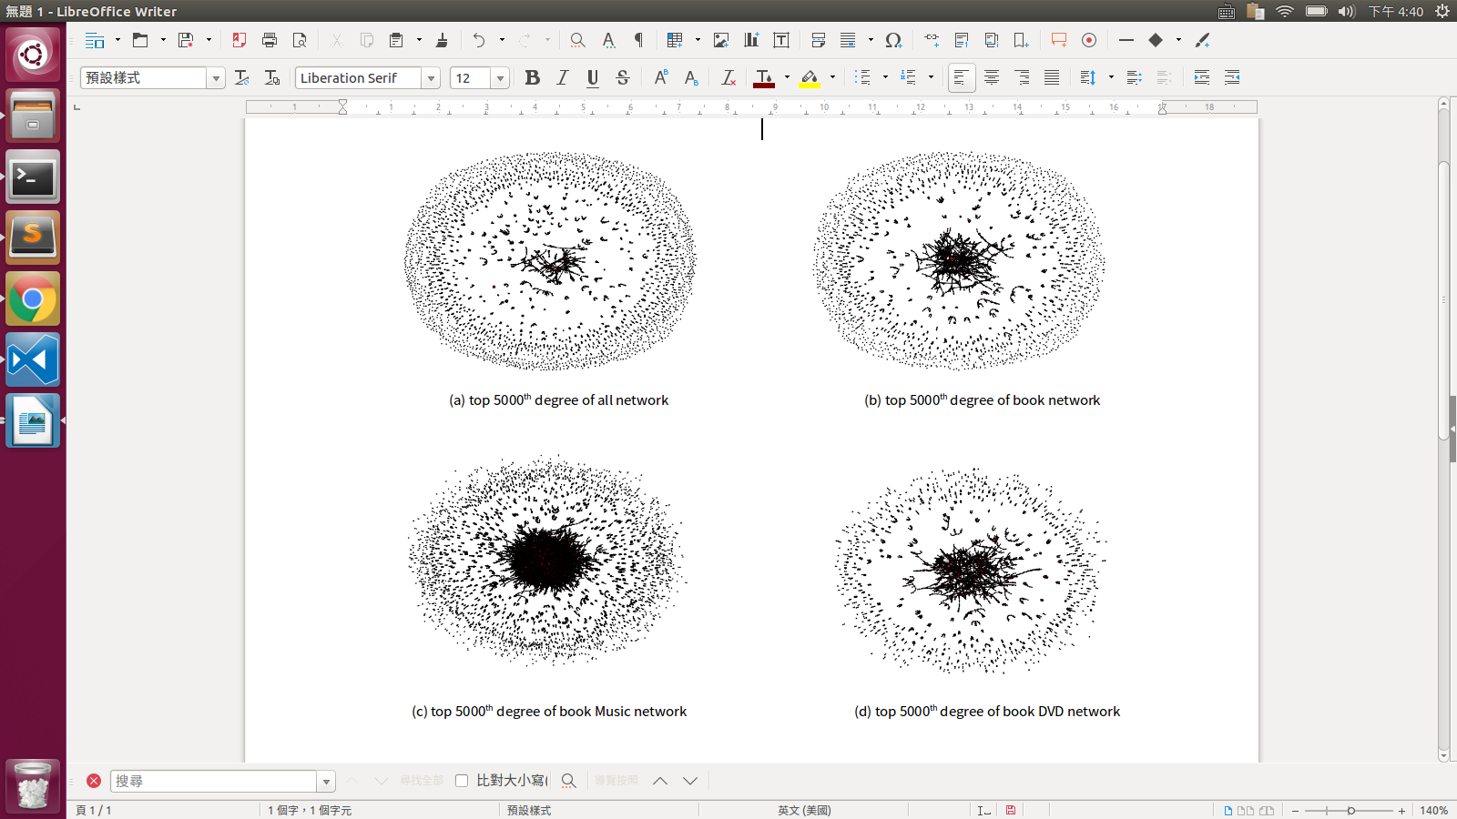According to the above form we can got the following picture, we plot the points through the spring layout. The points size depend on the value with the factor of average, so the bigger the point is, the higher the value.

we can find out that the all network become more sparse than three of others. And its similar to the Book graph. It’s quite trivial that the main characteristic is dominant by the book. And the sub-network have better connectivity.

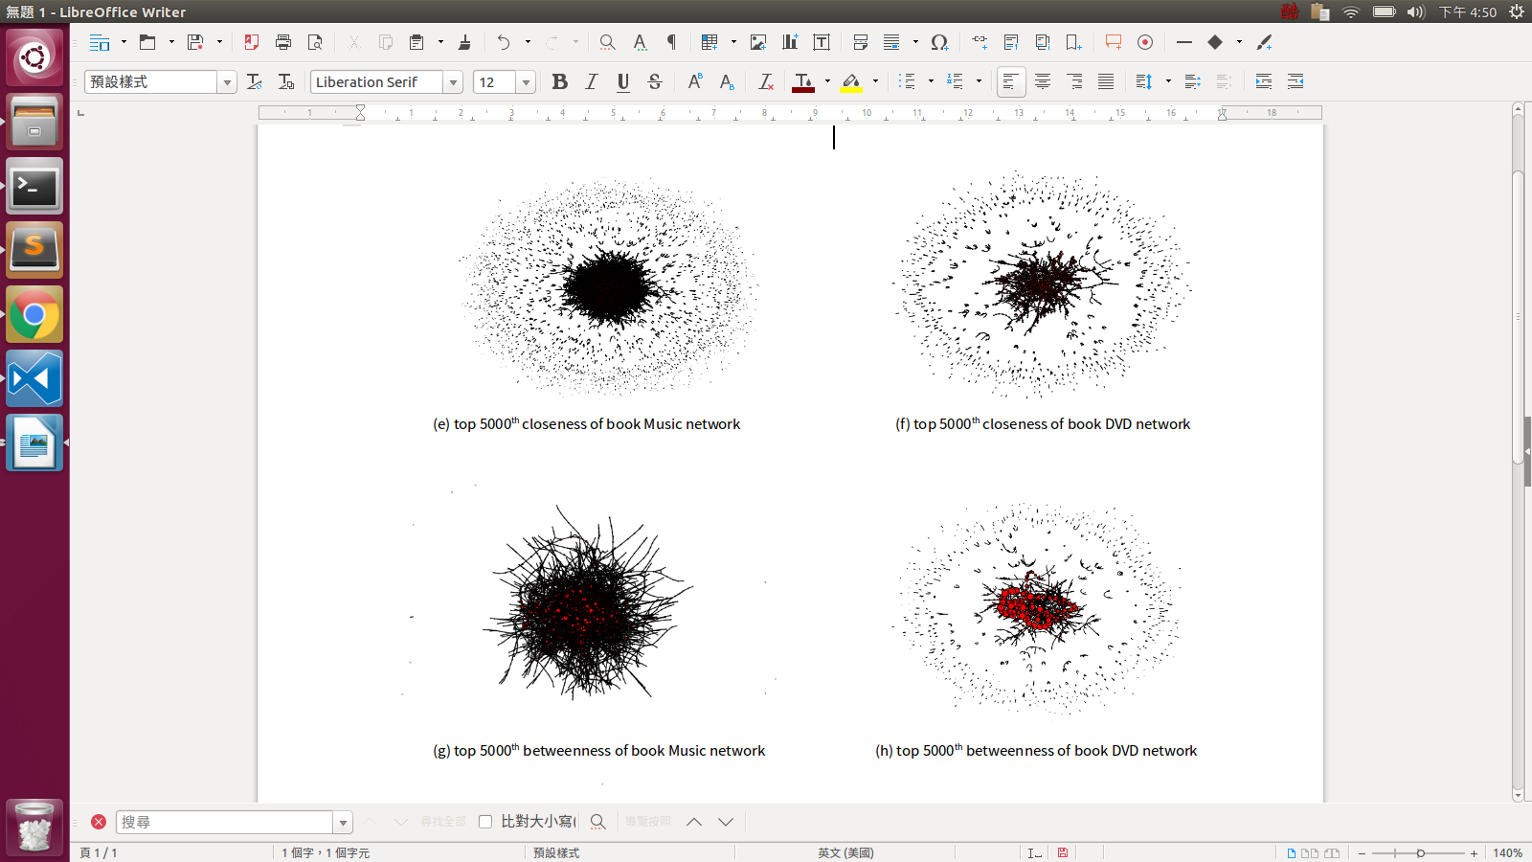

Than we focus on the difference sub-network : Music an DVD. According to the picture we can notice that the Music have the better connectivity in the central node. The even stick together become a K-clique graph. On the other hands DVD have the better local centrality. The central node might link to several unimportant nodes, just like a hub. Than each hub connect to each others.

The following form is that we list the most central mode from different measurement:

|  |  |  |  |  |  |
| --- | --- | --- | --- | --- | --- |
|  |  | All | Book | Music | DVD |
| degree | ID | 548091 | 199628 | 186810 | 20594 |
| Name | Laura (DVD) | The Great Gatsby | Dark Side of the Moon 30th Anniversary Edition | Hellsing - Complete Collection |
| value | 549 | 123 | 46 | 34 |
| betweenness | ID | X | X | 259613 | 236257 |
| Name | X | X | Ray Charles: Ultimate Hits Collection | A Prayer For The Dying |
| value | X | X | 0.0531 | 0.0115 |
| closeness | ID | X | X | 259613 | 20594 |
| Name | X | X | Ray Charles: Ultimate Hits Collection | Hellsing - Complete Collection |
| value | X | X | 0.0467 | 0.0124 |
| eigenvector | ID | X | X | 301097 | 44918 |
| Name | X | X | The Very Best of the Spinners [Rhino] | Hellsing - Complete Collection |
| value | X | X | 0.4497 | 0.4567 |

We can also found out that there are several repeat products in this form. It’s quite reasonable because the centrality might have some similarity. And those product have high sales rank, and it might frequently vanish in the similar tag.

* 1. Choose a product and calculate its similarity with other products based on the two similarity measures introduced in class. Find the “most similar” products of the chosen product. How do you interpret the results based on these similarity measures? Does it agree with our common sense? (Find out product names from the metadata file.)

We choose the top 10 similar pair from the DVD sub-network and fill the following form:

|  |  |  |  |  |  |
| --- | --- | --- | --- | --- | --- |
| rank | ID1 | name1 | ID2 | name2 | rate |
| 1 | 16650 | In Too Deep | 272315 | Out of Sync | 0.848 |
| 2 | 59463 | The Thin Man | 74222 | Arsenic and Old Lace | 0.841 |
| 3 | 249822 | The Legend of Drunken Master | 6292 | Winners and Sinners | 0.838 |
| 4 | 79816 | Musik Trienniale Koln 2000 - Berg Lulu Suite / Debussy Le Jet D'Eau / Stravinsky Firebird / Boulez, Chicago Symphony Orchestra | 79815 | Stravinsky - Le Sacre du Printemps (The Rite of Spring) / Symphonies D'Instrument Vent / Boulez, London | 0.836 |
| 5 | 119344 | Leave It to Beaver | 30810 | Mouse Hunt | 0.833 |

We can notice that the no.1 are both gangster films, no.2 are both 40th American old movies. The no.3 are both 90th cinema of Hong Kong, which are starred by Jackychen. No.4 are both Symphony Orchestra. And the no.5 have the less similarity one is a 60th TV show the other is a 90th movie, however there are both comedy.

Interestingly, four of our measurement is in the similar row in the meta data.

* 1. Amazon plans to re-design its product main page and select several products to highlight. What products do you suggest Amazon to put on the main page based on what you have learned from the dataset? Explain your reasoning. Do you have any other suggestion for Amazon based on ­your crawling of the dataset?

I would suggest a recommended system depends on the Katz centrality, because it can represent not only the importance of the itself, but also concern about neighborhood contribution. And the algorithm might be a weighted graph that the weight is relative to the log time . The newer the order is , the higher the weight is. As a result we can catch the current trend rather than promote the same products again and again.

1. (20%) Parse the metadata file of the Amazon product dataset mentioned in 2(b). Associate one feature (or, characteristic) with each product (e.g. sales rank, product category, average rating). Does the network exhibit assortative mixing for the chosen feature? Find out relevant measures and provide your reasoning.

First each central nodes have the high sales rank. Most of them are less then one thousand. Among four measurements, the degree has the highest correlation, and the betweenness are the least. It’s reasonable to say that the def betweenness is like th neck of our network , so it might not be the most popular product, but it connect several subgraph. Second the are all frequently list in the similar rows. And the average rating are all higher than 4.5, more over the votes of the comments are higher than others.