Social Distance Tracker Using Image processing

1. Introduction:

The COVID-19 pandemic has brought to light the critical importance of maintaining social distancing to mitigate the spread of infectious diseases. As countries and communities faced unprecedented challenges, researchers and technologists embarked on a quest to leverage technology for effective monitoring and enforcement of social distancing measures in public spaces. Among the innovative solutions, the application of a Support Vector Machine (SVM) with Histogram of Oriented Gradients (HOG) descriptor emerged as a promising approach to accurately track social distancing compliance.

The Social Distance Tracker using SVM HOG Descriptor represents an advanced computer vision and machine learning-based system designed to enhance public safety through real-time monitoring and analysis of video feeds from surveillance cameras. By identifying individuals and estimating the distance between them, this cutting-edge technology plays a pivotal role in promoting adherence to social distancing guidelines, thereby mitigating the resurgence of contagious diseases.

As the COVID-19 pandemic spread rapidly across the globe, health authorities emphasized the critical importance of maintaining a safe distance between individuals to reduce the risk of transmission. However, enforcing social distancing on a large scale proved to be a complex challenge for human resources. Traditional methods like manual counting and physical monitoring were not only time-consuming but also prone to errors and inefficiencies.

Recognizing the need for a more robust and automated solution, computer vision and machine learning technologies offered a glimmer of hope. Leveraging the capabilities of artificial intelligence, the Social Distance Tracker was developed to provide real-time monitoring and alerts for instances of unsafe proximity in public places.

The Social Distance Tracker operates through a multi-step process that combines computer vision algorithms with SVM classification to achieve its objectives.

Strategically placed cameras are employed to capture real-time video feeds of pedestrian areas, transportation hubs, commercial spaces, and other crowded locations.

Using the HOG descriptor, the system accurately detects and identifies individuals within the video frames. The HOG descriptor captures gradient orientation information, providing distinctive features for person recognition.

The extracted HOG descriptors are fed into an SVM classifier that has been trained on a dataset of labeled instances representing appropriate social distancing distances. This enables the classifier to distinguish between safe and unsafe interactions.

Based on the SVM's output, the system calculates the distance between detected individuals. By continuously analyzing the data, the Social Distance Tracker can quickly identify and flag potential violations of social distancing guidelines.

Whenever a violation is detected, the system triggers alerts to appropriate authorities or displays warning messages on-site, encouraging individuals to maintain safe distances.

The successful implementation of the Social Distance Tracker relies on the integration of cutting-edge hardware and software components. High-definition cameras with clear image capturing capabilities are essential for accurate person detection. On the software front, the system harnesses image processing libraries, machine learning frameworks, and communication protocols to ensure seamless data analysis and alert dissemination.

One of the key advantages of the SVM HOG Descriptor approach is its adaptability and potential for continuous improvement. By retraining the SVM classifier on updated datasets and refining the algorithm, the system can overcome challenges posed by varying environmental conditions, such as lighting changes and camera angles. This iterative process enhances the system's accuracy and reliability over time.

Beyond the context of the COVID-19 pandemic, the Social Distance Tracker holds great potential for a wide range of application

In future public health crises, the system can play a vital role in enforcing social distancing and monitoring the spread of infectious diseases in densely populated areas.

During large events, festivals, or demonstrations, the Social Distance Tracker can assist in ensuring crowd safety and preventing overcrowding.

As technology continues to evolve, the Social Distance Tracker holds the potential to become an indispensable tool in safeguarding public health and responding effectively to future challenges. With its potential applications spanning various sectors, this technology serves as a beacon of hope in navigating future health crises with greater resilience and preparedness.

2. Literature Review

This paper presents the detection of people with social distance monitoring as a precautionary measure in reducing physical contact between people. This study focuses on detecting people in areas of interest using the MobileNet Single Shot Multibox Detector (SSD) object tracking model and OpenCV library for image processing. The distance will be computed between the persons detected in the captured footage and then compared to a fixed pixels' values. The distance is measured between the central points and the overlapping boundary between persons in the segmented tracking area. With the detection of unsafe distances between people, alerts or warnings can be issued to keep the distance safe. In addition to social distance measure, another key feature of the system is detecting the presence of people in restricted areas, which can also be used to trigger warnings. Some analysis has been performed to test the effectiveness of the program for both purposes. From the results obtained, the distance tracking system achieved between 56.5% to 68% accuracy for testing performed on outdoor and challenging input videos, while 100% accuracy was achieved for the controlled environment on indoor testing. Whereas for the safety violation alert feature based on segmented ROI, it was found to have achieved better accuracy, i.e. between 95.8% to 100% for all tested input videos.

[Person detection for **social distancing**and safety violation **alert**based on segmented ROI](https://ieeexplore.ieee.org/abstract/document/9204934/)

[AH Ahamad](https://scholar.google.com/citations?user=pKtyKYYAAAAJ&hl=en&oi=sra), [N Zaini](https://scholar.google.com/citations?user=YvhIKDcAAAAJ&hl=en&oi=sra), [MFA Latip](https://scholar.google.com/citations?user=tdRqq1kAAAAJ&hl=en&oi=sra) - … conference on control **system** …, 2020 - ieeexplore.ieee.org

The proposed research work presents the Video Social Distancing issue, characterized as the programmed assessment of the between close to home good ways from a picture, and the portrayal of related individuals' conglomerations. Video Social Distancing is significant for a non-obtrusive investigation of whether individuals follow the Social Distancing limitation, and to give insights about the degree of security of explicit territories at whatever point this imperative is abused. It has been first viewed that, estimating Video Social Distancing isn't just a mathematical issue, however it additionally infers a more profound comprehension of the social conduct in the scene. The point is to genuinely identify possibly risky circumstances while keeping away from bogus alerts (e.g., a family with youngsters or family members, a senior with their guardians), the entirety of this by following current security strategies. At that point, the proposed research work will discuss about how video social distancing is related with past writing in social signal processing and show a way to investigate new computer vision techniques that can give an answer for such issue. This paper is concluded with future moves that are identified with the viability of video social distancing frameworks, moral ramifications and future application situations.

[Visual **social distance alert system**using computer vision & deep learning](https://ieeexplore.ieee.org/abstract/document/9297510/)

[S Degadwala](https://scholar.google.com/citations?user=rWhqJawAAAAJ&hl=en&oi=sra), [D Vyas](https://scholar.google.com/citations?user=yl5x-jgAAAAJ&hl=en&oi=sra), H Dave… - 2020 4th International …, 2020 - ieeexplore.ieee.org

In this paper, we developed a real-time pedestrian social distance risk alert system for COVID-19, which monitors the distance between people in real-time via video streaming and provides risk alerts to the person in charge, thus avoiding the problem of too close social distance between pedestrians in public places. We design a lightweight convolutional neural network architecture to detect the distance between people more accurately. In addition, due to the limitation of camera placement, the previous algorithm based on flat view is not applicable to the social distance calculation for cameras, so we designed and developed a perspective conversion module to reduce the image in the video to a bird’s eye view, which can avoid the error caused by the elevation view and thus provide accurate risk indication to the user. We selected images containing only person labels in the COCO2017 dataset to train our network model. The experimental results show that our network model achieves 82.3% detection accuracy and performs significantly better than other mainstream network architectures in the three metrics of Recall, Precision and mAP, proving the effectiveness of our system and the efficiency of our technology.

[A Real-Time Pedestrian **Social Distancing**Risk **Alert System**for COVID-19.](https://cdn.techscience.cn/files/csse/2023/TSP_CSSE-47-1/TSP_CSSE_39417/TSP_CSSE_39417.pdf)

Z Liu, X Li, S Liu, [W Li](https://scholar.google.com/citations?user=I3QXhTAAAAAJ&hl=en&oi=sra), X Meng… - Computer **Systems**Science …, 2023 - cdn.techscience.cn

Our project provides an approach for physical isolation revealing using machine knowledge toward indicate the necessary space to be maintained to decrease the collision of the corona virus contagious widespread spread. By analyzing a videotape provide for from the camera, the detect apparatus be fashioned in the direction of notify individuals toward maintain a out of harm's way aloofness on or after one an additional. The open-source person recognition pretrained model, YOLO3 algorithm, was utilized to recognize people using the video frame from the camera as input. YOLO3 has the benefit of mortal a lot quicker than further algorithms, at a halt maintain exactness and meets the real-time requirements for person detection. In order to calculate distance from the 2D plane, the video frames are afterwards transformed into top-down views. Estimated distance between individuals and any non-compliant pair of individuals within the display is indicate by means of a red colour edge and stripe, the moderate distance is represented with orange colour and the safe distance is represented by green colour frame. The suggested technique was examined lying on a pre record videotape as well as on the live video feed of persons walking on the road. Additionally an alarm sound is provided to notify the persons. The outcome show that the planned strategy is ready toward sees the societal separation trial among many populaces withinthe videotape.

[**Social Distance Alerting System**Using Machine Learning](https://ieeexplore.ieee.org/abstract/document/10040330/)

[V Usha](https://scholar.google.com/citations?user=B5TSr0EAAAAJ&hl=en&oi=sra), [KS Balaji](https://scholar.google.com/citations?user=Y65XukMAAAAJ&hl=en&oi=sra), KPN Singh… - 2022 1st …, 2022 - ieeexplore.ieee.org

we propose a system using the existing CCTV cameras or an IP camera and develop a Computer Vision and YOLOv3-based Deep Neural Network (DNN) model for automatic people detection. The model works in both in both indoor and outdoor environments. The model is trained using Microsoft Common Objects (COCO dataset). The model developed can alternatively be deployed for other applications including detection of autonomous cars, anomaly detection, crowd analysis etc.

[Real Time **Social Distance Monitoring**with **Alarm System**](https://ieeexplore.ieee.org/abstract/document/9885589/)

N Thakkar, N Eldho, P Shetty… - … and Intelligent **Systems** …, 2022 - ieeexplore.ieee.org

This paper proposes a novel infection management system named Crowd-based Alert and Tracing Services (CATS) to build a safe community cluster. CATS applies social distancing and masking principles to small, focused communities to provide higher privacy protection, efficient penetration of technology, and greater accuracy. We have designed a smart tag for managing social distancing. We also implemented a Machine Learning (ML)-based face mask tracking system to build non-binary Safety Impact Values (SIV).

[Cats: Crowd-based **alert**and tracing services for building a safe community cluster against covid-19](https://ieeexplore.ieee.org/abstract/document/9464005/)

[KJ Almalki](https://scholar.google.com/citations?user=HK3xKrsAAAAJ&hl=en&oi=sra), [S Song](https://scholar.google.com/citations?user=kHE12KEAAAAJ&hl=en&oi=sra), [M Mohzary](https://scholar.google.com/citations?user=2PnRY5AAAAAJ&hl=en&oi=sra)… - 2021 IFIP/IEEE …, 2021 - ieeexplore.ieee.org

In this paper, we aim to help in identifying the people that are violating social distancing norms set by the government (necessary during the COVID-19 pandemic in public places), by providing an efficient real-time deep learning-based framework to automate the process of monitoring the social distancing via object detection and tracking approaches. Our system is divided into two subsystems: one that deals with crowd detection and control, and the other that sends information to the police authorities. Our system technologies, including as IoT, image processing, web cams, BLE, OpenCV, and Cloud, are being considered for inclusion in the proposed framework. The image processing is divided into two sections, the first of which is the extraction of frames from real-time movies, and the second of which is the processing of the frame to determine the number of individuals in the crowd. Even in a crowd, dissemination may be restricted if people adhere to social distancing standards. As a result, the image processing model primarily targets the number of people who do not adhere to social distancing norms and stand too close together.

[Covid-19 crowd detection and **alert system**using image processing](https://ieeexplore.ieee.org/abstract/document/10074221/)

[N Lodha](https://scholar.google.com/citations?user=LnlYBn0AAAAJ&hl=en&oi=sra), HS Gahlaut - 2023 International Conference on …, 2023 - ieeexplore.ieee.org

we built a web application that aims at keeping people advised to wear masks constantly with the help of an integrated facemask detection and face-recognition system. The proposed system initially detects whether the person in the real-time video feed is wearing a mask or not and then recognizes the face of the person if they are not wearing a mask. Finally, the proposed system alerts that specific violator to wear a mask through an auto-generated email to his personal email id. The application also allows the admin and the violators to log in and access the list of fines levied along with photo evidence.

[An Integrated Facemask Detection with Face Recognition and **Alert System**Using MobileNetV2](https://link.springer.com/chapter/10.1007/978-981-16-9873-6_7)

GP Bhargav, KS Reddy, A Viswanath, BA Teja… - Intelligent and Cloud …, 2022 - Springer

3. Research Gap

The Social Distance Tracker using SVM HOG Descriptor is a novel approach in the realm of computer vision and machine learning, offering the potential to revolutionize social distancing monitoring and enforcement in public spaces. While this technology shows promise in enhancing public safety and mitigating the spread of infectious diseases, there are several research gaps that need to be addressed to further optimize and advance its capabilities. This section explores some of the key research gaps in the field:

3.1 Real-time Performance and Scalability:

One crucial aspect that requires further investigation is the real-time performance and scalability of the Social Distance Tracker. While the current system demonstrates accurate person detection and distance estimation, it is essential to evaluate its efficiency in high-density areas with large crowds. The speed of processing and analyzing video feeds in real-time can be a significant challenge, especially when dealing with multiple cameras or complex environments. Researchers must explore advanced optimization techniques, hardware acceleration, and parallel processing to ensure seamless performance and scalability.

3.2 Robustness to Environmental Variability:

The Social Distance Tracker's accuracy and reliability heavily depend on the quality of video data and environmental conditions. Variations in lighting, weather, camera angles, and occlusions can negatively impact person detection and distance estimation. Addressing this research gap requires developing algorithms that are robust to varying environmental factors, ensuring that the system can function effectively under diverse conditions.

3.3 Adapting to Changing Social Distancing Guidelines:

As social distancing guidelines and recommendations evolve over time, the Social Distance Tracker needs to adapt accordingly. This research gap calls for developing a mechanism that allows the system to update its training data and SVM model regularly. The ability to learn from new data and adjust to changing distancing norms is crucial for maintaining accuracy and relevance in different pandemic phases and situations.

3.4 Privacy and Ethical Concerns:

As the Social Distance Tracker involves video surveillance in public spaces, there are significant privacy and ethical concerns that need to be addressed. Balancing the benefits of public safety with individuals' right to privacy requires careful consideration. Research is needed to develop privacy-preserving approaches that anonymize data, comply with data protection regulations, and limit the use of surveillance data solely for social distancing monitoring.

3.5 Benchmarking and Comparative Studies:

To assess the performance of the Social Distance Tracker accurately, benchmarking against other social distancing monitoring systems and methods is crucial. Comparative studies with existing technologies will help researchers and practitioners understand the strengths and weaknesses of the SVM HOG Descriptor approach and identify potential areas of improvement.

3.6 Real-world Implementation Challenges:

Deploying the Social Distance Tracker in real-world scenarios poses numerous challenges. Researchers need to investigate the barriers to adoption, such as the cost of infrastructure, integration with existing surveillance systems, and public acceptance. Addressing these challenges will facilitate the practical implementation of the technology in various settings.

3.7 Multi-camera Tracking and Integration:

In larger public spaces with multiple cameras, the ability to track individuals across different camera views is vital. Research is required to develop efficient multi-camera tracking techniques and methods for integrating data from various sources to achieve comprehensive social distancing monitoring.

4. Project Progress:

The development of a Social Distance Monitoring System that displays the distance between two individuals approaching each other on a video frame represents a significant stride in ensuring public safety during the COVID-19 pandemic and beyond. This system utilizes computer vision techniques to detect and track individuals, along with distance estimation algorithms to determine their proximity. As the project progresses, it aims to enhance real-time monitoring capabilities and implement an alert mechanism to notify users when individuals get too close, thus encouraging social distancing compliance.

4.1 Initial Development Phase:

During the initial phase of the project, the primary focus was on establishing the foundational components of the Social Distance Monitoring System. This included setting up a video feed from surveillance cameras and implementing person detection using computer vision techniques such as the Histogram of Oriented Gradients (HOG) descriptor. The system is designed to identify individuals within the video frame and track their movements as they approach each other.

4.2 Distance Estimation Algorithm:

A critical aspect of the project's progress involves the implementation of a robust distance estimation algorithm. By utilizing the HOG descriptor's features and employing Support Vector Machine (SVM) classification, the system calculates the distance between two detected individuals accurately. The distance estimation algorithm is continuously updated in real-time, allowing for dynamic monitoring and responsive feedback.

4.3 Real-time Distance Display:

As the project evolves, it focuses on enhancing the user interface to display real-time distance measurements between individuals on the video frame. By providing an intuitive and easily understandable representation of the distance, the system enables operators to monitor social distancing compliance effectively. The distance display is presented in a clear and visually accessible manner, facilitating quick interpretation and response.

4.4 Threshold Distance Setting:

To ensure compliance with social distancing guidelines, the project includes a feature to set a threshold distance. When two individuals come within the specified distance of each other, the system triggers an alert indicating that they are "Too Close." The threshold distance can be adjusted based on the specific requirements of different environments or the prevailing social distancing guidelines.

4.5 Alert Mechanism:

The next phase of the project focuses on implementing an alert mechanism that notifies operators when individuals breach the set threshold distance. The alert can be in the form of visual cues on the user interface, audible alarms, or notifications sent to designated devices. The alert system serves as a proactive measure, empowering operators to respond promptly and intervene to enforce social distancing protocols.

4.6 Performance Optimization:

As the Social Distance Monitoring System progresses, efforts are directed towards performance optimization. This involves fine-tuning the algorithms to achieve real-time processing and reducing any potential false positives or false negatives in distance estimation. Additionally, the system is rigorously tested under various environmental conditions to ensure its accuracy and robustness.

4.7 Integration and Deployment:

The final stages of the project involve seamless integration of the Social Distance Monitoring System with existing surveillance networks. The system is designed to be easily deployable in various public spaces, including shopping malls, transportation hubs, and healthcare facilities. Extensive user testing and feedback collection ensure that the interface is user-friendly and that the system meets the specific needs of different establishments.

**4.8.1 Code file**

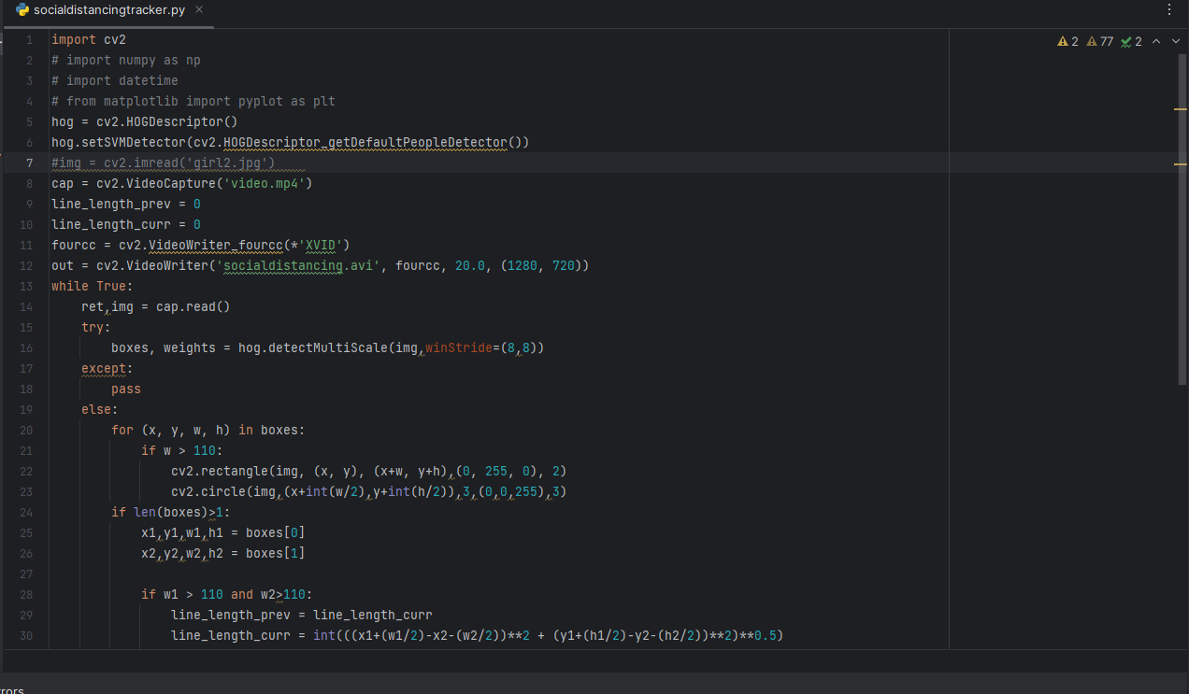

Figure Code file

**4.8.2 Distance tracker**

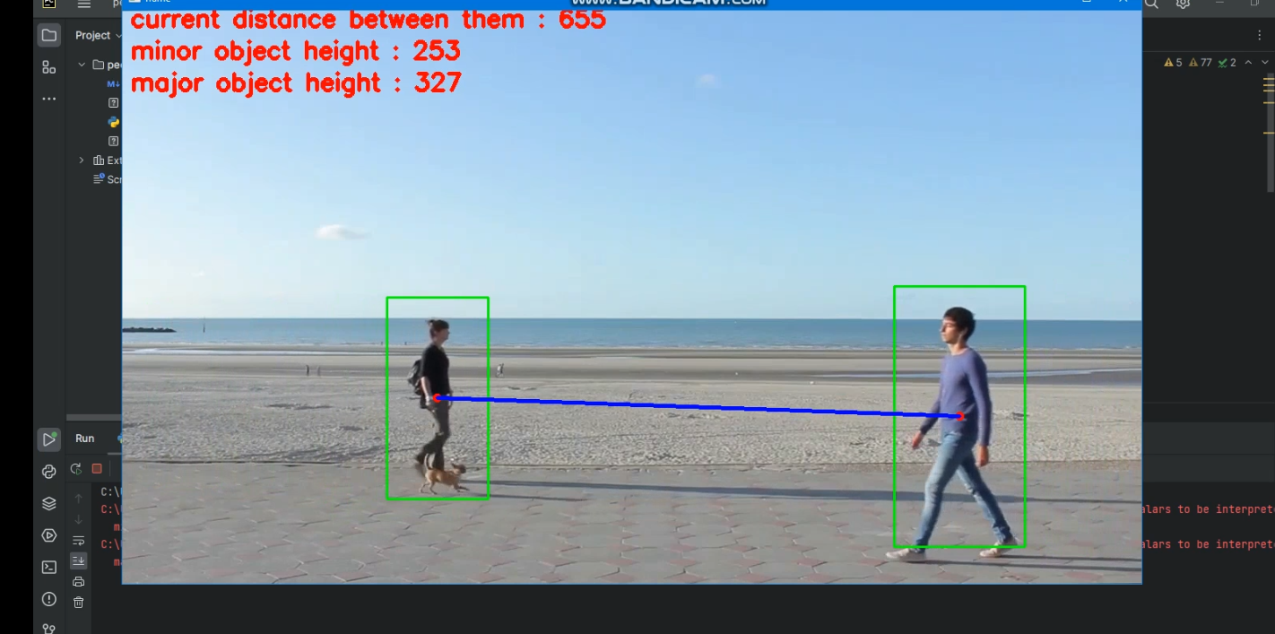

Figure Distance tracker

**4.8.3 Setting Distance Thresh hold**

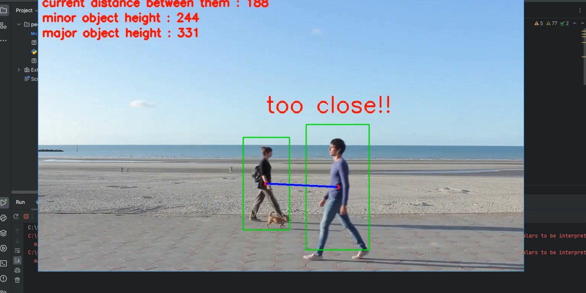

Figure Setting Distance Thresh hold

**4.8.4 Objects moving in Opposite direction**

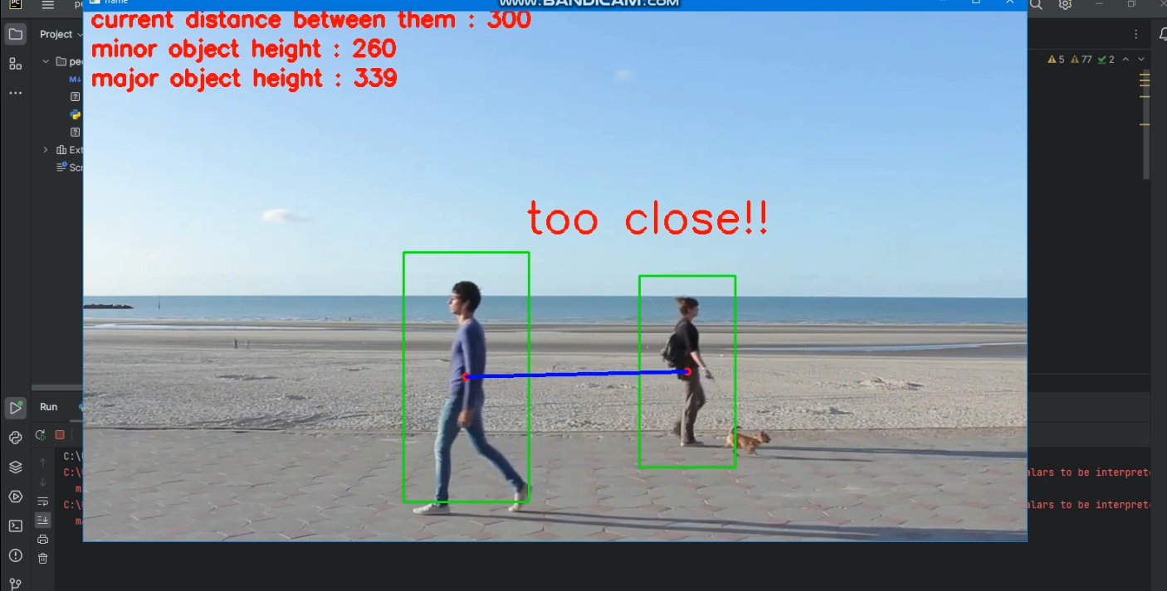

Figure Objects moving in Opposite direction

5. Future Plan

5.1 Advanced Machine Learning Techniques:

The future plan involves exploring and integrating advanced machine learning techniques to enhance the accuracy and efficiency of the Social Distance Monitoring System. Research will focus on leveraging deep learning algorithms, convolutional neural networks (CNNs), and recurrent neural networks (RNNs) to improve person detection and distance estimation. By employing these cutting-edge techniques, the system can better handle complex environments, occlusions, and variations in lighting conditions.

5.2 Multi-Camera Tracking and Integration:

To broaden the system's scope and applicability, the future plan includes multi-camera tracking and integration. By utilizing data from multiple cameras in a given area, the system can track individuals across different viewpoints, providing a comprehensive view of their movements and interactions. This integration will enable effective monitoring in larger public spaces and facilitate the enforcement of social distancing guidelines in diverse settings.

5.3 Edge Computing and Real-Time Processing:

To enhance the system's real-time processing capabilities, the future plan incorporates edge computing technologies. By processing data locally on the surveillance cameras or edge devices, the system can reduce latency and improve response times. This advancement is particularly crucial for time-sensitive applications where immediate actions are required to ensure public safety.

5.4 Behavioral Analysis and Anomaly Detection:

The future plan emphasizes integrating behavioral analysis and anomaly detection mechanisms into the Social Distance Monitoring System. By analyzing individuals' movement patterns and interactions, the system can identify unusual behavior and potential risks, such as crowding or prolonged close interactions. This proactive approach will allow for early intervention and preventive measures to ensure adherence to social distancing guidelines.

5.5 Privacy-Preserving Solutions:

As privacy concerns continue to be at the forefront of surveillance technologies, the future plan focuses on developing privacy-preserving solutions. Advanced encryption techniques and anonymization methods will be explored to safeguard personal data while maintaining the system's effectiveness. By implementing privacy measures, the system can foster public trust and ensure ethical usage of surveillance data.

5.6 Integration with Public Health Databases:

To contribute to broader public health efforts, the future plan involves integrating the Social Distance Monitoring System with public health databases and contact tracing systems. This integration will enable authorities to correlate social distancing compliance data with infection rates and identify potential hotspots for targeted interventions.

5.7 Global Deployment and Collaborations:

The future plan envisions the widespread deployment of the Social Distance Monitoring System in various countries and communities. Collaborations with public health authorities, local governments, and private sector organizations will be established to facilitate seamless implementation and ensure alignment with regional health guidelines.

**6. Conclusion:**

The Social Distance Monitoring System using SVM HOG Descriptor has made significant progress in addressing the need for effective social distancing enforcement in public spaces. Through advanced computer vision and machine learning technologies, the system accurately detects individuals and estimates their distances in real-time.

The user-friendly interface allows operators to monitor social distancing compliance and set threshold distances easily. The implementation of alert mechanisms ensures proactive intervention when individuals get too close, reinforcing social distancing protocols.

Looking ahead, the future plan includes integrating advanced machine learning techniques and multi-camera tracking to enhance accuracy and adaptability. The system's potential impact is vast, as it can be deployed in various public spaces and contribute to broader public health efforts.

The Social Distance Monitoring System represents a vital tool in promoting public safety and mitigating the spread of infectious diseases. Its continuous improvement and innovative approach promise a safer and healthier future for society.