Name: 張 承洋 Dep.:電機三 Student ID:B04901056

- (5%) Print the network architecture of your VGG16-FCN32s model.
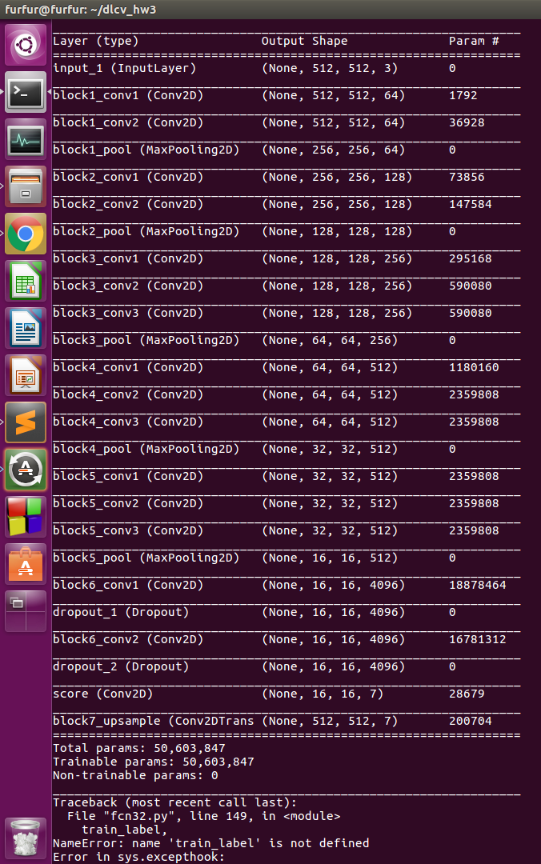

- (10%) Show the predicted segmentation mask of validation/0008_sat.jpg, validation/0097_sat.jpg, validation/0107_sat.jpg during the early, middle, and the final stage during the training stage. (For example, results of 1st, 10th, 20th epoch)

 | Epoch 1 | Epoch 10 | Epoch 20
0008_sat.jpg | 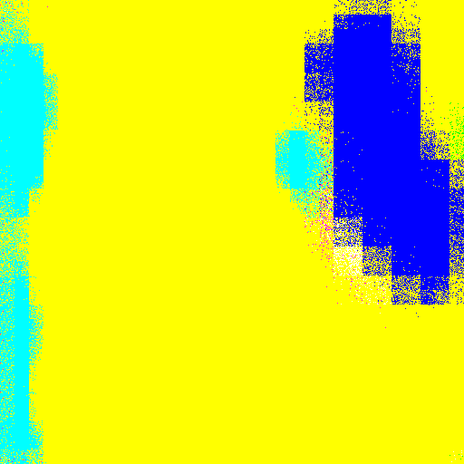 |  | 
0097_sat.jpg | 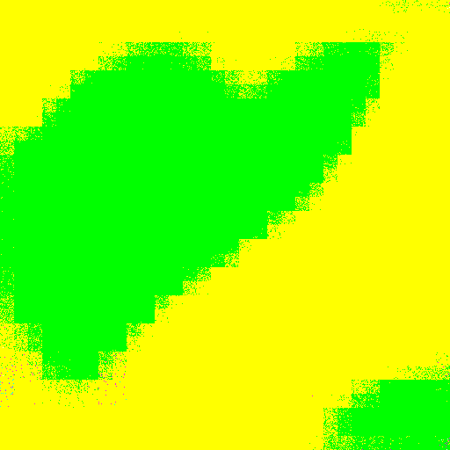 | 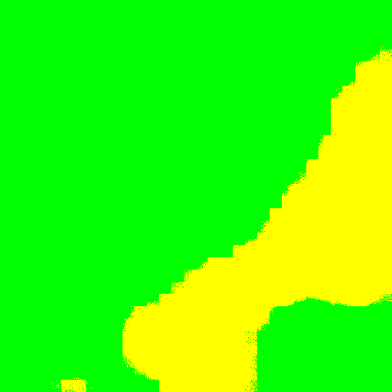 | 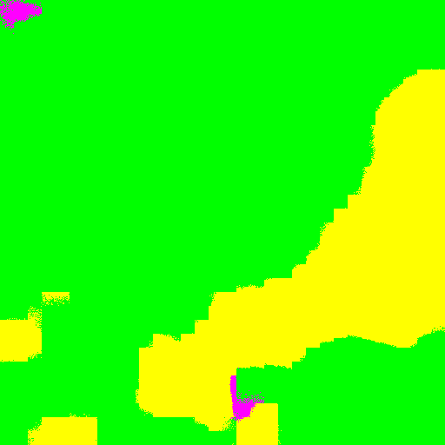
0107_sat.jpg |  |  | 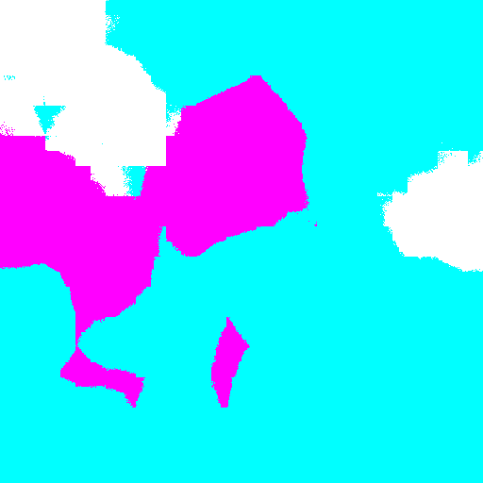

- (15%) Implement an improved model which performs better than your baseline model. Print the network architecture of this model.

(VGG16 + FCN16s)
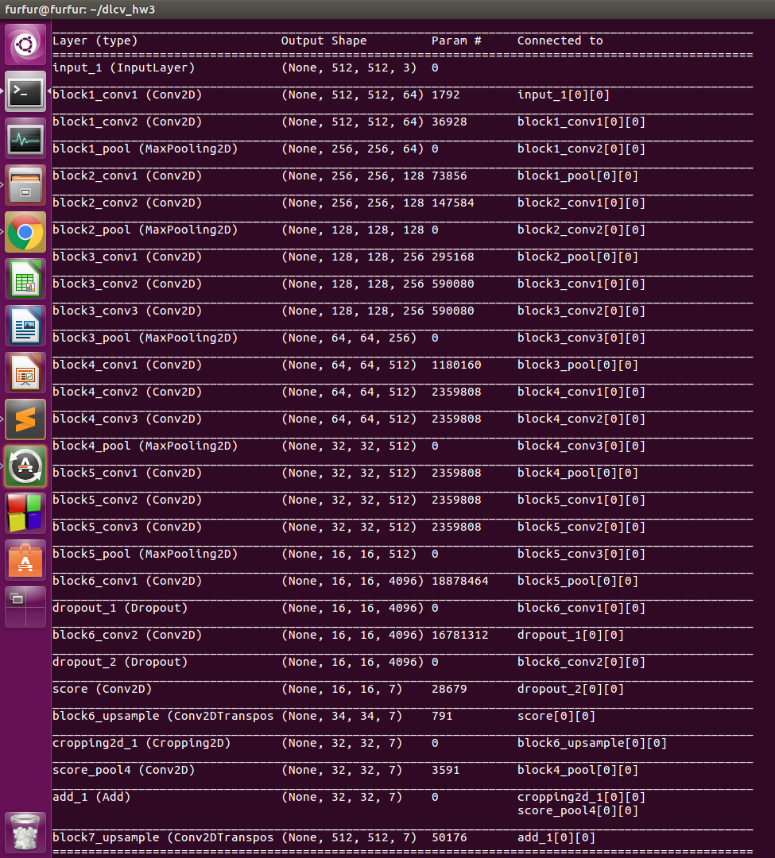

- (10%) Show the predicted segmentation mask of validation/0008_sat.jpg, validation/0097_sat.jpg, validation/0107_sat.jpg during the early, middle, and the final stage during the training process of this improved model.

 | Epoch 1 | Epoch 10 | Epoch 20
0008_sat.jpg |  |  | 
0097_sat.jpg | 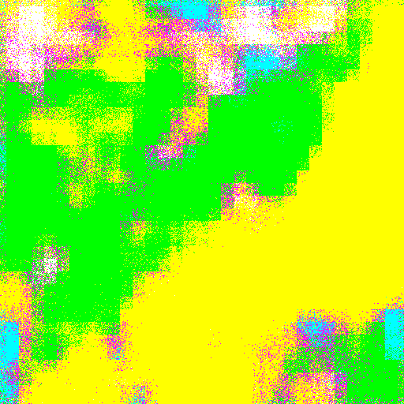 | 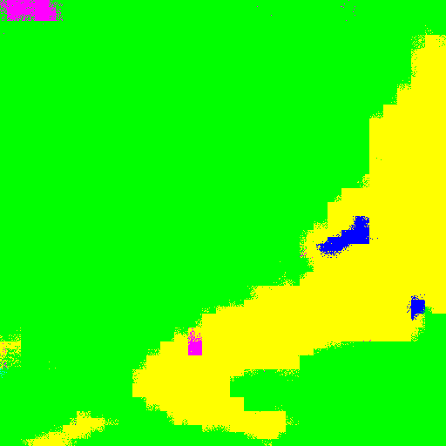 | 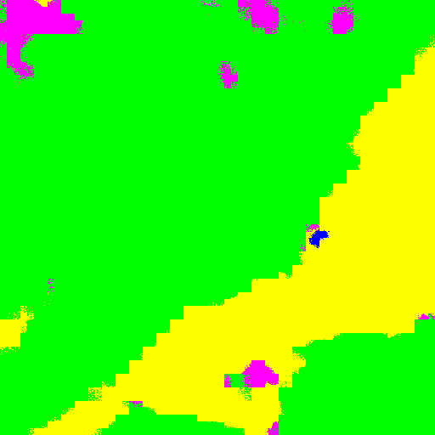
0107_sat.jpg |  | 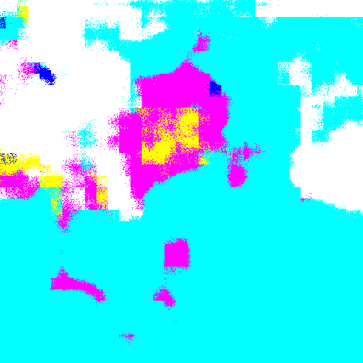 | 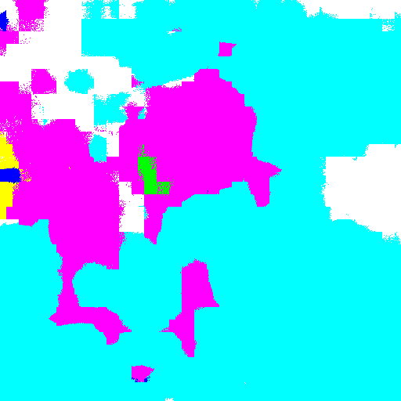

- (15%) Report mIoU score of both models on the validation set. Discuss the reason why the improved model performs better than the baseline one. You may conduct some experiments and show some evidences to support your discussion.

mIoU score | Epoch 1 | Epoch 10 | Epoch 20
VGG16 + FCN32s | 0.504 | 0.627 | 0.681
VGG16 + FCN16s | 0.454 | 0.682 | 0.699

從mIoU 可以看出，baseline model 雖然一開始有較好的表現，但隨著training epoch 數增加，improved model表現則超過baseline model。

從輸出圖片來看，FCN32明顯忽略了許多細節，圖片較為模糊 ; FCN16則是在pool4後多加了一層1*1的CNN得到的結果放大2倍，得到區分度更高的影像，然後再和最後的結果相加再進行放大16倍得到結果，可以保留更多的細節。

下面我選了幾張兩個model有明顯差異的圖片結果：

 | FCN32s | FCN16s
0030_sat.jpg | 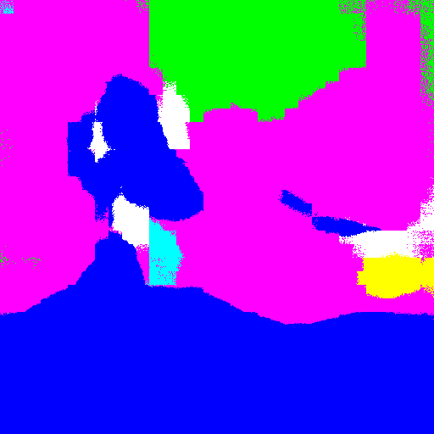 | 
0140_sat.jpg |  | 
0101_sat.jpg |  | 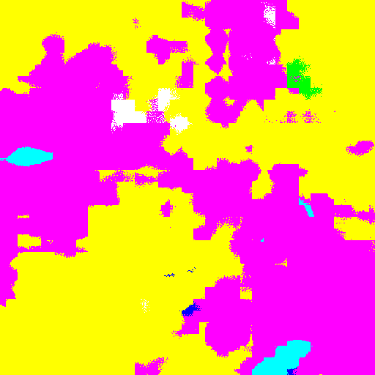

- (5%) [bonus] Calculate the result of d/dw G(w):

