Notice:

For this project, I have finished most functions of the parser, the compiler, and the runner. However, the function definition part and type checker are still in progress, so I wouldn’t be able to match some of the requirements of this assignment, but I will also show some features that are not included in the bullet points. In addition, my program supports “npm run build-web” and “npm test” but not “npm run build-cli”. Since there are some config errors, and the professor told us not to spend time on those errors, I decided to use those two commands and my debugstart.ts to debug and test. I believe these methods are enough for you to test.

1. A description of the representation of values (integers, booleans, and None) in your implementation. Show how the representation is used to print True/False for Boolean results rather than numeric output.

I defined Literal as a number, a Boolean, or none with tags and values, and a literal is also a kind of an expression. Since I haven’t finished the function part, I still use 1 to represent True and 0 to represent False when the print function is called. I will define a print_bool function for Boolean values after the function part is done, and True and False will be displayed.



1. Give an example of a program that uses
2. At least one global variable

Since the SPEC indicates that global declaration is not included in the subset we should implement, I exclude this feature. I will implement it if the conflict is resolved, and we are sure that this feature is needed.

1. At least one function with a parameter



The functions from the last project are all supported in this project.

1. At least one variable defined inside a function



Since I haven’t done the function part, I would just show you that I can define both integers and Booleans instead.

1. By linking to specific definitions and code in your implementation, describe where and how those three variables are stored and represented throughout compilation.一張含有 文字 的圖片

   自動產生的描述

Since I haven’t defined global variables and functions, all my variables are stored locally. I will probably use a similar structure to store my global variables. However, for function variables, I think I will need a stack to store those structs so that we can get correct variables and values under different environments.

1. Write a ChocoPy program that goes into an infinite loop. What happens when you run it on the web page using your compiler?



Since the program goes into an infinite loop, the web page would keep trying to collect all values that should be displayed. However, there are infinite values, and the web page would eventually shutdown. Ideally, we should be able to identify the infinite loop in the code and warn the user before the code is ran.

1. For each of the following scenarios, show a screenshot of your compiler running the scenario in the browser:
2. A program that reports a type error for adding a number and a boolean where one operand is a call expression and the other operand is a variable (for example, f(1) + x)



Since I haven’t done a type checker, the type error would not be reported, and the value would be 11 because True is considered as 1 in my program. This is a temporary feature, and it can be modified easily once the type checker is done.

1. A program that has a type error in a conditional position (the condition part of an if or while), where that position is a non-global identifier (function parameter or local variable)



Since I haven’t finished my type checker, there would be no type error, but I can show that a reference error would pop out if a variable that is not in scope is used as a condition.

1. A program that with a loop that has multiple iterations, and calls a function on each iteration (it can be the same function)

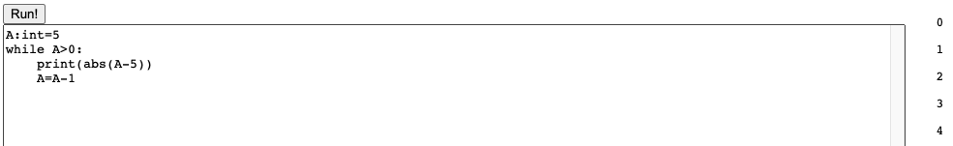

There are 5 iterations in this program, and the print function and the abs function are called on each iteration.

1. A program that returns from the body of a loop, and not on the first iteration of the loop

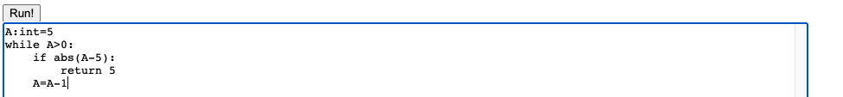

This program would return on the second iteration, and I can use a variable to get the return value once the function part is done.

1. Printing an integer and a Boolean



After the print_bool function is done, the output would be more ideal, but the output 10 and 0 are still reasonable now.

1. A recursive function that terminates (e.g. no stack overflow)



The function part is not done, but I can show that some of my functions can be called recursively.

1. Two mutually-recursive functions that terminate (e.g. no stack overflow)



The function part is not finished, but I can show that some of my functions can be called in a mutually-recursive way.

1. Choose one of example (1) or (2) above, show a few lines of code around the line that reports the error and describe the relevant parts of the type-checking environment at that point.

Since my program pops a reference error at example (2), I would like to show how my complier catches the error. Basically, it checks the definedVars struct which I used to store defined variables to know if a variable can be referenced.

Explanation:

I wouldn’t say that the required features are really hard to implement, but my initial strategy was to finish the parser, then the compiler, and then the type checker. Thus, I spent a lot of time checking the logic of my program and thinking of edge cases before I move on to the next steps. It might seem that there are a few requirements that I cannot meet, but I think that I am actually pretty close. It’s mainly related to my strategy, but I also don’t think this is wrong because what I focused is also really important for a practical compiler. For example, I spent a lot of time on the logic and test cases of the if statements, and this kinds of details stops me from finishing the program completely.