Programming Assignment #2  
OBST

112062636 游竣量

Input:

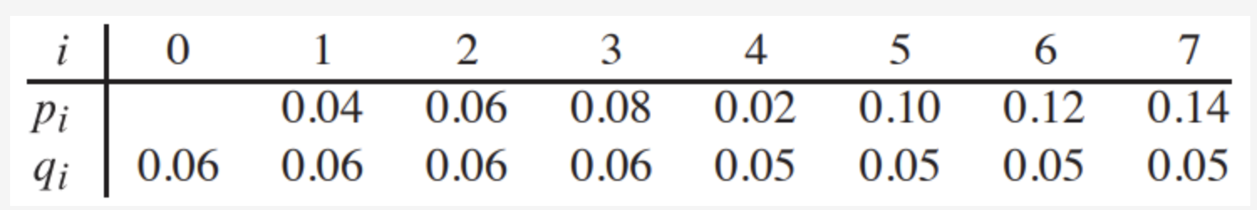

Output:

