Programming Assignment #3  
n-Queen Problem

112062636 游竣量

Input:

N = 8, 9, 10, 11, 12, 13, 14

Output:

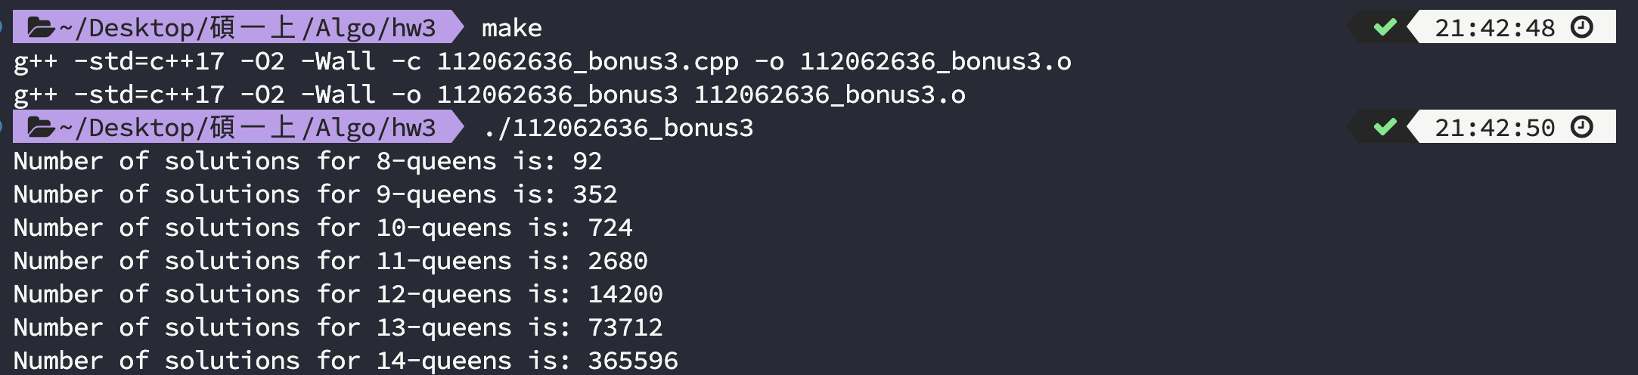

時間複雜度：T( n ) = n \* T( n - 1) = O (n!)