**Waveform**

1. Start the coefficient input (AXI-lite)

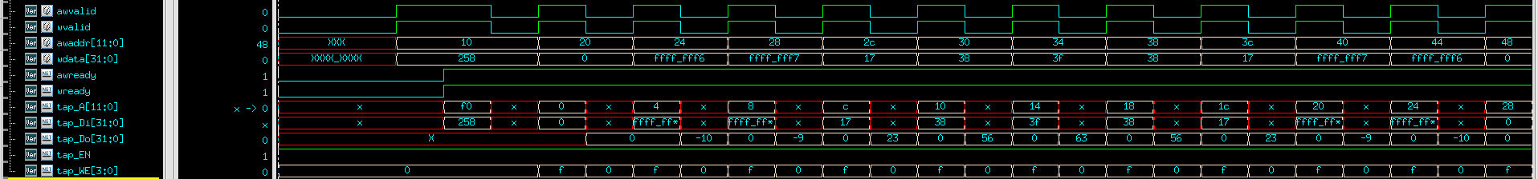

1. Check coefficient

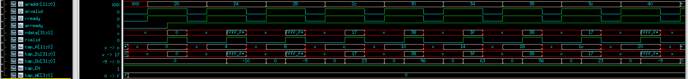

1. FIR FSM

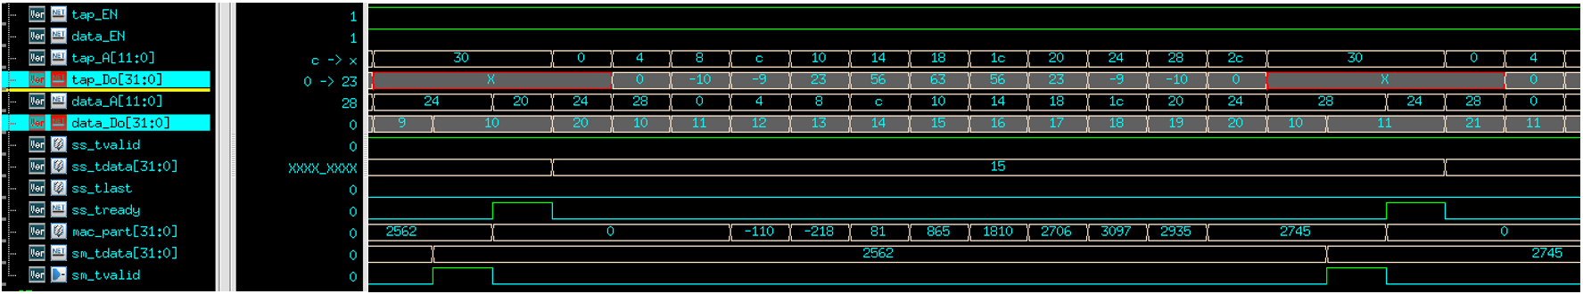

1. Overview
2. Beginning: coefficient input

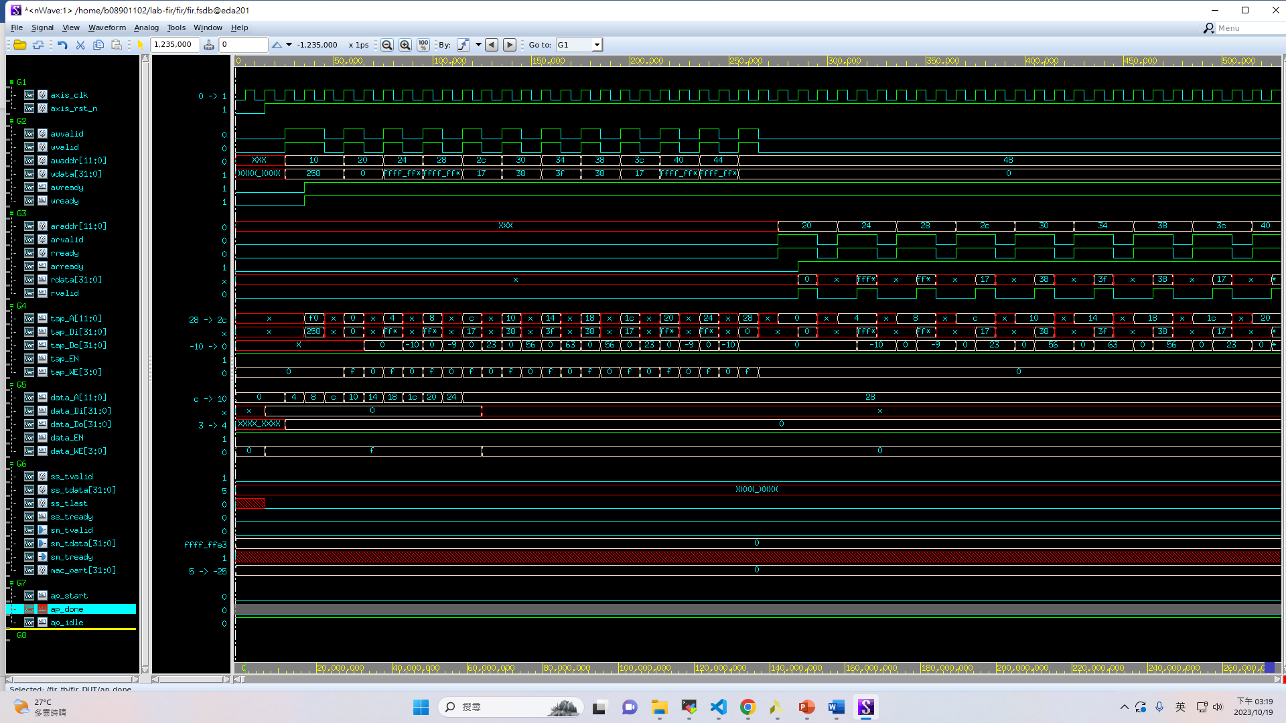

1. FIR process

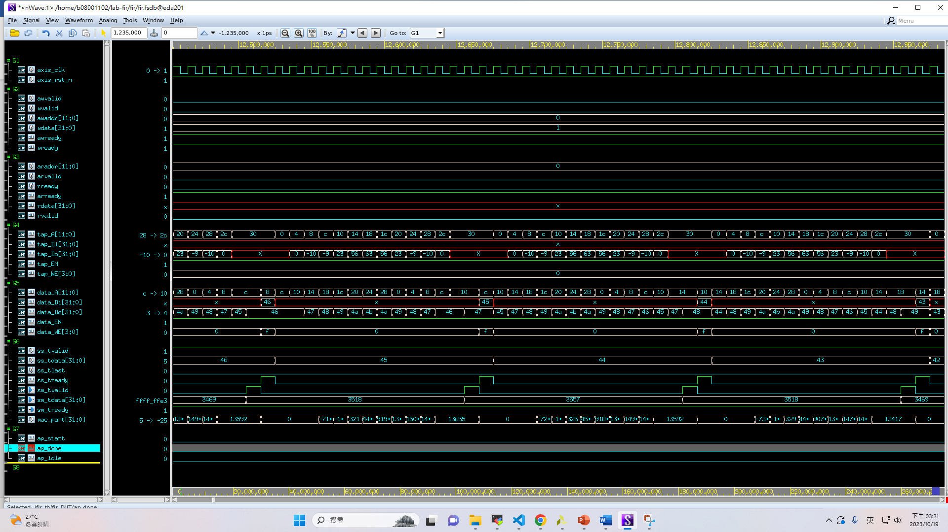

1. End: after 3 FIR

